

DEPARTMENT OF COMPUTER SCIENCE

FORMAN CHRISTIAN COLLEGE
(A CHARTERED UNIVERSITY)
LAHORE

Web Application Development
CSCS342
Lab Manual
 | DEPARTMENT OF COMPUTER SCIENCE  FORMAN CHRISTIAN COLLEGE  (A CHARTERED UNIVERSITY),  LAHORE

LAB #06: Javascript
Name:___Daim Bin Khalid_________________ Roll #: ____251686775_______________

Objective:
This lab is aimed to practice and revise your CSS, Html, JavaScript and React. In this lab you will have an opportunity to practice:
- JS inside JSX
- React Props

Task 1: Fix the h1 in the code below to use the timeOfDay string and see the output displayed. Attach the screenshot as well. [5 pts.]
import React from "react"
import ReactDOM from "react-dom"

function App() {
const date = new Date()
const hours = date.getHours()
let timeOfDay

if (hours < 12) {
timeOfDay = "morning"
} else if (hours >= 12 && hours < 17) {
timeOfDay = "afternoon"
} else {
timeOfDay = "night"
}

return (
<h1>Good afternoon!</h1>
)
}

ReactDOM.render(<App />, document.getElementById("root"))

Your code: (The line you changed)
return <h1>Good {timeOfDay}!</h1>;

Screenshot of the output:

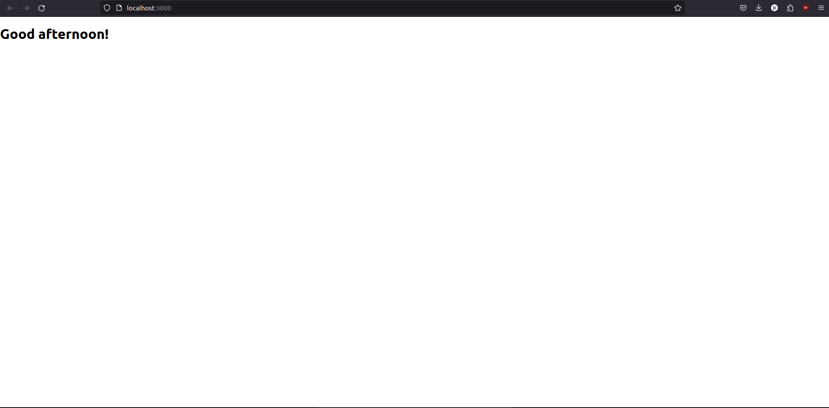
Task 2: Design a web page like following using Html, CSS and React. You are required to go to FC College website and choose 10 teachers of your choice from Computer Science department and display their information as shown in the example. (You can Style it as you wish however it has to be appealing). [15 pts]
Note: It is compulsory to use Props.
Sample:
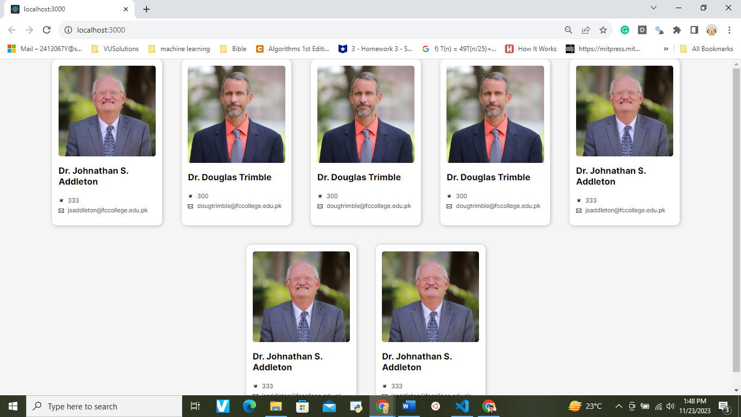

Your code:
App.js:
import React from "react";
import ContactCard from "./components/Contact";
import "./App.css";

const App = () => {
const contactData = [
{
name: "Dr. Mubashar Mushtaq",
image:
"https://www.fccollege.edu.pk/wp-content/uploads/Dr-Mubashar-Mushtaq-scaled.jpg",
phoneNumber: " EXT | 530 ",
email: "mubasharmushtaq@fccollege.edu.pk",
},
{
name: "Dr. Aasia Khanum",
image:
"https://www.fccollege.edu.pk/wp-content/uploads/Dr.-Aasia-Khanum-scaled.jpg",
phoneNumber: "EXT | 508 ",
email: "aasiakhanum@fccollege.edu.pk",
},
{
name: "Dr. Maria Tamoor",
image:
"https://www.fccollege.edu.pk/wp-content/uploads/Maria-Tamoor-scaled.jpg",
phoneNumber: "EXT | ",
email: "mariatamoor@fccollege.edu.pk",
},
{
name: "Dr. Sidra Minhas",
image:
"https://www.fccollege.edu.pk/wp-content/uploads/Sidra-Minhas-scaled.jpg",
phoneNumber: "EXT | ",
email: "sidraminhas@fccollege.edu.pk",
},
{
name: "Muhammad Rauf Butt",
image:
"https://www.fccollege.edu.pk/wp-content/uploads/Muhammad-Rauf-Butt-scaled.jpg",
phoneNumber: "EXT | ",
email: "raufbutt@fccollege.edu.pk",
},
{
name: "Muhammad Salman Chaudhry",
image:
"https://www.fccollege.edu.pk/wp-content/uploads/Muhammad-Salman-Chaudhry-scaled.jpg",
phoneNumber: "EXT | ",
email: "salmanchaudhry@fccollege.edu.pk",
},
{
name: "Fakhir Shaheen",
image:
"https://www.fccollege.edu.pk/wp-content/uploads/Fakhir-Shaheen-scaled.jpg",
phoneNumber: "EXT | ",
email: "fakhirshaheen@fccollege.edu.pk",
},
{
name: "Samia Asloob Qureshi",
image:
"https://www.fccollege.edu.pk/wp-content/uploads/Samia-Asloob-Qureshi-scaled.jpg",
phoneNumber: "EXT | 612",
email: "samiaqureshi@fccollege.edu.pk",
},
{
name: "Rabranea Bqa",
image:
"https://www.fccollege.edu.pk/wp-content/uploads/CS-Dep-Rabranea-scaled.jpg",
phoneNumber: "EXT | 621",
email: "rabraneabqa@fccollege.edu.pk",
},
{
name: "Sharoon Nasim",
image:
"https://www.fccollege.edu.pk/wp-content/uploads/Mr.-Sharoon-Nasim-scaled.jpg",
phoneNumber: "EXT | 624",
email: "sharoonnasim@fccollege.edu.pk",
},
];

return (
<div className="app">
<h1>Contact Cards</h1>
<div className="contact-container">
{contactData.map((contact, index) => (
<ContactCard
key={index}
image={contact.image}
name={contact.name}
phoneNumber={contact.phoneNumber}
email={contact.email}
/>
))}
</div>
</div>
);
};

export default App;

App.css:
.app h1 {
text-align: center;
}

Contact.js:
import React from "react";
import "./Contact.css";

const ContactCard = ({ image, name, phoneNumber, email }) => {
return (
<div className="contact-card">
<img src={image} alt={`${name}'s profile`} className="contact-image" />
<div className="contact-details">
<h2 className="contact-name">{name}</h2>
<div className="info">
<img
src="https://w7.pngwing.com/pngs/421/683/png-transparent-computer-icons-mobile-phones-telephone-email-home-business-phones-phone-icon-miscellaneous-angle-service-thumbnail.png"
alt="Phone Logo"
className="phone-logo"
/>
<p className="contact-info">{phoneNumber}</p>
</div>
<div className="info">
<img
src="https://png.pngtree.com/png-vector/20201109/ourmid/pngtree-email-icon-design-png-image_2413695.jpg"
alt="Email Logo"
className="email-logo"
/>
<p className="contact-info">{email}</p>
</div>
</div>
</div>
);
};

export default ContactCard;

Contact.css:
.contact-container {
display: flex;
flex-wrap: wrap;
justify-content: space-between;
}

.contact-card {
flex: 0 0 calc(20% - 20px);
display: flex;
flex-direction: column;
align-items: center;
justify-content: center;
padding: 20px;
border: 1px solid #ddd;
border-radius: 8px;
margin: 10px;
max-width: 300px;
}

.contact-image {
width: 180px;
height: 150px;
border-radius: 20px;
margin-bottom: 20px;
}

.contact-details {
text-align: center;
}

.info {
display: flex;
align-items: center;
justify-content: center;
}

.phone-logo,
.email-logo {
width: 20px;
height: 20px;
margin-right: 5px;
}

.contact-name {
font-size: 1.2rem;
margin-bottom: 5px;
}

.contact-info {
font-size: 1rem;
margin: 0;
color: #555;
}

Screenshot of the output:
