FORMAN CHRISTIAN COLLEGE
(A CHARTERED UNIVERSITY)



CSCS 306 - A
FALL 24
Lab 6 Report

Hafsah Shahbaz – 251684784
Daim Bin Khalid - 251686775
Syeda Manal Ammad - 251606966

14th November 2024
Introduction
This lab focused on creating an Arduino-based library, LedControl, to manage a 4-LED setup. The library provides functions for basic LED operations, such as turning all LEDs on or off, generating random binary numbers, counting up or down in binary, and shifting bits left or right. Through this library, users can easily perform common LED operations in Arduino projects without needing to implement LED control logic from scratch. This project emphasizes essential concepts in embedded systems and C++ library design for Arduino.
The code and further documentation for the LedControl library can be found on GitHub: https://github.com/Emeika/LedControl.

Functions
- begin(): Initializes the LED pins as outputs, setting them up for control operations.
- generateRandNumber(): Generates a random binary number between 0 and 15, displaying the result across the LEDs.
- upCount(): Counts up from 0 to 15 in binary, with each step represented on the LEDs.
- downCount(): Counts down from 15 to 0 in binary, displaying each step.
- shiftRight(int num, int shift_amount): Shifts the binary representation of num to the right by shift_amount, updating the LEDs after each shift.
- shiftLeft(int num, int shift_amount): Shifts the binary representation of num to the left by shift_amount, updating the LEDs after each shift.
- allOff(): Turns off all LEDs.
- allOn(): Turns on all LEDs.

These functions provide a comprehensive set of operations for LED manipulation, making the LedControl library versatile and user-friendly for embedded projects.

Algorithm and Logic
Setup Phase
- Initialize Serial Communication: For debugging purposes, Serial.begin(9600); is called to allow output to the Serial Monitor.
- Initialize the LED Pins: The begin() function configures each LED pin as an output.
- Visual Feedback: All LEDs blink three times using allOn() and allOff() to indicate the library is ready for use.
Function Demonstrations
- Random Number Generation: The generateRandNumber() function is used to generate a random binary number between 0 and 15, which is displayed on the LEDs.
- Counting Up and Down:
  - upCount(): Displays a binary count from 0 to 15 on the LEDs with a 2-second delay.
  - downCount(): Displays a binary count down from 15 to 0 with a 2-second delay.
- Shifting Operations:
  - shiftRight(num, shift_amount): Demonstrates a shift to the right on the initial binary number, updating the LEDs and Serial Monitor after each shift.
  - shiftLeft(num, shift_amount): Demonstrates a shift to the left, similarly updating the LEDs and Serial Monitor.
- LED Control:
  - allOn() and allOff(): These functions provide a quick way to toggle all LEDs on or off.

Example Sketch
#include <LedControl.h>
LedControl ledControl(2, 3, 4, 5); // Specify LED pins

void setup() {
Serial.begin(9600);
ledControl.begin();

Serial.println("Random number:");
ledControl.generateRandNumber();
delay(2000);

Serial.println("Counting up:");
ledControl.upCount();
delay(2000);

Serial.println("Counting down:");
ledControl.downCount();
delay(2000);

Serial.println("Shifting right:");
ledControl.shiftRight(8, 3);
delay(2000);

Serial.println("Shifting left:");
ledControl.shiftLeft(1, 2);
delay(2000);

Serial.println("Turning all LEDs on:");
ledControl.allOn();
delay(2000);

Serial.println("Turning all LEDs off:");
ledControl.allOff();
}

void loop() {
// Empty loop
}

Output
Random number:
Counting up:
Counting down:
Shifting right:
Displaying number: 8 (Binary: 1000)
Displaying number: 4 (Binary: 0100)
Displaying number: 2 (Binary: 0010)
Displaying number: 1 (Binary: 0001)
Shifting left:
Displaying number: 1 (Binary: 0001)
Displaying number: 2 (Binary: 0010)
Displaying number: 4 (Binary: 0100)
Turning all LEDs on:
Turning all LEDs off:

Output

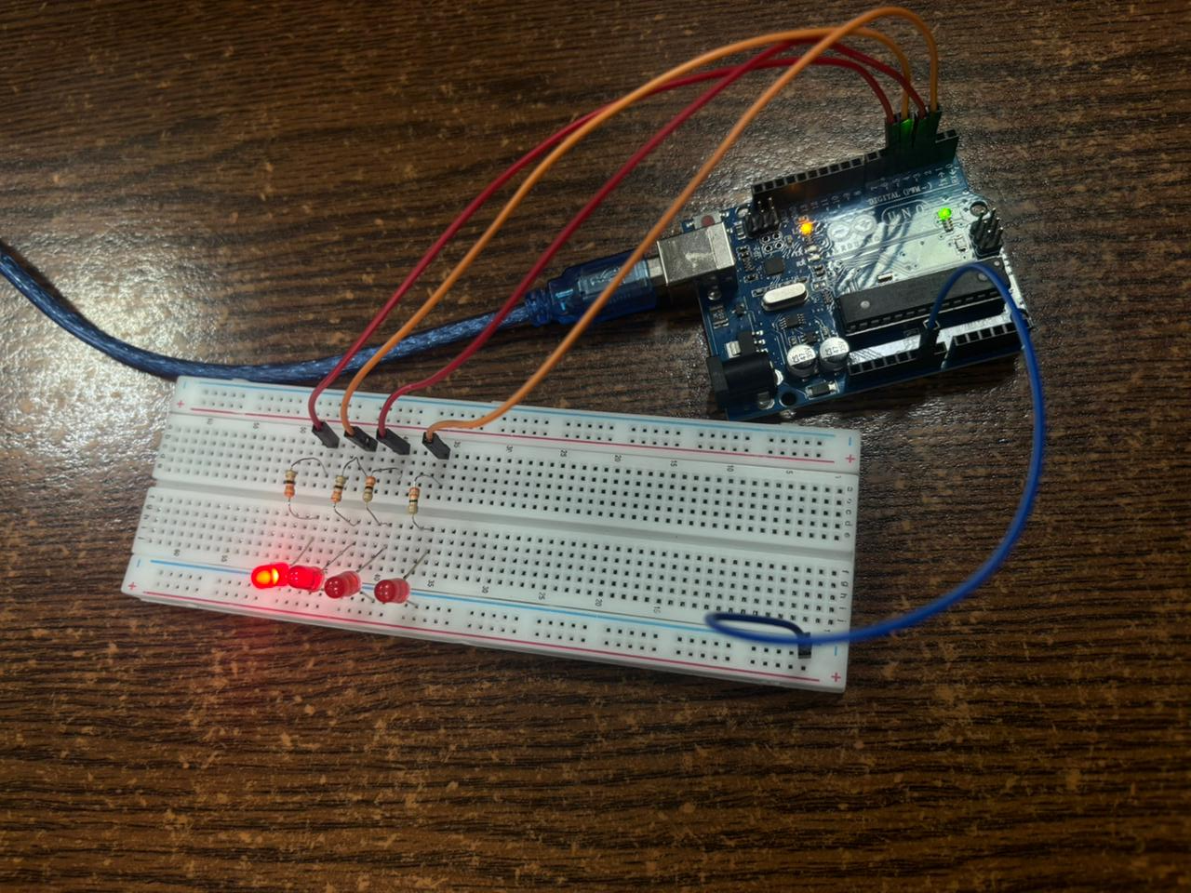

Comment: The output shows the number 8 being shown by the LEDs in binary.

