FORMAN CHRISTIAN COLLEGE
(A CHARTERED UNIVERSITY)



COMP421 - B
SPR25
Assignment 1

Daim Bin Khalid - 251686775

7th May 7, 2025
Setup DVWA
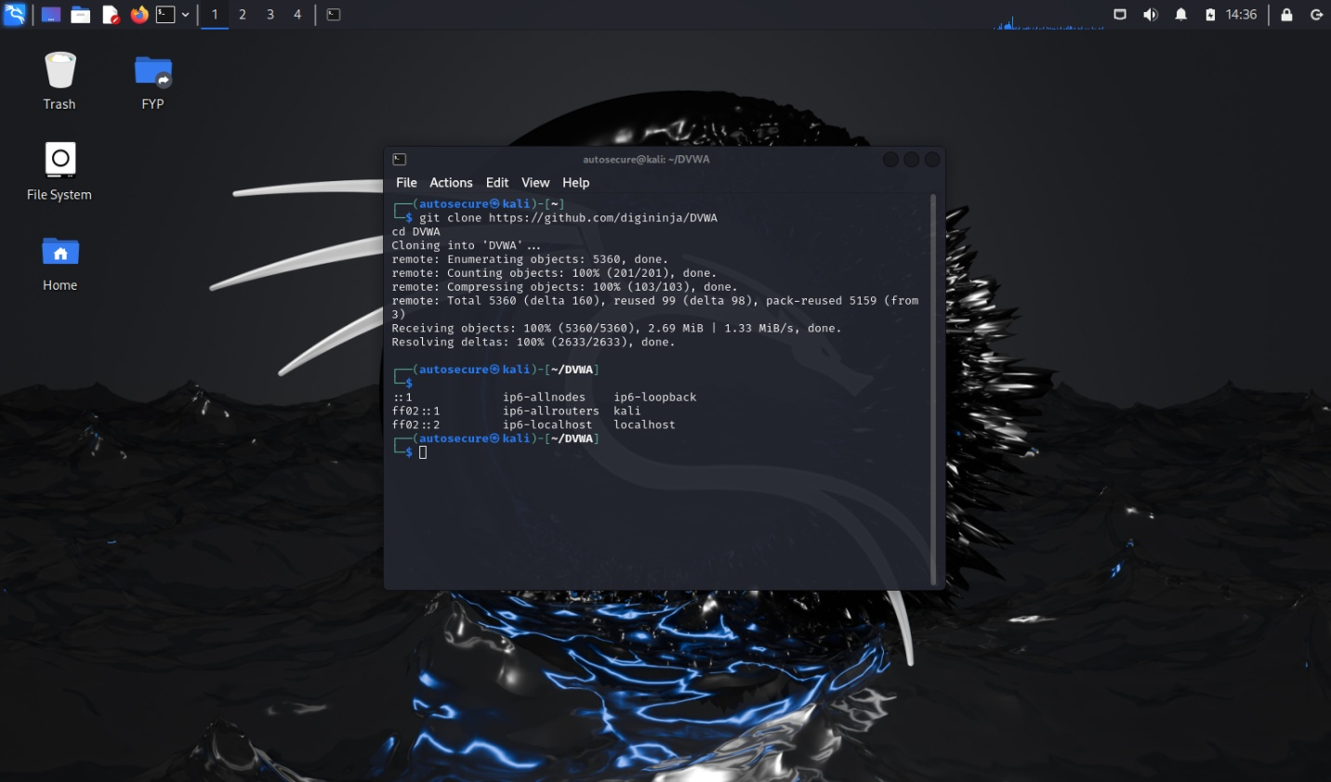

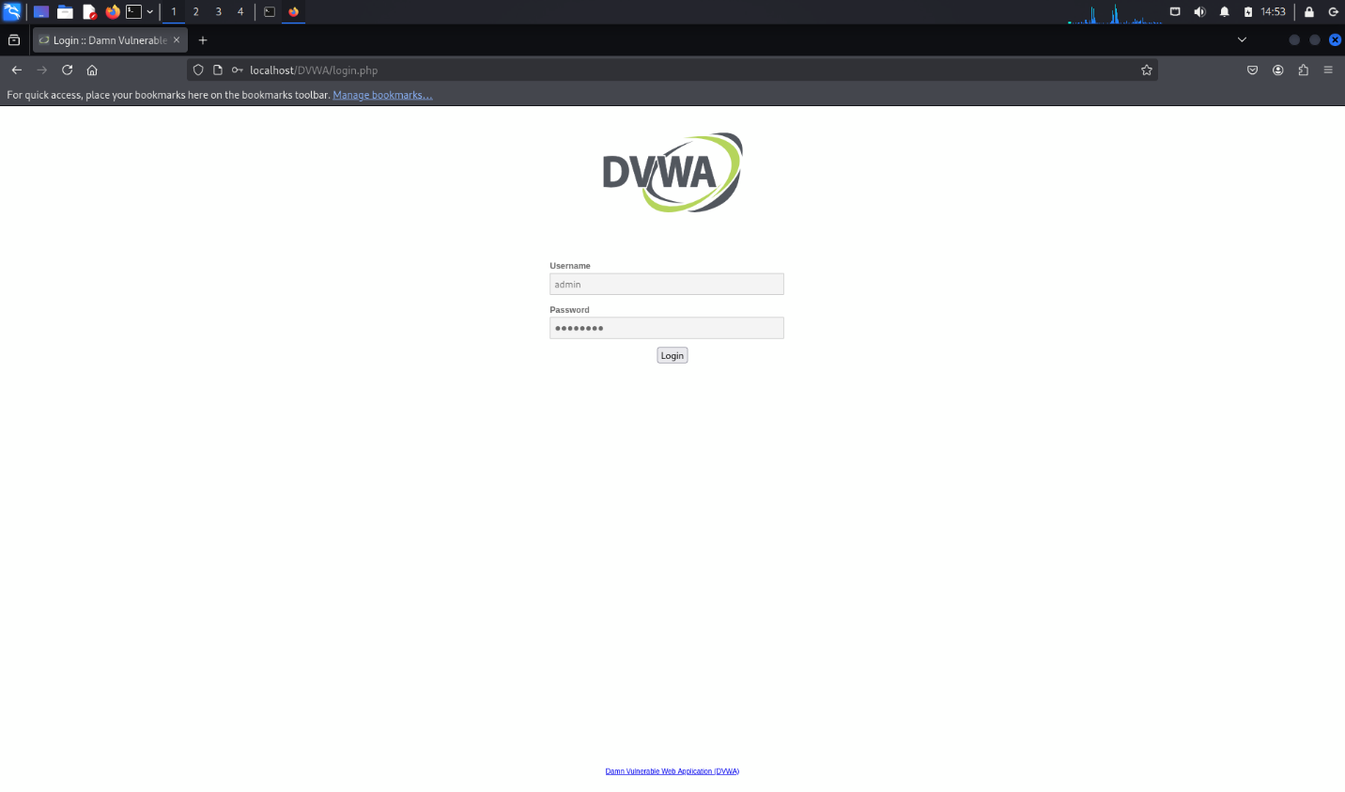

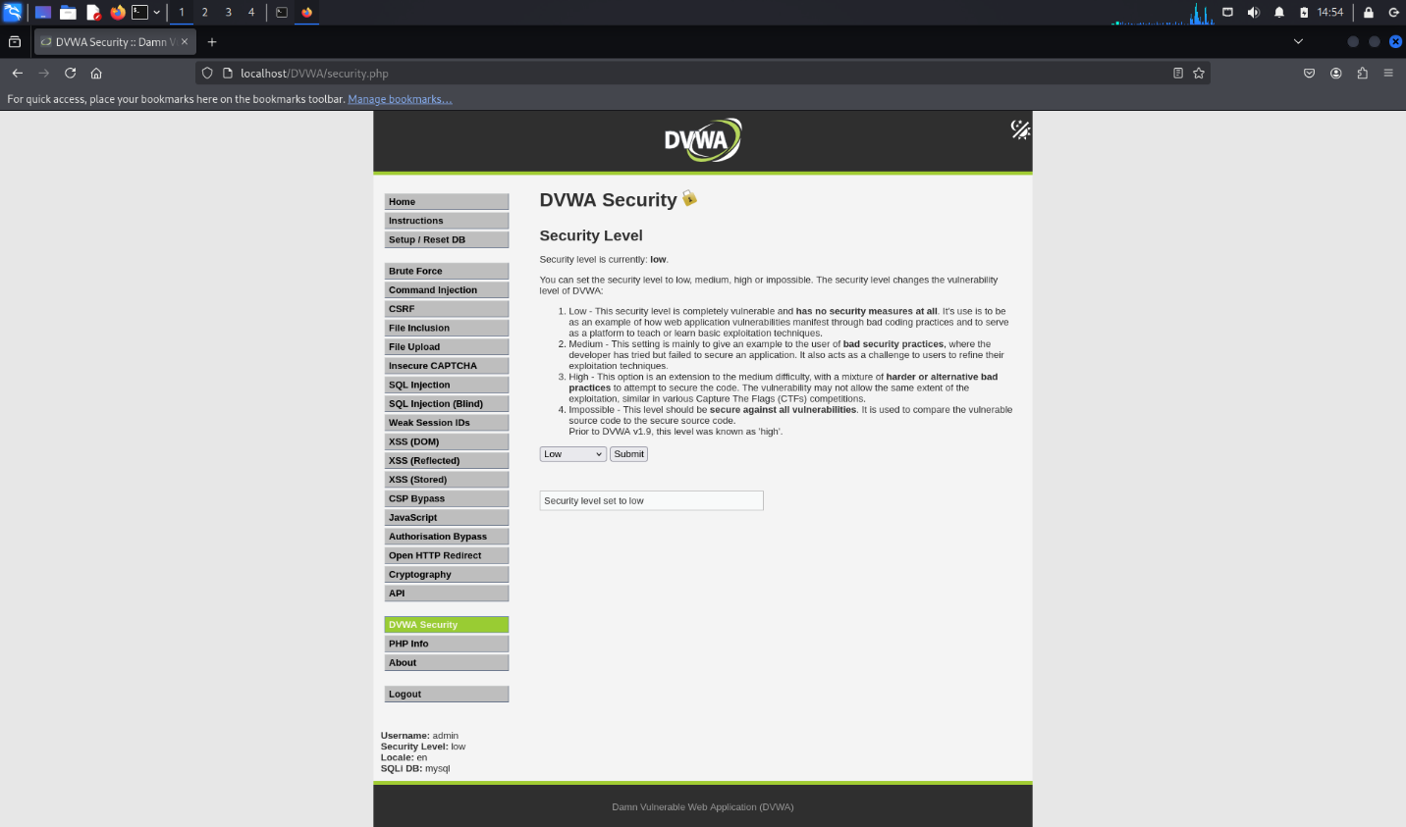

Task 1 (Identify File Inclusion Point):
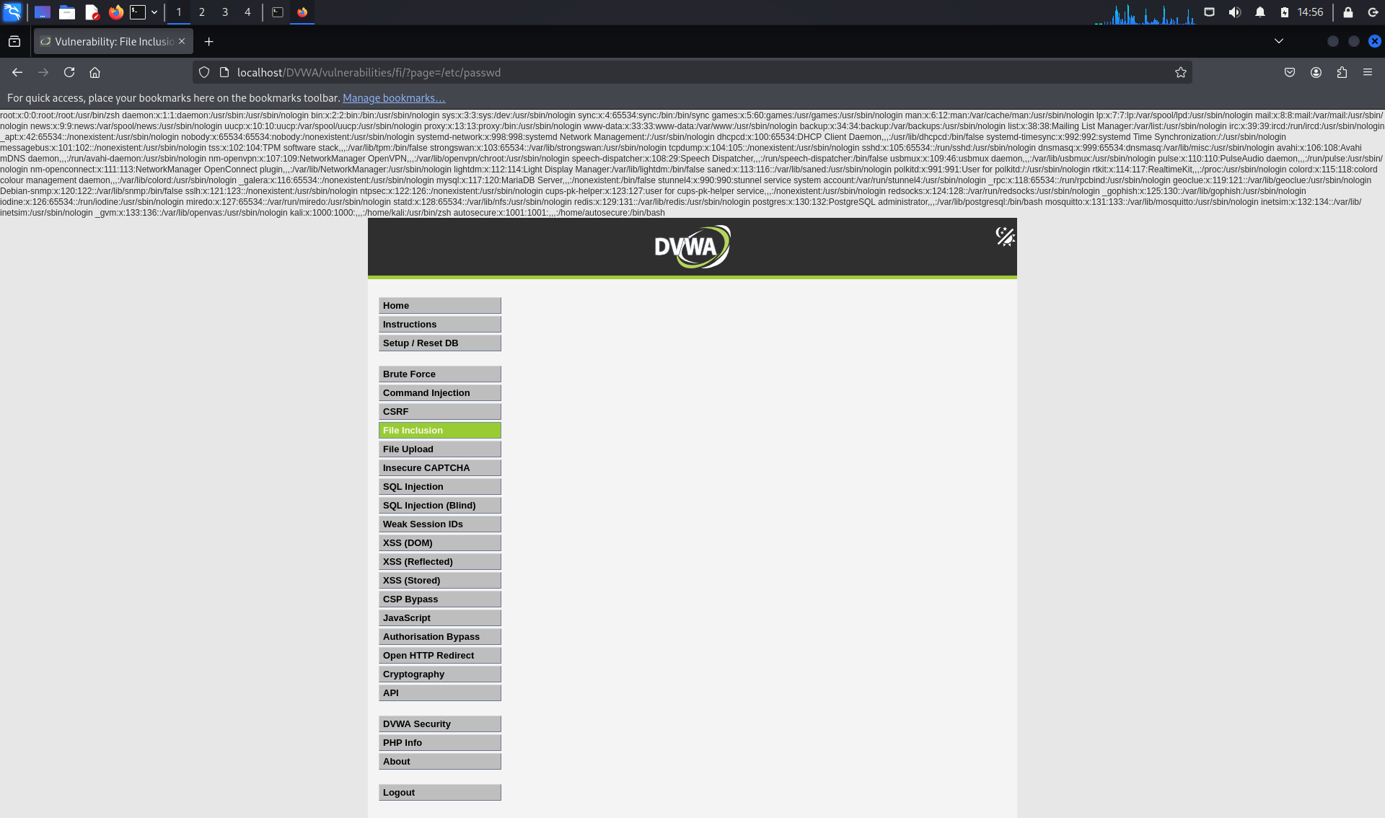

Used url: localhost/DVWA/vulnerabilities/fi/?page=/etc/passwd
Successfully retrieved contents of /etc/passwd, showing DVWA is vulnerable under "Low" security.

What I learnt:
LFI allows attackers to read sensitive files on the server.

Tasks 2 (Remote File Inclusion: RFI):
Setup a malicious PHP file and host it on port 8000:
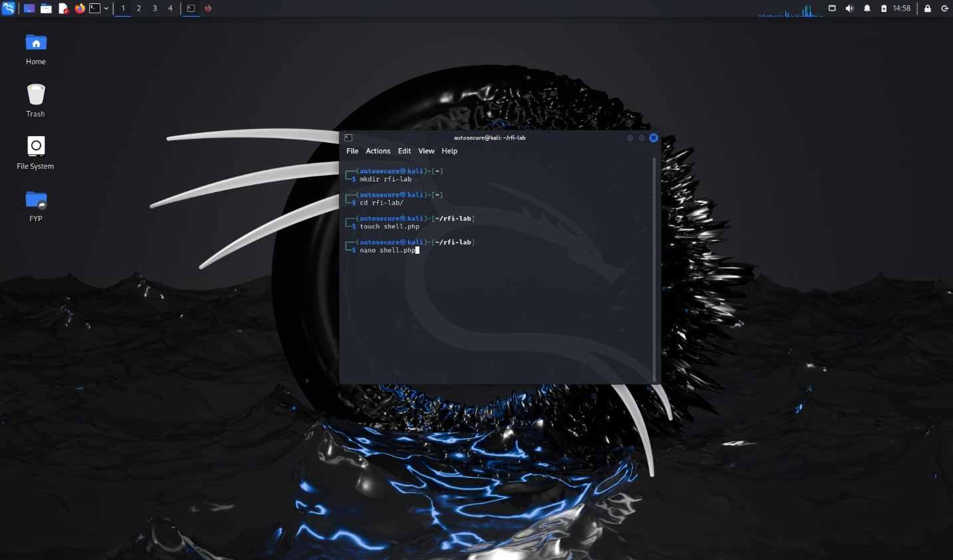

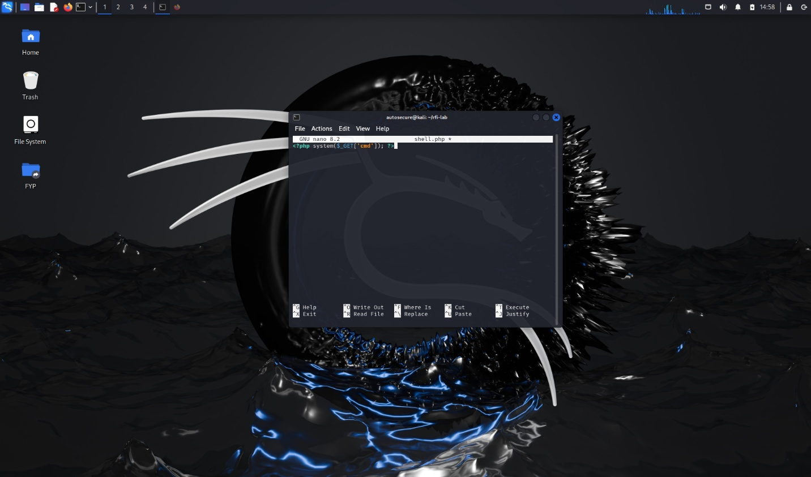
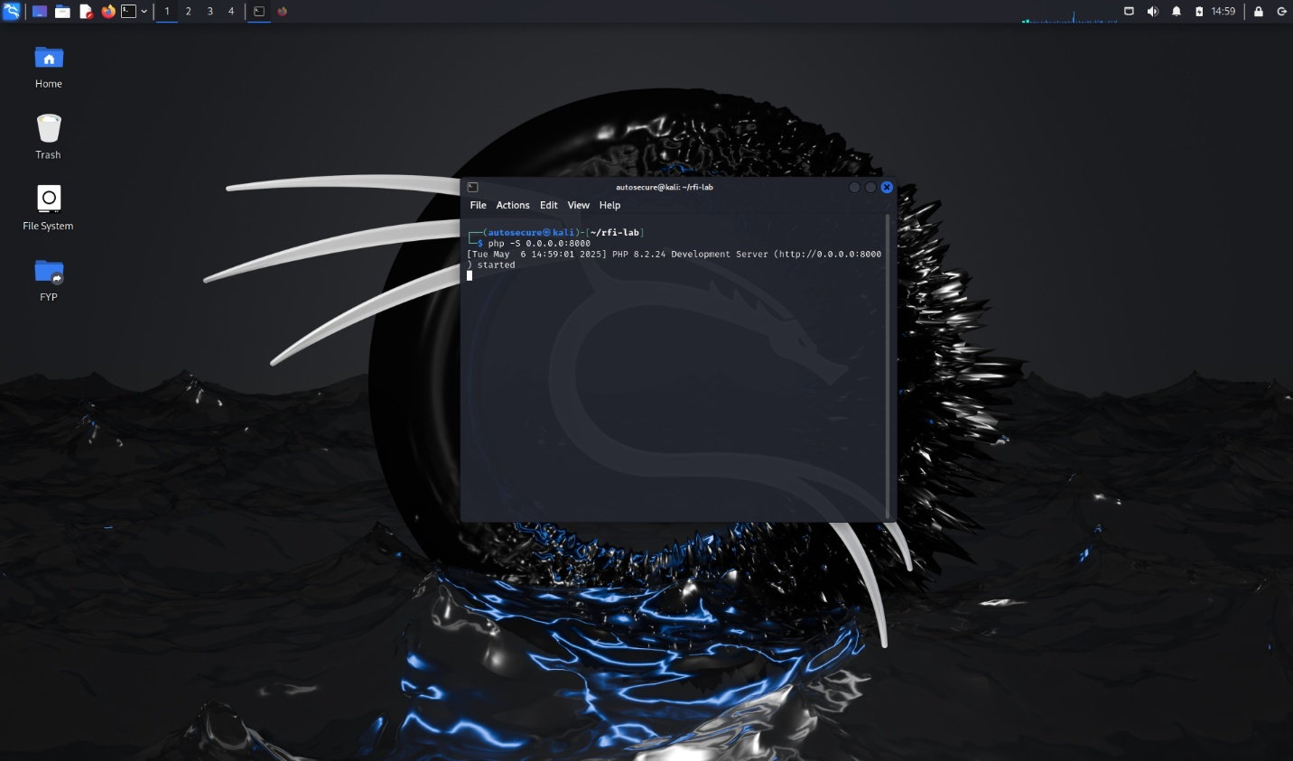

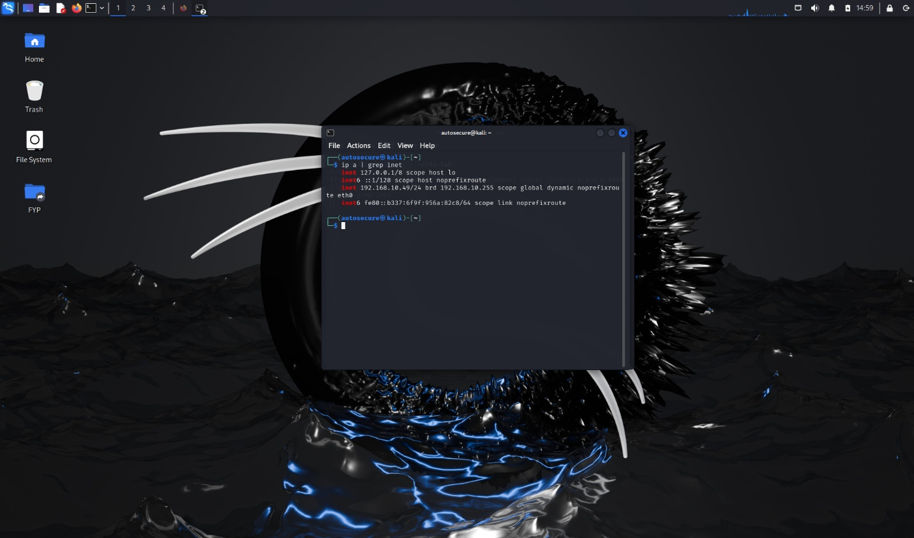

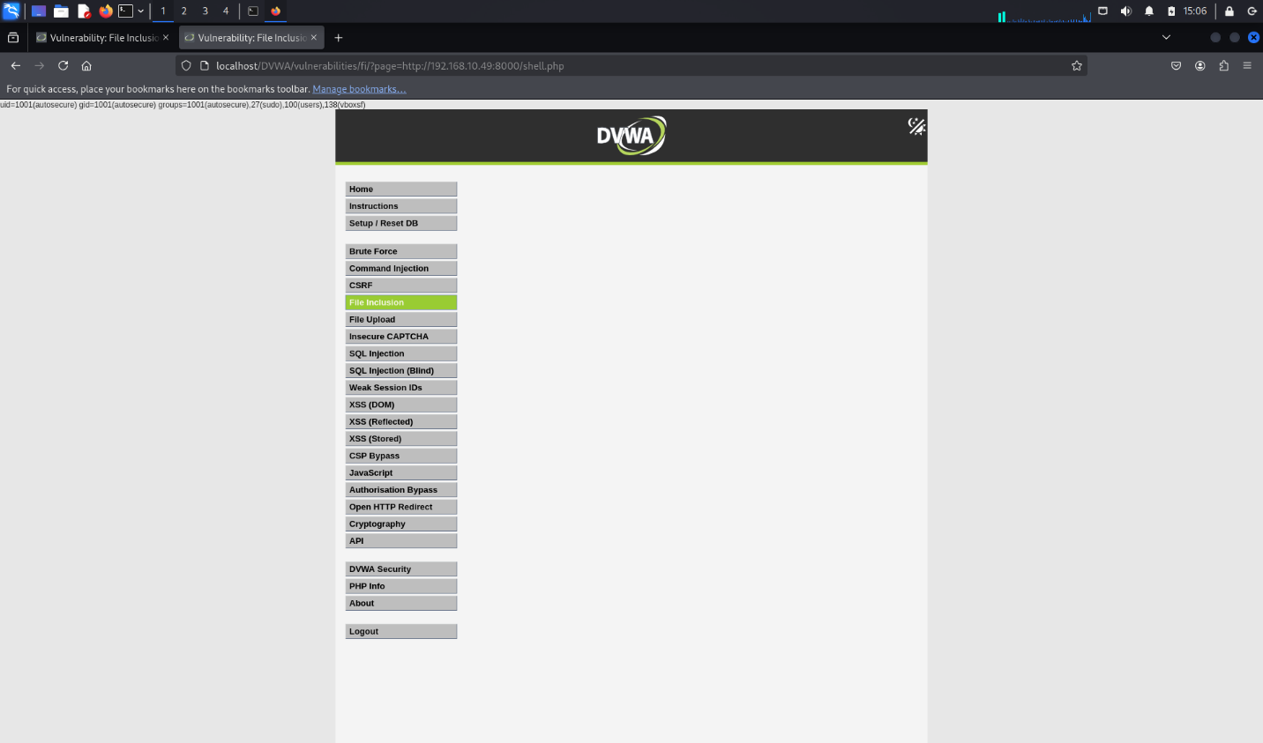

What I learnt:
RFI can lead to code execution by including remote scripts.
Proper PHP configuration and input validation are crucial to prevent such vulnerabilities.

