FORMAN CHRISTIAN COLLEGE
(A CHARTERED UNIVERSITY)



COMP421 - B
SPR25
Assignment 2

Daim Bin Khalid - 251686775

14th May 2025
Task 1 (Reflected XSS Attack):
1. Open your browser and go to: http://localhost/vulnerabilities/xss_r/
2. Enter the following in the input field: <script>alert('XSS Test')</script>
3. Click Submit
Note: You should see a popup showing “XSS Test”.

What I learnt:
In this task, I learned how reflected cross-site scripting (XSS) works. By injecting the script <script>alert('XSS Test')</script> into a form input, I triggered a JavaScript alert popup on the page. This showed how unsanitized user input can be immediately reflected and executed by the browser. It helped me understand the importance of input validation and output encoding in preventing such vulnerabilities.

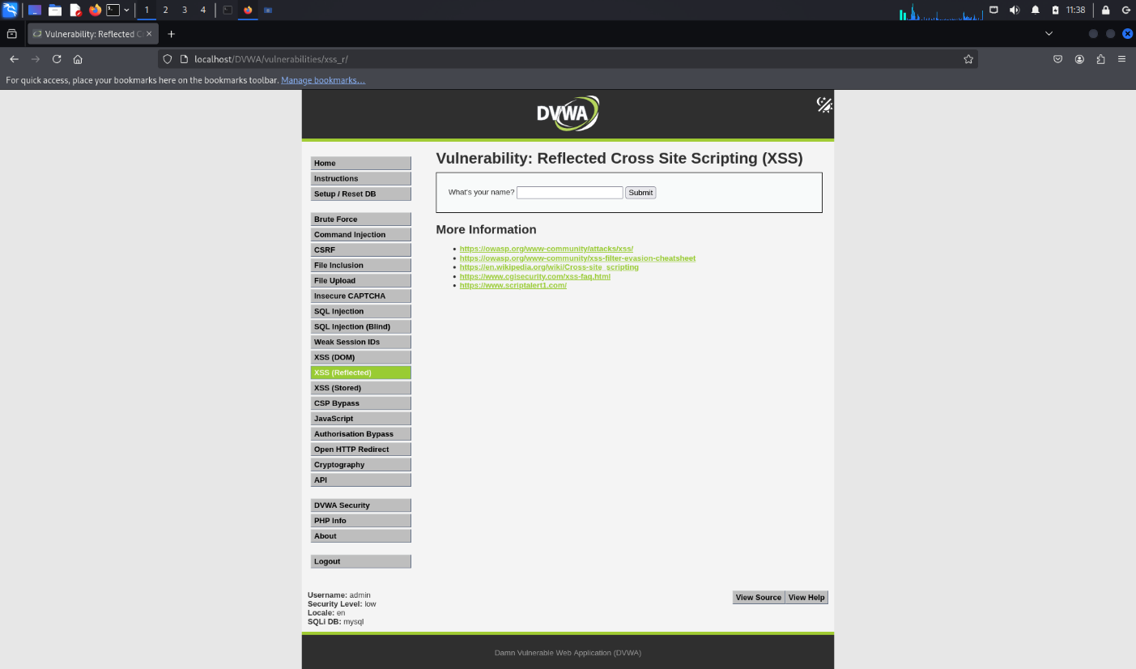

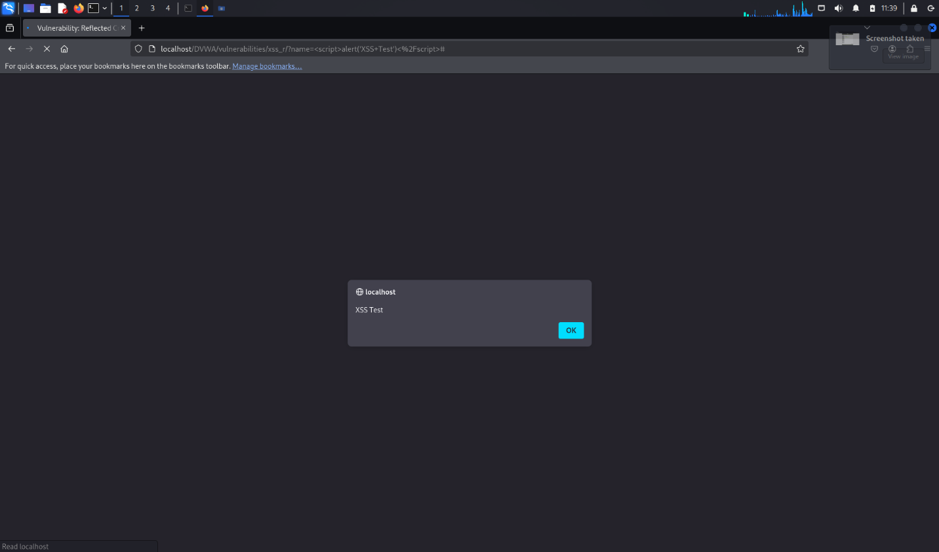

Task 2 (Steal Cookie via XSS):
Paste the following in the same input field: <script>document.write(document.cookie)
</script>
Note: The browser displays your current cookie, proving access.

What I learnt:
This task demonstrated the potential for XSS to be used maliciously, such as stealing a user’s session cookies. By injecting <script>document.write(document.cookie)</script>, the browser displayed my current cookie. This taught me how attackers can exploit XSS to gain access to sensitive session information, leading to session hijacking or impersonation of users. I learned why HTTP-only cookies and proper input sanitization are critical for web security.

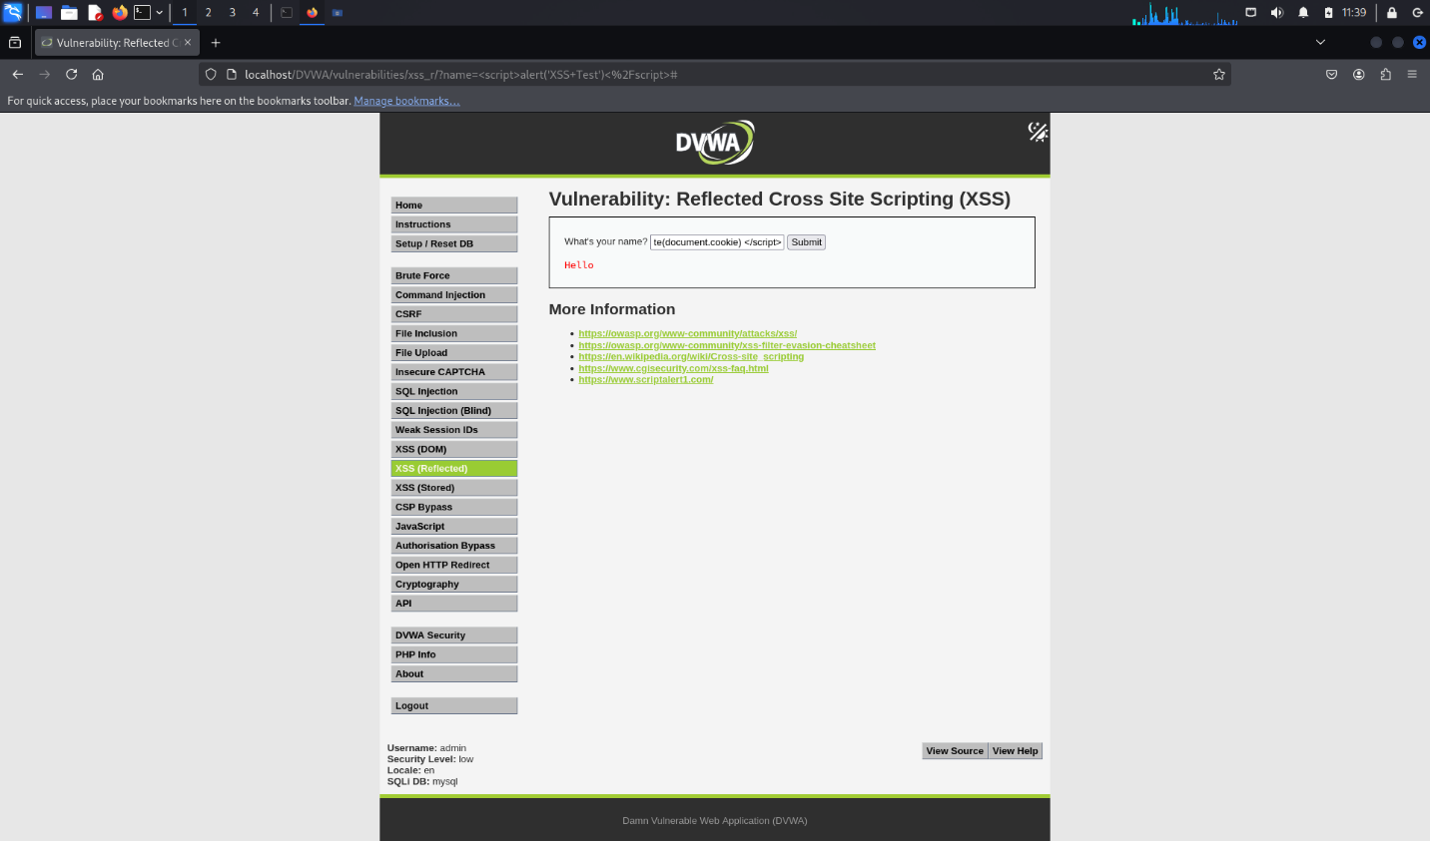

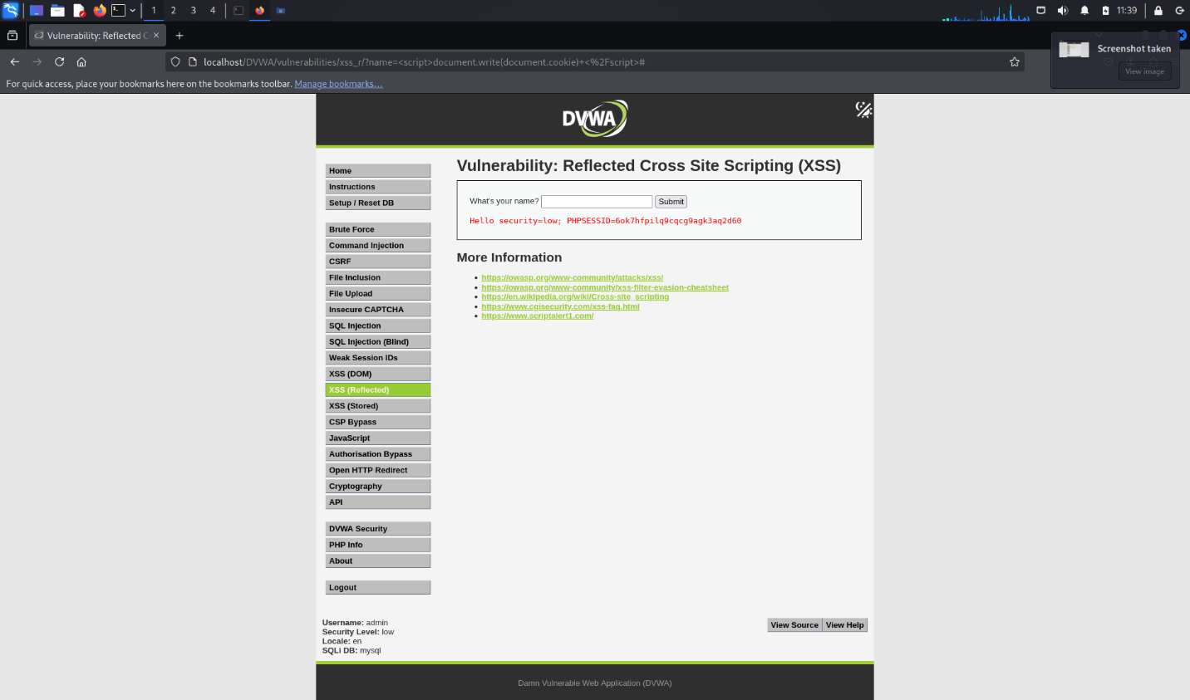

Task 3 (Stored XSS Attack):
1. Navigate to: http://localhost/vulnerabilities/xss_s/.
2. Post a comment like: <script>alert('Stored XSS')</script>
3. Refresh the page.
Note: Every time the page loads, the alert will trigger — this is a stored attack affecting all
users.

What I learnt:
In this task, I observed the effects of a stored XSS attack by submitting a comment with a script tag. Unlike reflected XSS, this script persisted in the system and executed every time the page was loaded, affecting all users. This taught me how dangerous stored XSS can be, especially in applications with user-generated content. It reinforced the need for persistent data validation, content sanitization, and the use of secure coding practices in database interactions.

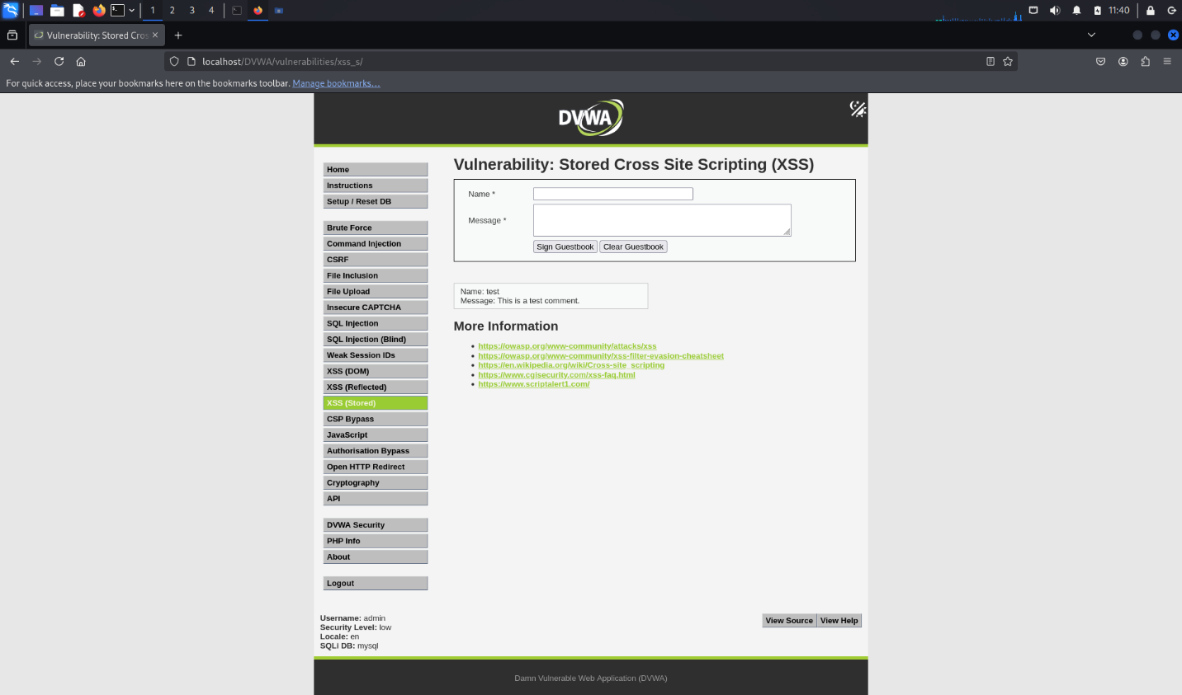

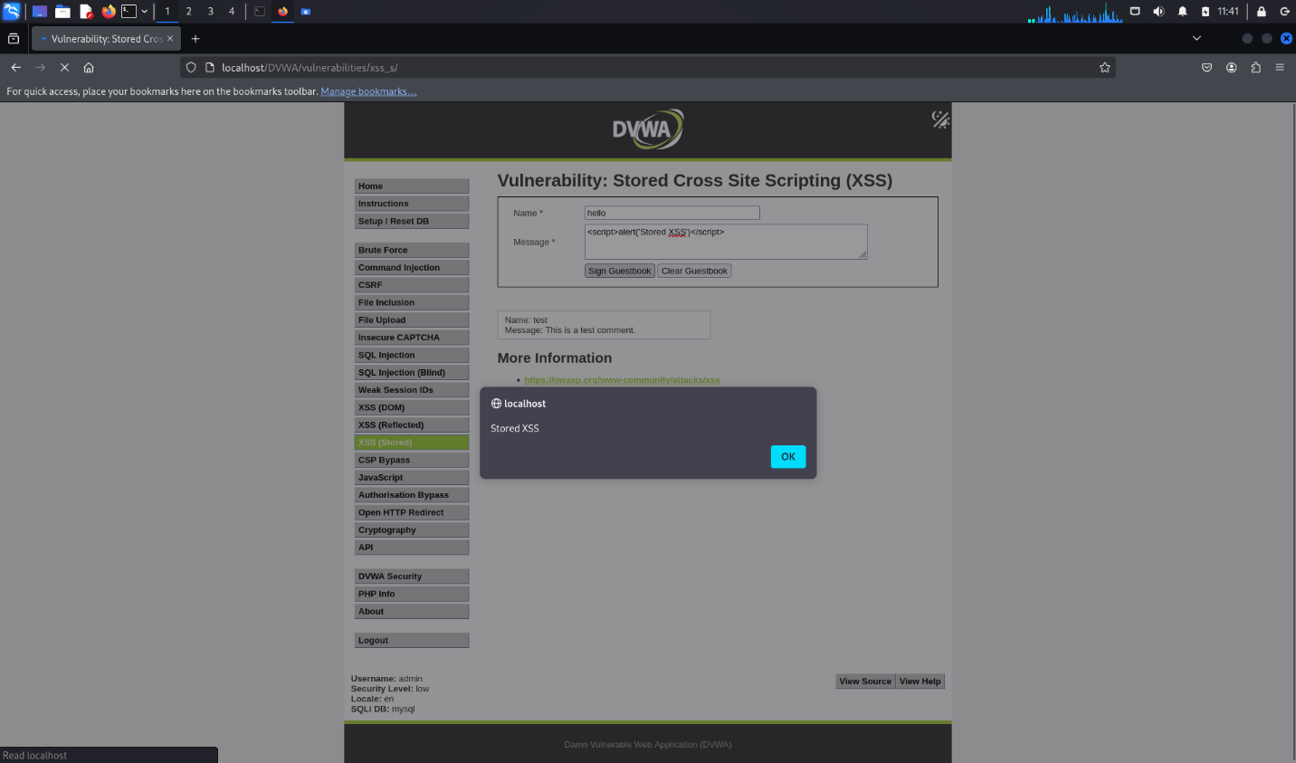
Alert on executing the XSS injection for the first time.

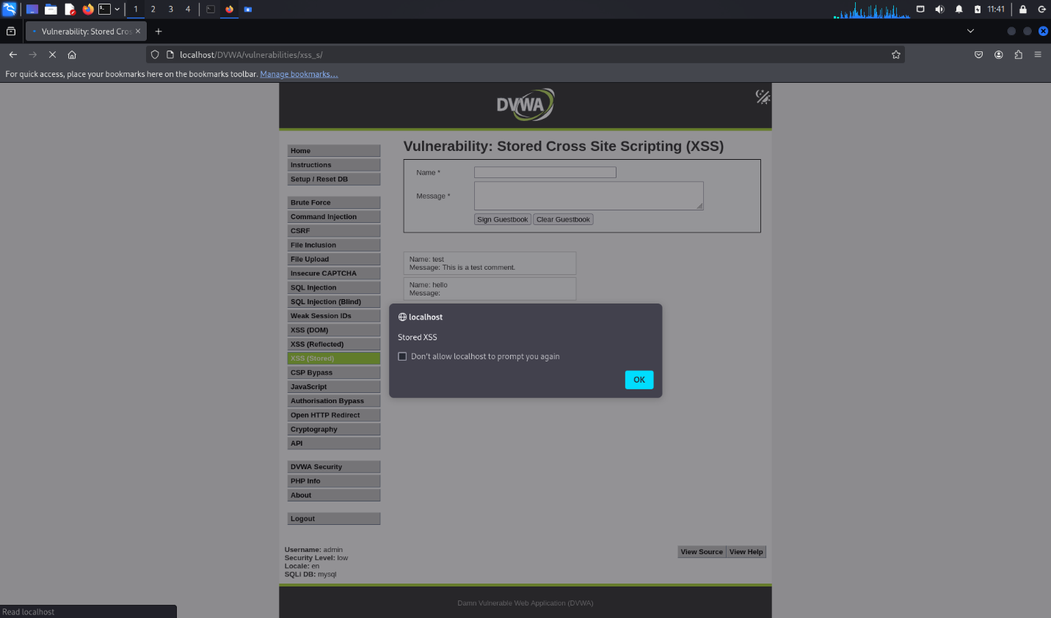
Persistent alert upon page reload.

