Kernal 3 Release  
Business Requirement Document

Lead Management

Document Version: 0.05

|  |  |
| --- | --- |
| **General Demand Information**  (Mandatory fields are marked by *) | |
| **Requestor Information**   |  |  |  |  | | --- | --- | --- | --- | | Name:* | Taural Rhoden | Telephone:* | 6304 | | E-Mail:* | Taural.Rhoden@daimler.com | Mobile: |  | | Org. Unit:* | MBC Marketing | Request Date:* | 17/02/2016 | | |
| **Request includes (specific requirements)*:**   |  |  |  |  | | --- | --- | --- | --- | |  | New and/or changed business process(es)/business function(s) |  | New and/or changed interface(s) | |  | New business data and/or change of existing business data (migration/changes/data structure/data security) |  | New or changed technology/infrastructure/platform(s) | |  | Legal and/or statutory regulations and obligations |  | Input, processing and output to be specified | |  |  |  |  |   **Please note:** It is mandatory to provide Demand information incl. BRD at latest in process phase  4.1.2 “Analyze Demand” to the Lead Enterprise Architect of your E2 area. | |
| **Demand classification:**   |  |  |  |  | | --- | --- | --- | --- | | Business priority:* | High | Medium | Low | | Risk classification:* | High | Medium | Low | | Benefit classification:* | Please choose | | | | |
| **Business Support ID:** | |
| **Supported business process(es)*:** | |
| **Impacted IT service(s)*:** | |
| **Plant ID(s)*:** | |
| **Planning and Funding principles:**   |  |  | | --- | --- | | Expected Go-live Date/Target Release: |  | | Funding principles/Funding Cost Center: |  | | Planned Budget from Business Unit: |  | | **Reference:**  Demand-ID:  (CISM Ticket ID, SAP SolMan ID or Clarity ID) |

Index of Content

Contents

Kernal 3 Release Business Requirement Document 1

Lead Management 1

Document Version: 0.05 1

1 Introduction 6

1.1 Description of the Initial Situation/Problem 6

1.2 Current interfaces (internal and external) 6

1.3 Description of target solution scenario 6

1.4 Expected implementation timeframe 6

1.5 General Requirements and dependencies 6

1.6 Economical and financial rationale (*MANDATORY) 9

2 Business / Functional requirements 10

2.1 Lead Management 10

2.1.1 Test Drive requests (existing) 10

2.1.2 Agility (existing) 16

2.1.3 Early Renewal (existing) 17

2.1.4 End of Contract (existing) 18

2.1.5 Quote Request 19

Business Unit 19

2.1.6 Campaign Management (Hand Raiser) 22

2.1.7 Parts Enquiry 24

2.1.8 Brochure Request 27

2.1.9 Brochure Request – PC Aftersales (these forms are not live) 31

2.1.10 Key 2 Key 32

2.1.11 Competitions - Prospects/Register Your Interest Prospects/eNews Sign Ups 33

2.1.12 Service Booking 35

2.1.13 Contact Us 39

2.1.14 AutoGate 45

2.1.15 POVL (Previously Owned Vehicle Locator) 46

2.1.16 Lead Management User’s & View 55

2.1.17 Lead Management Reporting Requirements 57

2.1.18 Lead Management Migration 57

2.2 Miscellaneous business requirements 57

3 Non-Functional Requirements 58

3.1 Load and stress performance 58

3.2 Business and operational environment 58

3.3 Reutilization opportunities 58

3.4 Infrastructure requirements (to be completed by IT) 58

3.4.1 Current IT infrastructure 58

3.4.2 Target IT infrastructure 58

3.4.3 Additional IT network infrastructure requirements 58

3.4.4 Ecologically determing factors (greenIT) 58

4 Organizational Requirements 59

4.1 User distribution and number of users 59

4.2 Service requirements 59

4.3 Miscellaneous organizational requirements 59

5 Open questions and /or issues 60

6 Approval 61

Please fill out all chapters that are relevant to describe this Demand. Document history

|  |  |  |  |
| --- | --- | --- | --- |
| Version | Date | Author(s) | Changes |
| V0.01 | 21/09/2015 | Andrea | Established Document First Draft |
| V0.02 | 19/10/2015 | Andrea | Updated Document With Lead Management Requirements |
| V0.03 | 17/02/2016 | Andrea | Update Document with Lead Management Req from Business |
| V0.04 | 29/02/2016 | Andrea | Update with Business feedback from initial review |
| V.005 | 01/03/2016 | Andrea | Update with Vans S & P feedback |

Table of references

|  |  |  |  |  |
| --- | --- | --- | --- | --- |
| No. | Title | Author(s) | Date/Version | Section |
| 1 |  |  |  |  |
| 2 |  |  |  |  |

# Introduction

## Description of the Initial Situation/Problem

* Dealerships currently receive leads from various sources within MBAuP and MBFS.
* Dealer Lead Management system, whilst in working order, is not sophisticated enough for today’s business requirements
* Dealerships are able to create leads / prospects in MB Online national database, whilst in working order, it is not sophisticated enough for today’s business requirements.

## Current interfaces (internal and external)

## Description of target solution scenario

* CRMOne is the central location for all MBAuP (cars and vans) and MBFS leads. Both Wholesale captured leads and also Dealer captured leads.
* Business will be able to have one funnel to view national leads and dealer leads
* Business will be able to report on the sales funnel ratios from enquiry capture right through to won or lost sale.
* CRMOne is in a state whereby MB Online can be sundown and the DLM can be sundown (for Vans and Cars).

## Expected implementation timeframe

## General Requirements and dependencies

**Scope**

* All PC requirements are for both AU and NZ

**Dependences and Assumptions**

* Dealer Portal go live and post pilot dealer testing – mandatory for dealers to be able to manage lead status via interface.
* Forms will need to feed directly to CRMOne once DLM sundown
* Interface to iShowroom Extended
* All leads should be migrated from the old DLM to the new CRMOne system so that all history is retained.
* Interface with Autogate for both carsales leads and Pre-Owned Vehicle Locator (POVL)
* At Wholesale, if new lead being created that matches an existing customer account is to be alerted to user (system generated message). Lead to be assigned to the existing account.
* Same if dealer is trying to create a lead.
* If dealer is trying to create a lead for an existing customer account but they are not the active dealer then a prospect record is created.
* ALL leads to be loaded into CRMOne no matter the data quality. Data quality checks incl validations and mandatory fields happen at the form level.
* Any code placed on a form to track media traffic should also be saved in CRMone so we can track conversions.
* Forms that sit off different platforms should be tagged in the CRMone system as to where they are from – eg Drive Away Pricing Calculator
* EG: <https://www.driveaway.mercedes-benz.com.au/CLS-Shooting-Brake/CLS-250-CDI>

**Forwarding Leads/Communicating to Leads**

* System can send an auto reply in HTML or plain text format to contact who has submitted form. Content of that email is managed within CRMOne. Content can be customized based on vehicle selected and include customized links dependent on vehicle chosen in form. . Content may include PDF attachments by product enquired about (selected in form) and system selects attachments based on logic provided.
* All leads forwarded to retail from wholesale can be forwarded by email generated **within** CRMOne system to assigned Dealer. Copy of requested email format below[1].
* Lead forwarding notification for sales people is to be generated as an email by the system to the outlook inbox of the lead recipient. Copy of requested email format below[2].
* Leads from wholesale to dealer first go to a lead administrator at a dealership who can allocate the lead to sales person. Administrator has a pick list of sales people to choose which will also show how many active leads that sales person has live.
* Leads being forwarded from EMC (wholesale) to dealer are able to have the preferred dealer overridden if the customer decides to change their mind. EMC can re-select which dealer the lead will be sent to.
* User should be able to reply to lead via system without needing to open outlook.
* All email history to lead from system needs to be viewable.

**Email content requirements: EMAIL TO LEADS ADMINISTRATOR**

**TO DEALER FROM WHOLESALE**

Subject line: <Lead Status> - Lead (lead reference – Lead <number>, <Business Unit>, <Todays date and time>.

Content:

Lead <number>, <Business Unit>, <Todays date and time>. Please review and initiate contact with your new lead from <title> <surname>.

Title:

Customer First Name:

Customer Surname:

Business unit:

Nature of request: <Insert ‘MBAuP Generated Pick List’ value>.

Home Phone:

Work Phone:

Mobile:

Vehicle Interested in:

Preferred test drive date:

Preferred time:

Intent to purchase:

Notes regarding lead: (Andrea, not sure what this field is called).

Customer Status: (Existing customer or Prospect)

Salesforce Customer Number:

MB Online Customer Number:

Allocate Lead immediately by clicking below:

<Sales Person 1>. Current open leads: <open lead tasks>

<Sales Person 2>. Current open leads: <open lead tasks>

<Sales Person 3>. Current open leads: <open lead tasks>

<Sales Person 4>. Current open leads: <open lead tasks>

<Sales Person 5>. Current open leads: <open lead tasks>

<Sales Person 6>. Current open leads: <open lead tasks>

{Have as many Sales people listed as is in the system for the dealer]

Please action your leads within the timelines as advised by MBAuP. Our goal is to create the Best Customer Experience possible.

Thank-you,

Mercedes-Benz Cars

**Email content requirements: EMAIL TO SALES PERSON**

**FROM DEALER LEADS ADMINISTRATOR TO SALES PERSON**

Subject line: <Lead Status> - Lead (lead reference – Lead <number>, <Business Unit>, <Todays date and time>.

Content:

Lead <number>, <Business Unit>, <Todays date and time>.

You have been assigned a new lead. Please review and initiate contact with your new lead from <title> <surname>.

Title:

Customer First Name:

Customer Surname:

Business unit:

Nature of request: <Insert ‘MBAuP Generated Pick List’ value>.

Home Phone:

Work Phone:

Mobile:

Vehicle Interested in:

Purchase Intent:

Comments:

Customer Status: (Existing customer or Prospect)

Salesforce Customer Number:

MB Online Customer Number:

Please click below once first contact attempt has been made

Contact attempt made

Please action your leads within the timelines as advised by MBAuP. Our goal is to create the Best Customer Experience possible.

Thank-you,

Mercedes-Benz

**Administrator Role**

* Administrator roles have ability to adjust the forwarding rules for lead types. Example changing test drive leads from direct to dealer to EMC. Also able to manage which lead types also are copied into EMC workflow for EMC follow up.
* Can add new staff members to receive leads at dealership (in some instances cannot wait until GSSN updated).

**Assumptions:**

All lead requirements implemented for AU will be implemented for MB NZ in 2016.

NZ forms are as follows:

Passenger Cars – New Zealand

|  |  |  |
| --- | --- | --- |
|  | Contact Us | <http://www1.mercedes-benz.com.au/Custom/Forms/ContactUsCar.aspx> |
|  | Test Drive* | <http://www1.mercedes-benz.com.au/Custom/Forms/TestDriveCar.aspx> |
|  | Brochure Request* | <http://www1.mercedes-benz.com.au/Custom/Forms/BrochureRequestCar.aspx> |
|  | eNews | <http://www1.mercedes-benz.com.au/Custom/Forms/ENewsletterCar.aspx> |
|  | Service Booking | <http://www1.mercedes-benz.com.au/Custom/Forms/ServiceBookingCar.aspx> |
|  | Parts Enquiry | <http://www1.mercedes-benz.com.au/Custom/Forms/PartsEnquiryCar.aspx> |
|  | Registration form for Mercedes-Benz WebParts | <http://www1.mercedes-benz.com.au/Custom/Forms/ContactUsWebParts.aspx> |
|  | Brochure Request Service & Parts | <http://www1.mercedes-benz.com.au/Custom/Forms/BrochureRequestService.aspx> |

Vans – New Zealand

|  |  |  |
| --- | --- | --- |
|  | Contact Us | <http://www1.mercedes-benz.com.au/Custom/Forms/ContactUsVan.aspx> |
|  | Contact Us (Fleet) | <http://www1.mercedes-benz.com.au/Custom/Forms/ContactUsVansFleet.aspx> |
|  | Test Drive | <http://www1.mercedes-benz.com.au/Custom/Forms/TestDriveVan.aspx> |
|  | Brochure Request | <http://www1.mercedes-benz.com.au/Custom/Forms/BrochureRequestLCV.aspx> |
|  | eNewsletter | <http://www1.mercedes-benz.com.au/Custom/Forms/ENewsletterVan.aspx> |
|  | Request a Quote | <http://www1.mercedes-benz.com.au/Custom/Forms/QuoteRequestFinanceVan.aspx> |
|  | Service Booking | <http://www1.mercedes-benz.com.au/Custom/Forms/ServiceBookingVan.aspx> |
|  | Parts Enquiries | <http://www1.mercedes-benz.com.au/Custom/Forms/PartsEnquiryVan.aspx> |

The current DLM system will be replaced by the Forms platform. Once the DLM is decommissioned, forms currently being sourced through DLM will be interface to EP through the new Form platform.

## Economical and financial rationale (*MANDATORY)

# Business / Functional requirements

## Lead Management

### Test Drive requests (existing)

**Unique ID – TDL2**

**Business Unit -**

MB Passenger Cars & MB Vans

**Source system -**

**(As Is)** DLM (Dealer Lead Management) system – forms are delivered from DLM through EP into CRMOne

Form URLS:

http://www1.mercedes-benz.com.au/Custom/Forms/TestDriveCar.aspx

<http://www1.mercedes-benz.com.au/Custom/Forms/TestDriveVan.aspx>

**Mandatory fields** –

|  |  |  |  |
| --- | --- | --- | --- |
| Mandatory Fields | | |  |
|  | PC | Van | Validations |
| Title | x | x |  |
| First Name | X | X | As Per the GTR document |
| Surname | X | X |
| Phone | X | X |
| Email | X | X |
| Postcode | X | X |
| Purchase Intent | X | X | Picklist |
| Car Model | X | X | picklist |
| Preferred Dealer | X | X | picklist |

* Title – Picklist
* First Name – free text
* Surname – free text
* Phone –numeric
* Email - varchar
* Postcode - numeric
* Purchase Intent – picklist
* Car Model - picklist
* Preferred Dealer – picklist

**NB:** Mandatory fields may be subject to change in the future.

The ability to change a field to mandatory or remove the mandatory from an existing field should be possible.

**Business Rules –**

**Common rules PC & Vans**

**Generate Lead**

* Form is submitted to EP
* If all mandatory fields are completed and data validated – lead to be sent to CRMOne
* Where an existing customer can be identified from the form data, the lead created and assigned to the existing customer account.
* Where an existing customer record cannot be identified, prospect account to be created and lead created and assigned to the prospect account.

**Business Rules specific to BU**

**Passenger Cars**

* The form type should be flagged in the system as a Test Drive.

**Other Requirements**

* CRMOne to trigger an automatic email confirmation to the customer once the form has been submitted. Email template to customer to include a web link to the brochure/s for download, PDF of brochure/s for the specific model selected on the submitted lead.
* If multiple vehicles are selected on the lead for then the reference link on the email template should show the link and PDF for each of the vehicles selected**.**
* The form type should be flagged in the system based on the tagging from form in CMS, for an example, if the lead is a test drive request, the lead should be tagged a test drive as per the picklist values.

**Business Rules specific to BU**

**Vans**

* Lead simultaneously sent to CRMOne & Preferred Dealer (as selected on the web form)
* Auto send pdf brochure to customer via email (based on model interest) IMMEDIATE
* If no 'Preferred Dealer' field entered on website, postcode (mandatory field) to determine & allocate lead to closest dealer (via PMA list in Dealer account)
* Lead to be actioned by Dealer within 4hrs, or first escalation (Lead escalations to be provided)
* Leads that have not met data quality:
* New Enquiries - missing, incomplete or incomplete data will not be submitted through web form. The customer will be presented with an error message on the website and form cannot be submitted?
* Who is the lead assigned to? And should this auto-conclude - i.e close - once the PDF has been sent?
* As per Dealer assignee rules – Dealers to manage their allocated leads via Dealer Portal
* Lead status in CRMOne auto-set to 'Lead sent to Dealer' or defined status – Head Office to have visibility of all of these leads for reporting purposes.

**Qualify Lead**

**Passenger Cars**

* **WHO WILL QUALIFY LEAD?**   
  If Head officeis selected on web form, lead sent directly to EMC Que.
* CRMOne will calculate Lead Priority and Lead Priority score based on the logic provided below.



* Lead Priority values = Hot / Warm / Cold
* Priority Score = Numeric value
* If a Dealer is selected on the web form as a preferred Dealer, the lead will be assigned to the selected Dealer.
* If a lead is scored cold (based on the logic) the lead will be assigned directly to the EMC que for nurturing / qualifying.
* If a Dealer is selected on the web form, EMC is to also receive the lead for follow up purposes**.** CRMOne should include the ability for the web form to be assigned to multiple assignees ie: assign lead directly to the selected / preferred Dealer & EMC.

**CUSTOMER IDENTIFICATION**

* EP / CRMOne todetermine if a customer is a current customer or not.
* If no existing customer account can be matched or identified, prospect account to be created and Lead assigned.
* If existing customer account can be matched or identified then lead is created and assigned to the account
* If existing customer lead is to be sent to a dealer that is **not** the active dealer, the receiving dealer cannot see that lead is an existing customer.
* If existing customer lead is to be sent to a dealer that **is** the active dealer, the receiving dealer can see that lead as assigned to existing account.

**WHAT SYSTEM SHOULD BE USED TO QUALIFY LEAD?**

* Ideally Salesforce system should be used to qualify the lead.  
    
  **IF LEAD CAN NOT BE CONTINUED?**
* If lead cannot be continued, EMC should close the lead and save the lost reason per picklist fields available.

**Qualifying Lead**

**Vans**

* Lead is automatically set as 'Hot' lead as default
* Lead then assigned to the Dealer as selected by the customer on the web form
* Dealer to qualify, manage lead & update status via Dealer Portal.
* Lead details captured in CRMOne
* CRMOne to record time 00:00 of customer request via website i.e Test Drive Submission Time

**Forwarding Lead**

**Passenger Cars**

**RECIPIENT OF LEAD:**

* All test drive leads will be assigned to the Dealer selected on the web form under “Preferred Dealer”.
* If “Head Office” is selected in the “Preferred Dealer” field on the web form, the lead is assigned to EMC.
* A system Administrator should have the ability to change if leads are assigned to Preferred Dealer only, EMC only or assigned to both EMC and Preferred Dealer.
* The business needs the access to change this process in the system.

Once Dealership receives lead:   
Dealerships: Will go to 1 or more preferred dealership emails.   
Dealers should be able to manage recipient of leads in the **Dealer Portal**.

* All leads should end up in the dealer portal regardless of person assigned the lead.

**HOW IS THIS DETERMINED**

* Either GSSN or bespoke logic for Lead allocation

**BUSINESS RULES:**

* Lead should be answered between 30 min and 3 hours of submission within normal business hours.
* Dealers should be able to select a time frame hours for lead to be processed.
* Dealers should be able to select this in the Dealer Portal.
* The escalated configuration should be determined in the dealership portal and different for each branch.
* If lead is not answered within selected time frame ( eg 24 hours) then lead is escalated to the recipient selected by the Dealership. Dealers should be able to manage the escalation timings and recipients in the Dealer Portal.
* Leads should be able to be forwarded to another person if the recipient can't action lead.
* All emails forwarded to the dealership will be seen in the Dealer portal + an email will be sent directly to the admin email or relevant sales email.

**Follow Up Reporting  
Passenger Car & Vans combined**

* Dealers should be able to create their own rules about the process of following up a lead: SMS Alert / Email alert / Phone call alert.
* Dealer to be able to create follow up tasks (to do tasks) that can interface with Dealer Outlook emails**. (Salesforce to Outlook – to be installed).**
* Dealers should be able to choose a contact person in the dealership to follow up any reporting on leads.

**Monitoring Tracking Escalations**

**Passenger Car & Vans combined**

**INFORMATION TRACKED FOR THIS LEAD TYPE**

* The information tracked for this lead type is the generic information already available on the form as well as any fields selected in the lead case including notes that the EMC staff or dealer have added to this lead.

**Escalations:**

* All escalations should be determined by the dealer; i.e - number of hours for lead handling, person of escalation, frequency of escalations.

**ESCALATIONS TRIGGERED:**

* Escalations can be triggered based on a time frame.

**PC**

* Head Office will generate reports based on own determined logic for set escalations, eg: a report showing all leads that have not been contacted within a determined time limit.
* Administrator can change determined time limit at any time.

**Vans**

* Dealers should be able to select a time frame of either -2 / 4/ 24 hours for lead to be actioned.
* Dealers should be able to select this in the Dealer Portal. The escalation configuration should be determined in the Dealer portal and can be different timings for each Dealer branch.

**Un-actioned Leads – Lead email escalated triggers**

4 hours untouched – email trigger to EMC

8 hours untouched – email trigger to Dealer Principal / BDM / Head Office

**CLOSE LEAD CASE AND REPORTING**

**Passenger Car and Vans combined**

**EXIPIRE OF LEADS**

* All leads should remain in the dealer portal until an action is added to the lead. They should not be automatically closed by the system.
* All leads not adhered to within the correct time frames will be flagged with HQ for a status report, at intervals determined by the business and configurable by the system administrator.
* The time stamp of dealership responses on actioning any of the lead statuses “Lead Status” field should be captured in the reporting.

**REPORTS (the reporting dashboard should provide availability for all data):**

* All reports are generated based on a choose time frame.
* All Reports are generated based on chosen sales staff / teams.
* Dealers should be able to extract the data.
* General lead figures
* Enquiry “Nature of Request” report
* Enquiry by Lead source
* Enquiry by MBAuP Lead, MBFS Lead or Dealer Lead
* Sales person ranking by number of deals closed
* Sales person ranking by total number of open lead cases
* Model Interest
* Brochure Interest
* Ownership reports; top 10 performing Dealers
* Top 10 Dealers by login count
* Completed sales steps (Show total count of lead statuses selected – This report will be structured around the “Total Status” count of closed leads. This report will be for Sales Managers & Dealer Principals to see how many leads their sales teams have closed.
* This report will be structured around the “Total Status” count of All leads that are “aren’t” in a closed status. This report will be for Sales Managers & Dealer Principals to see how many leads their sales teams have currently and what status each lead has. Based on non-closed leads ONLY
* All reports need to be executed at a National Level, State level, Dealership level and where advised at a Salesperson level.
* Reports can be set up based at a Business Unit and Offered Service level.

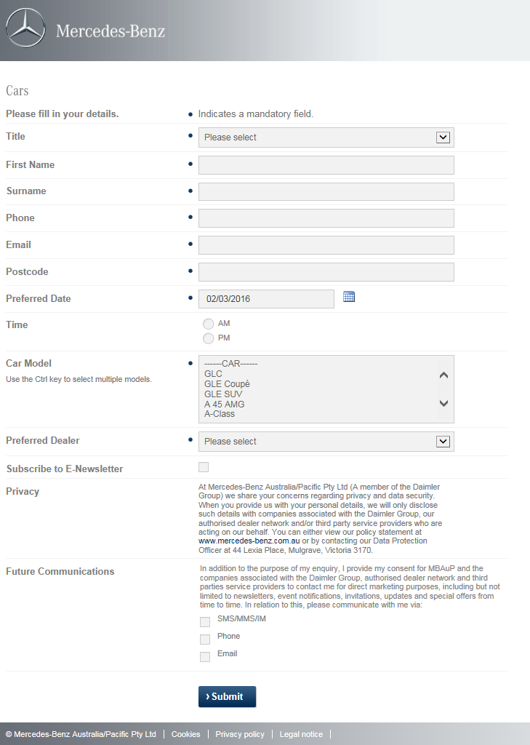

### Agility (existing)

**Unique ID – AGL12**

**Business Unit -**

MBFS

**Source system -**

Outbound Phone calls to existing MBFS customers

**Mandatory fields** –

* First Name
* Surname
* Mobile
* Originating Dealer
* Amount Financed
* Term
* Monthly Repayment
* GFV
* Maturity Date

**BUSINESS RULES:**

**Generate Lead**

* Agility customers are to be contacted at 13,6 and 3 months from maturity
* Data is automatically drawn from CMS
* Salesforce allows us to select which dealer the lead is to be sent to. If the originating dealer is no longer active, we will send the lead to an appropriate dealer with the customers consent.
* Customers with finance products of Operating Lease and Finance Lease are not included
* Lead is qualified by the Customer Retention Specialist. Once this has been qualified it is assigned to the Dealership for action.
* Lead template email to include links for status updates from Dealerships (until such time that the Dealer Portal is live).

**QUALIFYING LEAD**

* Customer Retention Specialist qualifies lead during call and also useS data within CMS.
* Temperature and scoring not required.
* If lead case should not be continued, dealer should click on 'Closed' option from hyperlinks within lead email.

**FORWARD LEAD**

* Lead recipients should be DEALER PRINCIPAL, DRM, Business Manager and Sales Staff.
* Lead will generally be sent to originating dealer unless customer specifies otherwise.

**FOLLOW UP REPORTING**

* Standard feedback should be whether lead resulted in a new purchase or RV refinance.
* If sale was made we need to know what vehicle was purchased

**MONITORING TRACKING ESCALATIONS**

* Kept inspection appointments, new vehicle purchases and refinances.
* Escalated to DRM if no outcome is determined after first 5 business days of the month the lead is assigned.

**CLOSE LEAD CASE AND REPORTING**

* Lead should expire after 90 days. Leads are currently manually closed.

**Reporting requirements**

* KPIs:
  + Leads sent per dealer,
  + Units sold,
  + Contracts refinanced,
  + Retention and conversion rate
* Reporting should be available at a National level (including ALL Dealerships), a State level (specific Dealers in each State) and at an Individual Dealership level.

### Early Renewal (existing)

**Unique ID – EAR11**

**Business Unit -**

MBFS

**Source system -**

Inbound phone calls

Leads generated from myMBFS – these leads will be manually entered into CRMOne as a finance lead.

**Mandatory fields** –

* First Name
* Surname
* Mobile
* Originating Dealer
* Amount Financed
* Term
* Monthly Repayment
* RV
* Maturity Date

**BUSINESS RULES:**

**Generate Lead**

* Lead data is drawn from CMS
* Salesforce allows us to select which dealer the lead is to be sent to. If the originating dealer is no longer active, we will send the lead to an appropriate alternative dealer with the customers consent.
* Leads can be generated for all finance products except Operating Lease  
  Poor payment history is determined by the Customer Retention user. This can depend on the

circumstance, approval requirements may be more lenient for customers with a long history. Currently it is up to the customer retention specialist to determine whether a customer should be contacted.

**Qualify Lead**

* Customer Retention Specialist qualifies lead during call and also uses data within CMS.
* Temperature and scoring not required.
* If lead case should not be continued, dealer should click on 'Closed' option from hyperlinks within lead email.

**Forward Lead**

* Lead recipients should be DP, DRM, Business Manager and Sales Staff.
* Lead will generally be sent to originating dealer unless customer specifies otherwise.

**Follow Up Reporting**

* Standard feedback should be whether lead resulted in a new purchase or RV refinance.
* If sale was made we need to know what vehicle was purchased

**Monitoring Tracking Escalations**

* New contract for vehicle purchase and new contract for RV refinance.
* No escalations for this type of lead required

**Close Lead Case and Reporting**

* Lead should expire after 90 days.- Leads are currently manually closed.

**Reporting requirements**

* KPIs:
  + Leads sent per dealer,
  + Units sold,
  + Contracts refinanced,
  + Retention and conversion rate
* Reporting should be available at a National level (including ALL Dealerships), a State level (specific Dealers in each State) and at an Individual Dealership level.

### End of Contract (existing)

**Unique ID – ECL13**

**Business Unit**

MBFS

**Source System**

CMS & CRMOne

**Mandatory fields**

* First Name
* Surname
* Mobile
* Originating Dealer
* Amount Financed
* Term
* Monthly Repayments
* GFV
* Maturity Date

**Business Rules**

**Generate Lead**

* Leads automatically emailed to dealer at 150, 60 and 30 days from maturity
* If there is a dealer name change which inactivates the originating dealer, the sales and marketing team link the new dealer name so that these automated leads are sent to the correct recipients.
* Where we cease to do business with a dealer, no EOC leads are sent, rather the customer retention team calls these customers directly to assist with any refinance queries.
* All finance types are to be included
* Customers with a poor payment history are not included in these. If a customer has received multiple default letters within the last 3 months or has been referred to an agent, email should not be sent.
* If a customer is a Fleet customer and owns multiple assets, a lead email should be sent for each contract.
* All customers regardless of opt in status are included.

**Qualify Lead**

* Automated lead sent via salesforce at 150, 90 and 30 days of contract expiry.
* Lead to be sent to originating dealer.

**Forward Lead**

* Lead recipients should be DP, DRM, Business Managers and Sales Staff.
* Lead always sent to originating dealer

**Follow Up Reporting**

* Standard feedback should be whether lead resulted in a new purchase or RV refinance.
* If sale was made we need to know what vehicle was purchased

**Monitoring Tracking Escalations**

* Customer Retention do not track outcomes as this is an automated lead source through Salesforce which serve as reminders to the business manager.
* No escalations.

**Close Lead Case and Reporting**

* Lead should expire 90 days after the final (30 day) automated lead is sent out.
* Leads are closed manually only by dealer clicking the relevant hyperlink from the lead email.
* KPI's we would like to track is conversion to new vehicle purchase or refinance, retention rate per dealer.

### Quote Request

### Business Unit

Vans

**Source System**

Data from DLM via Web form

<http://www1.mercedes-benz.com.au/Custom/Forms/QuoteRequestFinanceVan.aspx>

**Mandatory fields**

* Enquiry Type
* Title
* First Name
* Surname
* Email
* Address
* Suburb
* State
* Postcode
* Contact Number (landline or Mobile)
* Model
* Year
* Vehicle Use
* Date of purchase / intended purchase
* Preferred Dealer

**Business Rules:**

**Generate Lead**

* Lead to be sent directly to the preferred dealer and sent to CRMOne

**Qualify Lead**

* Dealer to qualify, manage lead & update status
* Lead details captured in CRMOne
* CRMOne to record time 00:00 of customer request via website

**Forward Lead**

* Leads should be forwarded to the preferred dealer as selected on the webform

**Monitoring Tracking Escalations**

* Dealers should be able to select a timeframe of either -2 / 4/ 24 hours for the lead to be actioned.
* Dealers should be able to to select this in the Dealer Portal.
* The escalation configuration should be determined in the Dealer Portal and can be different for each Dealer branch.

**Unactioned Leads – Lead email escalation triggers**

* 4 hours lead untouched – Email to EMC
* 8 Hours lead untouched – email to Dealer Principal / BDM / Head Office

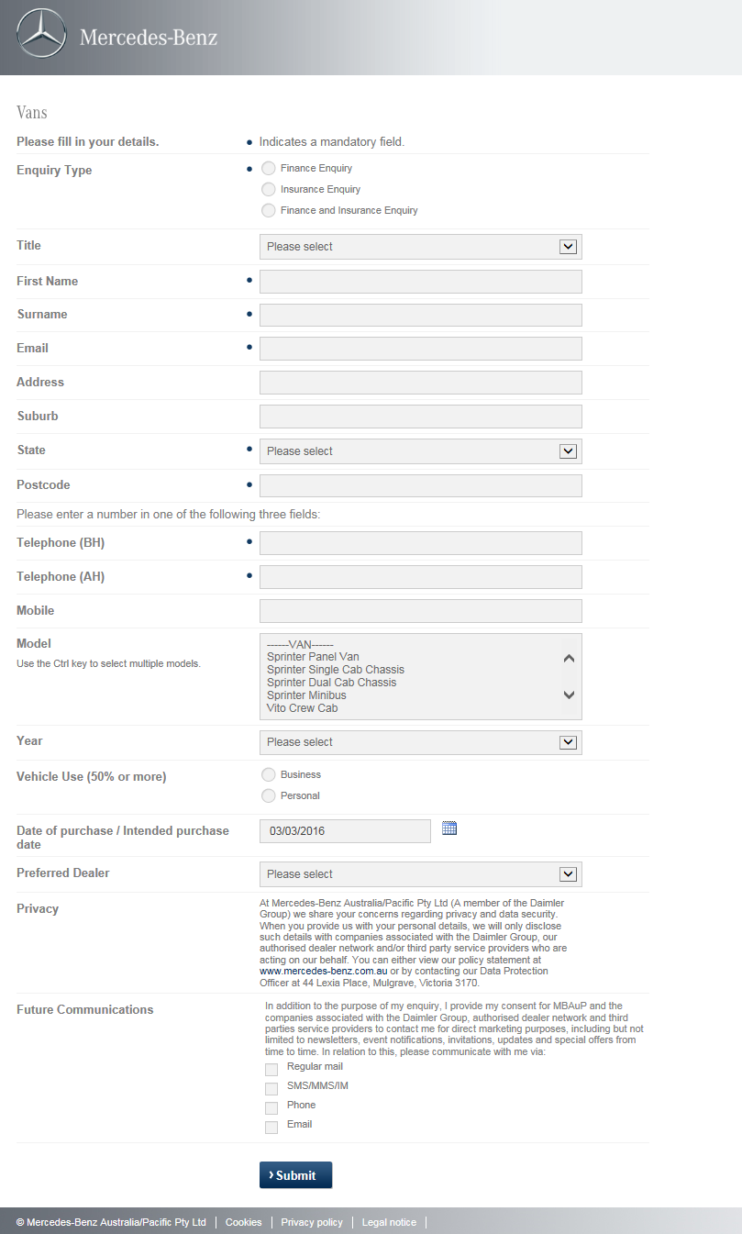

### Campaign Management (Hand Raiser)

**Business Unit**

* Vans Sales & Vans Aftersales

**Source System** – combined Sales & Aftersales

* DLM web forms

**Vans Aftersales form** –

http://www.mercedes-benz.com.au/content/australia/mpc/mpc_australia__website/en/home_mpc/van/home/service_parts/genuine-parts/trade-and-fleet-solutions/current-promotions.html

**Mandatory fields**

* Enquiry Type
* Title
* First Name
* Surname
* Email
* Address
* Suburb
* State
* Postcode
* Contact Number (either landline or mobile)
* Model
* Year
* Vehicle Interest
* Date of Purchase / intended Purchase
* Preferred Dealer

**Business Rules**

**Generate Lead**

Vans Sales and Vans Aftersales combined

* Data sent to CRMOne (immediately) after form submission on website
* Data to be stored in CRMOne

**Outbound Campaigns**

* Ability to load customer data from external sources/web forms for Ad hoc campaigns
* Campaign data to be easily accessible in system
* (Current functionality loads data in 'Campaigns' tab, activity(call/email) logged in 'Accounts' tab, lead creation in 'Leads' tab (not ideal functionality working across 3 different tabs)
* Functionality to be streamlined & user-friendly with customer details pre-populating if moving across several tabs (i.e. when creating Lead)
* So BU, Lead Type, Lead Source, customer detail fields should all populate without having to manually add fields when an Account exists - details should upload/be transferred from one area in the system to another

**Inbound Campaigns**

* Campaign members to be flagged as such with campaign details displayed i.e. if customer has service offer, customer profile needs to clearly display campaign details/eligibility etc (via hyperlink to campaign or details displayed when hovering over campaign)

**Qualify Lead**

Vans Sales and Vans Aftersales combined

* Data Qualification rules **–** all leads must include the mandatory fields and meet the data validation rules as per the GTR document
* If customer data entered not valid, exempt from campaigns i.e RYI campaigns  
  Customers to be flagged if targeted by multiple Campaigns

**Forward Lead**

Vans Sales and Vans Aftersales combined

**LEAD RECIPIENT:**   
**Van Campaign**

* Customer details to be captured and stored in CRMOne.
* Outbound call campaign leads to be assigned to the Dealer Network based on closest dealer via PMA or preferred Dealer.
* Dealer to then manage the lead via the Dealer Portal.

**Follow Up Reporting**

Vans Sales and Vans Aftersales combined

* Leads sent
* Leads actioned
* Response reporting on lead (status)

**Monitoring Tracking Escalations**

Vans Sales and Vans Aftersales combined

* Escalations to be determined by the Dealership (where the leads are assigned to a Dealer)
* Dealers should be able to select a timeframe of either -2 / 4/ 24 hours for the lead to be actioned.
* Dealers should be able to select this in the Dealer Portal.
* The escalation configuration should be determined in the Dealer Portal and can be different for each Dealer branch.

**Unactioned Leads – Lead email escalation triggers**

* 4 hours lead untouched – Email to EMC
* 8 Hours lead untouched – email to Dealer Principal / BDM / Head Office

**Close Lead Case and Reporting**

Vans Sales and Vans Aftersales combined

* Campaign Reporting Requirements
* Inbound/Outbound campaign
* Conversion from lead to sale
* Lost leads
* Escalated leads

### Parts Enquiry

**Business Unit**

Passenger Cars and Vans

**Source System**

PC – DLM web forms -https://www1.mercedes-benz.com.au/Custom/Forms/PartsEnquiryCar.aspx  
Vans – DLM web forms

**Mandatory fields**

**PC & Vans combined**

* Title
* First Name
* Surname
* Email
* Postcode
* Preferred Dealer
* Phone
* Vehicle Model
* VIN
* Parts required / Additional comments

**Business Rules**

**Generate Lead**

**PC and Vans combined**

* All fields listed above must be populated (mandatory) and data fields entered in the correct format (timing, special rules, etc.)
* Lead sent directly to the selected preferred Dealer and CRMOne

**Qualify Lead**

**PC specific -**

* If Head Office is selected as the preferred Dealer, leads are sent to specific recipients at Head Office ( Ian Fletcher / Michael Mykytenko) to be assigned to Dealer

**Qualify Lead**

**Vans Specific**

* If Head Office is selected as the preferred Dealer, leads are sent to specific recipients at Head Office (Rod Castles / Danny Milo) and then assigned to Dealer.

**Forward Lead**

**PC & Vans combined**

* These leads do not need to be scored.
* Require the ability to close the lead manually
* Recipients of these leads should be Parts Manager, Parts Advisors, Mercedes-Benz HQ contact assigned

.

**Vans specific –**

**LEAD RECIPIENT**

* Lead to be sent to the Dealership Parts Department

**Follow Up Reporting**

* Dealers should be able to run a report of any pending or outstanding parts enquiries which have been assigned to them.
* All leads should be loaded into CRMOne.
* The ability to 'track' enquiries from HQ and dealer is important to help gain insight and trends.
* An email is generated and sent to the dealer or HQ once the form is filled out provided all mandatory fields have been entered.

**Monitoring Tracking Escalations**

**PC specific**

The following fields will be used to track these leads

* Title
* First Name
* Surname
* Email
* Postcode
* Preferred Dealer
* Phone
* Vehicle Model
* VIN
* Parts Required / Additional comments
* No escalations will be required from Head Office. It is up to the dealership to handle the request and escalations.
* Recipients of escalations should be as follows:

If assigned to HQ: Ian Fletcher / Michael Mykytenko

If assigned to Dealer: Parts Manager

**Close Lead Case and Reporting**

* Leads do not automatically close or expire. Each dealership to action the request within the current Dealer DLM escalation criteria.
* Leads should only be able to be closed manually - dealers can only close a lead pending there is a resolution.
* The following KPI’s will tracked through these reports-What models and parts are been enquired about. i.e. E-Class 211 Air Filters.
* The following reports will be required for these lead types.

Back-end reporting should show:

* if the lead has been opened,
* actioned from the assigned dealers email address
* if not follow up on why it has not been actioned from HQ.

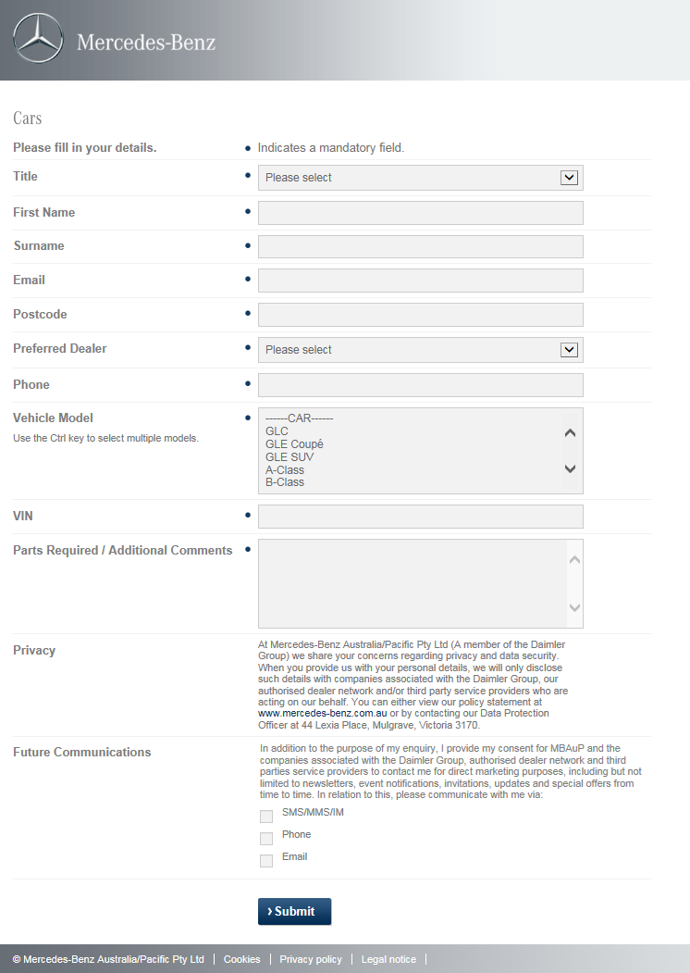

### Brochure Request

Unique ID – BRL1

**Business Unit**

Passenger Cars, Vans Sales, Vans After Sales

**Source System**

**All BU’s**

**(As Is)** DLM (Dealer Lead Management) system – forms are delivered from DLM through EP into CRMOne

**Mandatory fields**

**All BU’s**

* Title
* First Name
* Surname
* Email
* Postcode - (post code to auto match to closest dealer via website)
* Contact number (Landline or Mob.)
* Purchase Intent
* Preferred Dealer
* Vehicle make/model (can be multiple),

**Other Requirements**

* CRMOne to trigger an automatic email confirmation to the customer once the form has been submitted. Email template to customer to include a web link to the brochure/s for download or PDF of brochure/s for the specific model selected on the submitted lead.
* If multiple vehicles are selected on the lead for then the reference link on the email template should show the link and or PDF for each of the vehicles selected**.**
* The form type should be flagged in the system based on the tagging from form in CMS, for an example, if the lead is a test drive request, the lead should be tagged a test drive as per the picklist values.

**Generate Lead**

**All BU’s**

* All brochure request leads to be assigned to EMC for qualifying and action.
* EMC can select alternate dealer to assign lead to (if customer requests)
* Multi vehicle selection option available/ Vans range brochure – CRMOne to capture all vehicles selected on form.
* Ability to merge multiple vehicle selection requests into one (1) lead if consecutive requests made (displaying all vehicles selected in the one lead/view)
* i.e. when customer selects Vito, Sprinter, Valente there should not be 3 separate leads created (1 customer = 1 lead with multi vehicle selection)
* De-duplication of identically matching records (based on equivalent data matching rules) unless on different dates
* If requests across different BU's or Depts. (PC/Vans/Finance), separate leads to be created against the one profile (Account)
* System to ID Existing & Prospect customers (For all Leads)
* If existing customer lead is to be sent to a dealer that is **not** the active dealer, the receiving dealer cannot see that lead is an existing customer.
* If existing customer lead is to be sent to a dealer that **is** the active dealer, the receiving dealer can see that lead as assigned to existing account.

**Qualify Lead**

**All BU’s**

* All Brochure requests to be received & qualified by EMC
* EMC/Dealer to update status

**Qualify Lead**

**PC specific**

System scores the lead as per the lead scoring below:



**If the lead can't be continued at this point, what happens to the lead? is it closed, nurtured?**

* Enquiry can be 'closed' by EMC
* EMC to select appropriate 'Lost' reason via drop down options; including opportunity to 'nurture' (status)
* EMC can select to nurture the lead
* Need to have a separate field on the lead to flag is the lead is to be nurtured (New field). Lead can be in a closed status but can still be nurtured. This field needs to be a reportable field.
* EMC can set follow up tasks / actions on leads.
* Ability to change/update all fields including Preferred Dealer (EMC)
* Ability to Delete/remove non genuine/duplicate requests (As per current EMC functionality)

**Forward Lead**

**All BU’s**

LEAD RECIPIENT: * Only applicable if enquiry is converted to lead/qualified, otherwise N/A

* Lead Assigned to customers 'Preferred dealer' as noted on web form (*if lead qualified)
* Lead Assignee - to be assigned to at least one contact point within dealer (i.e. Vans Sales Manager cc Marketing,CRM,exec)

Dealer to determine & maintain Lead Assignee contact list directly in the system via the Dealer Portal. i.e. who lead is sent to within dealership   
  
**Follow Up Reporting**

**All BU’s**

**HO Reporting:-**

* All reports are generated based on chosen time frame.
* All reports are generated based on chosen sales staff/teams
* Dealers should be able to extract the data.
* General lead figures
* Enquiry “Nature of request” report
* Enquiry by lead source
* Enquiry by MBAuP Lead, MBFS Lead or Dealer Lead
* Sales person ranking by number of deals closed
* Sales person ranking by total number of open lead cases
* Model interest
* Brochure interest
* Ownership status, customer v prospect reports
* Dealership reports; top 10 performing dealers
* Top 10 dealers by login count  
  Completed sales steps (show total count of lead status’ selected
* Sales Pipeline (non-closed leads) show total count of lead status’ selected
* Reports can be set up based on Business Unit and Offered Service.
* Reports to be at a National Level, State level, Dealership level and Salesperson level

**Monitoring Tracking Escalations**

**All Bu’s**

**Tracking/Escalations**  
**Leads sent to Dealers:-**

* Dealer Lead Reaction Time - i.e. time dealer takes to respond to lead via EMC (based on status change)
* EMC qualifies lead>Lead sent to dealer>Dealer changes lead status (= DLRT)
* Opening hours to trigger escalation timings if request made outside Business hours  
    
  **Unactioned Leads (>4hrs or set time frame):-**  
  Lead email escalated triggered:-

**PC Leads specific – Lead email escalation triggers**

* System Administrator can set reports for HQ or EMC to receive reports on unactioned leads and perform follow ups to dealers.

**VANS Leads specific – Lead email escalation triggers**

* 4 hours lead untouched – Email to EMC
* 8 Hours lead untouched – email to Dealer Principal / BDM / Head Office

**Close Lead Case and Reporting**

**All BU’s**  
  
**Lost Leads (No further action required)**

* EMC to provide 'Lost' reason (Status)
* If EMC sets lead status to 'Lost', lead details to be retained in CRMOne

**Closed Leads * Dealer can close lead only**

* Dealer can apply 'Closed' or 'Lost' status
* Dealer to manage these leads internally
* *Long lead/Lead nurturing considerations for both EMC & Dealer i.e. 6-12month (Purchase Time) customers
* Allow for EMC to nurture long lead opportunities & send lead to dealer at any future time (i.e. 12mths after initial request made)

**Dealer Reporting (for all Lead Types)**

* Dashboard Reporting
* Automation of reports
* All stages of the Sales process (Referral/Appt. made/kept/vehicle sold etc. )
* All fields/filters on customer record should be reportable
* No. of dealer enquiries/p enquiry type /% conv/referrals/by staff/Dealer etc.
* All reports are generated based on a choose time frame.
* All Reports are generated based on chosen sales staff / teams.
* Dealers should be able to extract the data.
* General lead figures
* Enquiry “Nature of Request” report
* Enquiry by Lead source
* Enquiry by MBAuP Lead, MBFS Lead or Dealer Lead
* Sales person ranking by number of deals closed
* Sales person ranking by total number of open lead cases
* Model Interest
* Brochure Interest
* Ownership reports; top 10 performing Dealers
* Top 10 Dealers by login count
* Completed sales steps (Show total count of lead statuses selected – This report will be structured around the “Total Status” count of closed leads. This report will be for Sales Managers & Dealer Principals to see how many leads their sales teams have closed.
* This report will be structured around the “Total Status” count of All leads that are “aren’t” in a closed status. This report will be for Sales Managers & Dealer Principals to see how many leads their sales teams have currently and what status each lead has. Based on non-closed leads ONLY
* All reports need to be executed at a National Level, State level, Dealership level and where advised at a Salesperson level.
* Reports can be set up based on Business Unit and Offered Service.

**EMC/HO**

* To retain all current reporting functionality that is available in the K2 release and currently being used by the business incl. Dashboards  
   Automation of Reports

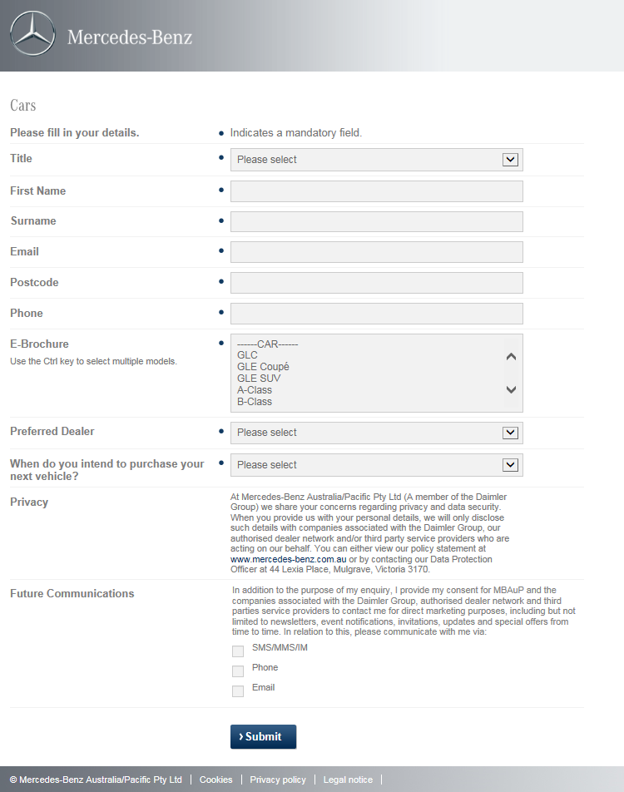

### Brochure Request – PC Aftersales (these forms are not live)

Unique ID – BRL1

**Business Unit**

Passenger Cars After Sales

**Source System**

DLM web forms

**Business Unit**

Passenger Cars, Vans Sales, Vans After Sales

**Source System**

**All BU’s**

DLM web forms

**Mandatory fields**

* Title
* First Name
* Surname
* Phone
* Email
* Postcode
* State
* Car Model

**Generate Lead**

* Form to go live in February/March - 'My Service' Brochure request that will send the customer 1 brochure relating to our Service Products (Capped Price Servicing or Service Plans).
* There is only 1 form and the customer can download it - no dealer interaction required as this is a HQ form.
* It is also used to gather more up-to-date customer information.

### Key 2 Key

Unique ID – KKL10

**Business Unit**

MBFS

**Source System**

Outbound Phone Calls

**Mandatory fields**

* Title
* First name
* Surname
* Mobile
* Originating dealer
* Amount financed
* Term
* Monthly repayments
* RV
* Maturity date

**Generate Lead**

* Only mine customers with enough estimated equity to upgrade for similar repayments.
* No contracts with poor payment history are to be targeted
* Data automatically drawn from CMS
* Salesforce allows us to select which dealer the lead is to be sent to. If the originating dealer is no longer active, we will send the lead to an appropriate alternative dealer with the customers consent
* Poor payment history is determined by the Customer Retention user. This can depend on the circumstance; approval requirements may be more lenient for customers with a long history. Currently it is up to the customer retention specialist to determine whether a customer should be contacted.

**Qualify Lead**

* Customer Retention Specialist qualifies lead during call and also uses data within CMS.
* Temperature and scoring not required.
* If lead case should not be continued, dealer should click on 'Closed' option from hyperlinks within lead email.

**Forward Lead**

* Lead recipients should be DP, DRM, Business Managers and Sales Staff.
* Lead will generally be sent to originating dealer unless customer specifies otherwise.

**Follow Up Reporting**

* Standard feedback should be whether customer showed up for their appointment and whether a sale was made.
* If sale was made, we need to know what vehicle was purchased

**Monitoring Tracking Escalations**

* Kept appointments and units sold are tracked.
* If we are not able to determine an outcome either from the customer or dealer, the follow up is escalated to the DRM. Escalation should be triggered if we receive no response after the first 5 business days of the month.

**Close Lead Case & Reporting**

* Lead should expire after 90 days. Leads are currently manually closed
* KPIs: Leads sent per dealer, appointments kept, units sold, retention and conversion rate

### Competitions - Prospects/Register Your Interest Prospects/eNews Sign Ups

Unique ID – COL9

**Business Unit**

Passenger Cars

**Source System**

**(As Is)** DLM (Dealer Lead Management) system – forms are delivered from DLM through EP into CRMOne

Forms will also be provided through 3rd Party platforms – forms hosted by IDDBM, Media Publishers and Competition partners.

**Mandatory fields**

* First Name
* Surname
* Phone
* Email
* Postcode
* Purchase Intent
* Car Model
* 25 words or less,
* Comments

**Generate Lead**

**Vans Specific**

* Data sent to Salesforce immediately after a form is submitted
* Leads should be saved in CRMOne and will require no action.
* The form type should be flagged in the system, for example as a Competition and we should be able to tag all our competitions.
* Form prospects who match with existing customers should be de-duped in the system.
* When the customer hits sales force the leads should be recorded against any existing customers.

**Generate Lead**

**PC Specific**

* Form data should be saved in CRMOne and will require no ‘lead’ action.
* The form type should be flagged in the system, for example as a Competition and we should be able to tag all our competitions/Register Your Interests/eNews Sign Ups.
* Form prospects who match with existing customers should have a communication task created with the as description the name and type of the form submitted.

**Close Lead Case & Reporting**

* System users should be able to report on the form name and see a list of all submissions of that particular form.

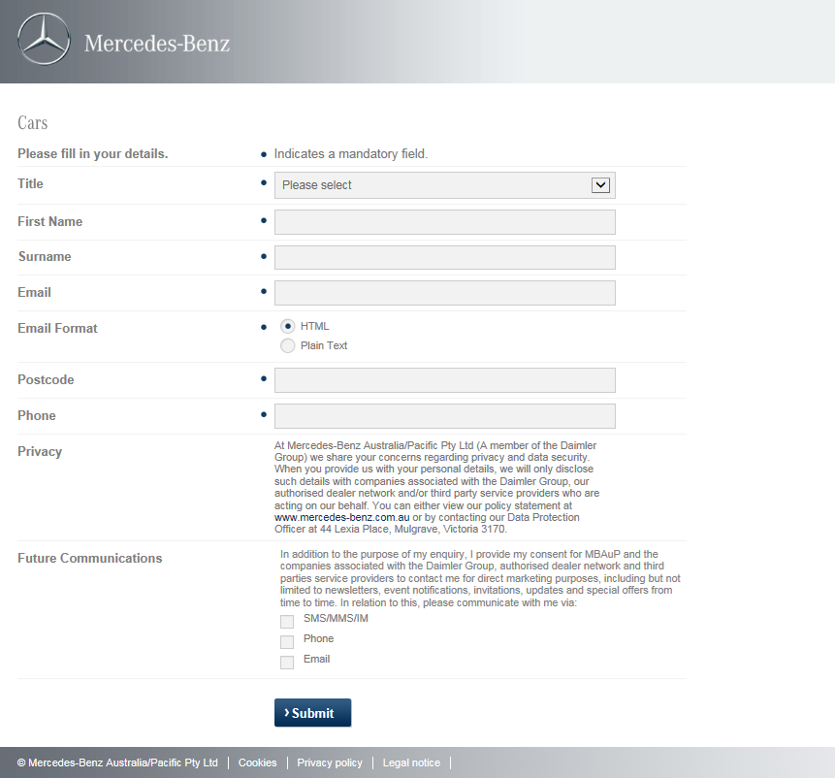

### Service Booking

Unique ID – SBL6

**Business Unit**

Passenger Cars After Sales & Vans After Sales

**Source System**

DLM web forms & QR Code

PC Specific - <http://www1.mercedes-benz.com.au/Custom/Forms/ServiceBookingCar.aspx>

http://www1.mercedes-benz.com.au/Custom/Forms/QRCode.aspx

**Mandatory fields**

* Title
* First Name
* Surname
* Email
* Postcode
* Phone
* Vehicle Model
* Registration Number
* Preferred Date
* Drop-off Time
* Pick-up time
* Preferred Servicing Dealer
* State

**Generate Lead**

**Qualify Lead**

**PC Specific**

* Dealership who lead is assigned to will qualify the lead
* Leads are currently not scored.
* Want to implement a time score to ensure Dealers get to service booking enquiries as soon as possible. (Dealer level and HQ view)
* Customer wait time (within 30 mins - 100 points, 30-60 mins - 50 points, 60+ minutes 20 points). Dream car bookings should be treated with a shorter waiting time. (across all customers)
* If lead cannot be continued they need the ability to close the lead

**Vans Specific**

* LEAD RECIPIENT: Dealer Service Department
* BUSINESS RULES: Dealer to determine

**Forward Lead**

**PC Specific**

* Service Manager or Service Advisors at Dealerships should receive these leads  
  Preferred Servicing Dealer and based on postcode determines the Dealership.
* The coding in the form links directly to each dealer PMA.
* Escalation rules should be based on currently dealer escalation criteria in DLM

**Vans Specific**

**As defined by dealer**Dealer to maintain/nurture lead

**Follow Up Reporting**

**PC Specific**

* Dealer reviews the lead and actions accordingly at their dealership.
* A lead can be called, emailed or SMS'd base on their stipulated communication avenue.

**Monitoring Tracking Escalations**

**PC Specific**

* Dealers should be able to run a report of any pending or outstanding service bookings which have been assigned to them. All leads should be loaded into CRMOne
* The mandatory fields are required to produce reporting for these service enquiries but may differ for each dealer.
* The ability to 'track' enquiries from HQ is important to help gain insight and trends.
* An email is generated and sent to the dealer once the form is filled out provided all mandatory fields have been entered.

**PC Service Booking Specific**-

* What information will you be tracking for this lead type?
* Vehicle Model,
* Year,
* Registration No,
* VIN
* Km Service,
* Preferred servicing dealer

**Who should get escalations?**

* If assigned to HQ: Helen Wang / Daniel Silvasich
* If assigned to Dealer: Dealer Principal / Service Manager

**PC QR Code booking specific-**

What information will you be tracking for this lead type?

* Title
* First Name
* Surname
* Phone
* Email
* Postcode
* State
* Car Model
* Registration Number
* Preferred Date
* Drop-off Time
* Dealership

Who should get escalations?

* If assigned to HQ: Helen Wang / Grace Chan
* If assigned to Dealer: Service & parts department

**Close Lead Case & Reporting**

**PC Specific**

* Leads can be manually closed - dealers can only close a lead pending there is a resolution.
* Back-end reporting should show if:
* The lead has been opened,
* The lead has been actioned from the assigned dealers email address and if not follow up on why it has not been actioned from HQ.

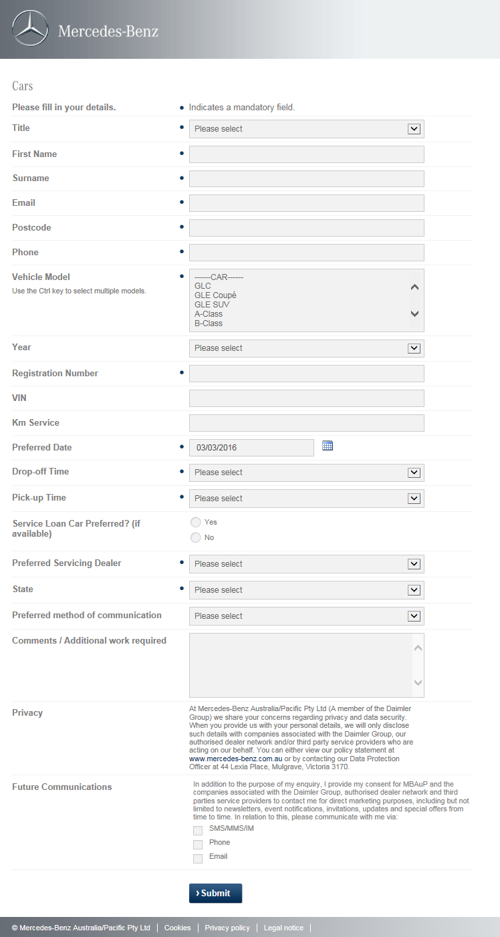

### Contact Us

Unique ID –CUL3

**Business Unit**

Passenger Cars & Vans

**Source System**

**PC & Vans**

**(As Is)** DLM (Dealer Lead Management) system – forms are delivered from DLM through EP into CRMOne

PC Specific - Reference to current form: https://www1.mercedes-benz.com.au/custom/forms/ContactUsCar.aspx

**Mandatory fields**

**PC Specific**

* Title
* First Name
* Surname
* Phone
* Email
* Postcode
* Purchase Intent
* Car Model
* Preferred dealer
* Comments
* Enquiry Topic (Mapped to ‘Offered Service’

**Generate Lead**

**PC Specific**

* If HQ is selected; Qualification by EMC is required (EMC to contact within 30mins).
* If dealership is selected then qualification by dealers will need to be determined.

NOTES:

* All leads should go through to CRMOne as the data validation stage takes place at the form submission.
* Forms can't be submitted without all data being valid.   
  We should be able to easily add fields to form and the CRMOne system should be flexible enough to capture any extra text fields.

**Vans Specific**

* Lead simultaneously sent to CRMOne

**Qualify Lead**

**PC Specific**

**WHO WILL QUALIFY LEAD?**

* If **Head office** is selected on web form, lead sent directly to EMC que. System will use supplied logic to apply a Lead Priority and Lead Priority Score. Logic is attached.
* Lead Priority: Hot, Warm, Cold

Priority Score: Numerical value

* If **a dealer** is selected on web form, lead will go to relevant dealer.
* System to use logic data to decide which dealer to send lead to.
* However, if lead is scored as cold lead will go to EMC not dealer for nurturing/qualifying.
* Where a lead status is set as “cold” an automatic task to be generated for a follow up on this lead. The user can select the date for the task follow up to be set at.
* If **a dealer** is selected on web form, EMC to receive a copy of that lead for follow up purposes.

**CUSTOMER IDENTIFICATION**

* EP / CRMOne todetermine if a customer is a current customer or not.
* If no existing customer account can be matched or identified, prospect account to be created and Lead assigned.
* If existing customer account can be matched or identified then lead is created and assigned to the account
* If existing customer lead is to be sent to a dealer that is **not** the active dealer, the receiving dealer cannot see that lead is an existing customer.
* If existing customer lead is to be sent to a dealer that **is** the active dealer, the receiving dealer can see that lead as assigned to existing account.

**WHAT SYSTEM SHOULD BE USED TO QUALIFY LEAD?**

* SalesForce system should be used to quality the lead.

**IF LEAD CANNOT BE CONTINUED?**

* If lead cannot be continued, EMC should close the lead and save the lost reason as per the picklist values available.

**Forwarding Lead**

**Passenger Cars**

**RECIPIENT OF LEAD:**

* All test drive leads go to selected dealer based on form field “Preferred Dealer”
* If head office selected on form leads go to EMC.
* Administrator to be able to change if leads are to go to EMC, Preferred Dealer or both.
* Business may adjust process from time to time.
* Once Dealership receives lead:   
  Dealerships: Will go to 1 or more preferred dealership emails.
* Dealers should be able to manage recipient of leads in the **Dealer Portal**. All leads should end up in the dealer portal regardless of person assigned the lead.
* Depending on the “offered service” pick list value chosen on the form, the enquiry could be automatically sent not just to the EMC but directly to the internal contact delegated as responsible for the enquiry type. Eg Parts enquiry to a Parts team member.

**HOW IS THIS DETERMINED**

* Delivered from the web form (determined in the DLM system)

**BUSINESS RULES:**

* Lead should be answered between 30 mins and 3 hours of submission within normal business hours.
* Dealers should be able to select a time frame lead to be processed before it is escalated within the dealership. Dealers should be able to select this in the Dealer Portal.
* The escalated configuration should be determined in the dealership portal and different for each branch.
* If lead is not answered within selected time frame (eg 24 hours) then lead is escalation to the Dealers selected manager.
* Dealers should be able to manage this in the Dealer Portal.
* Leads should be able to be forwarded to another person if the recipient can't action lead.
* All emails forwarded to the dealership will be seen in the Dealer portal + an email will be sent directly to the admin email or relevant sales email.

**Follow Up Reporting**Passenger Car & Vans combined

* Dealers should be able to create their own rules about the process of following up a lead: SMS Alert / Email alert / Phone call alert.
* Dealers should be able to create calendar alerts as a to-do item, interfacing to outlook calendar
* Dealers should be able to choose a contact person in the dealership to follow up any reporting on leads.

**Monitoring Tracking Escalations**

Passenger Car & Vans combined

**INFORMATION TRACKED FOR THIS LEAD TYPE**

* The information tracked for this lead type is the generic information already available on the form as well as any field selected in the lead case including notes that the EMC staff or dealers have added to this lead.

**Escalations:**

* All escalations should be determined by the dealer; i.e - number of hours for lead handling, person of escalation, frequency of escalations.
* Head office will generate reports based on own determined logic for set escalations, eg a report showing all leads that have not been contacted within a determined time limit. Administrator can change determined time limit at any time.

**ESCALATIONS TRIGGERED:**

* Escalations can be triggered based on a time frame.

**CLOSE LEAD CASE AND REPORTING**

**Passenger Car and Vans combined**

**EXIPIRE OF LEADS**

* All leads should remain in the dealer portal until an action is added to the lead. They should not be automatically closed by the system.
* All leads not adhered to within the correct time frames will be flagged with HQ for a status report at intervals determined by the system administrator.  
  The time stamp of dealership responses on actioning any of the lead statuses “Lead Status” field should be captured in the reporting.

**Vans Specific  
Enquiry routed as per the below Depts/Dealer/BU**

‘Nature of Request’ dropdown to include:

* Vehicle Purchase (Assigned to Dealer)
* Test Drive (Assigned to Dealer)
* Information Request
* Service & Parts (Assigned to Dealer)
* Finance & Insurance (Assigned to Dealer)
* Other (HO)

Or

* Product - (Assigned to Dealer)
* Sales - (Assigned to Dealer)
* Service & Parts - (Assigned to Dealer)
* After Sales - S & P - (Assigned to Dealer)
* Marketing/Campaigns - (Assigned to EMC)
* Insurance/Finance - (Assigned to Dealer)
* Head Office - (Assigned to Vans BU)
* Other - (Assigned to Vans BU)

**Vans Specifics**

* Ability to report on all data fields captured eg;  
  No. Leads sent to Dealer (from EMC)
* Time to action/update status on Lead (Dealer)
* Lead Status
* Lead Escalation & time to action (Qualified leads) e.g. Actioned/Leads not actioned 4hrs/6/12hrs etc.
* Flexible reporting & ability to manipulate report timings/filters as determined by Dealer/HO/EMC e.g. hourly/daily/monthly etc.

**Monitoring Tracking Escalations**

* ESCULATIONS TRIGGERED:   
  Escalations can be triggered based on a time frame.
* Close Lead Case & Reporting

**PC Specific**

**EXIPIRE OF LEADS;**

All leads should remain in the dealer portal until an action is added to the lead.   
  
All leads not adhered to within the correct time frames will be flagged with HQ for a weekly status report.   
The rate of dealership responses on actioning and closing the lead should be captured in the reporting.   
  
**REPORTS (the reporting dashboard should provide availability for all data):**

**Vans Specific**

* Dealers should be able to view how many test drives they have received and choose a time frame.
* Dealers should be able to extract the data.
* General lead figures
* Enquiry type report
* Contact us enquiries
* Product enquiries
* Age demographics / reports by state
* Model interest
* Brochure interest
* Ownership status
* Dealership reports; top 10 performing branches
* Top 10 reporting dealers by login
* Customer or prospect reports
* For any form entered CRM1 the dealership should be able to extract and select any information they would like to pull from that data capture.
* Please note that all leads should be migrated from the old DLM to the new CRM1 system so that all history is retained.

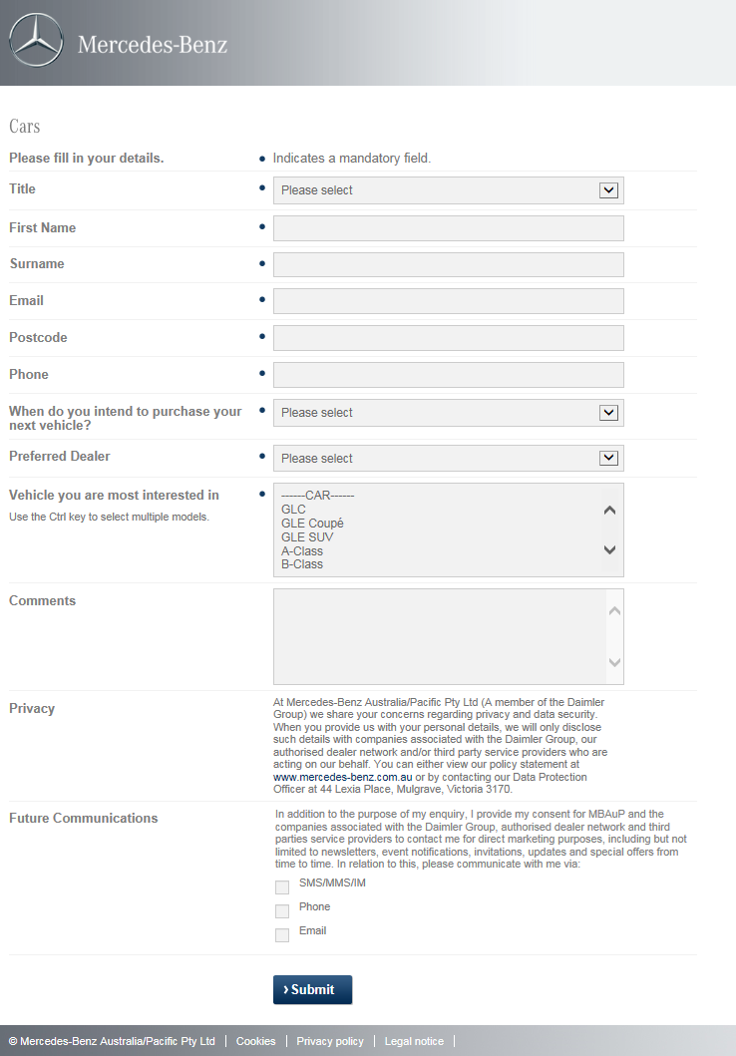

### AutoGate

**Unique ID – AUL13**

**Business Unit**

PC (new, demo & POV) & Vans (new, demo & POV)

**Source System**

**Autogate via Carsales**

**Mandatory Fields**

* Title
* Prospect Number – new field required
* Autogate Prospect number – new field required
* Phone
* Postcode
* Source – new field required (picklist values: carsales / Carsguide/ OEM)
* Model Details
* Date Received
* Time Received
* Comments
* Other

**Generate Leads**

**PC & Van New & Demo Specific**

* Prospect identifies a vehicle from within carsales.com.au, completes form and submits.
* Lead is submitted into Autogate, Dealer receives notification that an enquiry has been submitted in Autogate for them. Dealer logs in to Autogate to view the lead and the lead details. *(Proposed – Upon Dealer authorising the action in Autogate, all leads generated from Carsales could be sent directly to CRMOne for action and processing)*.
* Prospect will receive an automated response from carsales confirming the enquiry has been sent etc.
* Upon receipt of lead, Dealer allocates to salesperson and a response needs to be actioned within standard enquiry timeframes, outcome is currently entered into the Dealers CRMsystem and Autogate.
* If leads were sent to CRMone from Autogate the responses and outcomes will be captured in the there. If leads are updated in CRMOne directly, an interface will be required to send back lead updates and actions to Autogate.

**Qualify Leads**

**Both POV, New / Demo**

* Lead is submitted by prospect on a specific vehicle,
* Lead should be treated as very hot and needs immediate action.

**Forward Leads**

**New and Demo Specific**

* Depends if processed via Autogate or CRM1.  
  POV Sales Manager will be notified by Autogate that lead has been created but also needs to notify by CRM1.
* Standard processing times should apply.
* Prospect selects a specific vehicle and the owner of that car (i.e. Dealer) will be contacted via enquiry.

**Follow Up Reporting**

**Monitoring Tracking Escalations**

**New, Demo and POV (PC & Vans)**

* Depends if processed via Autogate or CRM1.  
  If lead not processed, it should be escalated based on standard criteria timeframe Please Advise on timeframes
* Email reminder to the sales manager and DP is necessary

**Close Lead Case & Reporting**

**New, Demo and POV (PC & Vans)**

* Depends if processed via Autogate or CRM1.  
  If CRM1, interface withAautogate is required outlining lead enquiry outcome.  
  If Autogate, interface with CRM1 is required outlining lead enquiry outcome.

### POVL (Previously Owned Vehicle Locator)

**Unique ID – POVL14**

**Business Unit**

PC (new, demo & POV) & Vans (new, demo & POV)

**Source System**

**POVL (OEM) website**

http://www.pre-owned.mercedes-benz.com.au/Locator/Items/01/000000000004409012?SearchID=111040

**Mandatory Fields**

* Title
* First Name
* Surname
* Email
* Phone

**Generate Leads**

**PC & Van POV & Demo Specific (POVL – Previous Owned Vehicle Locator)**

* Prospect identifies a vehicle from within POVL

completes form and submits.

* Lead is submitted via Autogate and data is currently sent to DLM for processing by Dealer.
* Prospect will receive an automated response from POVL (Autogate) confirming the enquiry has been sent etc.
* Upon receipt of lead, Dealer allocates to salesperson and a response needs to be actioned within standard enquiry timeframe (assuming MBAuP has standard timing).
* This will require a reverse (bi-directional) interface to send lead details and updates back to Autogate.

**Qualify Leads**

**PC & Van POVL**

* Lead is submitted by prospect on a specific vehicle,
* Lead should be treated as very hot and needs immediate action.

**Forward Leads**

**POV & Demo**

* POV Sales Manager will be notified by Autogate that lead has been created but also needs to notify by CRM1.
* Standard processing times should apply.
* Prospect selects a specific vehicle and the owner of that car (i.e. Dealer) will be contacted via enquiry.
* Demo lead could be sent to either new or POV sales manager

**Follow Up Reporting**

**Monitoring Tracking Escalations**

**POV Specific**

* If lead not processed, it should be escalated based on standard criteria timeframe. Please Advise on timeframes
* Email reminder to the sales manager and DP is necessary

**Close Lead Case & Reporting**

**Demo and POV (PC & Vans)**

* Depends if processed via Autogate or CRM1.  
  If CRM1, interface withAautogate is required outlining lead enquiry outcome.  
  If Autogate, interface with CRM1 is required outlining lead enquiry outcome.

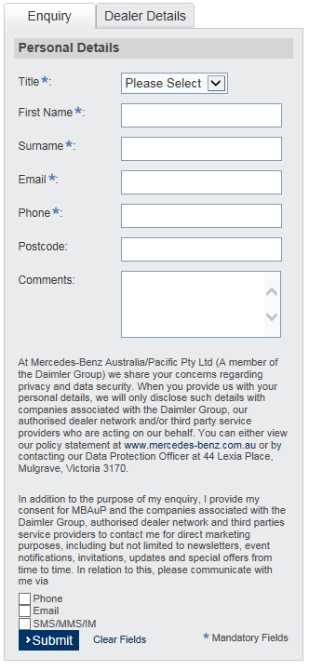

### 

### Business Solutions Enquiry

Unique ID – BSL15

**Business Unit**

Passenger Cars

**Source System**

**All BU’s**

**(As Is)** DLM (Dealer Lead Management) system – forms are delivered from DLM through EP into CRMOne

**Mandatory fields**

* Title
* First Name
* Surname
* Email
* Postcode - (post code to auto match to closest dealer via website)
* Contact number (Landline or Mob.)
* Preferred Dealer
* Vehicle make/model (can be multiple),

**Other Requirements**

* CRMOne to trigger an automatic email confirmation to the customer once the form has been submitted. Email template to customer to include a web link to the brochure/s for download or PDF of brochure/s for the specific model selected on the submitted lead.
* If multiple vehicles are selected on the lead for then the reference link on the email template should show the link and or PDF for each of the vehicles selected**.**
* The form type should be flagged in the system based on the tagging from form in CMS, for an example, if the lead is a test drive request, the lead should be tagged a test drive as per the picklist values.

**Generate Lead**

* All Business Solutions leads to be assigned to EMC for qualifying and action.
* EMC can select alternate dealer to assign lead to (if customer requests)
* Multi vehicle selection option available CRMOne to capture all vehicles selected on form.
* De-duplication of identically matching records (based on equivalent data matching rules) unless on different dates

**Qualify Lead**

* Qualified by EMC

**If the lead can't be continued at this point, what happens to the lead? is it closed, nurtured?**

* Enquiry can be 'closed' by EMC
* EMC to select appropriate 'Lost' reason via drop down options; including opportunity to 'nurture' (status)
* EMC can select to nurture the lead
* Need to have a separate field on the lead to flag is the lead is to be nurtured (New field). Lead can be in a closed status but can still be nurtured. This field needs to be a reportable field.
* EMC can set follow up tasks / actions on leads.
* Ability to change/update all fields including Preferred Dealer (EMC)
* Ability to Delete/remove non genuine/duplicate requests (As per current EMC functionality)

**Forward Lead**

**All BU’s**

LEAD RECIPIENT: * Only applicable if enquiry is converted to lead/qualified, otherwise N/A

* Lead Assigned to customers 'Preferred dealer' as noted on web form (*if lead qualified)
* Lead Assignee - to be assigned to at least one contact point within dealer (i.e. Vans Sales Manager cc Marketing,CRM,exec)
* Lead can alternatively be forwarded to an internal Fleet Team member in PC

**Monitoring Tracking Escalations**

**All Bu’s**

**Tracking/Escalations**  
**Leads sent to Dealers:-**

* Dealer Lead Reaction Time - i.e. time dealer takes to respond to lead via EMC (based on status change)
* EMC qualifies lead>Lead sent to dealer>Dealer changes lead status (= DLRT)
* Opening hours to trigger escalation timings if request made outside Business hours

**PC Leads specific – Lead email escalation triggers**

* System Administrator can set reports for HQ or EMC to receive reports on unactioned leads and perform follow ups to dealers.

**Close Lead Case and Reporting**

**All BU’s**  
  
**Lost Leads (No further action required)**

* EMC to provide 'Lost' reason (Status)
* If EMC sets lead status to 'Lost', lead details to be retained in CRMOne

**Closed Leads * Dealer can close lead only**

* Dealer can apply 'Closed' or 'Lost' status
* Dealer to manage these leads internally
* *Long lead/Lead nurturing considerations for both EMC & Dealer i.e. 6-12month (Purchase Time) customers
* Allow for EMC to nurture long lead opportunities & send lead to dealer at any future time (i.e. 12mths after initial request made)

**Dealer Reporting (for all Lead Types)**

* Dashboard Reporting
* Automation of reports
* All stages of the Sales process (Referral/Appt. made/kept/vehicle sold etc. )
* All fields/filters on customer record should be reportable
* No. of dealer enquiries/p enquiry type /% conv/referrals/by staff/Dealer etc.
* All reports are generated based on a choose time frame.
* All Reports are generated based on chosen sales staff / teams.
* Dealers should be able to extract the data.
* General lead figures
* Enquiry “Nature of Request” report
* Enquiry by Lead source
* Enquiry by MBAuP Lead, MBFS Lead or Dealer Lead
* Sales person ranking by number of deals closed
* Sales person ranking by total number of open lead cases
* Model Interest
* Brochure Interest
* Ownership reports; top 10 performing Dealers
* Top 10 Dealers by login count
* Completed sales steps (Show total count of lead statuses selected – This report will be structured around the “Total Status” count of closed leads. This report will be for Sales Managers & Dealer Principals to see how many leads their sales teams have closed.
* This report will be structured around the “Total Status” count of All leads that are “aren’t” in a closed status. This report will be for Sales Managers & Dealer Principals to see how many leads their sales teams have currently and what status each lead has. Based on non-closed leads ONLY
* All reports need to be executed at a National Level, State level, Dealership level and where advised at a Salesperson level.
* Reports can be set up based on Business Unit and Offered Service.

**EMC/HO**

* To retain all current reporting functionality incl. Dashboards  
   Automation of Reports

### Wholesale Enquiry – Sponsorship Request

Unique ID – WES16

**Business Unit**

Passenger Cars

**Source System**

**All BU’s**

**(As Is)** DLM (Dealer Lead Management) system – forms are delivered from DLM through EP into CRMOne

Sponsorship Request <http://www1.mercedes-benz.com.au/Custom/Forms/SponsorshipRequest.aspx>

**Mandatory fields**

*Indicates a mandatory field.

1. Organisation Name*

2. Website address*

3. Contact Person*

4. Position/Title*

5. Postal Address*

6. State*

Please select Australian Capital Territory Northern Territory New South Wales Queensland South Australia Tasmania Victoria Western Australia

7. Postcode*

8. Contact number*

9. Email address*

10. ABN/ACN*

11. Are you a registered charity or not-for-profit organisation?*

Yes

No

12. What is the number of employees/volunteers that are within the organisation?*

Please select <10 10-50 51-100 >100

13. What is the organisation's mission / purpose?*

Characters: 250

14. Are you a Government or Government affiliated organisation?*

Yes

No

15. How long has the organisation been in existence?*

Please select 0-2 years 3-5 years 5-10 years >10 years

16. Has the organisation worked with Mercedes-Benz in the past?*

Yes

No

17. Sponsorship Category*

If your proposal does not fall into any of these categories, unfortunately the application cannot be considered.

Please select Sports Lifestyle Education Science Technology Community Arts & Culture Charity Political Dialogue Environmental

18. Does this proposal offer automotive exclusivity?*

If your proposal does not offer automotive exclusivity, unfortunately the application cannot be considered.

Yes

19. What date are you looking to commence the commitment?*

Mercedes-Benz requires at least 12 months advance notice to allow effective evaluation, commitment and activation. If a commitment is required prior to 12 months, unfortunately the application cannot be considered.

Open the calendar popup.

<< < > >>

20. Provide an overview of the organisation, team, event, program or individual for which you are seeking sponsorship support.*

Characters: 1000

21. What level of support are you seeking (e.g. major partner, naming rights, sponsor etc)?*

Characters: 500

22. What is the duration of the proposed commitment?*

Please select 0-1 month 2-4 months 4-6 months 6-12 months >12 months

23. What is the value of the proposed investment in AUD dollars?*

Please enter numerical information only

24. Which of the following business benefits will the sponsorship deliver?

Event ticketing

Corporate hospitality

Access to database/mailing lists

Customer experience

Onsite event opportunities

Promotional opportunities

Special offers

Access to high profile personalities and celebrities

Venue access/usage

Public relations opportunities

Product exposure

Exclusive Content

Logo and brand signage placement

Profile networking

Other

25. Please expand on the above benefits.*

Characters: 750

26. What is the approximate value of benefits to MBAuP in AUD dollars?*

Please enter numerical information only

27. Which of the following media benefits will the sponsorship deliver?

Brand exposure in partners media plan

National broadcast rights

Website presence

Online activity

Onsite branding/signage

Print exposure

Outdoor exposure

Radio exposure

National television exposure

Local television exposure

Intellectual property rights

Other

28. Please outline the target audience for this sponsorship.*

Characters: 2500

29. Does the sponsorship proposal include a request for vehicles?*

In addition to the purpose of my enquiry, I provide my consent for MBAuP and the companies associated with the Daimler Group, authorised dealer network and third parties service providers to contact me for direct marketing purposes, including but not limited to newsletters, event notifications, invitations, updates and special offers from time to time. In relation to this, please communicate with me via:

Yes

No

30. Vehicle Model*

Use the Ctrl key to select multiple models.

31. If you have met all of the criteria, please upload the full proposal or any additional material to support the proposal that will assist with the evaluation process.

Supported file types are: pdf, doc, docx, txt, jpg, jpeg, png, gif, xls, xlsx, ppt, pptx.

32. I have read and accept the Privacy Statement.*

**Generate Lead**

* No de-duping required.
* Enquiry to be sent to a wholesale email address with the full content of the enquiry.
* Not generated as a lead task in salesforce

**Qualify Lead**

* NA
* There is no need for any closure required as it is not created as a lead task.

**Forward Lead**

* Not required.

**Tracking/Escalations**  
Not required.

**Close Lead Case and Reporting**  
Not required.

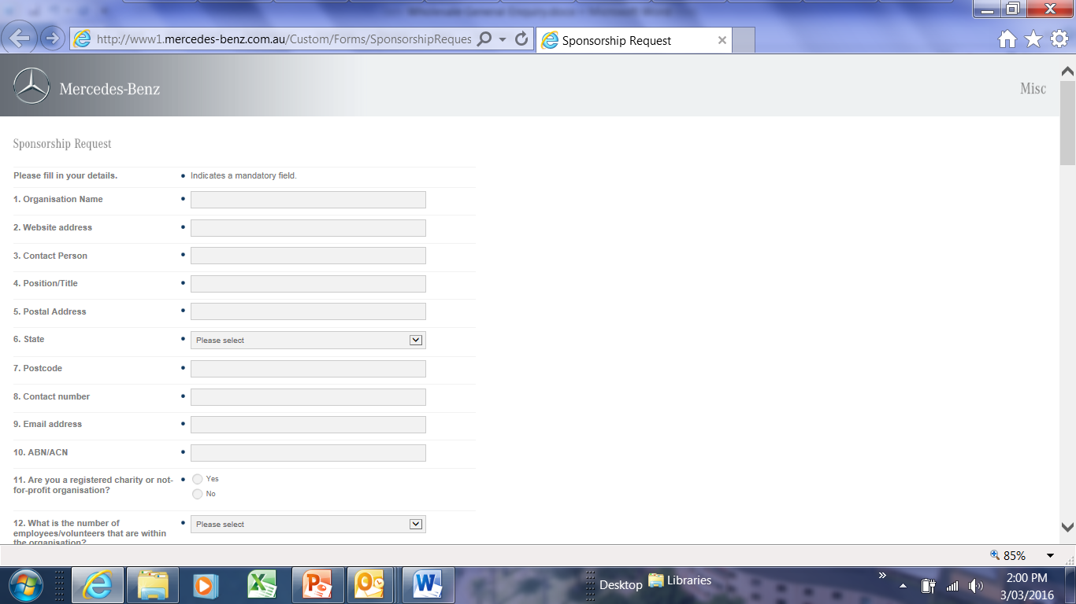

### Wholesale Enquiry - Website Feedback

Unique ID – WEW17

**Business Unit**

Passenger Cars

**Source System**

**All BU’s**

**(As Is)** DLM (Dealer Lead Management) system – forms are delivered from DLM through EP into CRMOne

<http://www1.mercedes-benz.com.au/Custom/Forms/WebsiteFeedback.aspx>

**Mandatory fields**

* Title
* First Name
* Surname
* Email
* Confirm Email
* Comments

**Generate Lead**

* No de-duping required.
* Enquiry to be sent to a wholesale email address with the full content of the enquiry.
* Not generated as a lead task in salesforce

**Qualify Lead**

* NA

**If the lead can't be continued at this point, what happens to the lead? is it closed, nurtured?**

* There is no need for any closure required as it is not created as a lead task.

**Forward Lead**

* Not required.

**Tracking/Escalations**  
Not required.

**Close Lead Case and Reporting**  
Not required.

### 

### Lead Management User’s & View

### Lead Management Reporting Requirements

Below is a consolidated list of the reporting requirements for Lead Management –

**Test Drive requests:**

* All reports are generated based on a choose time frame.
* All Reports are generated based on chosen sales staff / teams.
* Dealers should be able to extract the data.
* General lead figures
* Enquiry “Nature of Request” report
* Enquiry by Lead source
* Enquiry by MBAuP Lead, MBFS Lead or Dealer Lead
* Sales person ranking by number of deals closed
* Sales person ranking by total number of open lead cases
* Model Interest
* Brochure Interest
* Ownership reports; top 10 performing Dealers
* Top 10 Dealers by login count
* Completed sales steps (Show total count of lead statuses selected – This report will be structured around the “Total Status” count of closed leads. This report will be for Sales Managers & Dealer Principals to see how many leads their sales teams have closed.
* This report will be structured around the “Total Status” count of All leads that are “aren’t” in a closed status. This report will be for Sales Managers & Dealer Principals to see how many leads their sales teams have currently and what status each lead has. Based on non-closed leads ONLY
* All reports need to be executed at a National Level, State level, Dealership level and where advised at a Salesperson level.
* Reports can be set up based at a Business Unit and Offered Service level.

**Agility:**

* Leads sent per dealer,
* Units sold,
* Contracts refinanced,
* Retention and conversion rate
* Reporting should be available at a National level (including ALL Dealerships), a State level (specific Dealers in each State) and at an Individual Dealership level.

**Early Renewal:**

* Leads sent per dealer,
* Units sold,
* Contracts refinanced,
* Retention and conversion rate
* Reporting should be available at a National level (including ALL Dealerships), a State level (specific Dealers in each State) and at an Individual Dealership level.

**End of Contract:**

* Report on leads that resulted in a new purchase or RV refinance.
* Report to show new vehicle sales generated from leads.
* Track and report conversion to new vehicle purchase or refinance, retention rate per dealer.

### Campaign Management (Hand Raiser):

* Report on number of total leads sent
* Report on number of total leads actioned
* Report on response reporting on lead (status)
* Conversion from lead to sale
* Report on Lost leads
* Report on Escalated leads

### Parts Enquiry:

* Report of any pending or outstanding parts enquiries which have been assigned to Dealers.
* Dealers to run a report on pending or outstanding parts enquiries which have been assigned to their Dealership.
* Report on Leads open rates
* Report on Leads that have been actioned by the Dealer
* Report on unopened / unactioned leads

### Brochure Request:

* All reports are generated based on chosen time frame.
* All reports are generated based on chosen sales staff/teams
* Dealers should be able to extract the data.
* General lead figures
* Enquiry “Nature of request” report
* Enquiry by lead source
* Enquiry by MBAuP Lead, MBFS Lead or Dealer Lead
* Sales person ranking by number of deals closed
* Sales person ranking by total number of open lead cases
* Model interest
* Brochure interest
* Ownership status, customer v prospect reports
* Dealership reports; top 10 performing dealers
* Top 10 dealers by login count  
  Completed sales steps (show total count of lead status’ selected
* Sales Pipeline (non-closed leads) show total count of lead status’ selected
* Reports can be set up based on Business Unit and Offered Service.
* Reports to be at a National Level, State level, Dealership level and Salesperson level
* Dashboard Reporting
* Automation of reports
* All stages of the Sales process (Referral/Appt. made/kept/vehicle sold etc. )
* All fields/filters on customer record should be reportable
* No. of dealer enquiries/p enquiry type /% conv/referrals/by staff/Dealer etc.
* All reports are generated based on a choose time frame.
* All Reports are generated based on chosen sales staff / teams.
* Dealers should be able to extract the data.
* General lead figures
* Enquiry “Nature of Request” report
* Enquiry by Lead source
* Enquiry by MBAuP Lead, MBFS Lead or Dealer Lead
* Sales person ranking by number of deals closed
* Sales person ranking by total number of open lead cases
* Ownership reports; top 10 performing Dealers Completed sales steps (Show total count of lead statuses selected – This report will be structured around the “Total Status” count of closed leads. This report will be for Sales Managers & Dealer Principals to see how many leads their sales teams have closed.
* This report will be structured around the “Total Status” count of All leads that are “aren’t” in a closed status. This report will be for Sales Managers & Dealer Principals to see how many leads their sales teams have currently and what status each lead has. Based on non-closed leads ONLY
* All reports need to be executed at a National Level, State level, Dealership level and where advised at a Salesperson level.
* Reports can be set up based on Business Unit and Offered Service.

### Key 2 Key:

* Reports on customer attendance to appointments
* Report on conversion to sale.
* If sale was made, we need to know what vehicle was purchased.

### Competitions - Prospects/Register Your Interest Prospects/eNews Sign Ups:

* System users should be able to report on the form name and see a list of all submissions of that particular form.

**Contact Us:**

* Dealers should be able to view how many test drives they have received and choose a time frame.
* General lead figures
* Enquiry type report
* Contact us enquiries
* Product enquiries
* Age demographics / reports by state
* Model interest
* Brochure interest
* Ownership status
* Dealership reports; top 10 performing branches
* Top 10 reporting dealers by login
* Customer or prospect reports
* For any form entered CRM1 the dealership should be able to extract and select any information they would like to pull from that data capture.

### Business Solutions Enquiry:

* Dashboard Reporting
* Automation of reports
* All stages of the Sales process (Referral/Appt. made/kept/vehicle sold etc. )
* All fields/filters on customer record should be reportable
* No. of dealer enquiries/p enquiry type /% conv/referrals/by staff/Dealer etc.
* All reports are generated based on a choose time frame.
* All Reports are generated based on chosen sales staff / teams.
* Dealers should be able to extract the data.
* General lead figures
* Enquiry “Nature of Request” report
* Enquiry by Lead source
* Enquiry by MBAuP Lead, MBFS Lead or Dealer Lead
* Sales person ranking by number of deals closed
* Sales person ranking by total number of open lead cases
* Model Interest
* Brochure Interest
* Ownership reports; top 10 performing Dealers
* Top 10 Dealers by login count
* Completed sales steps (Show total count of lead statuses selected – This report will be structured around the “Total Status” count of closed leads. This report will be for Sales Managers & Dealer Principals to see how many leads their sales teams have closed.
* This report will be structured around the “Total Status” count of All leads that are “aren’t” in a closed status. This report will be for Sales Managers & Dealer Principals to see how many leads their sales teams have currently and what status each lead has. Based on non-closed leads ONLY
* All reports need to be executed at a National Level, State level, Dealership level and where advised at a Salesperson level.
* Reports can be set up based on Business Unit and Offered Service.

### Lead Management Migration

## Miscellaneous business requirements

Pick List Value updates –

|  |  |  |  |  |
| --- | --- | --- | --- | --- |
|  |  | Lead Type | Vehicle Lead - Wholesale Created |  |
| **Key** |  |  |  |  |
| Field |  |  |  |  |
| **Field with Pick List** |  |  |  |  |
| Pick List |  |  |  |  |
| New/renamed |  |  |  |  |
| ~~Hide~~ |  |  |  |  |
|  |  |  |  |  |
| Lead Information | |  |  |  |
|  |  |  |  |  |
| Contact | |  | | --- | |  | | **Lead Source** | |  | | --- | |  | | **Sub Source** |
|  |  | Walk-in |  | EMC |
| Company Account |  | Outbount visit |  | F&I |
|  |  | **Phone-in** |  | Dealer |
| **Lead Source** |  | Phone-out |  |  |
|  |  | **Electronic-in** | |  | | --- | |  | | **Sub Source** |
| **Sub Source** |  | Electronic-out |  | Contact Us |
|  |  | ~~Campaign~~ |  | Test Drive Booking |
| Source Campaign |  | ~~End of Contract~~ |  | Brochure Request |
|  |  |  |  | Misc |
| **Nature of Request** | |  | | --- | |  | | **Nature of Request** |  | Service Booking |
|  |  | Brochure Request |  | Request a Quote |
| **Customer Type** |  | Corporate Dealer |  | Future Models |
| |  | | --- | |  | |  | Corporate Programme Employee |  | POVL Enquiry |
|  |  | Corporate Programme Employer |  | Social form - MB |
| **National Customer Type** |  | Early Payout |  | Social Form- Me Store |
| Customer |  | End of Contract |  | Test Drive - Event |
| Prospect |  | Fleet Programme |  | Brochure - Event |
|  |  | General Enquiry |  | Test Drive - Mercedes me |
|  |  | Insurance Purchase |  | Brochure - Mercedes me |
|  |  | Key 2 Key |  |  |
|  |  | Others |  |  |
|  |  | Service Booking |  |  |
|  |  | Test Drive Request |  |  |
|  |  | Vehicle Purchase |  |  |
|  |  |  |  |  |
| Lead Origin | |  | | --- | |  | |  |  |  |
|  |  | **Lead Origin** | (Pre-selected) |  |
|  |  | MBAuP |  |  |
|  |  | MBFS |  |  |
|  |  | Dealer |  |  |
|  |  |  |  |  |

-----------------------------------------------------------------------------------------------------------------------------------------------

|  |  |  |  |  |
| --- | --- | --- | --- | --- |
|  |  | Lead Type | Vehicle Lead - Wholesale Created |  |
| **Key** |  |  |  |  |
| Field |  |  |  |  |
| **Field with Pick List** |  |  |  |  |
| Pick List |  |  |  |  |
| New/renamed |  |  |  |  |
| ~~Hide~~ |  |  |  |  |
|  |  |  |  |  |
| Priority |  |  |  |  |
|  |  |  |  |  |
|  |  |  |  |  |
| Preferrd Date | **Calendar Date** |  |  |  |
|  |  |  |  |  |
| Preferred Time | Preferred Time |  |  |  |
|  | am |  |  |  |
|  | pm |  |  |  |
|  |  |  |  |  |
| Purchase Intent | Purchase Intent |  |  |  |
|  | 24 hours |  |  |  |
|  | 7 days |  |  |  |
|  | 1-4 weeks |  |  |  |
|  | 2-6 months |  |  |  |
|  | 6+ months |  |  |  |
|  |  |  |  |  |
| **Lead Priority** | |  | | --- | |  | | **Lead Priority** |  |  |
|  |  | Hot |  |  |
|  |  | Warm |  |  |
|  |  | Cold | System Generated Score |  |
|  |  |  |  |  |
|  |  |  |  |  |
|  |  |  |  |  |
|  |  |  |  |  |

-------------------------------------------------------------------------------------------------------------------------------------

|  |  |  |  |  |
| --- | --- | --- | --- | --- |
|  |  | Lead Type | Vehicle Lead - Wholesale Created |  |
| **Key** |  |  |  |  |
| Field |  |  |  |  |
| **Field with Pick List** |  |  |  |  |
| Pick List |  |  |  |  |
| New/renamed |  |  |  |  |
| ~~Hide~~ |  |  |  |  |
|  |  |  |  |  |
| Lead Information | |  |  |  |
|  |  |  |  |  |
| Owner | |  | | --- | |  | |  |  | **Business Unit** |
|  |  |  |  | Alliance |
| **Business Unit** |  | **Offered Service** |  | Allmakes |
|  |  | Sales |  | Bus & Coach |
| **Offered Service** |  | ? |  | Cars |
|  |  | ? |  | Mercedes-Me |
| **Lead Status** | |  | | --- | |  | | ? |  | Fleet |
|  |  |  |  | Freightliner |
| Close Date |  |  |  | Fuso |
|  |  | **Lead Status** |  | MBFS Cars |
| **Assigned Dealer** | |  | | --- | |  | | New Enquiry |  | MBFS Trucks |
|  |  | Contact Attempt made |  | MB Trucks |
| Record Type |  | Qualified |  | SelecTrucks |
|  |  | Request Actioned |  | smart |
|  |  | Pending Response |  | Special Vehicles |
|  |  | Closed |  | Unimog |
|  |  | Lost |  | Vans |
|  |  | Brochure Sent |  | Western Star |
|  |  |  |  |  |
|  |  | **Assigned Dealer** |  |  |
|  |  | From GSSN? |  |  |
|  |  |  |  |  |
| **Dealer Business Unit** | |  | | --- | |  | | **Dealer Business Unit** |  |  |
|  |  | New |  |  |
|  |  | Used |  |  |
|  |  | AMG Centre |  |  |
|  |  | Service |  |  |
|  |  | Parts |  |  |
|  |  | Financial Services |  |  |
|  |  |  |  |  |
|  |  |  |  |  |

|  |  |  |  |  |
| --- | --- | --- | --- | --- |
|  |  | Lead Type | Vehicle Lead - Wholesale Created |  |
| **Key** |  |  |  |  |
| Field |  |  |  |  |
| **Field with Pick List** |  |  |  |  |
| Pick List |  |  |  |  |
| New/renamed |  |  |  |  |
| ~~Hide~~ |  |  |  |  |
|  |  |  |  |  |
| Lost Information |  |  |  |  |
|  |  |  |  |  |
| |  | | --- | | **Lost Reason** | |  | **Lost Reason** |  |  |
|  |  | Hoax / Child |  |  |
|  |  | 3 Attempts no contact | |  |
|  |  | Competitor due to price | |  |
|  |  | Competitor due to product | |  |
|  |  | Competitor due to service support | |  |
|  |  | Competitor due to other reason | |  |
|  |  | Response Time to long | |  |
|  |  | Changed mind/not interested/not ready | | |
|  |  | Wrong / Invalid contact details | |  |
|  |  | Customer already attended Dealership | | |
|  |  | ~~Lost competitor~~ |  |  |
|  |  | Vehicle Hand Back | |  |
|  |  | Monetary reasons - tradein/finance | | |
|  |  | Vehicle unavailable/Future Stock/Delay | | |
|  |  | Customer Service | |  |
|  |  | Unreasonable expectations | |  |
| |  | | --- | | **Lost To** | |  |  |  |  |
|  |  | **Lost To** |  |  |
|  |  | Audi |  |  |
|  |  | BMW |  |  |
|  |  | Jaguar |  |  |
|  |  | Land Rover |  |  |
|  |  | Lexus |  |  |
|  |  | Volkswagen |  |  |
|  |  | Volvo |  |  |
|  |  | Other |  |  |
|  |  |  |  |  |
|  |  |  |  |  |
|  |  |  |  |  |

|  |  |  |  |  |
| --- | --- | --- | --- | --- |
|  |  | Lead Type | Vehicle Lead - Wholesale to Dlr |  |
| **Key** |  |  |  |  |
| Field | *Denotes a pre-selection made prior to dealer receiving lead | | | |
| **Field with Pick List** | # Denotes a locked pre-selection | |  |  |
| Pick List |  |  |  |  |
| New/renamed |  |  |  |  |
| ~~Hide~~ |  |  |  |  |
|  |  |  |  |  |
| Lead Information | |  |  |  |
|  |  |  |  |  |
| *Contact | |  | | --- | |  | | **Lead Source** |  |  |
|  |  | Walk-in |  |  |
| *Company Account |  | Outbount visit |  |  |
|  |  | Phone-in |  |  |
| **Lead Source** |  | Phone-out |  |  |
|  | |  | | --- | |  | | *Electronic-in |  | **Nature of Request** |
| **~~Sub Source~~** |  | Electronic-out |  | Contact Us |
|  |  | ~~Campaign~~ |  | Test Drive Booking |
| *Source Campaign |  | ~~End of Contract~~ |  | Brochure Request |
|  |  |  |  | Service Booking |
| **\*Nature of Request** |  |  |  | Request a Quote |
|  |  |  |  | Future Models |
| **Campaign Channel** |  |  |  | POVL Enquiry |
| |  | | --- | |  | | **Campaign Channel** |  |  | Carsales Enquiry |
|  | Active Prospecting |  |  | Social form - MB |
|  | BDC |  |  | Social Form- Me Store |
|  | Billboard |  |  | Test Drive - Event |
| **Customer Type** | CRM |  |  | Brochure - Event |
| |  | | --- | |  | | Event/S'Ship |  |  | Test Drive - Mercedes me |
|  | Local |  |  | Brochure - Mercedes me |
| **Dealer Customer Type** | Online |  |  | Corporate Programme |
| Customer | Print |  |  | Early Payout |
| Prospect | Radio |  |  | End of Contract |
|  | Referral-External |  |  | Fleet Programme |
|  | Referral-In Dealership |  |  | General Enquiry |
|  | Repeat |  |  | Insurance Purchase |
|  | TV |  |  | Key 2 Key |
|  |  |  |  | Campaign |
|  |  |  |  |  |
|  |  |  |  |  |
|  |  |  |  |  |
| # Lead Origin | |  | | --- | |  | |  |  |  |
|  |  | **Lead Origin** | (Pre-selected) |  |
|  |  | MBAuP |  |  |
|  |  | MBFS |  |  |
|  |  | Dealer |  |  |
|  |  |  |  |  |
|  |  |  |  |  |

|  |  |  |  |  |
| --- | --- | --- | --- | --- |
|  |  | Lead Type | Vehicle Lead - Wholesale to Dlr |  |
| **Key** |  |  |  |  |
| Field |  |  |  |  |
| **Field with Pick List** |  |  |  |  |
| Pick List |  |  |  |  |
| New/renamed |  |  |  |  |
| ~~Hide~~ |  |  |  |  |
|  |  |  |  |  |
| Priority |  |  |  |  |
|  |  |  |  |  |
|  |  |  |  |  |
| *Preferrd Date | **Calendar Date** |  |  |  |
|  |  |  |  |  |
| *Preferred Time | Preferred Time |  |  |  |
|  | am |  |  |  |
|  | pm |  |  |  |
|  |  |  |  |  |
| * Purchase Intent | Purchase Intent |  |  |  |
|  | 24 hours |  |  |  |
|  | 7 days |  |  |  |
|  | 1-4 weeks |  |  |  |
|  | 2-6 months |  |  |  |
|  | 6+ months |  |  |  |
|  |  |  |  |  |
| **\* Lead Priority** | |  | | --- | |  | | **Lead Priority** | System Generated Score |  |
|  |  | Hot |  |  |
|  |  | Warm |  |  |
|  |  | Cold |  |  |
|  |  |  |  |  |
|  |  |  |  |  |
| **\* Priority Score** | |  | | --- | |  | | **<Numerical 0-100>** | System Generated Score |  |
|  |  |  |  |  |
|  |  |  |  |  |
|  |  |  |  |  |

|  |  |  |  |  |
| --- | --- | --- | --- | --- |
|  |  | Lead Type | Vehicle Lead - Wholesale to Dlr |  |
| **Key** |  |  |  |  |
| Field |  |  |  |  |
| **Field with Pick List** |  |  |  |  |
| Pick List |  |  |  |  |
| New/renamed |  |  |  |  |
| ~~Hide~~ |  |  |  |  |
|  |  |  |  |  |
| Lead Information | |  |  |  |
|  |  |  |  |  |
| *Owner | |  | | --- | |  | |  |  | **Business Unit** |
|  |  |  |  | Alliance |
| **\*Business Unit** |  | **Offered Service** |  | Allmakes |
|  |  | New Sales |  | Bus & Coach |
| **\*Offered Service** |  | AMG New Sales |  | Cars |
|  |  | Pre-Owned Sales |  | Mercedes-Me |
|  |  | Service |  | Fleet |
|  |  | Parts |  | Freightliner |
|  |  | Finance and Insurance |  | Fuso |
|  |  | Product Enquiry |  | MBFS Cars |
|  |  | Customer Service Feedback |  | MBFS Trucks |
|  |  | Other Enquiry |  | MB Trucks |
|  |  |  |  | SelecTrucks |
|  |  |  |  | smart |
|  |  |  |  | Special Vehicles |
|  |  |  |  | Unimog |
| Nurture | Y |  |  | Vans |
|  | N |  |  | Western Star |
| If Yes,  Next contact | Calendar select | **If selected to do is created** | |  |
|  |  |  |  |  |
|  |  |  |  |  |
|  |  |  |  |  |
|  |  |  |  |  |

|  |  |  |  |  |
| --- | --- | --- | --- | --- |
|  |  | Lead Type | Vehicle Lead - Wholesale to Dlr |  |
| **Key** |  |  |  |  |
| Field |  |  |  |  |
| **Field with Pick List** |  |  |  |  |
| Pick List |  |  |  |  |
| New/renamed |  |  |  |  |
| ~~Hide~~ |  |  |  |  |
|  |  |  |  |  |
| Lost Information |  |  |  |  |
|  |  |  |  |  |
| |  | | --- | | **Lost Reason** | |  | **Lost Reason** |  |  |
|  |  | Hoax / Child |  |  |
|  |  | 3 Attempts no contact |  |  |
|  |  | Competitor due to price |  |  |
|  |  | Competitor due to product |  |  |
|  |  | Competitor due to service support |  |  |
|  |  | Competitor due to other reason |  |  |
|  |  | ~~Response Time to long~~ |  |  |
|  |  | Changed mind/not interested/not ready |  |  |
|  |  | Wrong / Invalid contact details |  |  |
|  |  | Customer already attended Dealership |  |  |
|  |  | ~~Lost competitor~~ |  |  |
|  |  | Vehicle Hand Back |  |  |
|  |  | Monetary reasons - tradein/finance |  |  |
|  |  | Vehicle unavailable/Future Stock/Delay |  |  |
|  |  | Customer Service |  |  |
|  |  |  |  |  |
| |  | | --- | | **Lost To** | |  |  |  |  |
|  |  | **Lost To** |  |  |
|  |  | Audi |  |  |
|  |  | BMW |  |  |
|  |  | Jaguar |  |  |
|  |  | Land Rover |  |  |
|  |  | Lexus |  |  |
|  |  | Volkswagen |  |  |
|  |  | Volvo |  |  |
|  |  | Other |  |  |

|  |  |  |  |  |
| --- | --- | --- | --- | --- |
|  |  | Lead Type | Vehicle Lead - Dealer Created |  |
| **Key** |  |  |  |  |
| Field |  | **Fields to be mapped to | |  |
| **Field with Pick List** |  | iShowroom Extended** | |  |
| Pick List |  |  |  |  |
|  |  |  |  |  |
| Lead Information | |  |  |  |
|  |  |  |  |  |
| Contact | |  | | --- | |  | | **Lead Source** |  |  |
|  |  | Walk-in |  |  |
| Company Account |  | Outbount visit |  |  |
|  |  | Phone-in |  |  |
| **Lead Source** |  | Phone-out |  |  |
|  |  | Electronic-in |  |  |
| **Sub Source** |  | Electronic-out |  |  |
|  |  | ~~Campaign~~ |  |  |
| **Source Campaign** | |  | | --- | |  | | ~~End of Contract~~ |  |  |
|  |  |  |  | **Source Campaign** |
| **Nature of Request** |  |  |  | Wholesale |
|  |  |  | **Nature of Request** | Dealer |
|  |  |  | Contact Us |  |
| **Campaign Channel** |  |  | Test Drive Booking |  |
| |  | | --- | |  | | **Campaign Channel** |  | Brochure Request |  |
|  | Active Prospecting |  | Service Booking |  |
|  | BDC |  | Request a Quote |  |
|  | Billboard |  | Future Models |  |
| **Customer Type** | CRM |  | POVL Enquiry |  |
| |  | | --- | |  | | Event/S'Ship |  | Carsales Enquiry |  |
|  | Local |  | Social form - MB |  |
| **Dealer Customer Type** | Online |  | Social Form- Me Store |  |
| Customer | Print |  | Test Drive - Event |  |
| Prospect | Radio |  | Brochure - Event |  |
|  | Referral-External |  | Test Drive - Mercedes me |  |
|  | Referral-In Dealership |  | Brochure - Mercedes me |  |
|  | Repeat |  | Corporate Programme |  |
|  | TV |  | Early Payout |  |
|  |  |  | End of Contract |  |
| Lead Origin | |  | | --- | |  | |  | Fleet Programme |  |
|  |  | **Lead Origin** | General Enquiry |  |
|  |  | Dealer | Insurance Purchase |  |
|  |  | (Pre-selected) | Key 2 Key |  |
|  |  |  | Campaign |  |
|  |  |  |  |  |
|  |  |  |  |  |
|  |  |  |  |  |
|  |  |  |  |  |
|  |  |  |  |  |

|  |  |  |  |  |
| --- | --- | --- | --- | --- |
|  |  | Lead Type | Vehicle Lead - Dealer Created |  |
| **Key** |  |  |  |  |
| Field |  | **Fields to be mapped to | |  |
| **Field with Pick List** |  | iShowroom Extended** | |  |
| Pick List |  |  |  |  |
|  |  |  |  |  |
| Contact Details |  |  |  |  |
|  |  |  |  |  |
|  |  |  |  |  |
|  | Keep all fields and pick lists as they are. | | |  |
|  |  |  |  |  |
|  | However marketing opt-out needs to be shown by each of the 4 channel options: | | | |
|  |  |  |  |  |
|  | Email |  |  |  |
|  | Phone |  |  |  |
|  | Regular Mail |  | **TBD depending opt out rules** | |
|  | SMS |  |  |  |
|  |  |  |  |  |
|  |  |  |  |  |
|  |  |  |  |  |
|  |  |  |  |  |
|  |  |  |  |  |
|  |  |  |  |  |
|  |  |  |  |  |
|  |  |  |  |  |
|  |  |  |  |  |
|  |  |  |  |  |
|  |  |  |  |  |
| Vehicle Details |  |  |  |  |
| Status |  | Status |  |  |
| New/Used# | Not In Stock |  |  |
| Stock # |  | On Order |  |  |
| **Year** |  | In Transit |  |  |
| **Make** |  | In Stock |  |  |
| **Model** |  | Check New Inventory |  |  |
| **Model Desc** |  | Sold |  |  |
| **VIN** |  |  |  |  |
| **List Price** |  | **Fuel** |  |  |
| **Vehicle Price** |  | **Current Kms** |  |  |
| **Deposit** |  | **Department** |  |  |
| **Class** | <Select One> | **Location** |  |  |
| **Exterior** |  | **Est Delivery Date** |  |  |
| **Interior** |  |  |  |  |
| **Additional Options** |  | Also add in existing SF fields. | |  |
| **Engine Size** |  |  |  |  |
| **Transmission** |  |  |  |  |
| **Drivetrain** |  |  |  |  |

|  |  |  |  |  |
| --- | --- | --- | --- | --- |
|  |  | Lead Type | Vehicle Lead - Dealer Created |  |
| **Key** |  |  |  |  |
| Field |  | **Fields to be mapped to | |  |
| **Field with Pick List** |  | iShowroom Extended** | |  |
| Pick List |  |  |  |  |
|  |  |  |  |  |
| Priority |  |  |  |  |
|  |  |  |  |  |
|  |  |  |  |  |
| Preferrd Date | **Calendar Date** |  |  |  |
|  |  |  |  |  |
| Preferred Time | Preferred Time |  |  |  |
|  | am |  |  |  |
|  | pm |  |  |  |
|  |  |  |  |  |
| Purchase Intent | Purchase Intent |  |  |  |
|  | 24 hours |  |  |  |
|  | 7 days |  |  |  |
|  | 1-4 weeks |  |  |  |
|  | 2-6 months |  |  |  |
|  | 6+ months |  |  |  |
|  |  |  |  |  |
| **Lead Priority** | |  | | --- | |  | | **Lead Priority** |  |  |
|  |  | Hot |  |  |
|  |  | Warm |  |  |
|  |  | Cold |  |  |
|  |  |  |  |  |
|  |  |  |  |  |
|  |  |  |  |  |
| **Primary Assigned** | *(eg Sales person)* | |  |  |
|  |  |  |  |  |
| Secondary Assigned | *(eg Sales person)* | |  |  |
|  |  |  |  |  |
|  |  |  |  |  |
|  |  |  |  |  |
|  |  |  |  |  |
|  |  |  |  |  |
|  |  |  |  |  |
|  |  |  |  |  |
| Additional Information | |  |  |  |
|  |  |  |  |  |
| Description |  |  |  |  |
|  |  |  |  |  |
|  |  |  |  |  |
| Lead No. |  |  |  |  |
|  |  |  |  |  |
|  |  |  |  |  |

|  |  |  |  |  |
| --- | --- | --- | --- | --- |
|  |  | Lead Type | Vehicle Lead - Dealer Created |  |
| **Key** |  |  |  |  |
| Field |  | **Fields to be mapped to | |  |
| **Field with Pick List** |  | iShowroom Extended** | |  |
| Pick List |  |  |  |  |
|  |  |  |  |  |
| Lead Information | |  |  |  |
|  | |  | | --- | |  | |  |  | **Business Unit** |
| Owner |  |  |  | Alliance |
|  |  | **Offered Service** |  | Allmakes |
| **Business Unit** |  | New Sales |  | Bus & Coach |
|  |  | AMG New Sales |  | Cars |
| **Offered Service** |  | Pre-Owned Sales |  | Mercedes-Me |
|  |  | Service |  | Fleet |
| **Lead Status** | |  | | --- | |  | | Parts |  | Freightliner |
|  |  | Finance and Insurance |  | Fuso |
|  |  | Product Enquiry |  | MBFS Cars |
|  |  | Customer Service Feedback |  | MBFS Trucks |
|  |  | Other Enquiry |  | MB Trucks |
|  |  | **Lead Status** | Y/N **All default to no**  **Date stamp status** | SelecTrucks |
|  |  | Contact attempt/s made |  | smart |
|  |  | Appointment scheduled |  | Special Vehicles |
|  |  | Appointment confirmed |  | Unimog |
|  |  | Appointment show |  | Vans |
|  |  | Vehicle Presentation |  | Western Star |
|  |  | Test Drive |  |  |
|  |  | Offer made |  |  |
| **System Generated depending on escalation logic** | | Order Placed |  |  |
| Overdue |  | Delivered |  |  |
|  | No |  |  |  |
|  | Yes |  |  |  |
|  | Escalated |  |  |  |
|  |  |  |  |  |
| Close Status | Won |  |  |  |
|  | Lost |  |  |  |
|  |  |  |  |  |
| Close Date | Calendar select |  |  |  |
|  |  |  |  |  |
| Nurture | Y |  |  |  |
|  | N |  |  |  |
| If Yes,  Next contact | Calendar select | **If selected to do is created** | |  |
|  |  |  |  |  |
| Will be back | Y/N |  |  |  |
|  |  |  |  |  |
| Record Type |  |  |  |  |

|  |  |  |  |  |
| --- | --- | --- | --- | --- |
|  |  | Lead Type | Vehicle Lead - Dealer Created |  |
| **Key** |  |  |  |  |
| Field |  | **Fields to be mapped to | |  |
| **Field with Pick List** |  | iShowroom Extended** | |  |
| Pick List |  |  |  |  |
|  |  |  |  |  |
| Lost Information |  |  |  |  |
|  |  |  |  |  |
| |  | | --- | | **Lost Reason** | |  | **Lost Reason** |  |  |
|  |  | Hoax / Child |  |  |
|  |  | 3 Attempts no contact |  |  |
|  |  | Competitor due to price |  |  |
|  |  | Competitor due to product |  |  |
|  |  | Competitor due to service support |  |  |
|  |  | Competitor due to other reason |  |  |
|  |  | ~~Response Time to long~~ |  |  |
|  |  | Changed mind/not interested/not ready |  |  |
|  |  | Wrong / Invalid contact details |  |  |
|  |  | Customer already attended Dealership |  |  |
|  |  | ~~Lost competitor~~ |  |  |
|  |  | Vehicle Hand Back |  |  |
|  |  | Monetary reasons - tradein/finance |  |  |
|  |  | Vehicle unavailable/Future Stock/Delay |  |  |
|  |  | Customer Service |  |  |
|  |  |  |  |  |
| |  | | --- | | **Lost To** | |  |  |  |  |
|  |  | **Lost To** |  |  |
|  |  | Audi |  |  |
|  |  | BMW |  |  |
|  |  | Jaguar |  |  |
|  |  | Land Rover |  |  |
|  |  | Lexus |  |  |
|  |  | Volkswagen |  |  |
|  |  | Volvo |  |  |
|  |  | Other |  |  |
|  |  |  |  |  |
|  |  |  |  |  |
|  |  |  |  |  |
|  |  |  |  |  |
|  |  |  |  |  |
|  |  |  |  |  |
|  |  |  |  |  |
|  |  |  |  |  |
|  |  |  |  |  |
|  |  |  |  |  |



Above picklist values document attached.

Vans pick list values



# Non-Functional Requirements

## Load and stress performance

## Business and operational environment

## Reutilization opportunities

## Infrastructure requirements (to be completed by IT)

### Current IT infrastructure

### Target IT infrastructure

Leads interface must be extendable to connections from multiple sources coming in (including DLM, Form CRM, CarSales(Datamotive). As a part of development an interface specification is required so that trusted Daimler providers can connect to the CRM end point.

### Additional IT network infrastructure requirements

### Ecologically determing factors (greenIT)

# Organizational Requirements

## User distribution and number of users

## Service requirements

## Miscellaneous organizational requirements

## Open questions and /or issues

# Approval

|  |  |  |  |
| --- | --- | --- | --- |
| Role | Name | Date | Signature |
|  |  |  |  |
|  |  |  |  |
|  |  |  |  |
|  |  |  |  |
|  |  |  |  |
|  |  |  |  |
|  |  |  |  |
|  |  |  |  |

Index of Requirements

Fehler! Es konnten keine Einträge für ein Abbildungsverzeichnis gefunden werden.

Index of Figures

Fehler! Es konnten keine Einträge für ein Abbildungsverzeichnis gefunden werden.

Index of Tables

Table 1: Master for tabular process documentation **Error! Bookmark not defined.**

Definitions and abbreviations

|  |  |
| --- | --- |
| Abbreviation | Description |
|  |  |
|  |  |
|  |  |

|  |  |
| --- | --- |
| Term | Definition |
|  |  |
|  |  |
|  |  |

1. Email template for Leads assigned to Dealers from Wholesale
2. Email template for Leads assigned to Salesperson from Dealer