Midge: Evaluating a Hybrid Deterministic and Language-Model Interface for MIDI Control
Jeremy Joubert
CAP 5636: Advanced Artificial Intelligence, University of Central Florida
Instructor: Professor Ozlem Garibay
July 2026
Repository: [INSERT GITHUB REPOSITORY URL]

Abstract
Natural-language control could reduce the configuration burden of multi-device MIDI systems, but live performance requires predictable execution and low latency. This paper presents Midge, a Python-based interface that translates musical commands into validated JSON actions and executable MIDI rules. The system combines handcrafted deterministic parsers with an optional local language-model fallback, then separates interpretation from execution through schema and state validation. We evaluate deterministic, LLM-only, and hybrid parsing on canonical commands and conversational paraphrases using semantic accuracy, validation success, latency, and LLM invocation rate. On 24 canonical cases, deterministic and hybrid parsing each achieved 75.0% semantic accuracy, whereas the Qwen2.5-1.5B model achieved 33.3%. On 12 paraphrases, deterministic accuracy fell to 25.0%, but LLM-only accuracy was lower at 16.7%. LLM inference also required roughly 30 seconds per command. The results show that the small zero-shot model did not extend reliable language coverage, while the hybrid design protected routine commands and exposed clear targets for fine-tuning and constrained generation.

1. Introduction
Musicians working with hardware synthesizers, electronic drums, sequencers, and digital audio workstations often manage routing through device menus, channel maps, and application-specific configuration panels. These mechanisms are precise, but they impose a memory and attention cost that can interrupt performance and experimentation. MIDI provides a common communication protocol across musical devices [1], yet the user is still responsible for translating an intention such as “make the toms play the active chord two octaves down” into channel assignments, note mappings, and conditional logic.
Large language models appear well suited to this translation problem because they can interpret varied wording and generate structured text. However, unconstrained model output is a poor match for a real-time control system. A plausible-looking response may reference a nonexistent alias, omit a condition, select the wrong transposition, or produce valid JSON with the wrong meaning. Model latency is also consequential during rehearsal or performance.
Midge addresses this tension through a hybrid architecture. Fast deterministic parsers handle known command families; a local language model is reserved for unrecognized commands; and every proposed action is validated before it can modify routing or reach the MIDI layer. The project is best characterized as an empirical study and application to a new domain: it compares parsing methods under controlled command sets while applying structured LLM generation to live musical control.
The project makes four contributions:
- A working natural-language-to-MIDI architecture that separates interpretation, validation, state management, and execution.
- A constrained action representation for routing, muting, source modes, trigger capture, and runtime musical rules.
- A controlled evaluator comparing deterministic, LLM-only, and hybrid parsing with semantic, not merely syntactic, scoring.
- An error analysis showing where a small local model fails and why validation alone does not guarantee correct intent.
The central research question is: Can a hybrid deterministic and LLM parser translate natural-language musical commands into executable MIDI control rules more reliably and efficiently than an LLM-only approach?

2. Related Work

2.1 MIDI control and interactive music systems
MIDI was designed to exchange performance information, including note events, program changes, and continuous control, between instruments and computers [1]. Its channel-oriented design makes it flexible enough to connect heterogeneous equipment, but the protocol itself does not provide a semantic layer for expressing musical intent. Midge retains standard MIDI messages as the execution substrate while adding a higher-level language interface.

2.2 Language models as structured controllers
Modern instruction-tuned language models can produce code, JSON, and tool calls, making them attractive as controllers for external systems. Qwen2.5 is an open-weight model family trained for instruction following and structured-data tasks across multiple model sizes [2]. This project deliberately uses the small 1.5B variant to investigate whether local, resource-conscious inference is sufficient for an interactive music application.
Structured output does not by itself establish semantic correctness. Recent work on constrained decoding emphasizes the distinction between schema compliance, generation efficiency, and the quality of the resulting content [3]. Midge therefore evaluates validation success separately from semantic accuracy. A command can pass a JSON schema and still route the wrong instrument or omit a requested condition.

2.3 Parameter-efficient adaptation
Low-Rank Adaptation (LoRA) freezes pretrained model weights and learns small low-rank update matrices, reducing trainable parameters and memory requirements for domain adaptation [4]. Although the present study evaluates a zero-shot model, LoRA is a natural next step because Midge’s output language is narrow, repeated, and amenable to paired utterance-action examples. The current experiment establishes the baseline that any future adapter must exceed.

3. Methods

3.1 System architecture
Midge is implemented in Python with Mido and python-rtmidi for MIDI input and output. A command-line interface accepts typed natural-language commands while a MIDI monitor receives real-time note and controller events. Persistent aliases, groups, routes, and runtime rules are stored in a JSON state file.
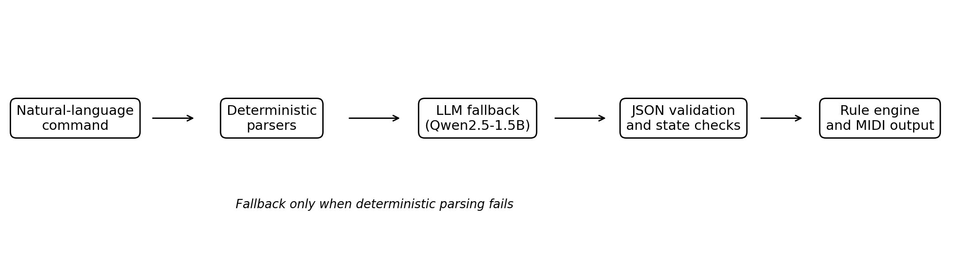
Figure 1. Midge processing pipeline. Deterministic parsing is attempted first; the LLM is a fallback rather than the default execution path.
The system exposes a constrained action vocabulary rather than allowing the model to emit Python or raw MIDI code. Representative actions include route_alias, route_group, route_source, mute_alias, unmute_alias, clear_alias_route, set_source_mode, capture_note_trigger, and install_rule. The runtime RuleEngine converts accepted actions into channel remapping, note generation, and conditional behavior.

3.2 Parsing conditions
Three parsing conditions were evaluated:
- Deterministic: only handcrafted regular-expression and template parsers are allowed.
- LLM-only: every command is sent directly to the local language model.
- Hybrid: deterministic parsing is attempted first, and the LLM is invoked only after deterministic failure.
The LLM condition used Qwen2.5-1.5B-Instruct served locally through llama-server. The prompt included the current alias and group state, available action types, field constraints, and the user command. The generated text was parsed as JSON and converted into the same internal action objects used by the deterministic path.

3.3 Validation and semantic comparison
Validation occurs in two layers. Structural validation checks action type, required fields, data types, and allowable values. Runtime validation checks references against the current state, preventing nonexistent aliases or groups from being installed. For evaluation, a separate semantic comparator canonicalizes harmless surface differences such as capitalization and leading articles, then compares the action and nested rule fields against the expected action.
User command: "Don't let the hi hat make any sound"
Expected action: {"action": "mute_alias", "alias": "hi hat"}
Scoring: correct only if the interpreted action matches the intended operation

3.4 Implementation scope
The implemented prototype supports direct alias and group routing, source-wide routing, passthrough and explicit-only modes, mute state, route clearing, next-note capture, fixed-note rules, and dynamic rules derived from the active chord. These features were exercised with a Simmons electronic drum kit and external MIDI sound modules.

4. Experiments

4.1 Evaluation datasets
The primary canonical benchmark contained 24 commands covering supported routing, source behavior, note capture, and runtime rules. These commands generally used wording anticipated by the deterministic grammar. A second benchmark contained 12 semantic paraphrases that requested supported actions using more conversational language without changing the intended result. Advanced compositional commands were also inspected qualitatively to characterize failure modes.
The benchmark state contained eight aliases, two groups, and one pre-existing rule. Each test began from the same state snapshot. Execution functions were replaced with in-memory recorders so that parser behavior could be measured without changing hardware configuration.

4.2 Baselines and ablation logic
The deterministic parser is the principal baseline because it represents the existing non-LLM control approach. The LLM-only condition tests whether a language model can replace that grammar. The hybrid condition is an architectural ablation: comparison with LLM-only measures the value of deterministic-first routing, while comparison with deterministic-only measures whether fallback adds coverage.

4.3 Metrics
- Semantic accuracy: percentage of outputs matching the complete expected action after canonicalization.
- Validation success: percentage of outputs accepted by structural and runtime validation, regardless of whether the meaning was correct.
- Median latency: median wall-clock parsing time per command.
- LLM invocation rate: percentage of commands requiring model inference.
Semantic accuracy is the primary metric. Validation success is reported separately because syntactically or structurally valid output may still be semantically wrong. Latency is reported because an accurate but 30-second interaction is not practical for live control.

5. Results and Discussion

5.1 Canonical command benchmark
Method | Semantic accuracy | Validation | Median latency | LLM invoked
Deterministic | 75.00% | 75.00% | 0.376 ms | 0.00%
LLM-only | 33.33% | 41.67% | ~28 s | 100.00%
Hybrid | 75.00% | 83.33% | 0.378 ms | 25.00%
Table 1. Results on 24 canonical commands.
The deterministic parser achieved 75.0% semantic accuracy with sub-millisecond latency. LLM-only parsing reached 33.3% accuracy and required approximately 28 seconds per command. The hybrid matched deterministic accuracy because the successful routine commands were resolved before fallback. Its median latency remained below one millisecond because only 25% of commands invoked the model. Hybrid validation was slightly higher than semantic accuracy, indicating that fallback produced some executable but incorrect actions.

5.2 Semantic paraphrase benchmark
Method | Semantic accuracy | Validation | Median latency | LLM invoked
Deterministic | 25.00% | 25.00% | 0.678 ms | 0.00%
LLM-only | 16.67% | 41.67% | 30.454 s | 100.00%
Table 2. Results on 12 conversational paraphrases of supported commands.
Paraphrasing exposed the brittleness of the handcrafted grammar: deterministic accuracy dropped from 75.0% to 25.0%. The expected advantage of the LLM did not materialize. LLM-only accuracy was 16.7%, although 41.7% of outputs passed validation. Thus, the model often produced structurally acceptable actions that did not represent the user’s request. Median latency increased to 30.454 seconds.
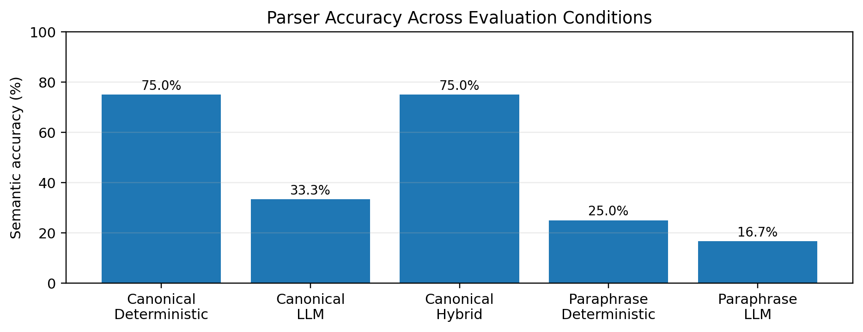
Figure 2. Semantic accuracy by parser and benchmark condition.

5.3 Error analysis
The qualitative failures clustered into four categories:
- State-reference hallucination: the model generated close but nonexistent names such as “tom” instead of the defined group “toms,” or “tom3” instead of “tom 3.”
- Action-selection error: a request to capture the next played note was converted into an ordinary installed rule rather than a capture action.
- Constraint omission: requested conditions such as every third hit were omitted even when the rest of the action was plausible.
- Musical-value error: the structure was correct but a transposition or note derivation value was wrong, such as one octave instead of two.
These failures explain the gap between validation and semantic accuracy. Schema validation can ensure that a transpose field is an integer, but it cannot infer that the requested “two octaves down” requires -24 rather than -12. Likewise, state validation can reject an unknown group, but it cannot repair the intended reference without an additional normalization or retrieval step.

5.4 Interpretation
The experiments do not support replacing the deterministic parser with the tested 1.5B model. The deterministic baseline was more accurate on both benchmarks and orders of magnitude faster. The hybrid architecture nevertheless remains justified as a safety and systems design: it protects known commands from model variability, provides a single validation boundary, and creates a location where a future adapted model can be introduced without rewriting MIDI execution.
The negative result is also empirically useful. A small local model’s general instruction-following ability did not transfer reliably to a narrow symbolic control language under zero-shot prompting. The result suggests that model size, fine-tuning data, grammar-constrained decoding, and retrieval of exact state names are not optional refinements; they are likely requirements for dependable performance.

5.5 Limitations
The benchmark is small and was created by the system developer, so it does not represent the full range of language used by independent musicians. Each command was run once, limiting analysis of sampling variance. The LLM was evaluated in one local configuration without prompt ablations, constrained decoding, or fine-tuning. Hardware limitations influenced the choice of a 1.5B model and contributed to high latency. Finally, evaluation focused on action interpretation rather than long-term usability during complete performances.

5.6 Operational demonstration and practical significance
In addition to offline evaluation, the prototype was exercised as a live system. Incoming drum events were observed through the MIDI monitor, matched against aliases such as kick drum, snare, hi hat, and tom groups, and retransmitted to configured output channels. Natural-language commands changed the persistent state without requiring the performer to stop and edit source code. This demonstration verifies that the evaluation is attached to an executable system rather than an isolated text-classification task.
The live workflow also clarifies why accuracy and latency must be considered together. A musician can tolerate a short configuration pause between pieces, but a response measured in tens of seconds disrupts rehearsal and makes conversational correction cumbersome. Incorrect actions are more serious: routing a drum to the wrong channel may trigger an unintended sound, while a malformed note-off rule can leave a synthesizer note sounding. Midge therefore favors conservative execution. Unrecognized deterministic commands fail without changing state, and model-generated actions must pass validation before installation.
The current results suggest a division of labor for future versions. Deterministic parsing should remain responsible for high-frequency operations with clear templates. A learned component should focus on mapping varied language into that existing action vocabulary, not on inventing new runtime semantics. When confidence is low, the interface should present the interpreted action in plain language and request confirmation. This design would convert an uncertain one-shot controller into a collaborative configuration assistant while retaining predictable MIDI execution.

5.7 Threats to validity
Internal validity may be affected by prompt design and evaluator assumptions. The deterministic parser and expected actions were produced within the same project, which favors consistency with the implemented action schema. To reduce superficial scoring errors, the evaluator canonicalized capitalization and leading articles, but it intentionally did not repair substantive differences. Timing was measured on one computer and includes local inference conditions specific to that hardware.
External validity is limited because the commands were authored by one musician-programmer. Independent participants may use different terminology, ellipsis, corrections, or references to prior turns. Construct validity is stronger than simple JSON-match evaluation because semantic fields were compared recursively, yet the benchmark still represents a selected subset of musical control. Finally, the small sample sizes mean that percentage differences should be interpreted descriptively rather than as population-level estimates. These limitations motivate releasing the cases and evaluator so that subsequent datasets can be compared against the same procedure.

6. Conclusion and Future Work
Midge demonstrates a complete natural-language control path from user command to validated MIDI behavior. Its core contribution is the separation of probabilistic language interpretation from deterministic execution. In controlled testing, deterministic parsing achieved 75.0% accuracy on canonical commands and 25.0% on paraphrases, while the zero-shot Qwen2.5-1.5B model achieved 33.3% and 16.7%, respectively. The model was also too slow for interactive use on the available hardware. Consequently, the current LLM fallback did not improve semantic coverage.
Future work will use the present evaluator as a fixed baseline. The highest-priority experiment is LoRA fine-tuning on paired musician utterances and Midge actions. Additional work should enforce JSON grammar during decoding, retrieve exact aliases and groups from current state, normalize near-match references, measure repeated stochastic trials, and collect commands from independent users. A confidence-aware hybrid could also decline ambiguous actions and request confirmation rather than installing a plausible but incorrect rule.

Individual Contribution
This was an individual project. Jeremy Joubert designed the research question and system architecture; implemented the deterministic parsers, LLM interface, validation layer, state manager, rule engine, MIDI routing, and evaluation framework; constructed and executed the benchmarks; analyzed failure cases; and prepared the report, repository, demonstration, and presentation.

Code and Reproducibility
Repository: [INSERT GITHUB REPOSITORY URL]
The repository should include the Midge source files, benchmark JSON files, evaluator, saved result directories, requirements or environment instructions, and a README explaining how to start llama-server, run the command-line application, and reproduce the canonical and semantic-paraphrase evaluations. Model weights are not included in the repository; the README should identify the exact model file and quantization used.
python evaluate_midge.py \
--cases midge_semantic_cases.json \
--methods deterministic llm \
--output-dir evaluation_semantic

AI Tools
Generative AI tools were used as permitted by the course policy. ChatGPT was used for coding assistance, debugging, test-design discussion, interpretation of evaluation logs, and editing support for the written report and presentation. The local Qwen2.5-1.5B model was itself an experimental component of Midge and generated candidate JSON actions during the LLM-only and hybrid conditions. All code was executed and inspected by the author, experimental outputs were produced by the implemented evaluator, and the author selected the methodology, verified the reported results, and is responsible for the final analysis and conclusions.

References
[1] The MIDI Association. MIDI 1.0 Detailed Specification and MIDI 1.0 Core Specifications. https://midi.org/specs (accessed July 2026).
[2] Qwen Team. Qwen2.5 Technical Report. arXiv:2412.15115, 2024.
[3] S. Geng, H. Cooper, M. Moskal, S. Jenkins, J. Berman, N. Ranchin, R. West, E. Horvitz, and H. Nori. Generating Structured Outputs from Language Models: Benchmark and Studies. arXiv:2501.10868, 2025.
[4] E. J. Hu, Y. Shen, P. Wallis, Z. Allen-Zhu, Y. Li, S. Wang, L. Wang, and W. Chen. LoRA: Low-Rank Adaptation of Large Language Models. In International Conference on Learning Representations, 2022.
[5] A. Vaswani et al. Attention Is All You Need. In Advances in Neural Information Processing Systems, 2017.

