- Check your instance's public IP by navigating to the instance summary (see step 9 above).
- Open a terminal on a machine with SSH installed, or using a program such as PuTTY, connect to your instance's public IP address using the key pair created previously. Note that the default user created for the Ubuntu 22.04 Server is "ubuntu".
ssh -i dshield.pem ubuntu@1.2.3.4
- When I tried doing this on Windows 11 Pro, I got an error: Load key "dshield.pem": bad permissions
- Use this guide if you run into the issue on Windows 10/11.
- On a *nix system, doing "chmod 700" to the file should fix this error.
- Optional: If you're going to directly ingest logs for analysis set hostname for your honeypot using:
sudo hostnamectl set-hostname "hostname"
- Make sure the OS is updated
sudo apt update && sudo apt full-upgrade -y
- You will have to install Python2, Python-pip, git [may be installed by default] manually. You may refer: https://linuxize.com/post/how-to-install-pip-on-ubuntu-22.04/ or use the following commands:
It is advisable to be in the home directory when carrying out the following commands. (cd ~)
cd ~ && sudo apt update && sudo apt full-upgrade -y && sudo apt install python-pip -y && sudo apt install python3-pip -y && sudo apt update && sudo apt install python2.7 -y && sudo apt install git -y && curl https://bootstrap.pypa.io/get-pip.py --output get-pip.py && sudo python2 get-pip.py && sudo python3 get-pip.py

sudo apt update
sudo apt install -y python3 python3-pip git

python3 --version
pip3 --version

- Follow installation steps from Readme.md
mkdir install
cd install
git clone https://github.com/DShield-ISC/dshield.git
cd dshield/bin
./install.sh
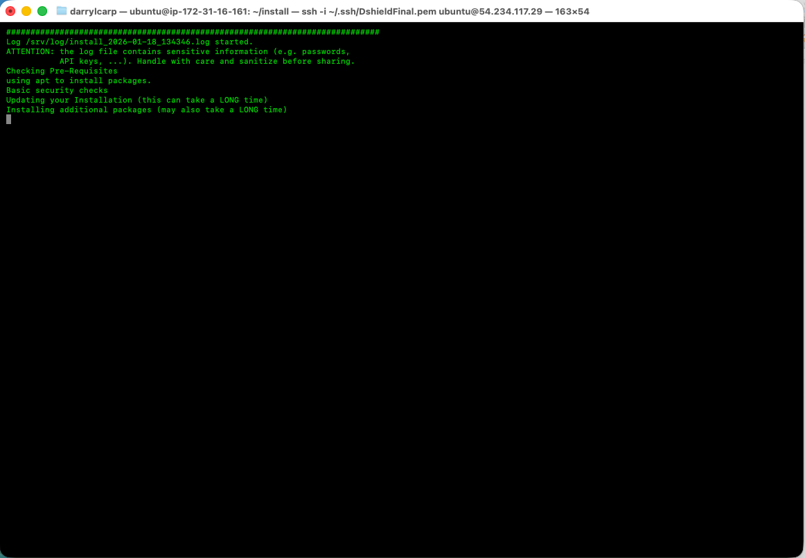
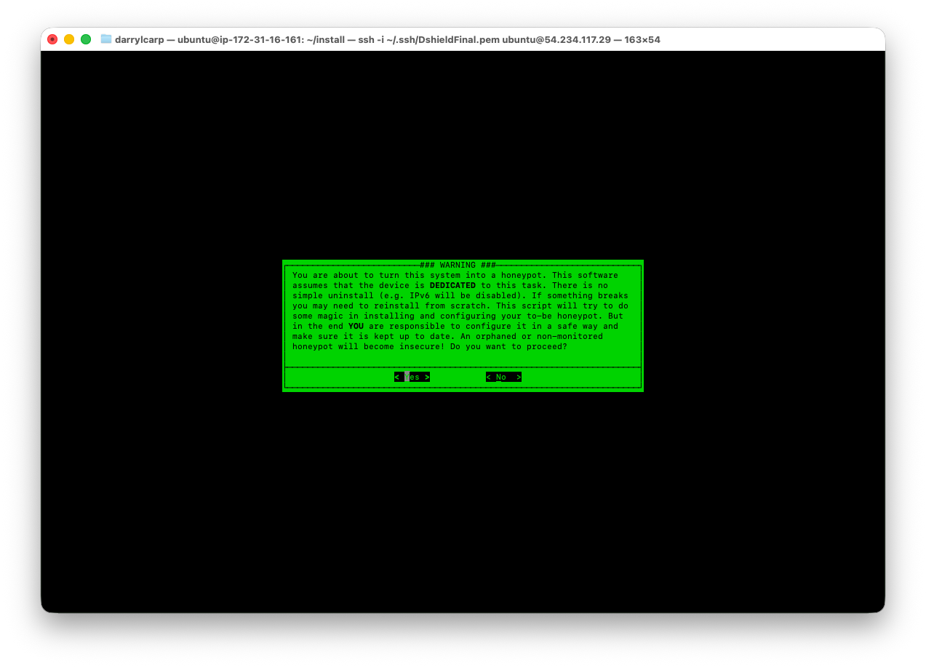
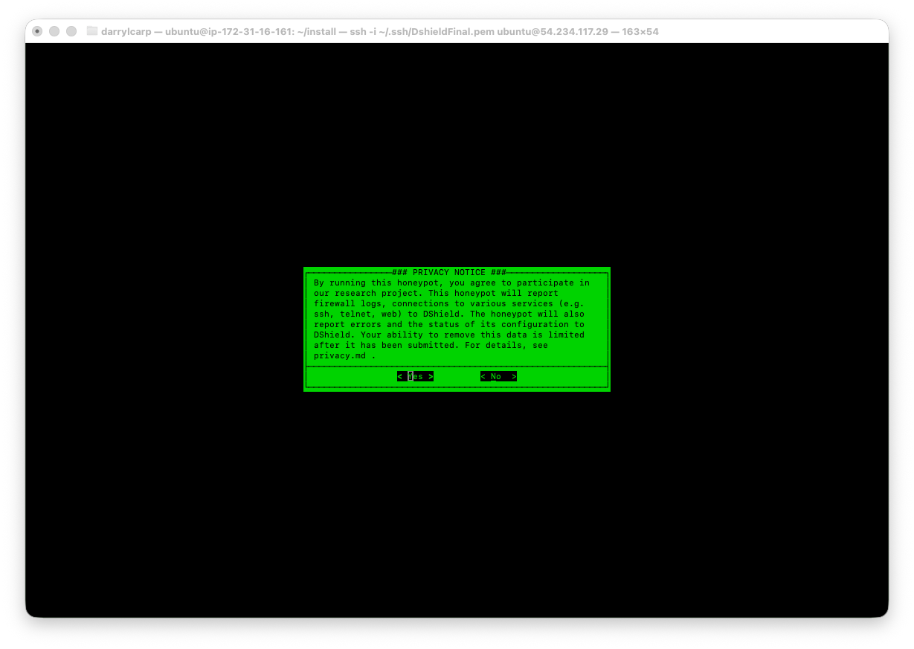
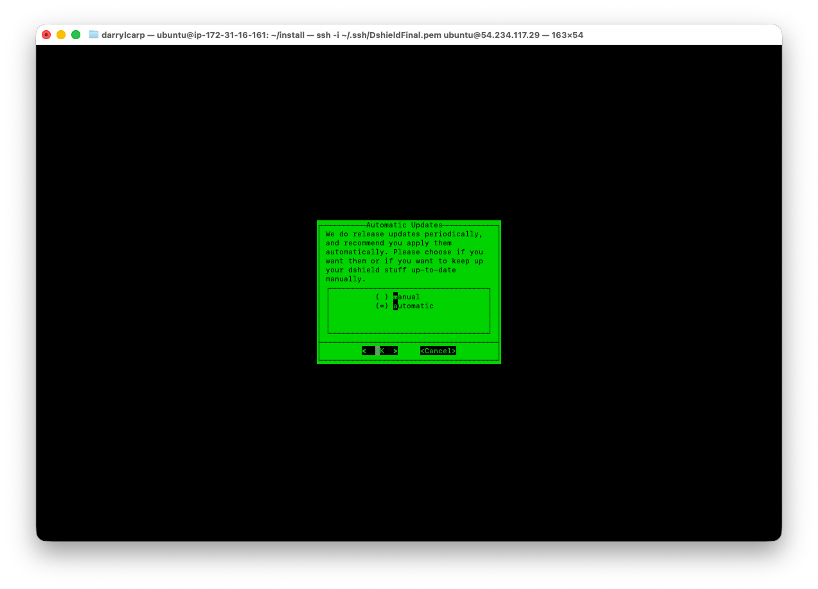

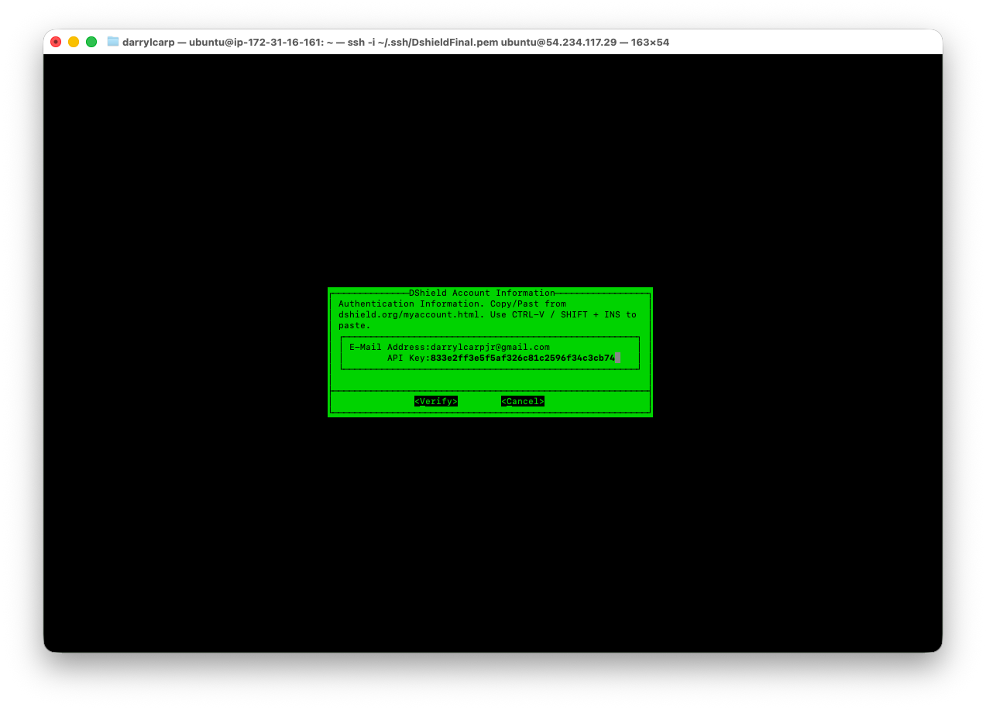

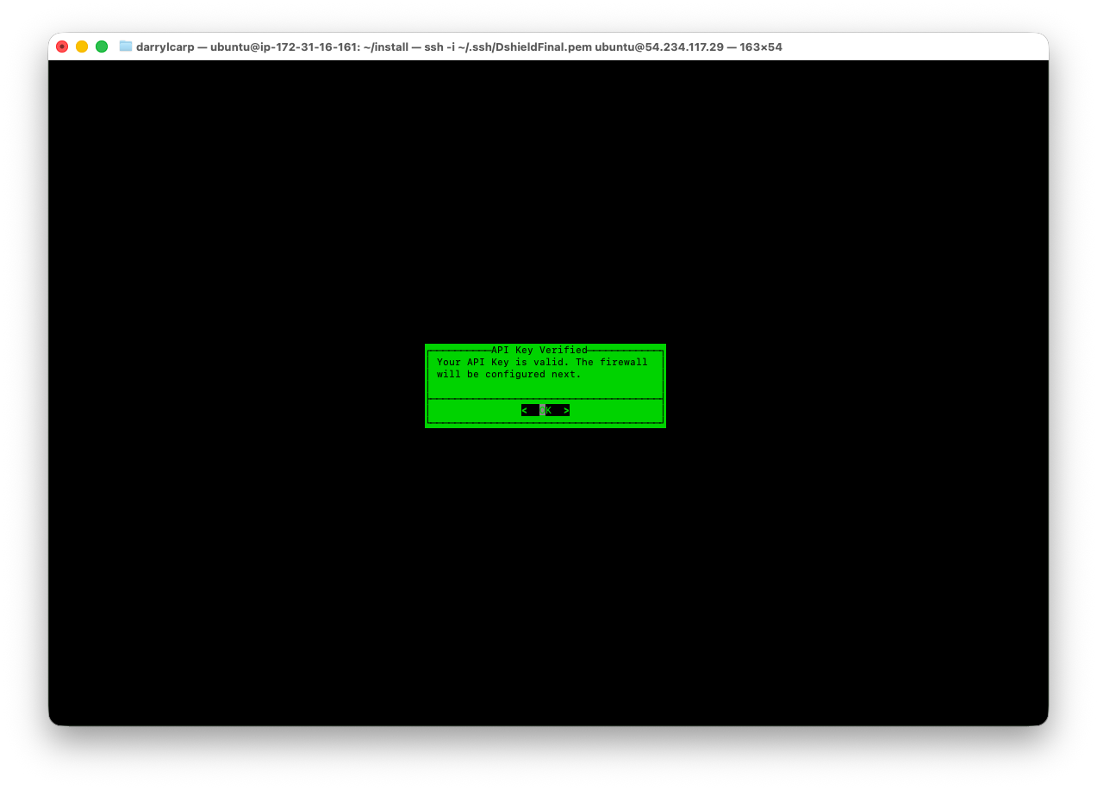
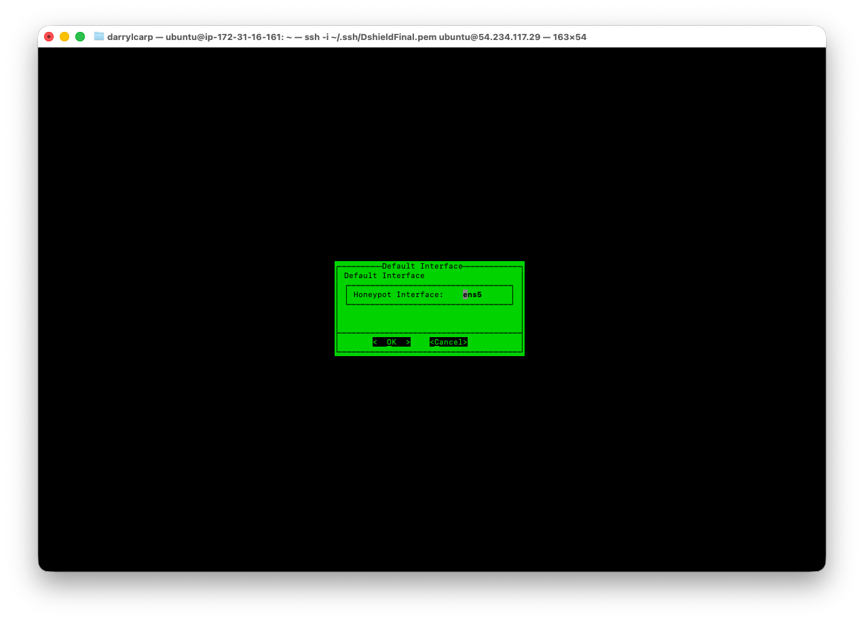
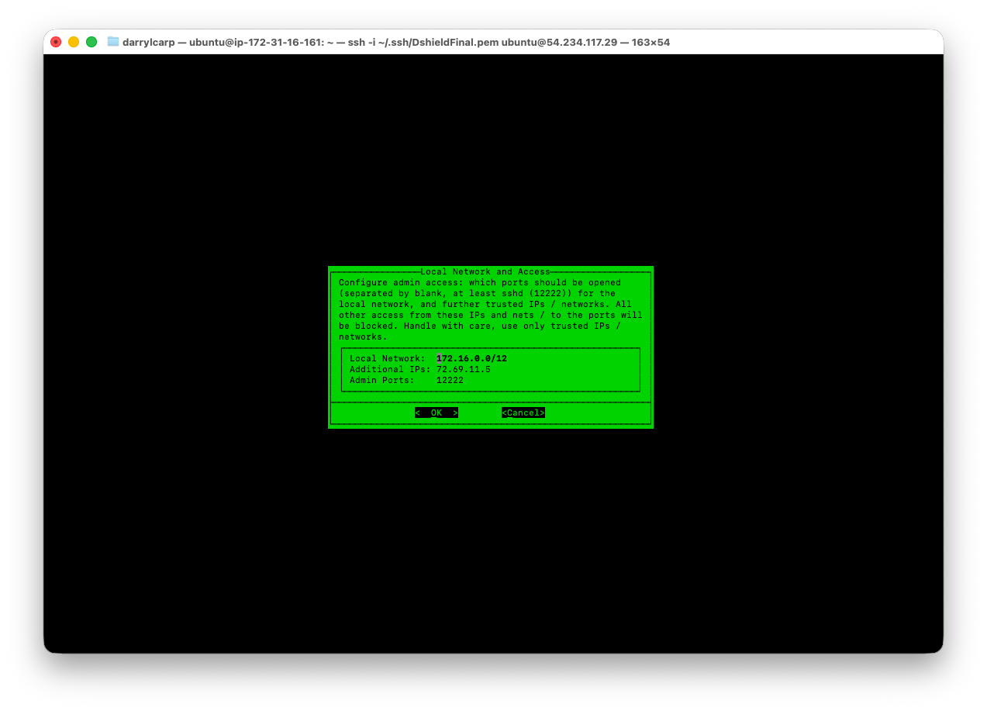
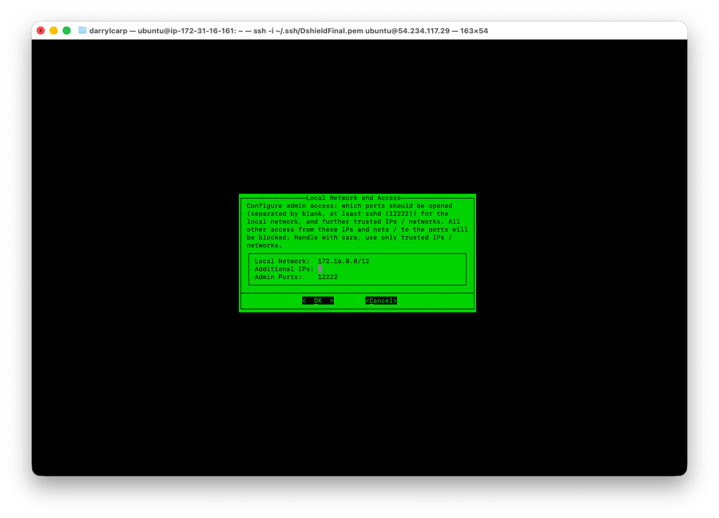

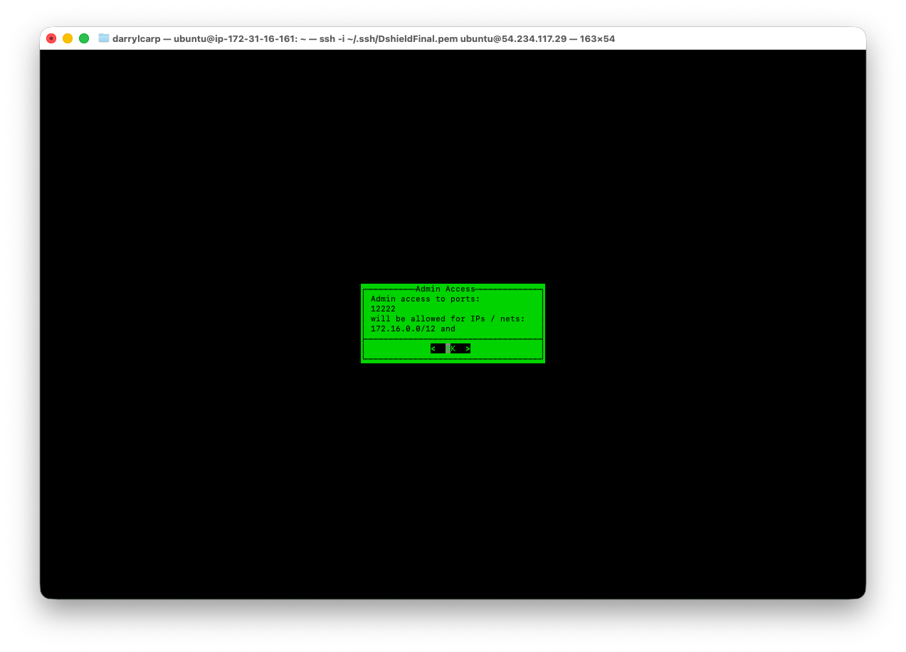

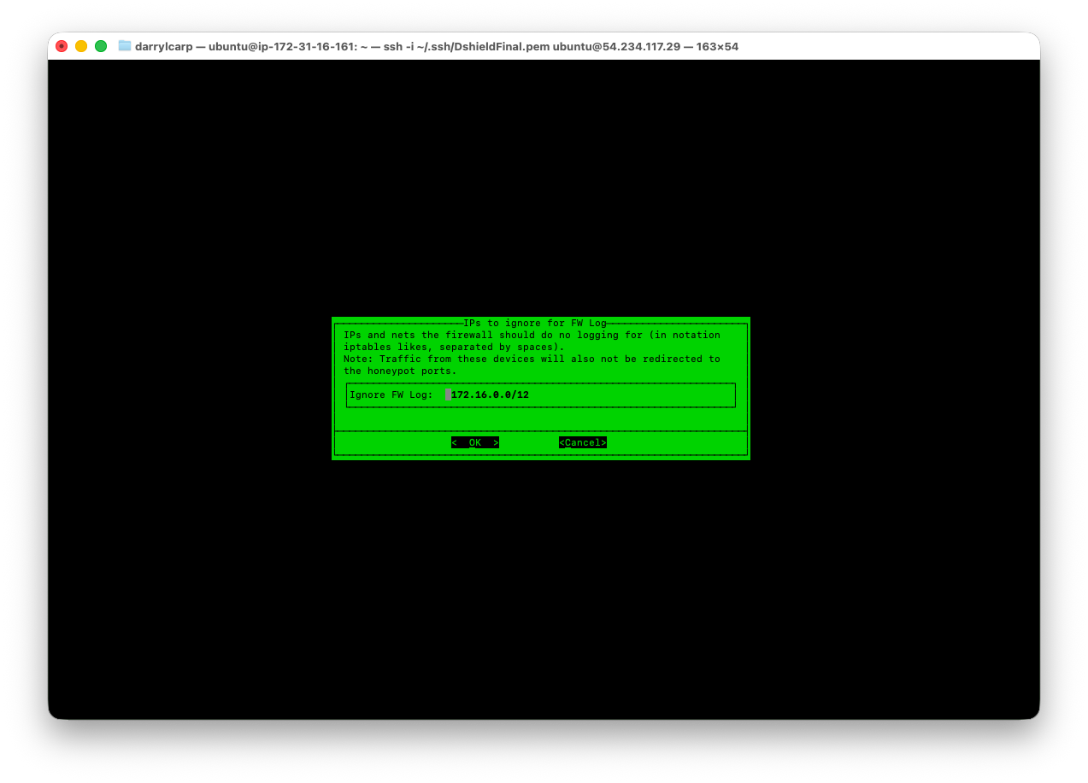
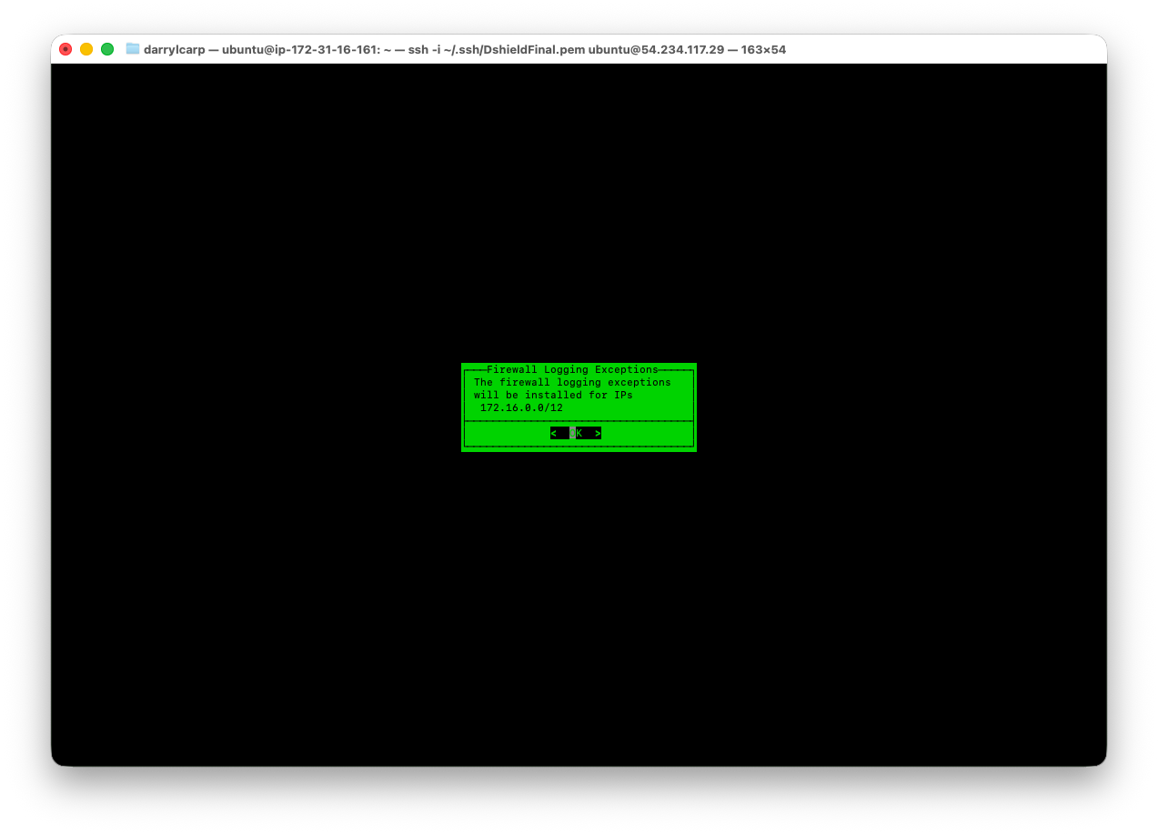

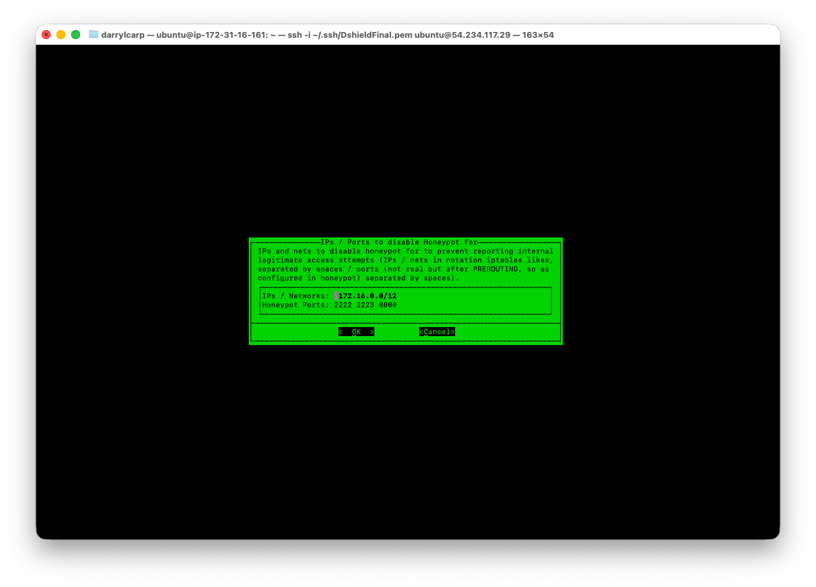
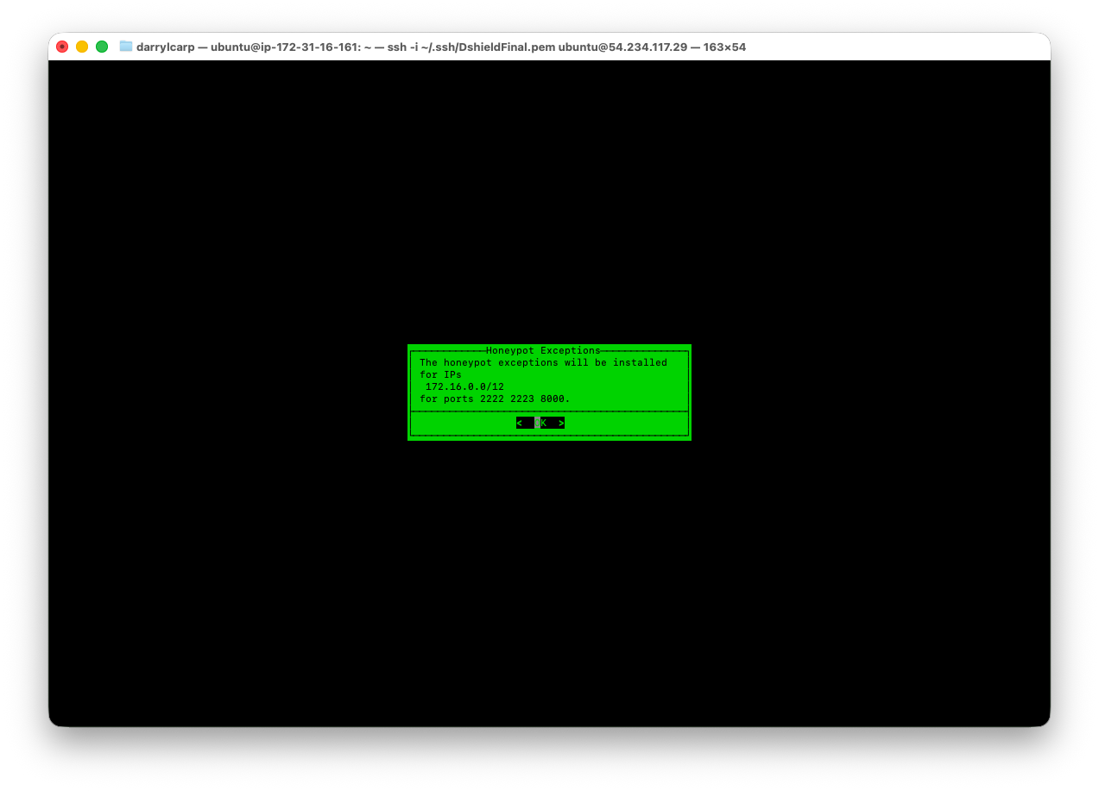

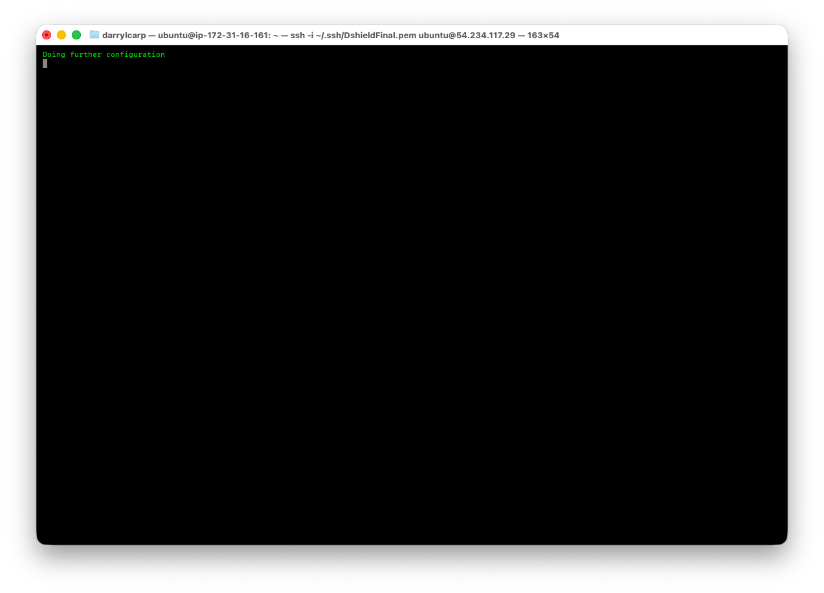
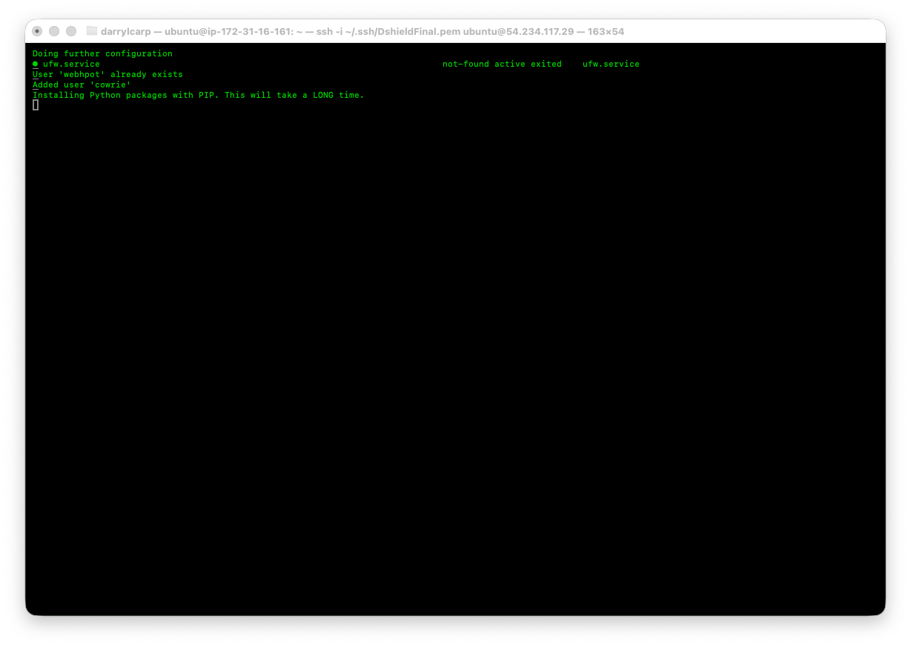

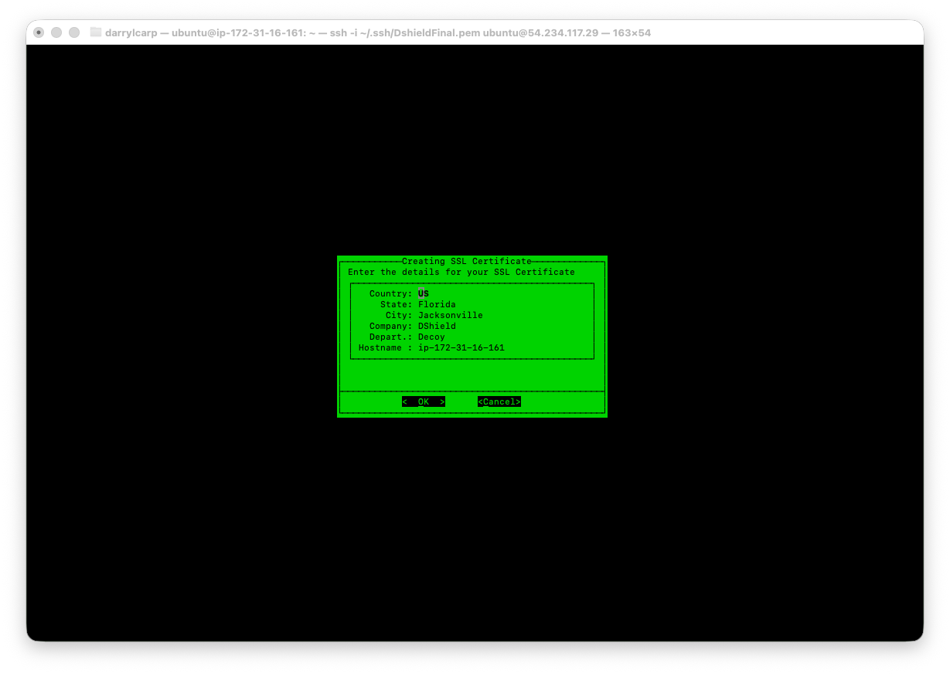
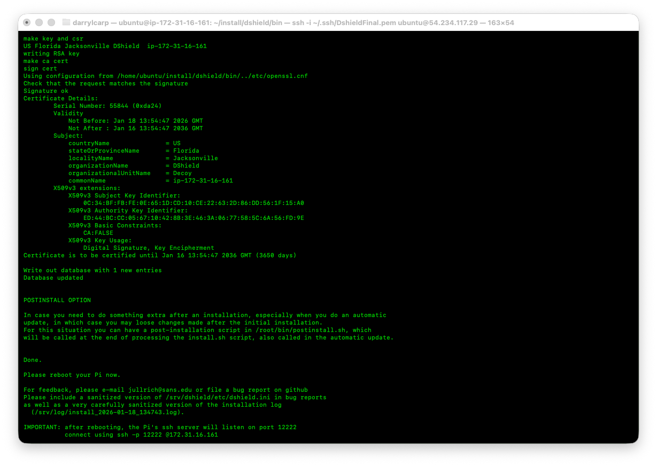
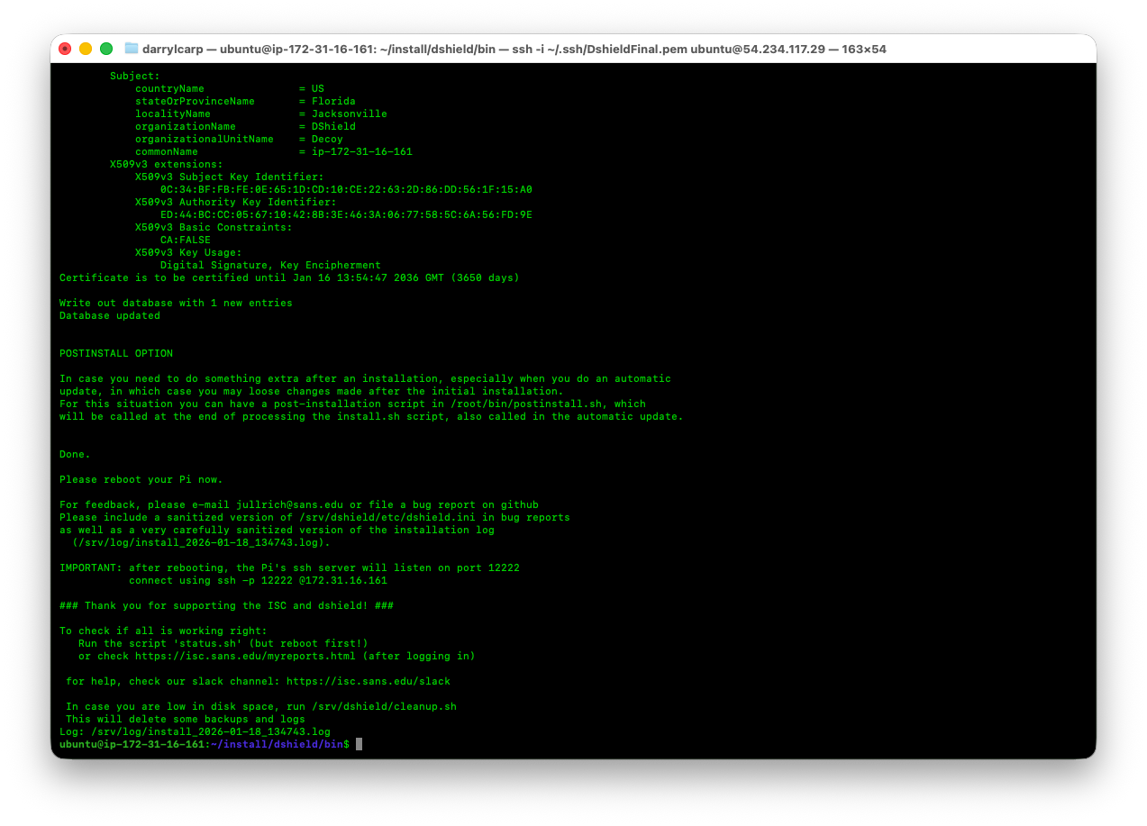

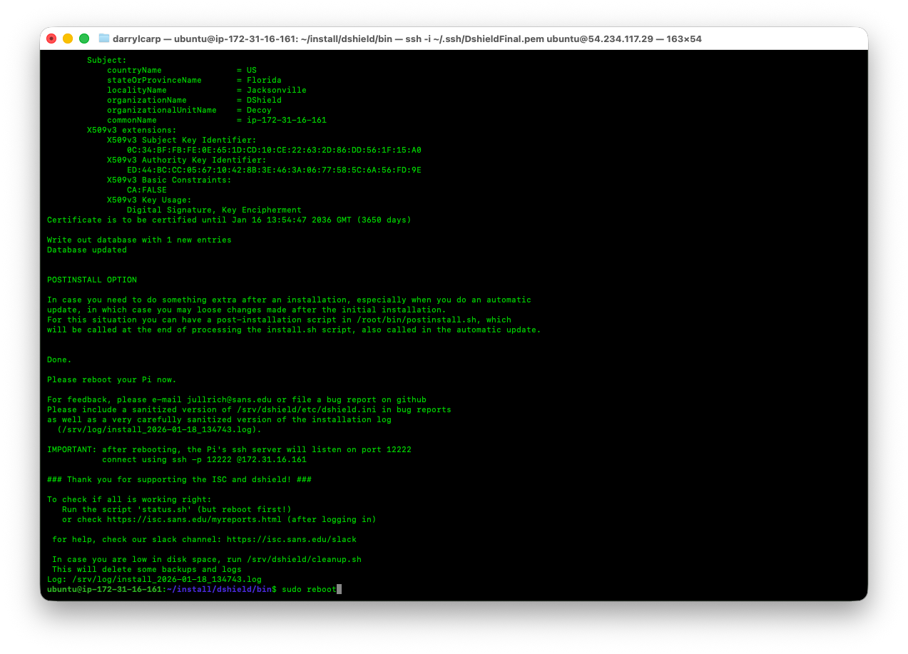
Type | Port | Source
SSH | 12222 | Your IP
TCP | 80 | 0.0.0.0/0
TCP | 443 | 0.0.0.0/0
Honeypots | (as configured) | 0.0.0.0/0

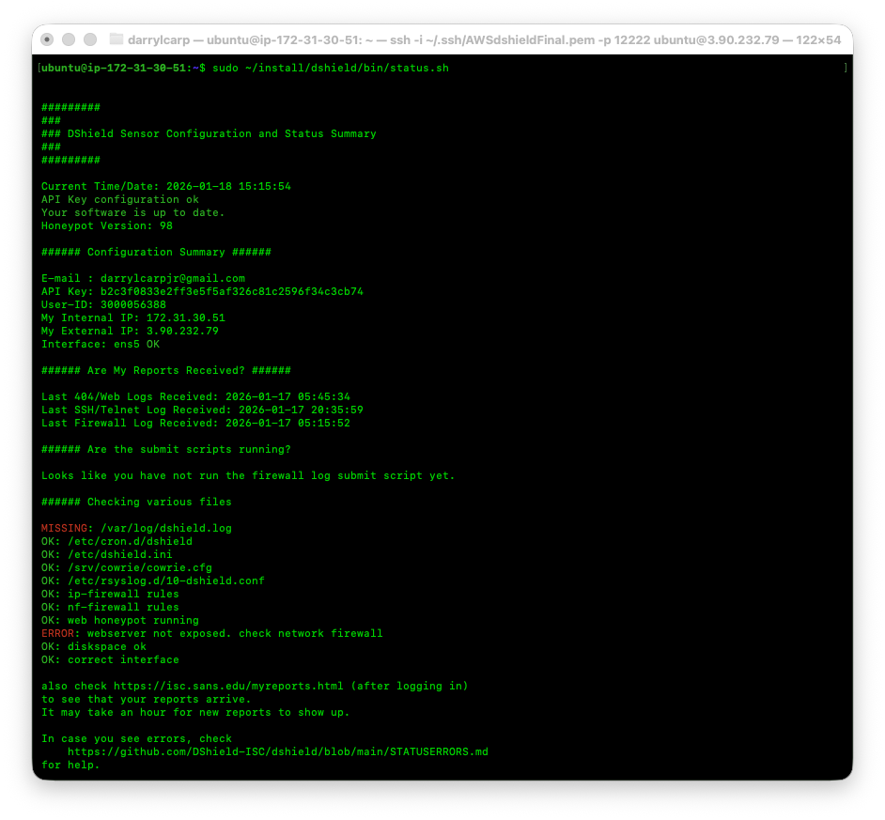

Missing /var/log/dshield.log
First, wait a bit longer (10 minutes) after a reboot for attacks to arrive. But most likely, your system is not exposed to the internet. Check your router/firewall configuration to ensure that the host's IP is properly exposed.

sudo touch /var/log/dshield.log
sudo chown syslog:adm /var/log/dshield.log
sudo chmod 640 /var/log/dshield.log

sudo /srv/dshield/bin/status.sh

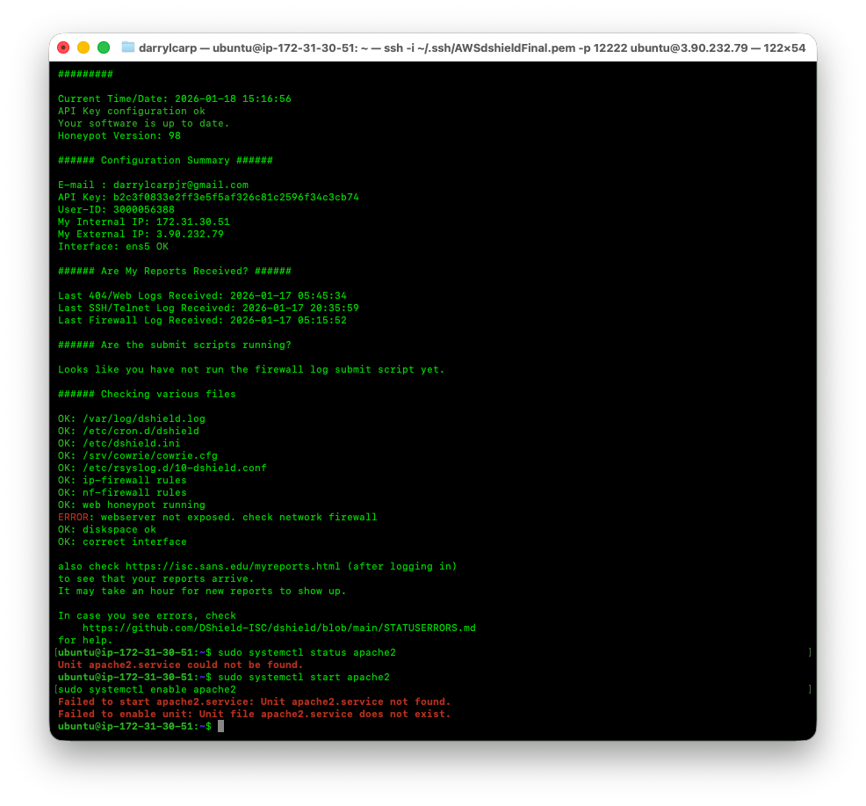

Step 1 — Install Apache

sudo apt update
sudo apt install -y apache2

Step 2 — Start and enable it

sudo systemctl start apache2
sudo systemctl enable apache2

sudo journalctl -u web-honeypot -f

$template DShieldTemplate,"%timegenerated:::date-unixtimestamp% %HOSTNAME% %syslogtag%%msg%\n"
if $msg contains " DSHIELDINPUT " then /var/log/dshield.log;DShieldTemplate
& stop

