NeST-Com: Fixed-Budget Next-Scale Token Communication
Anonymous Authors
Abstract
Next-scale tokens support progressive image transmission, but whole-scale endpoints can leave digital-frame capacity unused. NeST-Com transmits within-scale token prefixes, fits their terminated entropy-coded streams to a fixed symbol budget, and reconstructs missing tokens using a shared frozen prior. With the same prior and decoder, within-scale endpoints raise source-bit utilization from 78% to 95% at 10 dB and improve PSNR by 0.32–0.70 dB over whole-scale endpoints. For 1024 complex symbols per image, NeST-Com achieves the lowest mean DreamSim and highest mean CLIP-I among five methods on ImageNet at all three SNRs; continuous JSCC offers higher low-SNR PSNR and lower processing cost.

Index terms
Image communication, next-scale prediction, token transmission, generative reconstruction, source–channel coding.

I. Introduction
Image communication with a fixed number of channel uses requires the source representation, signaling, and channel protection to share a finite budget. A generative receiver can reconstruct an image from an incomplete representation, making the choice of transmitted information central to reconstruction quality. Next-scale visual autoregressive (VAR) models [1] provide a useful representation for this setting: coarse token maps describe large structures, and successive scales refine their residual information. However, the number of tokens grows with scale, so stopping only after a complete scale can leave substantial capacity unused.
Deep joint source–channel coding (DeepJSCC) maps images directly to channel symbols [2], and SwinJSCC uses hierarchical transformers to improve this mapping [3]. Generative image communication, including DiffCom [4], uses a learned prior to reconstruct images from channel observations. Discrete-token methods provide another route: Ada-TokenCom combines prefix transmission, arithmetic coding, tail generation, and rate/MCS adaptation [5], while TONIC studies token protection and completion for task-oriented communication [6]. Closest to next-scale transmission, ARPC combines scale selection, autoregressive entropy coding, and generation of missing scales for image compression [7]. Its transmitted prefixes end at complete scales, and its compression formulation does not specify a fixed-symbol digital frame.
Progressive image transmission using embedded source codes and channel protection under a target transmission rate is a classical problem [8]. For next-scale representations, a remaining issue is the granularity of legal token endpoints under a hard frame budget. Actual coded length varies across images, while complete-scale endpoints offer only coarse adjustments. We propose NeST-Com, which allows the transmitted prefix to end within a scale and fits its terminated arithmetic stream to the available frame capacity. The receiver reconstructs the coding probabilities from decoded coarse scales, preserves the received boundary tokens, and completes the remaining representation. Our same-prior comparison raises source-bit utilization from 77.70% to 95.21% at 10 dB and improves PSNR by 0.32–0.70 dB. On 500 ImageNet images at $N=1024$, NeST-Com achieves the lowest mean DreamSim and highest mean CLIP-I among five tested schemes at all three SNRs.

II. Proposed NeST-Com Framework

A. System Model and Multiscale Representation
We transmit an RGB image $x∈[0,1]^{256×256×3}$ through an additive white Gaussian noise channel,
$$y=s+n, n∼CN(0,σ^{2}I_{N}), \text{(1)}$$
with nominal symbol energy $E_{s}=2$ and $SNR=10\log_{10}(E_{s}/σ^{2})$. The main configuration allocates $N=1024$ complex channel uses per image. In NeST-Com, a 12-bit profile ID is protected by CRC16 and a terminated rate-1/2 convolutional code, then transmitted using 68 BPSK symbols with constellation $\{±(1+j)\}$. The remaining 956 symbols carry the coded body. The profile identifies the actual source endpoint and modulation and coding scheme (MCS), enabling the receiver to interpret the body.
A frozen residual vector-quantized tokenizer produces token maps $q_{1},…,q_{S}$. We use $S=10$ scales with side lengths $(1,2,3,4,5,6,8,10,13,16)$ and a 4096-entry codebook. At each scale, the encoder quantizes the residual left by coarser scales. Let $L_{s}$ be the number of tokens in map $q_{s}$ and $C_{s}$ the codebook lookup, resizing, and residual transform to the common latent resolution. The complete latent is $f_{q}=\sum_{s=1}^{S}{C_{s}}(q_{s})$, followed by image decoder $D_{c}$. The tokenizer and VAR prior are frozen. $D_{c}$ is fine-tuned on 20 000 ImageNet training images using a fixed mixture of continuous, fully quantized, and prefix-completion-interpolated latents; its weights remain fixed during evaluation.
The frozen VAR predicts a scale from its complete coarser context:
$$p_{θ}(q_{s}∣q_{<s})=\prod_{i=1}^{L_{s}}{p_{θ}}(q_{s,i}∣q_{<s}). \text{(2)}$$
These probabilities define arithmetic-coding cumulative distribution functions (CDFs) at both ends of the link [9]. Fig. 1 connects the representation, digital frame, and receiver completion.
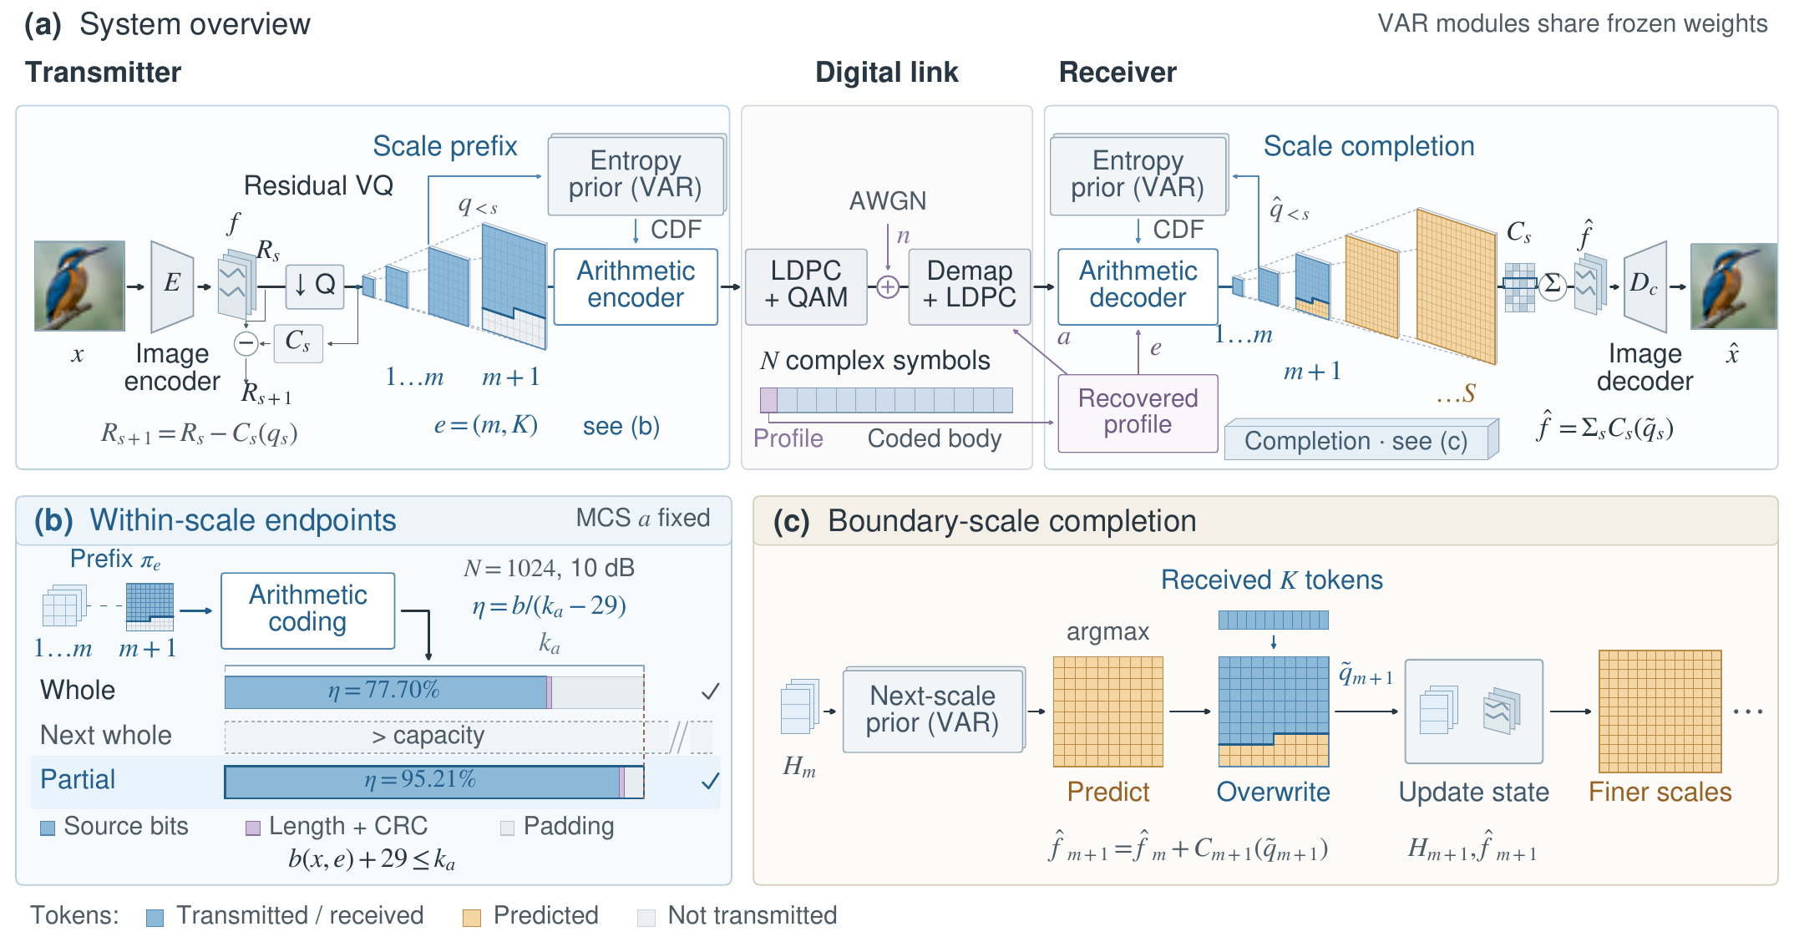
Fig. 1. NeST-Com. (a) The transmitter entropy-codes a next-scale token prefix with endpoint $e=(m,K)$ using CDFs from a frozen VAR. The receiver rebuilds these CDFs from decoded coarse-scale tokens ${\hat{q}}_{<s}$; the recovered profile gives $e$ and MCS $a$. (b) The terminated stream of length $b(x,e)$, a 13-bit length field, and CRC16 must fit within the LDPC information length $k_{a}$. Mean source-bit utilization rises from 77.70% to 95.21% (500 images, $N=1024$, 10 dB). WHOLE/PARTIAL bars use these measured means. (c) The $K$ received boundary tokens overwrite the VAR predictions; the merged map ${\tilde{q}}_{m+1}$ conditions finer scales. $H_{m}$ is the VAR state after scale $m$; $C_{s}$ comprises codebook lookup, resizing, and a scale-dependent residual transform.

B. Budget-Adaptive Within-Scale Prefix Transmission
For $m<S$, an endpoint $e=(m,K)$ specifies the transmitted prefix
$$π_{e}=(q_{1},…,q_{m},q_{m+1,1:K}), \text{(3)}$$
where positions within a map follow raster order. $K=0$ denotes a complete-scale endpoint. For a partial boundary with $L=L_{m+1}$, the implemented candidates are
$$K∈\{⌊L/4⌋,⌊L/2⌋,⌊3L/4⌋\}. \text{(4)}$$
We allow partial endpoints after scales $m=4,…,9$. Their resolution is one quarter of a scale, with integer floors when token counts are not divisible by four. The complete representation is $e=(S,0)$ with $π_{e}=(q_{1},…,q_{S})$ and needs no boundary completion.
For MCS $a=(M,r)$, the 956 body symbols carry $n_{a}=956\log_{2}M$ coded bits, and the LDPC information length is $k_{a}=⌊rn_{a}⌋$. Let $b(x,e)$ denote the actual bit length after arithmetic-code termination. A feasible prefix satisfies
$$b(x,e)+29≤k_{a}, η(x,e)=\frac{b(x,e)}{k_{a}−29}, \text{(5)}$$
where 29 bits comprise a 13-bit stream-length field and a 16-bit cyclic redundancy check (CRC). Remaining information positions are zero-padded before body LDPC encoding, using the 5G NR code and rate-matching procedures [10], and quadrature amplitude modulation (QAM).
Offline calibration selects an SNR-specific target endpoint, MCS, and ordered fallback chain by maximizing the mean DINOv2 cosine similarity between source and reconstructed images on a calibration set [11]. For each image, the transmitter arithmetic-codes the target prefix and moves to earlier legal endpoints until (5) holds, keeping the selected MCS fixed. The protected profile records the resulting endpoint. Checking the terminated length accounts for image-dependent entropy and coding overhead. Quarter-scale endpoints provide intermediate choices when the next whole scale exceeds capacity.
We report the source-wise mean of $η$. At 10 dB, $k_{a}=2549$ leaves 2520 source bits; complete-scale and within-scale endpoint sets use 77.70% and 95.21% of this capacity, respectively. Finite endpoint spacing still leaves padding, as illustrated in Fig. 1(b).

C. Prefix-Constrained Reconstruction
A reception is rejected if the protected profile fails its CRC or catalogue check, the body CRC, declared length, or known padding is invalid, or arithmetic-source parsing fails. The receiver then outputs a fixed gray image.
For an accepted reception, the receiver arithmetic-decodes $π_{e}$. Before decoding each transmitted scale, it reconstructs the CDFs from already decoded complete coarser maps ${\hat{q}}_{<s}$. This reproduces the transmitter’s probability model without transmitting CDFs. At the boundary scale, VAR predicts a full map from ${\hat{q}}_{≤m}$. Denoting its deterministic argmax prediction by $q_{m+1}^{pred}$, the receiver forms
$${\tilde{q}}_{m+1,i}=\left\{\begin{matrix}{\hat{q}}_{m+1,i}, & i≤K, \\ q_{m+1,i}^{pred}, & i>K.\end{matrix}\right. \text{(6)}$$
The merged map updates the accumulated latent and VAR state before prediction advances. Every received token thus contributes to reconstruction and conditions finer scales. For complete received scales, ${\tilde{q}}_{s}={\hat{q}}_{s}$; at the boundary, it follows (6); for untransmitted finer scales, it is the argmax prediction. The output is
$$\hat{x}=D_{c}​\left(\sum_{s=1}^{S}{C_{s}}({\tilde{q}}_{s})\right). \text{(7)}$$
This predict–overwrite–advance procedure makes a partial map a valid context for the same next-scale prior used by the entropy coder.

III. Experimental Results
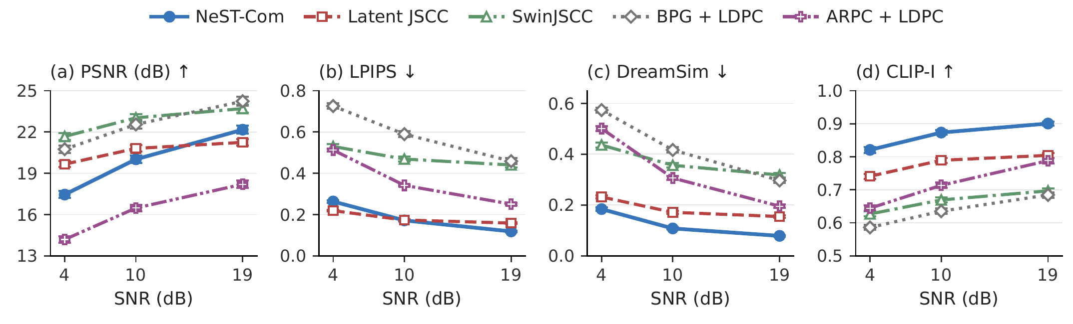
Fig. 2. Five-method performance on common500 at $N=1024$. Markers and error bars show source means and pointwise 95% bootstrap intervals after averaging three channel realizations per image. Higher PSNR/CLIP-I and lower LPIPS-Alex/DreamSim are favorable.

A. Experimental Setup
The main evaluation uses 500 ImageNet validation images [12], denoted common500, at $256×256$ resolution, with $N=1024$ and SNRs of 4, 10, and 19 dB. All methods use the same total symbol budget and nominal $E_{s}=2$. A separate set of 1000 calibration images is used for offline policy selection with DINOv2 ViT-L/14 features.
We additionally evaluate all 24 Kodak images [13] using fixed $256×256$ center crops at $N=1024$ and SNRs of 4, 10, and 19 dB, with three channel realizations per image. The models and ImageNet-calibrated policies remain fixed.
We compare NeST-Com with Latent JSCC, SwinJSCC [3], BPG + LDPC, and ARPC + LDPC. Latent JSCC is our convolutional baseline mapping the tokenizer’s continuous latent to channel symbols, trained with image MSE, LPIPS, and normalized-latent consistency losses. SwinJSCC is adapted to $256×256$ inputs and the $N=1024$ frame, including its protected mask/power signaling. Both JSCC baselines use the same 20 000 training images, and Latent JSCC shares $D_{c}$ with NeST-Com. We use the 100k-update Latent JSCC and adapted 200k-update SwinJSCC checkpoints. BPG [14] selects resolution and quantization to fit the payload. ARPC uses its native scale presets and the authors’ frozen weights; its caption is counted in the payload. Each implementation includes its required signaling in the symbol budget.
We measure pixel fidelity with PSNR, perceptual similarity with LPIPS-Alex [15] and DreamSim [16], and image-feature similarity with CLIP-I, the image–image cosine of CLIP ViT-L/14 embeddings [17]. DreamSim and CLIP use fixed $224×224$ preprocessing and FP32 inference. We first average each source’s three channel realizations, including fixed gray outputs from rejected digital receptions. Error bars are pointwise 95% source-bootstrap confidence intervals (CIs); differences use source-paired intervals. A matched 100-image subset supports the larger-budget and ARPC sensitivity experiments.

B. Comparison With Existing Methods
Fig. 2 shows that NeST-Com attains the lowest DreamSim and highest CLIP-I means at all three tested SNRs. At 10 dB, its DreamSim is 0.108, compared with 0.171 for Latent JSCC and 0.306 for ARPC; the corresponding CLIP-I values are 0.873, 0.789, and 0.713. Its PSNR exceeds ARPC by 3.26–3.97 dB across the three points. SwinJSCC and BPG achieve higher PSNR than NeST-Com throughout. Latent JSCC also has higher PSNR at 4 and 10 dB: 19.66 versus 17.45 dB and 20.80 versus 20.01 dB. For LPIPS, Latent JSCC leads at 4 dB, the methods are close at 10 dB (0.1733 versus 0.1715; paired CI includes zero), and NeST-Com leads at 19 dB. On the matched 100-image subset, we evaluated argmax and $τ=0.25$ as alternatives to ARPC’s original $τ=0.5$ sampling. The largest observed absolute change in mean PSNR was 0.15 dB, while both alternatives worsened LPIPS and DreamSim at 4 dB. These tested choices do not account for the multi-dB PSNR gap.
Fig. 3 shows two previously selected development examples at 10 dB. NeST-Com and Latent JSCC preserve the pastry arrangement and the dog’s silhouette, with clearer pastry folds and facial fur in the NeST-Com examples. SwinJSCC smooths detail, BPG introduces visible blocks, and ARPC produces texture with changes in shape and appearance. For the dog, Latent JSCC has lower LPIPS (0.203 versus 0.233), whereas NeST-Com has lower DreamSim (0.114 versus 0.166).
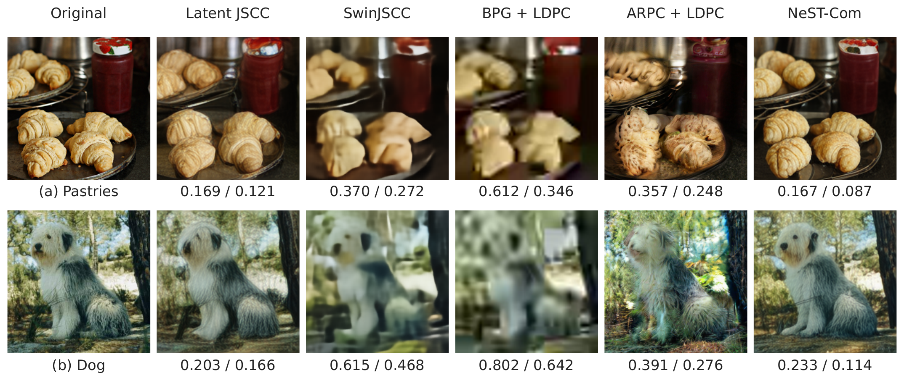
Fig. 3. Qualitative reconstructions at $N=1024$ and 10 dB for two selected development examples: (a) pastries and (b) a dog. Values below each reconstruction denote LPIPS-Alex$↓$ / DreamSim$↓$ for the displayed realization.
On Kodak at 10 dB, NeST-Com achieves DreamSim/CLIP-I of 0.110/0.869, versus 0.173/0.808 for Latent JSCC and 0.317/0.741 for ARPC. Its PSNR is 21.01 dB, below SwinJSCC (23.57 dB) and BPG (23.33 dB), but 3.44 dB above ARPC. NeST-Com also attains the lowest DreamSim and highest CLIP-I means at 4 and 19 dB; Latent JSCC retains lower LPIPS at 4 dB. At 10 dB, the NeST–Latent PSNR and LPIPS paired CIs include zero.

C. Effect of Within-Scale Endpoints
We compare WHOLE, which permits complete-scale endpoints, with PARTIAL, which additionally permits the quarter-scale endpoints in (4). The tokenizer, prior, entropy coder, and image decoder are shared. The two endpoint sets are calibrated separately and select the same MCS at each tested SNR. Table I reports PARTIAL minus WHOLE on common500 and Kodak.
On common500 at 10 dB, finer endpoints raise utilization from 77.70% to 95.21%, improve PSNR by 0.701 dB, and reduce DreamSim by 0.0240. Across all three SNRs, PSNR improves by 0.32–0.70 dB with positive CIs, and DreamSim decreases with negative CIs. The smallest gain occurs at 19 dB, where WHOLE has the highest source-bit utilization (85.24%). With shared model components and matched MCS, this comparison supports the benefit of endpoint granularity together with calibrated actual-length fitting: additional boundary tokens can be retained when the next complete scale would overflow the frame. On Kodak at 10 dB, utilization rises from 78.11% to 94.99%, with a 0.674 dB PSNR gain and a 0.0164 DreamSim reduction. The PSNR paired CIs are positive at all three SNRs; the 19 dB DreamSim interval includes zero.
Table I. Within-scale endpoint gains
SNR | $η$ (%), W/P | $Δ$PSNR (dB) | $Δ$DreamSim
common500 (500 images)
4 dB | 73.81/93.08 | $+0.616$ [$0.564,0.673$] | $−0.0207$ [$−0.0233,−0.0183$]
10 dB | 77.70/95.21 | $+0.701$ [$0.637,0.766$] | $−0.0240$ [$−0.0270,−0.0212$]
19 dB | 85.24/94.73 | $+0.319$ [$0.290,0.349$] | $−0.0030$ [$−0.0037,−0.0024$]
Kodak (24 images)
4 dB | 75.69/93.43 | $+0.396$ [$0.236,0.543$] | $−0.0276$ [$−0.0400,−0.0159$]
10 dB | 78.11/94.99 | $+0.674$ [$0.408,0.958$] | $−0.0164$ [$−0.0262,−0.0072$]
19 dB | 85.69/93.71 | $+0.228$ [$0.140,0.324$] | $−0.0013$ [$−0.0029,0.0003$]
W/P: WHOLE/PARTIAL. $η$ uses the terminated entropy length and source capacity in (5). Differences are PARTIAL minus WHOLE; brackets give source-paired 95% CIs.

D. Performance With a Larger Symbol Budget
The $N=2048$ experiment examines whether ARPC’s gap is explained by its full representation not fitting at $N=1024$. Each image uses two 1024-symbol subframes with their own protected headers. Table II compares adaptive configurations at 4 and 10 dB and complete-representation transmission at 19 dB, using 100 images and three channel realizations per image. All 300 receptions per method succeed in each reported condition.
When both complete representations are delivered at 19 dB, NeST-Com retains a 1.806 dB PSNR advantage and lower DreamSim. ARPC has lower DISTS [18]: NeST-Com minus ARPC is $+0.0054$, with 95% CI $[+0.0024,+0.0086]$. Representation and decoding also affect quality, with different perceptual criteria favoring different reconstructions. The full-system comparison includes these effects alongside the within-family endpoint gains in Table I.
Table II. NeST-Com minus ARPC at $N=2048$
Condition | $Δ$PSNR (dB) | $Δ$DreamSim
4 dB, adaptive | $+3.779$ [$3.493,4.082$] | $−0.2658$ [$−0.2933,−0.2386$]
10 dB, adaptive | $+3.877$ [$3.688,4.079$] | $−0.1174$ [$−0.1309,−0.1049$]
19 dB, full | $+1.806$ [$1.742,1.871$] | $−0.0086$ [$−0.0119,−0.0052$]
Source-paired 95% CIs over 100 images, each with three noise realizations. Full denotes delivery of both methods' complete representations.

E. Computational Cost
Table III reports the average processing time per image at 10 dB on an RTX PRO 6000 Blackwell GPU with six CPU cores and a batch size of one. NeST-Com requires 619.71 ms per image, compared with 42–45 ms for the continuous JSCC baselines, 1520.30 ms for ARPC, and 2293.01 ms for adaptive BPG.
Table III. Mean software processing latency at $N=1024$, 10 dB (ms/image)
Method | TX | RX | Total
NeST-Com | 220.89 | 398.82 | 619.71
Latent JSCC | 17.97 | 24.51 | 42.48
SwinJSCC | 24.81 | 19.89 | 44.69
BPG + LDPC | 2269.87 | 23.15 | 2293.01
ARPC + LDPC | 719.12 | 801.18 | 1520.30
RTX PRO 6000 Blackwell, six CPU cores, batch size one. Total is TX + RX; model initialization, channel-noise generation, and radio transmission time are excluded. Means over 16 images with three timed repetitions per image after warm-up.

IV. Conclusion
We presented NeST-Com, which fits next-scale token prefixes to a fixed-symbol digital frame using within-scale endpoints and actual terminated lengths. A shared prior supports entropy decoding and reconstruction constrained by received tokens. On common500, with the same prior and decoder, finer endpoints improve PSNR by 0.32–0.70 dB and increase utilization from approximately 78% to 95% at 10 dB. The five-method comparison shows favorable DreamSim and CLIP-I performance, together with SNR-dependent fidelity tradeoffs and higher processing cost than continuous JSCC. Future work will extend endpoint and MCS selection to fading channels and uncertain SNR estimates.

References
[1] K. Tian, Y. Jiang, Z. Yuan, B. Peng, and L. Wang, “Visual autoregressive modeling: Scalable image generation via next-scale prediction,” in Advances in Neural Information Processing Systems, vol. 37, 2024, pp. 84 839–84 865.
[2] E. Bourtsoulatze, D. B. Kurka, and D. Gündüz, “Deep joint source-channel coding for wireless image transmission,” IEEE Trans. Cogn. Commun. Netw., vol. 5, no. 3, pp. 567–579, Sep. 2019.
[3] K. Yang, S. Wang, J. Dai, X. Qin, K. Niu, and P. Zhang, “SwinJSCC: Taming Swin Transformer for deep joint source-channel coding,” IEEE Trans. Cogn. Commun. Netw., vol. 11, no. 1, pp. 90–104, Feb. 2025.
[4] S. Wang, J. Dai, K. Tan, X. Qin, K. Niu, and P. Zhang, “DiffCom: Channel received signal is a natural condition to guide diffusion posterior sampling,” IEEE J. Sel. Areas Commun., vol. 43, no. 7, pp. 2651–2666, Jul. 2025.
[5] Z. Zhang, L. Qiao, M. B. Mashhadi, Z. Gao, M. Bennis, and K. Huang, “Ada-TokenCom: Rate-adaptive token communications via large-model-driven token compression and generation,” 2026, arXiv:2608.28086.
[6] S. Liu and K. Wang, “TONIC: Token-centric semantic communication for task-oriented wireless systems,” 2026, arXiv:2605.21553.
[7] Z. Zhang, Y. Xia, B. Chen, T. Zhang, H. Wang, and H. Qiu, “Autoregressive-based progressive coding for ultra-low bitrate image compression,” in Int. Conf. Learning Representations, 2026.
[8] V. Chande and N. Farvardin, “Progressive transmission of images over memoryless noisy channels,” IEEE J. Sel. Areas Commun., vol. 18, no. 6, pp. 850–860, Jun. 2000, doi: 10.1109/49.848239.
[9] I. H. Witten, R. M. Neal, and J. G. Cleary, “Arithmetic coding for data compression,” Commun. ACM, vol. 30, no. 6, pp. 520–540, Jun. 1987, doi: 10.1145/214762.214771.
[10] 3GPP, “NR; Multiplexing and channel coding,” TS 38.212, ver. 16.5.0, Release 16, 2021. [Online]. Available: https://www.etsi.org/deliver/etsi_ts/138200_138299/138212/16.05.00_60/ts_138212v160500p.pdf
[11] M. Oquab et al., “DINOv2: Learning robust visual features without supervision,” Trans. Mach. Learn. Res., Jan. 2024. [Online]. Available: https://openreview.net/forum?id=a68SUt6zFt
[12] O. Russakovsky et al., “ImageNet large scale visual recognition challenge,” Int. J. Comput. Vis., vol. 115, no. 3, pp. 211–252, 2015.
[13] R. Franzen, “Kodak lossless true color image suite,” accessed Oct. 26, 2026. [Online]. Available: https://r0k.us/graphics/kodak/
[14] F. Bellard, “BPG image format,” accessed Oct. 22, 2026. [Online]. Available: https://bellard.org/bpg/
[15] R. Zhang, P. Isola, A. A. Efros, E. Shechtman, and O. Wang, “The unreasonable effectiveness of deep features as a perceptual metric,” in Proc. IEEE Conf. Comput. Vis. Pattern Recognit., Jun. 2018, pp. 586–595.
[16] S. Fu, N. Tamir, S. Sundaram, L. Chai, R. Zhang, T. Dekel, and P. Isola, “DreamSim: Learning new dimensions of human visual similarity using synthetic data,” in Advances in Neural Information Processing Systems, vol. 36, 2023, pp. 50 742–50 768.
[17] A. Radford et al., “Learning transferable visual models from natural language supervision,” in Proc. 38th Int. Conf. Mach. Learn., vol. 139, 2021, pp. 8748–8763.
[18] K. Ding, K. Ma, S. Wang, and E. P. Simoncelli, “Image quality assessment: Unifying structure and texture similarity,” IEEE Trans. Pattern Anal. Mach. Intell., vol. 44, no. 5, pp. 2567–2581, May 2022.

