NeST-Com: Fixed-Budget Next-Scale Token Communication
Anonymous Authors
Abstract
Next-scale residual tokens support source-referenced perceptual reconstruction from coarse descriptions, but whole-scale transmission can underfill fixed digital frames. NeST-Com fits independently terminated token-wise prefixes to the available capacity and uses received boundary tokens for residual correction and finer-scale conditioning. At 1024 symbols and 10 dB, source-bit utilization rises from 77.70% to 99.79%, reducing DISTS and DreamSim by 8.7% and 20.5% relative to shared-model whole-scale transmission. Equal-information-budget tests favor NeST-Com over adapted Ada-TokenCom on both distances at the three smallest tested budgets. At the same symbol/SNR setting, transmitter-plus-receiver processing takes 0.66 s versus 15.42 s for Ada on matched hardware.

Index terms
Image communication, next-scale tokens, fixed symbol budget, perceptual reconstruction.

I. Introduction
A hard per-image symbol budget must accommodate source information, signaling and protection. We focus on preserving source structure and perceptual similarity, primarily evaluated by DISTS and DreamSim, while retaining PSNR for pixelwise fidelity. Transmitted information constrains generative reconstruction to the source; a learned prior predicts untransmitted content. The description’s organization and use of payload capacity therefore affect reconstruction quality.
Next-scale tokenization provides complete coarse maps over the full latent grid, followed by residual refinements [1]. Within a scale, token probabilities share the completed coarse context, enabling scale-wise evaluation and completion. ARPC applies this representation to progressive compression [2]; Ada-TokenCom combines next-token prefix coding, tail generation and wireless adaptation [3]. These systems motivate studying next-scale descriptions under hard digital-frame budgets.
Progressive transmission has long matched source descriptions to channel resources [4]. A full next-scale map may exceed remaining capacity although much of it would fit. Image-dependent entropy lengths also prevent a fixed token count from specifying the bit requirement. Using residual capacity requires independently decodable within-scale endpoints and actual-length fitting. Received boundary tokens must then update both the residual representation and finer-scale conditioning.
NeST-Com combines token-wise endpoints, independently terminated arithmetic coding and prefix-constrained reconstruction. Shared-model comparisons and matched controls establish improvements in pixelwise fidelity and perceptual similarity. At 1024 symbols and 10 dB, source-bit utilization rises from 77.70% to 99.79%. Equal-information-budget tests identify a favorable tight-budget regime, while matched-hardware measurements show shorter processing than the fixed-frame Ada implementation. These results distinguish the practical value of the next-scale system from the contribution of its frame-fitting design.

II. Proposed NeST-Com Framework

A. Next-Scale Representation and Digital Frame
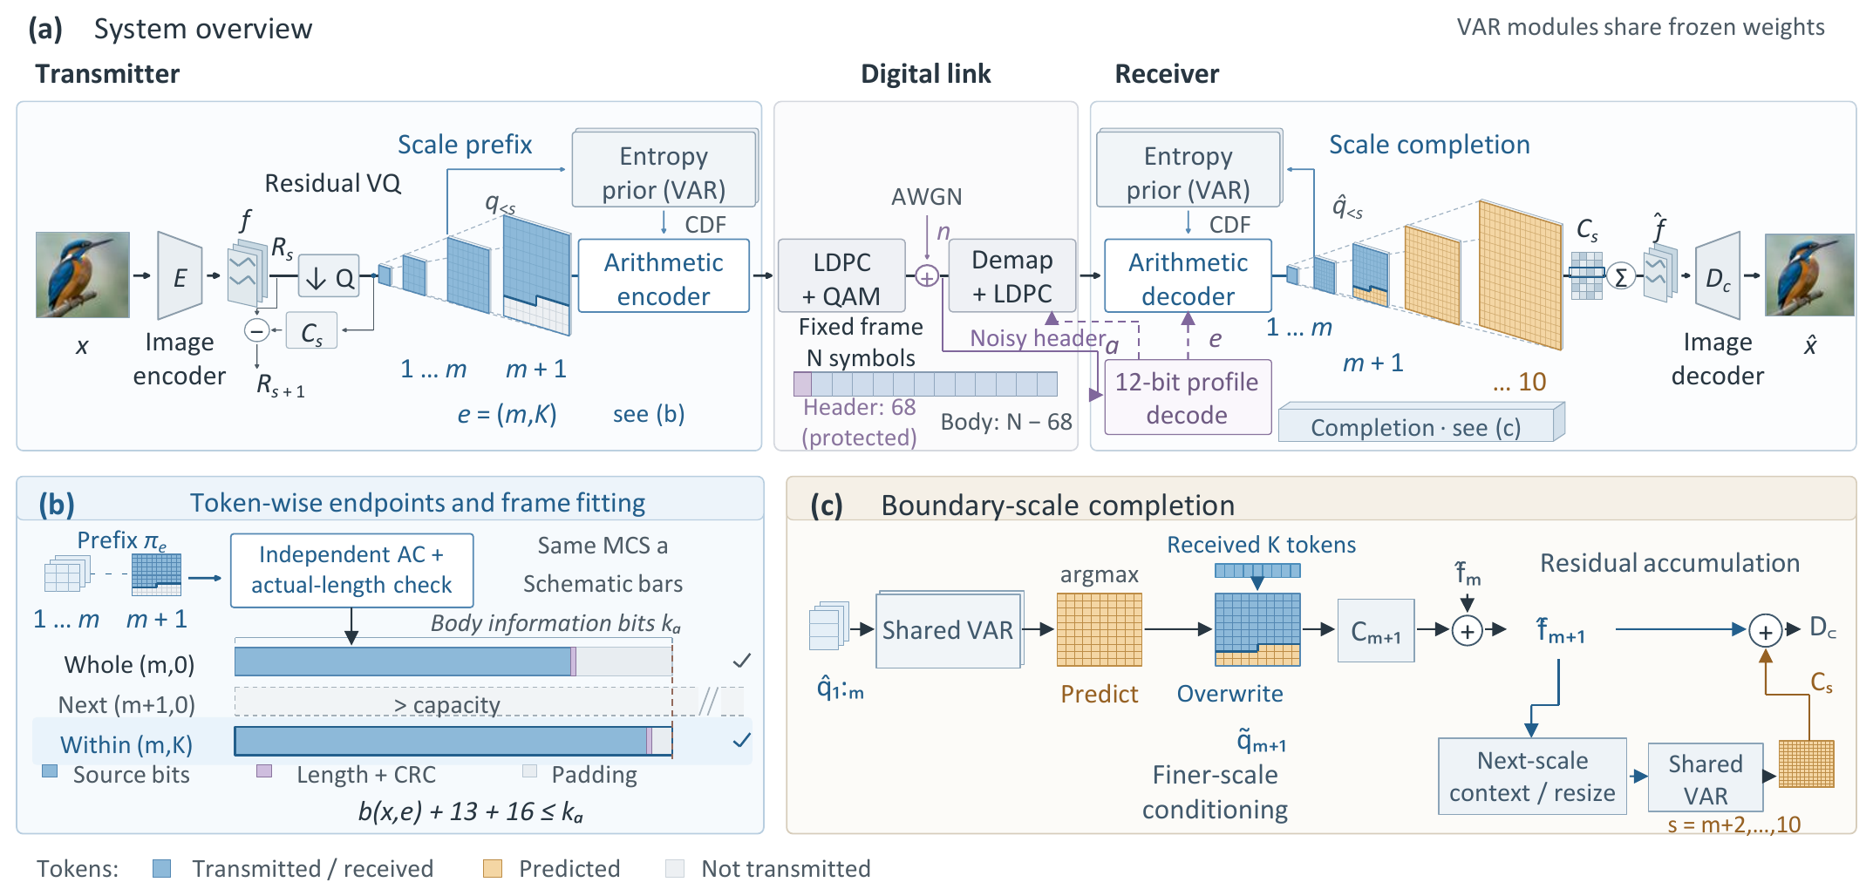
Fig. 1. NeST-Com. (a) The protected profile specifies the endpoint and MCS; both terminals reconstruct coding probabilities from the shared frozen VAR and known coarse tokens. (b) Independently terminated token-wise prefixes fit the body capacity; bars are schematic. (c) Received boundary tokens overwrite predicted positions. The merged map updates the residual latent and finer-scale context. Unreceived boundary positions retain their coarse-conditioned predictions.
We transmit $x∈[0,1]^{256×256×3}$ using $N$ complex symbols over AWGN,
$$y=s+n, n∼CN(0,σ^{2}I_{N}), SNR=10\log_{10}(E_{s}/σ^{2}), \text{(1)}$$
with nominal $E_{s}=2.$ TX uses the frozen policy for its design SNR; RX uses the actual noise variance for LLRs. Digital constellations have average energy two without per-frame renormalization. A 12-bit profile ID, CRC16, and terminated rate-1/2 convolutional code occupy 68 rotated-BPSK symbols $\{±(1+j)\}.$ The profile identifies the endpoint and MCS. The remaining $N−68$ symbols carry the LDPC-coded body, with public frame-dependent scrambling after rate matching and inverse scrambling before decoding. Continuous JSCC data are normalized per image to energy two; required side information is paid within $N.$
The frozen VAR tokenizer produces ten residual token maps $q_{s},$ with side lengths $(1,2,3,4,5,6,8,10,13,16)$ and a 4096-entry codebook [1]. Write $L_{s}$ for the number of positions and $C_{s}$ for codebook lookup, resizing to the full latent grid, and the scale-dependent residual transform. The latent sum s​Cs(qs) progressively refines a full-field description. Decoder $D_{c}$ is adapted on 20 000 ImageNet training images using MSE plus $0.1$ LPIPS, then frozen. The continuous/quantized/prefix-completed training mixture is specified in Supplement S1. The null-class VAR-d16 prior factorizes as
$$p_{θ}(q_{s}∣q_{<s})=\prod_{i=1}^{L_{s}}{p_{θ}}(q_{s,i}∣q_{<s}). \text{(2)}$$
Both terminals reconstruct identical integer CDFs, with total frequency $2^{24},$ for arithmetic coding [5]; no unreceived same-scale token is needed.

B. Token-Wise Endpoints and Actual-Length Fitting
An endpoint $e=(m,K)$ retains complete coarse maps and a raster-ordered boundary prefix:
$$π_{e}=(q_{1},…,q_{m},q_{m+1,1:K}). \text{(3)}$$
The fixed raster order specifies received positions without a mask. WHOLE permits $(m,0)$ for $m=4,…,10.$ NeST permits every integer $K=0,…,L_{m+1}−1$ for $m=4,…,9,$ together with $(10,0):$ 651 distinct endpoints from 30 through 680 retained tokens. The paid 12-bit profile directory covers the applicable endpoint/MCS combinations. Quarter and Eighth grids are controls, not the main configuration.
For MCS $a=(M,r),$ the coded body has $n_{a}=(N−68)\log_{2}M$ bits and information length $k_{a}=⌊rn_{a}⌋.$ Its independently terminated arithmetic length $b(x,e)$ must satisfy
$$b(x,e)+29≤k_{a}, η(x,e)=\frac{b(x,e)}{k_{a}−29}. \text{(4)}$$
The 29 bits comprise a 13-bit length and CRC16. Unused information positions are zero-padded before 5G NR LDPC coding, rate matching [6], and QAM. Thus $η$ measures source-bit capacity utilization after the length/CRC overhead.
Offline calibration fixes a target and MCS for each budget/SNR by DINOv2 source/reconstruction cosine [7]. NeST retains these targets/MCSs while refining endpoints; Supplement S1 specifies the family-specific candidate pools. A shared scale-wise probability and incremental coding traversal supplies candidates, each independently terminated rather than cut from a longer stream. With MCS fixed, TX selects the feasible endpoint with the most tokens up to the target. Actual terminated lengths determine feasibility without assuming length monotonicity. The timed implementation scans all allowed candidates. If none fits, the frozen $N=1024$ implementation raises an error; this did not occur in the evaluated sources. The $N=512$ implementation instead transmits a paid NULL profile and yields gray.

C. Prefix-Constrained Reconstruction
Invalid profile CRC/catalogue, body CRC, declared length, known padding, or arithmetic parsing yields a fixed gray image, as does valid NULL reception. Otherwise, RX decodes the actual prefix using the shared CDFs. It predicts the boundary map by argmax conditioned on complete received maps, then overwrites known positions [1]:
$${\tilde{q}}_{m+1,i}=\left\{\begin{matrix}{\hat{q}}_{m+1,i}, & i≤K, \\ q_{m+1,i}^{pred}, & i>K.\end{matrix}\right. \text{(5)}$$
Received boundary tokens serve two roles: they correct the residual representation and, through the merged boundary map, condition finer-scale prediction. Unreceived boundary positions retain their original coarse-conditioned prediction; there is no same-scale prediction loop. Complete received maps remain unchanged. After generating the finer maps,
$$\hat{x}=D_{c}​\left(\sum_{s=1}^{10}{C_{s}}({\tilde{q}}_{s})\right). \text{(6)}$$
At the last scale, overwrite only changes the residual contribution.

III. Experimental Results
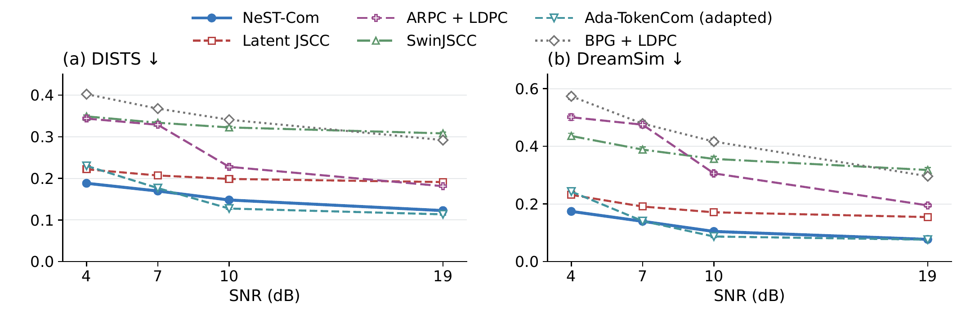
Fig. 2. Six-system reconstruction on common500 at $N=1024.$ Points and bars are equal-source means and pointwise 95% source-bootstrap intervals after averaging three channel realizations per source, including failures. Ada is the predicted-class, fixed-frame adaptation. Lower DISTS and DreamSim are favorable.

A. Experimental Setup
The 500 ImageNet validation sources [8] are disjoint from cal1000 and use fixed $256×256$ preprocessing. We evaluate $N=1024$ at 4/7/10/19 dB and $N=512$ at 4/10/19 dB. Each point averages three channel realizations per source, retaining gray failures, before equal-source means and direct paired 95% source-bootstrap intervals (10 000 resamples). Controls use the first 100 full manifest IDs. Historical noise identities remain method/budget-specific; the matched-grid control shares noise.
Latent JSCC maps tokenizer latents to symbols with convolutional layers and shares $D_{c},$ using MSE, LPIPS, and latent-consistency losses (100k updates). SwinJSCC [9] uses RGB MSE (200k updates, minimum calibration MSE selection). Both train on 20 000 images for $256×256$ and $N=1024.$ Digital baselines include BPG [10] and ARPC [2] with LDPC/QAM. The predicted-class, fixed-frame Ada-TokenCom adaptation [3] retains LlamaGen-L/VQ16, prefix arithmetic coding, and sampled completion (CFG=4, $T=1,$ top-$k=2000,$ top-$p=1$). ConvNeXt predicts its transmitted 10-bit class; ARPC captions and all required fields are likewise paid. This comparison does not reproduce Ada’s long-term budget controller or ARQ.
Decoder training and DINOv2 calibration are distinct from evaluation. DISTS [11] and DreamSim [12] are the primary measures of source-referenced perceptual reconstruction. PSNR quantifies pixelwise fidelity; LPIPS-Alex [13] and CLIP-I [14] are also reported. All metrics evaluate frozen systems on native float RGB. DISTS uses $256×256;$ DreamSim/CLIP use the frozen $224×224$ bicubic-antialias preprocessing. Model, numerical-route and calibration details appear in Supplement S1.
Processing uses 32 sources, two warmups and three measurements per source, batch one, one RTX PRO 6000 and two CPU cores. TX spans in-memory RGB to symbols; RX spans received symbols to RGB. Fresh probability evaluation, source coding, link processing and generation are included; loading, disk I/O and scoring are excluded. Original precision routes are retained; BPG is CPU-only on the same host/quota.
Table I. Within-scale transmission evidence. (A) NeST minus WHOLE under the frozen family policies. (B) Only endpoint granularity changes under matched model, MCS, ceiling, and noise. (C) Ordered receiver interventions on the actual NeST prefixes. Brackets are source-paired 95% intervals; each block uses its stated population.
(A) common500, N = 1024, family-specific policies
SNR | Util. W→N (%) | ΔDISTS [95% CI] | ΔDreamSim [95% CI]
4 | 73.81 → 99.56 | -0.0146  [-0.0157, -0.0136] | -0.0303  [-0.0333, -0.0273]
7 | 83.19 → 99.75 | -0.0060  [-0.0097, -0.0021] | -0.0108  [-0.0157, -0.0057]
10 | 77.70 → 99.79 | -0.0141  [-0.0153, -0.0128] | -0.0270  [-0.0299, -0.0241]
19 | 85.24 → 99.83 | -0.0048  [-0.0053, -0.0043] | -0.0043  [-0.0051, -0.0036]
(B) control100, 10 dB, common ceiling (8,126)
Grid (ends) | Utilization (%) | DISTS | DreamSim
Whole (5) | 78.13 | 0.1650 | 0.1387
Quarter (20) | 95.19 | 0.1535 | 0.1143
Eighth (39) | 97.44 | 0.1516 | 0.1137
Token (352) | 99.85 | 0.1505 | 0.1115
(C) control100, 10 dB, same received prefixes
Intervention | ΔPSNR (dB) | ΔDISTS | ΔDreamSim
B0−A0 | +0.287  [0.240, 0.335] | -0.0062  [-0.0077, -0.0048] | -0.0113  [-0.0147, -0.0083]
C0−B0 | +0.537  [0.404, 0.682] | -0.0083  [-0.0102, -0.0065] | -0.0159  [-0.0205, -0.0116]

B. Effect of Token-Wise Frame Fitting
Table I(A) compares NeST-Com with WHOLE using shared tokenizer, prior, coder and receiver under frozen family policies. Across seven budget/SNR settings, all five metrics favor NeST in the source-paired intervals, improving both pixelwise fidelity and perceptual similarity. At $N=1024,$ 10 dB, source-bit utilization rises from 77.70% to 99.79%, DISTS falls from 0.1621 to 0.1481, and DreamSim from 0.1317 to 0.1048. PSNR gains range from 0.45 to 0.88 dB over the four $N=1024$ points.
Block B isolates granularity on 100 sources with fixed model, 16-QAM rate 2/3, maximum position $(8,126)$ and shared noise. Whole/Quarter/Eighth/Token utilization is 78.13/95.19/97.44/99.85%. Token–Quarter improves PSNR by 0.172 [0.125, 0.221] dB, with DISTS and DreamSim differences −0.0030 [−0.0041, −0.0020] and −0.0028 [−0.0050, −0.0006]. Thus finer legal endpoints convert unused capacity into better reconstruction. Block A uses family-specific frozen policies.
Block C uses the same actual NeST prefixes for successive interventions. A0 retains prior completion; B0 adds the received boundary residual while retaining A0’s future conditioning; C0 also updates that conditioning. At 10 dB, B0–A0 improves PSNR by 0.287 dB and reduces DreamSim by 0.0113. C0–B0 adds 0.537 dB and a 0.0159 reduction, respectively. Both stages have favorable paired intervals for these metrics and DISTS. Boundary information therefore contributes through both residual correction and subsequent prediction. Supplement S3 reports 7 dB and the final-scale case, where no finer-scale propagation remains.

C. Reconstruction Quality and Processing Cost
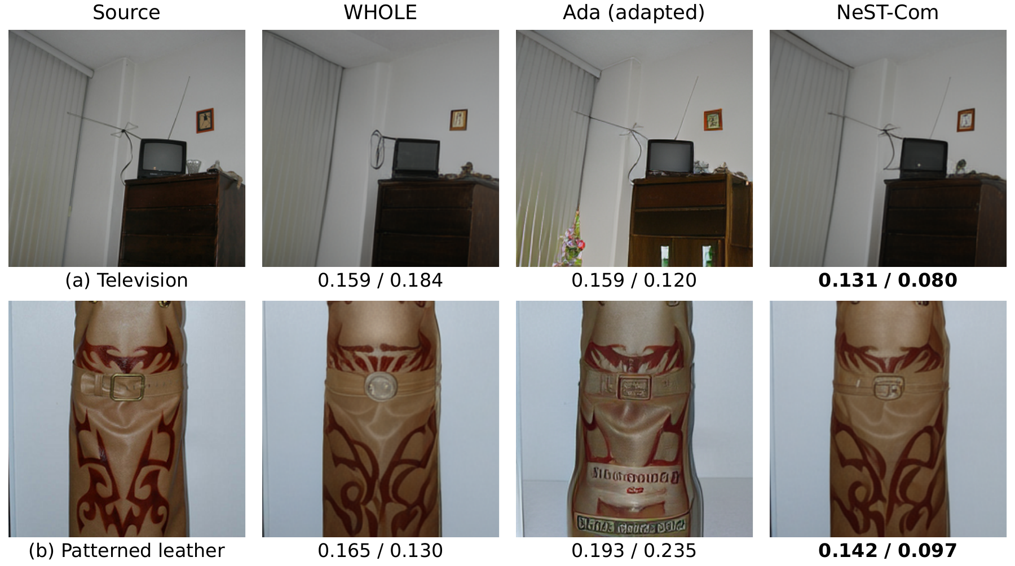
Fig. 3. Selected qualitative comparisons at $N=1024$ and 7 dB. Columns show the source, WHOLE, fixed-frame Ada, and NeST-Com. Values are full-image DISTS$↓$ / DreamSim$↓.$ Each output uses its method’s fixed first channel realization; source identities and the selection protocol are in Supplement S6.
Table II. Auxiliary quality and processing costs at N=1024, 10 dB. Quality uses common500; timing uses 32 sources, one RTX PRO 6000, two CPU cores, batch one, and complete TX/RX processing boundaries. BPG uses CPU only.
Method | PSNR↑ (dB) | LPIPS↓ | CLIP-I↑ | TX (ms) | RX (ms)
WHOLE | 19.31 | 0.199 | 0.858 | 213.8 | 369.9
NeST-Com | 20.19 | 0.166 | 0.877 | 248.4 | 411.6
Ada (adapted) | 19.56 | 0.167 | 0.884 | 7795.6 | 7626.1
Latent JSCC | 20.80 | 0.173 | 0.789 | 15.4 | 24.1
SwinJSCC | 23.03 | 0.469 | 0.669 | 20.5 | 17.6
BPG + LDPC | 22.54 | 0.589 | 0.635 | 2442.0 | 31.7
ARPC + LDPC | 16.47 | 0.341 | 0.713 | 661.7 | 797.0
Fig. 2 compares six complete systems with differing tokenizers, priors, decoders and conditioning. At all four $N=1024$ SNRs, NeST has lower DISTS and DreamSim than ARPC, SwinJSCC, Latent JSCC and BPG: all 32 corresponding paired intervals exclude zero. SwinJSCC and BPG have higher PSNR at all four points, showing an observed pixel-fidelity/perceptual-similarity tradeoff under the same symbol budget.
The closest perceptual competitor is adapted Ada. NeST improves both distances at 4 dB and DISTS at 7 dB; the latter DreamSim interval crosses zero. Ada yields lower distances at 10 dB and lower DISTS at 19 dB, where the DreamSim interval again crosses zero. NeST has higher PSNR than Ada at all four points. Table II and Supplement S2 retain the auxiliary metrics. At 7 dB, NeST/WHOLE/Ada/BPG have 13/7/7/11 gray outcomes in 1500 trials each, under their historical noise identities; NeST/WHOLE/Ada have none at 4/10/19 dB.
An error-free diagnostic separates information-budget effects from wireless decoding and MCS choices. It uses common500, six total budgets from 620 to 2577 bits, 57 shared overhead bits plus Ada’s 10-bit class, and independent source decoding. WHOLE/NeST share maximum $(10,0);$ Ada permits 256 tokens and averages three fixed generation repeats within source. NeST improves all five metrics over WHOLE at every budget with favorable paired intervals. Against Ada, DISTS favors NeST at 620/1212/1302/1940 bits and DreamSim at the first three; its 1940-bit DreamSim interval crosses zero. Ada is better on both at 2248/2577 bits. Full curves appear in Supplement S4.
Increasing the budget from 1212 to 1302 bits adds only 3.1 source bits on average to WHOLE. Token-wise fitting uses 89.9 of the additional 90 bits: DreamSim falls from 0.1837 to 0.1743, while WHOLE stays near 0.2047.
The selected Fig. 3 examples show NeST retaining the television-cabinet layout and antenna arrangement, and a more rectangular leather buckle. WHOLE rounds the buckle, whereas Ada introduces cabinet details or lettering absent from the source; Supplement S6 gives all systems on these sources.
At $N=1024,$ 10 dB, NeST takes 248.4 ms at TX and 411.6 ms at RX, totaling 0.660 s versus Ada’s 15.422 s, a processing-time ratio of 23.4 (Table II). Relative to WHOLE, NeST raises total processing from 583.7 to 660.0 ms (+13.1%). Under the matched endpoint ceiling, Quarter-to-Token refinement raises TX time from 214.1 to 248.4 ms (+16.0%). Timed Token scans all 352 allowed endpoints using one fresh probability traversal and nine scale-CDF steps; the quality diagnostic’s 125.96 cached-length comparisons measure descending selection rank. SwinJSCC and Latent JSCC require much less processing. Supplement S7 reports complete costs and operation counts.

D. Transmission With a Reduced Symbol Budget
Table III. Reduced-budget reconstruction on common500 at N=512. Means include all failures; PSNR differences use direct source-paired 95% intervals. All five metrics and paired comparisons are in Supplement S2.
SNR / method | PSNR↑ (dB) | DISTS↓ | DreamSim↓
4 / WHOLE | 15.11 | 0.2580 | 0.3247
4 / NeST-Com | 15.61 | 0.2363 | 0.2740
4 / Ada (adapted) | 11.32 | 0.2996 | 0.3847
NeST−WHOLE ΔPSNR: +0.504 [0.440, 0.573] dB
10 / WHOLE | 16.82 | 0.2030 | 0.2049
10 / NeST-Com | 17.41 | 0.1922 | 0.1837
10 / Ada (adapted) | 13.16 | 0.2367 | 0.2582
NeST−WHOLE ΔPSNR: +0.592 [0.544, 0.643] dB
19 / WHOLE | 18.64 | 0.1718 | 0.1458
19 / NeST-Com | 19.63 | 0.1554 | 0.1150
19 / Ada (adapted) | 17.69 | 0.1496 | 0.1078
NeST−WHOLE ΔPSNR: +0.994 [0.940, 1.048] dB
At $N=512,$ all five NeST–WHOLE paired intervals favor NeST at each SNR, with PSNR gains of 0.50–0.99 dB. At 10 dB both use target $(7,0)$ and 16-QAM rate 2/3; token-wise fitting raises utilization from 79.30% to 99.54%. Against Ada, NeST has higher PSNR and lower LPIPS throughout, and lower DISTS/DreamSim at 4/10 dB. Ada is better on both distances at 19 dB, with NeST–Ada differences 0.0058 [0.0036, 0.0079] and 0.0072 [0.0037, 0.0106]. This agrees with the favorable tight-information-budget region above. Ada’s mean CLIP-I is higher at all three points, with intervals crossing zero at 10/19 dB. Gray counts are 4/7/5 at 4 dB and zero at 10/19 dB, respectively. Each symbol budget uses independently calibrated policies and candidate pools.

E. Operation Near the Channel Threshold
With 10-dB policies fixed, 100 sources and 20 noise realizations per point yield 30 000 receptions over 8–10 dB. All three methods reject every frame at 8 dB. At 9 dB, WHOLE/NeST/Ada rejection rates are 15.75/14.95/13.50%; these fall to 0.10–0.20% at 9.5 dB, with no observed rejection at 10 dB. Overall quality includes rejected-frame gray outputs; successful-only quality is in Supplement S5. Source-reconstruction gains are realized within the reliable operating range of the selected digital-link policy.

IV. Conclusion
NeST-Com retains and uses additional source information through token-wise endpoints, actual-length fitting and prefix-constrained reconstruction. Shared-model and matched controls improve both pixel fidelity and perceptual similarity, with received boundary tokens correcting residuals and finer-scale conditioning. Equal-information-budget tests identify a favorable tight-budget regime, and matched-hardware tests show shorter processing than the Ada adaptation. These findings support next-scale perceptual reconstruction within the reliable range of the selected digital-link policy.

References
[1] K. Tian, Y. Jiang, Z. Yuan, B. Peng, and L. Wang, “Visual autoregressive modeling: Scalable image generation via next-scale prediction,” in Advances in Neural Information Processing Systems, vol. 37, 2024, pp. 84 839–84 865.
[2] Z. Zhang, Y. Xia, B. Chen, T. Zhang, H. Wang, and H. Qiu, “Autoregressive-based progressive coding for ultra-low bitrate image compression,” in Int. Conf. Learning Representations, 2026.
[3] Z. Zhang, L. Qiao, M. B. Mashhadi, Z. Gao, M. Bennis, and K. Huang, “Ada-TokenCom: Rate-adaptive token communications via large-model-driven token compression and generation,” 2026, arXiv:2608.28086.
[4] V. Chande and N. Farvardin, “Progressive transmission of images over memoryless noisy channels,” IEEE J. Sel. Areas Commun., vol. 18, no. 6, pp. 850–860, Jun. 2000, doi: 10.1109/49.848239.
[5] I. H. Witten, R. M. Neal, and J. G. Cleary, “Arithmetic coding for data compression,” Commun. ACM, vol. 30, no. 6, pp. 520–540, Jun. 1987, doi: 10.1145/214762.214771.
[6] 3GPP, “NR; Multiplexing and channel coding,” TS 38.212, ver. 16.5.0, Release 16, 2021. [Online]. Available: https:/​/​www.etsi.org/​deliver/​etsi_​ts/​138200_​138299/​138212/​16.05.00_​60/​ts_​138212v160500p.pdf
[7] M. Oquab et al., “DINOv2: Learning robust visual features without supervision,” Trans. Mach. Learn. Res., Jan. 2024. [Online]. Available: https:/​/​openreview.net/​forum?id=a68SUt6zFt
[8] O. Russakovsky et al., “ImageNet large scale visual recognition challenge,” Int. J. Comput. Vis., vol. 115, no. 3, pp. 211–252, 2015.
[9] K. Yang, S. Wang, J. Dai, X. Qin, K. Niu, and P. Zhang, “SwinJSCC: Taming Swin Transformer for deep joint source-channel coding,” IEEE Trans. Cogn. Commun. Netw., vol. 11, no. 1, pp. 90–104, Feb. 2025.
[10] F. Bellard, “BPG image format,” accessed Oct. 22, 2026. [Online]. Available: https:/​/​bellard.org/​bpg/​
[11] K. Ding, K. Ma, S. Wang, and E. P. Simoncelli, “Image quality assessment: Unifying structure and texture similarity,” IEEE Trans. Pattern Anal. Mach. Intell., 2021, doi: 10.1109/TPAMI.2020.3045810.
[12] S. Fu, N. Tamir, S. Sundaram, L. Chai, R. Zhang, T. Dekel, and P. Isola, “DreamSim: Learning new dimensions of human visual similarity using synthetic data,” in Advances in Neural Information Processing Systems, vol. 36, 2023, pp. 50 742–50 768.
[13] R. Zhang, P. Isola, A. A. Efros, E. Shechtman, and O. Wang, “The unreasonable effectiveness of deep features as a perceptual metric,” in Proc. IEEE Conf. Comput. Vis. Pattern Recognit., Jun. 2018, pp. 586–595.
[14] A. Radford et al., “Learning transferable visual models from natural language supervision,” in Proc. 38th Int. Conf. Mach. Learn., vol. 139, 2021, pp. 8748–8763.

