NeST-Com: Fixed-Budget Next-Scale Token Communication
Anonymous Authors
Abstract
Complete-scale endpoints can leave unused capacity in fixed-budget image communication. NeST-Com combines within-scale token endpoints, fitting by actual terminated entropy-code length, and prefix-constrained reconstruction with a shared frozen next-scale prior. On 500 ImageNet images, within-scale transmission improves PSNR by 0.32–0.70 dB over complete-scale transmission with the same model components; source-bit utilization at 10 dB rises from 77.70% to 95.21%. Controlled endpoint diagnostics and Kodak evaluation support this mechanism. A six-system comparison shows higher PSNR than a fixed-frame Ada-TokenCom adaptation, while Ada achieves better perceptual or feature-similarity scores at several operating points.

Index terms
Image communication, visual autoregressive models, fixed symbol budget, entropy coding.

I. Introduction
An image communication system with a hard per-image symbol budget must decide which information to retain before channel transmission. The decision depends on the image-dependent source-code length, channel protection, and the reconstruction attainable from the retained representation. A generative receiver can supply missing information, but its output must remain constrained by the information actually delivered. The resulting design trades pixel fidelity, perceptual similarity, feature consistency, and processing cost.
Digital image coding with forward error correction and learned joint source–channel coding (JSCC) offer different approaches to this tradeoff [1, 2]. Progressive transmission and truncation of embedded descriptions have a long history [3]. Recent token-based methods use large generative models: Ada-TokenCom combines prefix entropy coding, tail generation, and joint prefix/MCS selection under an average resource constraint [4]; TONIC studies task-oriented token communication [5]. ARPC constructs progressive image descriptions with an autoregressive prior [6]. Visual autoregressive modeling (VAR) provides a multiscale residual representation and a prior that predicts each scale from complete coarser maps [7].
For this next-scale representation, restricting transmission to complete maps gives large endpoint steps. Meanwhile, the terminated entropy-code length of a given endpoint varies across images. A next whole scale may exceed the frame even when the preceding whole endpoint leaves substantial room. Legal within-scale endpoints address this mismatch by retaining part of the boundary map. The next-scale factorization lets both ends construct matching CDFs from complete coarse maps, while the extra endpoints make this representation fit a hard frame more closely.
We present NeST-Com, which connects within-scale endpoints, actual-length fitting, and prefix-constrained reconstruction in one fixed-budget communication design. The receiver uses the existing known-token overwrite operation of VAR while updating both the accumulated residual latent and the context for finer scales. Our contributions are the endpoint/frame-fitting design and its evaluation through shared-model comparisons, controlled granularity diagnostics, and six-system experiments. On common500, quarter-scale endpoints improve PSNR by 0.32–0.70 dB over complete-scale endpoints. External comparisons expose complementary pixel and perceptual behavior rather than a uniform ranking.

II. Proposed NeST-Com Framework

A. Next-Scale Representation and Digital Frame
We transmit $x∈[0,1]^{256×256×3}$ over complex AWGN,
$$y=s+n, n∼CN(0,σ^{2}I_{N}), SNR=10\log_{10}(E_{s}/σ^{2}), \text{(1)}$$
with $N=1024$ complex symbols per image and nominal $E_{s}=2$. The channel-use ratio to RGB samples is $1/192$. In the matched-SNR experiments, TX selects its frozen policy using the channel SNR; RX uses the true noise variance for LLRs. Digital constellations have average energy two without per-frame renormalization. Continuous JSCC data are normalized per image to average energy two; required Swin side information is separately paid within $N$. A 12-bit profile ID, CRC16, and terminated rate-1/2 convolutional code occupy 68 rotated-BPSK symbols $\{±(1+j)\}$. The remaining 956 symbols carry the LDPC-coded body. The paid profile identifies the actual endpoint and MCS.
The frozen VAR tokenizer produces ten residual token maps $q_{s}$, with side lengths $(1,2,3,4,5,6,8,10,13,16)$ and a 4096-entry codebook [7]. Let $L_{s}$ be the map size and $C_{s}$ its codebook lookup, resizing, and residual transform. The complete quantized latent is fq=s​Cs(qs). Image decoder $D_{c}$ is adapted on 20 000 ImageNet training images using continuous, fully quantized, and prefix-completion-interpolated latents, then fixed. NeST-Com uses null-class conditioning. Its frozen next-scale prior factorizes as
$$p_{θ}(q_{s}∣q_{<s})=\prod_{i=1}^{L_{s}}{p_{θ}}(q_{s,i}∣q_{<s}), \text{(2)}$$
providing the local cumulative distribution functions (CDFs) for arithmetic coding [8] at both ends of Fig. 1.
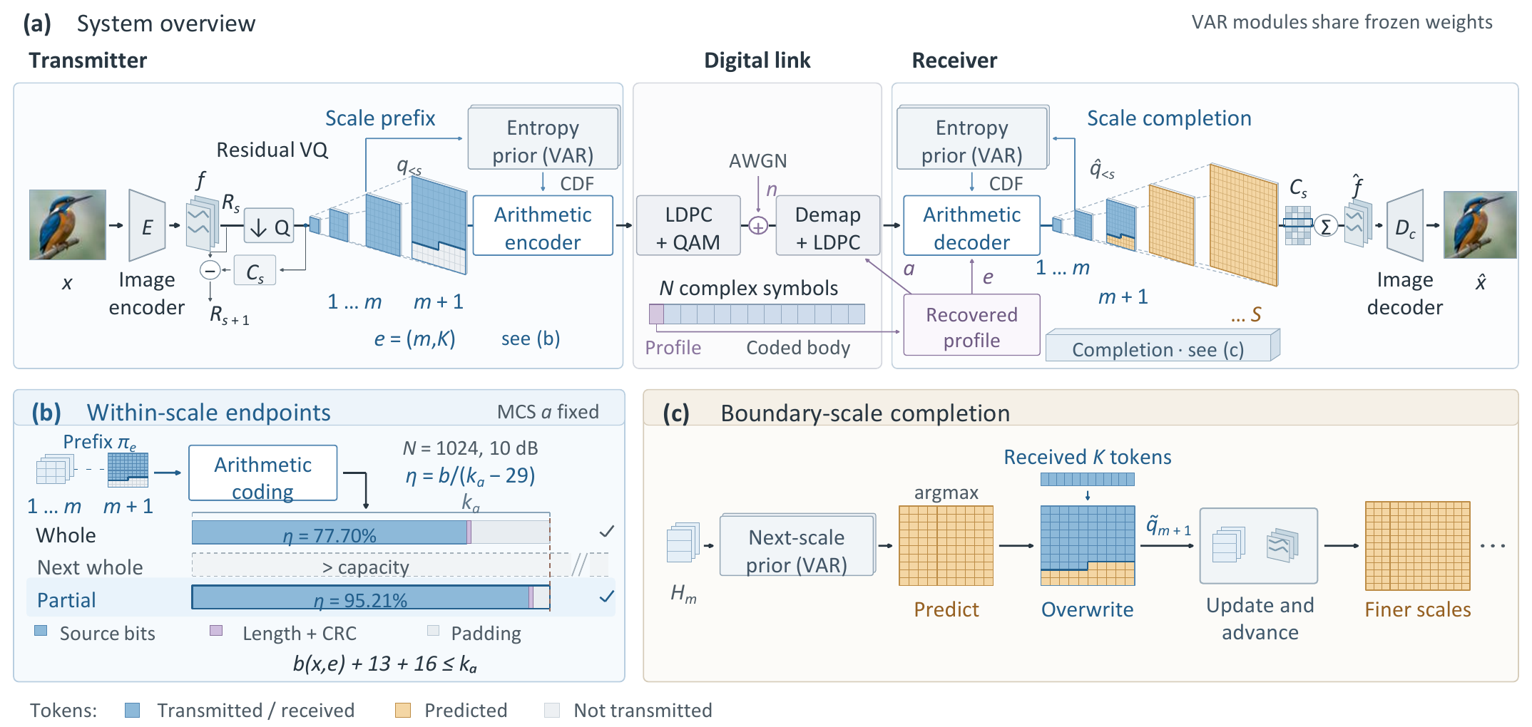
Fig. 1. NeST-Com. (a) A paid profile specifies endpoint $e$ and MCS $a$; TX/RX construct CDFs locally using the shared frozen VAR and their known coarse tokens. (b) Independently terminated prefixes, a 13-bit length field, and CRC16 fit the information capacity $k_{a}$. Bars show the common500 mean of per-image entropy-stream utilization at 10 dB (77.70%/95.21% for WHOLE/PARTIAL). (c) Received positions overwrite the predicted boundary map before residual accumulation and advancement to finer scales. $H_{m}$ denotes the prior state after scale $m$.

B. Within-Scale Endpoints and Actual-Length Fitting
An endpoint $e=(m,K)$ retains complete coarse maps and $K$ raster-ordered positions from the next map:
$$π_{e}=(q_{1},…,q_{m},q_{m+1,1:K}). \text{(3)}$$
WHOLE permits $K=0$. PARTIAL additionally uses $K∈\{⌊L_{m+1}/4⌋,⌊L_{m+1}/2⌋,⌊3L_{m+1}/4⌋\}$ for $m=4,…,9$; $(10,0)$ denotes the full representation.
For MCS $a=(M,r)$, the coded body has $n_{a}=956\log_{2}M$ bits and information length $k_{a}=⌊rn_{a}⌋$. With actual terminated arithmetic length $b(x,e)$,
$$b(x,e)+29≤k_{a}, η(x,e)=\frac{b(x,e)}{k_{a}−29}. \text{(4)}$$
The 29 bits comprise the length field and CRC16; unused information positions are zero-padded before 5G NR LDPC coding, rate matching [9], and QAM. Thus $η$ measures entropy-stream capacity utilization.
The target search first considers $m=7,8,9$, each with $K=0$ or the three quarter-scale counts, and 12 MCSs: $\log_{2}M∈\{2,4,6\}$ and $r∈\{1/2,2/3,3/4,5/6\}$. A 100-image pilot evaluates each candidate using one channel realization per image and shortlists its top three candidates plus the complete-scale anchor. Final evaluation compares these finalists and the full-scale $(10,0)$ candidates on all 1000 calibration images with three channel realizations per image, including the fixed gray outputs of rejected transmissions. Selection maximizes source/reconstruction DINOv2 cosine [10], first averaged over the three realizations of each image and then equally over sources. Exact ties follow a fixed candidate order documented in the configuration.
At 4/10/19 dB, frozen WHOLE targets are $(7,0)/(9,0)/(10,0)$ and PARTIAL targets are $(7,25)/(8,126)/(10,0)$. Both select $(\log_{2}M,r)=(2,2/3)/(4,2/3)/(6,5/6)$, yielding source capacities 1245/2520/4751 bits. The repository records the complete candidate and fallback lists.
The fallback chain is deterministic, not an additional learned parameter: enumerate legal endpoints no longer than the target, order by decreasing token count, and stop at $(4,0)$. WHOLE uses complete scales; PARTIAL also uses the quarter endpoints above. Counts are distinct, so no endpoint-order tie occurs. With fixed MCS, TX sends the first independently terminated stream satisfying (4); its paid profile identifies the actual endpoint. If no endpoint satisfies the budget, the implementation raises an error; this case did not occur for any evaluated source. A slice of a longer arithmetic stream is never used.

C. Prefix-Constrained Reconstruction
Invalid profile CRC/catalogue, body CRC, declared length, known padding, or arithmetic parsing produces a fixed gray image. Otherwise, the receiver decodes the prefix using CDFs rebuilt from the complete coarse maps actually received. It predicts the entire boundary map by VAR argmax conditioned on complete coarse maps, then applies known-token overwrite [7]:
$${\tilde{q}}_{m+1,i}=\left\{\begin{matrix}{\hat{q}}_{m+1,i}, & i≤K, \\ q_{m+1,i}^{pred}, & i>K.\end{matrix}\right. \text{(5)}$$
Unreceived boundary positions retain that coarse-conditioned prediction; they are not recomputed conditioned on the received $K$ positions. The merged map contributes directly to the residual latent and updates the prior state before finer-scale prediction. Complete received maps remain unchanged; subsequent maps are generated from this updated context. Reconstruction is
$$\hat{x}=D_{c}​\left(\sum_{s=1}^{10}{C_{s}}({\tilde{q}}_{s})\right). \text{(6)}$$
At the final scale, overwrite changes the residual contribution without any subsequent propagation.

III. Experimental Results
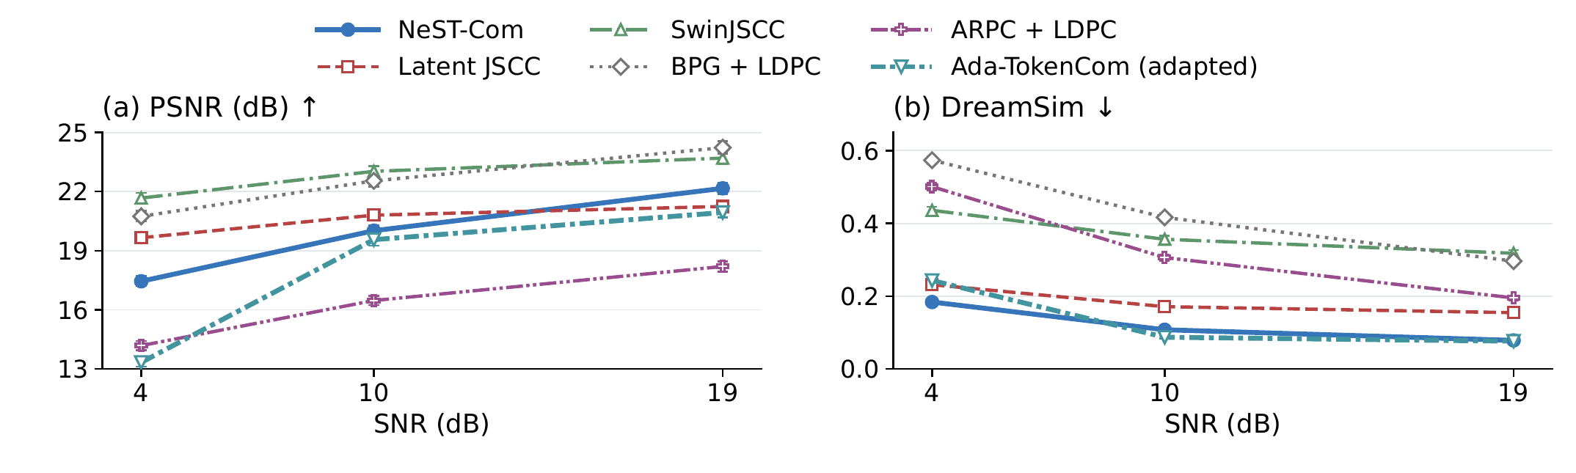
Fig. 2. Six-system performance on common500 at $N=1024$. Points and bars are source means and pointwise 95% source-bootstrap CIs after averaging three channel realizations. Ada denotes the predicted-class, fixed-frame adaptation. Higher PSNR and lower DreamSim are favorable.

A. Experimental Setup
We use common500 ImageNet validation images [11], a disjoint 1000-image calibration set, and the 24 Kodak images [12], with fixed $256×256$ preprocessing. Tests use $N=1024$, $E_{s}=2$, and 4/10/19 dB. ImageNet-calibrated policies remain fixed on Kodak.
The six systems are NeST-Com, Latent JSCC, adapted SwinJSCC [2], adaptive BPG [13] + LDPC, adapted ARPC [6] + LDPC, and Ada-TokenCom adapted to a fixed per-image frame. Our convolutional Latent JSCC maps tokenizer latents to symbols and shares $D_{c}$; its losses combine image MSE, LPIPS, and normalized-latent consistency. Latent JSCC and SwinJSCC use the same 20 000 training images and final 100k/200k-update checkpoints. SwinJSCC was still improving at its training budget cap. All required signaling is charged; ARPC’s caption is paid. Ada retains LlamaGen-L/VQ16, prefix arithmetic coding, and conditional tail sampling. A fixed ConvNeXt predicts the class, whose 10-bit ID is transmitted, giving $b+39≤k_{a}$. Calibration chooses its MCS; online fitting searches the predeclared 1–256-token endpoints. This changes Ada’s average-resource formulation to our fixed-frame task.
Metrics are PSNR, LPIPS-Alex [14], DreamSim [15], and CLIP-I, the CLIP ViT-L/14 image–image cosine [16]. DreamSim/CLIP use frozen FP32, $224×224$ preprocessing. We average three channel realizations per source, retaining gray failures, then compute equal-source means. Intervals are 95% source-bootstrap CIs; differences are directly source-paired. Pairing does not require identical noise realizations across methods. Generative seeds and decoding settings are fixed. No rejected or failed reconstructions occurred in the 1500 trials per method at each matched SNR on common500. Continuous Latent JSCC has no discrete CRC rejection rule. Transmitter fallback is counted separately.
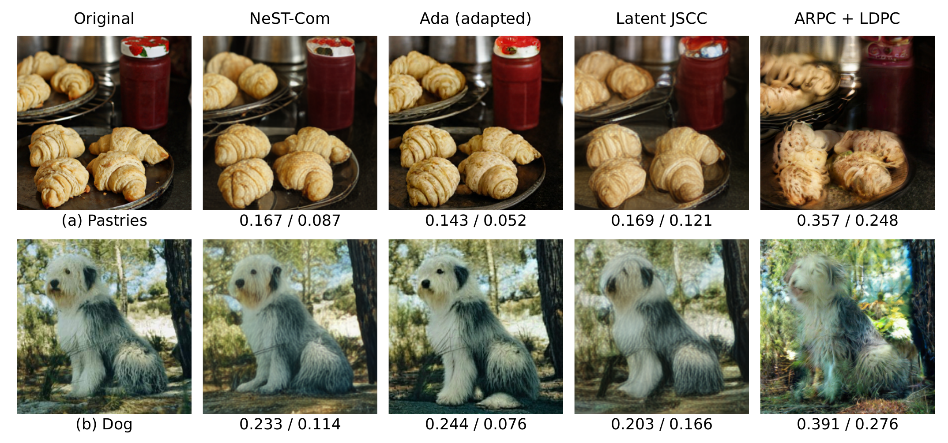
Fig. 3. Selected methods on two fixed development examples at $N=1024$ and 10 dB: (a) pastries and (b) a dog. Values below each reconstruction are LPIPS-Alex$↓$ / DreamSim$↓$ for that displayed realization.

B. Effect of Within-Scale Endpoints
Table I. Within-scale endpoint evidence. (A) Main family-specific policies; $Δ=PARTIAL−WHOLE$ with source-paired 95% CIs. (B) Controlled 100-source diagnostic at 10 dB.
(A) Main policies: utilization and paired PSNR gain
SNR | Utilization W$→$P (%) | $Δ$PSNR (dB) [95% CI]
common500
4 | 73.81 $→$ 93.08 | $+0.616 [0.564,0.673]$​
10 | 77.70 $→$ 95.21 | $+0.701 [0.637,0.766]$​
19 | 85.24 $→$ 94.73 | $+0.319 [0.290,0.349]$​
Kodak24
4 | 75.69 $→$ 93.43 | $+0.396 [0.236,0.543]$​
10 | 78.11 $→$ 94.99 | $+0.674 [0.408,0.958]$​
19 | 85.69 $→$ 93.71 | $+0.228 [0.140,0.324]$​
(B) Fixed model, MCS, maximum endpoint and fitting
Grid (candidates) | Utilization (%) | PSNR (dB)
Whole (7) | 78.15 | 18.952
Half (13) | 89.21 | 19.396
Quarter (25) | 95.38 | 19.612
Eighth (49) | 97.39 | 19.735
Table I(A) compares WHOLE/PARTIAL with shared tokenizer, prior, entropy coder, and $D_{c}$. Their target/MCS choices are calibrated separately and select the same MCS at each SNR; fallback follows the fixed rule. On common500, PSNR gains are 0.32–0.70 dB. At 10 dB, utilization rises from 77.70% to 95.21% and DreamSim decreases by 0.0240. Kodak gains 0.674 dB and reduces DreamSim by 0.0164 at 10 dB; its 19 dB DreamSim CI includes zero. These results connect additional legal endpoints and calibrated fitting to better use of a fixed body capacity.
Block B isolates granularity on 100 existing sources, holding model, MCS, maximum endpoint, and longest-feasible fitting fixed. WHOLE, half-, quarter-, and eighth-scale grids have 7/13/25/49 candidates. At 10 dB, QUARTER minus WHOLE gains $0.660 [0.515,0.814]$ dB, while EIGHTH adds $0.123 [0.079,0.169]$ dB over QUARTER. The denser grid also yields small PSNR/LPIPS gains at other SNRs; the main quarter grid remains the predefined configuration.
A receiver intervention uses the same 100 sources and actual received prefixes, without new endpoint selection or channel trials. A0 ignores received boundary positions and follows the prior path. B0 adds their correction only to the final residual latent, leaving finer-scale context on the A0 path. C0 updates both latent and context. All three use the same device and numerical precision. At 10 dB, B0$−$A0 and C0$−$B0 yield 0.220 and 0.440 dB mean PSNR differences. C0$−$B0 is zero at 19 dB because the boundary is the last scale.

C. Comparison With Existing Methods
Table II. Perceptual distance and image-feature similarity on common500. Each cell is LPIPS-Alex $↓$ / CLIP-I $↑$.
Method | 4 dB | 10 dB | 19 dB
NeST-Com | 0.263 / 0.821 | 0.171 / 0.873 | 0.118 / 0.900
Latent JSCC | 0.219 / 0.741 | 0.173 / 0.789 | 0.158 / 0.804
SwinJSCC | 0.530 / 0.627 | 0.469 / 0.669 | 0.440 / 0.697
BPG + LDPC | 0.725 / 0.586 | 0.589 / 0.635 | 0.458 / 0.684
ARPC + LDPC | 0.512 / 0.644 | 0.341 / 0.713 | 0.250 / 0.788
Ada (adapted) | 0.395 / 0.828 | 0.167 / 0.884 | 0.138 / 0.892
Fig. 2 and Table II show a quality tradeoff. NeST-Com exceeds adapted Ada in PSNR by 4.116/0.455/1.226 dB at 4/10/19 dB, respectively. At 10 dB, Ada has lower LPIPS and DreamSim and higher CLIP-I, with source-paired CIs excluding zero. Ada also has higher CLIP-I at 4 dB and slightly lower DreamSim at 19 dB; NeST has better PSNR, LPIPS, and CLIP-I at 19 dB. Ada delivers all 256 tokens at 19 dB, so no tail sampling occurs; its approximately 58% source-capacity utilization reflects completion of its representation.
SwinJSCC and BPG have higher PSNR than NeST at every tested SNR. Latent JSCC has higher PSNR at 4/10 dB and lower LPIPS at 4 dB. Thus perceptual criteria and pixel error need not rank systems alike. NeST’s PSNR advantage over ARPC is 3.26–3.97 dB. On matched100, replacing ARPC’s original $τ=0.5$ sampling by argmax or $τ=0.25$ changes mean PSNR by up to about 0.15 dB in the tested conditions.
Fig. 3 shows two selected development examples. Ada retains crisp pastry folds and dog fur; NeST and Latent JSCC smooth different details, while ARPC changes visible object contours and texture. For the dog, Latent JSCC has the lowest displayed LPIPS, whereas Ada has the lowest DreamSim. These individual outcomes complement the source-level comparison.

D. Additional Results and Processing Cost
On Kodak, all four paired metrics favor NeST over Ada at 4 dB. At 10 dB, only the PSNR difference has a 95% paired confidence interval excluding zero; at 19 dB, PSNR and LPIPS favor NeST while DreamSim/CLIP-I CIs cross zero.
The existing $N=2048$ comparison uses 100 sources and two paid 1024-symbol subframes. Its 4/10 dB conditions are adaptive, whereas 19 dB delivers both complete representations. At 19 dB, NeST exceeds ARPC by 1.806 dB PSNR, but ARPC has better DISTS [17]: NeST minus ARPC is $+0.0054 [+0.0024,+0.0086]$. Representation and decoding therefore remain relevant beyond payload fitting.
A TX-policy SNR mismatch diagnostic shares three AWGN vectors per source across WHOLE/PARTIAL and scales them to 8/10/12 dB. With both transmit policies fixed at 10 dB and RX using the true noise variance, all 300 receptions per method were rejected at 8 dB, whereas all succeeded at 10 and 12 dB on the existing 100-image subset. For each image and method, the recovered prefix and reconstruction were identical at 10 and 12 dB. PARTIAL exceeded WHOLE by $0.660 [0.515,0.814]$ dB in PSNR at both points, with a DreamSim difference of $−0.02384 [−0.02999,−0.01797]$. All 1800 outcomes, including gray failures, enter source-level statistics; the complete four-metric results are available in the repository.
Measured software processing latency at 10 dB averages 619.71 ms/image for NeST, 42.48 for Latent JSCC, 44.69 for SwinJSCC, 1520.30 for ARPC, and 2293.01 for BPG (RTX PRO 6000, six CPU cores, batch one, 16 development images measured three times after warm-up). These totals sum TX/RX software processing; Ada has not been timed under this protocol.

IV. Conclusion
NeST-Com connects within-scale endpoints, terminated-length fitting, and prefix-constrained reconstruction under a fixed symbol budget. Shared-model evaluations show improved capacity utilization and reconstruction quality, while controlled grids reveal further gains from denser endpoints. Six-system results expose pixel–perceptual tradeoffs, including operating points favoring adapted Ada. Alternative calibration objectives remain future work.

References
[1] E. Bourtsoulatze, D. B. Kurka, and D. Gündüz, “Deep joint source-channel coding for wireless image transmission,” IEEE Trans. Cogn. Commun. Netw., vol. 5, no. 3, pp. 567–579, Sep. 2019.
[2] K. Yang, S. Wang, J. Dai, X. Qin, K. Niu, and P. Zhang, “SwinJSCC: Taming Swin Transformer for deep joint source-channel coding,” IEEE Trans. Cogn. Commun. Netw., vol. 11, no. 1, pp. 90–104, Feb. 2025.
[3] V. Chande and N. Farvardin, “Progressive transmission of images over memoryless noisy channels,” IEEE J. Sel. Areas Commun., vol. 18, no. 6, pp. 850–860, Jun. 2000, doi: 10.1109/49.848239.
[4] Z. Zhang, L. Qiao, M. B. Mashhadi, Z. Gao, M. Bennis, and K. Huang, “Ada-TokenCom: Rate-adaptive token communications via large-model-driven token compression and generation,” 2026, arXiv:2608.28086.
[5] S. Liu and K. Wang, “TONIC: Token-centric semantic communication for task-oriented wireless systems,” 2026, arXiv:2605.21553.
[6] Z. Zhang, Y. Xia, B. Chen, T. Zhang, H. Wang, and H. Qiu, “Autoregressive-based progressive coding for ultra-low bitrate image compression,” in Int. Conf. Learning Representations, 2026.
[7] K. Tian, Y. Jiang, Z. Yuan, B. Peng, and L. Wang, “Visual autoregressive modeling: Scalable image generation via next-scale prediction,” in Advances in Neural Information Processing Systems, vol. 37, 2024, pp. 84 839–84 865.
[8] I. H. Witten, R. M. Neal, and J. G. Cleary, “Arithmetic coding for data compression,” Commun. ACM, vol. 30, no. 6, pp. 520–540, Jun. 1987, doi: 10.1145/214762.214771.
[9] 3GPP, “NR; Multiplexing and channel coding,” TS 38.212, ver. 16.5.0, Release 16, 2021. [Online]. Available: https://www.etsi.org/deliver/etsi_ts/138200_138299/138212/16.05.00_60/ts_138212v160500p.pdf
[10] M. Oquab et al., “DINOv2: Learning robust visual features without supervision,” Trans. Mach. Learn. Res., Jan. 2024. [Online]. Available: https://openreview.net/forum?id=a68SUt6zFt
[11] O. Russakovsky et al., “ImageNet large scale visual recognition challenge,” Int. J. Comput. Vis., vol. 115, no. 3, pp. 211–252, 2015.
[12] R. Franzen, “Kodak lossless true color image suite,” accessed Oct. 26, 2026. [Online]. Available: https://r0k.us/graphics/kodak/
[13] F. Bellard, “BPG image format,” accessed Oct. 22, 2026. [Online]. Available: https://bellard.org/bpg/
[14] R. Zhang, P. Isola, A. A. Efros, E. Shechtman, and O. Wang, “The unreasonable effectiveness of deep features as a perceptual metric,” in Proc. IEEE Conf. Comput. Vis. Pattern Recognit., Jun. 2018, pp. 586–595.
[15] S. Fu, N. Tamir, S. Sundaram, L. Chai, R. Zhang, T. Dekel, and P. Isola, “DreamSim: Learning new dimensions of human visual similarity using synthetic data,” in Advances in Neural Information Processing Systems, vol. 36, 2023, pp. 50 742–50 768.
[16] A. Radford et al., “Learning transferable visual models from natural language supervision,” in Proc. 38th Int. Conf. Mach. Learn., vol. 139, 2021, pp. 8748–8763.
[17] K. Ding, K. Ma, S. Wang, and E. P. Simoncelli, “Image quality assessment: Unifying structure and texture similarity,” IEEE Trans. Pattern Anal. Mach. Intell., vol. 44, no. 5, pp. 2567–2581, May 2022.

