NeST-Com: Fixed-Budget Next-Scale Token Communication
Anonymous Authors
Abstract
Next-scale token maps provide a coarse-to-fine source description, but whole-scale endpoints can underfill fixed digital frames. NeST-Com retains scale-wise prediction while allowing transmission to stop within a scale. It fits independently terminated prefixes using their actual lengths and incorporates received boundary tokens into the residual state for subsequent prediction. At 1024 symbols and 10 dB, source-bit utilization increases from 77.70% to 99.79%, reducing DISTS and DreamSim by 8.7% and 20.5% relative to shared-model whole-scale transmission. Matched controls establish the granularity effect, while different budgets and measured processing costs reveal quality–cost tradeoffs.

Index terms
Image communication, next-scale tokens, fixed symbol budget, perceptual reconstruction.

I. Introduction
A fixed per-image digital frame must accommodate source information, signaling and protection. Transmitted information anchors reconstruction to the source, while a learned prior predicts untransmitted content. Reconstruction therefore depends on the transmitted description and how closely its coded length fits the available capacity.
Next-scale representations organize an image into complete coarse maps followed by residual refinements [1]. Each coarse map covers the full latent field; probabilities within the next scale share this context. ARPC establishes progressive compression by coding coarse scales and generating the remaining scales [2], providing the closest source-coding precedent. Ada-TokenCom combines next-token prefix coding, tail generation and wireless adaptation [3], while ResARC codes suffix-generation residuals [4].
Progressive communication matches source descriptions to channel resources [5]. For next-scale tokens, prediction and transmission units need not coincide: a complete next map may exceed the remaining frame capacity even when many of its tokens would fit. Image-dependent entropy lengths also prevent fixed token counts from specifying fixed frame sizes. This motivates within-scale transmission endpoints while retaining scale-wise prediction.
NeST-Com fits independently terminated within-scale prefixes to protected frames using their actual lengths. VAR’s known-token overwrite and recursive residual update [1] incorporate received tokens into reconstruction and finer-scale conditioning. Shared-model policies quantify fixed-frame gains; matched controls isolate endpoint granularity and explain token use. Equal-information-budget and complete-system comparisons characterize reconstruction tradeoffs alongside measured processing costs.

II. Proposed NeST-Com Framework

A. Next-Scale Representation and Digital Frame
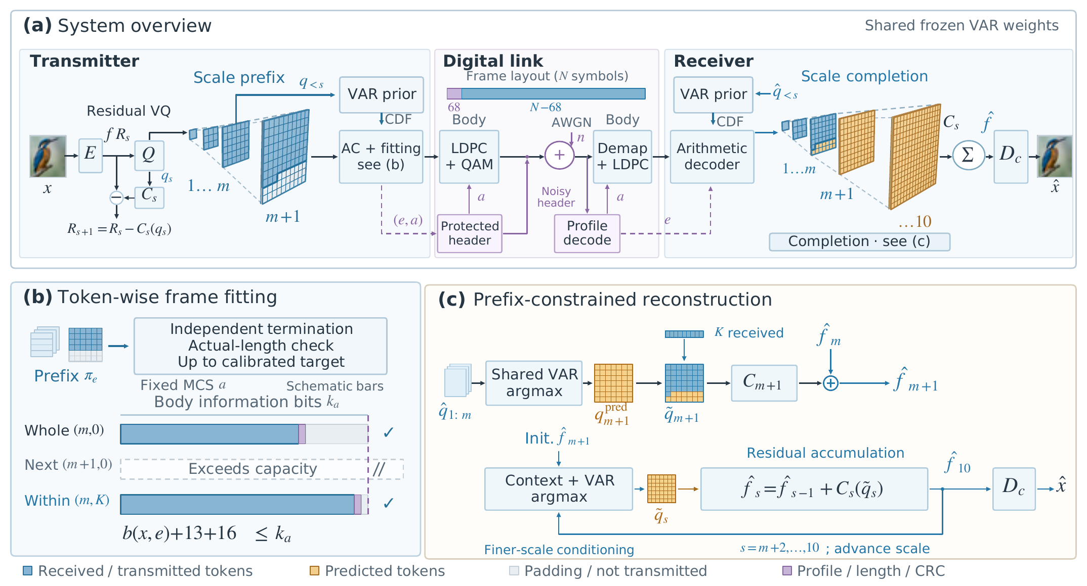
Fig. 1. NeST-Com. (a) The shared policy fixes the MCS and profile directory; the protected profile selects the endpoint. VAR and known coarse tokens provide coding probabilities. (b) Independently terminated prefixes fit the actual capacity below the target; bars are schematic. (c) Received tokens overwrite boundary predictions. Recursive state updates accumulate residuals and condition each finer scale before decoding. Unreceived boundary positions retain their coarse-conditioned predictions.
We transmit $x∈[0,1]^{256×256×3}$ using $N$ complex symbols over AWGN,
$$y=s+n, n∼CN(0,σ^{2}I_{N}), SNR=10\log_{10}(E_{s}/σ^{2}), \text{(1)}$$
with nominal $E_{s}=2.$ TX uses the frozen policy for its design SNR; RX uses the actual noise variance for LLRs. Digital constellations have average energy two without per-frame renormalization. A 12-bit profile ID, CRC16, and terminated rate-1/2 convolutional code occupy 68 rotated-BPSK symbols $\{±(1+j)\}.$ Under a preconfigured policy, both terminals know the MCS and profile directory; the 12-bit profile identifies the endpoint within that directory. The remaining $N−68$ symbols carry the LDPC-coded body, with public frame-dependent scrambling after rate matching and inverse scrambling before decoding. Continuous JSCC data are normalized per image to energy two; required side information is paid within $N.$
The frozen VAR tokenizer produces ten residual token maps $q_{s},$ with side lengths $(1,2,3,4,5,6,8,10,13,16)$ and a 4096-entry codebook [1]. Write $L_{s}$ for the number of positions and $C_{s}$ for codebook lookup, resizing to the full latent grid, and the scale-dependent residual transform. The latent sum s​Cs(qs) progressively refines a full-field description. Decoder $D_{c}$ is adapted on 20 000 ImageNet training images using MSE plus $0.1$ LPIPS, then frozen. The continuous/quantized/prefix-completed training mixture is specified in Supplement S1. The null-class VAR-d16 prior factorizes as
$$p_{θ}(q_{s}∣q_{<s})=\prod_{i=1}^{L_{s}}{p_{θ}}(q_{s,i}∣q_{<s}). \text{(2)}$$
Both terminals reconstruct identical integer CDFs, with total frequency $2^{24},$ for arithmetic coding [6]; no unreceived same-scale token is needed. Transmission can therefore end within a scale while probability evaluation remains scale-wise.

B. Within-Scale Endpoints and Actual-Length Fitting
An endpoint $e=(m,K)$ retains complete coarse maps and a raster-ordered boundary prefix:
$$π_{e}=(q_{1},…,q_{m},q_{m+1,1:K}). \text{(3)}$$
The boundary prefix is empty for $K=0,$ including $e=(10,0).$ The fixed raster order specifies received positions without a mask. WHOLE permits $(m,0)$ for $m=4,…,10.$ NeST permits every integer $K=0,…,L_{m+1}−1$ for $m=4,…,9,$ together with $(10,0):$ 651 endpoints from 30 through 680 retained tokens. Quarter/Eighth retain $K=⌊jL_{m+1}/d⌋,$ $j=1,…,d−1,$ for $d=4/8,$ plus complete-scale boundaries, with duplicates removed. Token is the main configuration.
For MCS $a=(M,r),$ the coded body has $n_{a}=(N−68)\log_{2}M$ bits and information length $k_{a}=⌊rn_{a}⌋.$ Its independently terminated arithmetic length $b(x,e)$ must satisfy
$$b(x,e)+29≤k_{a}, η(x,e)=\frac{b(x,e)}{k_{a}−29}. \text{(4)}$$
The 29 bits comprise a 13-bit length and CRC16. Unused information positions are zero-padded before 5G NR LDPC coding, rate matching [7], and QAM. Thus $η$ measures source-bit capacity utilization after the length/CRC overhead.
For $N=1024,$ WHOLE, NeST and Ada use the same 12 MCSs: QPSK/16-QAM/64-QAM with rates $1/2,2/3,3/4,5/6.$ WHOLE has seven target ceilings; NeST searches 25 Quarter ceilings while allowing all Token endpoints below each; Ada allows all prefixes up to 256. The 396 candidates undergo a common 100-image, one-realization pilot. Per method/SNR, the top three and a preset QPSK rate-1/2 anchor advance to all 1000 calibration sources with three realizations. Maximum equal-source DINOv2 cosine [8], including gray failures, selects the frozen policy. $N=512$ retains its independently calibrated policies (Table IV).
A public method/MCS directory is frozen before calibration and shared across target ceilings and images. The paid profile selects an endpoint within it. A shared scale-wise probability and incremental coding traversal supplies independently terminated candidate streams, rather than slices of a longer stream. With MCS fixed, TX scans their actual lengths and selects the most-token feasible endpoint below the target. If none fits, it sends a paid NULL profile with a two-bit zero payload, yielding gray. Supplement S1 gives the exact scan algorithm, directory entries and the coder-specific nondecreasing-length proof; the measured implementation still generates and scans all allowed candidates.

C. Prefix-Constrained Reconstruction
Invalid profile CRC/catalogue, body CRC, declared length, known padding, or arithmetic parsing yields a fixed gray image, as does valid NULL reception. Otherwise, RX decodes the actual prefix using the shared CDFs. At $e=(10,0),$ all maps are received and directly decoded. For an incomplete prefix, RX applies VAR’s known-token overwrite and recursive state update [1]. It predicts the boundary map by argmax conditioned on complete received maps, then overwrites received positions:
$${\tilde{q}}_{m+1,i}=\left\{\begin{matrix}{\hat{q}}_{m+1,i}, & i≤K, \\ q_{m+1,i}^{pred}, & i>K.\end{matrix}\right. \text{(5)}$$
Received boundary tokens serve two roles: they correct the residual representation and, through the merged boundary map, condition finer-scale prediction. Unreceived boundary positions retain their original coarse-conditioned prediction; there is no same-scale prediction loop. Complete received maps remain unchanged. After generating the finer maps,
$$\hat{x}=D_{c}​\left(\sum_{s=1}^{10}{C_{s}}({\tilde{q}}_{s})\right). \text{(6)}$$
At the last scale, overwrite only changes the residual contribution.

III. Experimental Results
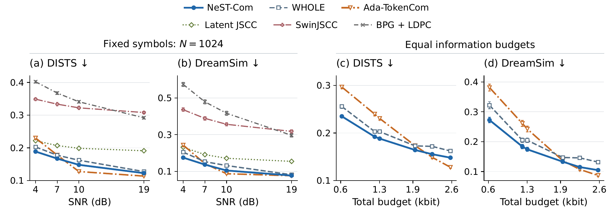
Fig. 2. Source-referenced reconstruction on 500 ImageNet images. (a,b) Six methods at $N=1024;$ WHOLE, NeST and Ada share the 12-MCS calibration procedure. Three outcomes per source include gray failures. (c,d) Equal, error-free information budgets pay 57 shared protocol bits and Ada’s additional 10-bit class; WHOLE/NeST share ceiling $(10,0).$ Points and bars are equal-source means and pointwise 95% source-bootstrap intervals after within-source averaging. Ada-TokenCom is the predicted-class, fixed-frame adaptation. Lower values are favorable.

A. Experimental Setup
The common500 ImageNet validation sources [9] are disjoint from cal1000, with fixed $256×256$ preprocessing. We test $N=1024$ at 4/7/10/19 dB and $N=512$ at 4/10/19 dB. Three realizations, including gray failures, are averaged per source before equal-source means and direct paired 95% bootstrap intervals (10 000 source resamples). Controls use fixed control100 identities. Newly calibrated token systems and matched-grid controls share noise; reused external systems retain their historical streams.
Latent JSCC maps tokenizer latents to symbols and shares $D_{c}$ (MSE, LPIPS and latent-consistency losses, 100k updates). SwinJSCC [10] uses RGB MSE (200k updates, calibration-MSE selection). Both train on 20 000 images at $N=1024.$ BPG [11] uses LDPC/QAM. Ada-TokenCom [3] is a predicted-class, fixed-frame adaptation: LlamaGen-L/VQ16, prefix arithmetic coding, CFG=4, $T=1,$ top-$k=2000,$ top-$p=1,$ and a paid 10-bit ConvNeXt class. Long-term control and ARQ are excluded. Supplement S1 specifies training, numerical routes and our ARPC digital adaptation.
DISTS [12] and DreamSim [13] assess source-referenced perceptual reconstruction; PSNR, LPIPS-Alex [14] and CLIP-I [15] complete the evaluation. Metrics use native float RGB, with fixed preprocessing (S1). Timing uses 32 sources, two warmups and three measurements, batch one, one RTX PRO 6000 and two physical CPU cores. Synchronized in-memory RGB-to-symbols and symbols-to-RGB spans include coding, link processing and generation, excluding loading, I/O and scoring. S7 identifies each measured policy.
Table I. Within-scale transmission. (A) Shared-model NeST–WHOLE differences. (B) Matched endpoint granularity. (C) Ordered receiver interventions. Brackets are source-paired 95% intervals; sample sizes are specified for each block.
(A) 500 sources, N = 1024, uniformly calibrated policies
SNR | Util. W→N (%) | ΔDISTS [95% CI] | ΔDreamSim [95% CI]
4 | 73.81 → 99.56 | -0.0142  [-0.0155, -0.0127] | -0.0297  [-0.0330, -0.0264]
7 | 83.19 → 99.71 | -0.0103  [-0.0139, -0.0068] | -0.0159  [-0.0207, -0.0112]
10 | 77.70 → 99.79 | -0.0141  [-0.0153, -0.0128] | -0.0270  [-0.0299, -0.0241]
19 | 85.24 → 99.83 | -0.0048  [-0.0053, -0.0043] | -0.0043  [-0.0051, -0.0036]
(B) 100 quality sources; 32 timing sources; ceiling (8,126)
Grid | Utilization (%) | DISTS | DreamSim | TX (ms)
Whole | 78.13 | 0.1650 | 0.1387 | 185.2
Quarter | 95.19 | 0.1535 | 0.1143 | 215.8
Eighth | 97.44 | 0.1516 | 0.1137 | 217.8
Token | 99.85 | 0.1505 | 0.1115 | 248.4
(C) 100 sources, 10 dB, same received prefixes
Intervention | ΔPSNR (dB) | ΔDISTS | ΔDreamSim
B0−A0 | +0.287  [0.240, 0.335] | -0.0062  [-0.0077, -0.0048] | -0.0113  [-0.0147, -0.0083]
C0−B0 | +0.537  [0.404, 0.682] | -0.0083  [-0.0102, -0.0065] | -0.0159  [-0.0205, -0.0116]
A0: prior completion without received boundary tokens. B0: A0 plus boundary residual correction. C0: B0 plus updated finer-scale conditioning.

B. Within-Scale Fitting and Granularity
Table I(A) compares NeST with WHOLE using shared tokenizer, prior, coder and receiver under the frozen family policies. Across seven budget/SNR settings, all five metrics favor NeST in the paired intervals. At $N=1024,$ 10 dB, source-bit capacity utilization rises from 77.70% to 99.79%, DISTS falls from 0.1621 to 0.1481, and DreamSim from 0.1317 to 0.1048. PSNR gains span 0.49–0.88 dB across the four $N=1024$ points.
To isolate endpoint granularity, Block B fixes model, 16-QAM rate 2/3, ceiling $(8,126),$ fitting rule and noise. Within-scale grids convert unused capacity into better reconstruction. Eighth retains approximately 92% of the Whole-to-Token gain in PSNR, DISTS and DreamSim. Token raises utilization from 97.44% to 99.85% and adds 0.066 [0.034, 0.101] dB PSNR, with DISTS/DreamSim differences −0.0011 [−0.0020, −0.0002]/−0.0022 [−0.0042, −0.0001], at 30.7 ms additional TX processing. Eighth thus offers a lower-cost option; Token retains the most feasible source tokens.
At $N=512,$ 10 dB, a second matched control fixes the same 100 sources, three noise realizations, model, receiver, 16-QAM rate 2/3 and ceiling $(7,0).$ Token–Whole improves PSNR by 0.534 [0.446, 0.625] dB; Eighth–Whole gives 0.464 [0.383, 0.547] dB, retaining about 87% of the mean gain. Token–Eighth adds 0.070 [0.029, 0.115] dB and improves LPIPS/DreamSim, while DISTS/CLIP-I intervals cross zero (S3). Finer termination thus remains useful at the reduced budget.
Block C verifies VAR’s adopted overwrite/conditioning mechanism through ordered interventions on the same actual NeST prefixes. A0 completes boundary and finer maps without received boundary tokens. B0 adds their residual correction while retaining A0’s finer-scale conditioning; C0 also updates that conditioning. At 10 dB, B0–A0 improves PSNR by 0.287 dB and reduces DreamSim by 0.0113; C0–B0 adds 0.537 dB and a 0.0159 reduction. Paired intervals favor both stages for these metrics and DISTS. Supplement S3 includes 7 dB and the final-scale case, where no finer-scale propagation remains.

C. Perceptual Reconstruction and Processing Cost
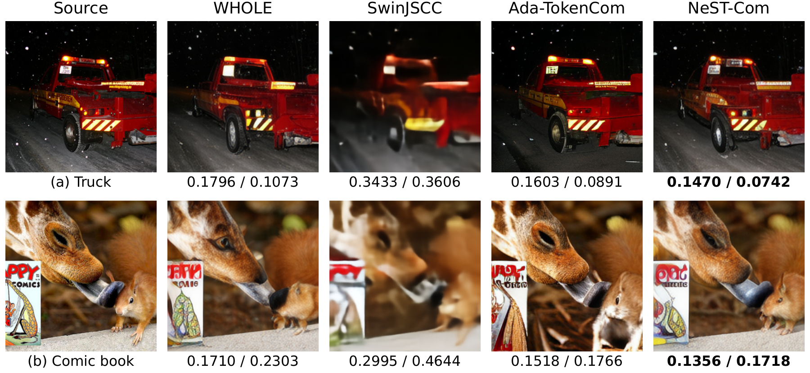
Fig. 3. Selected reconstructions at $N=1024$ and 10 dB. WHOLE, NeST and the predicted-class fixed-frame Ada-TokenCom adaptation use the policies in Table IV. Values are full-image DISTS$↓$ / DreamSim$↓$ for each method’s first prescribed realization. Supplement S6 gives the fixed source identities, selection details and additional examples.
Table II. Auxiliary quality on common500 at N=1024, 10 dB. Means include three realizations per source and gray failures. Policy-specific timing is reported separately in S7.
Method | PSNR↑ (dB) | LPIPS↓ | CLIP-I↑
WHOLE | 19.31 | 0.199 | 0.858
NeST-Com | 20.19 | 0.166 | 0.877
Ada-TokenCom | 19.56 | 0.167 | 0.884
Latent JSCC | 20.80 | 0.173 | 0.789
SwinJSCC | 23.03 | 0.469 | 0.669
BPG + LDPC | 22.54 | 0.589 | 0.635
Fig. 2(a,b) compares six methods under the same per-image symbol constraint, with WHOLE providing the shared-model reference. Comparisons to other systems reflect their combined representation, coding and receiver choices. At all four $N=1024$ SNRs, NeST has lower DISTS and DreamSim than SwinJSCC, Latent JSCC and BPG: all 24 paired intervals exclude zero. SwinJSCC and BPG have higher PSNR throughout, showing a pixel-fidelity/perceptual-similarity tradeoff at the same symbol budget.
Against Ada, NeST improves both distances at 4 dB and DISTS at 7 dB; at 7 dB, the DreamSim difference interval crosses zero. Ada yields lower distances at 10 dB and lower DISTS at 19 dB, where DreamSim again crosses zero. NeST has higher PSNR throughout. At 7 dB, WHOLE/NeST/Ada reject 11/7/10 of 1500 receptions each; NeST rejects one at 4 dB, with zero rejections at the other token-system points and no NULL outputs. These gray reconstructions remain in all means. Table II and Supplement S2 report auxiliary metrics.
Fig. 2(c,d) compares the three token systems without channel errors at six equal information budgets, 620–2577 bits, separating source-rate behavior from link reliability. Totals pay 57 shared overhead bits plus Ada’s 10-bit class. WHOLE/NeST share ceiling $(10,0);$ Ada permits 256 tokens and averages three generation repeats per source. NeST improves all five metrics over WHOLE throughout. Against Ada, DISTS favors NeST at the four smallest budgets and DreamSim at the first three; the 1940-bit DreamSim interval crosses zero. Ada has lower distances at 2248/2577 bits.
Ada’s completion rule also affects quality. Under the earlier frozen policies, on 100 fixed sources with identical received prefixes and model components, replacing sampling by argmax increases DreamSim by 0.0450 [0.0282, 0.0621], 0.0345 [0.0232, 0.0461] and 0.00358 [0.00101, 0.00601] at $N$/SNR=512/4, 512/10 and 1024/10, respectively (Supplement S3).
In the two selected cases in Fig. 3, NeST better preserves the truck markings and foreground contours than WHOLE. Its DISTS/DreamSim are lower than all displayed comparators, while SwinJSCC has higher PSNR. S6 provides source identities, the selection rule and broader examples.
With the earlier $N=1024$/10-dB policies (S7), NeST’s mean TX/RX costs are 248.44/403.99 ms, versus 215.29/366.42 ms for WHOLE (32 sources, one RTX PRO 6000, two physical CPU cores). These spans include complete RGB-to-symbol and symbol-to-RGB processing. Compiled Ada’s 3.064-s total and corresponding 32-source quality are reported separately in S7.4–S7.5.

D. Reduced Budget and Transfer to Kodak
Table III. Reduced-budget reconstruction on 500 sources at N=512. Means include all failures; PSNR differences use direct source-paired 95% intervals. All five metrics and paired comparisons are in Supplement S2.
SNR / method | PSNR↑ (dB) | DISTS↓ | DreamSim↓
4 / WHOLE | 15.11 | 0.2580 | 0.3247
4 / NeST-Com | 15.61 | 0.2363 | 0.2740
4 / Ada-TokenCom | 11.32 | 0.2996 | 0.3847
NeST−WHOLE ΔPSNR: +0.504 [0.440, 0.573] dB
10 / WHOLE | 16.82 | 0.2030 | 0.2049
10 / NeST-Com | 17.41 | 0.1922 | 0.1837
10 / Ada-TokenCom | 13.16 | 0.2367 | 0.2582
NeST−WHOLE ΔPSNR: +0.592 [0.544, 0.643] dB
19 / WHOLE | 18.64 | 0.1718 | 0.1458
19 / NeST-Com | 19.63 | 0.1554 | 0.1150
19 / Ada-TokenCom | 17.69 | 0.1496 | 0.1078
NeST−WHOLE ΔPSNR: +0.994 [0.940, 1.048] dB
Table IV. Frozen policies: MCS (q,r) (bits/symbol, code rate) and target ceiling e, with feasible fallback. Ada's ceiling is 256 tokens. Budgets are calibrated independently.
N / SNR | WHOLE MCS | WHOLE ceiling | NeST MCS | NeST ceiling | Ada MCS
1024/4 | 2,2/3 | (7,0) | 2,2/3 | (7,25) | 2,2/3
1024/7 | 4,1/2 | (8,0) | 4,1/2 | (8,0) | 4,1/2
1024/10 | 4,2/3 | (9,0) | 4,2/3 | (8,126) | 4,2/3
1024/19 | 6,5/6 | (10,0) | 6,5/6 | (10,0) | 4,5/6
512/4 | 2,2/3 | (6,0) | 2,2/3 | (5,27) | 2,2/3
512/10 | 4,2/3 | (7,0) | 4,2/3 | (7,0) | 4,2/3
512/19 | 6,5/6 | (8,0) | 6,5/6 | (8,84) | 6,5/6
At $N=512,$ all five NeST–WHOLE intervals favor NeST at each SNR, with PSNR gains of 0.50–0.99 dB. At 10 dB both use target $(7,0)$ and 16-QAM rate 2/3; utilization rises from 79.30% to 99.54%. Against Ada, NeST has higher PSNR and lower LPIPS throughout, and lower DISTS/DreamSim at 4/10 dB. Ada is better on both distances at 19 dB: NeST–Ada differences are 0.0058 [0.0036, 0.0079] and 0.0072 [0.0037, 0.0106]. Supplement S2 gives CLIP-I and rejection counts.
With the earlier ImageNet-calibrated policies, Kodak24 center crops give Token–WHOLE PSNR gains of 0.567/0.794/0.405 dB at 4/10/19 dB and favorable DISTS/DreamSim intervals throughout. Against Ada, Token has lower distances at 4 dB; Ada has lower DISTS at 10/19 dB, where DreamSim intervals cross zero. All 864 events succeed (S8).

E. Operation Near the Channel Threshold
With the earlier 10-dB policies fixed, 100 sources and 20 noise realizations per point yield 30 000 receptions over 8–10 dB. All three methods reject every frame at 8 dB. WHOLE/NeST/Ada rejection rates are 15.75/14.95/13.50% at 9 dB, 0.10–0.20% at 9.5 dB and zero observed at 10 dB. Gray failures enter overall quality (S5). Reconstruction gains require a sufficiently reliable digital link.

IV. Conclusion
NeST-Com fits independently terminated within-scale prefixes to fixed digital frames while retaining scale-wise prediction. Matched controls show how finer endpoints convert unused capacity into improved reconstruction at additional processing cost. Complete-system comparisons show favorable source-referenced reconstruction at tight budgets, with perceptual rankings depending on budget and receiver choice.

References
[1] K. Tian, Y. Jiang, Z. Yuan, B. Peng, and L. Wang, “Visual autoregressive modeling: Scalable image generation via next-scale prediction,” in Advances in Neural Information Processing Systems, vol. 37, 2024, pp. 84 839–84 865.
[2] Z. Zhang, Y. Xia, B. Chen, T. Zhang, H. Wang, and H. Qiu, “Autoregressive-based progressive coding for ultra-low bitrate image compression,” in Int. Conf. Learning Representations, 2026.
[3] Z. Zhang, L. Qiao, M. B. Mashhadi, Z. Gao, M. Bennis, and K. Huang, “Ada-TokenCom: Rate-adaptive token communications via large-model-driven token compression and generation,” 2026, arXiv:2608.28086.
[4] Q. Yan et al., “ResARC: Residual-aware autoregressive coding for ultra-low bitrate image compression,” arXiv:2609.39451v1, 2026.
[5] V. Chande and N. Farvardin, “Progressive transmission of images over memoryless noisy channels,” IEEE J. Sel. Areas Commun., vol. 18, no. 6, pp. 850–860, Jun. 2000, doi: 10.1109/49.848239.
[6] I. H. Witten, R. M. Neal, and J. G. Cleary, “Arithmetic coding for data compression,” Commun. ACM, vol. 30, no. 6, pp. 520–540, Jun. 1987, doi: 10.1145/214762.214771.
[7] 3GPP, “NR; Multiplexing and channel coding,” TS 38.212, ver. 16.5.0, Release 16, 2021. [Online]. Available: https:/​/​www.etsi.org/​deliver/​etsi_​ts/​138200_​138299/​138212/​16.05.00_​60/​ts_​138212v160500p.pdf
[8] M. Oquab et al., “DINOv2: Learning robust visual features without supervision,” Trans. Mach. Learn. Res., Jan. 2024. [Online]. Available: https:/​/​openreview.net/​forum?id=a68SUt6zFt
[9] O. Russakovsky et al., “ImageNet large scale visual recognition challenge,” Int. J. Comput. Vis., vol. 115, no. 3, pp. 211–252, 2015.
[10] K. Yang, S. Wang, J. Dai, X. Qin, K. Niu, and P. Zhang, “SwinJSCC: Taming Swin Transformer for deep joint source-channel coding,” IEEE Trans. Cogn. Commun. Netw., vol. 11, no. 1, pp. 90–104, Feb. 2025.
[11] F. Bellard, “BPG image format,” accessed Oct. 22, 2026. [Online]. Available: https:/​/​bellard.org/​bpg/​
[12] K. Ding, K. Ma, S. Wang, and E. P. Simoncelli, “Image quality assessment: Unifying structure and texture similarity,” IEEE Trans. Pattern Anal. Mach. Intell., vol. 44, no. 5, pp. 2567–2581, May 2022, doi: 10.1109/TPAMI.2020.3045810.
[13] S. Fu, N. Tamir, S. Sundaram, L. Chai, R. Zhang, T. Dekel, and P. Isola, “DreamSim: Learning new dimensions of human visual similarity using synthetic data,” in Advances in Neural Information Processing Systems, vol. 36, 2023, pp. 50 742–50 768.
[14] R. Zhang, P. Isola, A. A. Efros, E. Shechtman, and O. Wang, “The unreasonable effectiveness of deep features as a perceptual metric,” in Proc. IEEE Conf. Comput. Vis. Pattern Recognit., Jun. 2018, pp. 586–595.
[15] A. Radford et al., “Learning transferable visual models from natural language supervision,” in Proc. 38th Int. Conf. Mach. Learn., vol. 139, 2021, pp. 8748–8763.

