NeST-Com: Fixed-Budget Next-Scale Token Communication
Anonymous Authors
Abstract
NeST-Com uses next-scale residual tokens for digital image communication under a fixed per-image symbol budget. Within-scale endpoints fit independently terminated entropy-coded prefixes to available payloads; received boundary tokens update residual reconstruction and finer-scale prediction. Against whole-scale transmission with shared models at 512 and 1024 symbols, LPIPS and DreamSim decrease at all matched SNRs, with PSNR gains of 0.32–0.79 dB. At 1024 symbols and 10 dB, source-bit utilization rises from 77.70% to 95.21%, while LPIPS and DreamSim fall by 13.7% and 18.3%. Complete-system comparisons characterize the resulting quality tradeoffs.

Index terms
Semantic communication, next-scale tokens, fixed-budget transmission, generative reconstruction.

I. Introduction
A fixed per-image channel-symbol budget must accommodate source information, signaling, and channel protection. Digital coding and learned joint source–channel coding (JSCC) address this constraint through different representations [1, 2]. With a generative receiver, delivered information constrains reconstruction to the source image while a learned prior predicts untransmitted content. Efficient communication depends on both retaining useful information within the frame and using it during reconstruction.
Next-scale tokenization organizes an image into complete coarse maps followed by residual refinements. Each resized coarse map covers the full latent grid, providing a basis for finer-scale prediction. Visual autoregressive modeling (VAR) reported state-of-the-art class-conditional ImageNet generation results [7], motivating its use as a completion prior. ARPC uses next-scale entropy coding and scale completion for progressive image compression [6]. Ada-TokenCom couples next-token prefix coding and tail generation with wireless resource adaptation [4]; TONIC studies task-oriented token transmission [5]. We develop next-scale image communication under a hard symbol budget for each image.
Adapting progressive descriptions to channel resources is a classical communication problem [3]. Next-scale boundaries can leave usable frame capacity: a complete map may not fit although a subset of its tokens would. Entropy-code lengths vary across images, so fitting requires actual decodable lengths. The resulting incomplete boundary map must then contribute to residual reconstruction and to the conditions for predicting finer scales.
NeST-Com addresses these requirements through within-scale endpoints, actual-length fitting, and prefix-constrained reconstruction. Both terminals obtain boundary coding probabilities from complete coarse maps. Independently finalized arithmetic prefixes provide decodable candidates; received tokens overwrite boundary predictions [7], and the merged map updates residual accumulation and finer-scale conditioning. Shared-model experiments show lower LPIPS and DreamSim than whole-scale transmission at all six matched budget/SNR points. At 1024 symbols and 10 dB, source-bit utilization rises from 77.70% to 95.21%, with LPIPS and DreamSim reductions of 13.7% and 18.3%. Endpoint controls and receiver interventions explain these gains; system comparisons include digital adaptations of ARPC and Ada-TokenCom under the same frame budget.

II. Proposed NeST-Com Framework

A. Next-Scale Representation and Digital Frame
We transmit $x∈[0,1]^{256×256×3}$ over complex AWGN,
$$y=s+n, n∼CN(0,σ^{2}I_{N}), SNR=10\log_{10}(E_{s}/σ^{2}), \text{(1)}$$
using $N$ complex symbols per image and nominal $E_{s}=2.$ TX selects a frozen policy for the channel SNR; RX uses the true noise variance for LLRs. Digital constellations have average energy two without per-frame renormalization. Continuous JSCC data are normalized per image to average energy two, with required Swin side information paid within $N.$ A 12-bit profile ID, CRC16, and terminated rate-1/2 convolutional code occupy 68 rotated-BPSK symbols $\{±(1+j)\}.$ The remaining $N−68$ symbols carry the LDPC-coded body. After rate matching, a public frame-dependent scrambling mask is applied before QAM modulation and reversed at the receiver before LDPC decoding. The paid profile identifies the actual endpoint and MCS. Our main budget is $N=1024;$ the reduced-budget experiment uses $N=512$ without increasing $E_{s}.$
The frozen VAR tokenizer produces ten residual token maps $q_{s},$ with side lengths $(1,2,3,4,5,6,8,10,13,16)$ and a 4096-entry codebook [7]. Let $h_{s}$ denote the side length, $L_{s}=h_{s}^{2}$ the number of positions, and $C_{s}$ the scale-dependent codebook lookup, resizing, and residual transform. Complete coarse maps span the whole latent grid after resizing; the sum fq=s​Cs(qs) accumulates their residual refinements. Image decoder $D_{c}$ is adapted on 20 000 ImageNet training images with MSE plus $0.1$ LPIPS, then fixed. Its inputs mix continuous, fully quantized, and interpolated prefix-completed latents in proportions 50/25/25%; the last interpolate between a continuous latent and completion from the first eight source scales (Supplement S1). NeST-Com uses null-class conditioning. Its frozen VAR-d16 prior factorizes [7] as
$$p_{θ}(q_{s}∣q_{<s})=\prod_{i=1}^{L_{s}}{p_{θ}}(q_{s,i}∣q_{<s}), \text{(2)}$$
All positions in a scale obtain coding probabilities from the same complete coarse maps. RX can therefore construct boundary-scale cumulative distribution functions (CDFs) without any unreceived same-scale token. Both terminals use the same integer CDFs, with total frequency $2^{24},$ for arithmetic coding [8] of the within-scale subset (Fig. 1; Supplement S1.1).
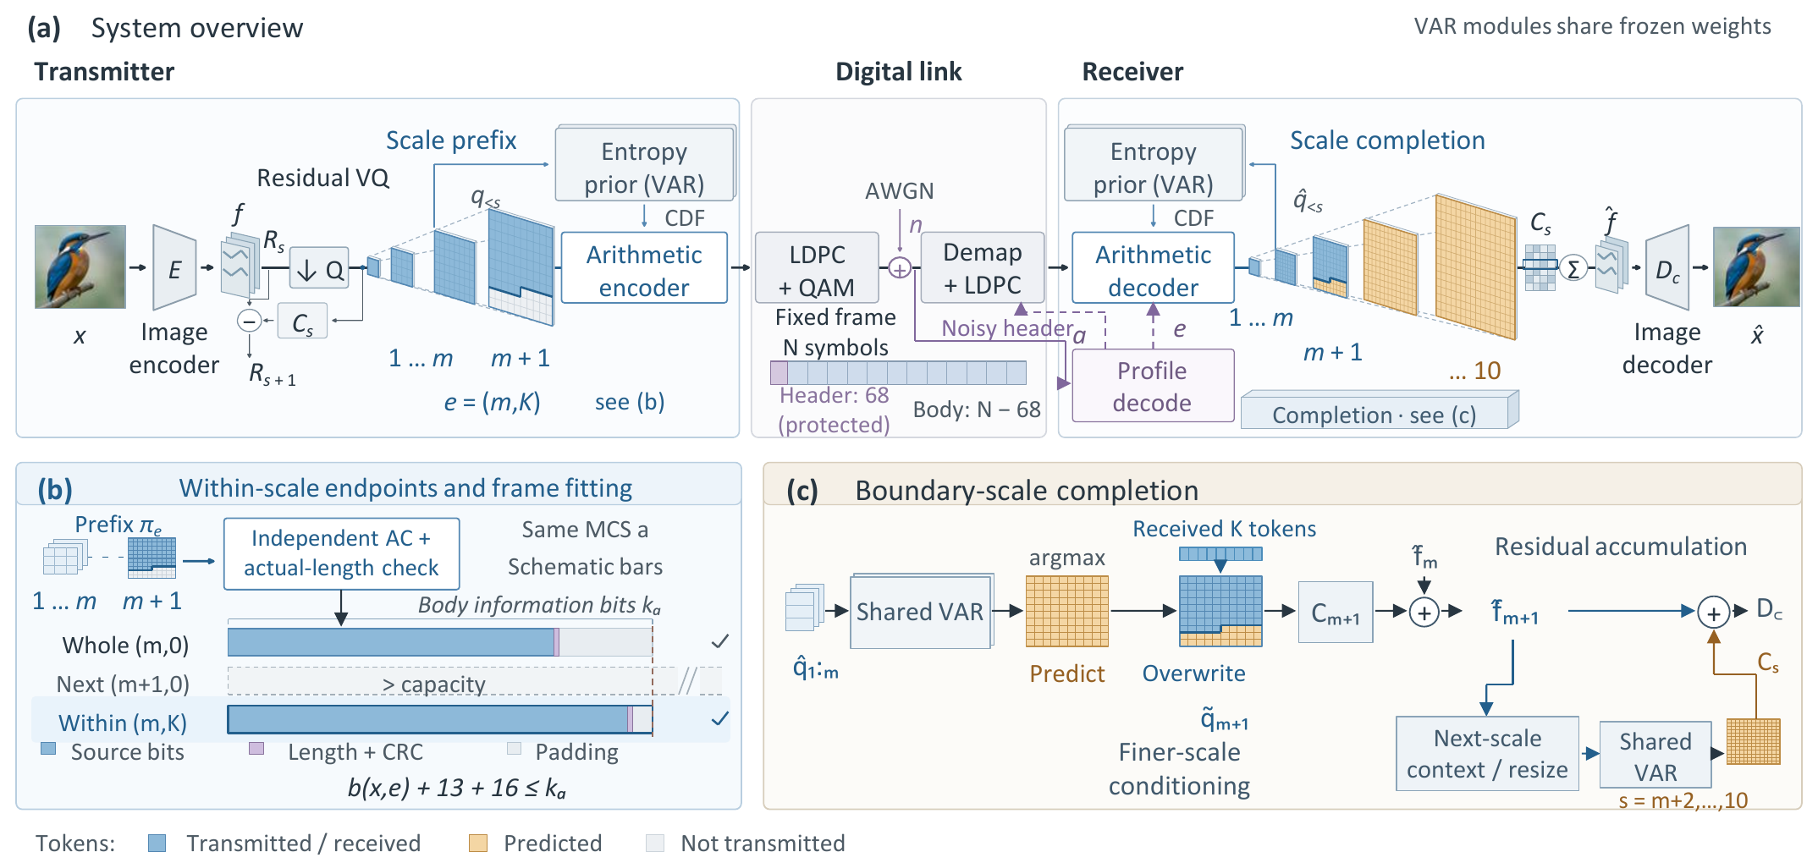
Fig. 1. NeST-Com: (a) The protected profile and body share the fixed noisy frame; both terminals reconstruct coding probabilities from the shared frozen VAR and known coarse tokens. (b) Candidate prefixes share the coding traversal and are finalized independently for actual-length fitting. Bars are schematic for the same MCS. (c) Received tokens overwrite boundary predictions; the merged map updates the residual latent and finer-scale context.

B. Within-Scale Endpoints and Actual-Length Fitting
An endpoint $e=(m,K)$ retains complete coarse maps and $K$ raster-ordered positions from the next map:
$$π_{e}=(q_{1},…,q_{m},q_{m+1,1:K}). \text{(3)}$$
The fixed raster order identifies received positions from the endpoint alone, without a position mask. For $K=0,$ the boundary tail is absent. WHOLE permits $K=0$ for $m=4,…,10.$ Our main PARTIAL configuration uses a Quarter grid, adding $K∈\{⌊L_{m+1}/4⌋,⌊L_{m+1}/2⌋,⌊3L_{m+1}/4⌋\}$ for $m=4,…,9,$ giving 25 endpoints in total. $(10,0)$ is the full representation.
For MCS $a=(M,r),$ the coded body has $n_{a}=(N−68)\log_{2}M$ bits and information length $k_{a}=⌊rn_{a}⌋.$ With actual terminated arithmetic length $b(x,e),$
$$b(x,e)+29≤k_{a}, η(x,e)=\frac{b(x,e)}{k_{a}−29}. \text{(4)}$$
The endpoint specifies retained source tokens; its actual terminated length determines frame feasibility. The 29 bits comprise the 13-bit length field and CRC16; unused information positions are zero-padded before 5G NR LDPC coding, rate matching [9], and QAM. Thus $η$ measures source-bit capacity utilization, not total over-the-air efficiency.
Offline calibration selects a target endpoint and MCS separately for each budget and SNR on an independent image set. It maximizes source/reconstruction DINOv2 cosine [10], averaged first over channel realizations and then equally over sources. The selected policy is frozen for testing; candidate pools and screening rules are given in Supplement S1; targets and MCSs are in S1.1.
Candidate prefixes share one scale-wise probability and incremental arithmetic-coding traversal. Non-mutating finalization produces an independently terminated stream at each legal endpoint; no stream is cut from a longer one. With the calibrated MCS fixed, TX checks endpoints no longer than the target in decreasing token count down to $(4,0)$ and selects the first satisfying (4). This retains the most tokens among feasible candidates without assuming monotone code lengths or optimizing per-image distortion. If none fits, a paid NULL profile and short payload occupy the full frame and yield gray. Supplement S7 gives the versioned no-fit handling and its protocol checks.

C. Prefix-Constrained Reconstruction
Invalid profile CRC/catalogue, body CRC, declared length, known padding, or arithmetic parsing produces a fixed gray image; so does a valid NULL reception. Otherwise, RX decodes the prefix using CDFs rebuilt from received complete coarse maps. It predicts the boundary map by VAR argmax conditioned on those maps, then applies known-token overwrite [7]:
$${\tilde{q}}_{m+1,i}=\left\{\begin{matrix}{\hat{q}}_{m+1,i}, & i≤K, \\ q_{m+1,i}^{pred}, & i>K.\end{matrix}\right. \text{(5)}$$
Unreceived boundary positions retain their coarse-conditioned prediction. Received boundary tokens serve two roles: they correct the residual representation and, through the merged boundary map, condition the prediction of finer scales. Complete received maps remain unchanged; subsequent maps are generated from this updated context. Reconstruction is
$$\hat{x}=D_{c}​\left(\sum_{s=1}^{10}{C_{s}}({\tilde{q}}_{s})\right). \text{(6)}$$
At the final scale, overwrite changes the residual contribution without any subsequent propagation.

III. Experimental Results
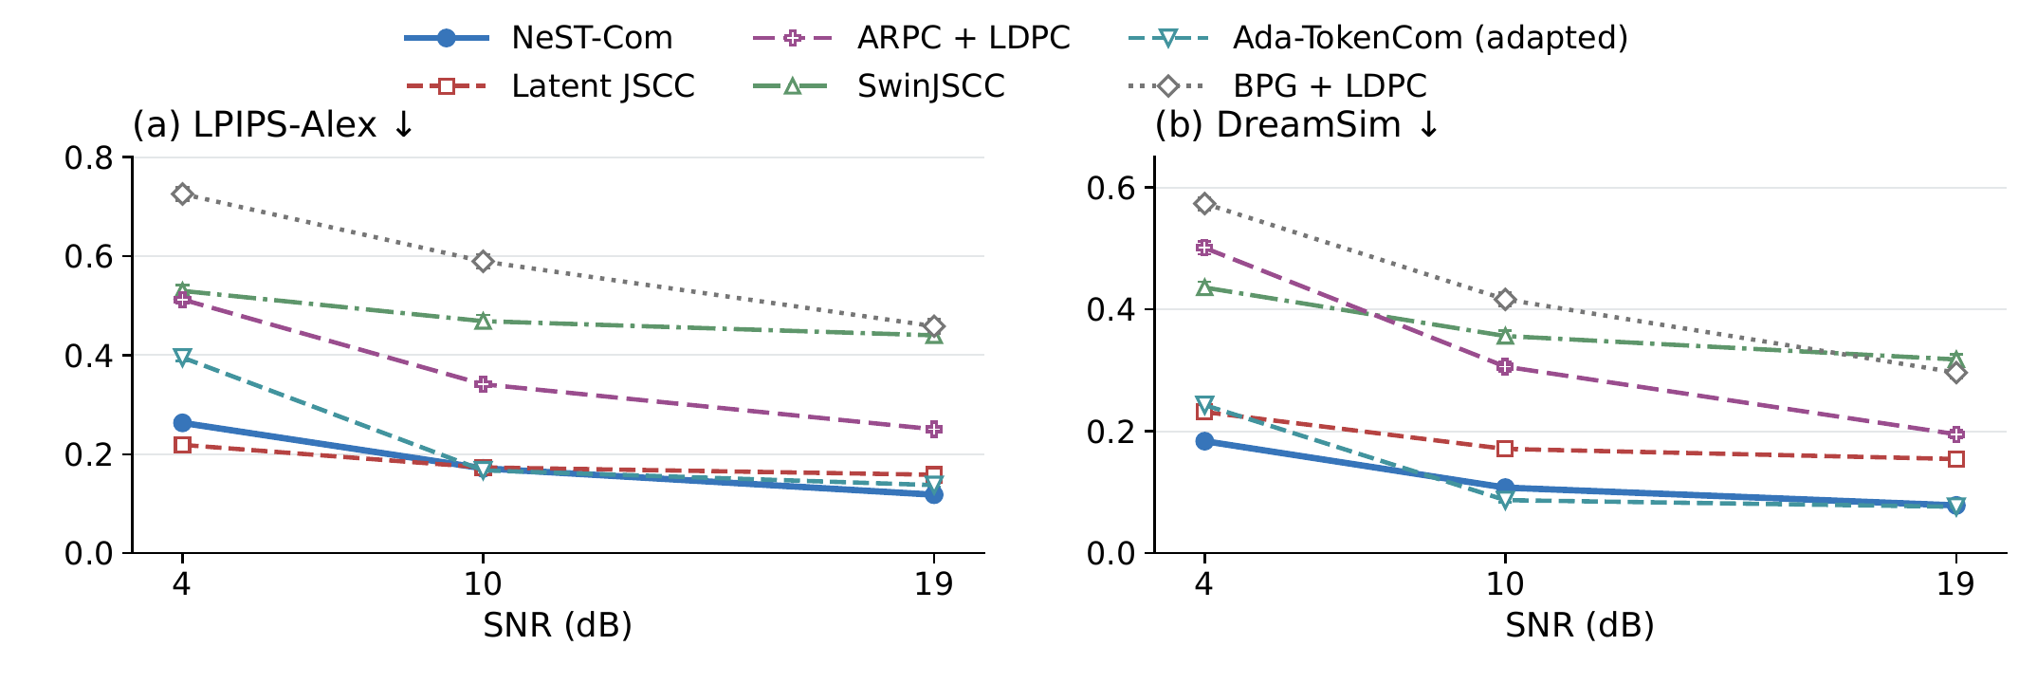
Fig. 2. Source-referenced perceptual distances on common500 at $N=1024.$ Points and error bars are equal-source means and pointwise 95% source-bootstrap intervals after averaging three channel outcomes per source. Lower LPIPS-Alex and DreamSim are favorable. Ada denotes the predicted-class, fixed-frame adaptation.

A. Experimental Setup
We use common500 ImageNet validation images [11], a disjoint cal1000 set, and Kodak24 [12], with fixed $256×256$ preprocessing. ImageNet-calibrated policies remain fixed on Kodak. The six-system main study uses $N=1024;$ NeST, WHOLE, and Ada also use $N=512,$ each calibrated separately at 4/10/19 dB.
Our convolutional Latent JSCC maps tokenizer latents to symbols and shares $D_{c},$ using MSE, LPIPS, and latent-consistency losses with a 100k-update checkpoint. SwinJSCC [2] is trained for 200k updates with RGB MSE and selected by minimum mean calibration MSE. Both use 20 000 training images and are adapted to $256×256$ and $N=1024.$ Digital baselines include adaptive BPG [13] + LDPC. We implement ARPC [6] with LDPC/QAM and adapt Ada-TokenCom [4] to fixed frames, counting captions, classes, and protocol overhead within the symbol budget. Ada retains LlamaGen-L/VQ16 and prefix arithmetic coding, with a fixed ConvNeXt predicting a paid 10-bit class. Its sampled tail uses CFG=4, $T=1,$ top-$k=2000,$ and top-$p=1$ (Supplement S1.2).
At both budgets, NeST, WHOLE, and Ada select QPSK rate 2/3, 16-QAM rate 2/3, and 64-QAM rate 5/6 at 4/10/19 dB. In that order, NeST/WHOLE targets are $(7,25)/(7,0),$ $(8,126)/(9,0),$ and $(10,0)/(10,0)$ at $N=1024;$ they are $(5,27)/(6,0),$ $(7,0)/(7,0),$ and $(8,84)/(8,0)$ at $N=512.$ Ada permits up to 256 tokens before fitting.
The primary reconstruction measures are source-referenced LPIPS-Alex [14] and DreamSim [15]. PSNR measures pixel fidelity, and CLIP ViT-L/14 image–image cosine (CLIP-I) measures feature similarity [16]. Frozen FP32 preprocessing uses $224×224$ bicubic-antialias inputs for DreamSim/CLIP. We average three channel outcomes per image, including gray failures, before computing equal-source means and direct source-paired 95% bootstrap intervals (10 000 resamples). The endpoint and receiver controls use a fixed 100-image subset.

B. Effect of Within-Scale Transmission
Table I. Within-scale endpoint and receiver evidence. (A) Main common500 policies, PARTIAL minus WHOLE. (B) Fixed 100-source model/MCS/maximum-endpoint control. (C) Ordered interventions on the same 100 sources and actual prefixes. Brackets give source-paired 95% CIs.
(A) Main policies at N = 1024
SNR | Util. W→P (%) | ΔLPIPS [95% CI]
4 | 73.81 → 93.08 | -0.0246 [-0.0262, -0.0230]
10 | 77.70 → 95.21 | -0.0273 [-0.0296, -0.0249]
19 | 85.24 → 94.73 | -0.0052 [-0.0056, -0.0048]
(B) Fixed-granularity diagnostic, 10 dB
Grid (candidates) | Utilization (%) | LPIPS
Whole (7) | 78.15 | 0.2018
Half (13) | 89.21 | 0.1838
Quarter (25) | 95.38 | 0.1752
Eighth (49) | 97.39 | 0.1729
(C) Receiver interventions: ΔLPIPS [95% CI]
SNR | B0−A0 | C0−B0
10 | -0.0100  [-0.0120, -0.0080] | -0.0166  [-0.0205, -0.0129]
19 | -0.0051  [-0.0060, -0.0043] | +0.0000  [0.0000, 0.0000]
Boundary tokens: A0, unused; B0, residual correction only; C0, residual correction and conditioning update. All three use the received complete coarse scales.
Table I(A) compares WHOLE and NeST-Com (PARTIAL) with a shared tokenizer, prior, entropy coder, and $D_{c}.$ Their separately calibrated policies select the same MCS at each SNR. At $N=1024,$ 10 dB, within-scale transmission increases source-bit utilization from 77.70% to 95.21%. Mean LPIPS decreases from 0.198718 to 0.171465, and DreamSim from 0.131728 to 0.107680, corresponding to relative metric reductions of 13.7% and 18.3%. The paired DreamSim difference is −0.0240 [−0.0270, −0.0212]. Both distances improve at all three SNRs, with PSNR gains of 0.32–0.70 dB (Supplement S2.4). Kodak also has lower LPIPS at all three SNRs under the unchanged ImageNet policies (S2.5).
Block B fixes the 100 sources, model, MCS, maximum endpoint, and fitting rule. Whole-to-Eighth refinement raises utilization from 78.15% to 97.39% and lowers LPIPS from 0.201821 to 0.172939. Compared with the predefined Quarter grid, Eighth reduces LPIPS by 0.00223 [0.00131, 0.00323] and increases PSNR by 0.123 [0.079, 0.169] dB. Its DreamSim difference is −0.00073 [−0.00196, 0.00048]. Both grids use ten prior-scale calls and one 680-token coding traversal, with 25/49 independent finalizations, respectively (Supplement S5.1).
Block C uses identical actual received prefixes to examine how boundary information affects reconstruction. At 10 dB, adding residual correction (B0–A0) reduces LPIPS by 0.01003; then updating finer-scale conditioning (C0–B0) reduces it by a further 0.01662. The corresponding DreamSim differences are −0.00845 [−0.01136, −0.00564] and −0.01537 [−0.01988, −0.01111]. These ordered interventions show how the additional source tokens constrain perceptual reconstruction. At 19 dB the boundary lies in the final scale, so the conditioning update has zero effect.
With the 10-dB WHOLE/PARTIAL policies frozen, both methods reject all 300 receptions at an actual SNR of 8 dB and none at 10/12 dB. Their recovered prefixes and per-source reconstructions coincide between 10 and 12 dB, preserving the within-scale gain after successful delivery (Supplement S5).

C. Comparison With Existing Methods
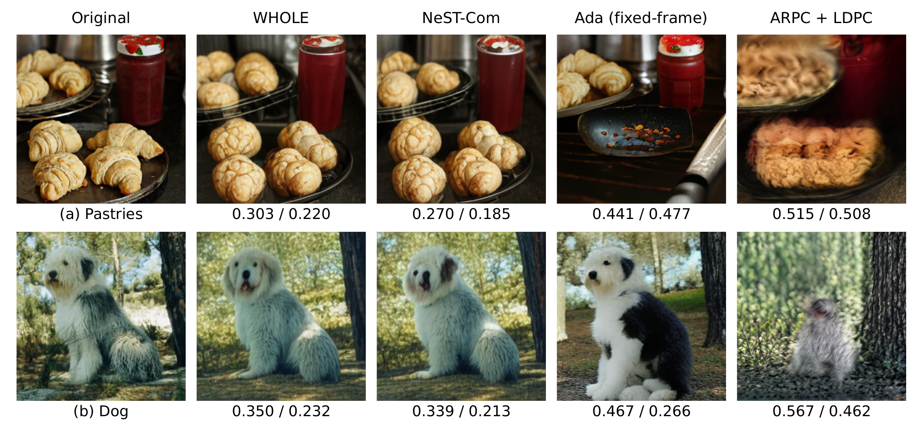
Fig. 3. Qualitative reconstructions of two fixed development examples at $N=1024$ and 4 dB. Values denote LPIPS-Alex$↓$ / DreamSim$↓$ for each displayed realization. Ada denotes the predicted-class, fixed-frame adaptation.
Table II. Pixel fidelity and image-feature similarity on common500 at N=1024. Each cell is PSNR (dB)↑ / CLIP-I↑. Ada denotes the fixed-frame adaptation. Values are source means.
Method | 4 dB | 10 dB | 19 dB
NeST-Com | 17.448 / 0.821 | 20.014 / 0.873 | 22.164 / 0.900
Latent JSCC | 19.658 / 0.741 | 20.803 / 0.789 | 21.245 / 0.804
SwinJSCC | 21.671 / 0.627 | 23.026 / 0.669 | 23.698 / 0.697
BPG + LDPC | 20.743 / 0.586 | 22.543 / 0.635 | 24.230 / 0.684
ARPC + LDPC | 14.184 / 0.644 | 16.471 / 0.713 | 18.199 / 0.788
Ada (adapted) | 13.332 / 0.828 | 19.559 / 0.884 | 20.938 / 0.892
Fig. 2 compares the six complete systems at $N=1024.$ NeST has lower mean LPIPS and DreamSim than SwinJSCC, BPG, and ARPC at all tested SNRs. Table II shows the associated pixel-fidelity results: SwinJSCC and BPG have higher PSNR throughout. Against Latent JSCC, NeST has lower DreamSim at all three points; at 4 dB Latent JSCC has lower LPIPS and higher PSNR.
At 4 dB, NeST achieves mean LPIPS/DreamSim of 0.263/0.184, compared with 0.395/0.243 for Ada. At 10 dB Ada has lower LPIPS and DreamSim and higher CLIP-I, whereas NeST has higher PSNR. At 19 dB NeST has lower LPIPS, while Ada has slightly lower DreamSim. Ada also has higher CLIP-I at 4 dB. NeST’s PSNR gains over Ada are 4.116/0.455/1.226 dB at 4/10/19 dB. All 1500 evaluated transmissions per SNR succeed for NeST, WHOLE, and Ada, so their overall and success-conditioned means coincide (Supplement S2).
On the fixed 100-source control set, replacing Ada’s sampled tail with argmax increases both LPIPS and DreamSim at $N=512,$ 4/10 dB and $N=1024,$ 10 dB; all six paired intervals exclude zero (Supplement S3). Thus sampling gives the stronger perceptual baseline at these tested points.
Fig. 3 shows fixed 4-dB development cases. WHOLE and NeST retain scene layout but round off croissant shapes. NeST better preserves the dog’s dark ear; Ada changes plate contents and coat pattern, while ARPC changes shapes and pose. Supplement S8 retains all methods and the 10-dB view.
NeST’s mean TX/RX times at $N=1024,$ 10 dB are 220.89/398.82 ms (RTX PRO 6000, six cores, batch one, 16 sources, three repetitions; Supplement S5). ARPC averages 268.64 caption bits including mode/length fields; visual tokens occupy 56.80/74.57/84.10% of its source container at 4/10/19 dB (100-source audit; S1.3).

D. Transmission With a Reduced Symbol Budget
Table III. Reduced-budget perceptual differences on common500 at N=512. (A) NeST-Com minus WHOLE with shared models. (B) NeST-Com minus the fixed-frame Ada-TokenCom adaptation. Brackets give direct source-paired 95% CIs; negative values favor NeST-Com.
SNR | ΔLPIPS | ΔDreamSim
(A) NeST-Com minus WHOLE
4 | -0.0299  [-0.0337, -0.0264] | -0.0428  [-0.0483, -0.0373]
10 | -0.0155  [-0.0170, -0.0137] | -0.0127  [-0.0150, -0.0104]
19 | -0.0275  [-0.0288, -0.0262] | -0.0241  [-0.0264, -0.0220]
(B) NeST-Com minus Ada (adapted)
4 | -0.1890  [-0.1966, -0.1814] | -0.1029  [-0.1142, -0.0917]
10 | -0.1384  [-0.1440, -0.1328] | -0.0660  [-0.0747, -0.0573]
19 | -0.0245  [-0.0280, -0.0212] | +0.0139  [0.0103, 0.0173]
Successful receptions (4/10/19 dB), each out of 1500: NeST 1496/1499/1500; WHOLE 1493/1500/1500; Ada 1495/1500/1500. All failures are body-CRC rejections retained as gray.
Table III(A) tests within-scale transmission at $N=512.$ NeST improves LPIPS and DreamSim over WHOLE at all three SNRs, with all paired intervals excluding zero. PSNR improves by 0.39–0.79 dB and CLIP-I also increases. At 10 dB both methods select target $(7,0)$ and 16-QAM rate 2/3. Both fall back from this target for 99.6% of sources, but NeST retains a within-scale prefix for 89.0%. Mean retained tokens increase from 91.3 to 107.9, raising source-bit utilization from 79.30% to 93.46%.
Table III(B) gives the complete-system comparison with Ada. NeST has lower LPIPS throughout and lower DreamSim at 4/10 dB; Ada has lower DreamSim at 19 dB and higher CLIP-I throughout. WHOLE itself has lower mean LPIPS and DreamSim than Ada at 4/10 dB, and within-scale transmission adds the gains in block A. NeST exceeds Ada in PSNR by 1.74–4.18 dB. Joint-success comparisons retain all 500 sources and the same LPIPS/DreamSim directions (Supplement S2.3); S4 examines completion versus coarse-only decoding.

IV. Conclusion
NeST-Com enables next-scale image communication within fixed digital frames through within-scale prefixes, actual terminated-length fitting, and prefix-constrained reconstruction. Shared-model controls at 512 and 1024 symbols show that additional boundary information improves source-bit utilization and perceptual reconstruction. Comparisons with digital adaptations of ARPC and Ada-TokenCom, conventional coding, and JSCC establish the system’s perceptual and pixel-fidelity tradeoffs.

References
[1] E. Bourtsoulatze, D. B. Kurka, and D. Gündüz, “Deep joint source-channel coding for wireless image transmission,” IEEE Trans. Cogn. Commun. Netw., vol. 5, no. 3, pp. 567–579, Sep. 2019.
[2] K. Yang, S. Wang, J. Dai, X. Qin, K. Niu, and P. Zhang, “SwinJSCC: Taming Swin Transformer for deep joint source-channel coding,” IEEE Trans. Cogn. Commun. Netw., vol. 11, no. 1, pp. 90–104, Feb. 2025.
[3] V. Chande and N. Farvardin, “Progressive transmission of images over memoryless noisy channels,” IEEE J. Sel. Areas Commun., vol. 18, no. 6, pp. 850–860, Jun. 2000, doi: 10.1109/49.848239.
[4] Z. Zhang, L. Qiao, M. B. Mashhadi, Z. Gao, M. Bennis, and K. Huang, “Ada-TokenCom: Rate-adaptive token communications via large-model-driven token compression and generation,” 2026, arXiv:2608.28086.
[5] S. Liu and K. Wang, “TONIC: Token-centric semantic communication for task-oriented wireless systems,” 2026, arXiv:2605.21553.
[6] Z. Zhang, Y. Xia, B. Chen, T. Zhang, H. Wang, and H. Qiu, “Autoregressive-based progressive coding for ultra-low bitrate image compression,” in Int. Conf. Learning Representations, 2026.
[7] K. Tian, Y. Jiang, Z. Yuan, B. Peng, and L. Wang, “Visual autoregressive modeling: Scalable image generation via next-scale prediction,” in Advances in Neural Information Processing Systems, vol. 37, 2024, pp. 84 839–84 865.
[8] I. H. Witten, R. M. Neal, and J. G. Cleary, “Arithmetic coding for data compression,” Commun. ACM, vol. 30, no. 6, pp. 520–540, Jun. 1987, doi: 10.1145/214762.214771.
[9] 3GPP, “NR; Multiplexing and channel coding,” TS 38.212, ver. 16.5.0, Release 16, 2021. [Online]. Available: https:/​/​www.etsi.org/​deliver/​etsi_​ts/​138200_​138299/​138212/​16.05.00_​60/​ts_​138212v160500p.pdf
[10] M. Oquab et al., “DINOv2: Learning robust visual features without supervision,” Trans. Mach. Learn. Res., Jan. 2024. [Online]. Available: https:/​/​openreview.net/​forum?id=a68SUt6zFt
[11] O. Russakovsky et al., “ImageNet large scale visual recognition challenge,” Int. J. Comput. Vis., vol. 115, no. 3, pp. 211–252, 2015.
[12] R. Franzen, “Kodak lossless true color image suite,” accessed Oct. 26, 2026. [Online]. Available: https:/​/​r0k.us/​graphics/​kodak/​
[13] F. Bellard, “BPG image format,” accessed Oct. 22, 2026. [Online]. Available: https:/​/​bellard.org/​bpg/​
[14] R. Zhang, P. Isola, A. A. Efros, E. Shechtman, and O. Wang, “The unreasonable effectiveness of deep features as a perceptual metric,” in Proc. IEEE Conf. Comput. Vis. Pattern Recognit., Jun. 2018, pp. 586–595.
[15] S. Fu, N. Tamir, S. Sundaram, L. Chai, R. Zhang, T. Dekel, and P. Isola, “DreamSim: Learning new dimensions of human visual similarity using synthetic data,” in Advances in Neural Information Processing Systems, vol. 36, 2023, pp. 50 742–50 768.
[16] A. Radford et al., “Learning transferable visual models from natural language supervision,” in Proc. 38th Int. Conf. Mach. Learn., vol. 139, 2021, pp. 8748–8763.

