NeST-Com: Fixed-Budget Next-Scale Token Communication
Anonymous Authors
Abstract
Next-scale residual tokens provide a coarse-to-fine image description, but whole-scale endpoints can underfill fixed digital frames. NeST-Com fits independently terminated, entropy-coded within-scale prefixes to fixed frames and uses received tokens for residual reconstruction and finer-scale conditioning. With shared model components, it improves PSNR over whole-scale transmission by 0.32–0.70 dB at 1024 symbols and 0.39–0.79 dB at 512 symbols. At 1024 symbols and 10 dB, source-bit utilization increases from 77.70% to 95.21%. Comparisons with existing systems show favorable low-budget source reconstruction and metric-dependent perceptual tradeoffs.

Index terms
Image communication, visual autoregressive models, fixed symbol budget, entropy coding.

I. Introduction
A fixed per-image channel-symbol budget limits the source description available for reconstruction. Its useful content depends on image-dependent source-code length and the protection carried in the same frame. A generative receiver can complete untransmitted information, while the received description constrains that completion to the source image. The challenge is to retain as much useful source information as the frame permits and to use it throughout reconstruction.
Next-scale representations organize an image into complete coarse token maps followed by residual refinements. After resizing, each coarse map covers the full latent grid, providing a global description before finer maps add detail. Visual autoregressive modeling (VAR) reported state-of-the-art results in its original class-conditional ImageNet generation benchmarks [7], motivating its use as a completion prior. Digital coding and learned joint source–channel coding (JSCC) address limited channel resources [1, 2]; adapting progressive descriptions is a classical problem [3]. Recent token schemes include Ada-TokenCom’s prefix coding and tail generation [4], task-oriented TONIC [5], and next-scale progressive ARPC [6].
Whole-scale boundaries need not align with fixed frame capacity: a scale adds many tokens, and the terminated entropy-code length varies across images. Legal endpoints inside a scale can retain source tokens that would otherwise be excluded. VAR’s coarse-conditioned factorization lets both terminals construct matching probabilities for these positions from complete coarse maps. The delivered boundary tokens must then refine both residual accumulation and the context for predicting finer scales.
NeST-Com combines within-scale endpoints, independently terminated arithmetic streams, actual-length fitting, and prefix-constrained reconstruction. Using VAR’s known-token overwrite [7], it merges received positions with predictions and updates both the residual latent and finer-scale context. With shared model components, it improves PSNR over whole-scale transmission by 0.32–0.70 dB at 1024 symbols and 0.39–0.79 dB at 512 symbols. At 1024 symbols and 10 dB, source-bit utilization rises from 77.70% to 95.21%. Controlled experiments examine the endpoint and receiver designs, while complete-system comparisons show their reconstruction tradeoffs.

II. Proposed NeST-Com Framework

A. Next-Scale Representation and Digital Frame
We transmit $x∈[0,1]^{256×256×3}$ over complex AWGN,
$$y=s+n, n∼CN(0,σ^{2}I_{N}), SNR=10\log_{10}(E_{s}/σ^{2}), \text{(1)}$$
using $N$ complex symbols per image and nominal $E_{s}=2$. TX selects a frozen policy for the channel SNR; RX uses the true noise variance for LLRs. Digital constellations have average energy two without per-frame renormalization. Continuous JSCC data are normalized per image to average energy two, with required Swin side information paid within $N$. A 12-bit profile ID, CRC16, and terminated rate-1/2 convolutional code occupy 68 rotated-BPSK symbols $\{±(1+j)\}$. The remaining $N−68$ symbols carry the LDPC-coded body. The paid profile identifies the actual endpoint and MCS. Our main budget is $N=1024$; the reduced-budget experiment uses $N=512$ without increasing $E_{s}$.
The frozen VAR tokenizer produces ten residual token maps $q_{s}$, with side lengths $(1,2,3,4,5,6,8,10,13,16)$ and a 4096-entry codebook [7]. Let $h_{s}$ denote the side length, $L_{s}=h_{s}^{2}$ the number of positions, and $C_{s}$ the scale-dependent codebook lookup, resizing, and residual transform. Complete coarse maps span the whole latent grid after resizing; the sum fq=s​Cs(qs) accumulates their residual refinements. Image decoder $D_{c}$ is adapted on 20 000 ImageNet training images using continuous, fully quantized, and prefix-completion-interpolated latents, then fixed. NeST-Com uses null-class conditioning. Its frozen next-scale prior factorizes [7] as
$$p_{θ}(q_{s}∣q_{<s})=\prod_{i=1}^{L_{s}}{p_{θ}}(q_{s,i}∣q_{<s}), \text{(2)}$$
All positions in a scale thus obtain coding probabilities from the same complete coarse maps. Both terminals can construct identical cumulative distribution functions (CDFs) for arithmetic coding [8] of a transmitted within-scale subset (Fig. 1).
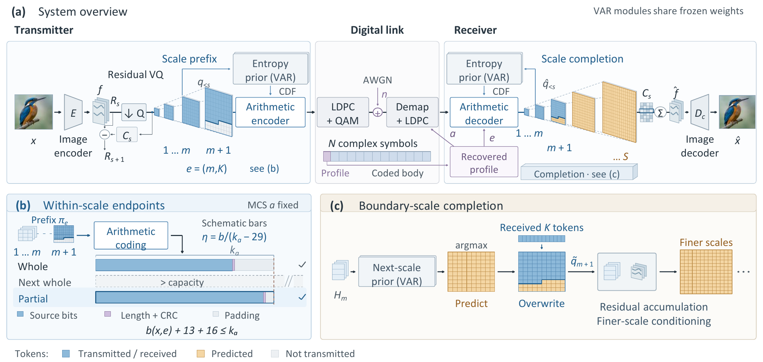
Fig. 1. NeST-Com. (a) The protected profile specifies the endpoint and MCS; both terminals reconstruct coding probabilities from the shared frozen VAR and their known coarse tokens. (b) Independently terminated within-scale prefixes fit the body capacity; bars are schematic. (c) Received boundary tokens overwrite predicted positions. The merged map updates the residual latent and the context for finer-scale prediction. Unreceived boundary positions retain their coarse-conditioned predictions.

B. Within-Scale Endpoints and Actual-Length Fitting
An endpoint $e=(m,K)$ retains complete coarse maps and $K$ raster-ordered positions from the next map:
$$π_{e}=(q_{1},…,q_{m},q_{m+1,1:K}). \text{(3)}$$
For $K=0$, the boundary tail is absent. WHOLE permits $K=0$ for $m=4,…,10$. PARTIAL adds $K∈\{⌊L_{m+1}/4⌋,⌊L_{m+1}/2⌋,⌊3L_{m+1}/4⌋\}$ for $m=4,…,9$, giving 25 endpoints in total. $(10,0)$ is the full representation.
For MCS $a=(M,r)$, the coded body has $n_{a}=(N−68)\log_{2}M$ bits and information length $k_{a}=⌊rn_{a}⌋$. With actual terminated arithmetic length $b(x,e)$,
$$b(x,e)+29≤k_{a}, η(x,e)=\frac{b(x,e)}{k_{a}−29}. \text{(4)}$$
The endpoint specifies retained source tokens; its actual terminated length determines frame feasibility. The 29 bits comprise the 13-bit length field and CRC16; unused information positions are zero-padded before 5G NR LDPC coding, rate matching [9], and QAM. Thus $η$ measures source-bit capacity utilization, not total over-the-air efficiency.
Offline calibration selects a target endpoint and MCS separately for each budget and SNR on an independent image set. It maximizes source/reconstruction DINOv2 cosine [10], averaged first over channel realizations and then equally over sources. The selected policy is frozen for testing; candidate pools and screening rules are given in the accompanying configuration material.
Online fitting fixes the selected MCS and searches legal endpoints no longer than the target, in decreasing token count down to $(4,0)$. TX sends the first independently terminated stream satisfying (4); the paid profile identifies the actual endpoint. Each candidate prefix is independently arithmetic-coded and terminated, rather than cut from a longer stream. This source-coding operation leaves the body-level acceptance rule unchanged. If no endpoint fits, the N512 protocol sends a paid NULL profile and short NULL payload through the complete frame, retaining a gray reconstruction in the denominator. The N1024 implementation instead raises an error; no evaluated N1024 source encountered this case.

C. Prefix-Constrained Reconstruction
Invalid profile CRC/catalogue, body CRC, declared length, known padding, or arithmetic parsing produces a fixed gray image; so does a valid N512 NULL reception. Otherwise, RX decodes the prefix using CDFs rebuilt from received complete coarse maps. It predicts the boundary map by VAR argmax conditioned on those maps, then applies known-token overwrite [7]:
$${\tilde{q}}_{m+1,i}=\left\{\begin{matrix}{\hat{q}}_{m+1,i}, & i≤K, \\ q_{m+1,i}^{pred}, & i>K.\end{matrix}\right. \text{(5)}$$
Unreceived boundary positions retain their coarse-conditioned prediction. Received boundary tokens serve two roles: they correct the residual representation and, through the merged boundary map, condition the prediction of finer scales. Complete received maps remain unchanged; subsequent maps are generated from this updated context. Reconstruction is
$$\hat{x}=D_{c}​\left(\sum_{s=1}^{10}{C_{s}}({\tilde{q}}_{s})\right). \text{(6)}$$
At the final scale, overwrite changes the residual contribution without any subsequent propagation.

III. Experimental Results
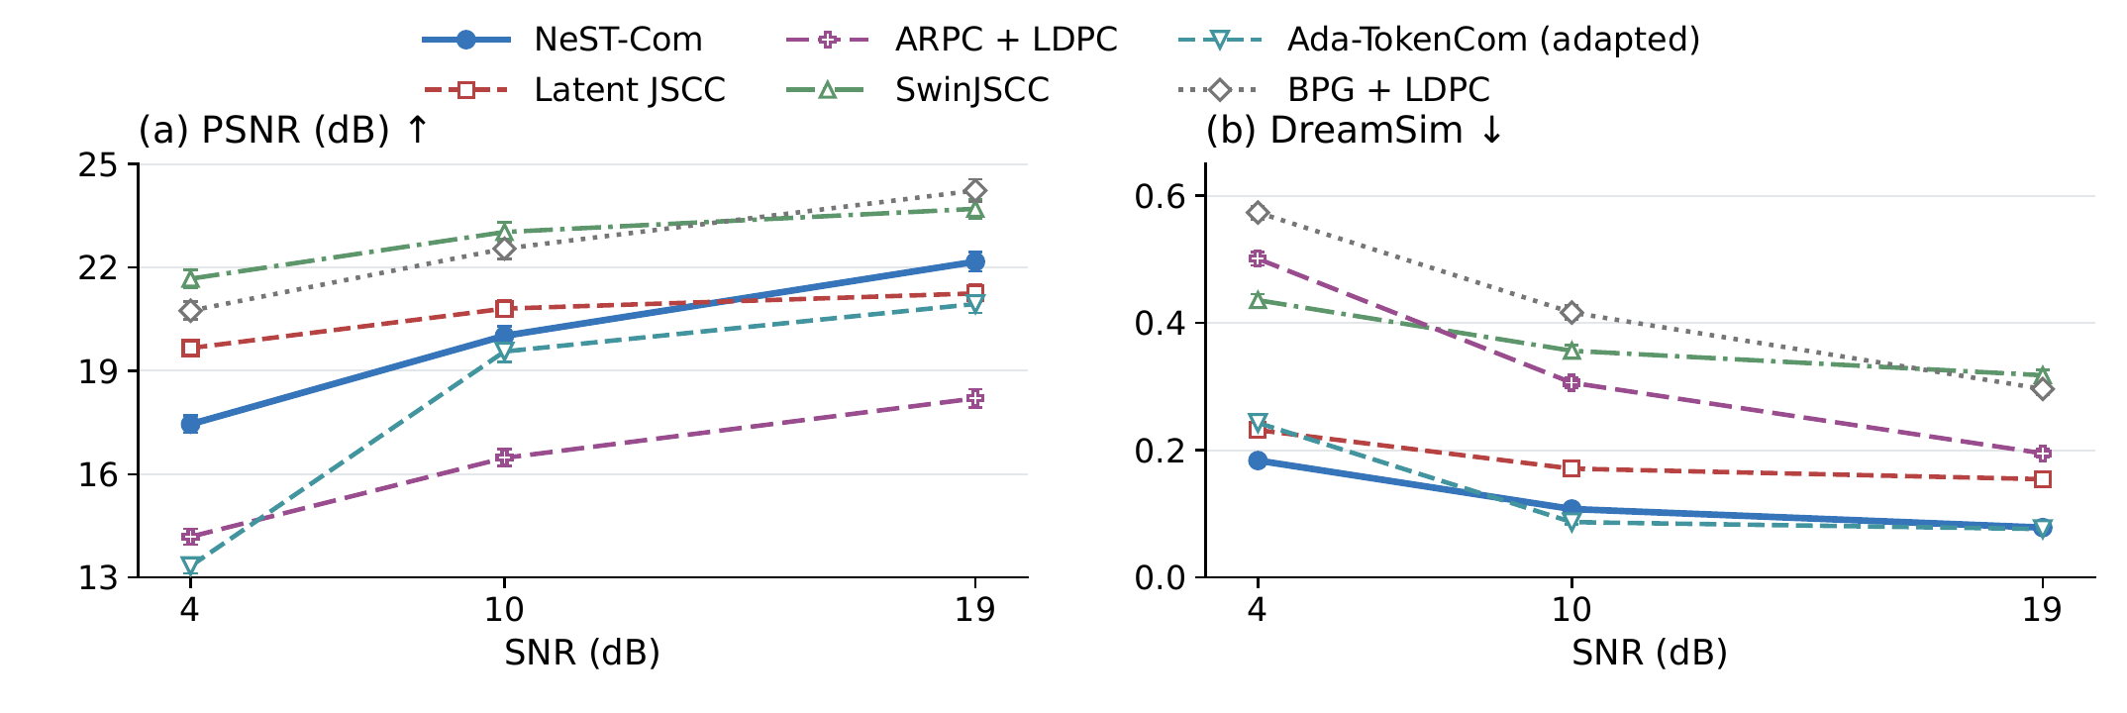
Fig. 2. Performance on 500 ImageNet validation images at $N=1024$. Error bars show 95% source-bootstrap confidence intervals. Ada denotes the fixed-frame adaptation.

A. Experimental Setup
We use common500 ImageNet validation images [11], a disjoint cal1000 set, and Kodak24 [12], with fixed $256×256$ preprocessing. ImageNet-calibrated policies remain fixed on Kodak. The six-system main study uses $N=1024$; NeST, WHOLE, and Ada also use $N=512$, each independently calibrated at 4/10/19 dB.
Our convolutional Latent JSCC maps tokenizer latents to symbols and shares $D_{c}$, using MSE, LPIPS, and latent-consistency losses. It and SwinJSCC [2], adapted to $256×256$ and $N=1024$, use the same 20 000 training images and final 100k/200k-update checkpoints. Digital baselines are adaptive BPG [13] + LDPC, ARPC [6] + LDPC with paid captions, and Ada-TokenCom [4] adapted to the same fixed single-frame budget. Ada retains LlamaGen-L/VQ16 and prefix arithmetic coding, with a fixed ConvNeXt predicting a paid 10-bit class. Its sampled tail uses CFG=4, $T=1$, top-$k=2000$, and top-$p=1$. Full configurations and training records accompany this letter.
Metrics are PSNR, LPIPS-Alex [14], DreamSim [15], and CLIP ViT-L/14 image–image cosine (CLIP-I) [16]. Frozen FP32 preprocessing uses $224×224$ bicubic-antialias inputs for DreamSim/CLIP. Three channel outcomes per image, including the gray outputs defined in Sec. II-C, are averaged before equal-source means and direct source-paired 95% bootstrap intervals (10 000 resamples). Endpoint, receiver, and decoding controls use a fixed 100-image subset. Complete four-metric diagnostics and statistical identities are provided in the supplementary material.

B. Effect of Within-Scale Endpoints
Table I. Within-scale endpoint and receiver evidence. (A) Main family-specific policies; differences are PARTIAL minus WHOLE. (B) Controlled granularity on 100 sources with fixed model, MCS, maximum endpoint and fitting rule. (C) Receiver interventions on the same 100 sources and actual prefixes. Brackets give source-paired 95% CIs; populations and conditions are as stated.
(A) Main policies at $N=1024$
SNR | Util. W$→$P (%) | $Δ$PSNR (dB) [95% CI]
common500
4 | 73.81 $→$ 93.08 | $+0.616 [0.564,0.673]$​
10 | 77.70 $→$ 95.21 | $+0.701 [0.637,0.766]$​
19 | 85.24 $→$ 94.73 | $+0.319 [0.290,0.349]$​
Kodak24
4 | 75.69 $→$ 93.43 | $+0.396 [0.236,0.543]$​
10 | 78.11 $→$ 94.99 | $+0.674 [0.408,0.958]$​
19 | 85.69 $→$ 93.71 | $+0.228 [0.140,0.324]$​
(B) Fixed-granularity diagnostic, 10 dB
Grid (candidates) | Utilization (%) | PSNR (dB)
Whole (7) | 78.15 | 18.952
Half (13) | 89.21 | 19.396
Quarter (25) | 95.38 | 19.612
Eighth (49) | 97.39 | 19.735
(C) Receiver interventions: $Δ$PSNR (dB) [95% CI]
SNR | B0$−$A0 | C0$−$B0
10 | $+0.220 [0.176,0.264]$​ | $+0.440 [0.330,0.558]$​
19 | $+0.301 [0.247,0.358]$​ | $+0.000 [0.000,0.000]$​
Table I(A) compares WHOLE/PARTIAL with shared tokenizer, prior, entropy coder, and $D_{c}$. Separate family calibration selects the same MCS at each SNR. Common500 PSNR gains are 0.616/0.701/0.319 dB at 4/10/19 dB. At 10 dB, source-bit utilization rises from 77.70% to 95.21% and DreamSim falls by 0.0240. On Kodak, the corresponding PSNR gain is 0.674 dB and DreamSim decreases by 0.0164; its 19 dB DreamSim interval includes zero. The higher utilization retains additional source tokens within the same frame.
Block B fixes the 100 sources, model, MCS, maximum endpoint, and fitting rule. Whole/Half/Quarter/Eighth grids increase utilization from 78.15% through 89.21% and 95.38% to 97.39%, with PSNR increasing from 18.952 to 19.735 dB. Relative to the predefined Quarter configuration, Eighth adds $0.123 [0.079,0.169]$ dB at 10 dB; its DreamSim/CLIP-I difference intervals cross zero.
Block C uses the same 100 sources and actual received prefixes. A0 ignores received boundary tokens and follows the prior. B0 adds their correction to the final residual latent while finer-scale conditioning follows A0. C0 updates both latent and conditioning. The ordered PSNR gains are 0.220 and 0.440 dB at 10 dB, supporting both uses of received boundary tokens. At 19 dB, the boundary lies in the last scale, so the additional conditioning update has zero effect.
Completion versus coarse decoding: With an identical received WHOLE prefix and the same adapted decoder, next-scale completion reduces DreamSim by 0.420 and 0.452 at $N=512$, 4 and 10 dB, respectively. Its PSNR changes are $+0.026 [−0.204,0.271]$ and $+0.771 [0.563,0.986]$ dB on the fixed 100-image subset. LPIPS decreases and CLIP-I increases at both points with paired intervals excluding zero. Completion improves these perceptual measures at both operating points, with a clear PSNR benefit at 10 dB.

C. Comparison With Existing Methods
Table II. Perceptual distance and image-feature similarity on common500 at $N=1024$. Each cell is LPIPS-Alex$↓$ / CLIP-I$↑$. Ada denotes the fixed-frame adaptation. Values are source means.
Method | 4 dB | 10 dB | 19 dB
NeST-Com | 0.263 / 0.821 | 0.171 / 0.873 | 0.118 / 0.900
Latent JSCC | 0.219 / 0.741 | 0.173 / 0.789 | 0.158 / 0.804
SwinJSCC | 0.530 / 0.627 | 0.469 / 0.669 | 0.440 / 0.697
BPG + LDPC | 0.725 / 0.586 | 0.589 / 0.635 | 0.458 / 0.684
ARPC + LDPC | 0.512 / 0.644 | 0.341 / 0.713 | 0.250 / 0.788
Ada (adapted) | 0.395 / 0.828 | 0.167 / 0.884 | 0.138 / 0.892
Fig. 2 and Table II show the complete-system tradeoffs at $N=1024$. NeST exceeds Ada in PSNR by 4.116/0.455/1.226 dB at 4/10/19 dB and exceeds ARPC by 3.26–3.97 dB. Ada has better LPIPS, DreamSim, and CLIP-I at 10 dB, higher CLIP-I at 4 dB, and slightly lower DreamSim at 19 dB. SwinJSCC and BPG have higher PSNR than NeST throughout; Latent JSCC has higher PSNR at 4/10 dB and lower LPIPS at 4 dB. Thus the source-constrained generative route offers a different balance between pixel fidelity and perceptual reconstruction.

D. Transmission With a Reduced Symbol Budget
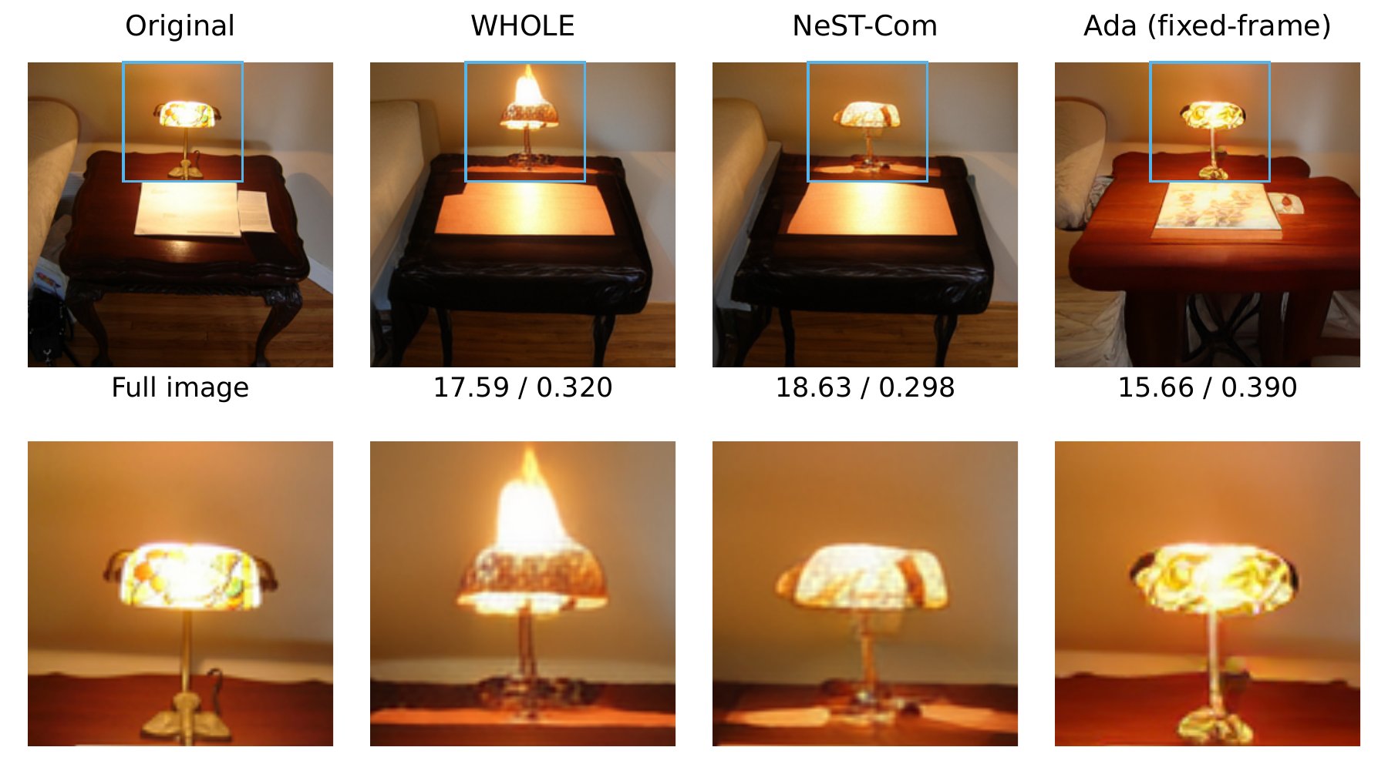
Fig. 3. Example reconstructions at $N=512$ and 10 dB. The top row shows full images and the bottom row enlarges the same marked region. Values denote full-image PSNR$↑$ / LPIPS$↓$. Ada denotes the fixed-frame adaptation.
Table III. Reduced-budget comparison on common500 at $N=512$. Differences are NeST-Com minus the fixed-frame Ada-TokenCom adaptation; brackets give source-paired 95% CIs. Positive PSNR and negative DreamSim favor NeST-Com.
SNR | $Δ$PSNR (dB) | $Δ$DreamSim
4 | $+4.180$​ | $−0.1029$​
 | $[3.991,4.377]$​ | $[−0.1142,−0.0917]$​
10 | $+4.055$​ | $−0.0660$​
 | $[3.880,4.235]$​ | $[−0.0747,−0.0573]$​
19 | $+1.740$​ | $+0.0139$​
 | $[1.577,1.909]$​ | $[0.0103,0.0173]$​
At $N=512$, 68 header symbols leave 444 body symbols. NeST improves over WHOLE by $0.392 [0.341,0.444]$, $0.399 [0.356,0.445]$, and $0.792 [0.740,0.844]$ dB at 4/10/19 dB. All corresponding LPIPS, DreamSim, and CLIP-I paired intervals also favor NeST. At 10 dB, WHOLE and NeST select the same target $(7,0)$ and 16-QAM rate-2/3 MCS. When that target exceeds an image’s capacity, within-scale fallback endpoints preserve more of its description than the preceding whole scale, raising utilization from 79.30% to 93.46%.
WHOLE already has higher mean PSNR than Ada by 3.79/3.66/0.95 dB. NeST increases these gaps to 4.180/4.055/1.740 dB (Table III) and has lower LPIPS at all three SNRs. DreamSim favors NeST at 4/10 dB and Ada at 19 dB; CLIP-I favors Ada throughout. Fig. 3 shows how the additional within-scale tokens improve the reconstructed lamp-shade geometry relative to whole-scale transmission.
On the fixed 100-image subset, replacing Ada’s sampled tail with greedy decoding preserves NeST-Com’s low-budget PSNR advantage, yielding gains of 4.63 and 4.60 dB at 4 and 10 dB, respectively. The original sampling baseline remains the main comparison; complete sensitivity results, including $N=1024$, are in the supplement.

IV. Conclusion
NeST-Com adapts next-scale residual representations to fixed digital frames through within-scale endpoints, actual-length fitting, and prefix-constrained reconstruction. Received boundary tokens improve both residual reconstruction and finer-scale prediction. Shared-model experiments show higher source-bit utilization and consistent PSNR gains at 512- and 1024-symbol budgets, while comparisons with existing systems demonstrate useful low-budget reconstruction performance. Future work will extend frame selection to uncertain channel conditions.

References
[1] E. Bourtsoulatze, D. B. Kurka, and D. Gündüz, “Deep joint source-channel coding for wireless image transmission,” IEEE Trans. Cogn. Commun. Netw., vol. 5, no. 3, pp. 567–579, Sep. 2019.
[2] K. Yang, S. Wang, J. Dai, X. Qin, K. Niu, and P. Zhang, “SwinJSCC: Taming Swin Transformer for deep joint source-channel coding,” IEEE Trans. Cogn. Commun. Netw., vol. 11, no. 1, pp. 90–104, Feb. 2025.
[3] V. Chande and N. Farvardin, “Progressive transmission of images over memoryless noisy channels,” IEEE J. Sel. Areas Commun., vol. 18, no. 6, pp. 850–860, Jun. 2000, doi: 10.1109/49.848239.
[4] Z. Zhang, L. Qiao, M. B. Mashhadi, Z. Gao, M. Bennis, and K. Huang, “Ada-TokenCom: Rate-adaptive token communications via large-model-driven token compression and generation,” 2026, arXiv:2608.28086.
[5] S. Liu and K. Wang, “TONIC: Token-centric semantic communication for task-oriented wireless systems,” 2026, arXiv:2605.21553.
[6] Z. Zhang, Y. Xia, B. Chen, T. Zhang, H. Wang, and H. Qiu, “Autoregressive-based progressive coding for ultra-low bitrate image compression,” in Int. Conf. Learning Representations, 2026.
[7] K. Tian, Y. Jiang, Z. Yuan, B. Peng, and L. Wang, “Visual autoregressive modeling: Scalable image generation via next-scale prediction,” in Advances in Neural Information Processing Systems, vol. 37, 2024, pp. 84 839–84 865.
[8] I. H. Witten, R. M. Neal, and J. G. Cleary, “Arithmetic coding for data compression,” Commun. ACM, vol. 30, no. 6, pp. 520–540, Jun. 1987, doi: 10.1145/214762.214771.
[9] 3GPP, “NR; Multiplexing and channel coding,” TS 38.212, ver. 16.5.0, Release 16, 2021. [Online]. Available: https://www.etsi.org/deliver/etsi_ts/138200_138299/138212/16.05.00_60/ts_138212v160500p.pdf
[10] M. Oquab et al., “DINOv2: Learning robust visual features without supervision,” Trans. Mach. Learn. Res., Jan. 2024. [Online]. Available: https://openreview.net/forum?id=a68SUt6zFt
[11] O. Russakovsky et al., “ImageNet large scale visual recognition challenge,” Int. J. Comput. Vis., vol. 115, no. 3, pp. 211–252, 2015.
[12] R. Franzen, “Kodak lossless true color image suite,” accessed Oct. 26, 2026. [Online]. Available: https://r0k.us/graphics/kodak/
[13] F. Bellard, “BPG image format,” accessed Oct. 22, 2026. [Online]. Available: https://bellard.org/bpg/
[14] R. Zhang, P. Isola, A. A. Efros, E. Shechtman, and O. Wang, “The unreasonable effectiveness of deep features as a perceptual metric,” in Proc. IEEE Conf. Comput. Vis. Pattern Recognit., Jun. 2018, pp. 586–595.
[15] S. Fu, N. Tamir, S. Sundaram, L. Chai, R. Zhang, T. Dekel, and P. Isola, “DreamSim: Learning new dimensions of human visual similarity using synthetic data,” in Advances in Neural Information Processing Systems, vol. 36, 2023, pp. 50 742–50 768.
[16] A. Radford et al., “Learning transferable visual models from natural language supervision,” in Proc. 38th Int. Conf. Mach. Learn., vol. 139, 2021, pp. 8748–8763.

