NeST-Com: Fixed-Budget Next-Scale Token Communication
Anonymous Authors
Abstract
NeST-Com targets perceptually faithful image reconstruction within fixed digital frames. It fits independently terminated within-scale prefixes of a next-scale residual representation and uses received boundary tokens for residual reconstruction and finer-scale conditioning. With shared models on 500 ImageNet images, LPIPS and DreamSim decrease across all tested SNRs at 512 and 1024 symbols, alongside 0.32–0.79 dB PSNR gains. At 1024 symbols and 10 dB, source-bit utilization rises from 77.70% to 95.21%, while mean LPIPS and DreamSim fall by 13.7% and 18.3%. Comparisons with existing systems reveal perceptual and pixel fidelity tradeoffs.

Index terms
Semantic communication, next-scale tokens, fixed-budget transmission, generative reconstruction.

I. Introduction
A fixed per-image channel-symbol budget limits the source description available for perceptually faithful reconstruction of image structure, appearance, and content. Its useful content depends on image-dependent source-code length and the protection carried in the same frame. A generative receiver can complete untransmitted information, while the received description constrains that completion to the source image. The challenge is to retain useful source information within the frame and use it to improve perceptual similarity to the source.
Next-scale representations organize an image into complete coarse token maps followed by residual refinements. After resizing, each coarse map covers the full latent grid, providing a global description before finer maps add detail. Visual autoregressive modeling (VAR) reported state-of-the-art results in its original class-conditional ImageNet generation benchmarks [7], motivating its use as a completion prior. Digital coding and learned joint source–channel coding (JSCC) address limited channel resources [1, 2]; adapting progressive descriptions is a classical problem [3]. Recent token schemes include Ada-TokenCom’s prefix coding and tail generation [4], task-oriented TONIC [5], and next-scale progressive ARPC [6].
Whole-scale boundaries need not align with fixed frame capacity: a scale adds many tokens, and the terminated entropy-code length varies across images. Legal endpoints inside a scale can retain source tokens that would otherwise be excluded. VAR’s coarse-conditioned factorization lets both terminals construct matching probabilities for these positions from complete coarse maps. The delivered boundary tokens must then refine both residual accumulation and the context for predicting finer scales.
NeST-Com combines within-scale endpoints, independently terminated arithmetic streams, actual-length fitting, and prefix-constrained reconstruction. Using VAR’s known-token overwrite [7], it merges received positions with predictions and updates both the residual latent and finer-scale context. With shared model components on common500, it reduces LPIPS and DreamSim at all six tested budget/SNR points, with PSNR gains of 0.32–0.79 dB over whole-scale transmission. At 1024 symbols and 10 dB, source-bit utilization rises from 77.70% to 95.21%, while mean LPIPS and DreamSim fall by 13.7% and 18.3%. Controlled experiments examine how retained boundary information affects reconstruction; complete-system comparisons reveal perceptual and pixel fidelity tradeoffs.

II. Proposed NeST-Com Framework

A. Next-Scale Representation and Digital Frame
We transmit $x∈[0,1]^{256×256×3}$ over complex AWGN,
$$y=s+n, n∼CN(0,σ^{2}I_{N}), SNR=10\log_{10}(E_{s}/σ^{2}), \text{(1)}$$
using $N$ complex symbols per image and nominal $E_{s}=2$. TX selects a frozen policy for the channel SNR; RX uses the true noise variance for LLRs. Digital constellations have average energy two without per-frame renormalization. Continuous JSCC data are normalized per image to average energy two, with required Swin side information paid within $N$. A 12-bit profile ID, CRC16, and terminated rate-1/2 convolutional code occupy 68 rotated-BPSK symbols $\{±(1+j)\}$. The remaining $N−68$ symbols carry the LDPC-coded body. After rate matching, a public frame-dependent scrambling mask is applied before QAM modulation and reversed at the receiver before LDPC decoding. The paid profile identifies the actual endpoint and MCS. Our main budget is $N=1024$; the reduced-budget experiment uses $N=512$ without increasing $E_{s}$.
The frozen VAR tokenizer produces ten residual token maps $q_{s}$, with side lengths $(1,2,3,4,5,6,8,10,13,16)$ and a 4096-entry codebook [7]. Let $h_{s}$ denote the side length, $L_{s}=h_{s}^{2}$ the number of positions, and $C_{s}$ the scale-dependent codebook lookup, resizing, and residual transform. Complete coarse maps span the whole latent grid after resizing; the sum fq=s​Cs(qs) accumulates their residual refinements. Image decoder $D_{c}$ is adapted on 20 000 ImageNet training images using continuous, fully quantized, and prefix-completion-interpolated latents, then fixed. NeST-Com uses null-class conditioning. Its frozen VAR-d16 next-scale prior factorizes [7] as
$$p_{θ}(q_{s}∣q_{<s})=\prod_{i=1}^{L_{s}}{p_{θ}}(q_{s,i}∣q_{<s}), \text{(2)}$$
All positions in a scale thus obtain coding probabilities from the same complete coarse maps. Both terminals construct the same integer cumulative distribution functions (CDFs), with total frequency $2^{24}$, for arithmetic coding [8] of a within-scale subset (Fig. 1; Supplement S1.1).
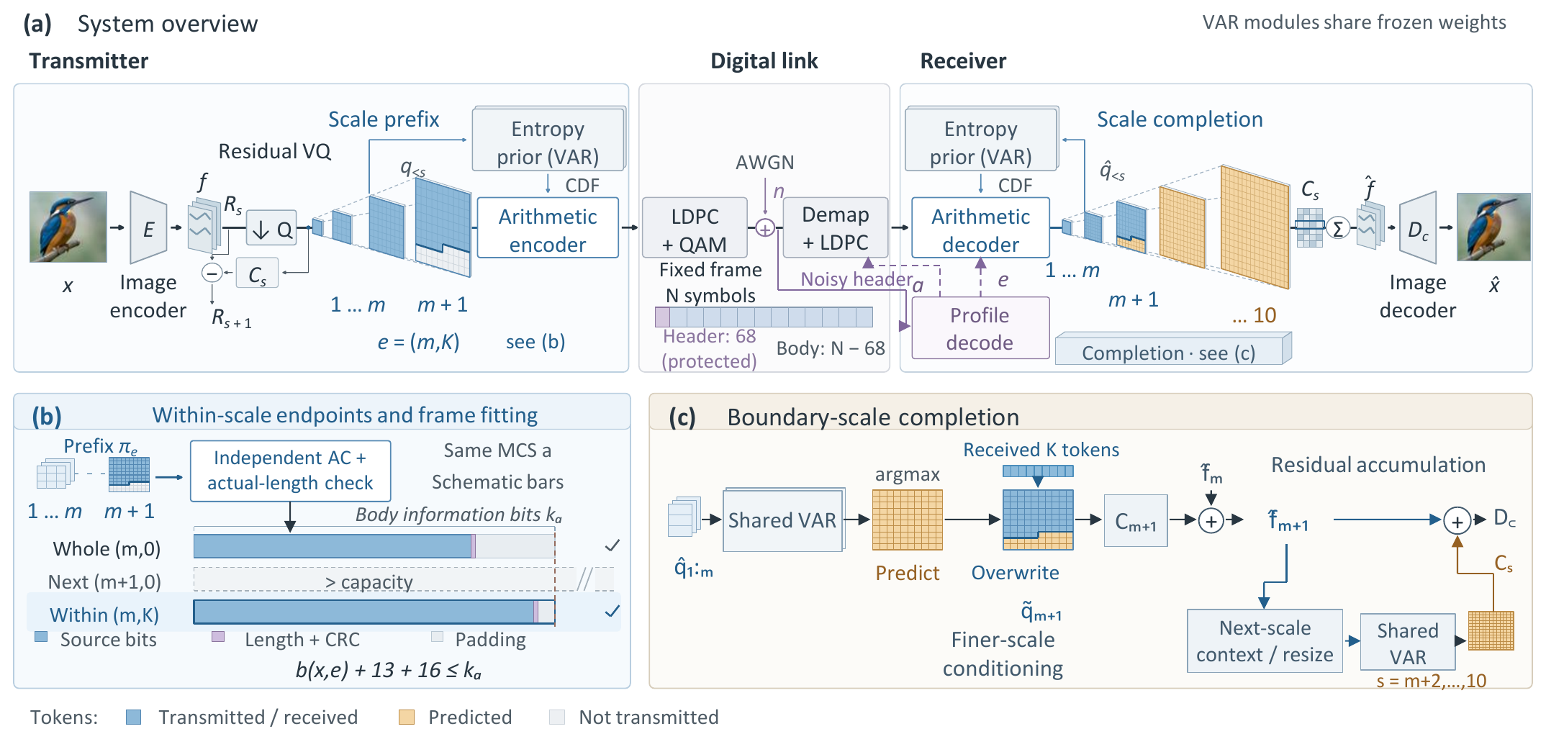
Fig. 1. NeST-Com: (a) The protected profile and body share the fixed noisy frame; both terminals reconstruct coding probabilities from the shared frozen VAR and known coarse tokens. (b) Independently terminated within-scale prefixes fit the body information capacity; bars are schematic for the same MCS. (c) Received tokens overwrite boundary predictions, and the merged map updates the residual latent and finer-scale context while unreceived positions retain their coarse-conditioned predictions.

B. Within-Scale Endpoints and Actual-Length Fitting
An endpoint $e=(m,K)$ retains complete coarse maps and $K$ raster-ordered positions from the next map:
$$π_{e}=(q_{1},…,q_{m},q_{m+1,1:K}). \text{(3)}$$
For $K=0$, the boundary tail is absent. WHOLE permits $K=0$ for $m=4,…,10$. PARTIAL adds $K∈\{⌊L_{m+1}/4⌋,⌊L_{m+1}/2⌋,⌊3L_{m+1}/4⌋\}$ for $m=4,…,9$, giving 25 endpoints in total. $(10,0)$ is the full representation.
For MCS $a=(M,r)$, the coded body has $n_{a}=(N−68)\log_{2}M$ bits and information length $k_{a}=⌊rn_{a}⌋$. With actual terminated arithmetic length $b(x,e)$,
$$b(x,e)+29≤k_{a}, η(x,e)=\frac{b(x,e)}{k_{a}−29}. \text{(4)}$$
The endpoint specifies retained source tokens; its actual terminated length determines frame feasibility. The 29 bits comprise the 13-bit length field and CRC16; unused information positions are zero-padded before 5G NR LDPC coding, rate matching [9], and QAM. Thus $η$ measures source-bit capacity utilization, not total over-the-air efficiency.
Offline calibration selects a target endpoint and MCS separately for each budget and SNR on an independent image set. It maximizes source/reconstruction DINOv2 cosine [10], averaged first over channel realizations and then equally over sources. The selected policy is frozen for testing; candidate pools and screening rules are given in Supplement S1; targets and MCSs are in S1.1.
Candidate prefixes share one scale-wise probability and incremental arithmetic-coding traversal. Non-mutating finalization produces an independently terminated stream at each legal endpoint; no stream is cut from a longer one. With the calibrated MCS fixed, TX checks endpoints no longer than the target in decreasing token count down to $(4,0)$ and selects the first satisfying (4). This retains the most tokens among feasible candidates without assuming monotone code lengths or optimizing per-image distortion. If none fits, a paid NULL profile and short payload occupy the full frame and yield gray. Both budgets support this behavior; the versioned N1024 extension preserves normal paths (Supplement S7). Historical N1024 evaluations used error-on-no-fit and never encountered that case.

C. Prefix-Constrained Reconstruction
Invalid profile CRC/catalogue, body CRC, declared length, known padding, or arithmetic parsing produces a fixed gray image; so does a valid NULL reception. Otherwise, RX decodes the prefix using CDFs rebuilt from received complete coarse maps. It predicts the boundary map by VAR argmax conditioned on those maps, then applies known-token overwrite [7]:
$${\tilde{q}}_{m+1,i}=\left\{\begin{matrix}{\hat{q}}_{m+1,i}, & i≤K, \\ q_{m+1,i}^{pred}, & i>K.\end{matrix}\right. \text{(5)}$$
Unreceived boundary positions retain their coarse-conditioned prediction. Received boundary tokens serve two roles: they correct the residual representation and, through the merged boundary map, condition the prediction of finer scales. Complete received maps remain unchanged; subsequent maps are generated from this updated context. Reconstruction is
$$\hat{x}=D_{c}​\left(\sum_{s=1}^{10}{C_{s}}({\tilde{q}}_{s})\right). \text{(6)}$$
At the final scale, overwrite changes the residual contribution without any subsequent propagation.

III. Experimental Results
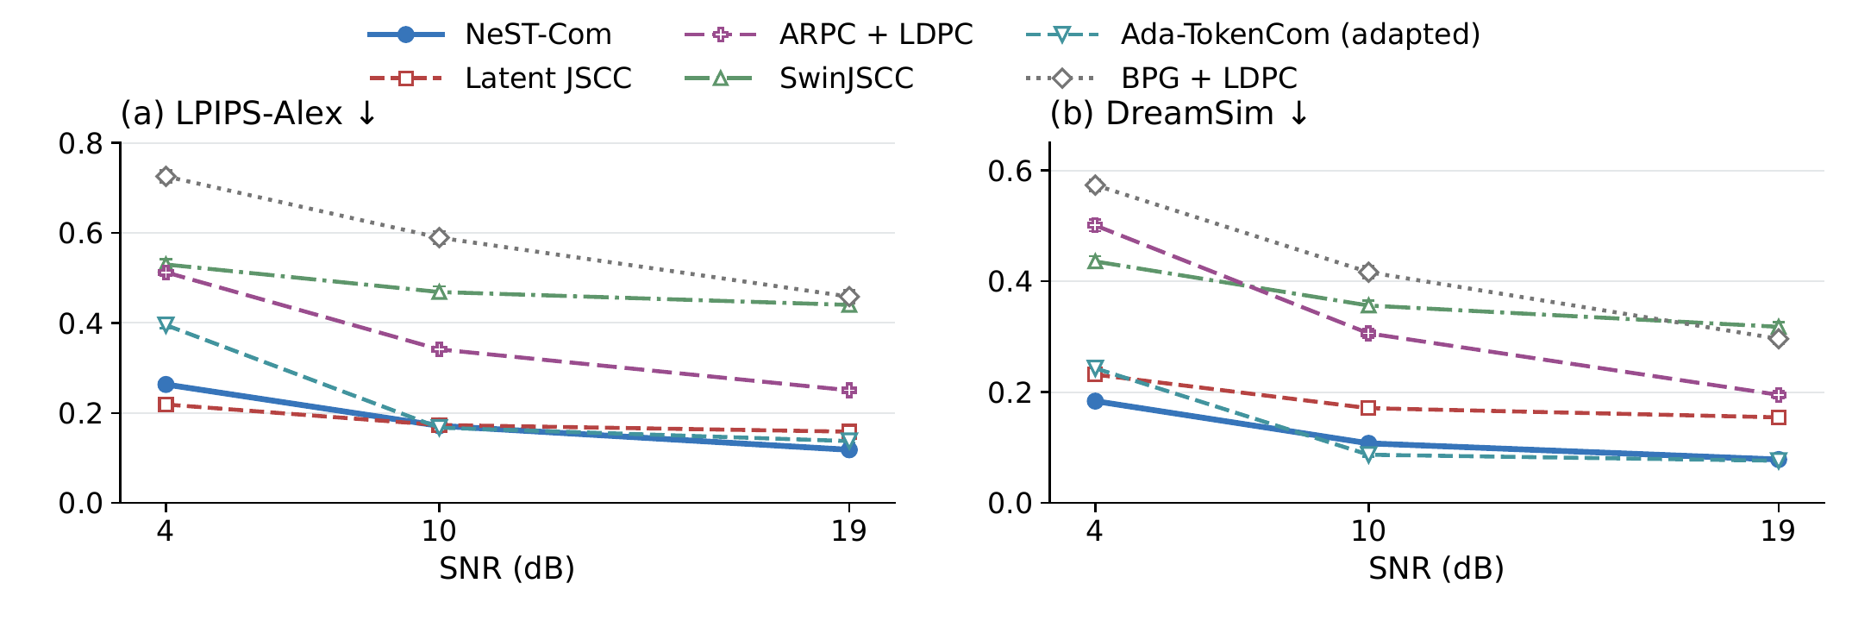
Fig. 2. Source-referenced perceptual distances on common500 at $N=1024$. Points and error bars are equal-source means and pointwise 95% source-bootstrap intervals after averaging three channel outcomes per source. Lower LPIPS-Alex and DreamSim are favorable. Ada denotes the predicted-class, fixed-frame adaptation.

A. Experimental Setup
We use common500 ImageNet validation images [11], a disjoint cal1000 set, and Kodak24 [12], with fixed $256×256$ preprocessing. ImageNet-calibrated policies remain fixed on Kodak. The six-system main study uses $N=1024$; NeST, WHOLE, and Ada also use $N=512$, each independently calibrated at 4/10/19 dB.
Our convolutional Latent JSCC maps tokenizer latents to symbols and shares $D_{c}$, using MSE, LPIPS, and latent-consistency losses. It and SwinJSCC [2], adapted to $256×256$ and $N=1024$, use the same 20 000 training images and final 100k/200k-update checkpoints. Digital baselines are adaptive BPG [13] + LDPC, ARPC [6] + LDPC with paid captions, and Ada-TokenCom [4] adapted to the fixed single-frame budget. Ada retains LlamaGen-L/VQ16 and prefix arithmetic coding, with a fixed ConvNeXt predicting a paid 10-bit class. Its sampled tail uses CFG=4, $T=1$, top-$k=2000$, and top-$p=1$. Supplement S1.2 details the six adaptations and their calibration objectives and populations. NeST, WHOLE, and Ada select QPSK rate 2/3, 16-QAM rate 2/3, and 64-QAM rate 5/6 at 4/10/19 dB, respectively, at both budgets; S1.1 lists their targets.
We evaluate source-referenced LPIPS-Alex [14] and DreamSim [15], pixel fidelity by PSNR, and image-feature similarity by CLIP ViT-L/14 cosine (CLIP-I) [16]. Frozen FP32 preprocessing uses $224×224$ bicubic-antialias inputs for DreamSim/CLIP. Three channel outcomes per image, including gray failures, are averaged before equal-source means and direct source-paired 95% bootstrap intervals (10 000 resamples). Controls use a fixed 100-image subset. DINOv2 selects generative transmission policies; it is related to feature-based evaluation, rather than an independent perceptual validation.

B. Effect of Within-Scale Endpoints
Table I. Within-scale endpoint and receiver evidence. (A) Main family-specific policies, PARTIAL minus WHOLE. (B) Fixed 100-source model/MCS/maximum-endpoint control. (C) Ordered interventions on the same 100 sources and actual prefixes. Brackets give source-paired 95% CIs.
(A) Main policies at N=1024
SNR | Util. W→P (%) | ΔLPIPS [95% CI]
common500
4 | 73.81 → 93.08 | −0.0246 [−0.0262,−0.0230]​
10 | 77.70 → 95.21 | −0.0273 [−0.0296,−0.0249]​
19 | 85.24 → 94.73 | −0.0052 [−0.0056,−0.0048]​
Kodak24
4 | 75.69 → 93.43 | −0.0189 [−0.0247,−0.0130]​
10 | 78.11 → 94.99 | −0.0267 [−0.0370,−0.0167]​
19 | 85.69 → 93.71 | −0.0038 [−0.0056,−0.0022]​
(B) Fixed-granularity diagnostic, 10 dB
Grid (candidates) | Utilization (%) | LPIPS
Whole (7) | 78.15 | 0.2018
Half (13) | 89.21 | 0.1838
Quarter (25) | 95.38 | 0.1752
Eighth (49) | 97.39 | 0.1729
(C) Receiver interventions: ΔLPIPS [95% CI]
SNR | B0−A0 | C0−B0
10 | −0.0100​ | −0.0166​
 | [−0.0120,−0.0080]​ | [−0.0205,−0.0129]​
19 | −0.0051​ | +0.0000​
 | [−0.0060,−0.0043]​ | [0.0000,0.0000]​
Boundary tokens: A0, unused; B0, residual correction only; C0, residual correction and conditioning update. All three use the received complete coarse scales.
Table I(A) compares WHOLE/PARTIAL with shared tokenizer, prior, entropy coder, and $D_{c}$. Separate family calibration selects the same MCS at each SNR. At $N=1024$, 10 dB, utilization rises from 77.70% to 95.21%, retaining more source tokens. Mean LPIPS falls from 0.198718 to 0.171465 and DreamSim from 0.131728 to 0.107680: relative metric reductions of 13.7% and 18.3%. Their paired differences are $−0.0273 [−0.0296,−0.0249]$ and $−0.0240 [−0.0270,−0.0212]$. LPIPS and DreamSim improve at all six common500 budget/SNR points, with intervals excluding zero (Supplement S2.4). The N1024 PSNR gains are 0.32–0.70 dB. Kodak LPIPS also improves at all three SNRs; its 19 dB DreamSim interval includes zero.
Block B fixes 100 sources, the model, MCS, maximum endpoint, and fitting rule. Whole/Half/Quarter/Eighth increase utilization from 78.15% to 97.39% and reduce LPIPS from 0.201821 to 0.172939. Eighth improves over the predefined Quarter by $0.00223 [0.00131,0.00323]$ in LPIPS and $0.123 [0.079,0.169]$ dB in PSNR. Its DreamSim difference is $−0.00073 [−0.00196,0.00048]$, which does not establish equivalence or an optimal grid. The grids share ten prior-scale calls and encode 680 tokens once; complete TX timing remains unvalidated because a source-token identity check failed (Supplement S5.1).
Block C applies the defined ordered interventions to identical actual prefixes. At 10 dB, residual correction and the subsequent conditioning update reduce LPIPS by 0.01003 and 0.01662. Their DreamSim differences are $−0.00845 [−0.01136,−0.00564]$ and $−0.01537 [−0.01988,−0.01111]$. Thus boundary tokens improve perceptual reconstruction through both uses. At the final scale, the additional conditioning update has zero effect. Within the fixed adapted receiver, completion also improves the three perceptual measures over coarse-only decoding at both tested low-budget points (Supplement S4).

C. Comparison With Existing Methods
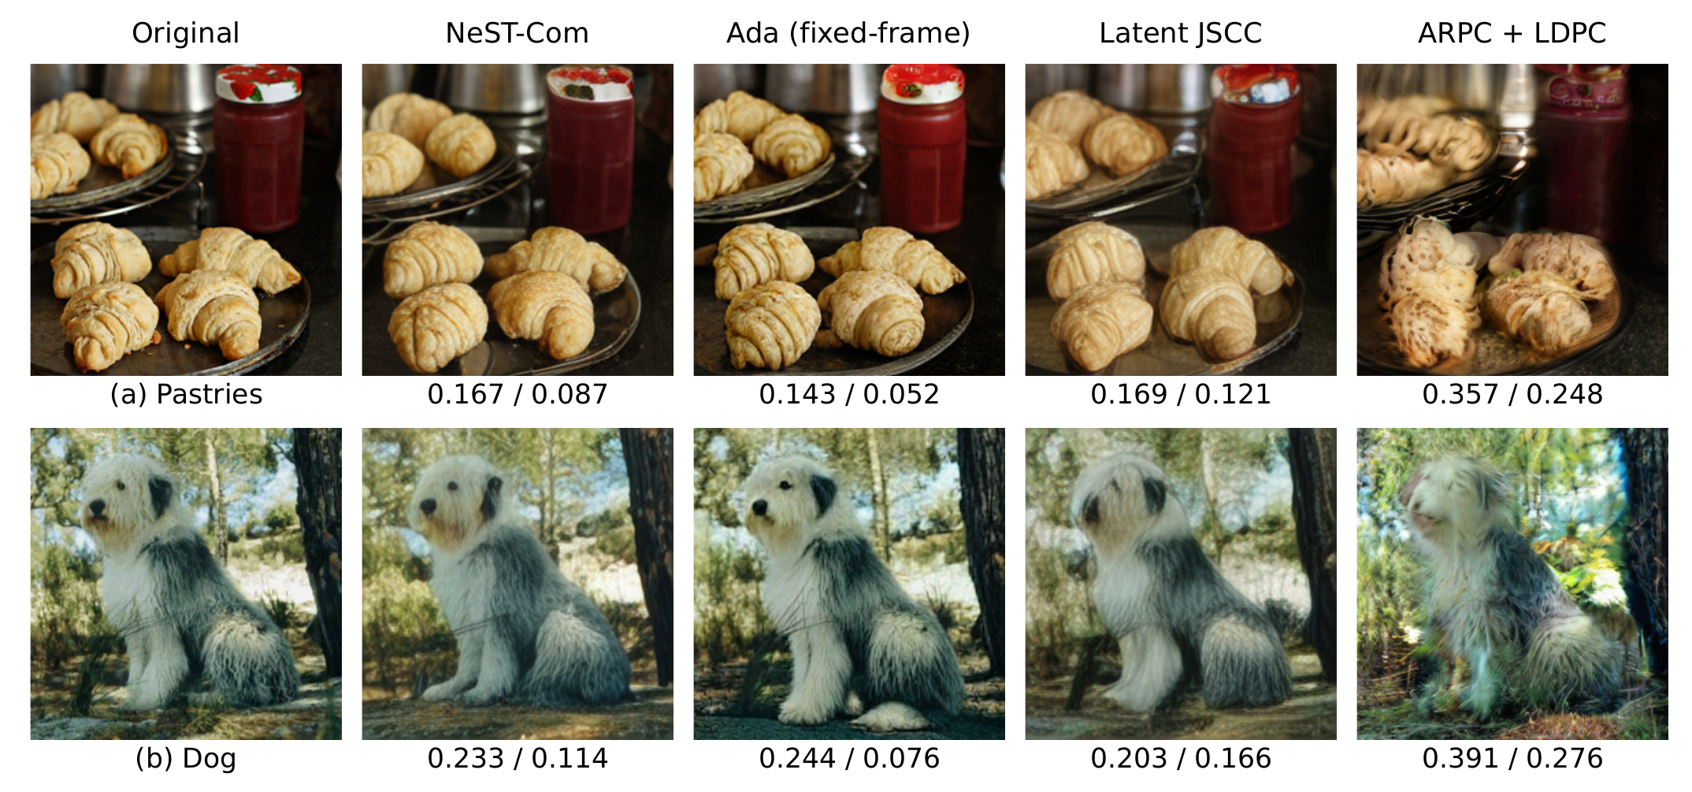
Fig. 3. Qualitative reconstructions of two development examples at $N=1024$ and 10 dB. Values denote LPIPS-Alex$↓$ / DreamSim$↓$. Ada denotes the fixed-frame adaptation.
Table II. Pixel fidelity and image-feature similarity on common500 at $N=1024$. Each cell is PSNR (dB)$↑$ / CLIP-I$↑$. Ada denotes the fixed-frame adaptation. Values are source means.
Method | 4 dB | 10 dB | 19 dB
NeST-Com | 17.448 / 0.821 | 20.014 / 0.873 | 22.164 / 0.900
Latent JSCC | 19.658 / 0.741 | 20.803 / 0.789 | 21.245 / 0.804
SwinJSCC | 21.671 / 0.627 | 23.026 / 0.669 | 23.698 / 0.697
BPG + LDPC | 20.743 / 0.586 | 22.543 / 0.635 | 24.230 / 0.684
ARPC + LDPC | 14.184 / 0.644 | 16.471 / 0.713 | 18.199 / 0.788
Ada (adapted) | 13.332 / 0.828 | 19.559 / 0.884 | 20.938 / 0.892
At all tested N1024 SNRs, NeST has lower mean LPIPS and DreamSim than the implemented SwinJSCC, BPG, and ARPC systems (Fig. 2). Table II shows the accompanying pixel-fidelity tradeoff: SwinJSCC and BPG have higher PSNR throughout. At 4 dB, Latent JSCC has higher PSNR and lower LPIPS than NeST, while NeST has lower DreamSim. These comparisons involve different tokenizers, priors, decoders, training, and conditioning.
Ada’s relative performance depends on SNR and metric. At 10 dB it has better LPIPS, DreamSim, and CLIP-I; NeST has higher PSNR. Ada also has higher CLIP-I at 4 dB and slightly lower DreamSim at 19 dB. NeST exceeds Ada in PSNR by 4.116/0.455/1.226 dB at 4/10/19 dB. NeST, WHOLE, and Ada successfully reconstruct all 1500 evaluated transmissions per SNR, so overall and success-conditioned means coincide. The two development examples in Fig. 3 illustrate smoother pastry ridges and facial details with Latent JSCC and altered pastry shapes and dog pose with ARPC. NeST and Ada retain more of these structures but differ in detail; metric rankings vary by image.

D. Transmission With a Reduced Symbol Budget
Table III. Reduced-budget comparison on common500 at $N=512$. Differences are NeST-Com minus the fixed-frame Ada-TokenCom adaptation; brackets give source-paired 95% CIs. Negative LPIPS and DreamSim favor NeST-Com.
SNR | ΔLPIPS | ΔDreamSim
4 | −0.1890​ | −0.1029​
 | [−0.1966,−0.1814]​ | [−0.1142,−0.0917]​
10 | −0.1384​ | −0.0660​
 | [−0.1440,−0.1328]​ | [−0.0747,−0.0573]​
19 | −0.0245​ | +0.0139​
 | [−0.0280,−0.0212]​ | [0.0103,0.0173]​
Successful receptions (4/10/19 dB), each out of 1500: NeST 1496/1499/1500; WHOLE 1493/1500/1500; Ada 1495/1500/1500. All failures are body-CRC rejections retained as gray.
At $N=512$, NeST–WHOLE LPIPS differences are $−0.02995/−0.01548/−0.02749$ at 4/10/19 dB; DreamSim differences are $−0.04280/−0.01269/−0.02412$. All paired intervals favor NeST, as do PSNR (0.39–0.79 dB gains) and CLIP-I. At 10 dB both methods select target $(7,0)$ and 16-QAM rate 2/3. Both fall back for 99.6% of sources, but NeST retains a within-scale prefix for 89.0%. Mean retained tokens increase from 91.3 to 107.9 and source-bit utilization from 79.30% to 93.46%.
Against Ada, NeST has lower LPIPS at all three SNRs and lower DreamSim at 4/10 dB; Ada has lower DreamSim at 19 dB (Table III) and higher CLIP-I throughout. WHOLE already exceeds Ada’s mean PSNR by 3.79/3.66/0.95 dB; NeST increases these gaps to 4.180/4.055/1.740 dB. Joint-success comparisons retain all 500 sources and the same LPIPS/DreamSim directions; their PSNR gaps are 0.389/0.399/0.792 dB against WHOLE and 4.190/4.056/1.740 dB against Ada. These descriptive conditional results do not replace the failure-inclusive means (Supplement S2.3).
On the fixed 100-image subset, replacing Ada’s sampled tail by argmax leaves NeST higher in PSNR by 4.63/4.60 dB at $N=512$, 4/10 dB; the full perceptual sensitivity results are retained in Supplement S3.

IV. Conclusion
NeST-Com fits independently terminated within-scale prefixes into fixed digital frames and uses received boundary tokens for residual correction and finer-scale conditioning. Shared-model experiments at 512 and 1024 symbols show higher source-bit utilization and consistent improvements in source-referenced LPIPS and DreamSim. Complete-system comparisons demonstrate the value of this limited-budget reconstruction route, with perceptual and pixel fidelity tradeoffs that depend on SNR and the baseline. Future work will extend frame selection to uncertain channel conditions.

References
[1] E. Bourtsoulatze, D. B. Kurka, and D. Gündüz, “Deep joint source-channel coding for wireless image transmission,” IEEE Trans. Cogn. Commun. Netw., vol. 5, no. 3, pp. 567–579, Sep. 2019.
[2] K. Yang, S. Wang, J. Dai, X. Qin, K. Niu, and P. Zhang, “SwinJSCC: Taming Swin Transformer for deep joint source-channel coding,” IEEE Trans. Cogn. Commun. Netw., vol. 11, no. 1, pp. 90–104, Feb. 2025.
[3] V. Chande and N. Farvardin, “Progressive transmission of images over memoryless noisy channels,” IEEE J. Sel. Areas Commun., vol. 18, no. 6, pp. 850–860, Jun. 2000, doi: 10.1109/49.848239.
[4] Z. Zhang, L. Qiao, M. B. Mashhadi, Z. Gao, M. Bennis, and K. Huang, “Ada-TokenCom: Rate-adaptive token communications via large-model-driven token compression and generation,” 2026, arXiv:2608.28086.
[5] S. Liu and K. Wang, “TONIC: Token-centric semantic communication for task-oriented wireless systems,” 2026, arXiv:2605.21553.
[6] Z. Zhang, Y. Xia, B. Chen, T. Zhang, H. Wang, and H. Qiu, “Autoregressive-based progressive coding for ultra-low bitrate image compression,” in Int. Conf. Learning Representations, 2026.
[7] K. Tian, Y. Jiang, Z. Yuan, B. Peng, and L. Wang, “Visual autoregressive modeling: Scalable image generation via next-scale prediction,” in Advances in Neural Information Processing Systems, vol. 37, 2024, pp. 84 839–84 865.
[8] I. H. Witten, R. M. Neal, and J. G. Cleary, “Arithmetic coding for data compression,” Commun. ACM, vol. 30, no. 6, pp. 520–540, Jun. 1987, doi: 10.1145/214762.214771.
[9] 3GPP, “NR; Multiplexing and channel coding,” TS 38.212, ver. 16.5.0, Release 16, 2021. [Online]. Available: https://www.etsi.org/deliver/etsi_ts/138200_138299/138212/16.05.00_60/ts_138212v160500p.pdf
[10] M. Oquab et al., “DINOv2: Learning robust visual features without supervision,” Trans. Mach. Learn. Res., Jan. 2024. [Online]. Available: https://openreview.net/forum?id=a68SUt6zFt
[11] O. Russakovsky et al., “ImageNet large scale visual recognition challenge,” Int. J. Comput. Vis., vol. 115, no. 3, pp. 211–252, 2015.
[12] R. Franzen, “Kodak lossless true color image suite,” accessed Oct. 26, 2026. [Online]. Available: https://r0k.us/graphics/kodak/
[13] F. Bellard, “BPG image format,” accessed Oct. 22, 2026. [Online]. Available: https://bellard.org/bpg/
[14] R. Zhang, P. Isola, A. A. Efros, E. Shechtman, and O. Wang, “The unreasonable effectiveness of deep features as a perceptual metric,” in Proc. IEEE Conf. Comput. Vis. Pattern Recognit., Jun. 2018, pp. 586–595.
[15] S. Fu, N. Tamir, S. Sundaram, L. Chai, R. Zhang, T. Dekel, and P. Isola, “DreamSim: Learning new dimensions of human visual similarity using synthetic data,” in Advances in Neural Information Processing Systems, vol. 36, 2023, pp. 50 742–50 768.
[16] A. Radford et al., “Learning transferable visual models from natural language supervision,” in Proc. 38th Int. Conf. Mach. Learn., vol. 139, 2021, pp. 8748–8763.

