NeST-Com: Fixed-Budget Next-Scale Token Communication
Anonymous Authors
Abstract
Next-scale tokens describe images through coarse-to-fine residual maps, but complete-scale endpoints can underfill fixed digital frames. NeST-Com fits independently terminated within-scale prefixes and uses received boundary tokens for residual reconstruction and finer-scale prediction. At 1024 symbols, shared-model comparisons improve PSNR by 0.32–0.70 dB and raise source-bit utilization from 77.70% to 95.21% at 10 dB. Six-system comparisons reveal pixel–perceptual tradeoffs. With independently calibrated 512-symbol policies, NeST exceeds a fixed-frame Ada-TokenCom adaptation by 1.74–4.18 dB PSNR, while Ada retains higher CLIP image similarity at all tested SNRs and lower DreamSim at 19 dB.

Index terms
Image communication, visual autoregressive models, fixed symbol budget, entropy coding.

I. Introduction
An image communication system with a hard per-image symbol budget must decide which information to retain before transmission. The decision depends on image-dependent source-code length, channel protection, and reconstruction from the retained representation. A generative receiver can supply missing information, but its output must remain constrained by what was delivered. Pixel fidelity, perceptual similarity, feature consistency, and processing cost can favor different operating points.
Digital image coding with error correction and learned joint source–channel coding (JSCC) offer different approaches [1, 2]. Truncation of progressive descriptions to fit a channel budget is a classical problem [3]. Ada-TokenCom combines prefix entropy coding, tail generation, and joint prefix/MCS selection under an average resource constraint [4]; TONIC studies task-oriented token communication [5]. ARPC constructs progressive descriptions with an autoregressive prior [6]. We use the next-scale representation of visual autoregressive modeling (VAR) [7]: complete coarse maps describe the full feature grid at low resolution, finer maps add residual detail, and earlier scales condition later generation. This structure supports reconstruction from a coarse description with progressively more residual information.
Fixed frames do not generally align with complete-scale endpoints. Their token-count steps are large, while terminated entropy-code lengths vary across images. The next complete scale can exceed the frame even when the preceding endpoint leaves room. Within-scale endpoints retain part of this boundary map, filling the gap between whole scales. The next-scale factorization also lets both ends construct matching coding probabilities from the complete coarse maps, so the extra endpoints can be decoded without transmitting probability tables.
NeST-Com adapts coarse-to-fine token prefixes to fixed-budget digital transmission through within-scale endpoints, actual-length fitting, and prefix-constrained reconstruction. Received boundary positions update both the residual latent and the context used to generate finer scales, using VAR’s known-token overwrite operation. With shared model components, quarter-scale endpoints improve PSNR by 0.32–0.70 dB over whole-scale transmission and raise entropy-stream utilization from 77.70% to 95.21% at 10 dB. Controlled endpoint and receiver interventions examine these mechanisms. Six-system comparisons at $N=1024$ and a focused, independently calibrated $N=512$ comparison locate the resulting pixel–perceptual tradeoffs under two symbol budgets.

II. Proposed NeST-Com Framework

A. Next-Scale Representation and Digital Frame
We transmit $x∈[0,1]^{256×256×3}$ over complex AWGN,
$$y=s+n, n∼CN(0,σ^{2}I_{N}), SNR=10\log_{10}(E_{s}/σ^{2}), \text{(1)}$$
using $N$ complex symbols per image and nominal $E_{s}=2$. TX selects a frozen policy for the channel SNR; RX uses the true noise variance for LLRs. Digital constellations have average energy two without per-frame renormalization. Continuous JSCC data are normalized per image to average energy two, with required Swin side information paid within $N$. A 12-bit profile ID, CRC16, and terminated rate-1/2 convolutional code occupy 68 rotated-BPSK symbols $\{±(1+j)\}$. The remaining $N−68$ symbols carry the LDPC-coded body. The paid profile identifies the actual endpoint and MCS. Our main budget is $N=1024$; the reduced-budget experiment uses $N=512$ without increasing $E_{s}$.
The frozen VAR tokenizer produces ten residual token maps $q_{s}$, with side lengths $(1,2,3,4,5,6,8,10,13,16)$ and a 4096-entry codebook [7]. Let $L_{s}$ be the map size and $C_{s}$ its codebook lookup, resizing, and residual transform. Complete coarse maps span the whole latent grid after resizing; the sum fq=s​Cs(qs) accumulates their residual refinements. Image decoder $D_{c}$ is adapted on 20 000 ImageNet training images using continuous, fully quantized, and prefix-completion-interpolated latents, then fixed. NeST-Com uses null-class conditioning. Its frozen next-scale prior factorizes as
$$p_{θ}(q_{s}∣q_{<s})=\prod_{i=1}^{L_{s}}{p_{θ}}(q_{s,i}∣q_{<s}), \text{(2)}$$
providing local cumulative distribution functions (CDFs) for arithmetic coding [8] at both ends of Fig. 1.
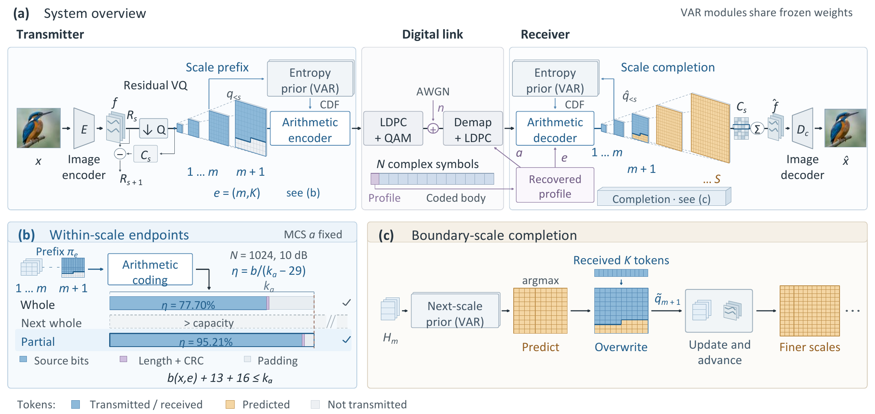
Fig. 1. NeST-Com. (a) The paid profile specifies endpoint $e$ and MCS $a$; TX/RX construct CDFs from the shared frozen VAR and their known coarse tokens. (b) Independently terminated prefixes, a 13-bit length field, and CRC16 fit $k_{a}$. Bars show common500 entropy-stream capacity utilization at $N=1024$, 10 dB (WHOLE 77.70%; PARTIAL 95.21%). (c) Received positions overwrite the predicted boundary map before residual accumulation and advancement to finer scales. $H_{m}$ denotes the prior state after scale $m$.

B. Within-Scale Endpoints and Actual-Length Fitting
An endpoint $e=(m,K)$ retains complete coarse maps and $K$ raster-ordered positions from the next map:
$$π_{e}=(q_{1},…,q_{m},q_{m+1,1:K}). \text{(3)}$$
WHOLE permits $K=0$ for $m=4,…,10$. PARTIAL adds $K∈\{⌊L_{m+1}/4⌋,⌊L_{m+1}/2⌋,⌊3L_{m+1}/4⌋\}$ for $m=4,…,9$, giving 25 endpoints in total. $(10,0)$ is the full representation.
For MCS $a=(M,r)$, the coded body has $n_{a}=(N−68)\log_{2}M$ bits and information length $k_{a}=⌊rn_{a}⌋$. With actual terminated arithmetic length $b(x,e)$,
$$b(x,e)+29≤k_{a}, η(x,e)=\frac{b(x,e)}{k_{a}−29}. \text{(4)}$$
The 29 bits comprise the length field and CRC16; unused information positions are zero-padded before 5G NR LDPC coding, rate matching [9], and QAM. Thus $η$ measures entropy-stream capacity utilization.
Offline calibration selects a target endpoint and MCS for each budget/SNR. A 100-image pilot uses one channel realization per image; the finalists are evaluated on all 1000 calibration images with three realizations per image. Selection maximizes source/reconstruction DINOv2 cosine [10], averaged over realizations first and then equally over sources, including gray failures. Exact ties use a fixed candidate order. At $N=1024$, target screening starts at scales 7–9 and includes full-scale $(10,0)$ candidates in final evaluation. At $N=512$, WHOLE/PARTIAL screen all 7/25 targets against the same 12 MCSs, $\log_{2}M∈\{2,4,6\}$ and $r∈\{1/2,2/3,3/4,5/6\}$. Each method/SNR advances the top three plus a maximum-endpoint QPSK rate-1/2 anchor. Ada uses the same N512 MCS pool with longest-feasible fitting up to 256 tokens. The full candidate and selection rules are provided with the results.
Online fitting fixes the selected MCS and searches legal endpoints no longer than the target, in decreasing token count down to $(4,0)$. TX sends the first independently terminated stream satisfying (4); the paid profile identifies the actual endpoint. Arithmetic streams are never cut from longer streams. If no endpoint fits, the N512 protocol sends a paid NULL profile and short NULL payload through the complete frame, retaining a gray reconstruction in the denominator. The N1024 implementation instead raises an error; no evaluated N1024 source encountered this case.

C. Prefix-Constrained Reconstruction
Invalid profile CRC/catalogue, body CRC, declared length, known padding, or arithmetic parsing produces a fixed gray image; so does a valid N512 NULL reception. Otherwise, RX decodes the prefix using CDFs rebuilt from received complete coarse maps. It predicts the boundary map by VAR argmax conditioned on those maps, then applies known-token overwrite [7]:
$${\tilde{q}}_{m+1,i}=\left\{\begin{matrix}{\hat{q}}_{m+1,i}, & i≤K, \\ q_{m+1,i}^{pred}, & i>K.\end{matrix}\right. \text{(5)}$$
Unreceived boundary positions retain their coarse-conditioned prediction. The merged map contributes to the residual latent and updates the prior state before finer-scale prediction. Complete received maps remain unchanged; subsequent maps are generated from this updated context. Reconstruction is
$$\hat{x}=D_{c}​\left(\sum_{s=1}^{10}{C_{s}}({\tilde{q}}_{s})\right). \text{(6)}$$
At the final scale, overwrite changes the residual contribution without any subsequent propagation.

III. Experimental Results
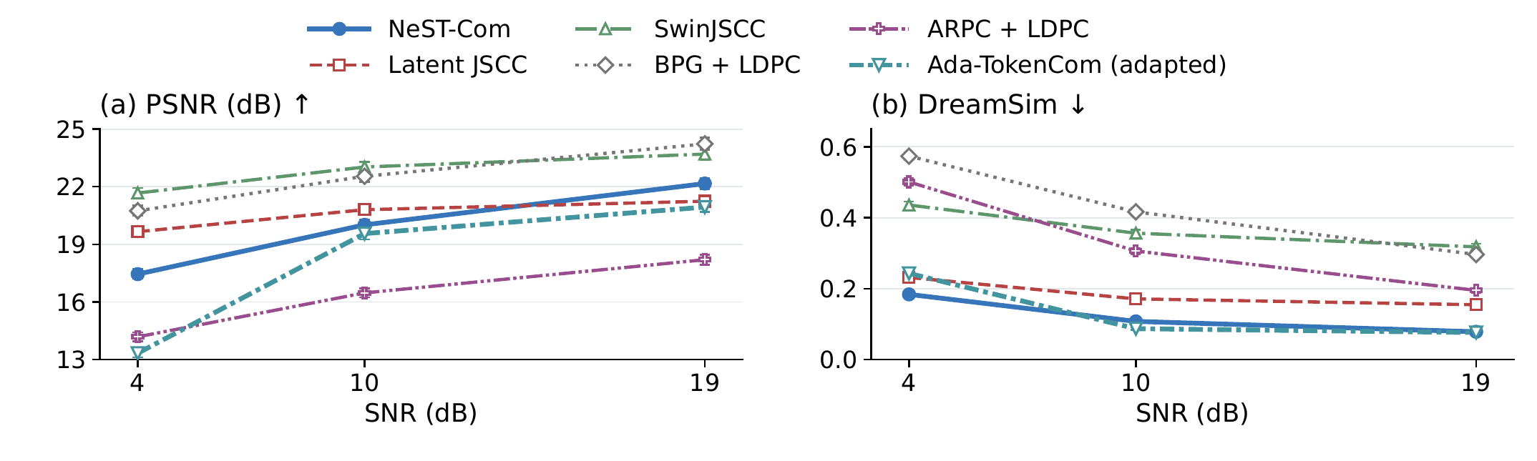
Fig. 2. Six-system performance on common500 at $N=1024$. Points and bars are source means and pointwise 95% source-bootstrap CIs after averaging three channel realizations. Ada denotes the predicted-class, fixed-frame adaptation. Higher PSNR and lower DreamSim are favorable.

A. Experimental Setup
We use common500 ImageNet validation images [11], a disjoint 1000-image calibration set, and the 24 Kodak images [12], with fixed $256×256$ preprocessing. The six-system main experiment uses $N=1024$; the reduced-budget study compares NeST, WHOLE, and Ada at $N=512$. Both use $E_{s}=2$ and 4/10/19 dB. ImageNet-calibrated policies remain fixed on Kodak.
The six systems are NeST-Com, Latent JSCC, adapted SwinJSCC [2], adaptive BPG [13] + LDPC, adapted ARPC [6] + LDPC, and Ada-TokenCom adapted to a fixed per-image frame. Our convolutional Latent JSCC maps tokenizer latents to symbols and shares $D_{c}$; its losses combine image MSE, LPIPS, and normalized-latent consistency. Latent JSCC and SwinJSCC use the same 20 000 training images and final 100k/200k-update checkpoints. SwinJSCC was still improving at its training budget cap. All required signaling is charged; ARPC’s caption is paid. Ada retains LlamaGen-L/VQ16, prefix arithmetic coding, and conditional tail sampling. A fixed ConvNeXt predicts the class, whose 10-bit ID is transmitted, giving $b+39≤k_{a}$. Calibration chooses its MCS; online fitting searches the predeclared 1–256-token endpoints. This changes Ada’s average-resource formulation to our fixed-frame task.
Metrics are PSNR, LPIPS-Alex [14], DreamSim [15], and CLIP-I, the CLIP ViT-L/14 image–image cosine [16]. DreamSim/CLIP use frozen FP32, $224×224$ preprocessing. We average three channel realizations per source, retaining gray failures, then compute equal-source means. Intervals are 95% source-bootstrap CIs; differences are directly source-paired. Pairing does not require identical noise realizations across methods. Generative seeds and decoding settings are fixed. N512 methods share source/repeat-specific AWGN; the historical N1024 systems retain their original noise realizations. At $N=1024$, no rejected or failed reconstructions occurred in the 1500 trials per method at each matched SNR on common500. Continuous Latent JSCC has no discrete CRC rejection rule. Transmitter fallback is counted separately.
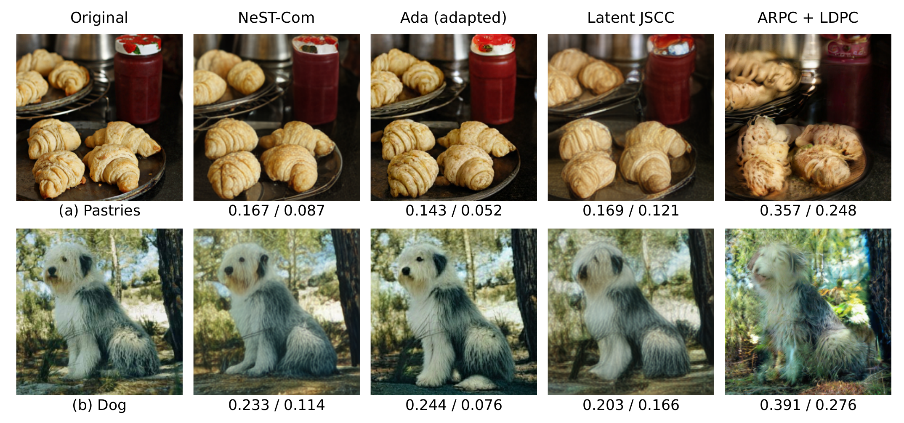
Fig. 3. Selected methods on two fixed development examples at $N=1024$ and 10 dB: (a) pastries and (b) a dog. Values below each reconstruction are LPIPS-Alex$↓$ / DreamSim$↓$ for that displayed realization.

B. Effect of Within-Scale Endpoints
Table I. Within-scale endpoint evidence. (A) Main family-specific policies; $Δ=PARTIAL−WHOLE$ with source-paired 95% CIs. (B) Controlled 100-source diagnostic at 10 dB.
(A) Main policies: utilization and paired PSNR gain
SNR | Utilization W$→$P (%) | $Δ$PSNR (dB) [95% CI]
common500
4 | 73.81 $→$ 93.08 | $+0.616 [0.564,0.673]$​
10 | 77.70 $→$ 95.21 | $+0.701 [0.637,0.766]$​
19 | 85.24 $→$ 94.73 | $+0.319 [0.290,0.349]$​
Kodak24
4 | 75.69 $→$ 93.43 | $+0.396 [0.236,0.543]$​
10 | 78.11 $→$ 94.99 | $+0.674 [0.408,0.958]$​
19 | 85.69 $→$ 93.71 | $+0.228 [0.140,0.324]$​
(B) Fixed model, MCS, maximum endpoint and fitting
Grid (candidates) | Utilization (%) | PSNR (dB)
Whole (7) | 78.15 | 18.952
Half (13) | 89.21 | 19.396
Quarter (25) | 95.38 | 19.612
Eighth (49) | 97.39 | 19.735
Table I(A) compares WHOLE/PARTIAL with shared tokenizer, prior, entropy coder, and $D_{c}$. Their target/MCS choices are calibrated separately and select the same MCS at each SNR; fallback follows the fixed rule. On common500, PSNR gains are 0.32–0.70 dB. At 10 dB, utilization rises from 77.70% to 95.21% and DreamSim decreases by 0.0240. Kodak gains 0.674 dB and reduces DreamSim by 0.0164 at 10 dB; its 19 dB DreamSim CI includes zero. These results connect additional legal endpoints and calibrated fitting to better use of a fixed body capacity.
Block B isolates granularity on 100 existing sources, holding model, MCS, maximum endpoint, and longest-feasible fitting fixed. WHOLE, half-, quarter-, and eighth-scale grids have 7/13/25/49 candidates. At 10 dB, QUARTER minus WHOLE gains $0.660 [0.515,0.814]$ dB, while EIGHTH adds $0.123 [0.079,0.169]$ dB over QUARTER. The denser grid also yields small PSNR/LPIPS gains at other SNRs; the main quarter grid remains the predefined configuration.
A receiver intervention uses the same 100 sources and actual received prefixes, without new endpoint selection or channel trials. A0 ignores received boundary positions and follows the prior path. B0 adds their correction only to the final residual latent, leaving finer-scale context on the A0 path. C0 updates both latent and context. All three use the same device and numerical precision. At 10 dB, B0$−$A0 and C0$−$B0 yield 0.220 and 0.440 dB mean PSNR differences. C0$−$B0 is zero at 19 dB because the boundary is the last scale.

C. Comparison With Existing Methods
Table II. Perceptual distance and image-feature similarity on common500. Each cell is LPIPS-Alex $↓$ / CLIP-I $↑$.
Method | 4 dB | 10 dB | 19 dB
NeST-Com | 0.263 / 0.821 | 0.171 / 0.873 | 0.118 / 0.900
Latent JSCC | 0.219 / 0.741 | 0.173 / 0.789 | 0.158 / 0.804
SwinJSCC | 0.530 / 0.627 | 0.469 / 0.669 | 0.440 / 0.697
BPG + LDPC | 0.725 / 0.586 | 0.589 / 0.635 | 0.458 / 0.684
ARPC + LDPC | 0.512 / 0.644 | 0.341 / 0.713 | 0.250 / 0.788
Ada (adapted) | 0.395 / 0.828 | 0.167 / 0.884 | 0.138 / 0.892
Fig. 2 and Table II show a quality tradeoff. NeST-Com exceeds adapted Ada in PSNR by 4.116/0.455/1.226 dB at 4/10/19 dB, respectively. At 10 dB, Ada has lower LPIPS and DreamSim and higher CLIP-I, with source-paired CIs excluding zero. Ada also has higher CLIP-I at 4 dB and slightly lower DreamSim at 19 dB; NeST has better PSNR, LPIPS, and CLIP-I at 19 dB. Ada delivers all 256 tokens at 19 dB, so no tail sampling occurs; its approximately 58% source-capacity utilization reflects completion of its representation.
SwinJSCC and BPG have higher PSNR than NeST at every tested SNR. Latent JSCC has higher PSNR at 4/10 dB and lower LPIPS at 4 dB. Thus perceptual criteria and pixel error need not rank systems alike. NeST’s PSNR advantage over ARPC is 3.26–3.97 dB. On matched100, replacing ARPC’s original $τ=0.5$ sampling by argmax or $τ=0.25$ changes mean PSNR by up to about 0.15 dB in the tested conditions.
Fig. 3 shows two selected development examples. Ada retains crisp pastry folds and dog fur; NeST and Latent JSCC smooth different details, while ARPC changes visible object contours and texture. For the dog, Latent JSCC has the lowest displayed LPIPS, whereas Ada has the lowest DreamSim. These individual outcomes complement the source-level comparison.
On Kodak, all four paired metrics favor NeST over Ada at 4 dB. At 10 dB, only the PSNR difference has a 95% paired confidence interval excluding zero; at 19 dB, PSNR and LPIPS favor NeST while DreamSim/CLIP-I CIs cross zero.

D. Transmission With a Reduced Symbol Budget
Table III. Reduced-budget comparison on common500 at $N=512$. $Δ=NeST−Ada$; brackets give source-paired 95% CIs. Positive PSNR and negative DreamSim favor NeST.
SNR | $Δ$PSNR (dB) | $Δ$DreamSim
4 | $+4.180$​ | $−0.1029$​
 | $[+3.991,+4.377]$​ | $[−0.1142,−0.0917]$​
10 | $+4.055$​ | $−0.0660$​
 | $[+3.880,+4.235]$​ | $[−0.0747,−0.0573]$​
19 | $+1.740$​ | $+0.0139$​
 | $[+1.577,+1.909]$​ | $[+0.0103,+0.0173]$​
At $N=512$, 68 header symbols leave 444 body symbols. Policies are recalibrated on the same independent calibration set using a common MCS pool. Table III shows higher NeST PSNR at all SNRs and lower DreamSim at 4/10 dB. LPIPS also favors NeST throughout; Ada has higher CLIP-I throughout and lower DreamSim at 19 dB, with paired CIs excluding zero. Against WHOLE, NeST gains 0.392/0.399/0.792 dB PSNR at 4/10/19 dB, while utilization increases from 75.99/79.30/73.01% to 93.00/93.46/94.68%. Body-CRC rejections number 4/7/5 for NeST/WHOLE/Ada at 4 dB, 1/0/0 at 10 dB, and zero at 19 dB, each out of 1500 receptions; all remain in the means. No source requires NULL. These results describe separately calibrated systems: the N512 candidate pool also differs from historical N1024 calibration. They do not isolate representation order or a change of $N$ alone.

E. Additional Results and Processing Cost
The existing $N=2048$ comparison uses 100 sources and two paid 1024-symbol subframes, with adaptive conditions at 4/10 dB and complete representations at 19 dB. At 19 dB, NeST exceeds ARPC by 1.806 dB PSNR, but ARPC has better DISTS [17]: NeST minus ARPC is $+0.0054 [+0.0024,+0.0086]$.
With WHOLE/PARTIAL transmit policies fixed at 10 dB and RX using the true noise variance, all 300 receptions per method on a 100-image subset are rejected at 8 dB, whereas all succeed at 10/12 dB. For each source and method, the recovered prefix and reconstruction are identical at 10 and 12 dB; gray failures remain in the statistics.
Software processing latency at 10 dB averages 619.71 ms/image for NeST, 42.48 for Latent JSCC, 44.69 for SwinJSCC, 1520.30 for ARPC, and 2293.01 for BPG (RTX PRO 6000, six CPU cores, batch one, 16 development images measured three times after warm-up). Totals sum TX/RX software processing; Ada has not been timed under this protocol.

IV. Conclusion
NeST-Com fits coarse-to-fine residual tokens to fixed digital frames through within-scale endpoints, actual terminated lengths, and prefix-constrained reconstruction. Shared-model results connect improved utilization to quality gains, with received boundary tokens affecting both residual reconstruction and finer-scale context. Gains over whole-scale transmission persist at 512 symbols. External comparisons retain pixel–perceptual tradeoffs, including Ada’s stronger CLIP-I at that budget. Policies for uncertain SNR remain future work.

References
[1] E. Bourtsoulatze, D. B. Kurka, and D. Gündüz, “Deep joint source-channel coding for wireless image transmission,” IEEE Trans. Cogn. Commun. Netw., vol. 5, no. 3, pp. 567–579, Sep. 2019.
[2] K. Yang, S. Wang, J. Dai, X. Qin, K. Niu, and P. Zhang, “SwinJSCC: Taming Swin Transformer for deep joint source-channel coding,” IEEE Trans. Cogn. Commun. Netw., vol. 11, no. 1, pp. 90–104, Feb. 2025.
[3] V. Chande and N. Farvardin, “Progressive transmission of images over memoryless noisy channels,” IEEE J. Sel. Areas Commun., vol. 18, no. 6, pp. 850–860, Jun. 2000, doi: 10.1109/49.848239.
[4] Z. Zhang, L. Qiao, M. B. Mashhadi, Z. Gao, M. Bennis, and K. Huang, “Ada-TokenCom: Rate-adaptive token communications via large-model-driven token compression and generation,” 2026, arXiv:2608.28086.
[5] S. Liu and K. Wang, “TONIC: Token-centric semantic communication for task-oriented wireless systems,” 2026, arXiv:2605.21553.
[6] Z. Zhang, Y. Xia, B. Chen, T. Zhang, H. Wang, and H. Qiu, “Autoregressive-based progressive coding for ultra-low bitrate image compression,” in Int. Conf. Learning Representations, 2026.
[7] K. Tian, Y. Jiang, Z. Yuan, B. Peng, and L. Wang, “Visual autoregressive modeling: Scalable image generation via next-scale prediction,” in Advances in Neural Information Processing Systems, vol. 37, 2024, pp. 84 839–84 865.
[8] I. H. Witten, R. M. Neal, and J. G. Cleary, “Arithmetic coding for data compression,” Commun. ACM, vol. 30, no. 6, pp. 520–540, Jun. 1987, doi: 10.1145/214762.214771.
[9] 3GPP, “NR; Multiplexing and channel coding,” TS 38.212, ver. 16.5.0, Release 16, 2021. [Online]. Available: https://www.etsi.org/deliver/etsi_ts/138200_138299/138212/16.05.00_60/ts_138212v160500p.pdf
[10] M. Oquab et al., “DINOv2: Learning robust visual features without supervision,” Trans. Mach. Learn. Res., Jan. 2024. [Online]. Available: https://openreview.net/forum?id=a68SUt6zFt
[11] O. Russakovsky et al., “ImageNet large scale visual recognition challenge,” Int. J. Comput. Vis., vol. 115, no. 3, pp. 211–252, 2015.
[12] R. Franzen, “Kodak lossless true color image suite,” accessed Oct. 26, 2026. [Online]. Available: https://r0k.us/graphics/kodak/
[13] F. Bellard, “BPG image format,” accessed Oct. 22, 2026. [Online]. Available: https://bellard.org/bpg/
[14] R. Zhang, P. Isola, A. A. Efros, E. Shechtman, and O. Wang, “The unreasonable effectiveness of deep features as a perceptual metric,” in Proc. IEEE Conf. Comput. Vis. Pattern Recognit., Jun. 2018, pp. 586–595.
[15] S. Fu, N. Tamir, S. Sundaram, L. Chai, R. Zhang, T. Dekel, and P. Isola, “DreamSim: Learning new dimensions of human visual similarity using synthetic data,” in Advances in Neural Information Processing Systems, vol. 36, 2023, pp. 50 742–50 768.
[16] A. Radford et al., “Learning transferable visual models from natural language supervision,” in Proc. 38th Int. Conf. Mach. Learn., vol. 139, 2021, pp. 8748–8763.
[17] K. Ding, K. Ma, S. Wang, and E. P. Simoncelli, “Image quality assessment: Unifying structure and texture similarity,” IEEE Trans. Pattern Anal. Mach. Intell., vol. 44, no. 5, pp. 2567–2581, May 2022.

