NeST-Com: Fixed-Budget Next-Scale Token Communication
Anonymous Authors
Abstract
Next-scale residual tokens provide a coarse-to-fine image description, but whole-scale endpoints can underfill fixed digital frames. NeST-Com fits independently terminated token-wise prefixes to the actual frame capacity and uses received boundary tokens for residual reconstruction and finer-scale conditioning. With shared model components, it improves PSNR over whole-scale transmission by 0.45–0.88 dB at 1024 symbols and 0.50–0.99 dB at 512 symbols, with lower DISTS and DreamSim at all seven tested points. At 1024 symbols and 10 dB, source-bit utilization increases from 77.70% to 99.79%. External comparisons reveal budget-dependent perceptual tradeoffs.

Index terms
Image communication, fixed-budget transmission, next-scale prediction, generative reconstruction.

I. Introduction
A fixed per-image channel-symbol budget must accommodate source information, signaling, and protection. Digital coding and learned joint source–channel coding (JSCC) address this constraint with different representations [1, 2]. At a generative receiver, transmitted information constrains reconstruction to the source while the prior predicts missing content.
Next-scale tokenization provides complete coarse maps covering the latent grid, followed by residual refinements. Visual autoregressive modeling (VAR) reported state-of-the-art results in its original class-conditional ImageNet generation benchmarks [7], motivating this completion prior. ARPC uses next-scale entropy coding and completion [6]; Ada-TokenCom combines next-token prefix coding, tail generation, and wireless adaptation [4]. TONIC considers task-oriented token communication [5]. Here, the task is source-image reconstruction under a hard per-image symbol budget.
Fitting progressive descriptions to channel resources is classical [3]. A complete next-scale residual map can exceed remaining frame capacity even when some tokens fit. Image-dependent entropy lengths require actual decodable length checks, and incomplete boundary maps must enter both residual reconstruction and subsequent prediction.
NeST-Com combines token-wise endpoints, independently terminated arithmetic streams, and prefix-constrained reconstruction. Shared coarse maps determine coding probabilities; received tokens overwrite predicted positions [7], updating the residual latent and finer-scale context. Shared-model controls favor NeST over whole-scale transmission on DISTS and DreamSim at all seven budget/SNR points. Matched grids and receiver interventions examine the design, while external comparisons establish complete-system tradeoffs.

II. Proposed NeST-Com Framework

A. Next-Scale Representation and Digital Frame
We transmit $x∈[0,1]^{256×256×3}$ using $N$ complex symbols over AWGN,
$$y=s+n, n∼CN(0,σ^{2}I_{N}), SNR=10\log_{10}(E_{s}/σ^{2}), \text{(1)}$$
with nominal $E_{s}=2.$ TX uses the frozen policy for its design SNR; RX uses the actual noise variance for LLRs. Digital constellations have average energy two without per-frame renormalization. A 12-bit profile ID, CRC16, and terminated rate-1/2 convolutional code occupy 68 rotated-BPSK symbols $\{±(1+j)\}.$ The profile identifies the endpoint and MCS. The remaining $N−68$ symbols carry the LDPC-coded body, with public frame-dependent scrambling after rate matching and inverse scrambling before decoding. Continuous JSCC data are normalized per image to energy two; required side information is paid within $N.$
The frozen VAR tokenizer produces ten residual token maps $q_{s},$ with side lengths $(1,2,3,4,5,6,8,10,13,16)$ and a 4096-entry codebook [7]. Write $L_{s}$ for the number of positions and $C_{s}$ for codebook lookup, resizing to the full latent grid, and the scale-dependent residual transform. The latent sum s​Cs(qs) progressively refines a full-field description. Decoder $D_{c}$ is adapted on 20 000 ImageNet training images using MSE plus $0.1$ LPIPS, then frozen. Training mixes continuous, fully quantized, and interpolated prefix-completed latents in proportions 50/25/25%; the latter use completion from eight source scales (Supplement S1). The null-class VAR-d16 prior factorizes as
$$p_{θ}(q_{s}∣q_{<s})=\prod_{i=1}^{L_{s}}{p_{θ}}(q_{s,i}∣q_{<s}). \text{(2)}$$
Every boundary position has coding probabilities conditioned on the same complete coarse maps. Both terminals reconstruct identical integer CDFs, with total frequency $2^{24},$ for arithmetic coding [8]; no unreceived same-scale token is needed.
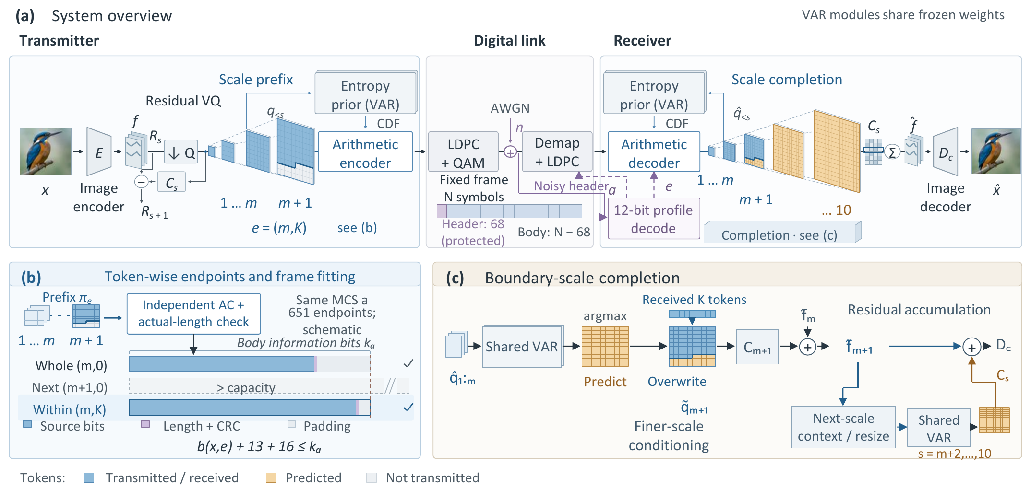
Fig. 1. NeST-Com. (a) The protected profile specifies the endpoint and MCS; both terminals reconstruct coding probabilities from the shared frozen VAR and known coarse tokens. (b) Independently terminated token-wise prefixes fit the body capacity; bars are schematic. (c) Received boundary tokens overwrite predicted positions. The merged map updates the residual latent and finer-scale context. Unreceived boundary positions retain their coarse-conditioned predictions.

B. Within-Scale Endpoints and Actual-Length Fitting
An endpoint $e=(m,K)$ retains complete coarse maps and a raster-ordered boundary prefix:
$$π_{e}=(q_{1},…,q_{m},q_{m+1,1:K}). \text{(3)}$$
The fixed raster order specifies received positions without a mask. WHOLE permits $(m,0)$ for $m=4,…,10.$ NeST permits every integer $K=0,…,L_{m+1}−1$ for $m=4,…,9,$ together with $(10,0):$ 651 distinct endpoints from 30 through 680 retained tokens. The paid 12-bit profile directory covers the applicable endpoint/MCS combinations. Quarter and Eighth grids are controls, not the main configuration.
For MCS $a=(M,r),$ the coded body has $n_{a}=(N−68)\log_{2}M$ bits and information length $k_{a}=⌊rn_{a}⌋.$ Its independently terminated arithmetic length $b(x,e)$ must satisfy
$$b(x,e)+29≤k_{a}, η(x,e)=\frac{b(x,e)}{k_{a}−29}. \text{(4)}$$
The 29 bits comprise a 13-bit length and CRC16. Unused information positions are zero-padded before 5G NR LDPC coding, rate matching [9], and QAM. Thus $η$ is source-bit capacity utilization, not total air-interface efficiency.
Offline calibration fixes a target endpoint and MCS for each budget/SNR by source/reconstruction DINOv2 cosine [10]. NeST retains these target/MCS choices while refining the available endpoints. Family-specific candidate pools and selection rules are in Supplement S1. A common scale-wise probability and incremental coding traversal supplies candidates; non-mutating finalization terminates each stream independently, rather than cutting a longer stream. Online, TX holds the MCS fixed, checks endpoints no longer than the target in decreasing token count, and retains the first satisfying (4). This finds the longest feasible prefix without assuming monotone code lengths or selecting by image quality. If none fits, the frozen $N=1024$ implementation raises an error; this did not occur in the evaluated sources. The $N=512$ implementation instead transmits a paid NULL profile and yields gray.

C. Prefix-Constrained Reconstruction
Invalid profile CRC/catalogue, body CRC, declared length, known padding, or arithmetic parsing yields a fixed gray image, as does valid NULL reception. Otherwise, RX decodes the actual prefix using the shared CDFs. It predicts the boundary map by argmax conditioned on complete received maps, then overwrites known positions [7]:
$${\tilde{q}}_{m+1,i}=\left\{\begin{matrix}{\hat{q}}_{m+1,i}, & i≤K, \\ q_{m+1,i}^{pred}, & i>K.\end{matrix}\right. \text{(5)}$$
Received boundary tokens serve two roles: they correct the residual representation and, through the merged boundary map, condition finer-scale prediction. Unreceived boundary positions retain their original coarse-conditioned prediction; there is no same-scale prediction loop. Complete received maps remain unchanged. After generating the finer maps,
$$\hat{x}=D_{c}​\left(\sum_{s=1}^{10}{C_{s}}({\tilde{q}}_{s})\right). \text{(6)}$$
At the last scale, overwrite only changes the residual contribution.

III. Experimental Results
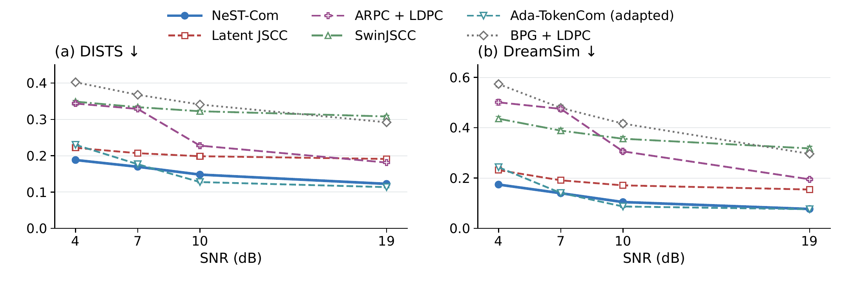
Fig. 2. Six-system reconstruction on common500 at $N=1024.$ Points and bars are equal-source means and pointwise 95% source-bootstrap intervals after averaging three channel realizations per source, including failures. Ada is the predicted-class, fixed-frame adaptation. Lower DISTS and DreamSim are favorable.

A. Experimental Setup
The 500 ImageNet validation sources [11] are disjoint from cal1000 and use fixed $256×256$ preprocessing. We evaluate $N=1024$ at 4/7/10/19 dB and $N=512$ at 4/10/19 dB. Each point averages three channel realizations per source, retaining gray failures, before equal-source means and direct paired 95% source-bootstrap intervals (10 000 resamples). Controls use the first 100 full manifest IDs. Historical noise identities remain method/budget-specific; the matched-grid control shares noise.
Latent JSCC maps tokenizer latents to symbols with convolutional layers and shares $D_{c},$ using MSE, LPIPS, and latent-consistency losses (100k updates). SwinJSCC [2] uses RGB MSE (200k updates, minimum calibration MSE selection). Both train on 20 000 images for $256×256$ and $N=1024.$ Digital baselines include BPG [13] and ARPC [6] with LDPC/QAM. The predicted-class, fixed-frame Ada-TokenCom adaptation [4] retains LlamaGen-L/VQ16, prefix arithmetic coding, and sampled completion (CFG=4, $T=1,$ top-$k=2000,$ top-$p=1$). ConvNeXt predicts its transmitted 10-bit class; ARPC captions and all required fields are likewise paid. This comparison does not reproduce Ada’s long-term budget controller or ARQ.
DISTS [17] and DreamSim [15] measure source-referenced structure/texture and perceptual distance. We also report PSNR, LPIPS-Alex [14], and CLIP-I [16]. Metrics use native floating-point RGB: DISTS uses $256×256$ without resizing; DreamSim/CLIP use the frozen $224×224$ bicubic-antialias preprocessing. DINO-based calibration and feature-based evaluation are related criteria, rather than independent perceptual judgments. All models and numeric routes are frozen; Supplement S1 specifies policies and the differing calibration pools.

B. Effect of Within-Scale Transmission
Table I. Within-scale transmission evidence. (A) NeST minus WHOLE under the frozen family policies. (B) Only endpoint granularity changes under matched model, MCS, ceiling, and noise. (C) Ordered receiver interventions on the actual NeST prefixes. Brackets are source-paired 95% intervals; each block uses its stated population.
(A) common500, N = 1024, family-specific policies
SNR | Util. W→N (%) | ΔDISTS [95% CI] | ΔDreamSim [95% CI]
4 | 73.81 → 99.56 | -0.0146  [-0.0157, -0.0136] | -0.0303  [-0.0333, -0.0273]
7 | 83.19 → 99.75 | -0.0060  [-0.0097, -0.0021] | -0.0108  [-0.0157, -0.0057]
10 | 77.70 → 99.79 | -0.0141  [-0.0153, -0.0128] | -0.0270  [-0.0299, -0.0241]
19 | 85.24 → 99.83 | -0.0048  [-0.0053, -0.0043] | -0.0043  [-0.0051, -0.0036]
(B) control100, 10 dB, common ceiling (8,126)
Grid (ends) | Utilization (%) | DISTS | DreamSim
Whole (5) | 78.13 | 0.1650 | 0.1387
Quarter (20) | 95.19 | 0.1535 | 0.1143
Eighth (39) | 97.44 | 0.1516 | 0.1137
Token (352) | 99.85 | 0.1505 | 0.1115
(C) control100, 10 dB, same received prefixes
Intervention | ΔPSNR (dB) | ΔDISTS | ΔDreamSim
B0−A0 | +0.287  [0.240, 0.335] | -0.0062  [-0.0077, -0.0048] | -0.0113  [-0.0147, -0.0083]
C0−B0 | +0.537  [0.404, 0.682] | -0.0083  [-0.0102, -0.0065] | -0.0159  [-0.0205, -0.0116]
Table I(A) compares the shared tokenizer, prior, coder, and receiver under frozen family policies. At $N=1024,$ 10 dB, token-wise transmission increases utilization from 77.70% to 99.79%. Its paired DISTS and DreamSim differences are −0.0141 [−0.0153, −0.0128] and −0.0270 [−0.0299, −0.0241]. All seven budget/SNR points favor NeST on both distances; PSNR gains over WHOLE range from 0.45 to 0.88 dB at $N=1024.$
Block B isolates endpoint granularity on 100 sources with fixed 16-QAM rate 2/3, maximum position $(8,126),$ and common noise. Quarter-to-Token refinement raises utilization from 95.19% to 99.85%, improving DISTS by −0.0030 [−0.0041, −0.0020], DreamSim by −0.0028 [−0.0050, −0.0006], and PSNR by 0.172 [0.125, 0.221] dB. The mean descending length comparisons are 1.55/4.51/7.57/125.96 for Whole/Quarter/Eighth/Token. These count cached-length comparisons, not neural forwards or elapsed time. Relative to the historical Quarter policies on common500, Token improves DISTS and DreamSim at six of seven points; the 7-dB intervals cross zero (Supplement S2).
Block C holds the actual NeST prefixes fixed. A0 ignores the boundary correction but retains prior completion; B0 adds its residual correction while retaining the A0 conditioning path; C0 updates both. At 10 dB, B0–A0 and C0–B0 reduce DreamSim by $0.0113$ and $0.0159,$ respectively, with intervals excluding zero. These ordered whole-boundary interventions do not partition the extra Token–Quarter gain. The 7-dB results and final-scale check are in Supplement S3.

C. Comparison With Existing Methods
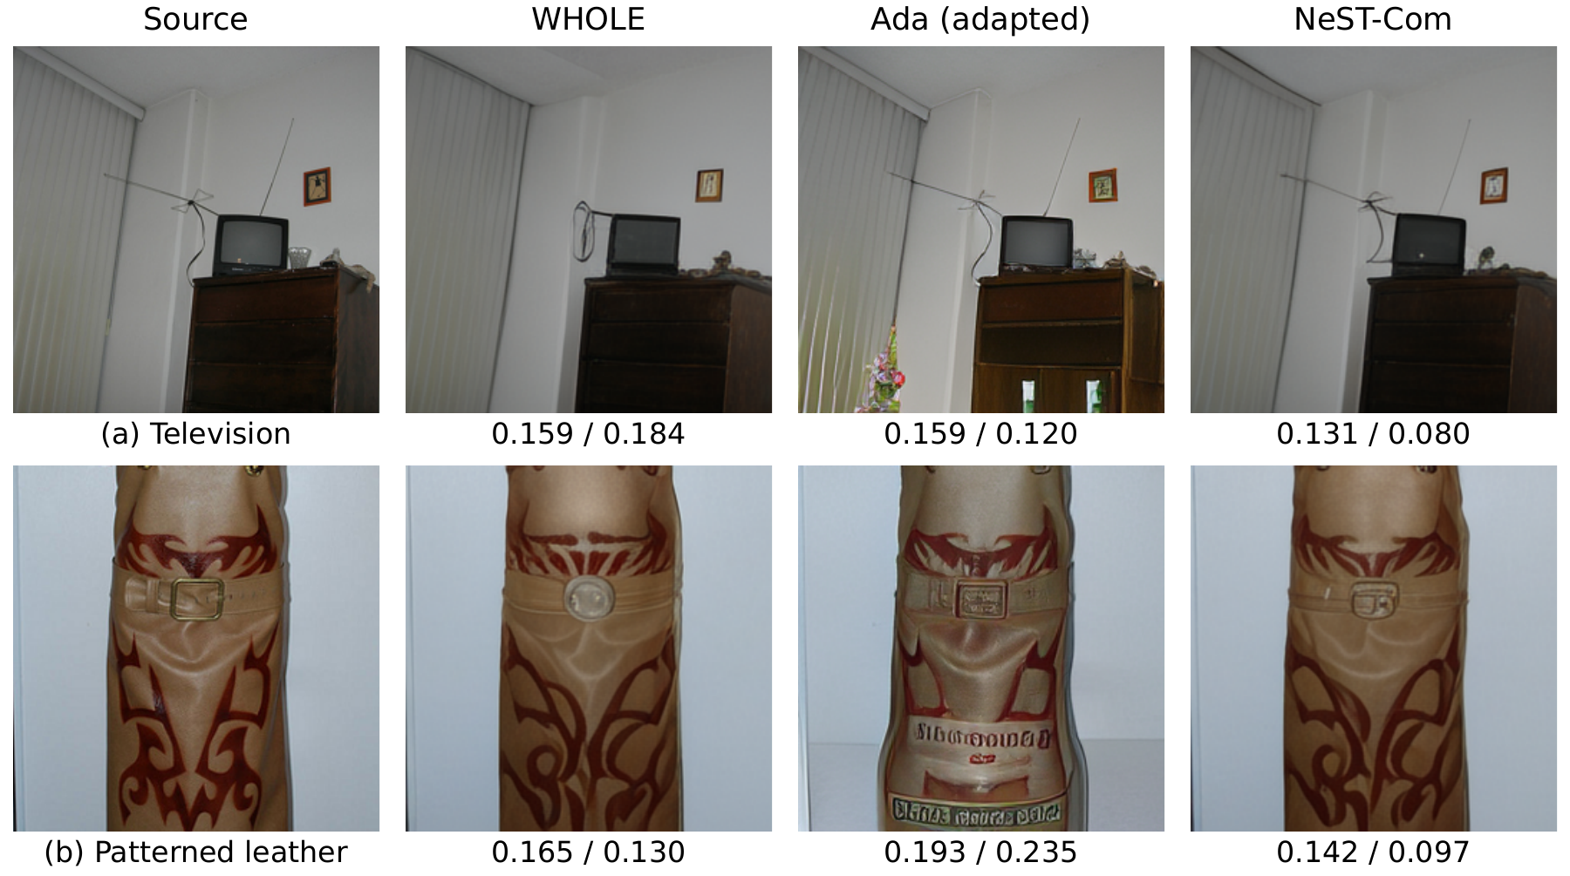
Fig. 3. Selected qualitative examples at $N=1024$ and 7 dB. Columns show source, WHOLE, fixed-frame Ada, and NeST-Com. These examples illustrate visible advantages rather than a random sample. Each uses the fixed first channel realization for that method. Values are DISTS$↓$ / DreamSim$↓$ for the displayed full-field output.
Table II. Auxiliary quality and processing costs at N=1024, 10 dB. Quality uses common500; timing uses 32 sources, one RTX PRO 6000, two CPU cores, batch one, and complete TX/RX processing boundaries. BPG uses CPU only.
Method | PSNR↑ (dB) | LPIPS↓ | CLIP-I↑ | TX (ms) | RX (ms)
WHOLE | 19.31 | 0.199 | 0.858 | 213.8 | 369.9
NeST-Com | 20.19 | 0.166 | 0.877 | 248.4 | 411.6
Ada (adapted) | 19.56 | 0.167 | 0.884 | 7795.6 | 7626.1
Latent JSCC | 20.80 | 0.173 | 0.789 | 15.4 | 24.1
SwinJSCC | 23.03 | 0.469 | 0.669 | 20.5 | 17.6
BPG + LDPC | 22.54 | 0.589 | 0.635 | 2442.0 | 31.7
ARPC + LDPC | 16.47 | 0.341 | 0.713 | 661.7 | 797.0
Fig. 2 compares six complete systems, whose tokenizer, prior, decoder, and conditioning differ. At 4 dB, NeST has lower DISTS and DreamSim than Ada, with paired differences −0.0418 [−0.0450, −0.0386] and −0.0688 [−0.0767, −0.0611]. At 7 dB its DISTS advantage is −0.0070 [−0.0112, −0.0027], whereas the DreamSim interval crosses zero. Ada is better on both distances at 10 dB; at 19 dB Ada is better on DISTS and the DreamSim interval crosses zero. NeST has higher PSNR than Ada at all four points, but SwinJSCC and BPG offer higher PSNR at the original 4/10/19-dB points. Table II and Supplement S2 retain the other metrics.
Fig. 3 illustrates two selected 7-dB advantages. NeST retains the television cabinet and antenna arrangement more faithfully, while recovering a rectangular buckle in the patterned leather example that WHOLE rounds off. Ada changes cabinet contents and adds lettering in these examples. Supplement S6 retains Quarter and all external systems for the same sources.
At 7 dB, NeST/WHOLE/Ada/BPG have 13/7/7/11 gray outcomes among 1500 trials each. NeST/WHOLE/Ada have none at the original $N=1024$ SNRs. Their historical noise identities differ at 7 dB, so these counts alone do not isolate an endpoint effect on reliability.

D. Transmission With a Reduced Symbol Budget
Table III. Reduced-budget reconstruction on common500 at N=512. Means include all failures; PSNR differences use direct source-paired 95% intervals. All five metrics and paired comparisons are in Supplement S2.
SNR / method | PSNR↑ (dB) | DISTS↓ | DreamSim↓
4 / WHOLE | 15.11 | 0.2580 | 0.3247
4 / NeST-Com | 15.61 | 0.2363 | 0.2740
4 / Ada (adapted) | 11.32 | 0.2996 | 0.3847
NeST−WHOLE ΔPSNR: +0.504 [0.440, 0.573] dB
10 / WHOLE | 16.82 | 0.2030 | 0.2049
10 / NeST-Com | 17.41 | 0.1922 | 0.1837
10 / Ada (adapted) | 13.16 | 0.2367 | 0.2582
NeST−WHOLE ΔPSNR: +0.592 [0.544, 0.643] dB
19 / WHOLE | 18.64 | 0.1718 | 0.1458
19 / NeST-Com | 19.63 | 0.1554 | 0.1150
19 / Ada (adapted) | 17.69 | 0.1496 | 0.1078
NeST−WHOLE ΔPSNR: +0.994 [0.940, 1.048] dB
At $N=512,$ NeST improves all five metrics over WHOLE at each SNR, with every paired interval excluding zero. At 10 dB both use target $(7,0)$ and 16-QAM rate 2/3; token-wise fitting raises utilization from 79.30% to 99.54%. Against Ada, NeST improves PSNR by 4.29/4.25/1.94 dB and LPIPS throughout. Its DISTS and DreamSim are lower at 4/10 dB, but higher at 19 dB: differences are 0.0058 [0.0036, 0.0079] and 0.0072 [0.0037, 0.0106]. Ada has higher mean CLIP-I at all three points; paired intervals cross zero at 10/19 dB. NeST/WHOLE/Ada have 4/7/5 gray outputs at 4 dB and none at 10/19 dB. The budgets were calibrated independently, so cross-budget differences are not a causal effect of changing $N$ alone.

E. Information Budget, Channel Threshold, and Cost
An error-free diagnostic compares common500 at six total budgets, 620–2577 bits, including 57 shared overhead bits and Ada’s 10-bit class. WHOLE/NeST share maximum $(10,0);$ Ada permits 256 tokens. Independent decoding yields 15 000 logical outputs, averaging Ada’s three generation repeats within source. NeST improves all five metrics over WHOLE at every budget with paired intervals excluding zero. Against Ada, DISTS favors NeST at 620–1940 bits and Ada at 2248/2577 bits; DreamSim favors NeST at the first three budgets, crosses zero at 1940 bits, and favors Ada at the last two. NeST–Ada DISTS changes from −0.0616 [−0.0651, −0.0582] at 620 bits to 0.0202 [0.0185, 0.0218] at 2577 bits. This removes wireless/MCS effects, while retaining source-system differences (Supplement S4).
With 10-dB policies frozen, 100 sources and 20 noise realizations yield 30 000 receptions at 8/8.5/9/9.5/10 dB. All 2000 receptions per method fail at 8 dB. WHOLE/NeST/Ada rejection rates are 15.75/14.95/13.50% at 9 dB, 0.20/0.10/0.10% at 9.5 dB, and zero observed at 10 dB. Overall quality retains gray rejections; successful-only results are separate (Supplement S5). This does not establish SNR robustness.
Table II reports processing costs on 32 sources, with two warmups and three measurements, batch one, one RTX PRO 6000 and two CPU cores. Under the matched ceiling, Whole/Quarter/Eighth/Token TX means are 183.5/214.1/217.2/248.4 ms. Timing includes fresh probabilities, independent termination, full candidate scanning, and actual link decoding; loading, disk I/O and scoring are excluded. Supplement S7 gives all 16 groups, median/p95 and successful-RX costs. These software costs are not radio latency or optimized-hardware bounds.

IV. Conclusion
NeST-Com fits token-wise next-scale prefixes to fixed digital frames using actual independently terminated code lengths, then uses received tokens for residual correction and finer-scale conditioning. Shared-model comparisons and matched controls support improved source-bit utilization and source-referenced reconstruction. Complete-system results show a low-budget advantage over the fixed-frame Ada adaptation alongside metric-dependent tradeoffs at larger budgets. Reliability remains tied to the chosen digital-link policy.

References
[1] E. Bourtsoulatze, D. B. Kurka, and D. Gündüz, “Deep joint source-channel coding for wireless image transmission,” IEEE Trans. Cogn. Commun. Netw., vol. 5, no. 3, pp. 567–579, Sep. 2019.
[2] K. Yang, S. Wang, J. Dai, X. Qin, K. Niu, and P. Zhang, “SwinJSCC: Taming Swin Transformer for deep joint source-channel coding,” IEEE Trans. Cogn. Commun. Netw., vol. 11, no. 1, pp. 90–104, Feb. 2025.
[3] V. Chande and N. Farvardin, “Progressive transmission of images over memoryless noisy channels,” IEEE J. Sel. Areas Commun., vol. 18, no. 6, pp. 850–860, Jun. 2000, doi: 10.1109/49.848239.
[4] Z. Zhang, L. Qiao, M. B. Mashhadi, Z. Gao, M. Bennis, and K. Huang, “Ada-TokenCom: Rate-adaptive token communications via large-model-driven token compression and generation,” 2026, arXiv:2608.28086.
[5] S. Liu and K. Wang, “TONIC: Token-centric semantic communication for task-oriented wireless systems,” 2026, arXiv:2605.21553.
[6] Z. Zhang, Y. Xia, B. Chen, T. Zhang, H. Wang, and H. Qiu, “Autoregressive-based progressive coding for ultra-low bitrate image compression,” in Int. Conf. Learning Representations, 2026.
[7] K. Tian, Y. Jiang, Z. Yuan, B. Peng, and L. Wang, “Visual autoregressive modeling: Scalable image generation via next-scale prediction,” in Advances in Neural Information Processing Systems, vol. 37, 2024, pp. 84 839–84 865.
[8] I. H. Witten, R. M. Neal, and J. G. Cleary, “Arithmetic coding for data compression,” Commun. ACM, vol. 30, no. 6, pp. 520–540, Jun. 1987, doi: 10.1145/214762.214771.
[9] 3GPP, “NR; Multiplexing and channel coding,” TS 38.212, ver. 16.5.0, Release 16, 2021. [Online]. Available: https:/​/​www.etsi.org/​deliver/​etsi_​ts/​138200_​138299/​138212/​16.05.00_​60/​ts_​138212v160500p.pdf
[10] M. Oquab et al., “DINOv2: Learning robust visual features without supervision,” Trans. Mach. Learn. Res., Jan. 2024. [Online]. Available: https:/​/​openreview.net/​forum?id=a68SUt6zFt
[11] O. Russakovsky et al., “ImageNet large scale visual recognition challenge,” Int. J. Comput. Vis., vol. 115, no. 3, pp. 211–252, 2015.
[12] R. Franzen, “Kodak lossless true color image suite,” accessed Oct. 26, 2026. [Online]. Available: https:/​/​r0k.us/​graphics/​kodak/​
[13] F. Bellard, “BPG image format,” accessed Oct. 22, 2026. [Online]. Available: https:/​/​bellard.org/​bpg/​
[14] R. Zhang, P. Isola, A. A. Efros, E. Shechtman, and O. Wang, “The unreasonable effectiveness of deep features as a perceptual metric,” in Proc. IEEE Conf. Comput. Vis. Pattern Recognit., Jun. 2018, pp. 586–595.
[15] S. Fu, N. Tamir, S. Sundaram, L. Chai, R. Zhang, T. Dekel, and P. Isola, “DreamSim: Learning new dimensions of human visual similarity using synthetic data,” in Advances in Neural Information Processing Systems, vol. 36, 2023, pp. 50 742–50 768.
[16] A. Radford et al., “Learning transferable visual models from natural language supervision,” in Proc. 38th Int. Conf. Mach. Learn., vol. 139, 2021, pp. 8748–8763.
[17] K. Ding, K. Ma, S. Wang, and E. P. Simoncelli, “Image quality assessment: Unifying structure and texture similarity,” IEEE Trans. Pattern Anal. Mach. Intell., 2021, doi: 10.1109/TPAMI.2020.3045810.

