CS 401 7/10/14

Kernel Trick: Everytime we see x^{(i)} . x^{(j)}, we replace it with k(x^{(i)}, x^{(j)})

Kernel Matrix: k_{ij} = (k(x^{(i)}, x^{(j)}))_{ij}

k(x.x') = Ø(x).Ø(x') ..... Ø : R^{n} → R^{(n)2}

Polynomial Kernel: k(x, x') = (x.x' + 1)²

Unsupervised Learning: Clustering

Clustering is useful for: image recognition, speech recognition. Texct recognition, etc.

Works by finding obvious patterns in data.

Consider an input space ...
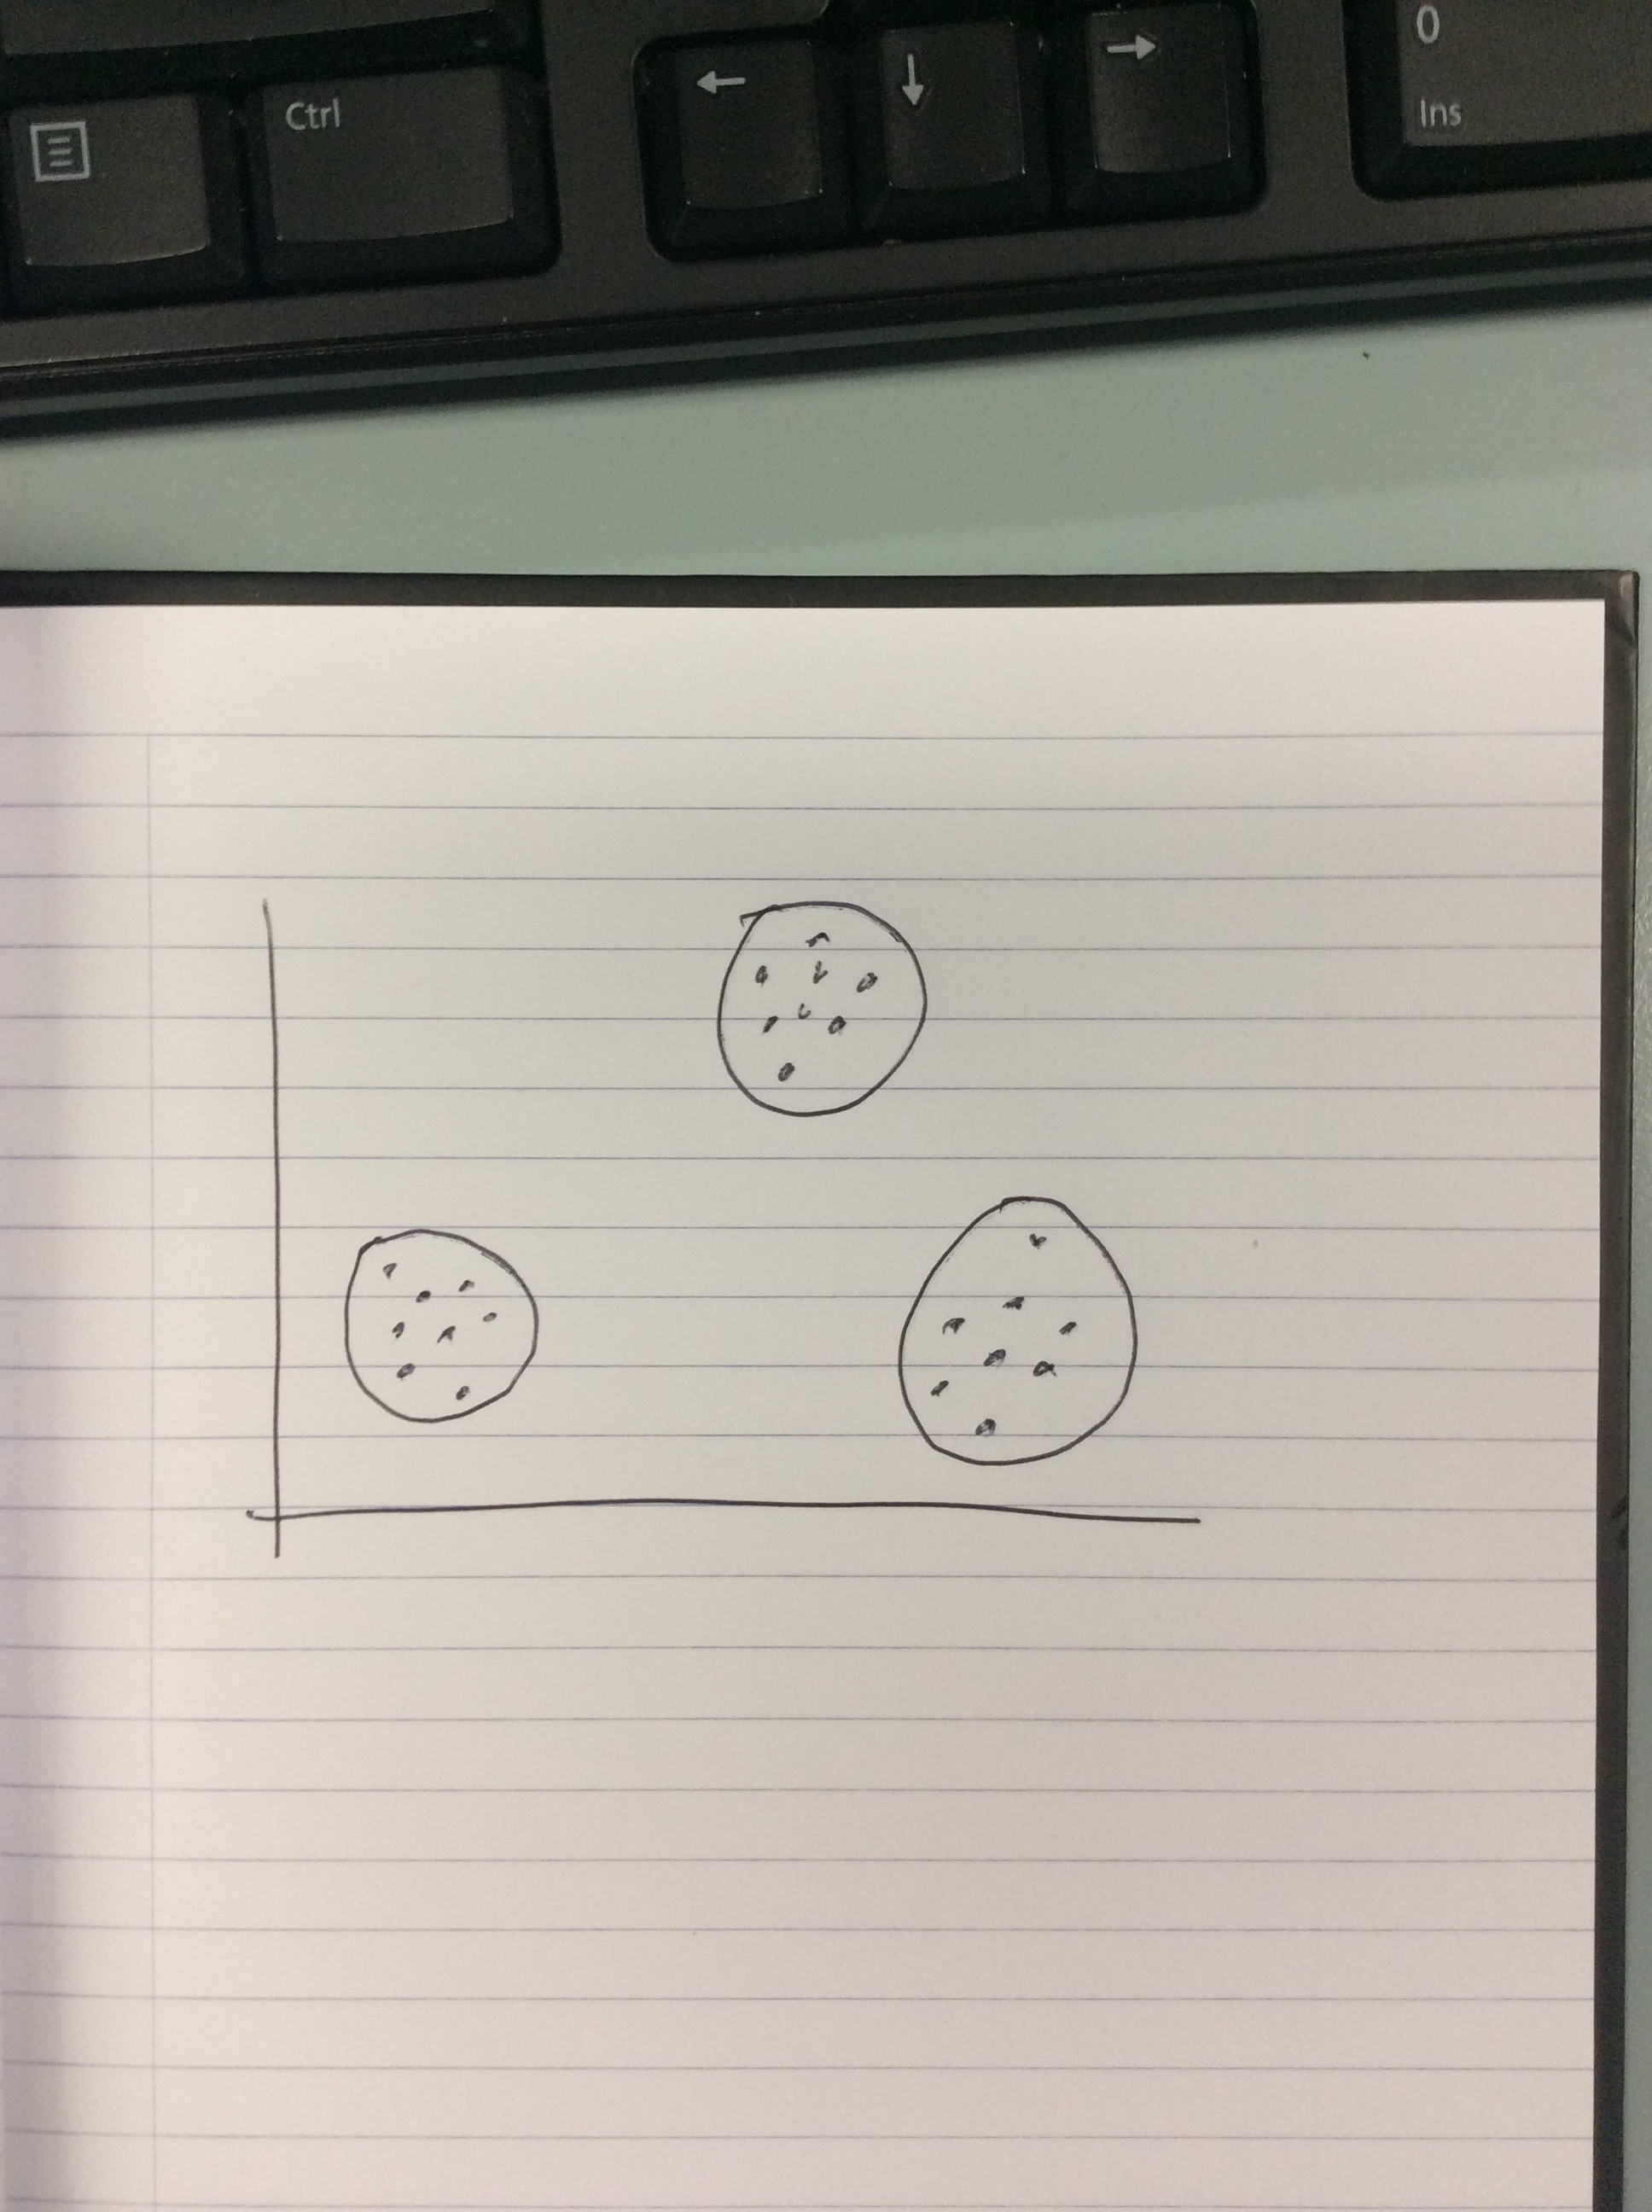

We can see that there are 3 clusters or “means” on this graph

Clustering Algorithm:
k = k clusters
means = each cluster has a cluster center or mean

initialize k-means:

loop {
get input x
j = argmin ||x – c_{j}|| // This finds the closest c to x
c_{j} := c_{j} + (x – c_{j}).ε // Steps towards c_{j}
}

