Perceptron (i.e. linear threshold unit)

Neurons
In the late 1940’s, it was figured out how neurons work. Alan Hodgkin and Andrew Huxley performed experiments on the giant squid axon, recording ionic currents (for which they got the 1963 Nobel Prize in Physiology and Medicine).
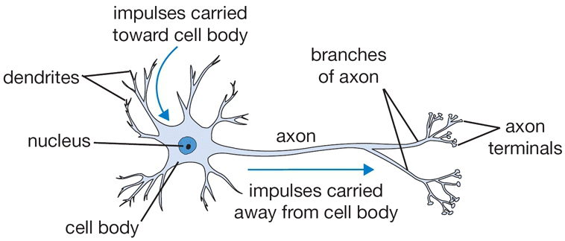

The potential difference between the inside of a neuron and the outside is -80mV. A pulse is transmitted through the axon terminal, causing a chemical reaction and the “gate opens up”. This allows some particles through - ions. Sodium rushes into the neuron, and the voltage increases past the threshold - this is a spike. Now other neurons can figure out what the neuron is doing.

In a neuron, the maximum spiking rate is 1kHz. This rate is only seen in a dieing neuron though. The average spiking rate is ~0.1Hz.

Why the tiny voltage (-80mV)?
Well, why are our chips getting smaller and smaller voltages? 1. Less heat, and 2. an insulator can only insulate so much, so if the wall gets thinner - voltage must go down. The membrane in a neuron is only 2 molecules thick. Really thin! So it requires a very low voltage.

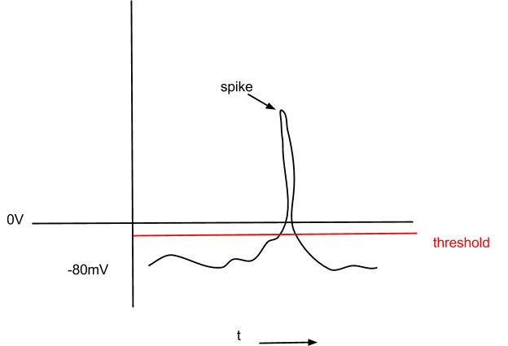Why don’t we use chemical reactions like this in computers? Cause its slow!

What’s the simplest mathematical model we can make of this?

amount of charge injected:
← -80mV

Aside: A neuron is kinda like a capacitor. Spikes are coming in at some rate. So instead of 0 or 1, its more like in between 0 and 1. And when it goes over the threshold, 1. (Modern thought is beginning to favour the more formal method though).

Linear threshold graph
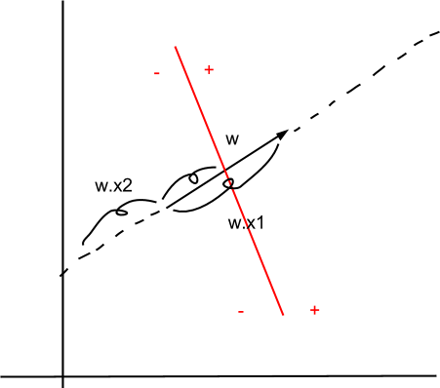

can’t use linear regression.

so

x^ = (diagY)x

^ (1) ← set of linear constraints on w.
(...)
(...)
(…)
(1)

find w so that:
(1) = 1
(..)
(1)
Linear programming: e.g. for farmers. Put in all constraints, what’s my max profit, which amount of fields should I plant.

Perceptron Learning Rule

Input comes in
Checks if correctly classified
if it is → do nothing
if it’s not → change weights by the minimum amount (rotate w a little bit) so that it would be correctly classified

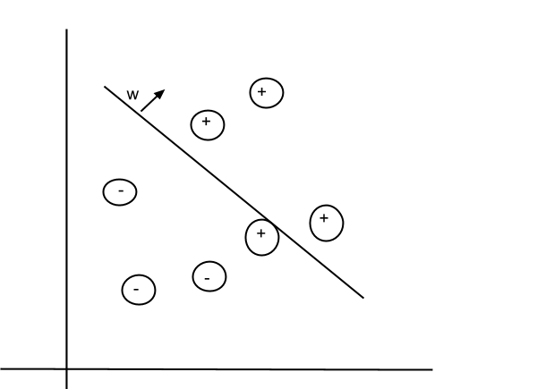
Looks kinda like regression. Same basic idea.

Convergence rule: if w exists, then by cycling through the inputs you’ll eventually find w, where all inputs are classified correctly.

w doesn’t exist if there is even a single outlier. No admissible solution.

