“Back propagation, an abbreviation for "backward propagation of errors", is a common method of training artificial neural networks used in conjunction with an optimization method such as gradient descent. The method calculates the gradient of a loss function with respects to all the weights in the network. The gradient is fed to the optimization method which in turn uses it to update the weights, in an attempt to minimize the loss function.
Back propagation requires a known, desired output for each input value in order to calculate the loss function gradient. It is therefore usually considered to be a supervised learning method, although it is also used in some unsupervised networks such as auto encoders. It is a generalization of the delta rule to multi-layered feed forward networks, made possible by using the chain rule to iteratively compute gradients for each layer. Back propagation requires that the activation function used by the artificial neurons (or "nodes") be differentiable.”(wiki)

-1
+

-

X₂

+1
+

-

-1 X₁ +1
X₁
X₂
5
5
5
^y
y
-5
-5
+5
5
5

+5

dim w = 9

+

-
0
S(ϑ) = (1/1+e ^{2ϑ} -1/2) *2

(x_{1,} x₂) --> x_{1 XOR} x₂
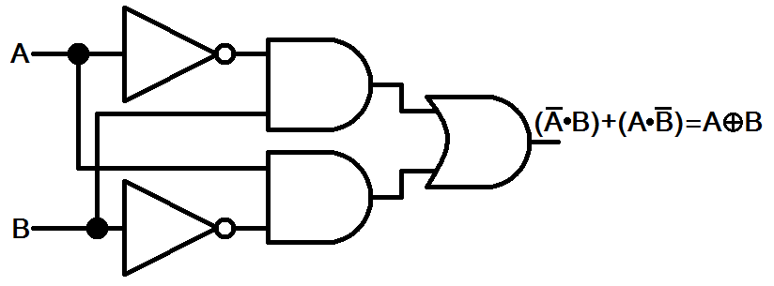

w^{new} = w – ζ ▼_{w} E ζ – learning rate, ζ > 0

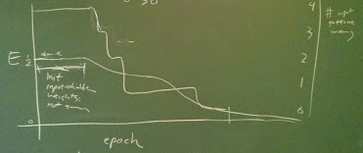
Number of input patterns wrong
Init
input->hidden weight not small

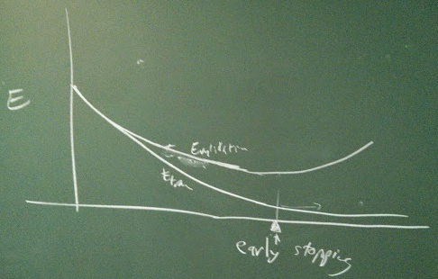
Error on validation
Erron on training set
Add extra to the error:
+ α ∑ _{j} w _{j}² α - hyper parameter

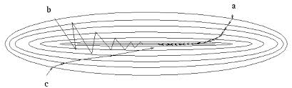
w₁
w₂

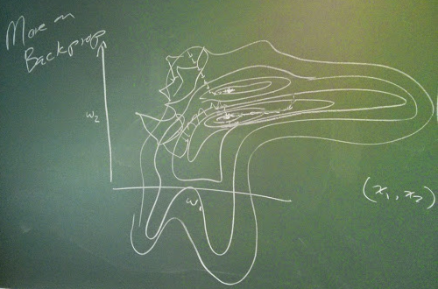

∆w = - ζ ▼_{w} E
∆w = ζ₁ * V
∆v = - ζ₂ ▼_{w} E gradient descent with momentum
<- acceleration change in velocity
Greater ∆v would allow to take bigger steps.
∆w = - ζ* 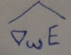 (“hat” means eg.that something includes a lot of noise) Stochastic gradient
Stochastic gradient descent is a gradient descent optimization method for minimizing an objective function that is written as a sum of differentiable functions.
E = < E _{p}> - an average #p – number of training patterns
▼E = <▼ E _{p} >
= pick random example from training set
Deterministic gradient – going down hill
Stochastic gradient – bouncing around
then ∆w = - ζ* ζ ~ (c* ζ)/(t + c), 1/√t

