<en.wikipedia.ord/wiki/AdaBoost>

weights on data points

$$wi,o=1/n$$

Et =

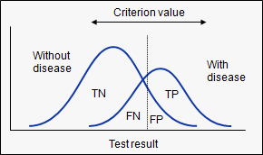

Nearest Neighbour Classifier

-Memory based

K-NN’s (K Nearest Neighbours)

Quad matrix algorithm

-for sorting in a multidimensional space