Supplementary Material

Part 1: Benchmark construction
Anti-HIV activity data was downloaded from ChEMBLdb and NCI. In ChEMBLdb, the compound whose target is "human immunodeficiency virus type 1" and with the activity better than 10 μmol/L was consider as active compounds. In NCI, the DTP AIDS Antiviral Screen has checked tens of thousands of compounds for evidence of anti-HIV activity. Screening result and chemical structures were downloaded from: "https://wiki.nci.nih.gov/display/NCIDTPdata/AIDS+Antiviral+Screen+Data". The file "aids_conc_may04.txt" is an ASCII comma delimited file containing the screening results for 43,850 compounds. Another file is "AIDO99SD.BIN" which contains chemical structural data of the 42,390 compounds from the DTP's Drug Information System. To obtain high-quality benchmark data, the active compounds and inactive compounds were identified as follow: The compound with more than 2 replication experiments and with EC50 less than 10 μmol/L was consider as active compounds. And the other compounds with EC50 more than 100 μmol/L were consider as inactive compounds. Finally, all compounds in the two databases were incorporated by removed the conflict and replicated compounds. This procedure yielded 9584 active and 23998 inactive compounds, respectively. The detailed method of the construction of benchmark dataset is showed in Figure S1. The final benchmark dataset can be downloaded from our website website: http://bsb.kiz.ac.cn/site_media/download/Anti-HIV-Pre/Benchmark.rar
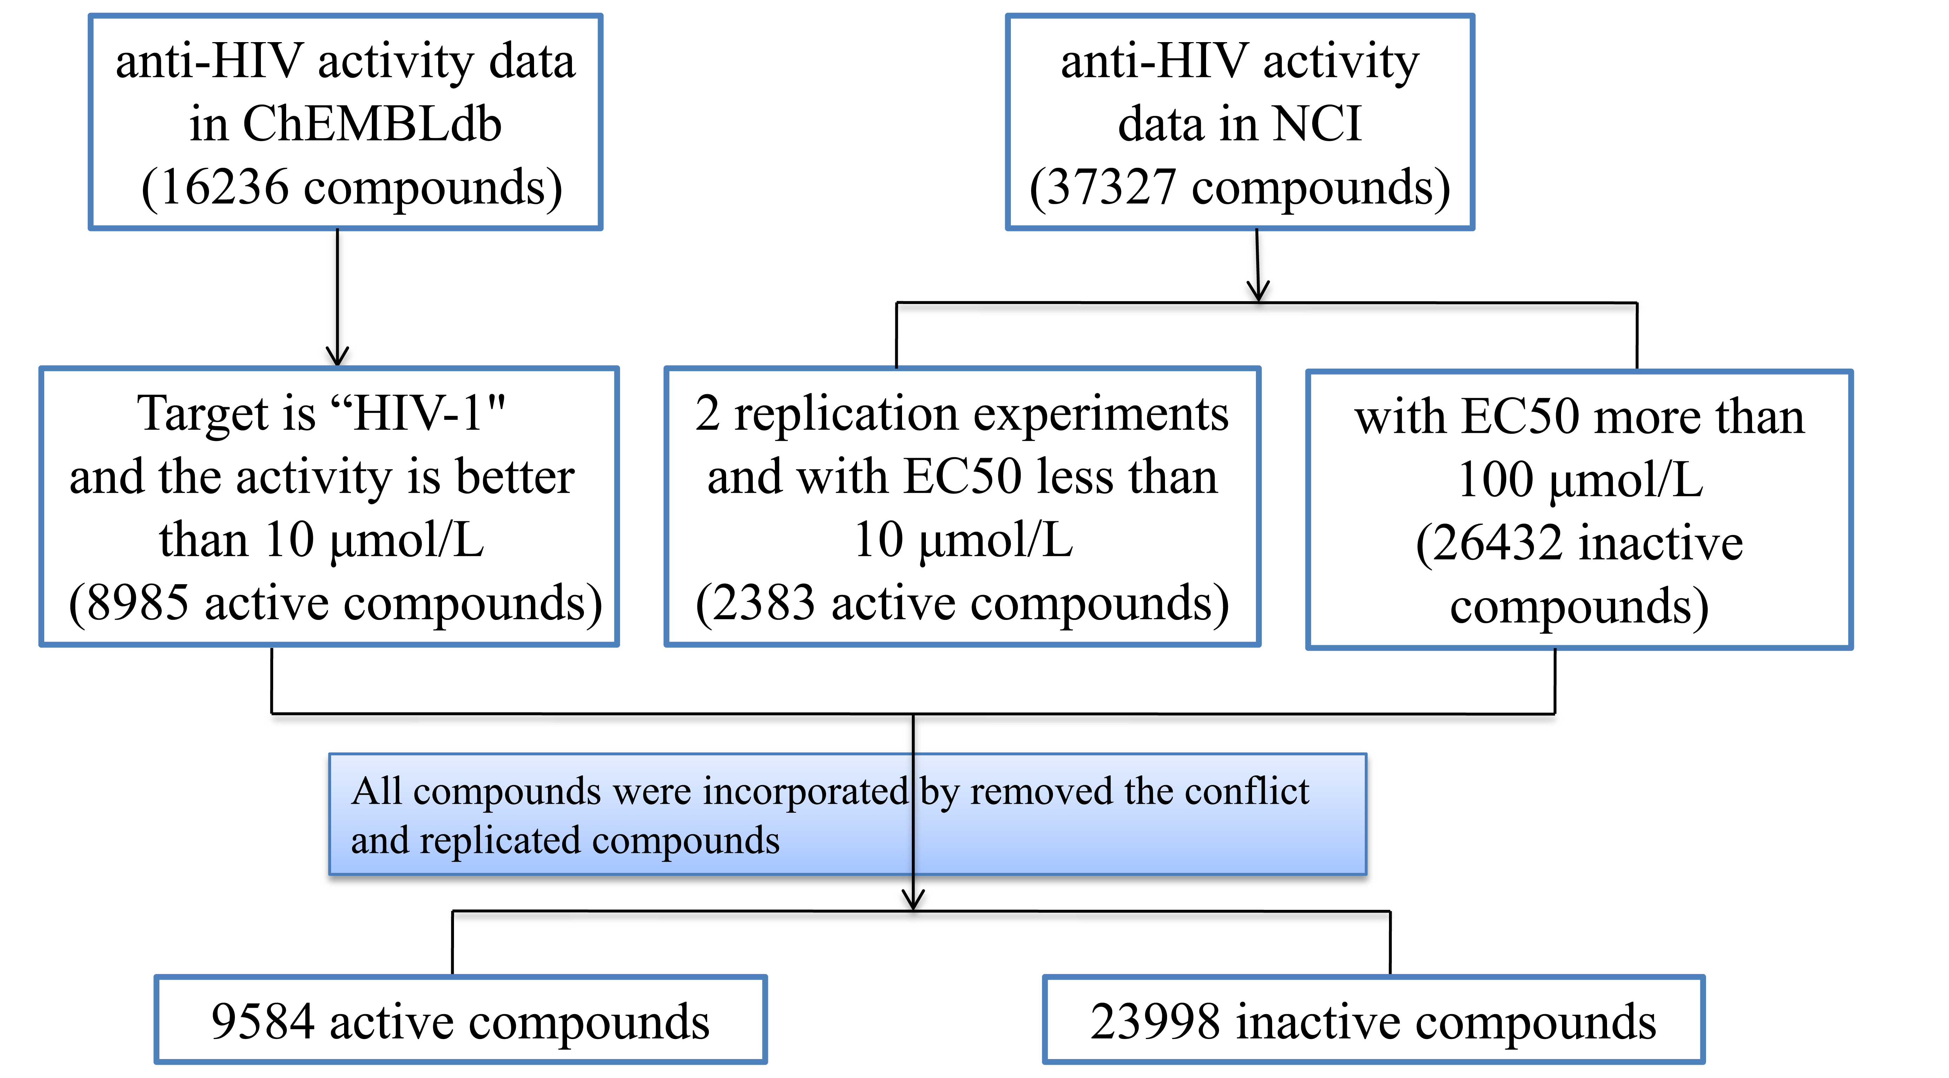
Figure S1. Construction of benchmark dataset for predicting anti-HIV activity of chemical compounds.

Part 2: Cross-validation dataset

The performance of Anti-HIV-Pre is analyzed by cross-validation method. We performed 10 runs 5-fold cross-validation. The pseudo code for implement of cross-validation is as following.

1. For each run i = 1, 2, …, 10

2. Randomly splice both active and inactive compounds into 5 fold (groups)

3. For each fold k = 1, 2, …, 5

4. Set kth fold as test data

5. Set other folds as training data

6. Performance analysis using test and training data

7. Endfor

8. Average the performance outputs at ith run

9. Endfor

Part 3: The selection of kernel function and the penalty parameter C for SVM model

The Scikit-learn Python wrappers for libsvm27 were used to choose kernel function and explore the hyper-parameter space. We firstly compared the performance of SVM model with different kernel function: 'linear', 'poly', 'rbf', 'sigmoid' and 'precomputed' by changing the kernel function but fixing the other parameters. We found the model with kernel function rbf performed best. Then the models with kernel function rbf and different the penalty parameter C were evaluated. The best-performing model was selected by plotting receiver operating characteristic (ROC) curve and calculating the area under the curve (AUC). The results are shown in Figure S4.

Figure S2. The selection of kernel function and the penalty parameter C for SVM model. The optimal penalty parameter C is boxed by red lines. When penalty parameter C equal to 500, the SVM model performs best and the area under the curve (AUC) reaches to 0.9739.

Part 4: The selection of parameter 'n_estimators' for RF model

The RF models with different parameter 'n_estimators' were evaluated. The best-performing model was selected by plotting receiver operating characteristic (ROC) curve and calculating the area under the curve (AUC). The results are shown in Figure S3.

Figure S3. The selection of parameter 'n_estimators' for RF model. The optimal parameter 'n_estimators' is boxed by red lines. When 'n_estimators' equal to 900, the RF model performs best and the area under the curve (AUC) reaches to 0.9817.

Part 6: Standard-alone version and Source code of Anti-HIV-Predictor
We provide source code of Anti-HIV-Predictor for all users in our website: http://bsb.kiz.ac.cn/site_media/download/antihiv/data/Source_code.zip
In this version, we use pybel to calculate the daylight fingerprint and use SVM and RF implemented in Scikit-learn to training model and predict anti-HIV activity of given compounds. Therefore, Anti-HIV-Predictor requires both Python and Scikit-learn.

