SET1710 module configuration program

The board APCI-1710 is the interface between an industrial process and a personal computer (PC). You have ordered the APCI-1710 board with a function for each module. Witch the SET1710 program, you have the possibility to set the functionality for each module.
This program exist for Windows 3.11 (16-bit program) and Windows NT/95 (32-bit program).
Exit from program
SET1710 introduction window
Version number
About SET1710
Configuration selection
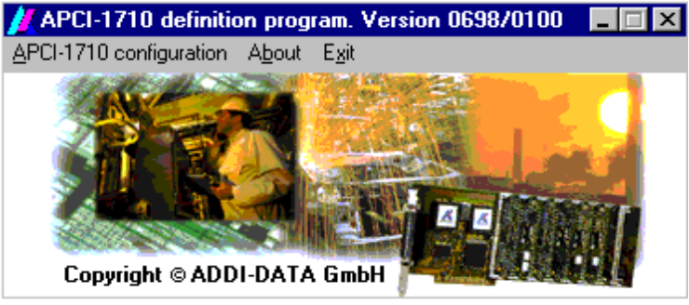

APCI-1710 configuration:
Select the APCI-1710 board to define and open the define window

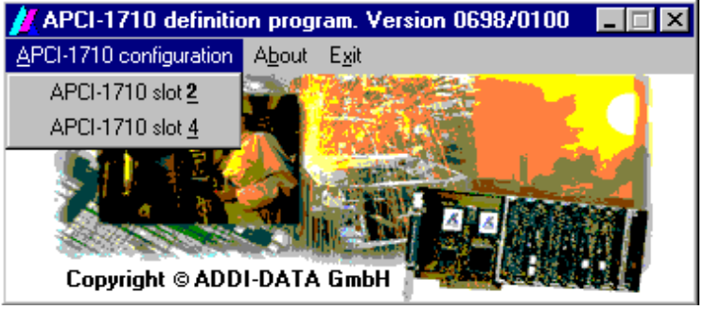
List of APCI-1710 found in your PC
About:
About SET1710 program
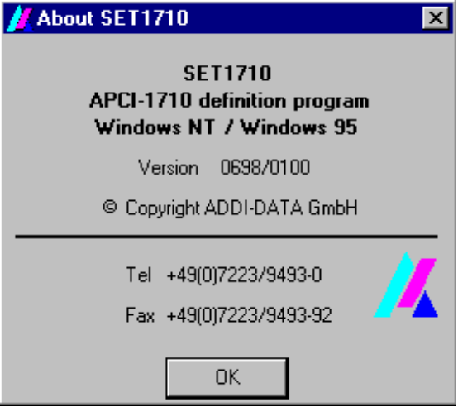
Windows system
SET1710 version
ADDI-DATA phone number
ADDI-DATA fax number
Exit:
Exit from SET1710 program
SET1710 define window

Configure the APCI-1710
Selected APCI-1710 slot number
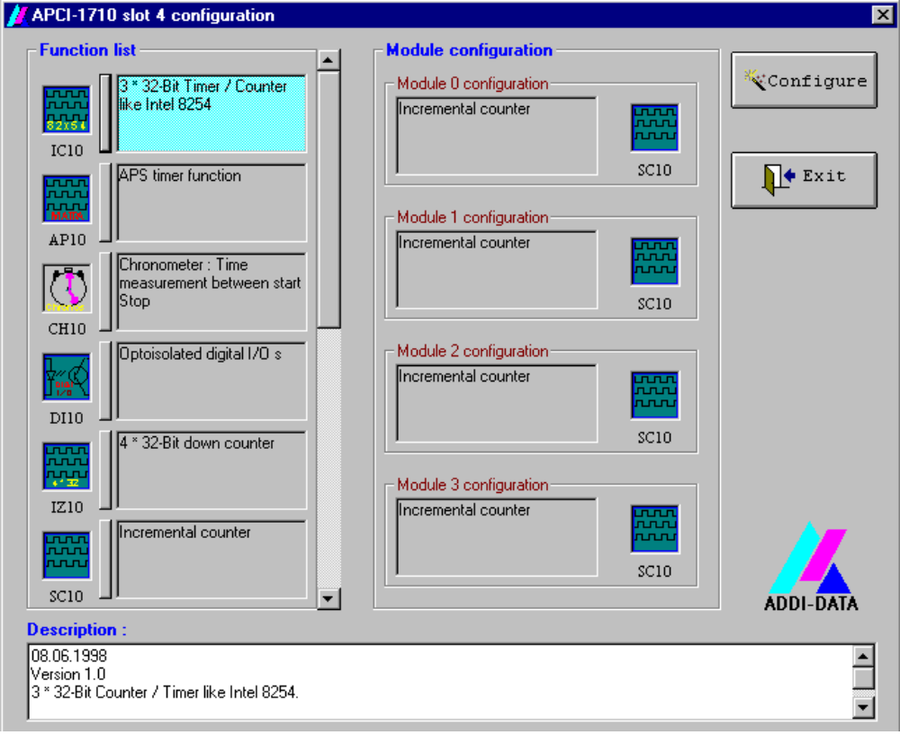
Exit from window
Module number
Version

Function list:
All available functionality module configuration list.
Each module functionality is define in a configuration file.
The location of this configurations file is the CFG directory.

Module configuration:
Actual module configuration from selected APCI-1710

Description:
Selected functionality description from „Function list“.
You find in this description the version, the update description and all other information’s about the functionality.

Configure:
Program the APCI-1710 witch the actual module configuration

Exit:
Close the window

Set the module configuration via the mouse

Click witch the left mouse button to the selected functionality icon from the „Function list“ and move the mouse to the desired module.
Set the module configuration via the keyboard

Press the carriage return key of the select functionality icon from the „Function list“.

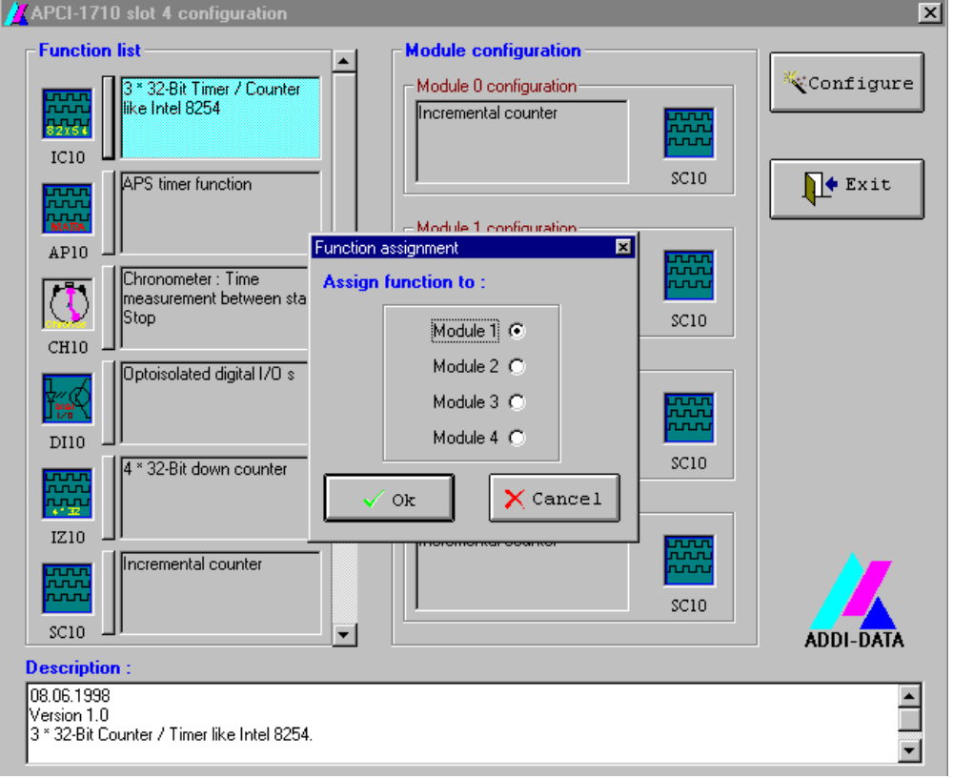

Select the module to set the configuration and validate witch „Ok“

