ADDIREG documentation

Introduction:

The ADDIREG registration program is a 32 bit program.
With this program you can registrate all hardware information neccessary to operate the
ADDI-DATA PC-boards.

Program description:

Please install the ADDI-DATA PC board you wish to registrate in your PC before you use the ADDIREG program. This allows you to check the registration.

After calling the program the following screen will be displayed:

Table:
The table in the middle contains the registrated boards and their parameters.

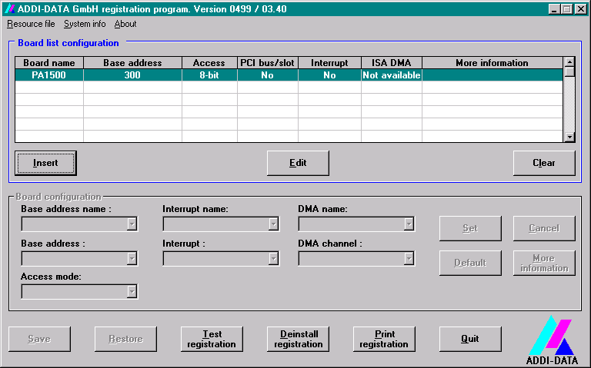

Board name:
In this field the name of the registrated boards will be displayed (like APCI-1500).
If you use the program for the first time, no board is displayed on the screen.

Base address:
Displays the selected base address of the board.

Access mode:

Determine the access mode for ISA boards

PCI bus/slot:
Displays the used PCI bus/slot. If the board is no PCI-board, the message "NO" will appear.

Interrupt:
In this field, the used interrupt will be displayed. If the board uses no interrupt, the message "Not available" appears on the screen.

DMA:
Displays the selected DMA channel or "Not available", if the board uses no DMA.

More information:
Informations like the Identifier string (the serial boards with the ADDI-DATA driver) or the installed standard COM interfaces are displayed.

Text boxes:
Under the table are six text boxes. With this text boxes you can change the parameters of the boards.

Base address name:
If the board uses several base addresses (One for port 1 and another for port 2) you can select the base address you will change.

Base address:
In this text box you can select the base address of your board. All displayed addresses are available. If an address is already used by another board, this base address will not be displayed in the box.

Interrupt name:
If your board supports different interrupts (Common or single interrupt), you can select this option in this text box.

Interrupt:
Here you can select which interrupt number your board has to use.

DMA name:
If your board supports two DMA channels, you can select which DMA channel you will change.

DMA channel:
In this text box you can select the DMA channel you will use.

The button functions are described in the following page.

Buttons:

Edit:
Selects a highlighted board and shows its parameters in the different text boxes.
Has the same effect as a double click on the wished board.

Insert:
If you want insert a new board, you have to click on the "Insert" button.
The following mask is displayed:

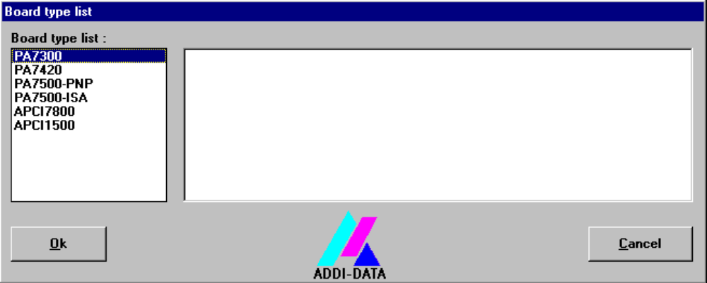

In the left-hand list are all boards you can registrate. Click on the wished board, the board should be highlighted. Click on "OK" to validate the selection.
The first screen should be displayed again.

In the right list are short technical descriptions about the board.

Clear:
With this button you can delete the registration of a board. Highlight the board you wish to delete and click on "Clear".

Set:
Sets the parametered board configuration. You have to set the configuration before you can save it.

Cancel:
Resets the changed parameters to the previous configuration.

Default:
Sets the standart parameters of the board.

More information:

With this button you can change board specific parameters like the Identfier string, the COM number, the operation mode of a communication board and so on.
If your board does not have such informations, you cannot activate this button.

We make differences between PCI board and communication boards:

Comunication boards:

In the following dialog box you see an example for 4 serial interfaces.

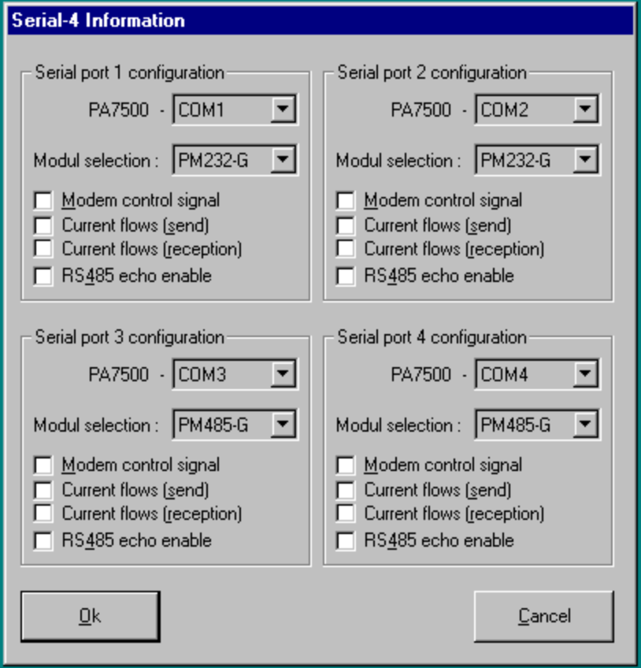

If you use the standard drivers from Windows, you can select the COM number you will use.
If you use the ADDI-DATA drivers, you can select the identifier string for each modul.
You can only activate the following options like "Modul selection" and the different parameters if the function are available.

Save:
Saves the parameters and registrates the board.

Restore:
Reactivates the previous parameters and registration.

Test registration:
Checks if there is a confilict between the board and another device.
A message prints either "OK" or the parameter which have generated the conflict.

Deinstall registration:
Deinstalls all registrations of all boards in the table.

Print registration:
Prints the registration parameters on your standard printer.

Quit:
Ends the ADDIREG program.

Registrating a new board:

To registrate a new board you need Administrator rights. If you have user rights you cannot registrate a new board or change an existing registration!!

- Call the ADDIREG program. The screen of page 1 will be displayed. Click on "Insert".
Select the board you need.

- Select the board to be registrated and click on "Ok".The default address, interrupt and the other parameters are automatically selected. The parameters are set in the fields under the table. If the parameters are not automatically set by the BIOS (by the PCI boards for example), you can change the parameters. For this please use the scroll functions of the fields. Click on the scroll-function and select the new value. Validate it with a click. Do the same for all values you wish to change.

- When the configuration have been completed, click on "Set".

- Save the configuration with the button "Save".

- You can test if the registration is OK. For this, click on the "Test registration" button. This function tests the registrated parameters and if the board is present on the selected base address.After this you can quit the ADDIREG program. Your board will be initialized with the configurated parameters and is ready to be used. The PC should normally reboot. But if there is no message asking you to boot it, the parameters are written in files which do not command rebooting the PC to be saved.

Changing the registration of an existing board:

For changing an existing registration you need administrator rights. If you have user rights you cannot change an existing registration or registrate a new board.

- Call the ADDIREG program. Please highlight the board you wish to change.
The parameters of the board (like base address, DMA channel and so on) are displayed in the fields under the table.

- Click on the parameters to be changed and open the scroll function.

- Select the new value and validate it with a click. Do the same for each parameter you wish to change.

- Click on the button "SET" to validate your configuration.

- Save your registration with the "SAVE" button.

- Now you can test the registration with "Test registration". If everything is OK you can quit the ADDIREG program. When neccessary, a message ask you to reboot your PC.

ADDIREG command line:

Insert:

/I PAXXX AXXX[,XXX] [IXX[,XX] [DX[,X]] [MXX] [SXX]] :
Insert the ADDI-DATA board PAXXX.
The parameter AXXX[,XXX] indicates the base address(s).
The parameter IXX[,XX] indicates the interrupt(s)
The parameter DXX[,XX] indicates the DMA channel(s)
The parameter MXX indicates the ISA board access mode.
(A8 for 8-bit or A16 for 16-bit)
The parameter SXX indicates board identifier string.
It is not necessary to declare the interrupt(s) and DMA channel(s),
only if your application uses this resource.

Example: ADDIREG /I PA1000 A300 I10 M16

/I PCIXXXX
Insert all ADDI-DATA PCI board(s) of type : PCIXXXX

/I PCI
Insert all ADDI-DATA PCI board(s)

Clear:

/C PAXXX AXXX
Clear the ISA board of type PAXXX and base address AXXX

/C PCIXXXX
Clear all ADDI-DATA PCI board(s) of type : PCIXXXX

/C PCI
Clear all ADDI-DATA PCI board(s)

/C ISA
Clear all ADDI-DATA ISA board(s)

/C
Clear all ADDI-DATA ISA and PCI board(s)

Uninstall

/U
Clear all ADDIREG registration(s)

Windows

/V
No ADDIREG windows open.

ADDI-DATA GmbH
Meß- und Steuerungstechnik
Dieselstraße 3
D-77833 Ottersweier
Telephone: +49 (0) 7223/9493-0 Telefax: +49 (0) 7223/9493-92
e-mail: info@addi-data.com Internet: http://www.addi-data.com

