Orpheus
Speech Synthesiser
Version 2.01
For the Microsoft Windows Operating System

Copyright © 1998-2004 Dolphin Oceanic Ltd.
Technology House
Blackpole Estate West
Worcester WR3 8TJ
United Kingdom
Tel: +44 (0)1905 754577
Fax: +44 (0)1905 754559
All Rights Reserved Worldwide
Manual version 044-2.01, 18/02/2004
Contents
1 Introduction 9
1.1 What's New 9
2 Installing Orpheus 11
2.1 Network Installation 11
3 Configuring Orpheus 13
3.1 General 13
3.2 Audio 15
3.3 Languages 16
3.4 Advanced 17
3.5 Voices 18
3.5.1. Edit Voice dialog 19
4 Orpheus Controls 21
4.1 Audio Controls 21
4.2 Presentation Controls 21
4.3 Voice Controls 22
5 Exceptions Editor 25
5.1 Exceptions 25
5.2 Words and Phonemes 25
5.3 Using the Exceptions Editor 26
5.3.1. Adding an Exception 27
5.3.2. Editing an Exception 28
5.3.3. Using Phonemes 28
5.3.4. Deleting an Exception 30
5.3.5. Searching for Exceptions 30
5.3.6. Loading and Saving 31
5.3.7. Importing and Exporting Exceptions 32
5.3.8. Exceptions Editor Options 33
6 Tips & Troubleshooting 35
6.1 Using the Exceptions Editor with a Screen Reader 35
6.2 General Troubleshooting 36
6.3 Performance Troubleshooting 36
6.4 Mixer and Direct Sound Troubleshooting (Windows 95 only) 37
6.5 Hardware Mixing Troubleshooting 37
6.6 Technical Support 38
7 Version History 39
8 Index 45

Software Licence
This End User Licence Agreement (EULA) is a legal agreement between you, the end user ("You") and Dolphin Computer Access Ltd ("Dolphin").
Please read this EULA carefully. If you do not agree to these terms, you must return the full product with proof of purchase to your dealer within 30 days for a full refund.
- Ownership. This Product includes computer software ("Software"), associated media, Braille, audio CD or audio cassette or print materials and any electronic documentation. The Product is licensed to you and not sold. The Product is protected by copyright laws, international copyright treaties and intellectual property laws.
- Licence. This Product is licensed for a single user only. You may install and use it only on computers that you operate or own. If a network or multi-user site license has been purchased, the number of concurrent users is restricted to that purchased. Additional licences must be purchased for any additional users.
- Restrictions. You may not copy the Software, except for one copy solely for backup or archival purposes providing you keep this copy in your possession. You may not modify, translate, decompile, disassemble, or otherwise reverse engineer the Software. You may not loan, rent, lease or sub-licence the Software or any copy to others for any purpose.
- Transfer. You may transfer the Product to another party on a permanent basis providing the recipient agrees to the terms of this EULA and you retain no copies of the Software.
- Termination. You may terminate this EULA at any time. If this EULA is terminated you must destroy the Product together with all copies of the Software in any form.
- General. If you break the terms of this agreement, Dolphin may terminate this EULA and reserves the right to take action to prevent or restrict your use of the Software.

Copyright Notice
Copyright ©1998 - 2004 Dolphin Oceanic Limited and Dolphin Computer Access Limited. All rights reserved worldwide.
Information in this document is subject to change without notice. Companies, names and data used in examples herein are fictitious unless otherwise noted. No part of this document or the supplied software may be reproduced or transmitted in any form or by any means, electronic or mechanical, for any purpose, without the express permission of Dolphin Computer Access Ltd or Dolphin Oceanic Ltd.
Hal, Supernova, Lunar, LunarPlus, SAM and Orpheus are all trademarks of Dolphin Oceanic Ltd. Windows, Windows NT, Windows ME, Windows 2000 and Windows XP are registered trademarks of Microsoft Corporation. All other products are trademarks or registered trademarks of their respective owners.
Warranty and disclaimer
Dolphin warrants that the media on which the product is distributed are free from defects and will replace defective media at no charge. Dolphin gives no warranties with respect to any bugs or errors in the software or audio content, or to its fitness for a particular purpose. Any liability, consequential or otherwise, will be limited to the amount paid for the product. Please inform us of any bugs you may find and we will endeavour to rectify them.
N.B.
- You should save your work and make regular backups, particularly before installing new software or hardware.
- Due to the many possible hardware configurations and inherently complex nature of software, errors do occur.
Care of your compact disc
- Do not put your disc in direct sunlight.
- Avoid high heat and humidity.
- Handle your disc carefully to avoid scratching it.
- Never stick labels on your disc.
- Never write on your disc.
- Keep your disc in the supplied case when not in use.

Introduction
Welcome to Orpheus
Version 2.01
Orpheus is the software speech synthesiser from Dolphin. Orpheus is designed to give you all the flexibility of a hardware synthesiser, but uses the computer's internal soundcard, so there are no extra cables or hardware boxes.
Orpheus runs under Windows 95, 98, Millennium, NT, 2000 and XP on a Pentium 2 processor or above with any SoundBlaster 16 compatible sound card.
Orpheus is compatible with Dolphin's Synthesiser Access Manager (SAM) which is always supplied with Orpheus, and is freely available from the Dolphin web site (http://www.dolphinuk.co.uk). SAM allows sharing and selection of a speech output device by one or more applications or screen access products.
Orpheus behaves like any other SAM compatible Synthesiser. So, to use Orpheus with Supernova for instance, install Orpheus and select Orpheus from the list of available synthesisers in Supernova. Orpheus should operate in exactly the same way as any other Synthesiser through Supernova.
Orpheus also supports SAPI 4 and 5. You can use Orpheus with any application or screen access product which supports SAM, SAPI 4 or SAPI 5.
Orpheus is available with natural sounding voices as a Full version, or with synthetic voices only as a Lite version.

What's New
- Supports more natural sounding voices as well as clearer sounding synthetic voices.
- Available either with natural sounding voices as a Full version or without as a Lite version.
- A new control panel using property sheets to simplify operation.
- A Direct Sound option, selectable from the control panel.
- More sample rates, selectable from the control panel.
- The ability to use anomaly processing, e.g. for currency rules.
- The ability to use user-defined exceptions and an exceptions editor.
- The ability to speak tone languages and many character languages like Chinese.
- Skim Reading control.
- Bass and treble controls.
- Various bug fixes.
- Context sensitive help.
- Supports SAPI 4 and SAPI 5.
- Windows CE version 3 and later supported.
- More sound effects
For more detailed information, please consult the version history (page 39).

Installing Orpheus
Orpheus is supplied alone or with Dolphin talking applications such as Cicero and screen access systems such as Supernova, Hal and LunarPlus.
If you have purchased software including Orpheus on a CD, just insert the CD in your drive and the installation will begin. If it doesn't:
- Press the Windows key or CONTROL+ESCAPE to bring up the Windows Start menu.
- Press R to select the option "Run…".
- Type x:\SETUP, where x is the drive letter of your CD-ROM drive, and press ENTER to start installation.
The installation will talk you through the installation process using Orpheus on the CD or any SAM compatible synthesiser you already have installed. If you have no existing compatible synthesiser, the installation will always speak using Orpheus on the CD. Just follow the instructions.
If you want to use Orpheus via the SAPI interface rather than via SAM then you need to install the SAPI 4 and/or SAPI 5 runtime. You can do this by simply selecting the shortcut to the SAPI 4 runtime and/or SAPI 5 runtime in the Orpheus group in the Windows start menu.

Network Installation
After installing the network copies of Orpheus and SAM to the network file server or other shared resource, locate the SAM\Orpheus subfolder. Create a new text file named DOLOSTUB.INI containing the lines:
[ORPHEUS]
INSTALL=install_folder
where install_folder is the public or sharing name of the folder to which Orpheus was installed.
If required copy the Orpheus Start menu items to the Start menu for each user that will be using Orpheus.

Configuring Orpheus
To configure Orpheus, choose the Configure option from the Orpheus sub-menu of the start menu. This will call up the Orpheus Control Panel. You may also call up the Orpheus Control Panel using the Configure option in SAM.
The Control Panel is divided into five property sheets: General (page 13), Audio (page 15), Languages (page 16), Advanced (page 17) and Voices (page 18).
From the Orpheus Control Panel you may:
- View registration information.
- Choose between Windows multimedia and direct sound.
- Alter the muting options Orpheus uses with the sound card
- List installed languages.
- Call up the Exceptions Editor.
- Alter the sample rate of the synthetic speech.
- Adjust the volume of sound effects relative to the speech.
- Turn speech off altogether.
- Re-apply default settings.
- Edit and create new voices.
The Control Panel also contains full context sensitive help. Press F1 to call up a brief description of each control.
All the controls are configuration controls and take effect the next time you start Orpheus. If you are altering the configuration settings from SAM, Orpheus will be restarted automatically for you.

General
The General tab in the Orpheus Control Panel displays the version and registration information of Orpheus. This information may be needed if you call Technical Support (page 37).
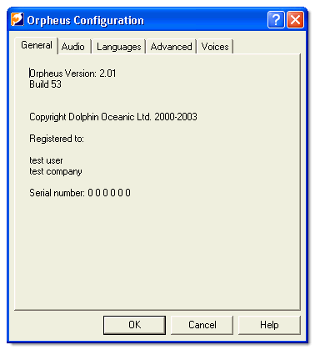

Audio
The Audio tab in the control panel contains options for how Orpheus interacts with your computer sound system.
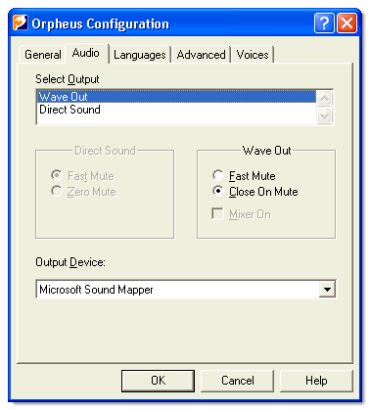

The Output Method list selects between using Windows multimedia (Wave Out) and Direct Sound.
A pair of radio buttons offers two options for muting (silencing) the sound card. The choice is either Fast Mute, which is quick but may make the sound card click, or Close On Mute, which is quieter but may be slightly slower. For single channel sound cards selecting Close On Mute also lets other system sounds through when Orpheus is not speaking. This is not an issue with multi channel sound cards like SoundBlaster Live where system sounds can be played alongside Orpheus' speech output.
For use on older systems Orpheus includes a Windows 95 utility for mixing the speech of Orpheus with your system WAVE sounds. The Mixer On checkbox controls whether Orpheus will start the mixer or not the next time Orpheus starts. Clearing Mixer On while Orpheus is running leaves the mixer in operation until no applications are playing sounds or the system is restarted.
Using the mixer you will be able to hear any system sounds that you have set up, for instance to indicate opening windows or the arrival of email, alongside the speech.
The mixer only operates under Windows 95 and 98 (First Edition) and only with the Wave Out option. If you have DirectX installed read the notes in the section Tips and Trouble Shooting (see "Mixer and Direct Sound Troubleshooting (Windows 95 only)" page 37) regarding the mixer's operation.
The Output Device list chooses which soundcard to use for Orpheus. This list is generally only really of importance if you have more than one soundcard in your computer. Orpheus defaults to use Microsoft Sound Mapper.

Languages
The Languages tab displays information about the languages you have installed.
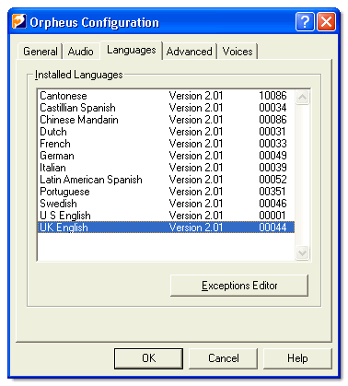

The Exceptions Editor button calls up the Exceptions Editor where you can adjust the pronunciation for the selected language. For more information see Exceptions Editor (page 25).
Adding and removing languages is done by separate install/deinstall.

Advanced
The Advanced tab contains options affecting how Orpheus produces synthetic speech.
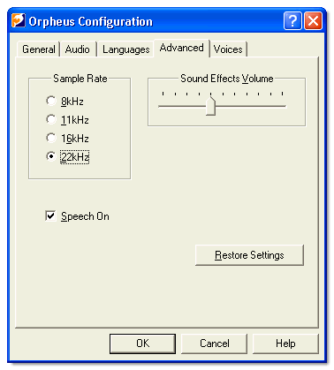

A series of radio buttons offers sample rate selection: The choices are 8, 11.025, 16 and 22.05 kilohertz. The higher the sample rate, the clearer the speech. However, more processor time may be needed to process the higher rate.
The Sound Effects Volume slider adjusts the volume of sound effects relative to the speech. Sound effects are used by screen access software for marking the position of capital letters for instance. Select the sound effect via the screen access software's control panel.
The Speech On check box operates like the On/Off switch of a hardware synthesiser.
The Restore Defaults button restores all settings to their factory defaults:
Output method is Wave Out.
Close on mute.
Mixer off.
Output device is Wave Mapper.
Sample rate at 22 kilohertz.
Speech on.
Sound effects volume 40%.

Note: The Restore Defaults button does not affect any exceptions you have made using the Exceptions Editor.

Voices
The controls in this property sheet let you create and modify voices.
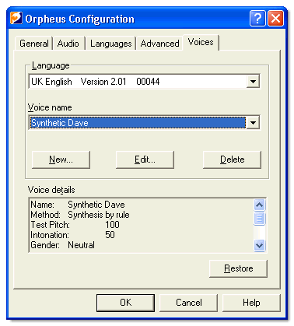

Voices are organised by language, so first select the language from the language list. The voice list then shows the voices available for that language; select one of the voices in this list. A box at the bottom of the panel shows information about this voice. Each voice in Orpheus is based on one of the voices in the voice database for the language. You can add, delete or edit any of the voices based on the database voices, you cannot edit or delete voices from the database itself.
Press the Edit... button to pop-up the Voice Edit dialog. This allows you to modify the currently selected voice. Press the New... button to call up the same Voice Edit dialog with an empty voice name.

Edit Voice dialog
This dialog allows you to edit voices.
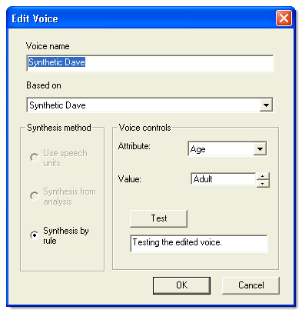

The first text entry box in the Edit Voice dialog shows the name of the voice. You can edit this name but you will not be able to set it to an empty name or an existing name.
The Based On list shows the preset voices available in the voice database. The default base for a new voice will be the first voice in the database. All voices in the database will be available in the Based-on list. You cannot delete them.
The items that are available in the Synthesis method and Voice controls groups depend on the chosen preset voice, so if you change from one Based-on voice to another one the items available in these groups may change.
You can vary the following attributes in the Voice controls group:
Age | Age does not affect the sound of the speech but only "labels" the voice.
Gender | Gender does not affect the sound of the speech but only "labels" the voice.
Intonation | Intonation is the excitability of the voice.
Pitch | Pitch is the default pitch used when a voice is selected: It may be overridden by the Orpheus controls (page 21).
In addition to the above attributes the following are available for voices that use "Synthesis by rule":
Head size | Makes the voice sound like it came from a smaller or larger person.
Voicing | Can make the voice more like a whisper.
Voicing pulse | Alters the sound of the voice.

Orpheus Controls
Orpheus offers a full range of controls for your application or screen access software to use. Controls are made available via the SAM or SAPI interface to the application or screen access software. Consult the documentation of your application or screen access product for more information on how it alters synthesiser controls.
The following categories of controls are available:
Audio controls (page 21)
Presentation controls (page 21)
Voice controls (page 22)

Audio Controls
The following are the basic audio controls:

Volume | Changes the volume level of the speech.
Bass | Boosts or reduces the bass.
Treble | Boosts or reduces the high tone of the speech.

Presentation Controls
The following controls augment the presentation of the spoken text:

Inter-word pause | Insert a specified pause between each word.
Inter-phrase pause | Insert a specified pause between each phrase.
Pause | Insert a specified pause.
Spelling | Spell words or numbers. 123 says one hundred and twenty three unless spelt when it will say one two three.
Skim read | When set, omits articles (a, the, …) and function words (to, by, …). Useful when quickly reviewing text. The higher the skim read level, the more classes of word will be omitted.
Anomalies | Turns on "intelligent" processing of currencies etc. For example, £4.99 says "four pounds and ninety-nine pence".
Exceptions | Turns on whether to use the pronunciation rules set using the Exceptions Editor (page 25).
Sound effects | Sound effects which your screen access software can assign to particular functions, such as capital letter indication.

Voice Controls
The following can be used to augment the different importance of types of text or message being spoken:

Speed | Controls the speed of the voice.
Pitch | Controls the average pitch of the voice.
Balance | If you have a stereo sound system and speakers you may be able to get your application or screen access software to associate left right position with different voices.
Language selection | Switches the synthesiser language.
Voice selection | Selects one of the voices that is available for the chosen language
More voice control is available from the voice editor (see "Edit Voice dialog" page 19) in the Orpheus control panel.

Exceptions Editor
The Exceptions Editor allows you to alter the way Orpheus pronounces words. For example, if you often use a particular abbreviation and Orpheus doesn't pronounce it very well, you may wish to teach it. You can, of course, also correct words which Orpheus genuinely doesn't pronounce correctly.

Exceptions
You can modify the way Orpheus pronounces words by creating an exceptions file. These files consist of a series of exceptions.
Each exception has three parts: the word to be changed, the new pronunciation and the type of the exception (whether it can be used anywhere, or only at the start or end of a word, or only as a whole word).
For example, if we had a word such as OEE, we could create an exception to say that the word OEE should be pronounced as Orpheus Exceptions Editor and this rule only applies as a whole word.

Words and Phonemes
When you create an exception, you can specify how the word should be pronounced by either using other words which are pronounced the way you want or by using special sequences of characters called phonemes.
A phoneme is a single sound in speech, for example the D sound in the word "dog".
For example, if you needed an exception for the word "baby", you could either misspell it as "bay bee" or you could use the phoneme equivalent "_b_ai_b_ey". (There is a list of these phonemes.)

Using the Exceptions Editor
The Display
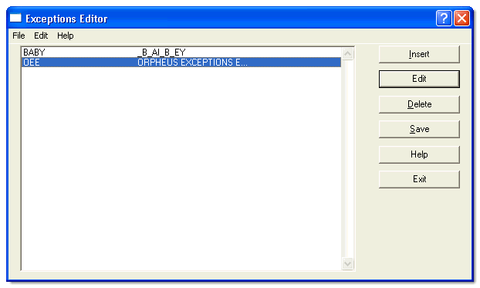

The main display of the Exceptions Editor consists of a list box and a number of command buttons.
The list shows the currently loaded exceptions. Use the buttons to edit the exceptions in this list.
The menu also allows you to edit exceptions, but it additionally contains commands to load and save the exception file, commands to search for exceptions and options to control how the editor behaves.

Note:
Screen reader users might notice unexpected results when editing the exceptions for the voice that is currently used by the screen reader, as the replacement word will be spoken instead of the exception. Please refer to the section "Using the Exceptions Editor with a Screen Reader (page 35)" for more details.

Adding an Exception
To add a new exception to the list, choose the Insert button (or press the INS key). This calls up the Rule Edit Dialog.
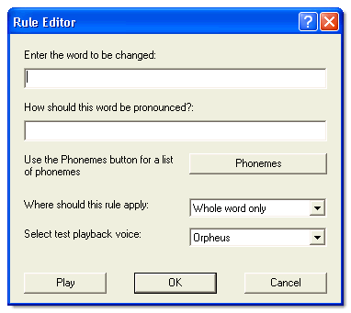

This dialog allows you to enter the word you want to change the pronunciation for, along with how you want it pronounced.
You can also specify whether you want the exception to apply only as a whole word, or just at the beginning or end of a word, or anywhere.
The Play button will make Orpheus speak what you have typed in as the correct pronunciation, so you can hear if your exception will work.
The Voice list lets you choose which voice you want to use to play your exception.

Note: The Play function will only work if the soundcard in your computer is free. For example, if you are using a screen reader with a synthesiser which uses the soundcard, we recommend that you turn off the voice before you press Play.

If you are not sure about how to pronounce the word, use the Phonemes button to get a list.
When you have finished, choose the OK button to add the new exception to the list, or Cancel to abandon it.

Editing an Exception
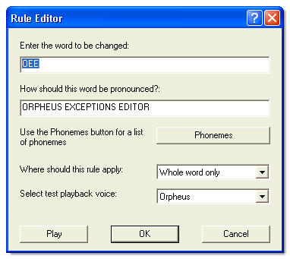

You may wish to edit an exception already in the list. To do this, select the exception you wish to edit from the list in the main dialog. Then, choose the Edit button to call up the Rule Edit Dialog. Then, proceed as if you were adding an exception (page 27).

Using Phonemes
When you are correcting the pronunciation of a word, you can either type in one or more other words which are pronounced correctly, or you can use phonemes. Phonemes are the basic building blocks, the individual sounds, which make up words.
If you know them, you can just type the phonemes in the Rule Edit Dialog. Alternatively, you can choose the Phonemes button to get a list.
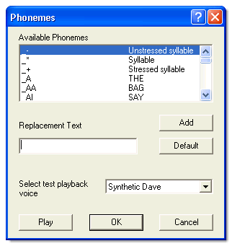

The list contains all available phonemes. From this list, either select each phoneme you want and choose the Add button, or just type into the edit box.
The Default button will enter the phonemes which Orpheus uses by default for the mispronounced word. You may find this useful to get started.
Use the Play button to hear what the phonemes sound like. The Voice list lets you choose which voice you want to use for playback.

Note: The Play function will only work if the soundcard in your computer is free. For example, if you are using a screen reader with a synthesiser which uses the soundcard, we recommend that you turn off the voice before you press Play.

Note: It is recommended that you do not mix phonemes and ordinary characters within a word.

Deleting an Exception
To remove an exception from the list, select it from the list in the main dialog and choose the Delete button (or press the DEL key).

Note: When you delete an exception, there is no "undo" facility. For this reason, you will be asked to confirm the deletion. If you don't want this confirmation, choose Options (see "Exceptions Editor Options" page 32) from the Edit menu.

Searching for Exceptions
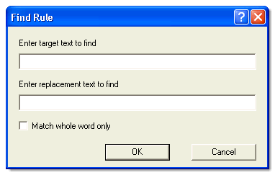

Use the Find command on the Edit menu to call up the Exception Finder. This allows you to search for exceptions by entering either the mispronounced word or correct pronunciation text or both.
Choose the OK button to start the search or Cancel to abandon.
You can use the Find Next command on the Edit menu (or press F3) to find the next occurrence of your search text.

Loading and Saving
In order to make Orpheus use your exceptions, they must be saved to disk. Use either the Save button in the main dialog or the Save command on the File menu.
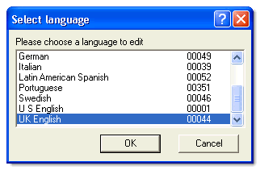

To work on a different language, use the Open command on the File menu. This calls up a dialog listing the available Orpheus languages. Choose the one you want and press the OK button.
The exceptions for the new language will be displayed in the list in the main dialog.

Importing and Exporting Exceptions
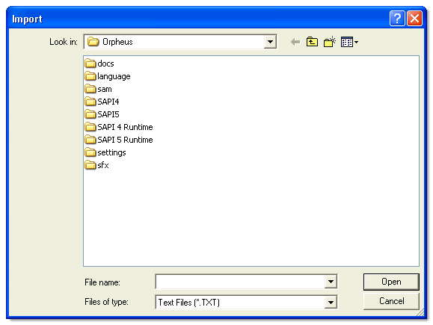

The Import and Export commands on the File menu load and save exceptions in a human-readable (text) form. This can be useful if you want to share exceptions with others.

Note: The Import command inserts the new exceptions merging them with those already loaded.

Exceptions Editor Options
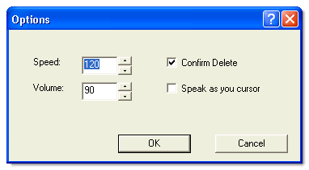

The Options command on the Edit menu calls up a dialog where you can set the style of the voice used to play exceptions.
You can also set whether or not the voice speaks as you cursor through the list, and whether or not to display the confirmation dialog when you delete an exception.

Tips & Troubleshooting
The following sections may help resolve any problems experienced with using Orpheus:
Using the Exceptions Editor with a Screen Reader (page 35)
General Troubleshooting (page 36)
Performance Troubleshooting (page 36)
Mixer and Direct Sound Troubleshooting (Windows 95 Only) (page 37)
Hardware Mixing Troubleshooting (page 37)
Technical Support (page 37)

Using the Exceptions Editor with a Screen Reader
Screen reader users might notice unexpected results when using the Exceptions Editor. When you try to edit the exceptions for the voice that is currently used by the screen reader you need to be aware that the exceptions will be aplied to all matching text on the screen. Therefore the original text and the replacement text will both be spoken the same.
Example:
If you have an exception for "OEE" to be announced as "Orpheus Exceptions Editor" then the exceptions list will show this as "OEE Orpheus Exceptions Editor". Your screen reader is using this exception to read the line, so the screen reader will announce it as "Orpheus Exceptions Editor Orpheus Exceptions Editor".
Tip:
To avoid this we recommend that you disable the exceptions while you are working with the exception editor. This will usually be done via the voice settings of your screen reader, please consult the screen reader documentation for further information.
To switch off the exceptions using Dolphin access products (Supernova, Hal or LunarPlus):
- Open the control panel of your Dolphin access product.
- Open the "Speech Output Settings" dialog.
- Press the "Voice and Language Selection" button.
- Choose "Create User Defined Voices".
- You can find the setting for the exceptions among the settings in the group "Other Speech Parameters".

General Troubleshooting
Orpheus uses the computer's sound output system to play the speech it has synthesised. This is normally perfectly adequate, but it is important to be aware of some limitations of the sound system. Unless you have a multi channel sound card like SoundBlaster Live or you are using the Dolphin mixer, other sounds may be blocked while you are using the synthesiser. Selecting the Close On Mute option on the Audio tab of the Orpheus control panel will let sounds through when Orpheus is not speaking.

Performance Troubleshooting
On a few machines running Windows 95 or 98 with older floppy drivers, when a floppy is starting up then the floppy driver can take up all of the processing time. This may cause the speech to appear to stutter for a few seconds. This has not been observed on later versions of Windows, but if you experience it on these systems please let us know.
If your machine is sluggish when using Orpheus, try using a lower sampling rate option from the Orpheus control panel. You may need to restart your talking software or system before the change will take effect.

Mixer and Direct Sound Troubleshooting (Windows 95 only)
If you have Direct Sound installed but are using Orpheus' Wave Out you may experience problems using the mixer. The mixer mixes the channel output, such as that from Orpheus, with any other wave channel output such as system sounds. In a system with Direct sound, system sounds are still played as wave channel output and may not be played or mixed by the Direct Sound system.
You may still be able to use the Dolphin mixer to hear the system sounds but will have to disable some or all of the Direct sound system for it to be guaranteed to work, as follows.
When you install DirectX into Windows95 or you have Windows95 OSR2.5, ActiveMovie becomes the default wave audio player. If you want to mix these sounds with the synthesiser output then, in Windows 95, set the default program for opening wave (WAV) files back to Sound Recorder.
Under Windows98 there is a Hardware Acceleration slider in the multimedia properties for the wave output device and this can be reduced until the mixer works with Active Movie. Additionally, if you experience any other problems running the mixer in Windows98 this is always a good course of action and may solve the problem.

Hardware Mixing Troubleshooting
If you have a PCI soundcard, notably a SoundBlaster Live or one based upon the Aureal 8820 chipset, then you already have hardware mixing ability. In this case the mixer will run but not actively mix with the sound system until the device runs out of hardware mixing channels.
Please note that it appears that not all PCI soundcards have the ability to mix in hardware, for instance, the SoundBlaster PCI-128. However, if you have hardware mixing we recommend that you use that instead of the software mixer.

Technical Support
If you have problems, please contact your Dolphin dealer or the Dolphin Technical Support help line and they will be only too glad to assist.

Dolphin Computer Access Ltd.
Technology House
Worcester
WR3 8TJ
UK
Tel: | +44 (0)1905 754577
Fax: | +44 (0)1905 754559
E-mail: | support@dolphinuk.co.uk
Internet: | http://www.dolphinuk.co.uk

Version History
Version 2.01
NEW: Supports more natural sounding voices as well as clearer sounding synthetic voices.
NEW: Available either with natural sounding voices as a Full version or without as a Lite version.
NEW: A new control panel using property sheets to simplify operation.
NEW: A Direct Sound option, selectable from the control panel.
NEW: More sample rates, selectable from the control panel.
NEW: The ability to use anomaly processing, e.g. for currency rules.
NEW: The ability to use user-defined exceptions and an exceptions editor.
NEW: The ability to speak tone languages and many character languages like Chinese.
NEW: Skim Reading control.
NEW: Bass and treble controls.
FIX: Various bug fixes.
NEW: Context sensitive help.
NEW: Supports SAPI 4 and SAPI 5.
NEW: Windows CE version 3 and later supported.
NEW: Windows CE SDK available
NEW: More sound effects

Version 1.06
NEW: Increase execution priority of A3S.dll. This should reduce the stuttering recently observed on slower machines. DolABF is also modified to return to Windows while sending blocks of data to the sound system, as the high priority could mean the loop was too tight for the sound system itself to break in causing a gap at the beginning of speech.
NEW: Close on mute extended to close the audio while Orpheus is not speaking. This will allow the occasional beep to be heard without using the mixer and will reduce problems associated with SAM start up with multiple software synthesisers.
CHANGE: Always use WAVE_MAPPER as the sound output device (unless the Orpheus registry entry is edited). This should make Orpheus' operation less dependent on particular sound drivers and be totally consistent across platforms - in theory. Also fix the bug in the DolABF indexing system which assumed the wrong format of position information if WAVE_MAPPER is the driver.
FIX: Several bugs in the Windows 95 mixer are fixed. Some were to do with indexing, DolMIx should be accurate to within +/-1/10 second of the speech. A couple of others were to do with system behaviour and could have had unpredictable effects (a couple of odd crashes had been reported).
CHANGE: In Orpheus, reduce the start and stop silence periods to help Orpheus feel more responsive.
CHANGE: Installation does not ask for a reboot if installing Orpheus alone.
FIX: Occasional mispronunciation caused by sometimes using wrong (last) language's character set.

Version 1.05
NEW: Translatable control panel.
FIX: Bug in Timer setting and use in Orpheus and the SAM driver(s).
FIX: Safety check modification added to DolMix to fix possible crashes with "genuine" non-PnP soundcard drivers.
FIX: Fix Left right mix-up in balance control in DolABF.
NEW: Include this version history file in distribution.
FIX: Incorrect processing of WM_ENDSESSION message caused mixer to abort even though end session is being cancelled.
FIX: Mixer start up and restart code. If the mixer failed to open any devices first time, it opened 11kHz when it retried, causing a variety of problems. Recoded Init_Intercept() to separate hook installation from getting wave-channels allocated and ensure same processes used on each attempt to start.
CHANGE: Remove wraparound test before outputting mixer samples; they have been divided by 2, so don't need it.
FIX: Problems in DolABF if the sound driver "event" processing timed-out resulting in an operating but silent Orpheus, or the shut-down to hang. Redid DolABF, with one thread only, using a callback function rather than event processing; simpler and more efficient. (A fixed original version is retained, e.g. for Tech support).
FIX: Bug in Orpheus allowed a released Orpheus to read a "renamed" demo language file.
FIX: Stop two copies of Orpheus running.
FIX: Minor improvements to stop Boundschecker complaining. Code a failure to start the mixer so it doesn't remove invalid handle. Also in the prompt loading code, don't call GetPrivateProfileString for unused (null) prompt list entries.
FIX: Correct selection of unstressed shortening factors for word-medial and final-vocalics - was reversed.
CHANGE: Numerous Speed improvements, e.g. DOLABF 3 times faster, TTS_Open call does less. Speed improvements in the synthesiser and symbol rule matcher.
FIX: Bug in hypermode removed adjectives rather than function words! Nobody noticed till now!
NEW: Add work around for the Win 2000 and 98 SE stutter problem. Give another option in the control panel to choose between Reset or a Reset, Close, Open sequences when muting. The latter is quieter, doesn't show up the stutter problem but is slower. It also has a risk that a re-open doesn't work, so recovery is added.

Version 1.04
Released 20/04/99
FIX: Correction to network operation.
FIX: Clearing of a wrong registry key handle. Could crash if already cleared.

Version 1.03
Released 5/01/99
CHANGE: Removed the average DC level from stored voiced pulse and during "F0" processing.
NEW: Create demonstration version.
NEW: Added network capability.
FIX: I D Window not being removed; call DestroyWindow on DLL process detach.
CHANGE: Ensure DEMO version cannot use a released language and vice-versa by.... Also ensure that DEMO language files are named D00001.tts, D00044.tts and so on.
CHANGE: Remove leading and trailing spaces from default (english) parameter names.
CHANGE: Adjust TAB Order of Main Config box to end..... OK, CANCEL, ABOUT. Ensure that "child" dialog boxes are owned by the parent to stop multiple "About" and "Language Load" box possibility.
FIX - SAM Driver modified to wait for asynchronous speak function to finish when collecting language character set definitions.
CHANGE: Make Language installation dialog box easier to use. Window two starts on the list box and tabs to Copy then Cancel. The list box is no longer unselected although the user cannot make selections in it.
CHANGE: Non linear speed-up algorithm improved.
NEW: Shortening inter phonetic segment transitions as speed-up occurs improves intelligibility at fast talking rates. Use same non-linear shortening algorithm as for the segment durations themselves. Results for fast speech presented at C S U N 1999.
NEW: Include Mixer (Win 95 only). Control the mixer via a tick box in the Orpheus control panel. This controls a flag in the registry under: HKEY_CURRENT_USER\Software\Dolphin\Mixer\Mixer OnOff.
FIX: Write larger chunks to the sound output controller, DolABF, to cure the "TH-THis" problem sometimes heard in the first phoneme in a phrase.
CHANGE: DolABF version 1.04 released. New Dolmix version (Beta?) 1.03 released.
FIX: Correct timing of sfx.
CHANGE: Increase the Orpheus volume (by a factor of 2.4) by clipping rather than wrapping-round the output. Gives distortion rather than clicking if a sample exceeds short integer range.
CHANGE: Improve the operation of the Grammar (operator) processing.
FIX: Orpheus hanging or slow reading when no mutes issued (e.g. reading installation license agreement). Orpheus didn't always set the amount of silence to be played at the end of a phrase to "run-down" the element-to-element interpolation. Now set to 20ms of silence.
CHANGE: Speed improvements to filters and synthesis engine. Orpheus takes 12s cpu to speak 88s of speech on a 200MHz Pentium II, so is about 7.3* real time or takes ~13% cpu usage.
FIX: Force reset of the voicing generator if returning from fully unvoiced state.
CHANGE: Implemented the mixing of the glottal area function for unvoiced with the time-varying voicing component as per the original specification for the parallel formant synthesiser.
FIX: DOLABF accepted an index marker even though the data was rejected (buffers full) causing indexing to temporarily go wrong.

Version 1.02
Released 21/7/98
FIX: Reduce clicks on a mute.
FIX: Ensure Sound Effects list is emptied on a mute.
FIX: Uninstall failed to delete SFX files if Orpheus loaded into memory.
FIX: Include a Window name and class "Orpheus" enabling uninstall to detect if Orpheus is present.
FIX: Vowels sounded not always fully voiced. Corrected "voicing offset" table values.
CHANGE: Design change to synthesiser - stop sudden drops in formant amplitude causing blips.
FIX: DolABF bug causing Orpheus eventually to stop after an hour or two of continuous use.

Version 1.01
Released 30/06/98
First Version.

Index
A
Adding an Exception • 27
Advanced • 17
Audio • 15
Audio Controls • 21
C
Configuring Orpheus • 13
D
Deleting an Exception • 30
E
Edit Voice dialog • 19
Editing an Exception • 28
Exceptions • 25
Exceptions Editor • 25
Exceptions Editor Options • 33
G
General • 13
General Troubleshooting • 36
H
Hardware Mixing Troubleshooting • 37
I
Importing and Exporting Exceptions • 32
Installing Orpheus • 11
Introduction • 9
L
Languages • 16
Loading and Saving • 31
M
Mixer and Direct Sound Troubleshooting (Windows 95 only) • 37
N
Network Installation • 11
O
Orpheus Controls • 21
P
Performance Troubleshooting • 36
Presentation Controls • 21
S
Searching for Exceptions • 30
Software Licence • 7
T
Technical Support • 38
Tips & Troubleshooting • 35
U
Using Phonemes • 28
Using the Exceptions Editor • 26
Using the Exceptions Editor with a Screen Reader • 35
V
Version History • 39
Voice Controls • 22
Voices • 18
W
What's New • 9
Words and Phonemes • 25

