# SaveAsDAISY add-in Instruction Manual

Installing and using the SaveAsDAISY Add-in

Version 2.8.0 released in July 2023



***DAISY Consortium***

*www.daisy.org*

# Contents

SaveAsDAISY add-in Instruction Manual 1

Contents 2

The SaveAsDAISY add-in 3

Features 3

Installation 4

Prerequisites 4

Installing the Add-in 5

Confirmation of Installation 8

Saveasdaisy UI overview – The Accessibility ribbon 9

How to use Accessibility ribbon 10

Abbreviations: 10

Acronyms: 11

Importing Custom Styles: 11

Accessibility Check - validation of the document before conversion 12

Language Detection 12

Settings 12

Footnote in SaveAsDAISY (Office 2007) 14

SaveAsDAISY button 16

Preparation of the Microsoft Word document 18

Converting Word Documents to DTBook XML format 19

Converting Word Documents to DAISY3 book 22

Converting Multiple Documents 23

Text-to-Speech Configuration 25

Before version 2.8.0 25

Starting version 2.8.0 25

DAISY BOOK READERS & AUTHORING TOOLS 26

# The SaveAsDAISY add-in

The SaveAsDAISY add-in also known as DAISY translator is an add-in for Microsoft Word. It converts Word documents to DAISY XML and Full DAISY format. This add-in is provided free of cost by the DAISY Consortium.

The SaveAsDAISY add-in can convert any Word document to a multimedia DAISY book having text, images and recording of the content in text-to-speech voices available on the system. This format also known as Full DAISY provides a rich reading experience to people with various disabilities. The DAISY XML file created by the SaveAsDAISY add-in can be further converted to other alternative formats like Braille, EPUB and Large print using other tools.

SaveAsDAISY remains one of the fastest ways to convert Word documents to popular accessible formats. SaveAsDAISY requires a well-structured Word document and quality of the output depends upon the styling and mark-up of the Word document.

## Features

The Save as DAISY add-in supports the following elements:

* Dublin Core Metadata
* UID metadata
* Front matter, Book matter and rear matter mapping
* Levels and Headings
* Paragraphs
* Tables
* Lists
* Note’s and Note References
* Emphasis and Strong
* Superscript and Subscript
* Images
* Captions
* Page Numbers
* Sidebar
* Abbreviations and Acronyms
* Language Detection
* Block quotes
* Anchor
* BDO (Bidirectional object)
* Citation
* Table of Contents
* Custom styles
* MathML (Support for Mathematics)
* Helper Wizard
* Full Audio Support
* Shapes and Objects
* Alternative Footnote

# Installation

The DAISY Consortium provides a unified installer named “SaveAsDAISYInstaller.exe” for the SaveAsDAISY add-in on the release page of the add-in GitHub repository: <https://github.com/daisy/word-save-as-daisy/releases/latest>.

Add-in updates, including changelogs and new installers, can also be downloaded from:  
<https://daisy.github.io/word-save-as-daisy>

## Prerequisites

Following are the prerequisites for installing and converting documents. The installer for the DAISY add-in will install these prerequisites during the setup process; however, in a managed desktop environment it may be useful for administrators to be able to use this list to provide all prerequisites beforehand.

* The Microsoft .NET Framework 4.0 (included in Windows 10).
* Microsoft Office 2007 or above, or alternatively Microsoft Office 2003 or XP with the Microsoft Office 2007 compatibility pack installed on the machine.
* The Microsoft Office compatibility pack for Word 2007
* In the case of Office 2003, 2007 or 2010 the Primary Interop Assemblies

For the creation of large DTBook documents it is recommended to use a machine with a minimum of 2GHz processors and 2GB of RAM

Also note:

* **Multiple Versions of Office:** In an environment where the user has installed multiple versions of Microsoft Office (known as side-by-side installation), the SaveAsDAISY Add-in installer will install for the latest Office version available on the user’s system.
* **WORD2003/Word XP:** Version 2.6.0.0 of the Save as DAISY add-in specifically supports Office 2007, Office 2010 and higher including Office 365. If you are using Office 2003 or Office XP then the add-in version 2.5.0.0 may work with these versions, however testing has not been undertaken on these platforms.

## Installing the Add-in

Before installation you should close all office applications, as because it may cause some conflict during installation.

Step 1: Click on the SaveAsDAISYInstaller.exe.

The installation will start and you will see the Welcome screen.

Click on the Next button or hit Enter.

Step 2: The “License Agreement”.

To continue you must read and accept the license agreement. Check the Accept box and click next to continue

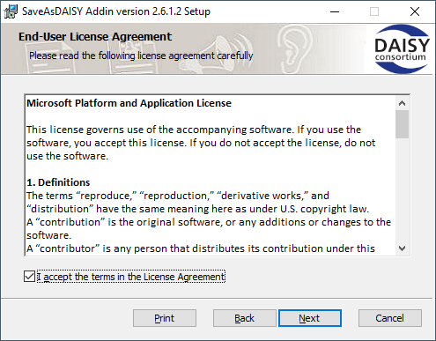

Step 3: Next you may select an installation scope. This will determine whether the add-in is installed for all users of the machine or just the current user.

Choose the appropriate option and click on Next.

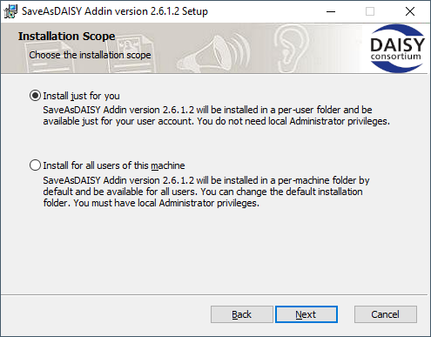

Step 4: You can now specify the installation folder  
Hit enter or click on Next button. You are given option to browse for a folder by pressing the Change button.

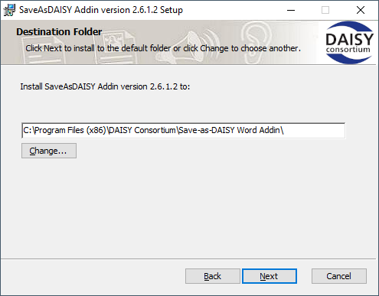

Step 5: The final step “Confirm Installation” is shown. Click on Install button.

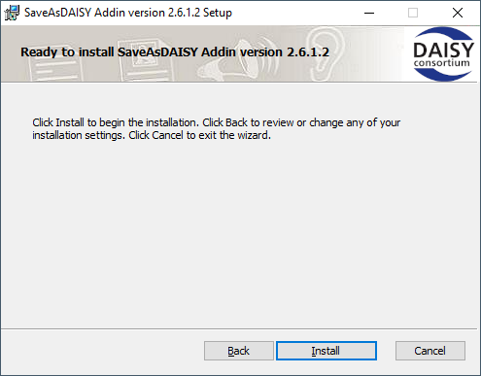

Step 6: Finally, a progress window appears showing the progress of the installation. You may be prompted during the installation to install certain prerequisites

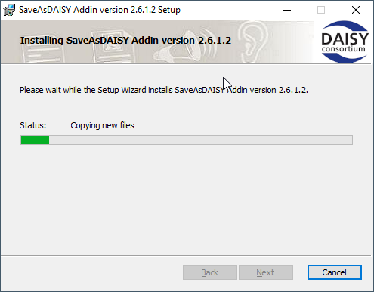

Step 7: On completion of the install process the last step of the wizard, “Completed the SaveAsDAISY add-in version X.X.X.X Setup Wizard”, provides an option to open the Help file. Hit Enter or click on Finish button.

Leaving the “Open the instruction manual” checkbox selected will open this document.

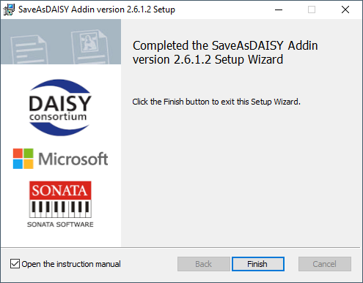

## Confirmation of Installation

After the setup is complete you can confirm that the installation has been successful by following the steps given below:

For Office 2007 and 2003:

* Open a new word document.
* Click on Office button or hit “Alt+F”
* Ensure “Save As DAISY” appears in the menu.

For Office 2010 and higher:

* Open a new word document.
* Check if a new Tab named *Accessibility* appears on the top right
* Click on Accessibility and ensure that the “Save As DAISY” button appears in it

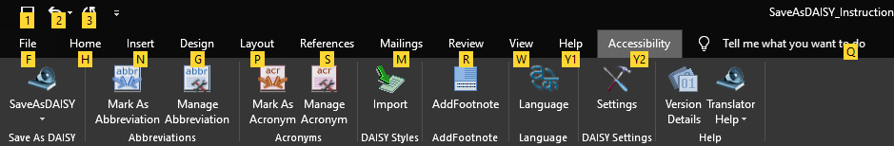

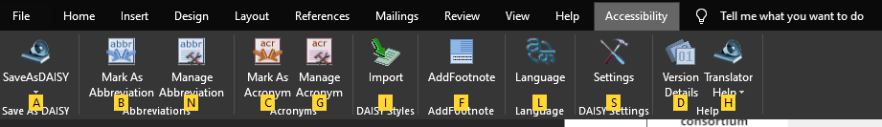

# Saveasdaisy UI overview – The Accessibility ribbon

On successful installation of SaveAsDAISY Add-in a new tab “Accessibility” will be added in the Microsoft Word ribbon. This “Accessibility” tab provides access to a number of key features in the add-in.

|  |  |
| --- | --- |
| **Accessibility ribbon item** | **Description** |
| **SaveAsDAISY** | This button provides access to the Save As DAISY menu.   1. **DAISY XML:** This sub menu will translate a Word document format to the “DTBook XML” format. 2. **DAISY3:** This sub menu will show a further sub menu providing for Text to Speech Translation which will translate a Word document to a full “DAISY3” book. 3. **EPUB3:** This sub menu will translate a group of documents into a single “DAISY XML” format. |
| **Mark As Abbreviation** | To mark a particular word as Abbreviation, select the text within Word, click on Accessibility tab and click this Mark as Abbreviation button. |
| **Manage Abbreviations** | The button opens a dialog box showing all the text marked as abbreviations listed. Any text marked as Abbreviation can be Unmarked using unmark button. |
| **Mark As Acronym** | To mark a particular word as Acronym, select the text within Word, click on Accessibility tab and click on this Mark as Acronym button. |
| **Manage Acronyms** | The button opens a dialog box showing all the text marked as listed. Any text marked as an acronym can be Unmarked using unmark button. |
| **Accessibility check (Office 2007)** | This button opens a word validation tool to check for accessibility compliance.  For Office 2010 and later, this tool is being discontinued in favor of the Word Accessibility Checker provided by Microsoft.  Please consult the authoring guidelines for more information. |
| **Import** | This button imports many SaveAsDAISY specific styles into the documents. These styles appear in the Styles panel and have the word (DAISY) appended to their name. |
| **Add Footnote (Office 2007)** | This button is used to create Footnotes in the document. |
| **Language** | This button is used to mark selected text as of a specific language. |
| **Settings** | This button opens the SaveAsDaisy settings having options for page numbers, translation of character styles and image size. |
| **Version Details** | Click on this button to know more about the SaveAsDAISY add-in version and to check for updates. |
| **Documentation** | This button opens a menu from where the following help documents can be launched:   * This instruction manual * The authoring guidelines |

## How to use Accessibility ribbon

### Abbreviations:

**To mark an abbreviation, follow these steps:**

1. Select a piece of text within the Word interface.
2. Click on “**Accessibility**” tab
3. Click on “**Mark** **as** **Abbreviation**” button
4. This opens the Manage Acronym dialog  
   You can then specify the full form of the selected word
5. The dialog provides the option of marking all occurrences of the selected word throughout the document as abbreviations.
6. Click on “Mark” button), to mark abbreviation for the selected text.

**To unmark an abbreviation, follow steps listed below:**

1. Click on “**Accessibility**” tab
2. Click on “**Manage Abbreviation**” button
3. The Manage Abbreviations dialog will be shown.
4. To unmark an abbreviation for a word, select that word from the existing items list and click on the “**Unmark**” button.
5. This will unmark as abbreviation all the occurrences of that particular word in the document.

### Acronyms:

To mark a word as an acronym, follow these steps:

1. Select a piece of text within the Word interface
2. Click on “Accessibility” tab.
3. Click on “Mark as Acronym” button.
4. The “Manage Acronym” dialog will be shown. Enter the Full form of the selected text
5. The “Apply for all occurrences of this word” checkbox allows all instances of the selected text within the document to be marked as acronyms
6. The “Pronounce the acronym in the reader” checkbox determines whether the acronym is pronounced as it would sound or spelled out, letter by letter in the reader. For example, the acronym EULA (End User License Agreement) would be pronounced “you-la” or spelled “E-U-L-A”
7. Click on “Mark” button), to mark acronym for the selected text.

**To unmark an acronym for a word, follow these steps:**

1. Click on “**Accessibility**” tab.
2. Click on “Manage Acronym” button.
3. The manage acronyms dialog will be shown listing all acronyms in the document.
4. To unmark an acronym for a word, select that word from the existing items list click on the “Unmark” button.
5. All occurrences of that particular word in the document will be unmarked.

### Importing Custom Styles:

A key to producing quality DAISY output from a Microsoft Word document is the use of the appropriate Styles. These are used to markup text such as headings. When this text is converted into DAISY XML it is correspondingly marked as having special properties in the XML

The DAISY add-in for Word leverages the native Styles feature in Microsoft Word by providing a set of predefined styles that can be applied to text. These styles must be imported into the Style collection for the document before they can be used.

To import the custom styles:

1. Click on “**Accessibility**” tab.
2. Click on the Import button to import the custom styles.

The custom styles will be added to the styles collection in the Word document. To mark a custom style on a piece of content, select it, apply the styles from styles menu or press (Ctrl +Shift +S).

**Enable and Disable of Import Daisy button:** If the active document has already imported the daisy styles then the “Import Daisy Styles” ribbon button will be in disabled state. If the active document doesn’t contain the daisy styles the “Import Daisy Styles” ribbon button will be in enabled state.

### Accessibility Check - validation of the document before conversion

In version 2.6.1, the internal validator has been replaced with the Microsoft Accessibility Checker. However, in Microsoft Word 2003 and 2007 where Microsoft Accessibility Checker is not available, the validation process remains same as in previous versions of this add-in.

To check your document for Word 2010 and later:

1. Click on “**Review**” tab.
2. Click on “Check Accessibility” button
3. Now click on Check Accessibility
4. The Microsoft Accessibility Checker will open in the Task Pane besides your document and will display errors, warnings and tips if any for improving the accessibility of the document
5. You should check each reported issue and try to fix it. More information is included in the document preparation guidelines on fixing accessibility issues.
6. When all issues are fixed or when you are satisfied that no more improvements can be made, you can proceed to convert the document to DAISY XML or Full DAISY book.

### Language Detection

This feature allows you to set the language for the selected paragraph/paragraphs in the document.

1. Select the text in the Word document.
2. Click on “**Accessibility**” tab
3. Click on “**Language**” button
4. This opens the “Language” dialog providing a list of languages.
5. Select the appropriate language and click on “Apply”) to set the chosen language for the selected paragraph.

**Note:** The Language feature uses a paragraph as the smallest indivisible unit. i.e. the language may be set for a whole paragraph only or multiple paragraphs. It may not be set for a single sentence in a paragraph.

### Settings

These are a number of global settings that can be set that will affect the translation process.

These are accessed from the Settings button on the Accessibility ribbon.

The following screenshot shows the available pre-translation settings.

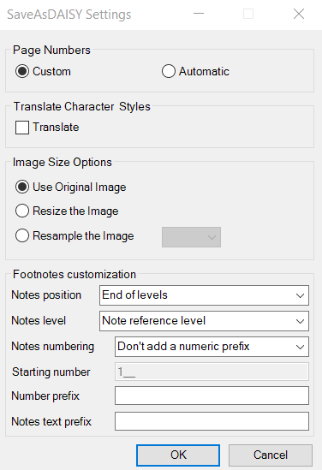

* Page Numbers: You can choose between using custom page numbering or automatic page numbering for the document.
* Translate Character Styles: You can choose to preserve character styles such as underline, strikethrough, indentation, alignment in the output xml.
* Image Size Options: You may specify an approach for handling images embedded in the document
  + Use Original image: This will preserve the original size of the image as inserted in the word document and same size of the image will be retained in the destination folder along with the output xml.
  + Resize: Selecting this radio button will put two new attributes namely “height” and “width” in the output xml indicating that the image in the word document has been resized.
  + Resample: Allows you to resample images to a lower “dpi” value i.e. 72, 96 or 120
    - Resampling is performed on the image inserted into the document based on the dpi value selected by you and same image is placed in the destination folder along with the output xml.
* Footnotes customization allows to change how footnotes are inserted in the resulting dtbook XML
  + “Notes positions” controls if the notes should be inserted either
    - At the end of the word document page where the note is first referenced,
    - At the end of the level first referencing the note,
    - “inlined in the content”, that is right after the paragraph referencing the note.
  + Notes level controls at which level the notes should be inserted if the notes positioning is not “end or page”:
    - Note reference level means the note will be inserted within the level were the note is referenced,
    - Other values represent the maximum targeted level where the notes should be inserted.

### Footnote in SaveAsDAISY (Office 2007)

**Beware that from version 2.8.0, this button is removed for newer office versions, as it is recommended to use Microsoft Word notes, under the ribbon’s “References” Tab.**

Footnotes are the links made to cite your reference on a word document. Word defaults numbering of footnotes from 1. These numbers are usually used as the reference for footnotes.

A footnote should ideally have two parts - Reference no & Footnote text.

Footnotes are found missing when scanned documents are converted back to the document. In such a scenario the footnote text can be selected by you and he would have the provision to see all the available occurrence of the reference throughout the document. The right text can be selected and set it back to footnote reference *following the steps below*:

* Select the text from the document which has to be converted to a footnote along with its reference.

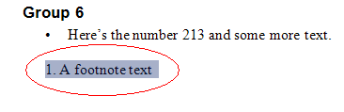

* Selecting the text, click on Accessibility -> Add Footnote
* The list of suggested references will be displayed on a new window. Suggested references will contain all the occurrences of reference (reference-text) throughout the document.

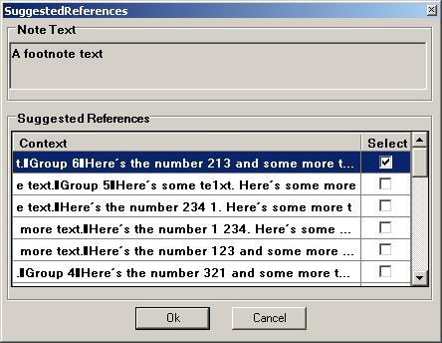

* Clicking on any of the line in suggested-references window, will select the same range of text in the document. This helps you to decide or confirm if the text in that particular range of text has to be converted to a footnote reference.
* You should select the line in suggested reference window by selecting the checkbox standing for the line and click OK button, to consider the text in it to be converted to the footnote reference.  
  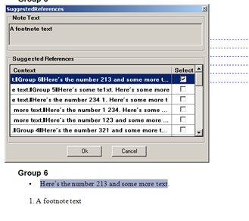

Below image shows the newly converted footnote reference through suggested reference window.

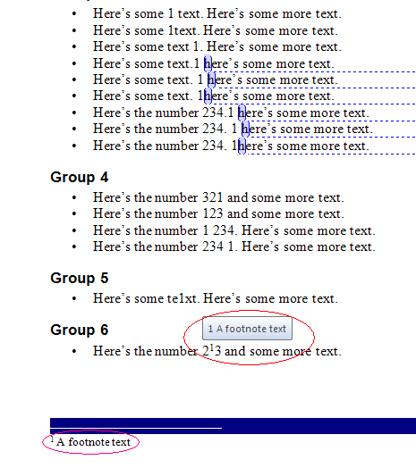

**Note:** Converted reference would be a custom footnote. There is no linking between word’s default footnote and word’s custom footnotes.

### SaveAsDAISY button

The Save functionality provided by the add-in is exposed in a different way for each of Word 2007 and later versions.

#### From the “Accessibility” ribbon’s tab

**Step1:** With a document opened, select the “Accessibility” Tab of the ribbon.

**Step 2:** Click on the “SaveAsDAISY” button in the Save As DAISY group.

#### Word 2007

**Step1:** Click on the Office Button (Top left-hand corner of the Word 2007 user interface) or hit Alt+F to open the File menu

**Step 2:** Select “Save as DAISY menu”.

It will show the 3 sub menus corresponding to each supported export format.

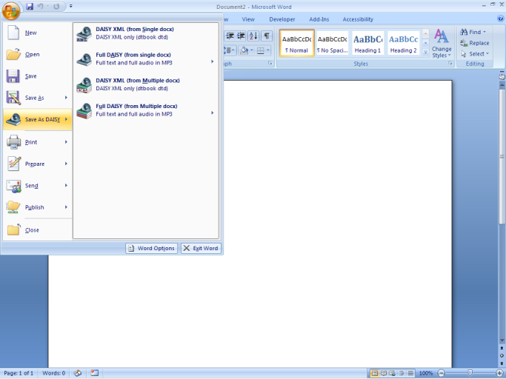

#### Word 2010 and higher

**Step1:** Click on the File ribbon tab (Top left-hand corner of the Word 2010 user interface) or hit Alt+F

**Step 2:** Click on the Add-ins menu on the left-hand side of the Backstage interface window, or press Alt-Z

**Step 2:** Select “Save as DAISY menu” or Press Y.

In both cases you will have access to It will show four sub menus. The Save As menu is also available directly from a Ribbon button on the Accessibility tab in both Word 2007 and Word 2010

1. **DAISY XML:** This sub menu will translate a Word document format to the “DAISY XML” format.
2. **DAISY3:** This sub menu will translate a Word document to a “DAISY DTBook” with text and/or synthesized audio.
3. **EPUB3 (experimental):** This sub menu will translate a Word document to a standard EPUB3 book, optionally with synthesized audio.

# Preparation of the Microsoft Word document

SaveAsDAISY requires a well-structured document conforming to accessibility guidelines and best practices. Refer to the Authoring Guidelines For using SaveAsDAISY and prepare your documents accordingly.

It is highly recommended that you use the Microsoft Accessibility Checker and fix all issues flagged by it in your document. Beginning version 2.6.0.0, SaveAsDAISY now uses the Microsoft Accessibility Checker in place of its own Validator.

In brief you need to take care of the following:

1. Apply HEADING STYLES on all sections and sub-sections
2. Provide image description (ALT TEXT) to pictures, charts, tables
3. Do not use text boxes, floating objects
4. Do not use color only to highlight. Add heading styles or underline etc.
5. Do not merge or split cells in tables, define header row
6. Avoid showing URLs, display meaningful text
7. Use auto-generated bullets and numbers in lists
8. Provide descriptive file names and fill up title, author information in properties
9. Remove blank lines and unnecessary tabs and spaces
10. Define language of content

# Converting Word Documents to DTBook XML format

To convert a Word document to DAISY XML format you should follow the steps below.

1. Open a document that needs to be translated in Microsoft Word
2. Ensure that document is saved before proceeding with the translation.
3. Open the Save As DAISY menu as detailed above
4. Choose the appropriate save option.
5. A progression dialog will open to track the state of the conversion.

1. If the document is a master sub document (current document having sub documents), the following dialog box will be displayed.

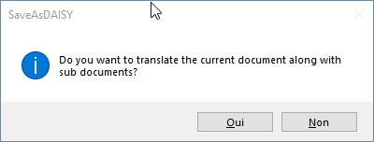   
  
On selecting *Yes*, the translation process will continue and the tool will translate the current document along with sub documents included in it. Otherwise, the tool will translate the current document excluding its sub documents. Before showing the Translation form, an Initializing Translation message is shown momentarily.

1. When the analysis process is finished, you are presented with a Translation dialog as shown below.   
   Une image contenant texte, capture d’écran, nombre, logiciel

   Description générée automatiquement

Translator form contains fields: DTBook XML Output folder, Document Title, Document creator, Document Publisher, Document UID; all these fields will be auto populated from the document properties. You may modify or change these values if required and then click on “Translate” button to continue.

Post-process actions are also available, including a list of possible DTBook fix routines and an option to activate sentence detection in the book (required if the DTBook is passed to an external text-to-speech software)  
  
The focus will come back to the conversion progression dialog to continue the conversion.

1. After successful translation, the folder where the result is stored will be opened in a new explorer window.
2. If the translation is successful and there were some fidelity losses identified in the process the *Fidelity Loss* dialog box will be displayed with an itemized list of loses that occurred during translation.  
   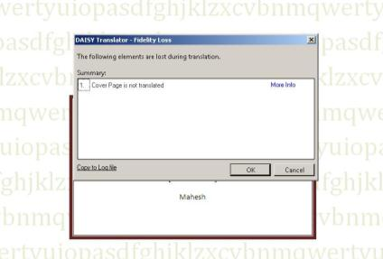

The screen shot above shows the Fidelity loss message “Cover Pages not translated “and provides a More Info button and an ability to copy the log messages to a file. The log file may be used for detailed analysis and rectification of fidelity loss issues.

In case of Master and Sub documenta single dialog will be show for all fidelity loss issues.

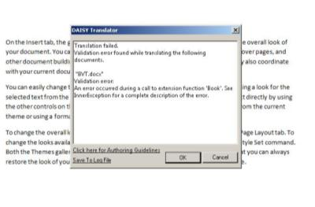

The “Daisy translator – Validation error” window provides an option to open the Authoring guidelines documentation for more information and guidance.

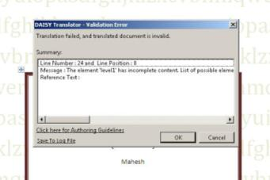

# Converting Word Documents to DAISY3 book

To convert a Word document to a full DAISY3 book is a similar process to above.

Follow steps 1 through 7 above after choosing the DAISY3 option from the Save As DAISY menu.

The translation dialog for a DAISY3 book output provides additional options.

The Advanced options may be accessed by clicking the Show Advanced button of pressing Ctrl-V.  
The options displayed are settings for the DAISY Pipeline 2 dtbook XML to DAISY3 export script. Please consult the [DTBook to DAISY 3](http://daisy.github.io/pipeline/Get-Help/User-Guide/Scripts/dtbook-to-daisy3/) script description page for more information on those settings.

Clicking the “Translate” button will start the translation process to DTBook XML and then to DAISY3. Progress will be reported though the conversion progress dialog.

On completion of the conversion, if no error occurred, the output folder will by opened in a new explorer window.

*Note that the translation process will take several minutes (and on some systems even hours) for large documents.  
The minimum recommended requirements for producing a large DTBook are a 2Ghz Processor and 2GB of RAM*

The "Cancel" button of the progress dialog allows you to prematurely abort the translation. Note that the Pipeline process might not terminate immediately but wait for the current task to complete. Some temporary files may then be left in the output directory.

The output directory will contain a directory named following the input document name. This directory will contain a DAISY 3 DTB (Z39.86-2005), a folder with many MP3 audio files, SMIL files and a .OPF file.

*Note that on some cases dummy headings may be added to the document to conform to the DAISY specification (this happens for instance when no heading were found in the entire input document).*

Step 13: When errors occur during translation, Errors are reported through an error dialog and in the progress dialog details.

Refer to the "Troubleshooting" section for further information on what to do. Press the "OK" button to return to the Microsoft Word document.

If the translation is successful but there were some fidelity losses the Fidelity loss dialog box will be shown.

If an error occurswhile translating theinput Documentthe“Daisy Translator - Validation error” dialog box will bedisplayed with details as to where the error occurred and how to correct it.

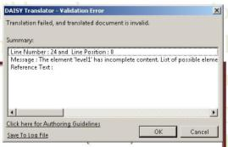 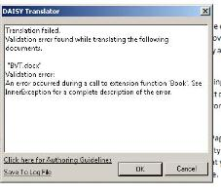

## Converting Multiple Documents

**This feature was experimental, it has been removed in version 2.8.0 due to lack of usage reports.**

The Save as DAISY add-in supports both single document translation, as set out above, as well as multiple document batch translation.

When one of the Multiple Documents options is selected from the Save as DAISY menu the multiple documents dialog will be displayed.

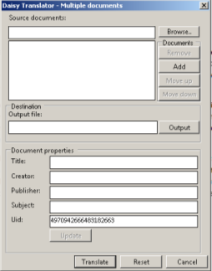

The dialog has the following fields and user interface elements

1. Browse – Allows you to select a folder containing the documents to be translated.
2. Output – Allows you to specify a destination folder.
3. The documents can be re-ordered the resulting order will determine the output order into the final DAISY XML file):
   1. Move up --Moves the selected document to one level up.
   2. Move down -- Moves the selected document to one level down.
   3. Add -- adds the selected document into the list of sub documents.
   4. Remove -- removes the selected document from the list of sub documents.
4. Translate --Translates all the documents which are in the list
5. Update - - populates the document properties fields with information from the currently selected source document
6. Reset -- Resets all the field values.
7. Cancel – exits from the form.

# Text-to-Speech Configuration

## Before version 2.8.0

The TTS voice used by the Pipeline Lite Narrator tool to produce the audio content is the voice configured by default on the Windows environment.

You can change this voice via the Windows Control Panel:

1. Go to the "Control Panel" (available via the "Start" menu)
2. Open the "Speech" item. You can also use the search bar to find this.
3. Select the "Text to Speech" tab
4. Select the required voice in the "Voice Selection" drop-down button

Further fine-grained configuration (such as silence duration, multiple language support, acronym pronunciation, etc.) is currently not directly exposed to the end user. Advanced users can however refer to the DAISY Pipeline developer documentation to fine tune the internal configuration files located in the Pipeline Lite installation directory: <http://daisymfc.sourceforge.net/doc/index-developer.html>

## Starting version 2.8.0

The DAISY Pipeline 2 Text-to-speech also rely on Microsoft SAPI / Onecore voices to synthesize the audio, but it can also use other Text-to-speech engines if available.

The configuration of text to speech is made though a TTS configuration file to be used as a parameter in the conversion process.

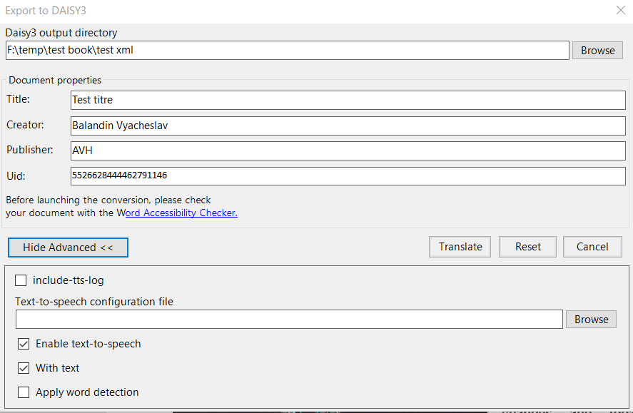

For more information about the design of this configuration, please check the DAISY Pipeline 2 dedicated page : [Text-To-Speech Configuration (daisy.github.io)](http://daisy.github.io/pipeline/Get-Help/User-Guide/Text-To-Speech/)

# DAISY BOOK READERS & AUTHORING TOOLS

After using SaveAsDAISY you will create either Full DAISY books or DAISY xml files.

The Full DAISY book can be distributed as is. People will need a DAISY Reader app for their computers/Smart phones or a DAISY compatible hardware eBook reader to read the book.

Some of the DAISY Reading options are:

* [Dolphin EasyReader](https://daisy.org/info-help/guidance-training/reading-systems/easyreader-windows-quick-start-guide/) app for the computer or Android/iOS Smart Phones
* [FSReader](https://daisy.org/info-help/guidance-training/reading-systems/fsreader-quick-start-guide/) for Windows computers
* [Victor Stream](https://daisy.org/info-help/guidance-training/reading-systems/victor-stream-getting-started-guide/) portable eBook reader

If you create DAISY XML files, you can:

* Import it in [Tobi](https://daisy.org/activities/software/tobi/) to synchronize the text with human voice recording and create a multi-media DAISY or EPUB book.
* Use [DAISY Pipeline 1](https://daisy.org/activities/software/pipeline-1/) or [DAISY Pipeline 2](https://daisy.org/activities/software/pipeline-2/) to convert it to DAISY, EPUB and other formats
* Import it in a Braille Translation tool like Duxbury to convert it to Braille.

Note that the reading and conversion options listed above are not exhaustive. The SaveAsDAISY output could be used by many other tools for different purposes.