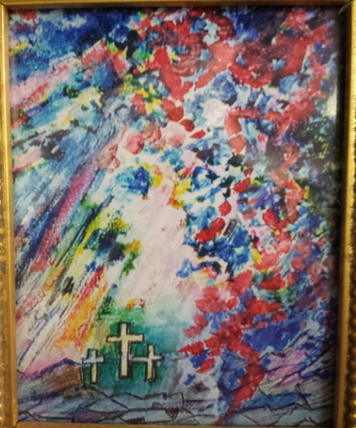Reflections on Holy Week

With Fr. John Catoir

**Holy Thursday**

Now that I, your Lord and Master, have washed your feet, you also should wash the feet of one another. --John 13:14

During the Eucharistic celebration there is the ceremony of the washing of feet. It was the custom to wash the feet of a guest in Jesus’ time. Today it is a sign of our willingness to love and care for our neighbor. Lord, make me willing to wash the feet of those who need my love.

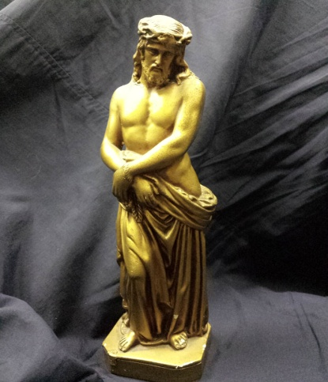

**Good Friday**

God forbid that I should glory save in the Cross of our Lord Jesus Christ. – Gal 6:14

To glory in the Cross is not making the Cross an end in itself. The Lord did not die that our cross may be heavy. He died that our joy may be complete. St. Augustine said, “We are an Easter people and Alleluia is our song.”

Dear Jesus, there are no words to express my gratitude for Your love. Help me to see that the Cross is merely a means to an end. Teach me that joy is the end of all revelation.

**Holy Saturday**

Because of the Preparation Day of the Jews, they laid Jesus in a new tomb in which no one had yet been laid.

– John 19:41-42

The readings in the Paschal Vigil carry us into the mysterious arena where human sin meets God’s justice and mercy. There life and death “have contended,” and there the victory of the risen Christ over death stands out as the source of our salvation and the model of Christian living – Pope Paul VI.

This day is filled with silence, Lord, as we await the outpouring of joy with which we celebrate Your Resurrection. Help me to prepare diligently for that great event.

**Easter Sunday**

God raised this Jesus to life. Of that we all are witnesses. – Acts 2:32

After the tragic death of Jesus, sadness covered the Holy Land. It lasted until the crack of dawn on Easter Sunday. Then a shout was heard around all of Jerusalem: He is risen! Jesus is risen from the dead! To this very day the same cry of joy is heard around the world. ALLELUIA!

Holy, holy, holy Lord, God Almighty. We joyfully proclaim Your Resurrection! Alleluia!

**Prayer to Live Joyfully**

Lord, at times I am overcome with joy. The world seems such a glorious place and all the cares of life seem far away. Thank you for giving us a glimpse of eternity. I know that such a grand feeling is sure to pass and that I will be once again confronted with the problems and worries of daily life. Let me realize that true joy never fades, for it is the gift of Your Spirit made possible by the saving action of Jesus.

Keep me in Your grace so that I may never lose that inner virtue of joy!