Notes for upgrading OpenLabFramework from 0.4 to 0.5
Author: Markus List
Date: 10.02.2011

Release Changes:
- Upgraded underlying java framework successively from Grails 1.3.2 to 1.3.6 and 1.3.7
- Upgraded underlying javascript framework from prototype 1.6.x to 1.7
- Fixed a lot of minor bugs caused by upgrades
- Fixed some minor bugs, mostly in appearance
- Improved browser compatibility
  - Should run fine now on Firefox (including v.4), Chrome (incl. v.9) and Opera (incl. 11).
  - Internet Explorer 8 not supported at this stage
- OLF does now also support mySQL databases
- Barcode/Labelprinting plugin has undergone major changes:
  - Addin now facilitates Dymo Javascript Library for direct printing of labels
  - Addin now allows to select a printer and offers a preview of the label
  - Printjob is now handled directly by the browser.
  - Dymo Label Xml is now stored as new property field 'xml' in BarcodeLabel database entities.
  - Labels can now easily be altered via settings manager.

Backup:
Before installing the new version a backup should be performed. First of all, in order to migrate settings from 0.4 to 0.5 and also to restore the original version in case 0.5 doesn't perform as expected.
- Create a backup of the MS-SQL database
- Copy the file openlabframework.properties from folder webapps\OpenLabFramework-0.4\WEB-INF\classes to a separate backup folder (it contains the database settings).
- Copy all the files olfSettingsDB.* from webapps\OpenLabFramework-0.4 to your backup folder (these contain the application and user specific settings).
- After stopping the Apache Tomcat server move the whole web application folder OpenLabFramework-0.4 to your backup folder. In this way, restoring the application's original state would be straight forward.

Installing the new version:
Detailled instructions can also be found in the OLF installation guide.
- Make sure you have followed the backup instructions of the previous chapter.
- Download the new version from the sourceforge webpage (https://sourceforge.net/projects/openlaboratory/files/).
- Rename the WAR file to OpenLabFramework.WAR (we don't want the URL of the application to change with each version change)
- Copy the WAR file into the Tomcat webapps folder.
- Start Tomcat to let it create the web application.
- Stop Tomcat
- Copy the olfSettingsDB.* back to the webapps\OpenLabFramework folder
- Copy the openlabframework.properties back to webapps\OpenLabFramework\WEB-INF\classes
- Start Tomcat
- Check if the application is up and running
- Check if data is still present, e.g. list genes (user: admin, pw: password).

Setup Label Printing:
Label printing does not facilitate a windows service anymore. Instead, a Dymo javascript library is used to access the printer directly. Therefore, the previously installed Windows service is not necessary anymore and can be disabled. As a consequence of the javascript approach, labels can only be printed on computers that have a label printer properly installed (e.g. the Olympus computer).
To set up the label printer correctly follow these steps:
- Install all DYMO software already installed on the computer (v. 8.2)
- Download the new DYMO Framework (http://download.dymo.com/download%20drivers/LW/DLS8Setup.8.3.0.1242.exe) (v. 8.3)
- Install the new DYMO Framework – FULL install
- Restart the computer for the changes to take effect.
- To find out whether the printer has been configured correcly, download the zip file LabelPrinterTest.zip from Sourceforge. Open the HTML site and see if a printer is recognized.
Now a label has to be configured in the OpenLabFramework: (see screenshots)
- Log into OpenLabFramework (user: admin, pw: password).
- Go to Barcode → Labels in the menu.
- There should be a label given, click on show and afterwards on edit.
- Download the file OLF.label from Sourceforge. Copy the content of the file and paste it to the 'xml' field of the label object. Save your changes and check if your operation was successfull.
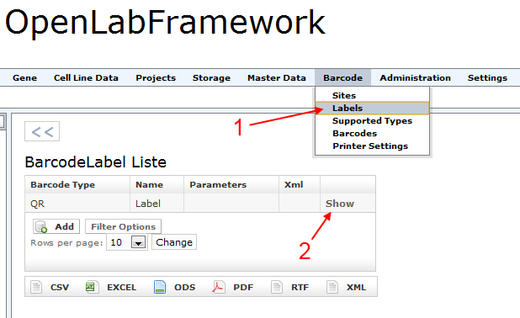Illustration 1: Open available labels. One should be predefined. Click on show to progress.
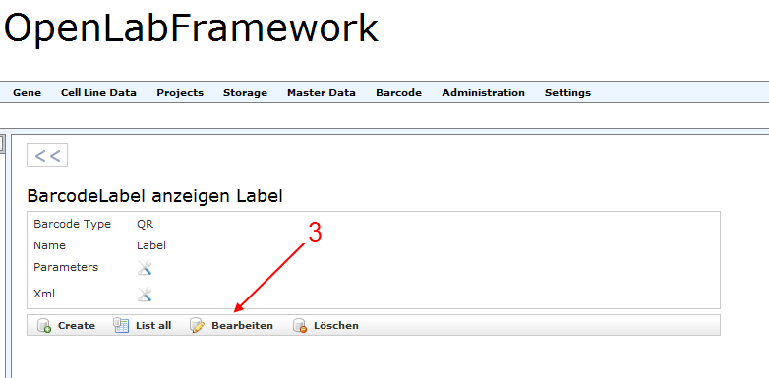Illustration 2: Click on edit to progress.

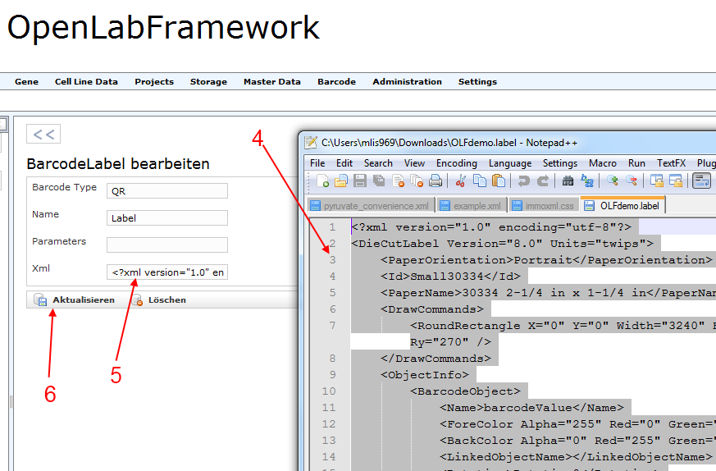Illustration 3: Copy the contents of OLF.label to the given xml field. Then press update.
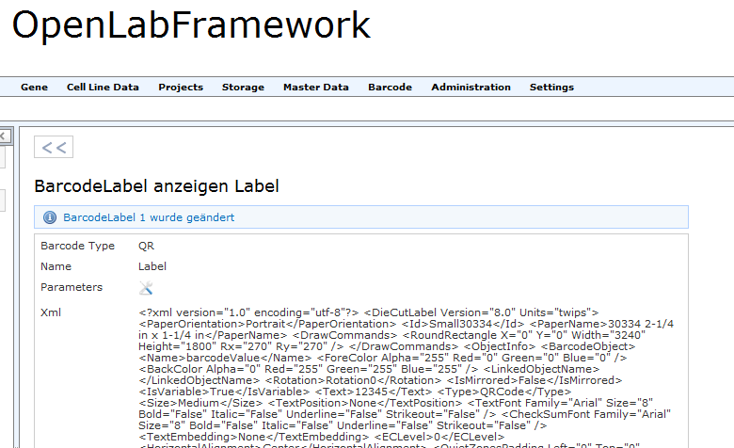Illustration 4: The updated label should look like this.
Now open a printable entity, e.g. a gene or CellLineData experiment:
- If addins have been configured properly, a barcode scanner addin on the right side should turn into a print dialog.
- In the print dialog click on preview.
- If the preview is generated correctly please go on and press print.
- Fingers crossed, a label is printed.
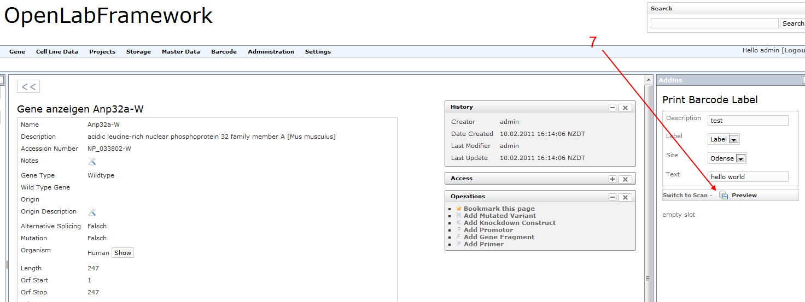Illustration 5: Once a printable entity like a gene is opened, the addin should show a print dialog instead of a barcode scanning interface. Click on preview to progress.
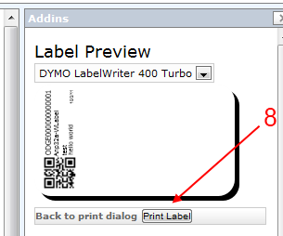Illustration 6: The preview should show a picture of the label that is going to be printed. Click Print Label to progress.
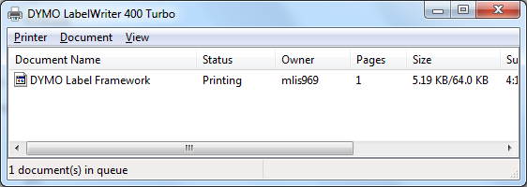Illustration 7: The label should now appear as a print job in the job queue. A label should be printed.
If there is no barcode-scanning / label printing addin present, go to Settings → Addins to configure one to be there.

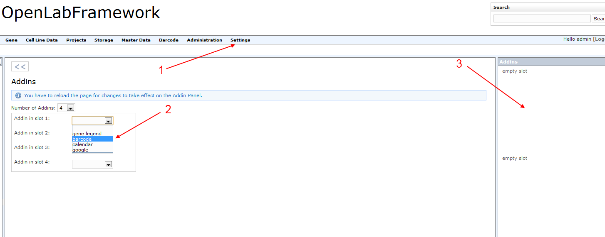Illustration 8: Select an addin: (1) Go to Settings -> Addins, then (2) select an addin. Hit F5 to (3) see the addin appear on its designated space.

