Website Ideas

Frameworks: Angular, Flask, sigma : http://sigmajs.org

1. Main page:

- Header with “SPONGE” as titel and a search and home button in the right upper corner. Header will be on all sites
- 3 sections with links to load new content:
          - Search (loads advanced search)
          - Explore (main features of the website ) (or Browse)
          - More about SPONGE (Links and maybe Abstract of the Paper? What is sponge… )

Other Ideas for the main page:

- Short Search above the 3 sections ; Search section → Advanced Search
- Beneath the 3 Sections: Summary Statistics which shows maybe some pie charts etc (Maybe cancertypes included in DB dataset)

2. Explore Section

- Contains default data that is shown, but the user can also define all necessary things such as cancer type, gene, miRNA
- There will be 5 or 6 Tabs on the left side, which will show specific content

Tabs:
- Interactions (Step B)
- P-Value Computation / Null Model → exclude?
- CeRNA Interactions visualized through Network
- Advanced Search
- Run Information
- Downloads

Somewhere on the site also website credits should be added.

Tabs detailed ideas:

1. Interactions

- Heatmap, Boxplots. Maybe visualize outliers with a highlitend color
- Table of Step B
- Heatmap should be interactive. If the user clicks at a field, the corresponding values in the table should be highlighted

2. Null Model

- explain values with which the plot was generated

3. Network

- interactive network: click, drag, subgraphs, clustering
- detail view if a node is selected (node degree, scores, page rank score)
- thicker or darker/lighter edge if the correlation is higher
- scale node corresponding to node degree
- no labels in the the big network but in the subgraphs or if the user clicks at a specific node
- network should be downloadble as .png o.ä.
- in case of bigger network: include loading screen with a notification: Could take a few min.

3.1 Subgraphs

- per Gen
- per click
- k nearest neighbor
- clustering visualized with transparent underlay

3.2 Plots

- Kaplan-Meier

Color Scheme: Dark blue, White

Layout Inspo

For the Explore Stuff: http://www.biomart.org

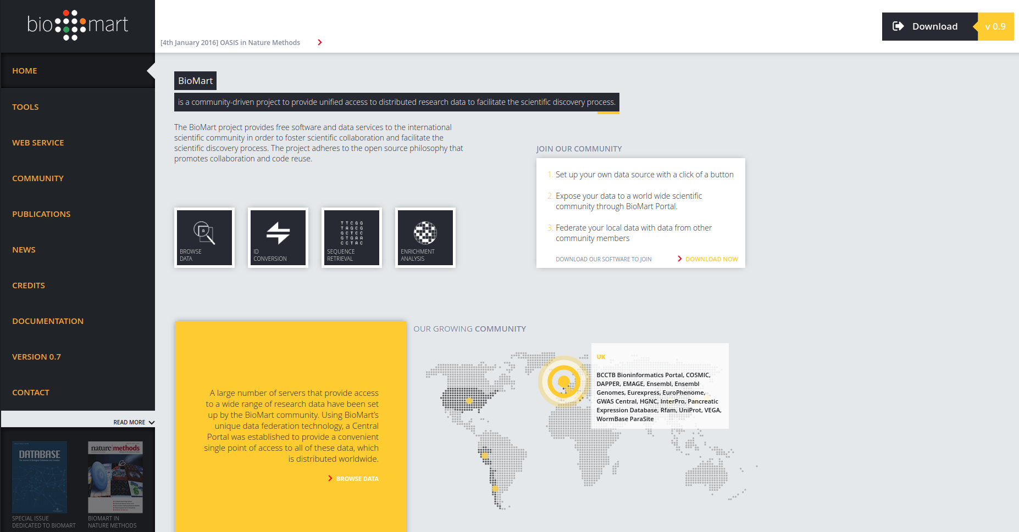

Subsection Example:
https://www.cancer.gov/about-nci/organization/ccg/research/structural-genomics/tcga/using-tcga/tools

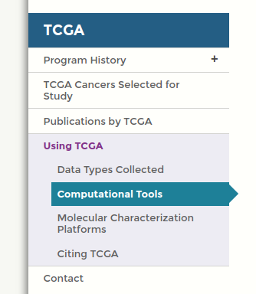

Main page:

