RPi dc3dd Duplicator Documentation

RPi dc3dd Duplicator – Help Notes (DRAFT)
with reference to:
Raspberry Pi 2 Model B
IDLE v3.2.3 (Python v3.2.3, Tkinter v8.5)
dc3dd ('sudo apt-get install dc3dd') (Mar 2015)

Overview

We wanted to make several copies of files to distribute to members of a local society, and, we wanted to avoid the downside of fat fingered typing when using command line tools.
Dc3dd allows multiple copies to be made simultaneously so that was the starting point.
RPi dc3dd Duplicator enables the user to
1. make copies of a specified directory. It does this recursively so that it can rename any filenames containing spaces (replacing them with the underscore character).
2. make clones of a specified drive/device. On screen updates include the dc3dd real time 'progress bar'.

RPi dc3dd Duplicator Screenshots
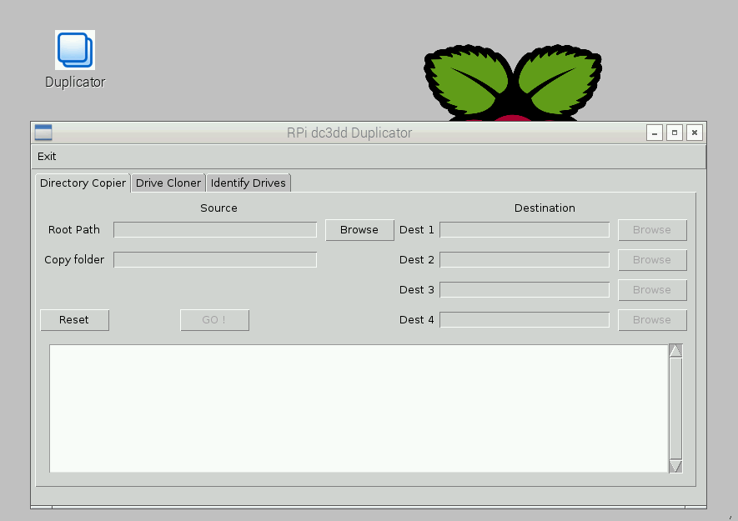Start RPi dc3dd Duplicator
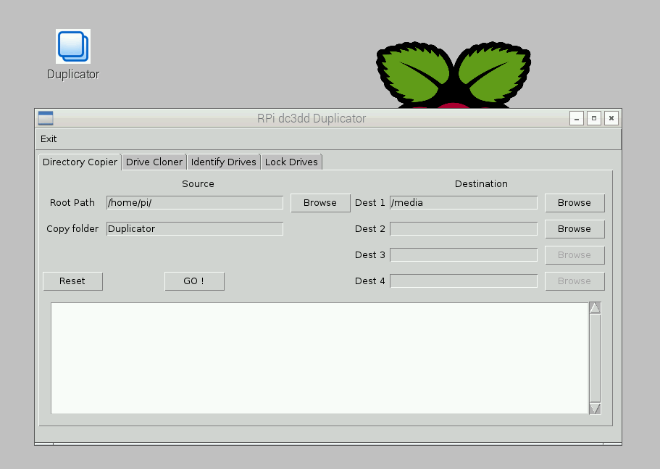Select source directory and destination directories
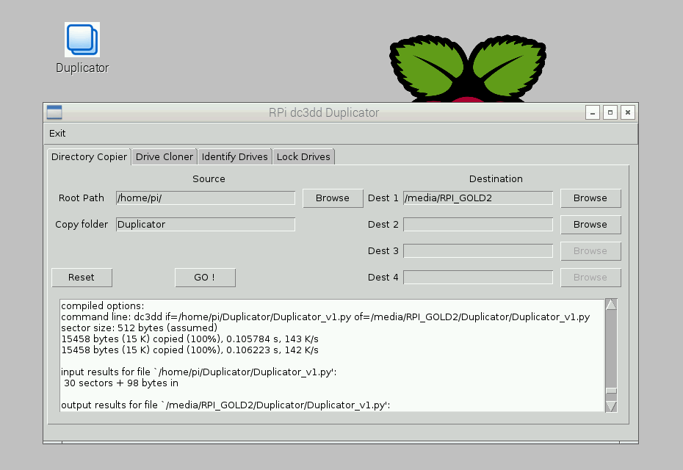dc3dd command line feedback is displayed on screen

Directory Copier

Drive/Device Cloner
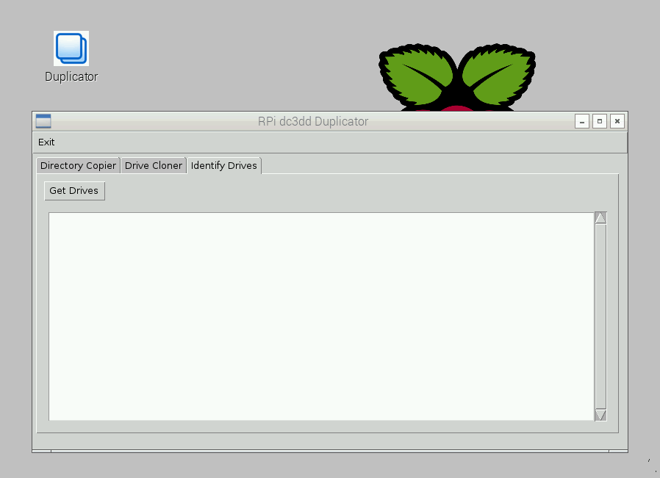to use drive/device cloning, start by identifying drives
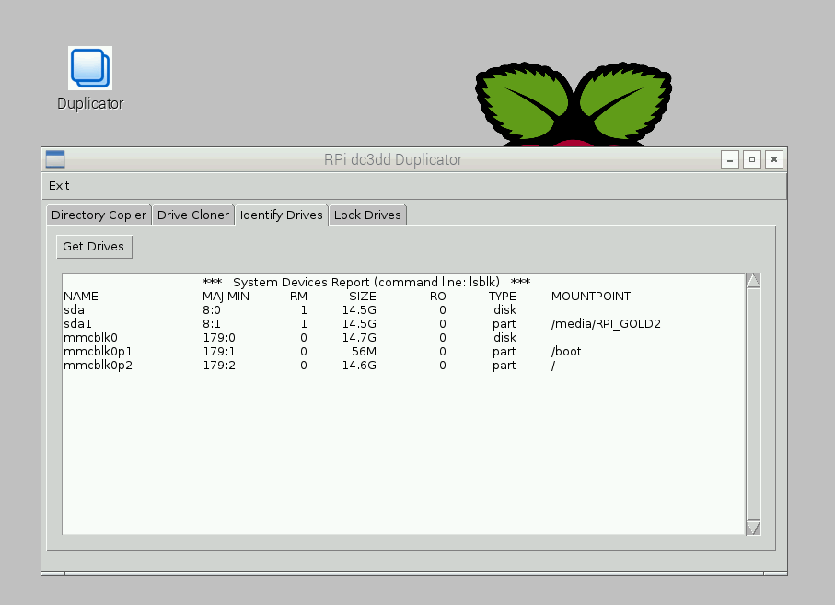drives found by command line lsblk listed on screen
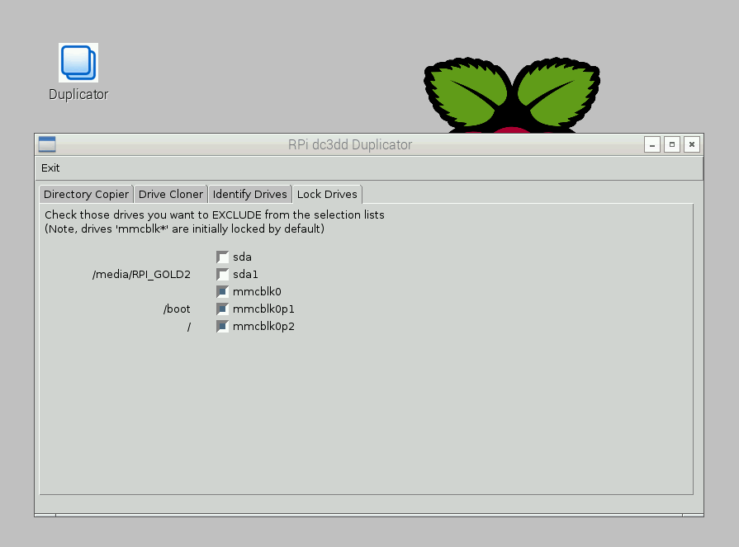optional: lock drives you don't want listed for selection

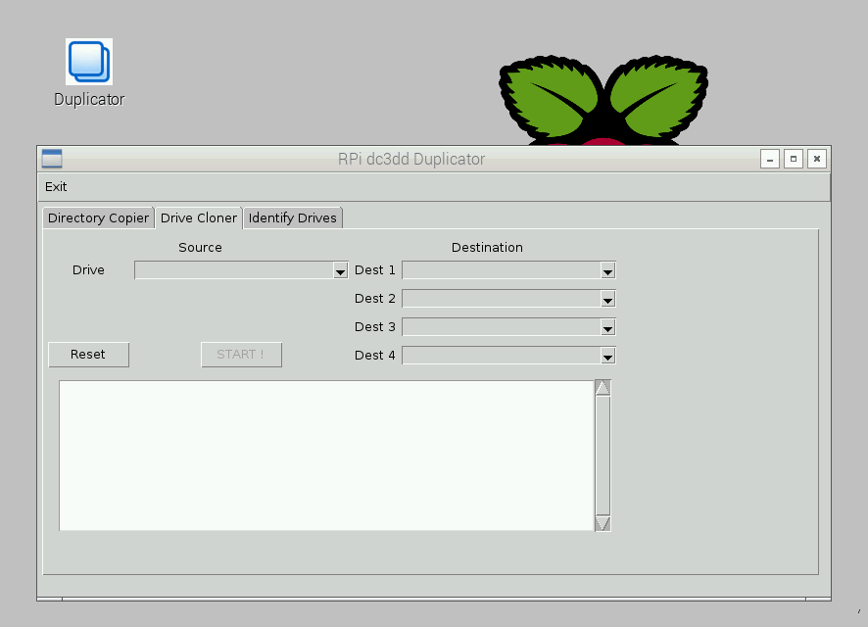Select the source and destination drives/devices

