

**Final Report**

Carlyle Deauna

Jenny Harmsen

Desislava LaFlamme

Gregor Merkle

Leo Wu

IT 460

**Executive Summary:**

The purpose of this project is to help AriZona Beverage Company find an IT solution to make their job more efficient and profitable.

**The Products:**

***Wireless Handheld Computer:*** It connects to a cellular network, will be internet-ready in order to forward real-time information to AriZona's Database, as data is transmitted instantly. AriZona's enterprise software will be integrated to the handheld device’s software thought APIs provided from the vendor. That will allow seamless integration of the data acquired during deliveries into the general ledger.

**Major Benefits:**

It will gain the accuracy of customers’ orders while deliveries are confirmed. it will reduce the hours to perform Route settlement tasks. It is real time performance; the system will track the execution of deliveries, and getting feedback instantly.

**Budget & Time:**

We plan to spend $750,000 and take 4 weeks to finish this project.

***Hardware:*** Handheld device and modules ($600,000). We are going to spend 2 weeks to purchase the hardware from the vendor and install it.

***Software:*** Handheld device’s software ($150,000) take 4 days to install.

***Data:*** Before integrating all data to the updated system, we are going spend another 3 days to test the system, and make sure the new modules and software work fine. Then we integrate all data to the updated system, and this process will take one week.

**Expectation:**

Increased driver productivity and delivery accuracy, improved customer service, reduce labor hours, and vehicle expense.

**Company Background:**AriZona Beverage Company is one of the leading beverage brands in US. The company offers iced teas, sport drinks, energy drinks, and specialized water. The business model includes both a direct sale company, serving the large retail chains, and tree distribution companies serving independent stores. The company sells its products in Canada, Mexico, Panama, Puerto Rico and the Caribbean. **Existing infrastructure:**All of AriZona’s core distribution business operations run on SAP software, and the route settlement information is punched in to the general ledger and warehouse management solutions. The SAP landscape runs on multiple Intel-architecture servers, and the comparatively complex web of dependencies combined with limits on processing capacity mean that both reliability and performance are major challenges for AriZona. The existing IT infrastructure (80-core Intel-architecture production landscape) is unreliable and lacks scalability, and in some cases vital reporting tools have to be switched off to allow standard applications to run.

**Problem:**

Their route settlement tasks take 120 people lots of hours to finish, with employees checking each and every shipment after the trucks returned to the warehouse at the end of the day to make sure that everyone received the correct shipment and that no shipment was left behind. They are often in danger of running over during the next working day. The existing IT infrastructure is also unreliable and lacking of scalability.

**Solution:**

The original solution of AriZona was to replace a sprawling estate of unreliable servers and underutilized external storage with IBM Power Systems servers running SAP applications on IBM I operating system. In short, they would replace their poor servers with servers that run on SAP applications.

In order to help AriZona complete their route accounting in a more effective way, we will implement the use of handheld reporting devices that drivers will bring along with them while they make deliveries. They will contain built-in barcode scanners to document that an order is correct, and a digital signature will confirm that an order was received. The devices, which connect to a cellular network, will be internet-ready in order to forward real-time information to AriZona's warehouse, as data is transmitted instantly. AriZona's enterprise software will be integrated to the handheld device’s software thought APIs provided from the vendor. That will allow seamless integration of the data acquired during deliveries into the general ledger.

The use of the handheld devices will eliminate the need to take stock of shipments at the end of the day, and will subsequently reduce the need for longer work hours, reduce the need for extra employees, and increase quality of customer service. They will also improve delivery efficiency and accuracy by reducing paperwork, capturing exceptions, and recording delivery errors.

With this new technology counting inventory in the end of the day will not be needed. This process will be automated and the company will save 32 working hours (from different employees) for each working day.

**Budget: $750.000**

The budget and time frames of this project are important for our decision for the solution.

**Identifying Alternatives:**

* Updating the old system
* Custom build software – in-house build
* Custom build software – outsourced
* Off the shelf software
* Off the shelf software with customization

**Defining Feasibility**

Updating the old legacy systems will be undo-able because it is written with old programming language and standards. It will be very timely in searching for experts in this area. Implementing the new software in-house (in the company’s IT department) is impossible because the IT employees in the company are not enough specialized in enterprise software coding. Custom Build software with outsourcing will be very costly in matter of consulting and pay by hour programming labor. The benefit of this software will be the most but its implementation will go 30% over the budget of this project. Examining different off the shelf enterprise systems and software our team could not find a complete match of the software services provided with company’s needs. We decided to order an off the shelf software product and customize it to suit the AriZona’s needs. That will save the company consulting fees.

**Defining Total Cost of Ownership**

***Outsourced Custom build Enterprise Solution:***

* Direct cost: $400,000
* Indirect cost: $450,000.
* Indirect cost: $50,000

Total: $900,000

***In house Custom build Enterprise Solution:***

* Direct cost: $400,000
* Indirect cost: $250,000
* Indirect cost: $250,000

Total: $900,000

***Off the shelf Enterprise Solution:***

* Direct cost: $350,000
* Indirect cost: $200,000
* Indirect cost: $250,000

Total: $800,000

***Off the shelf product with customization:***

* Direct cost: $350,000
* Indirect cost: $300,000
* Indirect cost: $50,000

Total: $700,000

**Defining Total Benefits of Ownership**

In-house and outsource custom build software will be expensive for the company. Off the shelf software will not be fully compatible with the business processes of the company. Off the shelf software with customization will provide the following benefits:

* Reducing time for preparing paperwork and reports.
* Easier communication between Financial, Shipping and Inventory departments.
* Eliminating data redundancy and data inconsistency.
* Faster order placing and shipping. That will increase customer satisfaction – better and faster customer service.

More efficient and faster reporting – delivery and inventory reports will lead to better decision making in the Inventory and Marketing Department.

**Analyzing Alternatives**

Custom build solution for AriZona’s problem will be expensive and 200 000 over budget. Off the shelf system will be affordable but it will cost too many changes in AriZona’s business process. Major changes to the business might turn to employee loss or higher percent of employee turnover. Off the shelf product with customization will be on budget because the company will buy enterprise system modules for the Shipping and Inventory departments, and it will customize the module for the Financial and Marketing department. Hardware cost will be more significant than software cost because AriZona will have to buy handheld mobile device for each delivery track. Another hardware expense will be for more powerful servers that will handle processes of data delivery, updating inventory data, and reporting.

**Propose & Support Recommendations**

Our team decided on the following solution for AriZona’s problem: Off the shelf customized product rated with 4.3 with the scale of 1 to 5. The product will fill all company’s requirements. Outsource and consulting will be involved only with implementing customization of the product (mobile handheld devices and servers). The new enterprise system modules will be integrated and customized to the old legacy systems. That will ensure efficiency of the system.

Scale: 1 – Disagree 5 - Agree

**Mobile Handheld will provide the following solutions to AriZona:**

* It will integrate with AriZona’s Customer Relationship Management system , and the Enterprise Resource Planning system that Arizona has already.
* **Wireless Handheld Computers** - Built to withstand the tough environments the drivers face every day, these handhelds can improve delivery efficiency and accuracy by reducing paperwork, capturing exceptions, and recording delivery errors.
* **Order accuracy** - handheld functionality includes a bar code reader to scan product as it is loaded or delivered for total order accuracy and a magnetic stripe reader to capture customers' credit card data electronically.
* **Accurate Deliveries with Consignee Signature Capture** - The built-in barcode scanner ensures the accuracy of customers' orders while deliveries are confirmed with the collection of consignee signatures.
* **Wireless Data Communications** - Mission-critical information is available when needed.  For times when coverage is less than optimal, "store and forward" technology ensures that messages are not lost.
* **Greener, More Efficient Operation** - Reduce paper clutter and delivery errors with the "electronic manifest" that captures arrival, departure, and delivery service times.
* **GPS Location Technology**- View current or historical GPS tracking information for company’s vehicles on graphical maps included with the new Servers.
* **Reports -** Customizable reports via the handheld device are available to collect and analyze various aspects of delivery operations, including route exceptions, driver performance, actual vs. planned, and over, short, and damaged.

• **Automatic Integration** - Data collected on the road will be automatically integrated into the inventory planning system to create real-time reports.

• **Management Reports** - View on screen or printed reports of actual vs. planned, route exception, driver performance, and inventory updates.  Compare goals and determine how well the company is meeting performance targets.

* **Loading Reports** - Final load sheet, driver check-out, load validation and pick sheets provide with all of the detailed information the company need.

**Picture of the mobile handheld device:**

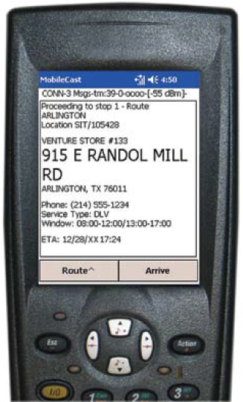

**The new Server will offer the following solutions to Arizona:**

* **Real-Time Dispatch and Route Execution** - Track the execution of deliveries, getting instant feedback on the status of each store delivery.  Make updates throughout the day, such as assigning drivers new delivery stops, resequencing stops, or sending text messages to facilitate instant communication.
* **Proactive Customer Service** - Dispatchers and Customer Service operations will have access to real-time planned, projected, and actual pickup and delivery times.  Be alerted to potential service failures before they occur and take action.
* **Data Integrity** - Protected access and a stable environment is available when using an Oracle or SQL database with the Server.
* **Exchange Information** - Using simple ASCII text interfaces or built-in APIs, employees can easily import and export data to and from the mobile handheld devices in real-time to help feed other critical business systems.  Update Warehouse Management Systems and host systems, or post real-time delivery status to AriZona’s company website.
* **Management Reports** - Analyzing how well the company is meeting its operational goals by utilizing the built-in reports or creating customized ones.

**Software interface:**

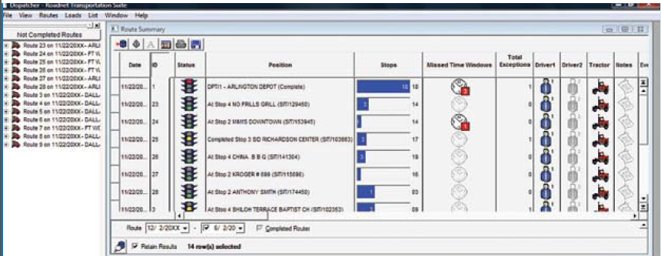

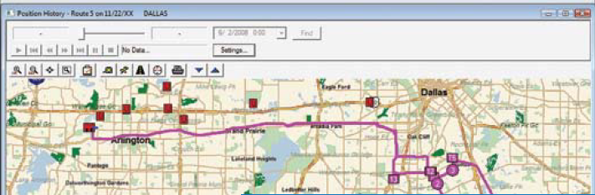

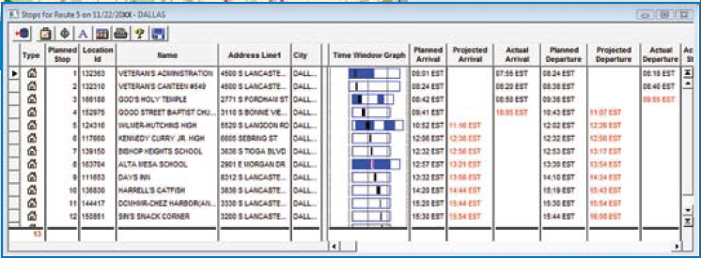

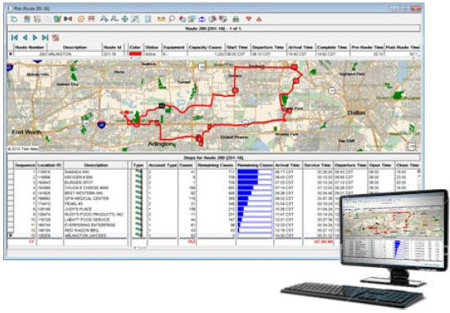

**Excepted long-term results:**

* Reduction in miles driven
* Increased driver productivity and delivery accuracy
* Improved customer service
* Reduction in vehicle expenses

**Assumptions and Rationale**

**Assumptions:**

1. Arizona is not yet using handheld devices on deliveries
2. It is easily possible to equip bigger delivery units of Arizona products with barcodes or they already have them

Depending on the usual packaging techniques barcodes might not be automatically applied to all the bigger units of products that are used during the transport.

**Rationale:**

AriZona Beverage Company is a classic success story; it grew from a very small drinks delivery company to a nationwide known supplier of all sorts of beverages. Due to this growth though the technical infrastructure of AriZona has several shortcomings, probably because nobody ever thought such high volume and demands would occur.

The classic success story became a classic example of the problem of scalability.

Therefore the existing hardware and software had to be overhauled. This bears the opportunity to do more than just what is absolutely needed because it will never be that easy again. Whenever further improvements will be done in the future it will cost more. It is also very likely that the way different systems work together, in other words the level of integration, will be better when as many changes as possible are done at the same time. Therefore it is the right time to implement these handheld devices into the delivery process of AriZona now.

**References:**

<http://www.roadnet.com/pub/products/MobileCast/Handheld/>

<http://www.01.ibm.com/software/success/cssdb.nsf/cs/STRD8RAEED?OpenDocument&Site=wsportal&cty=en_us>