Session 3: Tech Jobs and Grammar Basics

- Canciones https://lingoclip.com/
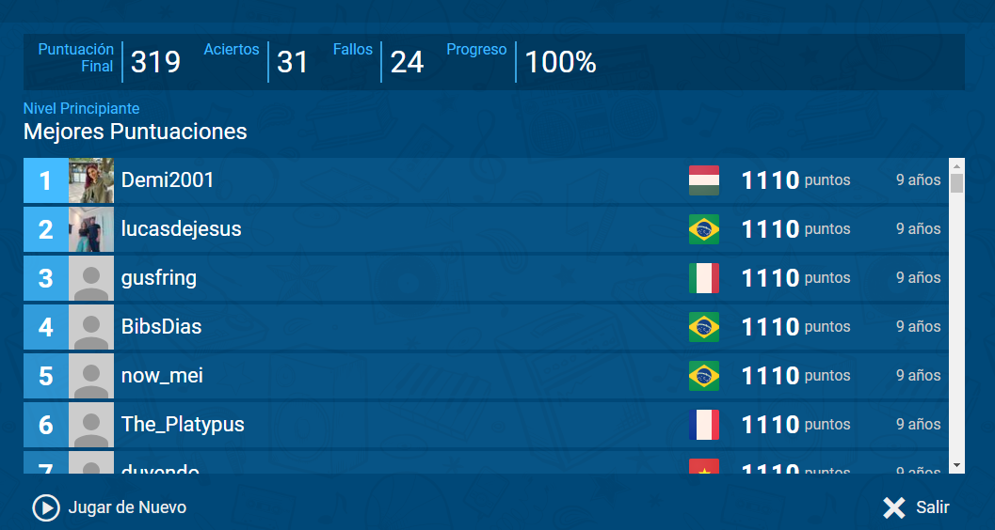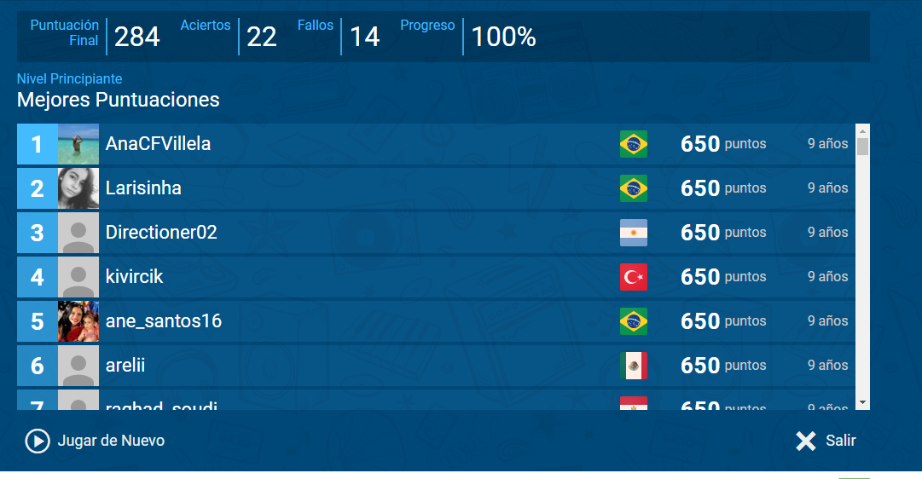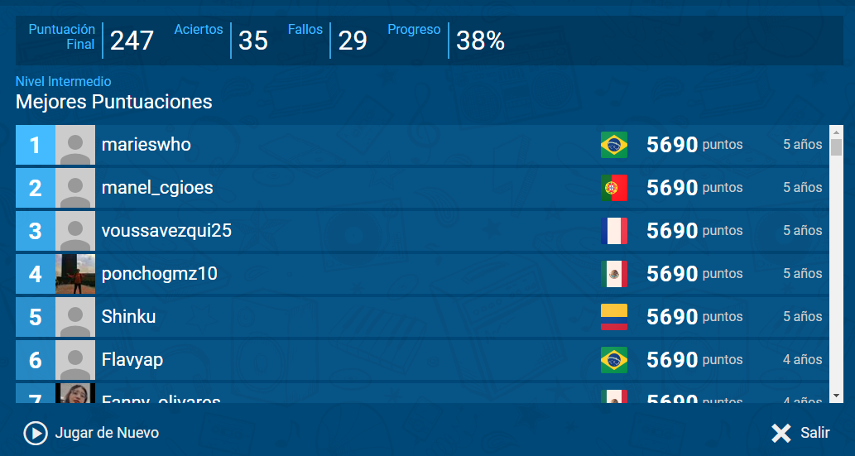

- Voz
- Complete
- An english Word learned today is Brackets
- An important Word that was not incluided is maintainable
- A complicated Word to pronunce is retrieve

