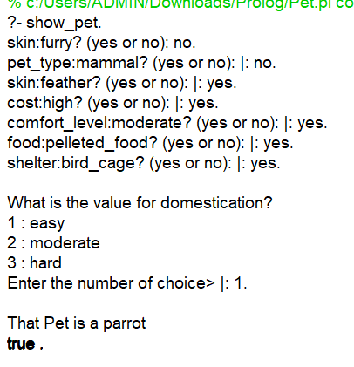

% Pets Prolog

:- dynamic(known/3).

:- discontiguous pet_type/1.

pet(dogs):- pet_type(mammal), food(dog_food), shelter(dog_house), domestication(easy).

pet(cats):- pet_type(mammal), food(cat_food), shelter(cat_foam), domestication(easy).

pet(rabbit):- pet_type(mammal), food(vegetables), shelter(cage), domestication(moderate).

pet(hamster):- pet_type(mammal), food(fruits), shelter(small_cage), domestication(moderate).

pet(ferret):- pet_type(mammal), food(kibble), shelter(small_cage), domestication(easy).

pet(guienea_pigs):- pet_type(mammal), food(pellets), shelter(small_cage), domestication(moderate).

pet(parrot):- pet_type(bird), food(pelleted_food), shelter(bird_cage), domestication(easy).

pet(canaries):- pet_type(bird), food(seed_mix), shelter(bird_cage), domestication(hard).

pet(finches):- pet_type(bird), food(leafy_greens), shelter(bird_cage), domestication(moderate).

pet(cockatiels):- pet_type(bird), food(sprouted_seeds), shelter(bird_cage), domestication(moderate).

pet(budgies):- pet_type(bird), food(budgie_seed_mix), shelter(bird_cage), domestication(hard).

pet(turtle):- pet_type(reptile), food(vegetables), shelter(small_swamp), domestication(hard).

pet(snake):- pet_type(reptile), food(prey_items), shelter(terrarium), domestication(hard).

pet(lizard):- pet_type(reptile), food(insects), shelter(vivarium), domestication(hard).

pet(chameleon):- pet_type(reptile), food(gut_loading), shelter(vivarium), domestication(hard).

pet(tortoise):- pet_type(reptile), food(pellets), shelter(swamp), domestication(moderate).

pet(gold_fish):- pet_type(fish), food(flakes), shelter(fish_tank), domestication(moderate).

pet(beta_fish):- pet_type(fish), food(frozen_foods), shelter(fish_bowl), domestication(hard).

pet(guppies):- pet_type(fish), food(pelleted_food), shelter(fish_pond), domestication(hard).

main :- show_pet.

show_pet :- retractall(known(_, _, _)), pet(X), write('That Pet is a '), write(X), nl.

show_pet :- write('I can''t identify that Pet'), nl.

pet(X) :- ask(pet, X).

pet_type(X) :- ask(pet_type, X).

skin(X) :- ask(skin, X).

cost(X) :- ask(cost, X).

comfort_level(X) :- ask(comfort_level, X).

food(X) :- ask(food, X).

shelter(X) :- ask(shelter, X).

domestication(X) :- menuask(domestication, X, [easy, moderate, hard]).

pet_type(mammal) :- skin(furry), cost(low), comfort_level(high).

pet_type(bird) :- skin(feather), cost(high), comfort_level(moderate).

pet_type(reptile) :- skin(scale), cost(high), comfort_level(low).

pet_type(fish) :- skin(fins), cost(moderate), comfort_level(low).

% Rest of code for ask/1, menuask/3, etc.

ask(Attribute, Value) :- known(yes, Attribute, Value), !.

ask(Attribute,Value):-known(_,Attribute,Value), !, fail.

ask(Attribute,_):- known(yes,Attribute,_), !, fail.

ask(A,V):- write(A:V),

% if we get here, we need to ask

  write('? (yes or no): '), read(Y),

% get the answer

  asserta(known(Y,A,V)),

  Y = yes.

% succeed or fail based on answer

menuask(Attribute, Value, _) :- known(yes, Attribute, Value), !.

menuask(Attribute, _, _) :-known(yes, Attribute, _), !, fail.

menuask(Attribute,AskValue,Menu):-

  nl,write('What is the value for '),write(Attribute),write('?'),nl,

  display_menu(Menu),

  write('Enter the number of choice> '),

  read(Num),nl,

  pick_menu(Num,AnswerValue,Menu),

  asserta(known(yes,Attribute,AnswerValue)),

  AskValue = AnswerValue.

display_menu(Menu):- disp_menu(1,Menu), !.

disp_menu(_, []).

disp_menu(N, [Item | Rest]) :- write(N), write(' : '), write(Item), nl, NN is N + 1, disp_menu(NN, Rest).

pick_menu(N,Val,Menu):- integer(N),

pic_menu(1,N,Val,Menu), !.

pick_menu(Val,Val,_).

pic_menu(_,_,none_of_the_above,[]).

pic_menu(N,N, Item, [Item|_]).

pic_menu(Ctr,N, Val, [_|Rest]):- NextCtr is Ctr + 1, pic_menu(NextCtr, N, Val, Rest).