Requirement & Design Specification
Global Access Management System (GAMS)
Version: 1.0

– DaNang, October 2025 –

Record of Changes
Version | Date | A*  M, D | In charge | Change Description
V1.0 | 24/10 | A | MinhPJ
 | 29/10 | A | KienLT | Design Specifications
 | 28/10 | A | DaiTB | Requirement Specifications
*A - Added M - Modified D - Deleted

Contents
Record of Changes 2
I. Overview 4
1. User Requirements 4
1.1 Actors 4
1.2 Use Cases 4
2. Overall Functionalities 5
2.1 Screens Flow 5
2.2 Screen Descriptions 5
2.3 Screen Authorization 5
2.4 Non-UI Functions 6
3. System High Level Design 6
3.1 Database Design 6
3.2 Code Packages 7
II. Requirement Specifications 8
1. <<Feature Name>> 8
1.1 <<UseCaseCode_UC Name>> 8
2. Common Functions 11
2.1 UC-2_Login System 11
3. Patron Feature 12
3.1 UC-5_Order a Meal 12
3.2 UC-6_Register for Payroll Deduction 13
III. Design Specifications 14
1. <<Feature Name>> 14
1.1 <<SubFeature Name>> 14
1.2 System Access 15
IV. Appendix 19
1. Assumptions & Dependencies 19
2. Limitations & Exclusions 19
3. Business Rules 19
4. .. 19

I. Overview

1. User Requirements
1.1 Actors

# | Actor | Description
1 | Add to Wishlist | Save favorite events
2 | Approve / Reject Event | Browse events created by the organizer
3 | Assign Roles | Assign roles (staff, organizer, admin)
4 | Assist Customer Issues | Assist in handling user issues
5 | Book Ticket | Book tickets for events
6 | Cancel Ticket | Cancel tickets (based on refund policy)
7 | Change Password | Change password
8 | Contact Support | Send support requests
9 | Create Event | Create a new event (awaiting staff approval)
10 | Delete Event | Delete events without sold tickets
11 | Download Invoice | Download ticket invoices
12 | Edit Event | Update event information
13 | Edit Profile | Update user information
14 | Filter Events | Filter events (category, location, price)
15 | Forgot Password | Send password reset email
16 | Handle Disputes / Complaints | Resolve complaints
17 | Login | Log in using account or Google
18 | Make Payment | Pay for tickets via online payment gateway
19 | Manage Categories / Tags | Manage event categories
20 | Manage Events | Delete/lock events that violate rules
21 | Manage Organizer Profile | Update business information
22 | Manage Payment Gateways | Configure payment settings
23 | Manage Refund Requests | Confirm refunds if the policy allows
24 | Manage Refund Requests | Check refund requests
25 | Manage Staff Accounts | Create and assign staff permissions
26 | Manage System Settings | Update policies and terms
27 | Manage Ticket Types | Set ticket prices, areas, quantities
28 | Manage Users | CRUD (Create, Read, Update, Delete) users
29 | Rate & Review Event | Rate events
30 | Receive Email Confirmation | Send ticket confirmation emails
31 | Receive Notifications | Receive notifications (push/email)
32 | Register Account | Register an account with email or phone number
33 | Request Payout | Withdraw revenue from the system
34 | Respond to Customer Queries | Respond to customer messages/inquiries
35 | Search Event | Search for events by name, location, time, type
36 | Select Seat / Zone | Select areas or seats
37 | Send Announcements | Send system notifications
38 | Upload Banner / Poster | Upload event images
39 | Verify Organizer | Verify organizer's identity
40 | View Event Detail | View event details (description, price, area, organizer)
41 | View Event List | View list of events created by the user
42 | View Global Reports | System-wide summary reports
43 | View My Bookings | View booking history
44 | View Organizer Info | View organizer's information
45 | View Pending Events | View list of events awaiting approval
46 | View Refund Policy | View refund policy
47 | View Reports | Internal reporting
48 | View Sales Report | Statistics on ticket sales, revenue, ratings
49 | View Terms & Policy | View policies and terms

1.2 Use Cases

a. Diagram(s)
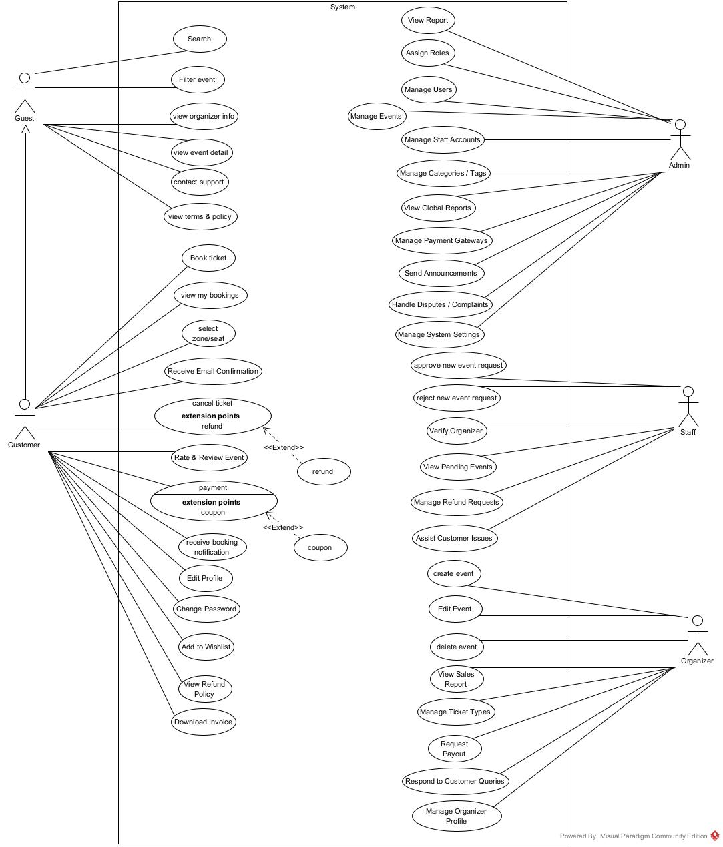
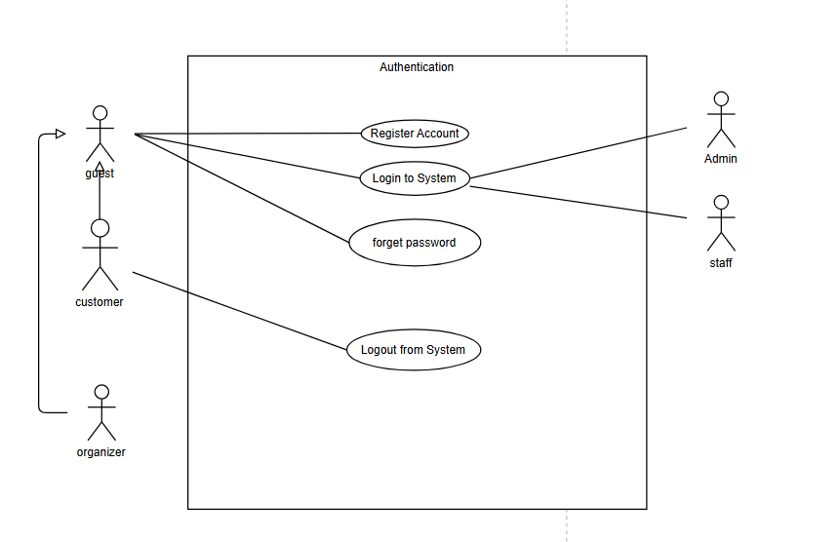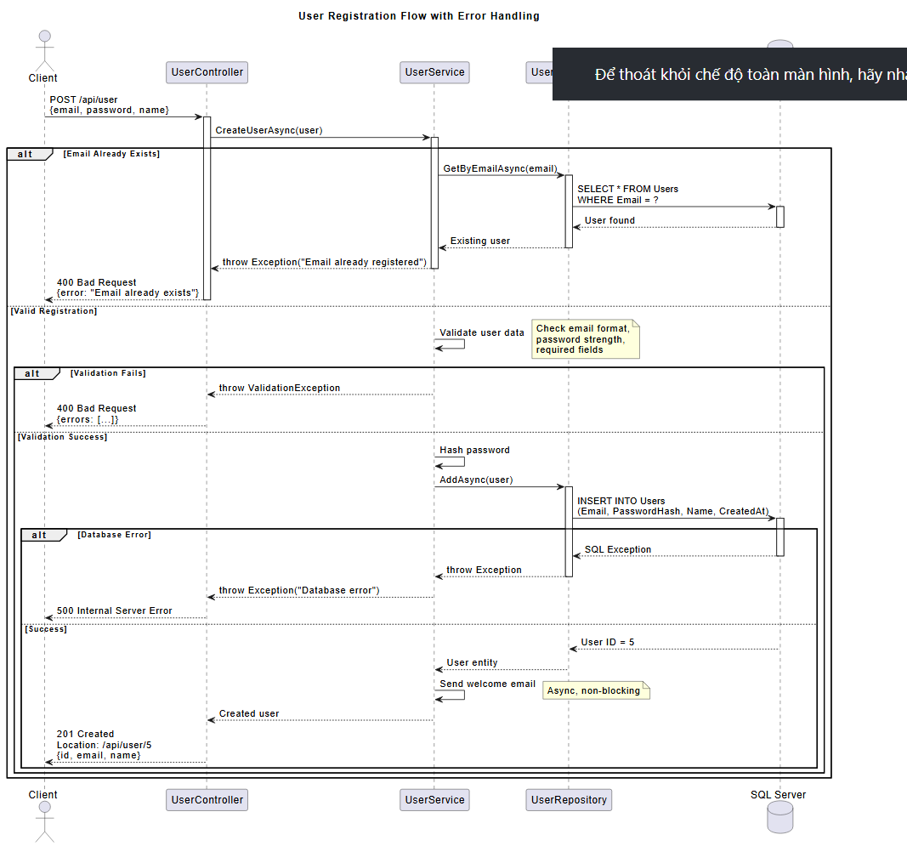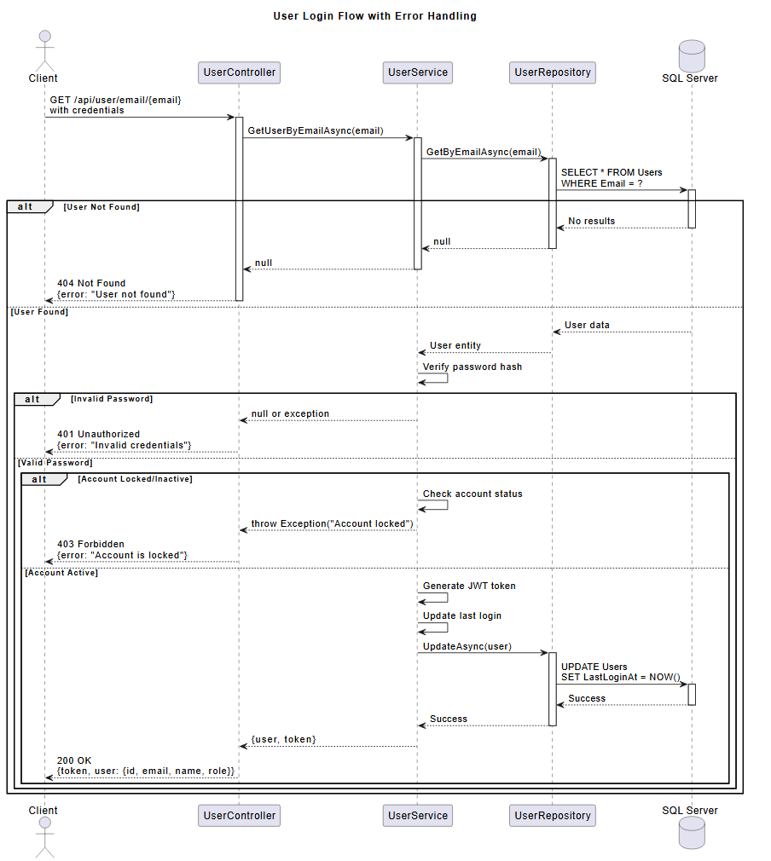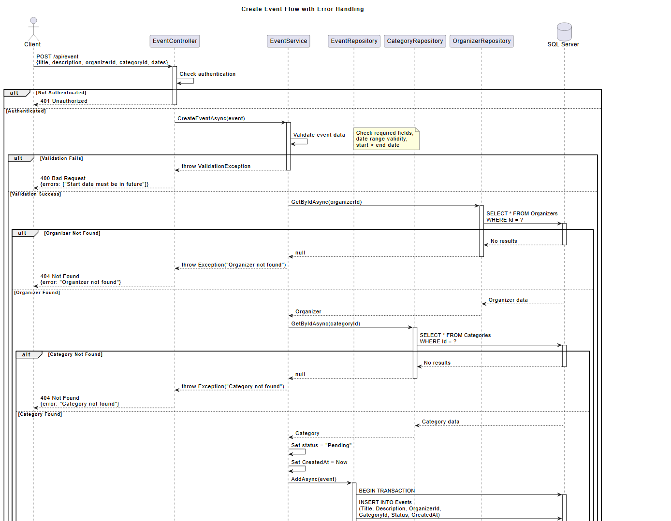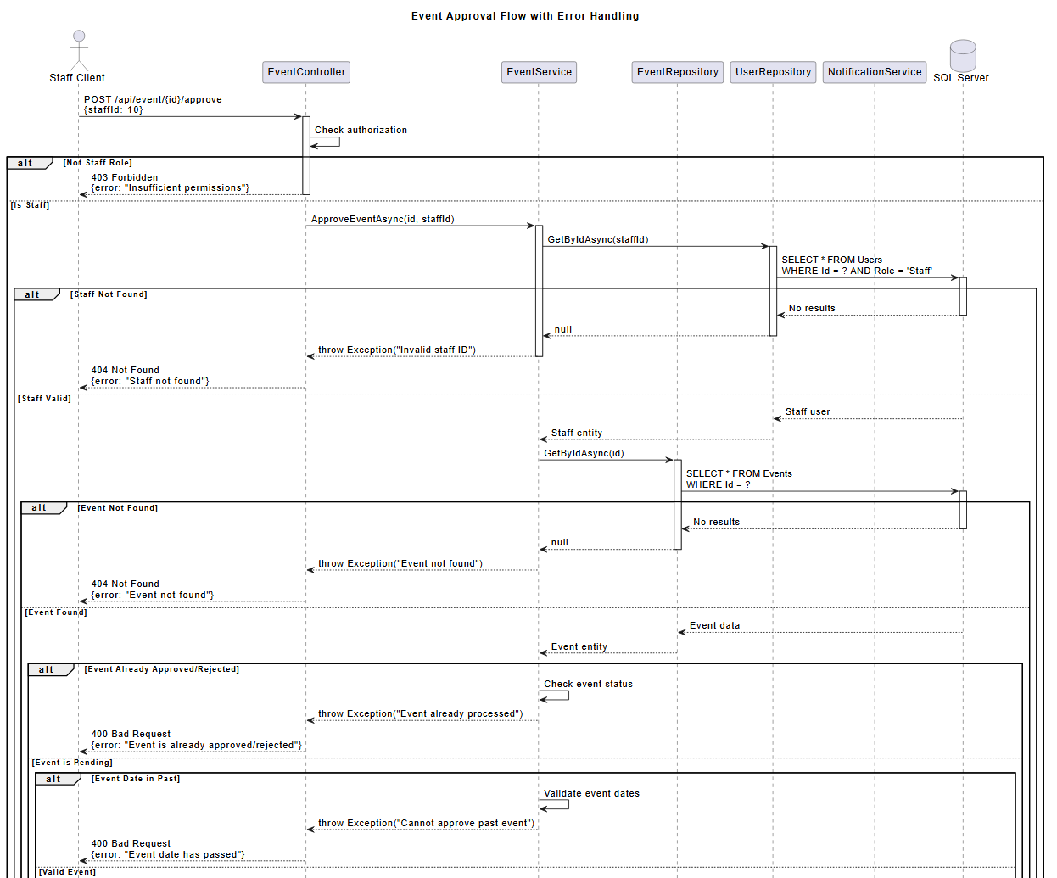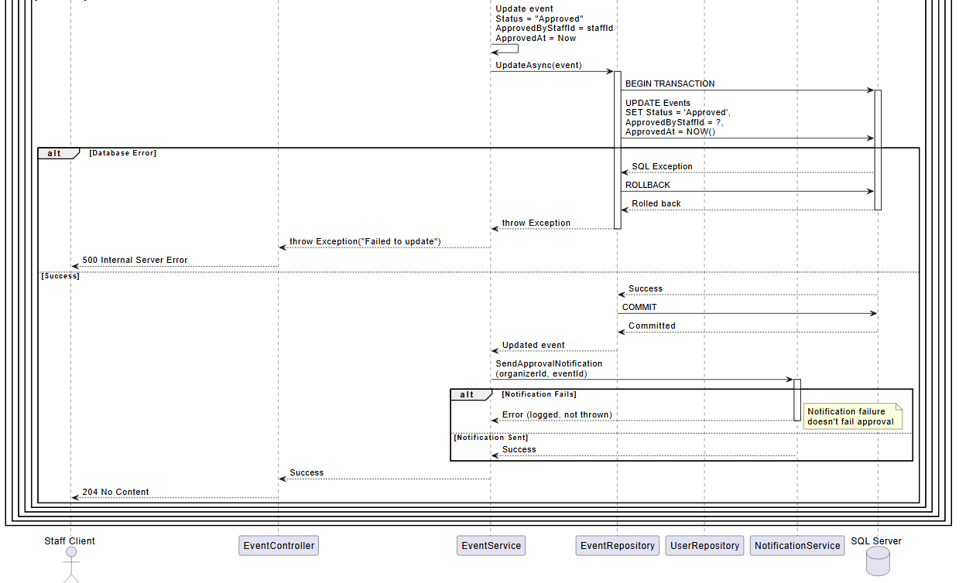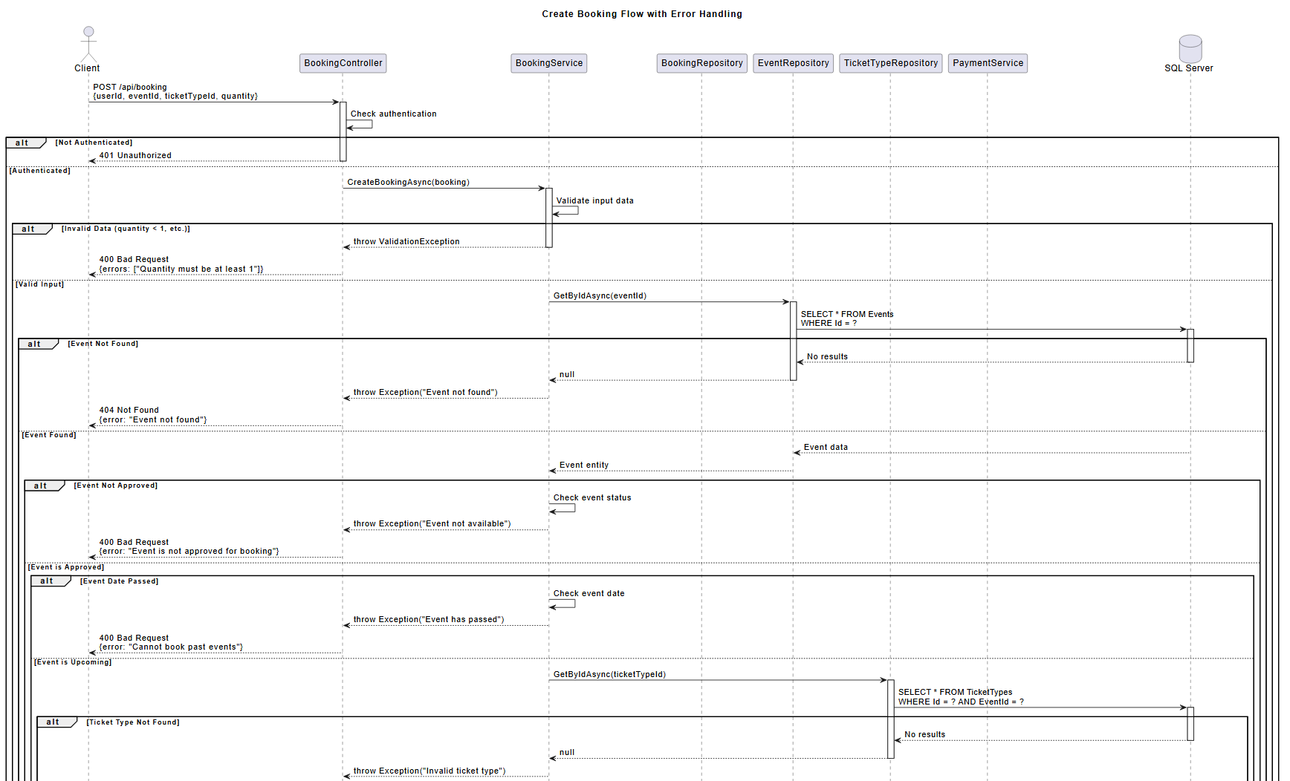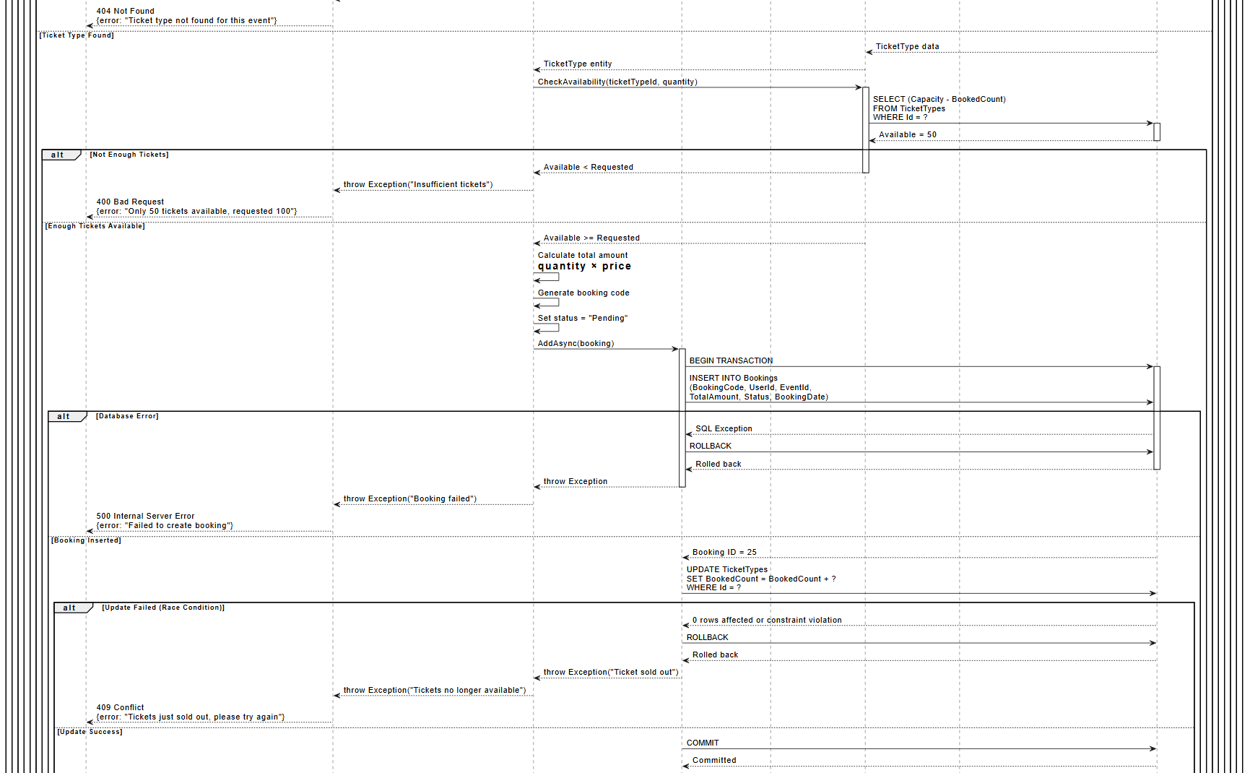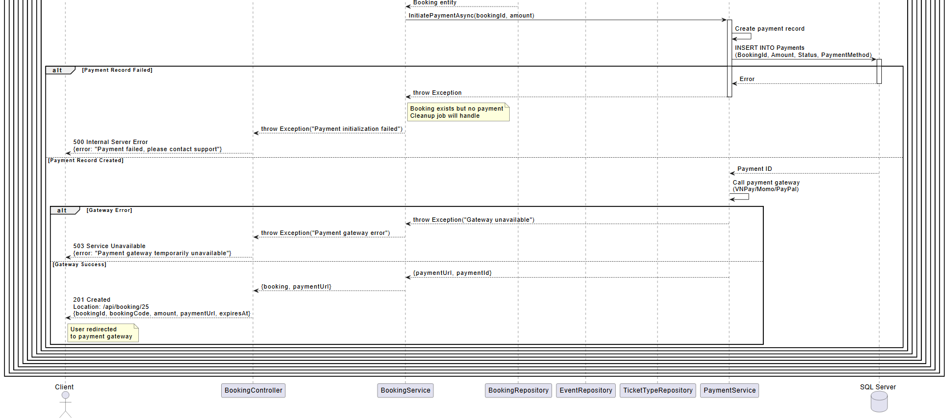

b. Descriptions

ID | Feature | Use-case | description
1 | User | Add to Wishlist | Save favorite events
2 | Event | Approve / Reject Event | Browse events created by the organizer
3 | System | Assign Roles | Assign roles (staff, organizer, admin)
4 | Support | Assist Customer Issues | Assist in handling user issues
5 | Booking | Book Ticket | Book tickets for events
6 | Booking | Cancel Ticket | Cancel tickets (based on refund policy)
7 | Authentication | Change Password | Change password
8 | Support | Contact Support | Send support requests
9 | Event | Create Event | Create a new event (awaiting staff approval)
10 | Event | Delete Event | Delete events without sold tickets
11 | Payment | Download Invoice | Download ticket invoices
12 | Event | Edit Event | Update event information
13 | User | Edit Profile | Update user information
14 | Event | Filter Events | Filter events (category, location, price)
15 | Authentication | Forgot Password | Send password reset email
16 | Support | Handle Disputes / Complaints | Resolve complaints
17 | Authentication | Login | Log in using account or Google
18 | Payment | Make Payment | Pay for tickets via online payment gateway
19 | Event | Manage Categories / Tags | Manage event categories
20 | Event | Manage Events | Delete/lock events that violate rules
21 | Organizer | Manage Organizer Profile | Update business information
22 | Payment | Manage Payment Gateways | Configure payment settings
23 | Payment | Manage Refund Requests | Confirm refunds if the policy allows
24 | Payment | Manage Refund Requests | Check refund requests
25 | System | Manage Staff Accounts | Create and assign staff permissions
26 | System | Manage System Settings | Update policies and terms
27 | Ticket | Manage Ticket Types | Set ticket prices, areas, quantities
28 | User | Manage Users | CRUD (Create, Read, Update, Delete) users
29 | Review | Rate & Review Event | Rate events
30 | Notification | Receive Email Confirmation | Send ticket confirmation emails
31 | Notification | Receive Notifications | Receive notifications (push/email)
32 | Authentication | Register Account | Register an account with email or phone number
33 | Payment | Request Payout | Withdraw revenue from the system
34 | Support | Respond to Customer Queries | Respond to customer messages/inquiries
35 | Event | Search Event | Search for events by name, location, time, type
36 | Booking | Select Seat / Zone | Select areas or seats
37 | Notification | Send Announcements | Send system notifications
38 | Media | Upload Banner / Poster | Upload event images
39 | Organizer | Verify Organizer | Verify organizer's identity
40 | Event | View Event Detail | View event details (description, price, area, organizer)
41 | Event | View Event List | View list of events created by the user
42 | Analytics | View Global Reports | System-wide summary reports
43 | Booking | View My Bookings | View booking history
44 | Organizer | View Organizer Info | View organizer's information
45 | Event | View Pending Events | View list of events awaiting approval
46 | System | View Refund Policy | View refund policy
47 | Analytics | View Reports | Internal reporting
48 | Analytics | View Sales Report | Statistics on ticket sales, revenue, ratings
49 | System | View Terms & Policy | View policies and terms

2. Overall Functionalities

2.1 Screens Flow

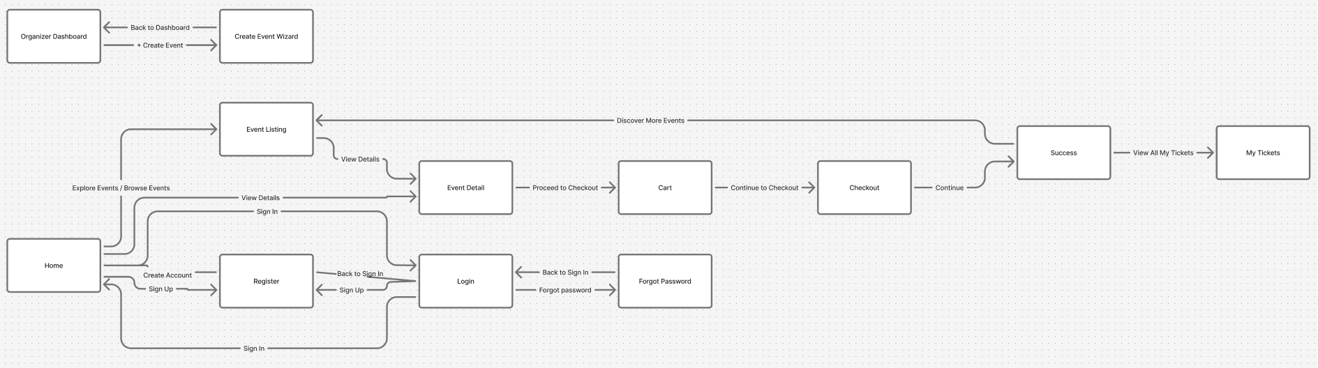

2.2 Screen Descriptions

# | Feature | Screen | Description
1 | Home & Discovery | Home Page | The main landing page where users can browse featured events, trending categories, and use the search bar or filter by city/date/type.
2 | Event Browsing | Public Events | A public list of all upcoming events with filtering, sorting, and pagination.
3 | Event Details | Event Detail | Displays complete information about an event including date/time, venue, pricing tiers, organizer info, and purchase options.
4 | Ticket Purchase | Cart | The shopping cart screen summarizing selected tickets, quantities, service fees, and total payment.
5 | Payment & Checkout | Checkout | Handles user information input, payment selection (e.g., Stripe, MoMo), and billing details confirmation.
6 | Purchase Result | Order Success | Confirmation screen shown after successful payment. Displays a QR ticket code, download links, and email receipt confirmation.
7 | My Tickets | My Tickets | A user’s personal list of purchased tickets, each with QR code and ticket status (Valid / Used / Refunded).
8 | My Orders | My Orders | Displays past purchase history with links to detailed order records.
9 | Order Details | Order Details | Shows detailed transaction information, payment status, number of tickets, and total cost.
10 | Authentication | User Login / Register | Login and registration forms, including password reset and email verification.
11 | Profile Management | User Profile | Allows users to view and edit their personal information, avatar, contact email, and change passwords.
12 | Organizer Dashboard | Organizer Dashboard | The main admin area for event organizers, summarizing active events, total sales, and statistics.
13 | Event Management | Event List / Event Update | Allows organizers to create, update, or delete their events and manage event-specific settings.
14 | Ticket Management | Ticket List | Defines ticket types, pricing, sales start/end dates, and availability.
15 | Promotion Management | Promotion List | Manage discount codes, coupons, or promotional bundles for events.
16 | Order Management | Orders List / Order Update | Enables review, modification, or refund of customer orders by organizers or staff.
17 | Customer Service | Customer Request | Displays customer inquiries, refund requests, or complaints related to specific events.
18 | On-site Check-in | Fulfilling / Check-in | Allows staff to scan QR codes to validate and mark tickets as used.
19 | User Administration | Users List / User Details / New User | Admin module to manage system users, create new accounts, or assign roles.
20 | System Configuration | Settings List / Setting Details | Manage system parameters such as payment gateways, API keys, or notification templates.
21 | Analytics & Reports | Analytics | Dashboard showing revenue summaries, ticket sales, refunds, and event performance metrics.

2.3 Screen Authorization

Screen | Guest | Customer | Organizer | Staff | Admin
Home Page | X | X | X | X | X
Public Events | X | X | X | X | X
Event Detail | X | X | X | X | X
Cart |  | X
Checkout |  | X
Order Success |  | X
My Tickets |  | X
My Orders |  | X
Order Details |  | X |  | X
Login / Register | X | X | X | X | X
User Profile |  | X | X | X | X
Organizer Dashboard |  |  | X | X | X
Event List / Update |  |  | X | X | X
Ticket List |  |  | X | X | X
Promotion List |  |  | X | X | X
Orders List / Update |  |  | X | X | X
Customer Request |  |  | X | X | X
Check-in |  |  |  | X
Users List / Details |  |  |  |  | X
Settings |  |  |  |  | X
Analytics |  |  | X | X | X

2.4 Non-UI Functions
[Provide the descriptions for the functions which have no UI (or not screens), i.e batch/cron job, service, API, etc.]
# | Feature | System Function | Description
1 | Authentication | Email Verification Service | Sends verification links and password recovery emails via SMTP.
2 | Payment Processing | Payment Gateway Service | Integrates with Stripe / MoMo APIs for secure payment handling.
3 | Ticket Generation | QR Ticket Generator | Automatically generates and stores a unique QR code for each purchased ticket.
4 | Refund Management | Refund Processor | Executes partial or full refunds for canceled or invalid tickets.
5 | Notification System | Email / Push Notification Service | Sends transactional emails (receipts, reminders, updates) and push alerts.
6 | Analytics & Reports | Data Aggregation Job | Periodically aggregates event sales data for dashboard analytics.
7 | Scheduler | Background Cron Jobs | Scheduled jobs to update expired events, ticket status, or run daily summaries.
8 | Logging & Auditing | Activity Logger | Records all user/system actions for monitoring and traceability.
9 | Security Middleware | JWT & Role-based Auth Guard | Validates user tokens and ensures access only to authorized screens.
10 | Database Maintenance | Backup & Restore Service | Performs automated backups and restores to cloud storage (e.g., AWS S3).

3. System High Level Design

3.1 Database Design
[Provide the tables relationship like example below]

a. Database Schema
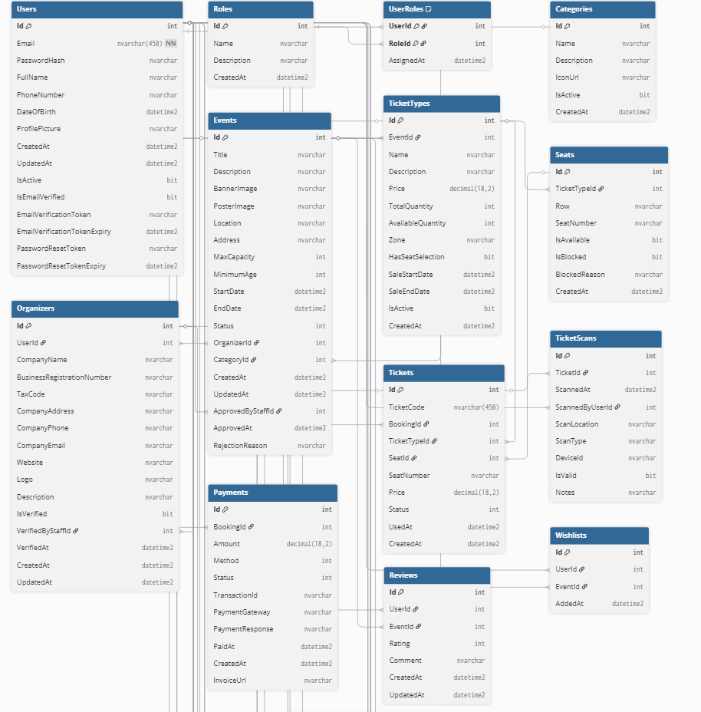
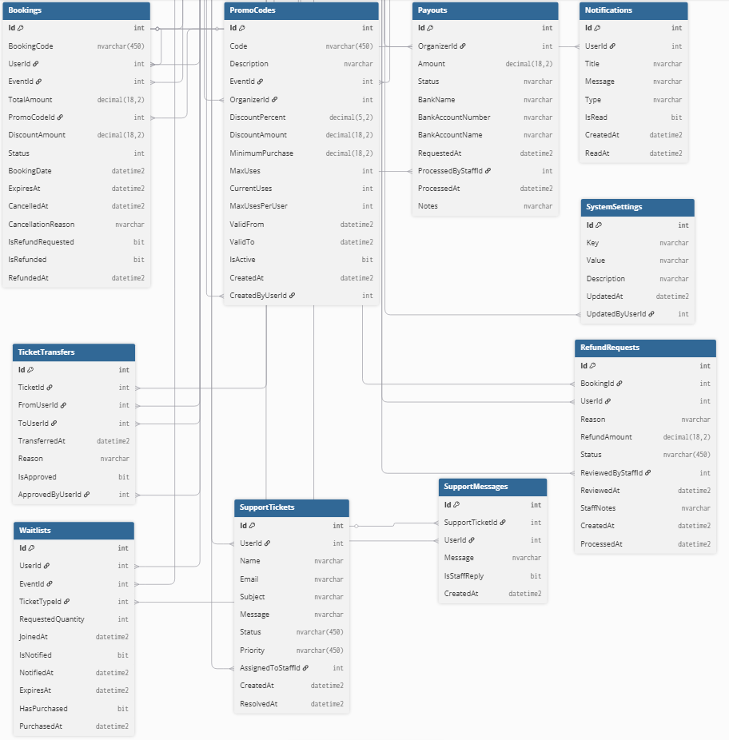

b. Table Descriptions
No | Table | Description
01 | Categories | Save information about event categories  - Primary keys: Id  - Foreign keys: None
02 | Roles | Store system roles such as Admin, Organizer, and User.  - Primary keys: Id  - Foreign keys: (none)
03 | User | Stores user information, including personal details, authentication data, and account status.  - Primary keys: Id  - Foreign keys: (none)
04 | UserRole | Links users with their assigned roles, defining permissions.  - Primary keys: UserId, RoleId  - Foreign keys: UserId → Users.Id, RoleId → Roles.Id
05 | Organizers | Stores organizer or company details responsible for hosting events.  - Primary keys: Id  - Foreign keys: UserId → Users.Id, VerifiedByStaffId → Users.Id
06 | Events | Contains detailed information about each event.  - Primary keys: Id  - Foreign keys: OrganizerId → Organizers.Id, CategoryId → Categories.Id, ApprovedByStaffId → Users.Id
07 | TicketTypes | Defines ticket categories for an event (e.g., VIP, Standard).  - Primary keys: Id  - Foreign keys: EventId → Events.Id
08 | Seats | Manages seat details for events that use seat selection.  - Primary keys: Id  - Foreign keys: TicketTypeId → TicketTypes.Id
09 | Bookings | Records user bookings for events.  - Primary keys: Id  - Foreign keys: UserId → Users.Id, EventId → Events.Id, PromoCodeId → PromoCodes.Id
10 | Payment | Stores payment transactions related to bookings.  - Primary keys: Id  - Foreign keys: BookingId → Bookings.Id
11 | Tickets | Stores individual ticket information generated after booking.  - Primary keys: Id  - Foreign keys: BookingId → Bookings.Id, TicketTypeId → TicketTypes.Id, SeatId → Seats.Id
12 | TicketScan | Records ticket scanning activity during event entry.  - Primary keys: Id  - Foreign keys: TicketId → Tickets.Id, ScannedByUserId → Users.Id
13 | TicketTransfer | Tracks ticket transfer history between users.  - Primary keys: Id  - Foreign keys: TicketId → Tickets.Id, FromUserId → Users.Id, ToUserId → Users.Id, ApprovedByUserId → Users.Id
14 | PromoCodes | Stores promotional codes for discounts on events or organizers.  - Primary keys: Id  - Foreign keys: EventId → Events.Id, OrganizerId → Organizers.Id, CreatedByUserId → Users.Id
15 | Review | Contains event reviews and ratings from users.  - Primary keys: Id  - Foreign keys: UserId → Users.Id, EventId → Events.Id
16 | WishList | Tracks events saved to a user’s wishlist.  - Primary keys: Id  - Foreign keys: UserId → Users.Id, EventId → Events.Id
17 | WaitList | Manages users waiting for tickets when an event is sold out.  - Primary keys: Id  - Foreign keys: UserId → Users.Id, EventId → Events.Id, TicketTypeId → TicketTypes.Id
18 | RefundRequests | Records refund requests submitted by users.  - Primary keys: Id  - Foreign keys: BookingId → Bookings.Id, UserId → Users.Id, ReviewedByStaffId → Users.Id
19 | Payouts | Tracks payouts made to event organizers.  - Primary keys: Id  - Foreign keys: OrganizerId → Organizers.Id, ProcessedByStaffId → Users.Id
20 | Notifications | Stores user notifications sent by the system.  - Primary keys: Id  - Foreign keys: UserId → Users.Id
21 | SupportTickets | Manages user-submitted support requests.  - Primary keys: Id  - Foreign keys: UserId → Users.Id, AssignedToStaffId → Users.Id
22 | SupportMessages | Stores message exchanges within a support ticket.  - Primary keys: Id  - Foreign keys: SupportTicketId → SupportTickets.Id, UserId → Users.Id
23 | SystemSettings | Contains configurable system key-value settings.  - Primary keys: Id  - Foreign keys: UpdatedByUserId → Users.Id

II. Requirement Specifications

1. User Authentication and Registration

UC01_Register Account

UC ID and Name: | UC01: Register Account
Created By: |  | Date Created:
Primary Actor: | Prospective User (Attendee, Organizer, or Staff) | Secondary Actors: | System
Trigger: | User clicks "Register" on the login screen and submits registration form with email or phone number.
Description: | The system allows a new user to create an account by providing basic information, verifying via email/phone, and assigning initial user role (e.g., Attendee by default). Outcome: A new user profile is created and user is notified.
Preconditions: | User has a valid email or phone number.  System email/SMS service is operational.
Postconditions: | New user record is inserted into the database with status "Active".  Verification email/SMS is sent to the user.  User is redirected to login screen.
Normal Flow: | User enters email/phone, full name, password, and selects role (default: Attendee).  System validates input (e.g., password strength, unique email/phone).  System sends verification code via email/SMS.  User enters verification code.  System confirms registration and creates account.
Alternative Flows: | User selects "Register with Google".  System authenticates via Google OAuth and auto-fills profile data.
Exceptions:
Priority: | High
Frequency of Use:
Business Rules: | Password must be at least 8 characters with uppercase, lowercase, and number.  Email/phone must be unique across all users.
Other Information:
Assumptions:

UC02_Login

UC ID and Name: | UC02: Login
Created By: |  | Date Created:
Primary Actor: | Register User | Secondary Actors: | System
Trigger: | User enters credentials on login screen and clicks "Login".
Description: | The system authenticates the user and grants access to role-based dashboard. Outcome: User session is established.
Preconditions: | User has a registered account.  Account status is "Active".
Postconditions: | User session token is generated and stored.  User is redirected to dashboard based on role (e.g., Attendee homepage).
Normal Flow: | User enters username/email and password.  System queries database for credentials.  System validates and logs successful login.  System redirects to appropriate screen.
Alternative Flows: | User selects "Login with Google".  System authenticates via Google and maps to existing account.
Exceptions:
Priority: | High
Frequency of Use: | N/A
Business Rules:
Other Information: | N/A
Assumptions:

UC03_Forgot Password

UC ID and Name: | UC03: Forgot Password
Created By: |  | Date Created:
Primary Actor: | Register User | Secondary Actors: | System
Trigger: | User clicks "Forgot Password" on login screen and enters email/phone.
Description: | The system sends a reset link/code to the user's contact method. Outcome: User can reset password securely.
Preconditions: | Valid registered email/phone provided.
Postconditions: | Temporary reset token is generated and emailed/SMSed.  Token expires in 15 minutes.
Normal Flow: | User enters email/phone.  System verifies existence and sends reset code/link.  User receives and uses code to set new password.  System updates password in database.
Alternative Flows:
Exceptions:
Priority: | High
Frequency of Use:
Business Rules:
Other Information:
Assumptions:

UC04_Change Password

UC ID and Name: | UC04: Change Password
Created By: |  | Date Created:
Primary Actor: | Logged-in User | Secondary Actors: | System
Trigger: | Logged-in user navigates to profile settings and clicks "Change Password".
Description: | User updates their password after verifying current one. Outcome: Password is securely updated.
Preconditions: | User is authenticated.
Postconditions: | New password is hashed and stored.  User is notified of successful change.
Normal Flow: | User enters current password, new password, and confirmation.  System verifies current password.  System updates database and logs change.
Alternative Flows: | None
Exceptions:
Priority: | Medium
Frequency of Use:
Business Rules:
Other Information:
Assumptions:

2. User Profile Management

UC05_Edit Profile

UC ID and Name: | UC05: Edit Profile
Created By: |  | Date Created:
Primary Actor: | Logged-in User | Secondary Actors: | System
Trigger: | User navigates to "My Profile" and clicks "Edit".
Description: | User updates personal details like name, photo, contact info. Outcome: Profile is updated in database.
Preconditions: | User is authenticated.
Postconditions: | Updated profile data saved.  Changes reflected immediately.
Normal Flow: | User modifies fields (e.g., name, email, image).  System validates changes (e.g., unique email).  System updates database.
Alternative Flows: | None
Exceptions:
Priority: | Should have
Frequency of Use: | Medium
Business Rules:
Other Information:
Assumptions:

UC06_Manage Organizer Profile

UC ID and Name: | UC06: Manage Organizer Profile
Created By: |  | Date Created:
Primary Actor: | Logged-in User | Secondary Actors: | System, Staff
Trigger: | User navigates to "My Profile" and clicks "Edit".
Description: | Organizer updates business details, uploads documents for verification. Outcome: Profile updated; verification status changed if approved.
Preconditions: | User role is Organizer.
Postconditions: | Business info updated.  Verification request queued for staff if documents uploaded.
Normal Flow: | Organizer enters business name, address, tax ID, uploads docs.  System saves changes and flags for verification.  Staff reviews (see UC39).
Alternative Flows: | None
Exceptions:
Priority: | Should have
Frequency of Use:
Business Rules:
Other Information:
Assumptions:

3. Event Discovery and Wishlist

UC07_Search Event

UC ID and Name: | UC07: Search Event
Created By: |  | Date Created:
Primary Actor: | Attendee | Secondary Actors: | System
Trigger: | User enters search query on homepage or events page.
Description: | System retrieves events matching keywords, location, time, type. Outcome: List of relevant events displayed.
Preconditions: | User is on events search screen.
Postconditions: | Search results paginated and displayed.
Normal Flow: | User inputs query (e.g., "concert Hanoi").  System queries database with filters.  System displays results with previews.
Alternative Flows: | None
Exceptions:
Priority: | High
Frequency of Use:
Business Rules:
Other Information:
Assumptions:

UC08_Filter Events

UC ID and Name: | UC08: Filter Events
Created By: |  | Date Created:
Primary Actor: | Attendee | Secondary Actors: | System
Trigger: | User applies filters (category, location, price) on events list.
Description: | System refines event list based on selected criteria. Outcome: Filtered results shown.
Preconditions: | Events list is loaded
Postconditions: | Filtered dataset returned.
Normal Flow: | User selects filters (e.g., category: Music, price <100k).  System applies filters to query.  System refreshes list.
Alternative Flows: | None
Exceptions:
Priority: | Medium
Frequency of Use: | High
Business Rules:
Other Information:
Assumptions:

UC09_View Event Detail

UC ID and Name: | UC09: View Event Detail
Created By: |  | Date Created:
Primary Actor: | Attendee or Organizer | Secondary Actors: | System
Trigger: | User clicks on event from list or search.
Description: | System displays full event info including description, prices, seats, organizer. Outcome: User informed for booking.
Preconditions: | Event exists and is approved.
Postconditions: | Event views incremented.
Normal Flow: | User selects event.  System fetches details from DB.  System renders page with images, map, etc.
Alternative Flows: | None
Exceptions:
Priority: | High
Frequency of Use:
Business Rules:
Other Information:
Assumptions:

UC10_View Organizer Info

UC ID and Name: | UC10_View Organizer Info
Created By: |  | Date Created:
Primary Actor: | Attendee | Secondary Actors: | System
Trigger: | User clicks "Organizer Profile" on event detail page.
Description: | System shows organizer's public profile, past events, ratings. Outcome: User assesses credibility.
Preconditions: | Organizer is verified.
Postconditions: | Profile viewed.
Normal Flow: | User selects organizer.  System retrieves profile data.  System displays info.
Alternative Flows: | None
Exceptions:
Priority: | Medium
Frequency of Use:
Business Rules:
Other Information:
Assumptions:

UC11_Add to Wishlist

a. Functional Description

UC ID and Name: | Add to Wishlist
Created By: |  | Date Created: | 24/10/2025
Primary Actor | Customer | Secondary Actors: | System
Trigger | Customer clicks “Add to Wishlist” button on event details page.
Description | Allows a logged-in customer to save an event to their personal wishlist so they can easily access or book it later.
Preconditions | PRE-1: Customer must be logged in.PRE-2: Event must exist and be publicly viewable.
Postconditions | POST-1: The selected event is saved in the customer’s wishlist table.POST-2: Customer sees confirmation message or icon updated.
Normal Flow | 1.0. Customer opens an event detail page.1.1. System displays event info and “Add to Wishlist” option.1.2. Customer clicks “Add to Wishlist”.1.3. System verifies user session.1.4. System saves record (userID, eventID, timestamp) to database.1.5. System updates UI and shows success message.
Alternative Flows | A1: If event is already in wishlist → System toggles to “Remove from Wishlist”.A2: If customer is not logged in → System redirects to login page.
Exceptions | E1: Database write error → System shows “Failed to save” message.E2: Network timeout → Retry or notify user.
Priority | High / Must Have
Frequency of Use | Frequent (many customers mark favorites daily).
Business Rules:
Assumptions | Database and user authentication are functional.
Other Information | Wishlist entries can later be used for marketing notifications or event reminders.

b. Business Rules: x
ID | Business Rule | Business Rule Description
FR1 | Password Encoding | User’s password must be encoded with MD5 hashing
FR2 | Invalid Logging In | User can’t be authenticated to login the system if below cases  - His/her logging-in details are incorrect  - His/her account has not been verified  - His/her account has been locked or blocked
FR3 | Account Locking | If user inputs wrong logging-in details 6 times continuously, his/her account would be locked in 30 minutes

UC12_Remove from Wishlist

a. Functional Description
UC ID and Name: | Remove from Wishlist
Created By: |  | Date Created: | 24/10/2025
Primary Actor | Customer | Secondary Actors: | System
Trigger | Customer clicks the “Remove from Wishlist” icon or button on event details or wishlist page.
Description | Allows a logged-in customer to remove a previously added event from their personal wishlist.
Preconditions | PRE-1: Customer must be logged in.  PRE-2: Event must already exist in the customer’s wishlist.
Postconditions | POST-1: The selected event is removed from the customer’s wishlist table.  POST-2: System updates UI to show that the event is no longer saved.
Normal Flow | 1.0. Customer opens the event detail or wishlist page.  1.1. System displays the “Remove from Wishlist” option.  1.2. Customer clicks “Remove from Wishlist”.  1.3. System verifies user session.  1.4. System deletes record (userID, eventID) from wishlist database.  1.5. System updates UI and confirms removal.
Alternative Flows | A1: If event is not found in wishlist → System shows “Event not in wishlist.”  A2: If user logs out mid-action → System cancels removal and redirects to login page.
Exceptions | E1: Database delete error → System shows “Failed to remove” message.  E2: Network timeout → Retry or notify user.
Priority | High / Must Have
Frequency of Use | Frequent (users often remove or toggle wishlist items).
Business Rules:
Assumptions | Database and user authentication services are active and reliable.
Other Information | The system may log the removal event for analytics and personalization purposes.

b. Business Rules
None

UC13_View Wishlist

a. Functional Description
UC ID and Name: | UC03_View Wishlist
Created By: |  | Date Created: | 24/10/2025
Primary Actor | Customer | Secondary Actors: | System
Trigger | Customer navigates to “My Wishlist” page or tab.
Description | Displays all events that the logged-in customer has added to their wishlist for quick access and management.
Preconditions | PRE-1: Customer must be logged in.  PRE-2: Wishlist table must contain entries for the user.
Postconditions | POST-1: System displays the user’s wishlist items.  POST-2: User can interact with listed items (view details or remove).
Normal Flow | 1.0. Customer clicks “My Wishlist” from menu.  1.1. System verifies user session.  1.2. System retrieves wishlist data (eventID, event name, image, date) from database.  1.3. System displays results in a paginated list.  1.4. User can click event to open its details page.
Alternative Flows | A1: If wishlist is empty → System shows “You have no saved events yet.”  A2: If session expired → Redirect to login.
Exceptions | E1: Database connection lost → System shows “Unable to load wishlist.”  E2: Slow query → System displays loading spinner.
Priority | Medium / Should Have
Frequency of Use | Frequent (users regularly check wishlist to decide on bookings).
Business Rules:
Assumptions | Database response time is optimized for user experience.
Other Information | Wishlist page may include filters (date, location, category) for better usability.

b. Business Rules
None

UC14: Create Event

UC ID and Name: | UC14: Create Event
Created By: |  | Date Created:
Primary Actor: | Organizer | Secondary Actors: | System
Trigger: | Organizer clicks "Create New Event" in dashboard.
Description: | Organizer inputs event details; system queues for staff approval. Outcome: Draft event created
Preconditions: | Organizer is verified.
Postconditions: | Event record inserted with status "Pending".  Notification sent to staff.
Normal Flow: | Organizer enters title, date, location, description, ticket types.  System validates and saves draft.  System sets status to Pending.
Alternative Flows: | Upload banner/poster
Exceptions:
Priority: | High
Frequency of Use:
Business Rules:
Other Information:
Assumptions:

UC15_Edit Event

UC ID and Name: | UC15_Edit Event
Created By: |  | Date Created:
Primary Actor: | Organizer or Staff | Secondary Actors: | System
Trigger: | User selects event and clicks "Edit".
Description: | User updates event info (if no tickets sold). Outcome: Changes saved.
Preconditions: | Event status allows edits (not Live with sales).
Postconditions: | Event updated.  If approved, re-queue for review.
Normal Flow: | User modifies fields.  System validates and updates.
Alternative Flows: | None
Exceptions:
Priority: | High
Frequency of Use:
Business Rules:
Other Information:
Assumptions:

UC16_Delete Event

UC ID and Name: | UC16_Delete Event
Created By: |  | Date Created:
Primary Actor: | Organizer, Staff | Secondary Actors: | System
Trigger: | User selects event and clicks "Delete".
Description: | System deletes event if no tickets sold. Outcome: Record removed.
Preconditions: | No bookings exist.
Postconditions: | Event record deleted.
Normal Flow: | User confirms deletion.  System checks bookings; if zero, deletes.
Alternative Flows: | None
Exceptions:
Priority: | Medium
Frequency of Use:
Business Rules:
Other Information:
Assumptions:

UC17_View Event List

UC ID and Name: | UC17: View Event List
Created By: |  | Date Created:
Primary Actor: | Organizer or Staff | Secondary Actors:
Trigger: | User navigates to "My Events" or "All Events".
Description: | System displays user's or all events with status filters. Outcome: Paginated list shown.
Preconditions: | Appropriate role access.
Postconditions: | List loaded.
Normal Flow: | User applies filters (status, date).  System queries and displays.
Alternative Flows: | Staff views pending
Exceptions:
Priority: | (Medium
Frequency of Use:
Business Rules:
Other Information:
Assumptions:

UC18_Manage Categories / Tags

UC ID and Name: | UC18_Manage Categories / Tags
Created By: |  | Date Created:
Primary Actor: | Admin | Secondary Actors: | System
Trigger: | Admin navigates to "Settings > Categories".
Description: | Admin creates, edits, deletes event categories/tags. Outcome: Taxonomy updated.
Preconditions: | Admin role
Postconditions: | Category record CRUD performed.
Normal Flow: | Admin selects action (create/edit).  System saves to DB.
Alternative Flows: | None
Exceptions:
Priority: | Low
Frequency of Use:
Business Rules:
Other Information:
Assumptions:

UC19_Manage Ticket Types

UC ID and Name: | UC19_Manage Ticket Types
Created By: |  | Date Created:
Primary Actor: | Organizer | Secondary Actors: | System
Trigger: | Organizer edits event and selects "Ticket Types".
Description: | Organizer sets prices, quantities, zones for tickets. Outcome: Ticket inventory configured.
Preconditions: | Event in draft/pending.
Postconditions: | Ticket types saved.
Normal Flow: | Organizer adds type (e.g., VIP: 500k, 100 qty).  System validates (total qty >0).  System saves.
Alternative Flows: | Add seat map for zones
Exceptions:
Priority: | High
Frequency of Use:
Business Rules:
Other Information:
Assumptions:

UC20_Upload Banner / Poster

UC ID and Name: | UC20_Upload Banner / Poster
Created By: |  | Date Created:
Primary Actor: | Orgnaizer | Secondary Actors: | System
Trigger: | Organizer clicks "Upload Image" during event creation/edit.
Description: | System stores event images securely. Outcome: Images associated with event.
Preconditions: | Valid file selected.
Postconditions: | Image URL saved in event record.
Normal Flow: | Organizer uploads file.  System resizes/compresses and stores.  System updates event.
Alternative Flows: | None
Exceptions:
Priority: | Medium,
Frequency of Use:
Business Rules:
Other Information:
Assumptions:

UC21_Approve / Reject Event

UC ID and Name: | UC21_Approve / Reject Event
Created By: |  | Date Created:
Primary Actor: | Staff | Secondary Actors: | System
Trigger: | Staff views pending events (UC45) and selects action.
Description: | Staff reviews and approves/rejects event; notifies organizer. Outcome: Event status updated.
Preconditions: | Event status "Pending".
Postconditions: | Status set to "Approved" or "Rejected".  Email sent to organizer.
Normal Flow: | Staff reviews details.  Staff clicks Approve/Reject with optional comment.  System updates and notifies.
Alternative Flows: | Request more info – Status to "Revision Needed"
Exceptions:
Priority: | High
Frequency of Use:
Business Rules:
Other Information:
Assumptions:

UC22: View Pending Events

UC ID and Name: | UC22: View Pending Events
Created By: |  | Date Created:
Primary Actor: | Staff | Secondary Actors: | System
Trigger: | Staff navigates to "Pending Events" dashboard.
Description: | System lists events awaiting approval. Outcome: Queue displayed for review.
Preconditions: | Staff role.
Postconditions: | List loaded.
Normal Flow: | Staff applies filters.  System queries pending events.
Alternative Flows: | None
Exceptions:
Priority: | Medium
Frequency of Use:
Business Rules:
Other Information:
Assumptions:

UC23_Manage Events

UC ID and Name: | UC23_Manage Events
Created By: |  | Date Created:
Primary Actor: | Admin | Secondary Actors: | System
Trigger: | Admin selects violating event from reports.
Description: | Admin deletes/locks events breaching rules. Outcome: Event status changed.
Preconditions: | Admin role.
Postconditions: | Event locked/deleted.  Organizer notified.
Normal Flow: | Admin reviews violation.  Admin locks/deletes.  System updates and notifies.
Alternative Flows: | None
Exceptions:
Priority: | High
Frequency of Use:
Business Rules:
Other Information:
Assumptions:

UC24_Verify Organizer

UC ID and Name: | UC24_Verify Organizer
Created By: |  | Date Created:
Primary Actor: | Staff | Secondary Actors: | System
Trigger: | Staff receives verification request from UC06.
Description: | Staff reviews docs and approves/rejects verification. Outcome: Organizer status updated.
Preconditions: | Docs uploaded.
Postconditions: | Status "Verified" or "Rejected".
Normal Flow: | Staff views docs.  Staff approves/rejects.  System notifies organizer.
Alternative Flows: | Request additional docs.
Exceptions:
Priority: | High
Frequency of Use:
Business Rules:
Other Information:
Assumptions:

UC25_Book Ticket

UC ID and Name: | UC25_Book Ticket
Created By: |  | Date Created:
Primary Actor: | Attendee | Secondary Actors: | System
Trigger: | User clicks "Book Now" on event detail.
Description: | User selects quantity/type; system reserves tickets temporarily. Outcome: Booking created.
Preconditions: | Event live, tickets available.
Postconditions: | Booking record inserted, inventory decremented temporarily.
Normal Flow: | User selects tickets.  System reserves (15-min hold).  User proceeds to payment (UC24).
Alternative Flows: | Select seats/zones
Exceptions:
Priority: | High
Frequency of Use:
Business Rules:
Other Information:
Assumptions:

UC26_Select Seat / Zone

UC ID and Name: | UC26_Select Seat / Zone
Created By: |  | Date Created:
Primary Actor: | Attendee | Secondary Actors: | System
Trigger: | During booking, user chooses "Select Seats".
Description: | System displays interactive seat map; user picks available seats. Outcome: Seats assigned to booking.
Preconditions: | Event has seat map.
Postconditions: | Seats reserved in booking.
Normal Flow: | System loads seat map.  User selects seats.  System validates availability and assigns.
Alternative Flows: | None
Exceptions:
Priority: | High
Frequency of Use:
Business Rules:
Other Information:
Assumptions:

UC27_View My Bookings

UC ID and Name: | UC27_View My Bookings
Created By: |  | Date Created:
Primary Actor: | Attendee | Secondary Actors: | System
Trigger: | User navigates to "My Bookings".
Description: | System lists user's past/current bookings with details. Outcome: History displayed.
Preconditions: | User logged in.
Postconditions: | Bookings loaded.
Normal Flow: | User filters by date/status.  System queries user bookings.
Alternative Flows: | None
Exceptions:
Priority: | High
Frequency of Use:
Business Rules:
Other Information:
Assumptions:

UC28_Cancel Ticket

UC ID and Name: | UC28_Cancel Ticket  User selects booking and clicks "Cancel".
Created By: |  | Date Created:
Primary Actor: | Attendee | Secondary Actors: | System
Trigger: | User selects booking and clicks "Cancel".
Description: | System cancels based on refund policy; refunds if applicable. Outcome: Booking status "Cancelled".
Preconditions: | Within cancellation window.
Postconditions: | Inventory restored.  Refund processed if eligible (UC35).
Normal Flow: | User confirms cancel.  System checks policy and cancels.
Alternative Flows: | None
Exceptions:
Priority: | High
Frequency of Use:
Business Rules:
Other Information:
Assumptions:

UC29_Make Payment

UC ID and Name: | UC29_Make Payment
Created By: |  | Date Created:
Primary Actor: | Attendee | Secondary Actors: | System
Trigger: | After booking, user clicks "Pay Now".
Description: | System integrates with gateway for payment; confirms on success. Outcome: Booking confirmed.
Preconditions: | Booking on hold.
Postconditions: | Payment recorded.  Hold released, inventory updated.
Normal Flow: | User selects method (card, bank).  System redirects to gateway.  Gateway callbacks success; system confirms.
Alternative Flows: | Failure – Release hold
Exceptions:
Priority: | High
Frequency of Use:
Business Rules:
Other Information:
Assumptions:

UC30_Download Invoice

UC ID and Name: | UC30_Download Invoice
Created By: |  | Date Created:
Primary Actor: | Attendee | Secondary Actors: | System
Trigger: | User clicks "Download Invoice" in booking details.
Description: | System generates PDF invoice with details. Outcome: File downloaded.
Preconditions: | Booking paid.
Postconditions: | PDF served.
Normal Flow: | User requests.  System generates and sends PDF.
Alternative Flows: | None
Exceptions:
Priority: | Medium
Frequency of Use:
Business Rules:
Other Information:
Assumptions:

UC31: Manage Payment Gateways

UC ID and Name: | UC31: Manage Payment Gateways
Created By: |  | Date Created:
Primary Actor: | Admin | Secondary Actors: | System
Trigger: | Admin goes to "Settings > Payments".
Description: | Admin configures/adds gateways (e.g., VNPay). Outcome: Config saved
Preconditions: | Admin role
Postconditions: | Geteway active
Normal Flow: | Admin enters API keys, enables.  System tests connection and saves.
Alternative Flows: | None
Exceptions:
Priority: | Low
Frequency of Use:
Business Rules:
Other Information:
Assumptions:
UC32_View Refund Policy

UC ID and Name: | UC32_View Refund Policy
Created By: |  | Date Created:
Primary Actor: | Attendee | Secondary Actors: | System
Trigger: | User clicks "Refund Policy" link.
Description: | System displays policy text. Outcome: Policy shown.
Preconditions: | None
Postconditions: | None
Normal Flow: | User requests.  System renders static/dynamic policy.
Alternative Flows: | None
Exceptions:
Priority: | Low
Frequency of Use:
Business Rules:
Other Information:
Assumptions:

UC33_Manage Refund Requests

UC ID and Name: | UC33_Manage Refund Requests
Created By: |  | Date Created:
Primary Actor: | Attendee | Secondary Actors: | System
Trigger: | Attendee requests refund on booking; Staff reviews.
Description: | System processes refund per policy. Outcome: Refund status updated.
Preconditions: | Eligible per UC46.
Postconditions: | Refund initiated via gateway.
Normal Flow: | Attendee submits request with reason.  Staff reviews and approves.  System refunds and notifies.
Alternative Flows: | Auto-approve if < threshold.
Exceptions:
Priority: | High
Frequency of Use:
Business Rules:
Other Information:
Assumptions:

UC34_Receive Email Confirmation

UC ID and Name: | UC34_Receive Email Confirmation
Created By: |  | Date Created:
Primary Actor: | Attendee | Secondary Actors: | System
Trigger: | Payment successful (UC27)
Description: | System sends booking confirmation email with details/QR. Outcome: Email delivered.
Preconditions: | Valid email
Postconditions: | Email send, logged
Normal Flow: | System triggers on payment.  System generates template and sends.
Alternative Flows: | SMS fallback if email fails
Exceptions:
Priority: | High
Frequency of Use:
Business Rules:
Other Information:
Assumptions:

UC35_Rate & Review Event

UC ID and Name: | UC35_Rate & Review Event
Created By: |  | Date Created:
Primary Actor: | Attendee | Secondary Actors: | System
Trigger: | Post-event, user gets prompt or navigates to review.
Description: | User submits rating (1-5) and text review. Outcome: Review published after moderation.
Preconditions: | User attended (booking confirmed).
Postconditions: | Review saved, average rating updated.
Normal Flow: | User enters rating/text. 33.1 System moderates and publishes
Alternative Flows: | None
Exceptions:
Priority: | Medium
Frequency of Use:
Business Rules:
Other Information:
Assumptions:

UC36_Request Payout

UC ID and Name: | UC36_Request Payout
Created By: |  | Date Created:
Primary Actor: | Attendee | Secondary Actors: | System
Trigger: | Organizer clicks "Request Payout" in revenue dashboard.
Description: | Organizer clicks System transfers net revenue to organizer's account. Outcome: Payout processedRequest Payout" in revenue dashboard.
Preconditions: | Minimum threshold met ($100).
Postconditions: | Balance deducted, transaction logged.
Normal Flow: | Organizer enters bank details, amount. 34.1 System validates and initiates transfer.
Alternative Flows: | None
Exceptions:
Priority: | High
Frequency of Use:
Business Rules:
Other Information:
Assumptions:

UC37_Contact Support

UC ID and Name: | UC37_Contact Support
Created By: |  | Date Created:
Primary Actor: | Attendee | Secondary Actors: | SYstem
Trigger: | User clicks "Contact Us" and submits form.
Description: | System creates support ticket and notifies staff. Outcome: Ticket queued.
Preconditions: | None
Postconditions: | Ticker ID generated, email confirmation sent
Normal Flow: | User enters issue, attaches files.  System creates ticket and assigns.
Alternative Flows: | Chatbot pre-handle.
Exceptions:
Priority: | Medium
Frequency of Use:
Business Rules:
Other Information:
Assumptions:

UC38_Assist Customer Issues

UC ID and Name: | UC38_Assist Customer Issues
Created By: |  | Date Created:
Primary Actor: | Staff | Secondary Actors: | System
Trigger: | Staff views open ticket.
Description: | Staff responds/resolves issue. Outcome: Ticket closed.
Preconditions: | Ticket assigned.
Postconditions: | Status "Resolved".
Normal Flow: | User notified.  Staff reviews ticket.  Staff replies/updates.  If resolved, close.
Alternative Flows: | Escalate to admin
Exceptions:
Priority: | High
Frequency of Use:
Business Rules:
Other Information:
Assumptions:

UC39_Respond to Customer Queries

UC ID and Name: | UC39_Respond to Customer Queries
Created By: |  | Date Created:
Primary Actor: | Staff | Secondary Actors: | System
Trigger: | New message in ticket.
Description: | Staff sends response via system. Outcome: Conversation updated.
Preconditions: | Active ticket.
Postconditions: | Message appended.
Normal Flow: | Staff composes response.  System sends to user.
Alternative Flows: | None
Exceptions:
Priority: | High
Frequency of Use:
Business Rules:
Other Information:
Assumptions:

UC40_Handle Disputes / Complaints

UC ID and Name: | UC40_Handle Disputes / Complaints
Created By: |  | Date Created:
Primary Actor: | Admin | Secondary Actors: | System
Trigger: | Dispute ticket created (e.g., refund denial).
Description: | Admin mediates and resolves. Outcome: Resolution logged.
Preconditions: | Dispute flagged.
Postconditions: | Status resolved, parties notified.
Normal Flow: | Admin gathers evidence.  Admin decides (e.g., refund).  System executes and closes.
Alternative Flows: | Escalate to legal.
Exceptions:
Priority: | High
Frequency of Use:
Business Rules:
Other Information:
Assumptions:

UC41_Send Announcements

UC ID and Name: | UC41_Send Announcements
Created By: |  | Date Created:
Primary Actor: | Admin | Secondary Actors: | System
Trigger: | Admin creates announcement in broadcast tool.
Description: | System sends bulk notifications (email/push). Outcome: Messages delivered.
Preconditions: | Admin role.
Postconditions: | Sent log recorded.
Normal Flow: | Admin writes message, selects audience.  System queues and sends.
Alternative Flows: | Schedule for later.
Exceptions:
Priority: | High
Frequency of Use:
Business Rules:
Other Information:
Assumptions:

UC42_Receive Notifications

UC ID and Name: | UC42_Receive Notificationsce
Created By: |  | Date Created:
Primary Actor: | Attendee | Secondary Actors: | System
Trigger: | System event (e.g., booking confirm, event update).
Description: | System pushes/emails notifications. Outcome: User informed real-time.
Preconditions: | Notifications enabled.
Postconditions: | Notification delivered/logged.
Normal Flow: | System triggers on event.  System selects channel (push/email).  Delivers.
Alternative Flows: | In-app only.
Exceptions:
Priority: | High
Frequency of Use:
Business Rules:
Other Information:
Assumptions:

11. Role and User Management
UC42_Assign Roles

UC ID and Name: | UC42_Assign Roles
Created By: |  | Date Created:
Primary Actor: | Admin | Secondary Actors: | System
Trigger: | Admin selects user in management panel.
Description: | Admin assigns roles (staff, organizer, admin). Outcome: Permissions updated.
Preconditions: | Admin role.
Postconditions: | User role changed, notified.
Normal Flow: | Admin chooses role.  System updates RBAC table.
Alternative Flows: | None
Exceptions:
Priority: | Medium
Frequency of Use:
Business Rules:
Other Information:
Assumptions:

UC43_Manage Staff Accounts

UC ID and Name: | UC43_Manage Staff Accounts
Created By: |  | Date Created:
Primary Actor: | Admin | Secondary Actors: | System
Trigger: | Admin goes to "Staff Management".
Description: | Admin CRUD staff accounts and permissions. Outcome: Staff list updated.
Preconditions: | Super admin.
Postconditions: | Account created/updated/deleted.
Normal Flow: | Admin performs CRUD.  System saves.
Alternative Flows: | Bulk import
Exceptions: | Duplicate - Reject
Priority: | Low
Frequency of Use:
Business Rules:
Other Information:
Assumptions:

UC44_Manage Users

UC ID and Name: | UC44_Manage Users
Created By: |  | Date Created:
Primary Actor: | Admin | Secondary Actors: | System
Trigger: | Admin searches users in panel.
Description: | Admin performs CRUD on user accounts. Outcome: User data managed.
Preconditions: | Appropriate role.
Postconditions: | User record modified.
Normal Flow: | Admin selects action. 43.1 System executes.
Alternative Flows: | Delete with bookings – Archive.
Exceptions:
Priority: | Medium
Frequency of Use:
Business Rules:
Other Information:
Assumptions:

UC45_View Reports

UC ID and Name: | UC45_View Reports
Created By: |  | Date Created:
Primary Actor: | Admin | Secondary Actors: | System
Trigger: | User navigates to "Reports".
Description: | System generates internal reports (e.g., user activity). Outcome: Data visualized.
Preconditions: | Role access
Postconditions: | Report displayed/exported.
Normal Flow: | User selects report type.  System queries and renders.
Alternative Flows: | None
Exceptions:
Priority: | Medium
Frequency of Use:
Business Rules:
Other Information:
Assumptions:

UC46_View Sales Report

UC ID and Name: | UC46_View Sales Report
Created By: |  | Date Created:
Primary Actor: | Admin | Secondary Actors: | System
Trigger: | User selects "Sales Analytics".
Description: | System shows ticket sales, revenue, ratings stats. Outcome: Dashboard loaded.
Preconditions: | Role-based data access.
Postconditions: | Metrics displayed.
Normal Flow: | User filters (event, period).  System aggregates data.
Alternative Flows: | Export PDF/CSV.
Exceptions: | No data – Zero state.
Priority: | High
Frequency of Use:
Business Rules:
Other Information:
Assumptions:

UC47_View Global Reports

UC ID and Name: | UC47_View Global Reports
Created By: |  | Date Created:
Primary Actor: | Admin | Secondary Actors: | System
Trigger: | Admin opens "Global Dashboard".
Description: | System provides system-wide summaries (users, events, revenue). Outcome: Overview shown.
Preconditions: | Admin role.
Postconditions: | KPIs loaded.
Normal Flow: | Admin views.  System fetches aggregates.
Alternative Flows: | None
Exceptions: | Calc fail – Estimate.
Priority: | Medium
Frequency of Use:
Business Rules:
Other Information:
Assumptions:

UC48_Manage System Settings

UC ID and Name: | UC48_Manage System Settings
Created By: |  | Date Created:
Primary Actor: | Admin | Secondary Actors: | System
Trigger: | Admin goes to "System Settings".
Description: | Admin updates policies, terms, configs. Outcome: Settings saved globally.
Preconditions: | Admin role
Postconditions: | Config table updated
Normal Flow: | Admin edits values.  System validates and applies.
Alternative Flows: | None
Exceptions:
Priority: | Low
Frequency of Use:
Business Rules:
Other Information:
Assumptions:

UC49_View Terms & Policy

UC ID and Name: | UC49_View Terms & Policy
Created By: |  | Date Created:
Primary Actor: | Any user | Secondary Actors: | System
Trigger: | User clicks "Terms & Conditions".
Description: | System displays current policies. Outcome: Content shown.
Preconditions: | None
Postconditions: | None
Normal Flow: | User requests.  System renders from DB.
Alternative Flows: | None
Exceptions: | None
Priority: | Low
Frequency of Use:
Business Rules:
Other Information:
Assumptions:

III. Design Specifications

1. Home & Discovery

a. Home Page
This screen is the main landing page where users can browse featured events, trending categories, and use the search bar or filter by city/date/type. Related use cases: Search Event, Filter Events

UI Design
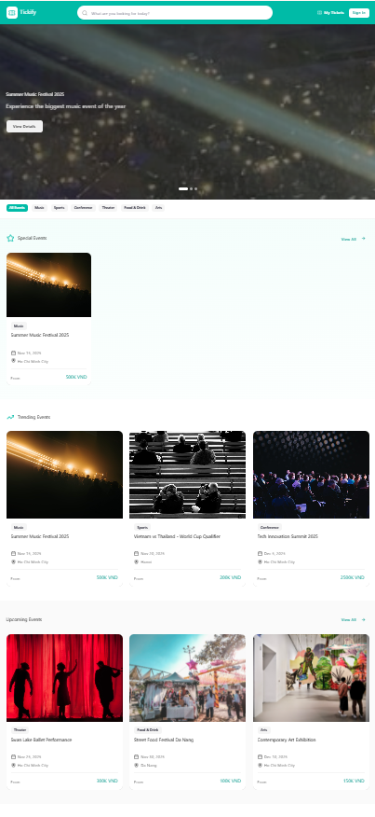

Field Name | Field Type | Description
Search & Filter
Search Bar | Text Box | Allows user to input event name, location, etc., for searching.
Date Filter | Date Picker | Filters events by date.
Type Filter | Dropdown/Combo Box | Filters events by type.
Event Display
Featured Events | List / Carousel | Displays promoted or featured events.
Trending Categories | List / Grid | Displays trending event categories.
Navigation
Login / Register | Button / Hyperlink | Navigates to the Login / Register screen.
My Profile / My Tickets | Icon / Hyperlink | Navigates to User Profile or My Tickets screen.

Database Access
[Provide the design description for the screen/function to access the database here: what table the screen/function would access, which transactions does it make (C-Create, R-Read, U-Update, or D-Delete), and how/purpose of the access (by providing Description and SQL commands)]
Table | CRUD | Description
Event | R | Read the list of featured and upcoming events for display.
Category | R | Read the list of trending categories for display.
Location | R | Read the list of cities/locations for the filter dropdown.

SQL Commands
[Provide the detailed SQL (select, insert, update...) which are used in implementing the screen/function]

b. Public Events
This screen is a public list of all upcoming events with filtering, sorting, and pagination. Related use cases: View Event List, Filter Events, Search Event.

UI Design
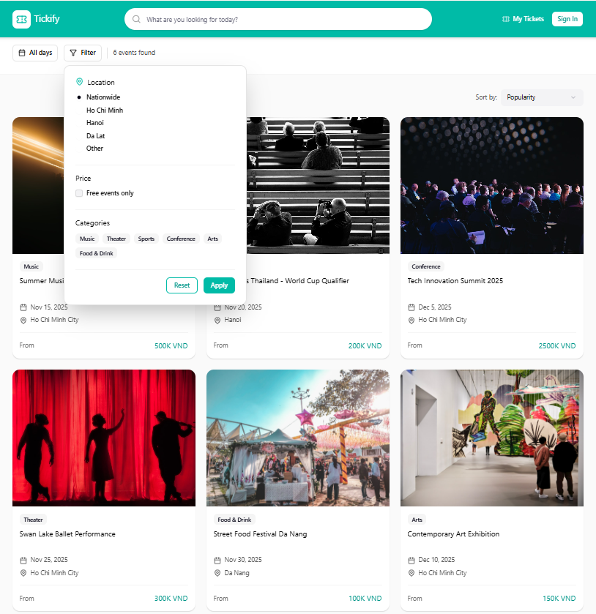

Field Name | Field Type | Description
Filter & Sort
Search Bar | Text Box | Allows searching by event name or description.
Filter Panel | Container | Contains detailed filters (Category, Location, Price Range, Date).
Sort By | Dropdown | Sort options (e.g., Date, Popularity, Price).
Event List
Event List Area | Grid / List View | Displays a list of event "cards". Each card includes image, name, date, location, and price.
Pagination Controls | Button Group | 'Next', 'Previous', and page number buttons for navigating the list.

Database Access

Table | CRUD | Description
Event | R | Query (Read) the list of events based on filter, sort, and pagination criteria.
Category | R | Read the list of categories to populate the filter panel.
Location | R | Read the list of locations to populate the filter panel.

c. Event Detail
Displays complete information about an event including date/time, venue, pricing tiers, organizer info, and purchase options. Related use cases: View Event Detail , View Organizer Info , Add to Wishlist , Book Ticket.

UI Design
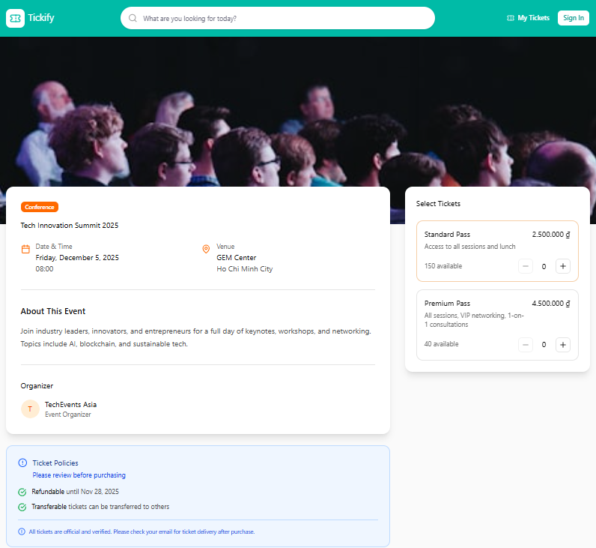

Field Name | Field Type | Description

Event Info
Event Banner / Poster | Image | Main image for the event.
Event Title | Text (Header) | The name of the event.
Date & Time | Text | The date and time of the event.
Venue / Location | Text / Map Link | The venue where the event is held.
Description | Text Area | Detailed description of the event.
Organizer Info | Link / Section | Name and link to the organizer's profile.

Purchase Options
Ticket Types List | List / Table | Displays ticket types (e.g., VIP, General), price, and availability.
Quantity Selector | Number Input | Allows user to select the quantity for each ticket type.
Add to Wishlist | Button / Icon | Button to add the event to the user's wishlist (Ref: UC01_Add to Wishlist ¹⁴).
Add to Cart / Book Now | Button | Primary button to begin the checkout process.

Database Access

Table | CRUD | Description
Event | R | Query (Read) the list of events based on filter, sort, and pagination criteria.
Category | R | Read the list of categories to populate the filter panel.
Location | R | Read the list of locations to populate the filter panel.

2. System Access

a. User Login
This screen allows user to be authenticated to the system screens/functionalities.

UI Design
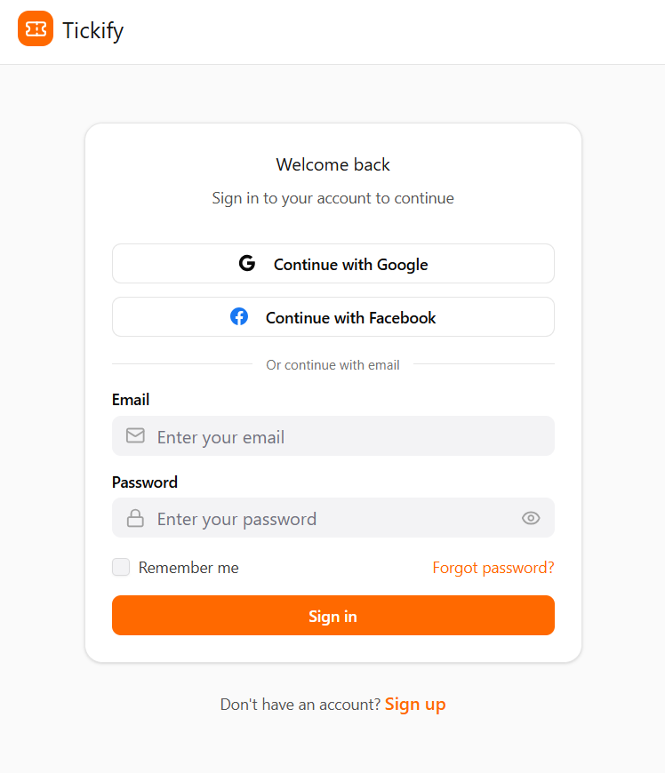

Field Name | Field Type | Description
Email* | Text Box | This is for user to input valid email address for logging in
Password* | Password Box | This is for user to input password for logging in
Login | Button | User clicks to authenticate him/herself into the system with provided email & password
Register | Button | User clicks to redirect to the User Register page for registering new user account to access the system
Forgot Password? | Hyperlink | User clicks to redirect to the Password Reset page for resetting his/her forgot password
Login with Google | Hyperlink | Allow user to login with his/her Google account
Login with Facebook | Hyperlink | Allow user to login with his/her Facebook account

Database Access
Table | CRUD | Description
User | R | Verify UserName & Password information
Setting, User | R | Specify the authorizations of the logged-in user

b. User Register
This screen allows a new user to create an account by providing basic information and verifying via email or phone.

UI Design
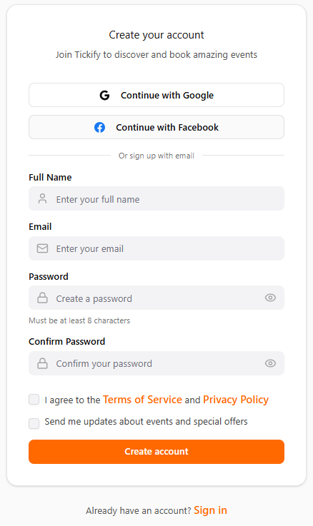

Field Name | Field Type | Description
Full Name* | Text Box | User's full name.
Email* | Text Box | User's email address. Must be unique.
Password* | Password Box | User's password. Must meet strength requirements (8+ characters, upper/lower case, number).
Confirm Password* | Password Box | Must match the Password field.
Register | Button | User clicks to submit the registration form.
Continue with Google | Button | Allows user to register using their Google account (Alternative Flow).
Login | Hyperlink | User clicks to redirect back to the User Login page.

Database Access
Table | CRUD | Description
User | C, R | Read (R) to check if email already exists. Create (C) to insert the new user record.

3. Ticket Management
- My Tickets
This screen displays a user’s personal list of purchased tickets, each with a QR code and ticket status (Valid / Used / Refunded).

UI Design
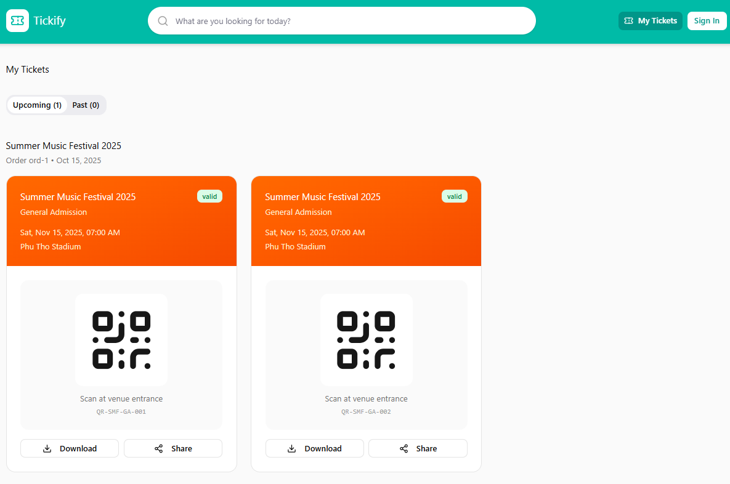

Field Name | Field Type | Description
Ticket List
Ticket Filter | Tabs / Dropdown | Allows user to filter tickets by status ("Upcoming", "Past", "Refunded").
Ticket Card (List Item) | Container | A repeating item for each ticket purchased.
Event Name | Text | The name of the event for the ticket.
Event Date & Time | Text | The date and time of the event.
Ticket Type | Text | "VIP", "General Admission".
Status | Text | The current status of the ticket (e.g., "Valid", "Used", "Refunded").
View QR Code | Button / Icon | User clicks to display the unique QR code for check-in.

Database Access

Table | CRUD | Description
Ticket | R | Read all tickets associated with the logged-in user.
Booking | R | Read booking information to link tickets to the user.
Event | R | Read event details (name, date) to display on the ticket card.
Ticket_Type | R | Read the name of the ticket type.

IV. Appendix

1. Assumptions & Dependencies
[Record any assumptions that were made when conceiving the project and writing this vision and scope document. Note any major dependencies the project must rely upon for success, such as specific technologies, third-party vendors, development partners, or other business relationships.]
<<Sample:
AS-1: Systems with appropriate user interfaces will be available for cafeteria employees to process the expected volume of meals ordered.
AS-2: Cafeteria staff and vehicles will be available to deliver all meals for specified delivery time slots within 15 minutes of the requested delivery time.
DE-1: If a restaurant has its own on-line ordering system, the Cafeteria Ordering System must be able to communicate with it bi-directionally.
>>

2. Limitations & Exclusions
[Identify any product features or characteristics that a stakeholder might anticipate, but which are not planned to be included in the new product]

3. Business Rules
[Provide common business rules that you must follow. The information can be provided in the table format as the sample below]
<<Sample
ID | Category | Rule Definition
BR-01 | Constraints | Delivery time windows are 15 minutes, beginning on each quarter hour.
BR-02 | Constraints | Deliveries must be completed between 10:00 A.M. and 2:00 P.M. local time, inclusive.
BR-03 | Facts | All meals in a single order must be delivered to the same location.
BR-04 | Facts | All meals in a single order must be paid for by using the same payment method.
BR-11 | Constraints | If an order is to be delivered, the patron must pay by payroll deduction.
BR-12 | Computations | Order price is calculated as the sum of each food item price times the quantity of that food item ordered, plus applicable sales tax, plus a delivery charge if a meal is delivered outside the free delivery zone.
>>

4. ..

