Project Overview and Design
Author: Sousuke Sasaki

Project purpose
This project shows one image on a flat screen with two projectors. We write the program in Python with OpenCV.
The projected areas of the two projectors overlap. We want the overlapping part to look like the rest of the image. A viewer should see one continuous image.

Problem
Without any processing, the overlapping area gets light from both projectors. It is brighter than the rest of the screen, and the border is easy to see.
We need to do two things.
- Put the two images in the right position on the screen.
- Adjust the brightness of the overlapping area.
For the second task, the course slides use blending masks. A mask lowers the brightness of an image step by step. In the overlapping area, the mask value goes down from 1 to 0 in a straight line. A mask with sudden steps leaves thin lines on the screen. A smooth mask does not.

Intended result
The overlapping area is as bright as the other areas. The viewer cannot see where one projector ends and the other begins.

Inputs and outputs
Input: a still image. The system handles at least still images, not video.
Output: two images, one for each projector, with the blending masks applied.
Other input data, such as the projector positions and the screen size, is not decided. See the open questions.

Scope
Confirmed
- Two projectors are used.
- The projected areas overlap.
- The system handles at least still images.
- The program uses Python with OpenCV.
- We start with a flat screen.
- We start with a MacBook Air.
- The optical axis of each projector is perpendicular to the screen.
- The project needs research and experiments with the projectors.
System design overview
This overview is a proposal based on the course slides. The team has not agreed on it yet. We will update it as the development team confirms each part.

Proposed workflow
- Read a still image.
- Describe the projectors and the screen with a simple model. The course slides suggest a linear model of projection (frustum).
- Find the area on the screen where the two projections overlap. The slides use ray tracing for this.
- Make a smooth blending mask for each projector.
- Apply each mask to its image.
- Project the two images and check the result.

Main parts of the system
The design has six classes. The list below is based on the Python files made from the UML. It is a proposal. The team has not confirmed the role of each class.
- MainAlphaBlender: the main class. It holds a ConfigReader and has a display method.
- ConfigReader: holds the settings, such as the projected image width and height, the distance between the projectors, the overlap and the gamma value. Its methods return these settings.
- ImageReadWrite: holds an image file name and an image. Its getImage method returns the image.
- CropImage: holds a left image and a right image. Its crop method cuts the image.
- CalculateOverlap: holds the side and the overlap width. Its alphaGamma method does the calculation.
- MaskCreator: holds the gamma value and the overlap in pixels. Its createMask method makes the blending mask.

UML explanation
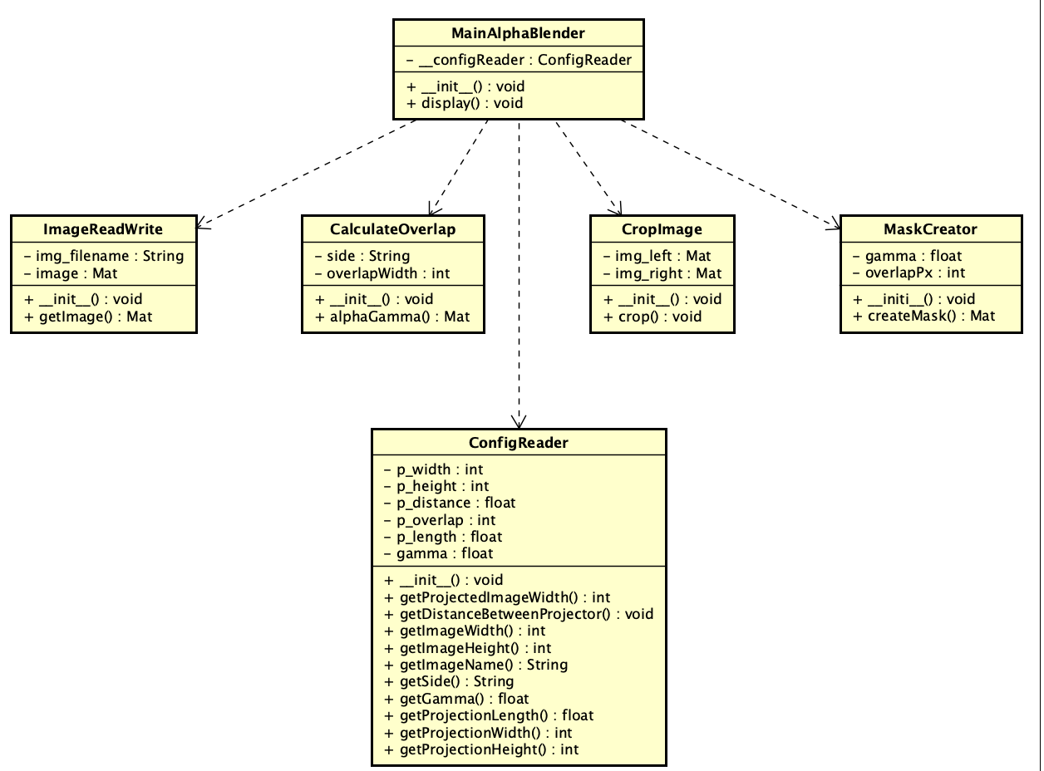
The diagram shows the class diagram of our system. It has six classes.

MainAlphaBlender is the main class. It has a private attribute, __configReader, and two methods, init and display. A dashed arrow goes from MainAlphaBlender to each of the other five classes. The arrows mean that MainAlphaBlender uses these classes. The five classes have no links to each other.

The other five classes are as follows.

ConfigReader holds the settings: the projected width and height, the distance between the projectors, the overlap, the projection length and the gamma value. Its methods that start with “get” return these values, the image name and the side.
ImageReadWrite holds an image file name and an image. Its method getImage returns the image.
CropImage holds a left image and a right image. Its method crop makes them.
CalculateOverlap holds the side and the overlap width. Its method alphaGamma returns an image.
MaskCreator holds the gamma value and the overlap in pixels. Its method createMask returns the mask

