**Week 9: Linking to Databases**

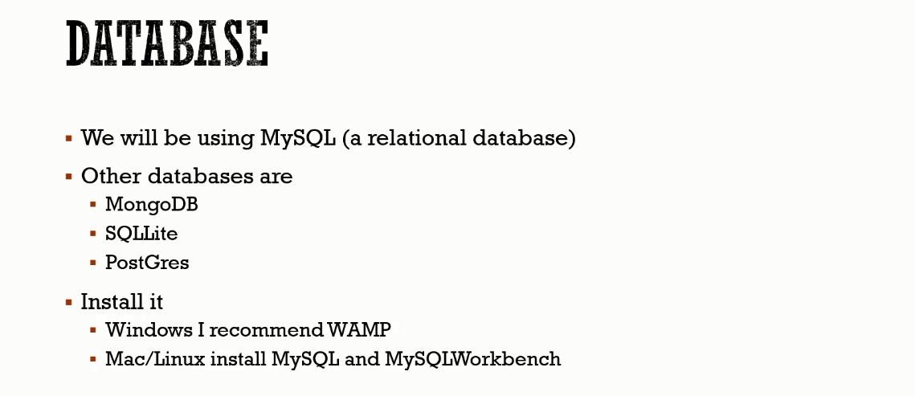

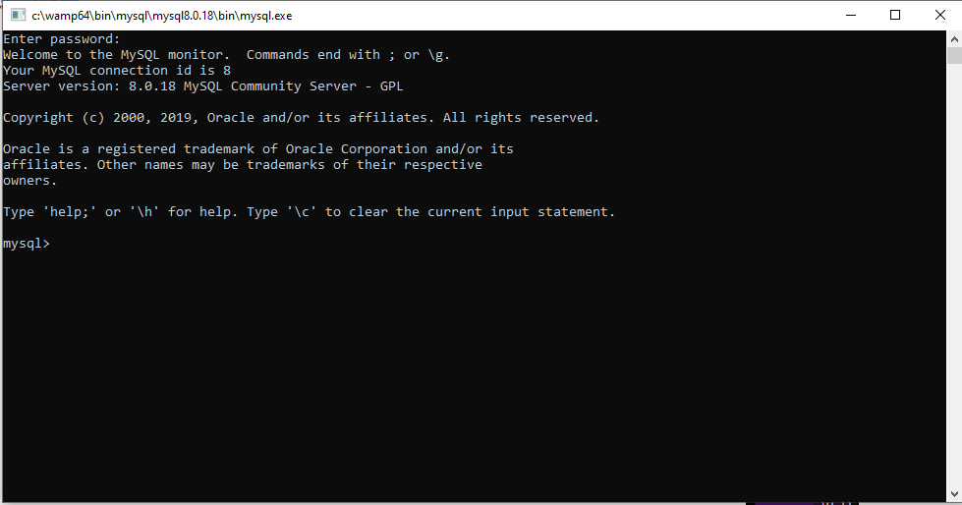



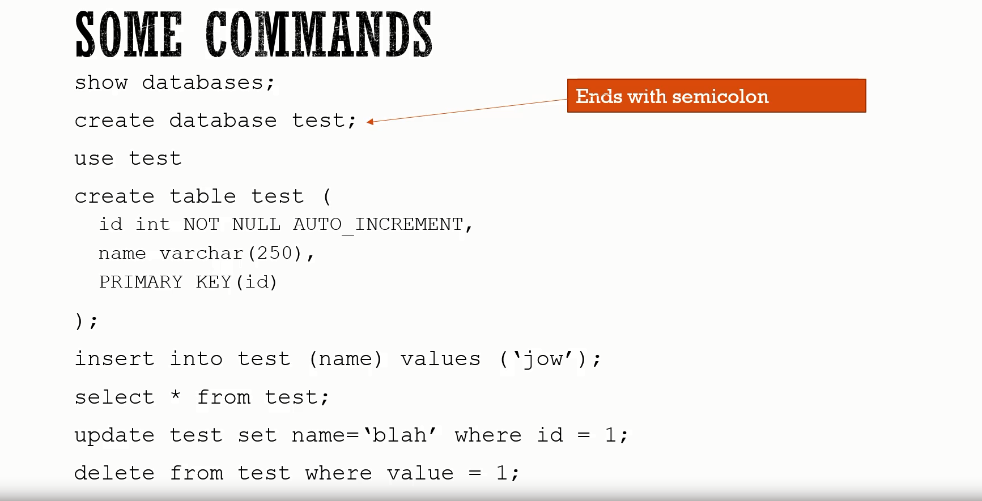

Lab: Week 9

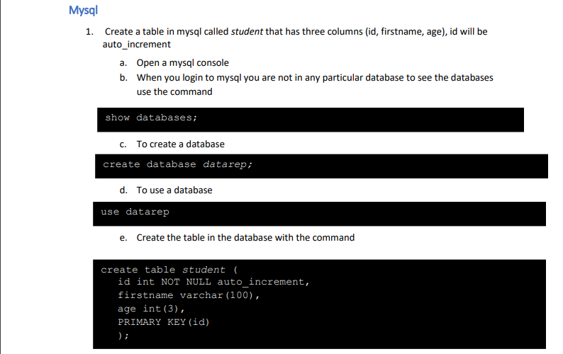

**Create database datarep;**

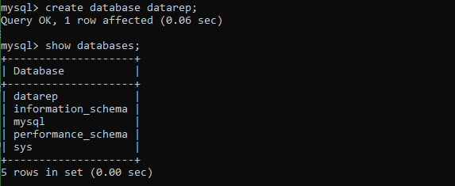

**Show databases;**

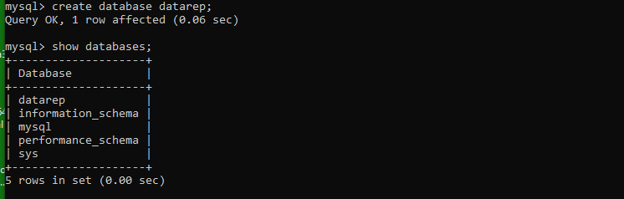

**Use database we created and create student table, describe it:**

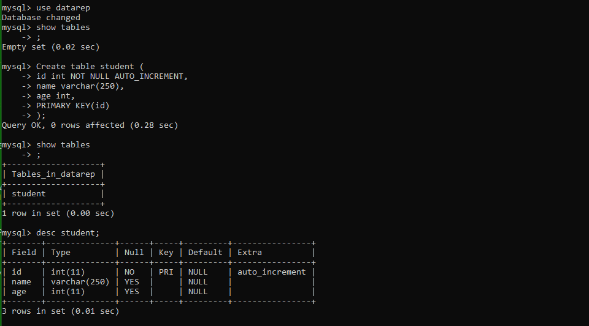

**Create second table with students.** 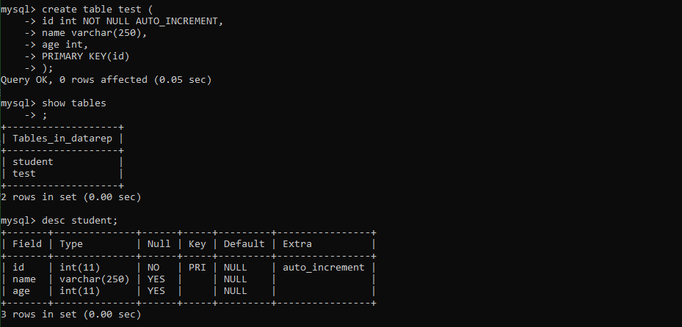

** **

**Insert data into student;** 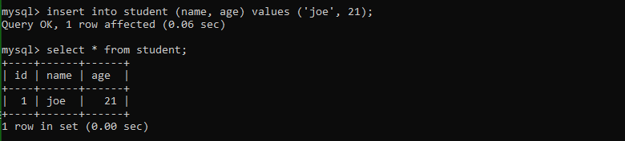



**Update**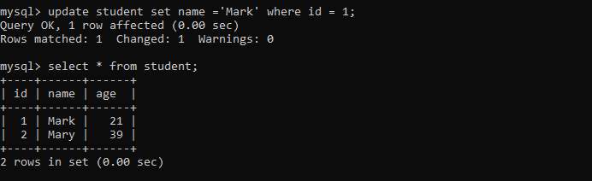

**Get information:**

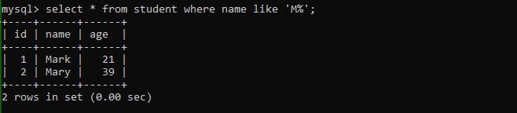



**Delete**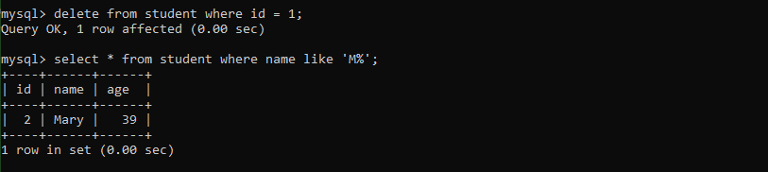

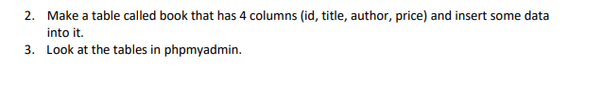 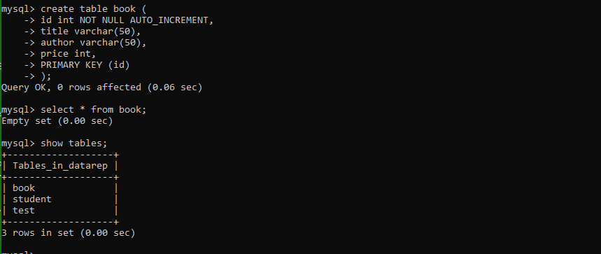

<https://www.hostpapa.ie/knowledgebase/search-database-using-phpmyadmin/>