**Week 9: Lecture 2 – Using Python to connect to Database**

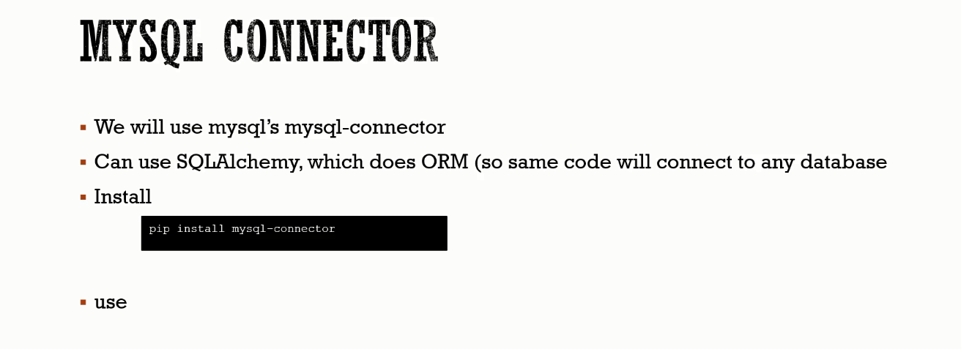

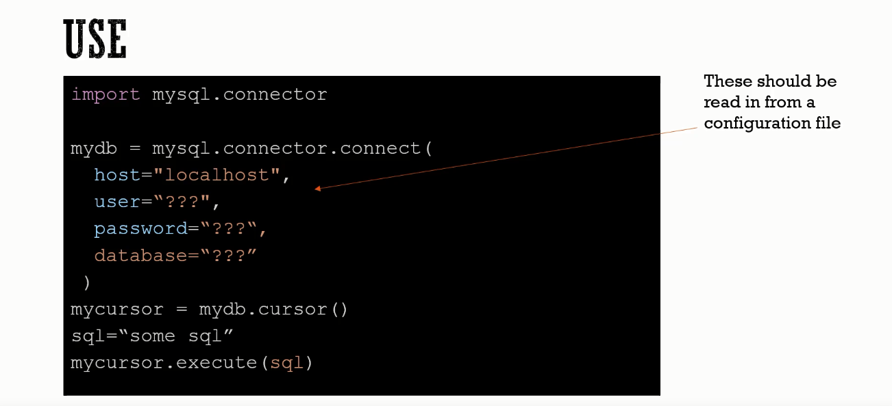

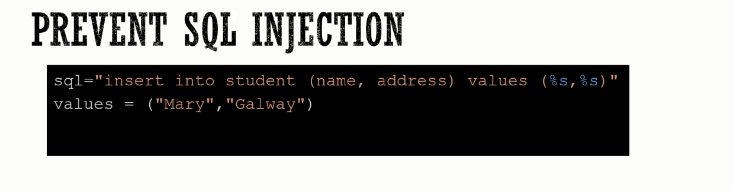

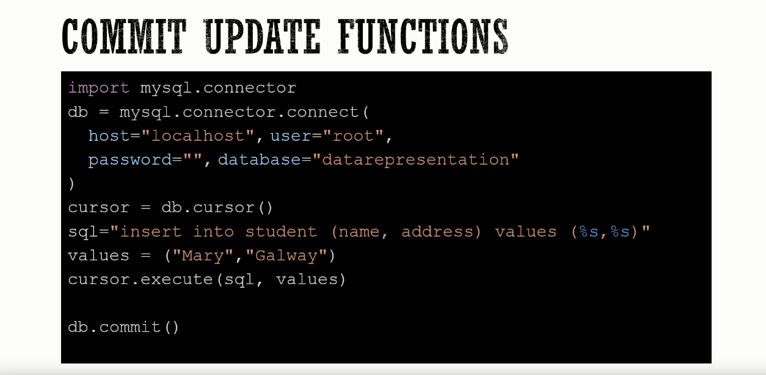

To get Data out of DB.

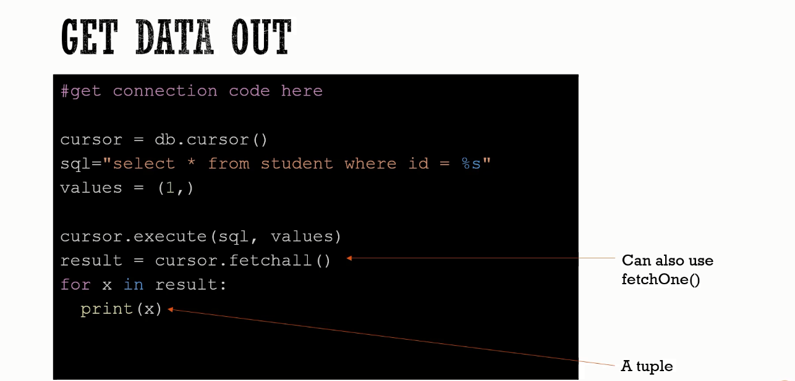

1. CREATE database.py

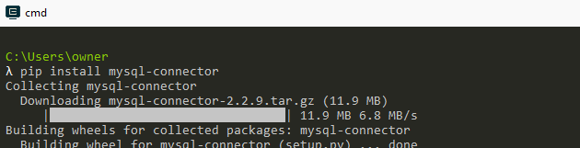

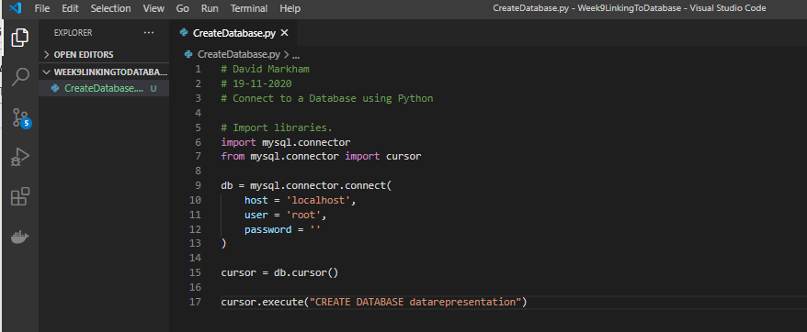

Then run it through Python on your command line



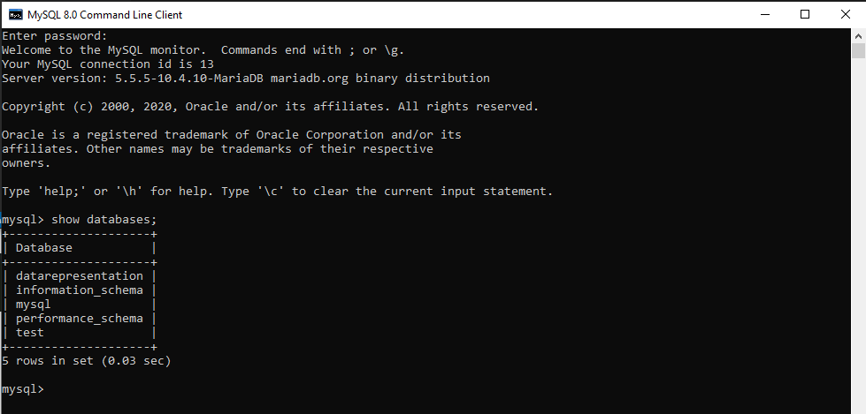

1. **Create Table**

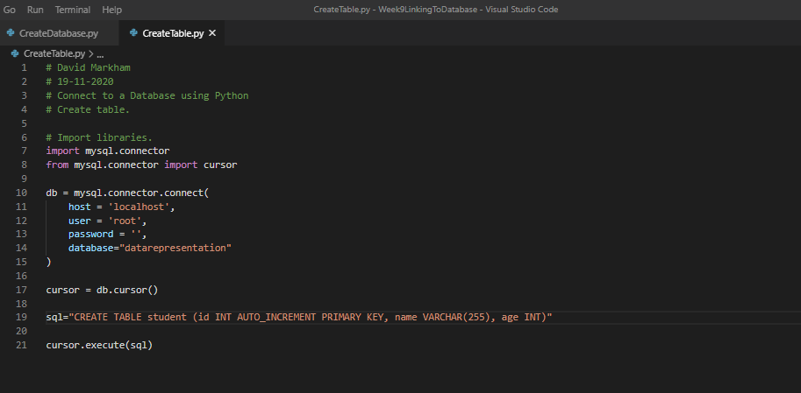

**Nothing there, so now we create table.**

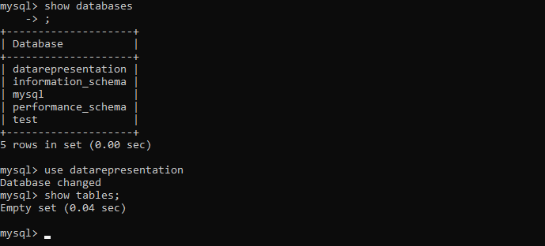

**Run the code**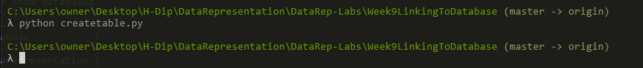

**Student table created;**

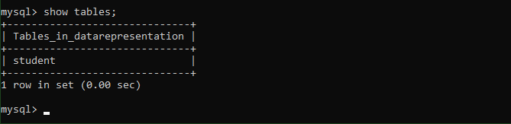

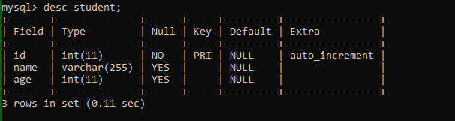

1. **Insert data into table**

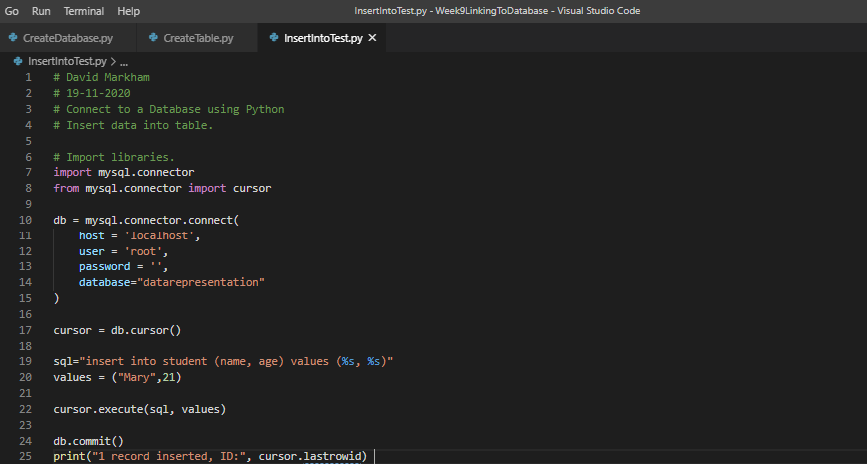

**We can see no data in there**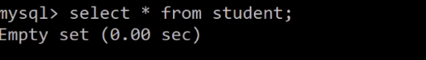



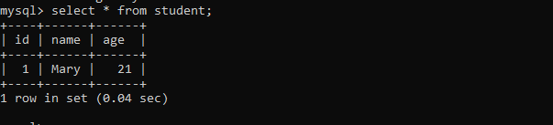

**4. Get data from table**

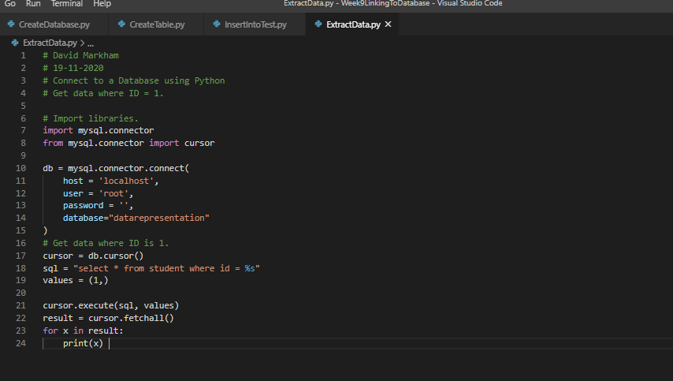



1. **UPDATE**

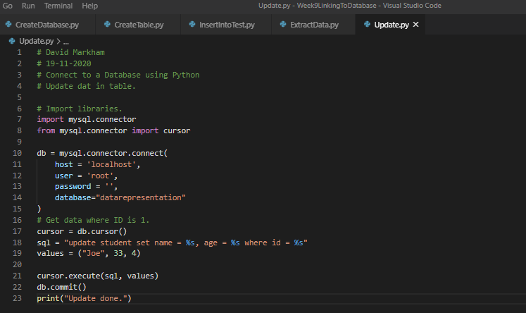

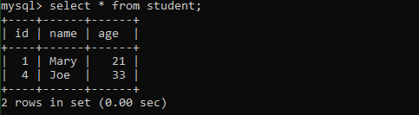

1. **Delete**

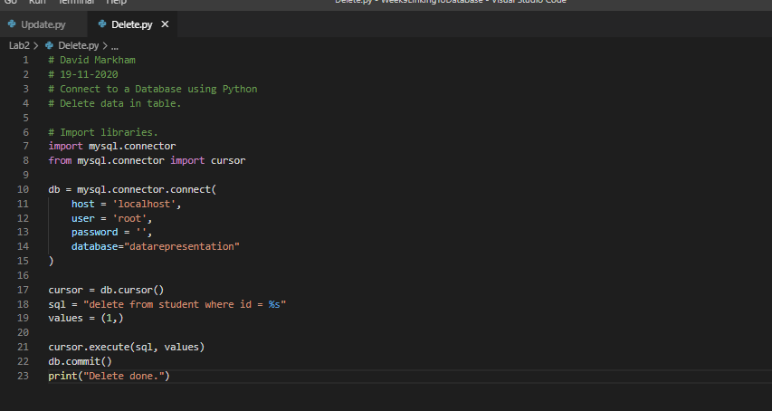****

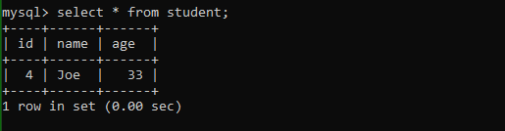

**Next part of LAB**