KLE Society's

KLE Technological University



Assessment Report On

**"SMART TRAVEL HUB”**

Database Applications Lab (15ECSP204)

Submitted by

|  |  |  |
| --- | --- | --- |
| Name:  DAIVIK.NAIK  SANJANA.H  SHASHANK.H  ASMITHA.K | Roll no:  01  02  22  47 | SRN:  02FE22BCS030  02FE22BCS107  02FE23BCS098  02FE24BCS414 |
|  |  | |

Faculty In-charge:

Prof. Savita M Bagewadi

DEPARTMENT OF COMPUTER SCIENCE AND ENGINEERING

Academic year 2024-25

SQL> create table customers( customerid int primary key, fullname varchar(50), email varchar(50), phno varchar(20), idproof varchar(100));

Table created.

SQL> create table employee( employeeid int primary key, empname varchar(50), department varchar(50), empsalary decimal(7,2), emp_position varchar(20));

Table created.

SQL> create table destination ( destinationid int primary key, destname varchar(50), distance int, country varchar(50));

Table created.

SQL> create table trains( trainid int primary key, trainname varchar(50), departuretime varchar(10), arrivaltime varchar(10), origin varchar(10), destination varchar(50), destinationid int, foreign key(destinationid) references destination(destinationid));

Table created.

SQL> create table flights ( flightid int primary key, flightnumber varchar(10), airline varchar(50), departuretime varchar(10),arrivaltime varchar(10), origin varchar(10), destination varchar(50), destinationid int, foreign key(destinationid) references destination(destinationid));

Table created.

SQL> create table buses ( busid int primary key, busnumber varchar(10), operator varchar(50), departuretime varchar(10), arrivaltime varchar(10), origin varchar(50), destination varchar(50), destinationid int, foreign key(destinationid) references destination(destinationid));

Table created.

SQL> commit;

Commit complete.

SQL> create table payment( paymentid int primary key, paymentmethod varchar(30), paymentamount decimal(7,2), paymentdate date, customerid int, foreign key(customerid) references customers(customerid));

Table created.

SQL> create table booking( bookingid int primary key, customerid int, bookingstatus varchar(20), paymentid int, bookingtime varchar(20), origin varchar(20),

destination varchar(20), foreign key(customerid) references customers(customerid), foreign key(paymentid) references payment(paymentid));

Table created.

SQL> desc customers;

Name Null? Type

----------------------------------------- -------- ----------------------------

CUSTOMERID NOT NULL NUMBER(38)

FULLNAME VARCHAR2(50)

EMAIL VARCHAR2(50)

PHNO VARCHAR2(20)

IDPROOF VARCHAR2(100)

SQL> desc employee;

Name Null? Type

----------------------------------------- -------- ----------------------------

EMPLOYEEID NOT NULL NUMBER(38)

EMPNAME VARCHAR2(50)

DEPARTMENT VARCHAR2(50)

EMPSALARY NUMBER(7,2)

EMP_POSITION VARCHAR2(20)

SQL> desc destination;

Name Null? Type

----------------------------------------- -------- ----------------------------

DESTINATIONID NOT NULL NUMBER(38)

DESTNAME VARCHAR2(50)

DISTANCE NUMBER(38)

COUNTRY VARCHAR2(50)

SQL> desc trains;

Name Null? Type

----------------------------------------- -------- ----------------------------

TRAINID NOT NULL NUMBER(38)

TRAINNAME VARCHAR2(50)

DEPARTURETIME VARCHAR2(10)

ARRIVALTIME VARCHAR2(10)

ORIGIN VARCHAR2(10)

DESTINATION VARCHAR2(50)

DESTINATIONID NUMBER(38)

SQL> desc flights;

Name Null? Type

----------------------------------------- -------- ----------------------------

FLIGHTID NOT NULL NUMBER(38)

FLIGHTNUMBER VARCHAR2(10)

AIRLINE VARCHAR2(50)

DEPARTURETIME VARCHAR2(10)

ARRIVALTIME VARCHAR2(10)

ORIGIN VARCHAR2(10)

DESTINATION VARCHAR2(50)

DESTINATIONID NUMBER(38)

SQL> desc buses;

Name Null? Type

----------------------------------------- -------- ----------------------------

BUSID NOT NULL NUMBER(38)

BUSNUMBER VARCHAR2(10)

OPERATOR VARCHAR2(50)

DEPARTURETIME VARCHAR2(10)

ARRIVALTIME VARCHAR2(10)

ORIGIN VARCHAR2(50)

DESTINATION VARCHAR2(50)

DESTINATIONID NUMBER(38)

SQL> desc payment;

Name Null? Type

----------------------------------------- -------- ----------------------------

PAYMENTID NOT NULL NUMBER(38)

PAYMENTMETHOD VARCHAR2(30)

PAYMENTAMOUNT NUMBER(7,2)

PAYMENTDATE DATE

CUSTOMERID NUMBER(38)

SQL> desc booking;

Name Null? Type

----------------------------------------- -------- ----------------------------

BOOKINGID NOT NULL NUMBER(38)

CUSTOMERID NUMBER(38)

BOOKINGSTATUS VARCHAR2(20)

PAYMENTID NUMBER(38)

BOOKINGTIME VARCHAR2(20)

ORIGIN VARCHAR2(20)

DESTINATION VARCHAR2(20)

SQL> insert into customers values(1, 'Daivik Naik', 'Daivik@gmail.com','9876543210', 'ADHAAR');

1 row created.

SQL> insert into customers values(2, 'asmitha', 'asmitha@gmail.com','9876543211', 'PAN');

1 row created.

SQL> insert into customers values(3, 'Shashank', 'Shashank@gmail.com', '9876543212', 'Passport');

1 row created.

SQL> insert into customers values(4, 'Sanjana', 'sanjana@gmail.com', '987654

3213', 'Aadhar');

1 row created.

SQL> insert into customers values(5, 'Jatin patil', 'jatin@gmail.com', '9876

543214', 'PAN');

1 row created.

SQL> insert into customers values(6, 'Shreyas', 'Shreyas@gmail.com', '987654

3215', 'Aadhar');

1 row created.

SQL> insert into customers values(7, 'Abhay patil', 'abhay@gmail.com', '9876543216', 'Passport');

1 row created.

SQL> insert into customers values(8, 'Amol Goudar', 'Amol@gmail.com', '98765

43217', 'Aadhar');

1 row created.

SQL> insert into customers values(9, 'Darshan Wadrali', 'Darshan@gmail.com',

'9876543218', 'PAN');

1 row created.

SQL> insert into customers values(10, 'Anuj K', 'Anuj@gmail.com', '987654321

9', 'Aadhar');

1 row created.

SQL> select * from customers;

CUSTOMERID FULLNAME

---------- --------------------------------------------------

EMAIL PHNO

-------------------------------------------------- --------------------

IDPROOF

--------------------------------------------------------------------------------

1 Daivik Naik

daivik@gmail.com 9876543210

Aadhaar

2 asmitha

asmitha@gmail.com 9876543211

PAN

CUSTOMERID FULLNAME

---------- --------------------------------------------------

EMAIL PHNO

-------------------------------------------------- --------------------

IDPROOF

--------------------------------------------------------------------------------

3 Shashank

Shashank@gmail.com 9876543212

Passport

4 Sanjana

sanjana@gmail.com 9876543213

CUSTOMERID FULLNAME

---------- --------------------------------------------------

EMAIL PHNO

-------------------------------------------------- --------------------

IDPROOF

--------------------------------------------------------------------------------

Aadhar

5 Jatin patil

jatin@gmail.com 9876543214

PAN

6 Shreyas

CUSTOMERID FULLNAME

---------- --------------------------------------------------

EMAIL PHNO

-------------------------------------------------- --------------------

IDPROOF

--------------------------------------------------------------------------------

Shreyas@gmail.com 9876543215

Aadhar

7 Abhay patil

abhay@gmail.com 9876543216

Passport

CUSTOMERID FULLNAME

---------- --------------------------------------------------

EMAIL PHNO

-------------------------------------------------- --------------------

IDPROOF

--------------------------------------------------------------------------------

8 Amol Goudar

Amol@gmail.com 9876543217

Aadhar

9 Darshan Wadrali

Darshan@gmail.com 9876543218

PAN

CUSTOMERID FULLNAME

---------- --------------------------------------------------

EMAIL PHNO

-------------------------------------------------- --------------------

IDPROOF

--------------------------------------------------------------------------------

10 Anuj K

Anuj@gmail.com 9876543219

Aadhar

10 rows selected.

SQL> insert into employee values(1, 'Amit Singh', 'Finance', 75000.00, 'Manager');

1 row created.

SQL> insert into employee values(1, 'Amit Singh', 'Bus', 75000.00, 'Driver');

1 row created.

SQL> insert into employee values(2, 'Rahul Verma', 'Train', 65000.00, 'Guide');

1 row created.

SQL> insert into employee values(3, 'Amey gupta', 'Flights', 50000.00, 'Supervisor');

1 row created.

SQL> insert into employee values(4, 'Vivek mishra', 'Bus', 60000.00, 'Booking agent');

1 row created.

SQL> insert into employee values(5, 'Pooja Gupta', 'Train', 70000.00, 'Driver');

1 row created.

SQL> insert into employee values(6, 'Jay Singh', 'Flight', 55000.00, 'Supervisor');

1 row created.

SQL> insert into employee values(7, 'Anup Sinha', 'Bus', 58000.00, 'Guide');

1 row created.

SQL> insert into employee values(8, 'Aditya N', 'Train', 62000.00, 'Booking Agent');

1 row created.

SQL> insert into employee values(9, 'Anurag Mishra', 'Flight', 72000.00, 'Driver');

1 row created.

SQL> insert into employee values(10, 'Shubham Rathod', 'Bus', 53000.00, 'Supervisor');

1 row created.

SQL> commit;

Commit complete.

SQL> select * from employee;

EMPLOYEEID EMPNAME

---------- --------------------------------------------------

DEPARTMENT EMPSALARY

-------------------------------------------------- ----------

EMP_POSITION

--------------------

1 Amit Singh

Bus 75000

Driver

2 Rahul Verma

Train 65000

Guide

EMPLOYEEID EMPNAME

---------- --------------------------------------------------

DEPARTMENT EMPSALARY

-------------------------------------------------- ----------

EMP_POSITION

--------------------

3 Amey gupta

Flights 50000

Supervisor

4 Vivek mishra

Bus 60000

EMPLOYEEID EMPNAME

---------- --------------------------------------------------

DEPARTMENT EMPSALARY

-------------------------------------------------- ----------

EMP_POSITION

--------------------

Booking agent

5 Pooja Gupta

Train 70000

Driver

6 Jay Singh

EMPLOYEEID EMPNAME

---------- --------------------------------------------------

DEPARTMENT EMPSALARY

-------------------------------------------------- ----------

EMP_POSITION

--------------------

Flight 55000

Supervisor

7 Anup Sinha

Bus 58000

Guide

EMPLOYEEID EMPNAME

---------- --------------------------------------------------

DEPARTMENT EMPSALARY

-------------------------------------------------- ----------

EMP_POSITION

--------------------

8 Aditya N

Train 62000

Booking Agent

9 Anurag Mishra

Flight 72000

Driver

EMPLOYEEID EMPNAME

---------- --------------------------------------------------

DEPARTMENT EMPSALARY

-------------------------------------------------- ----------

EMP_POSITION

--------------------

10 Shubham Rathod

Bus 53000

Supervisor

10 rows selected.

SQL> insert into destination values (201, 'Mumbai', 500, 'India');

1 row created.

SQL> insert into destination values (202, 'Pune', 400, 'India');

1 row created.

SQL> insert into destination values (203, 'Chennai', 439, 'India');

1 row created.

SQL> insert into destination values (204, 'Bangalore', 400, 'India');

1 row created.

SQL> insert into destination values (205, 'Hyderabad', 800, 'India');

1 row created.

SQL> insert into destination values (206, 'Delhi', 1300, 'India');

1 row created.

SQL> insert into destination values (207, 'Kolkata', 2000, 'India');

1 row created.

SQL> insert into destination values (208, 'London', 12768, 'United Kingdom');

1 row created.

SQL> insert into destination values (209, 'Singapore', 6800, 'Singapore');

1 row created.

SQL> insert into destination values (210, 'Dubai', 2250, 'United Arab Emirates');

1 row created.

SQL> select * from destination;

DESTINATIONID DESTNAME DISTANCE

------------- -------------------------------------------------- ----------

COUNTRY

--------------------------------------------------

201 Mumbai 500

India

202 Pune 400

India

203 Chennai 439

India

DESTINATIONID DESTNAME DISTANCE

------------- -------------------------------------------------- ----------

COUNTRY

--------------------------------------------------

204 Bangalore 400

India

205 Hyderabad 800

India

206 Delhi 1300

India

DESTINATIONID DESTNAME DISTANCE

------------- -------------------------------------------------- ----------

COUNTRY

--------------------------------------------------

207 Kolkata 2000

India

208 London 12768

United Kingdom

209 Singapore 6800

Singapore

DESTINATIONID DESTNAME DISTANCE

------------- -------------------------------------------------- ----------

COUNTRY

--------------------------------------------------

210 Dubai 2250

United Arab Emirates

10 rows selected.

SQL> insert into trains values(1, 'Rajdhani Express', '08:00:00', '15:00:00', 'Delhi', 'Mumbai', 201);

1 row created.

SQL> insert into trains values(2, 'Shatabdi Express', '09:00:00', '14:00:00', 'Mumbai', 'Pune', 202);

1 row created.

SQL> insert into trains values (3, 'Vande Bharat Express', '10:00:00', '17:00:00', 'Delhi', 'Chennai', 203);

1 row created.

SQL> insert into trains values (4, 'Garib Rath Express', '11:00:00', '18:00:00', 'Kolkata', 'Bangalore', 204);

1 row created.

SQL> insert into trains values (5, 'Shatabdi Express', '12:00:00', '19:00:00', 'Chennai', 'Hyderabad', 205);

1 row created.

SQL> insert into trains values (6, 'Rajdhani Express', '13:00:00', '20:00:00', 'Bangalore', 'Delhi', 206);

1 row created.

SQL> insert into trains values (7, 'Vande Bharat Express', '14:00:00', '21:00:00', 'Mumbai', 'Kolkata', 207);

1 row created.

SQL> insert into trains values (8, 'Garib Rath Express', '15:00:00', '22:00:00', 'Pune', 'Chennai', 208);

1 row created.

SQL> insert into trains values (9, 'Shatabdi Express', '16:00:00', '23:00:00', 'Delhi', 'Hyderabad', 209);

1 row created.

SQL> insert into trains values (10, 'Rajdhani Express', '17:00:00', '00:00:00', 'Kolkata', 'Mumbai', 210);

1 row created.

SQL> select * from trains;

TRAINID TRAINNAME DEPARTURET

---------- -------------------------------------------------- ----------

ARRIVALTIM ORIGIN DESTINATION

---------- ---------- --------------------------------------------------

DESTINATIONID

-------------

1 Rajdhani Express 08:00:00

15:00:00 Delhi Mumbai

201

2 Shatabdi Express 09:00:00

14:00:00 Mumbai Pune

202

TRAINID TRAINNAME DEPARTURET

---------- -------------------------------------------------- ----------

ARRIVALTIM ORIGIN DESTINATION

---------- ---------- --------------------------------------------------

DESTINATIONID

-------------

3 Vande Bharat Express 10:00:00

17:00:00 Delhi Chennai

203

4 Garib Rath Express 11:00:00

18:00:00 Kolkata Bangalore

TRAINID TRAINNAME DEPARTURET

---------- -------------------------------------------------- ----------

ARRIVALTIM ORIGIN DESTINATION

---------- ---------- --------------------------------------------------

DESTINATIONID

-------------

204

5 Shatabdi Express 12:00:00

19:00:00 Chennai Hyderabad

205

6 Rajdhani Express 13:00:00

TRAINID TRAINNAME DEPARTURET

---------- -------------------------------------------------- ----------

ARRIVALTIM ORIGIN DESTINATION

---------- ---------- --------------------------------------------------

DESTINATIONID

-------------

20:00:00 Bangalore Delhi

206

7 Vande Bharat Express 14:00:00

21:00:00 Mumbai Kolkata

207

TRAINID TRAINNAME DEPARTURET

---------- -------------------------------------------------- ----------

ARRIVALTIM ORIGIN DESTINATION

---------- ---------- --------------------------------------------------

DESTINATIONID

-------------

8 Garib Rath Express 15:00:00

22:00:00 Pune Chennai

208

9 Shatabdi Express 16:00:00

23:00:00 Delhi Hyderabad

209

TRAINID TRAINNAME DEPARTURET

---------- -------------------------------------------------- ----------

ARRIVALTIM ORIGIN DESTINATION

---------- ---------- --------------------------------------------------

DESTINATIONID

-------------

10 Rajdhani Express 17:00:00

00:00:00 Kolkata Mumbai

210

10 rows selected.

SQL> insert into flights values (1, 'AI101', 'Air India', ' 08:00:00', ' 10:00:00', 'Delhi', 'Mumbai', 201);

1 row created.

SQL> insert into flights values (2, 'AI102', 'Air India', '10:00:00', ' 12:00:00', 'Mumbai', 'Pune', 202);

1 row created.

SQL> insert into flights values (3, 'AI103', 'Air India', ' 12:00:00', '15:00:00', 'Delhi', 'Chennai', 203);

1 row created.

SQL> insert into flights values (4, 'AI104', 'Air India', ' 14:00:00', ' 17:00:00', 'Mumbai', 'Bangalore', 204);

1 row created.

SQL> insert into flights values(5, 'BA101', 'British Airways', ' 16:00:00', ' 18:00:00', 'Delhi', 'London', 205);

1 row created.

SQL> insert into flights values (6, 'SQ101', 'Singapore Airlines', ' 18:00:00', ' 20:00:00', 'Mumbai', 'Singapore', 206);

1 row created.

SQL> insert into flights values (7, 'EK101', 'Emirates', ' 20:00:00', ' 02:00:00', 'Delhi', 'Dubai', 207);

1 row created.

SQL> insert into flights values(8, 'LH101', 'Air Asia', ' 22:00:00', ' 01:00:00', 'Mumbai', 'Frankfurt', 208);

1 row created.

SQL> insert into flights values (9, 'QF101', 'Emirates', ' 01:00:00', ' 06:00:00', 'Delhi', 'Sydney', 209);

1 row created.

SQL> insert into flights values (10, 'SQ104', 'Singapore Airlines', ' 03:00:00', ' 05:00:00', 'Mumbai', 'Singapore', 210);

1 row created.

SQL> select * from flights;

FLIGHTID FLIGHTNUMB AIRLINE

---------- ---------- --------------------------------------------------

DEPARTURET ARRIVALTIM ORIGIN

---------- ---------- ----------

DESTINATION DESTINATIONID

-------------------------------------------------- -------------

1 AI101 Air India

08:00:00 10:00:00 Delhi

Mumbai 201

2 AI102 Air India

10:00:00 12:00:00 Mumbai

Pune 202

FLIGHTID FLIGHTNUMB AIRLINE

---------- ---------- --------------------------------------------------

DEPARTURET ARRIVALTIM ORIGIN

---------- ---------- ----------

DESTINATION DESTINATIONID

-------------------------------------------------- -------------

3 AI103 Air India

12:00:00 15:00:00 Delhi

Chennai 203

4 AI104 Air India

14:00:00 17:00:00 Mumbai

FLIGHTID FLIGHTNUMB AIRLINE

---------- ---------- --------------------------------------------------

DEPARTURET ARRIVALTIM ORIGIN

---------- ---------- ----------

DESTINATION DESTINATIONID

-------------------------------------------------- -------------

Bangalore 204

5 BA101 British Airways

16:00:00 18:00:00 Delhi

London 205

6 SQ101 Singapore Airlines

FLIGHTID FLIGHTNUMB AIRLINE

---------- ---------- --------------------------------------------------

DEPARTURET ARRIVALTIM ORIGIN

---------- ---------- ----------

DESTINATION DESTINATIONID

-------------------------------------------------- -------------

18:00:00 20:00:00 Mumbai

Singapore 206

7 EK101 Emirates

20:00:00 02:00:00 Delhi

Dubai 207

FLIGHTID FLIGHTNUMB AIRLINE

---------- ---------- --------------------------------------------------

DEPARTURET ARRIVALTIM ORIGIN

---------- ---------- ----------

DESTINATION DESTINATIONID

-------------------------------------------------- -------------

8 LH101 Air Asia

22:00:00 01:00:00 Mumbai

Frankfurt 208

9 QF101 Emirates

01:00:00 06:00:00 Delhi

Sydney 209

FLIGHTID FLIGHTNUMB AIRLINE

---------- ---------- --------------------------------------------------

DEPARTURET ARRIVALTIM ORIGIN

---------- ---------- ----------

DESTINATION DESTINATIONID

-------------------------------------------------- -------------

10 SQ104 Singapore Airlines

03:00:00 05:00:00 Mumbai

Singapore 210

10 rows selected.

SQL> insert into buses values(1, 'B001', 'ABC Bus Services', ' 08:00:00', ' 10:00:00', 'Delhi', 'Mumbai', 201);

1 row created.

SQL> insert into buses values (2, 'B002', 'XYZ Travels', ' 10:00:00', ' 12:00:00', 'Mumbai', 'Pune', 202);

1 row created.

SQL> insert into buses values (3, 'B003', 'RST Tours', ' 12:00:00', ' 15:00:00', 'Delhi', 'Chennai', 203);

1 row created.

SQL> insert into buses values(4, 'B004', 'PQR Roadways', ' 14:00:00', ' 17:00:00', 'Mumbai', 'Bangalore', 204);

1 row created.

SQL> insert into buses values (5, 'B005', 'LMN Travels', ' 16:00:00', ' 18:00:00', 'Delhi', 'Hyderabad', 205);

1 row created.

SQL> insert into buses values (6, 'B006', 'DEF Bus Lines', ' 18:00:00', ' 20:00:00', 'Mumbai', 'Kolkata', 206);

1 row created.

SQL> insert into buses values(7, 'B007', 'GHI Tours', ' 20:00:00', ' 02:00:00', 'Delhi', 'Lucknow', 207);

1 row created.

SQL> insert into buses values (8, 'B008', 'JKL Bus Services', ' 22:00:00', ' 01:00:00', 'Mumbai', 'Ahmedabad', 208);

1 row created.

SQL> insert into buses values (9, 'B009', 'MNO Roadways', ' 01:00:00', ' 06:00:00', 'Delhi', 'Jaipur', 209);

1 row created.

SQL> insert into buses values (10, 'B010', 'PQR Travels', ' 03:00:00', ' 05:00:00', 'Mumbai', 'Pune', 210);

1 row created.

SQL> select * from buses;

BUSID BUSNUMBER OPERATOR

---------- ---------- --------------------------------------------------

DEPARTURET ARRIVALTIM ORIGIN

---------- ---------- --------------------------------------------------

DESTINATION DESTINATIONID

-------------------------------------------------- -------------

1 B001 ABC Bus Services

08:00:00 10:00:00 Delhi

Mumbai 201

2 B002 XYZ Travels

10:00:00 12:00:00 Mumbai

Pune 202

BUSID BUSNUMBER OPERATOR

---------- ---------- --------------------------------------------------

DEPARTURET ARRIVALTIM ORIGIN

---------- ---------- --------------------------------------------------

DESTINATION DESTINATIONID

-------------------------------------------------- -------------

3 B003 RST Tours

12:00:00 15:00:00 Delhi

Chennai 203

4 B004 PQR Roadways

14:00:00 17:00:00 Mumbai

BUSID BUSNUMBER OPERATOR

---------- ---------- --------------------------------------------------

DEPARTURET ARRIVALTIM ORIGIN

---------- ---------- --------------------------------------------------

DESTINATION DESTINATIONID

-------------------------------------------------- -------------

Bangalore 204

5 B005 LMN Travels

16:00:00 18:00:00 Delhi

Hyderabad 205

6 B006 DEF Bus Lines

BUSID BUSNUMBER OPERATOR

---------- ---------- --------------------------------------------------

DEPARTURET ARRIVALTIM ORIGIN

---------- ---------- --------------------------------------------------

DESTINATION DESTINATIONID

-------------------------------------------------- -------------

18:00:00 20:00:00 Mumbai

Kolkata 206

7 B007 GHI Tours

20:00:00 02:00:00 Delhi

Lucknow 207

BUSID BUSNUMBER OPERATOR

---------- ---------- --------------------------------------------------

DEPARTURET ARRIVALTIM ORIGIN

---------- ---------- --------------------------------------------------

DESTINATION DESTINATIONID

-------------------------------------------------- -------------

8 B008 JKL Bus Services

22:00:00 01:00:00 Mumbai

Ahmedabad 208

9 B009 MNO Roadways

01:00:00 06:00:00 Delhi

Jaipur 209

BUSID BUSNUMBER OPERATOR

---------- ---------- --------------------------------------------------

DEPARTURET ARRIVALTIM ORIGIN

---------- ---------- --------------------------------------------------

DESTINATION DESTINATIONID

-------------------------------------------------- -------------

10 B010 PQR Travels

03:00:00 05:00:00 Mumbai

Pune 210

10 rows selected.

SQL> insert into payment values (101, 'Credit Card', 5000.00, '15-jan-2024', 1);

1 row created.

SQL> insert into payment values (102, 'Debit Card', 3000.00, '20-feb-2024', 2);

1 row created.

SQL> insert into payment values (103, 'Net Banking', 2000.00, '25-mar-2024', 3);

1 row created.

SQL> insert into payment values (104, 'UPI', 4000.00, '30-Apr-2024', 4);

1 row created.

SQL> insert into payment values (105, 'Cash', 2500.00, '05-May-2024', 5);

1 row created.

SQL> insert into payment values (106, 'Credit Card', 3500.00, '10-Jun-2024', 6);

1 row created.

SQL> insert into payment values (107, 'Debit Card', 2800.00, '15-Jul-2024', 7);

1 row created.

SQL> insert into payment values (108, 'Net Banking', 1800.00, '20-Aug-2024', 8);

1 row created.

SQL> insert into payment values (109, 'UPI', 4200.00, '25-Sep-2024', 9);

1 row created.

SQL> insert into payment values (110, 'Cash', 2300.00, '30-Oct-2024', 10);

1 row created.

SQL> select * from payment;

PAYMENTID PAYMENTMETHOD PAYMENTAMOUNT PAYMENTDA CUSTOMERID

---------- ------------------------------ ------------- --------- ----------

101 Credit Card 5000 15-JAN-24 1

102 Debit Card 3000 20-FEB-24 2

103 Net Banking 2000 25-MAR-24 3

104 UPI 4000 30-APR-24 4

105 Cash 2500 05-MAY-24 5

106 Credit Card 3500 10-JUN-24 6

107 Debit Card 2800 15-JUL-24 7

108 Net Banking 1800 20-AUG-24 8

109 UPI 4200 25-SEP-24 9

110 Cash 2300 30-OCT-24 10

10 rows selected.

SQL> insert into booking values (1, 1, 'Confirmed', 101, ' 08:00:00', 'Delhi','Mumbai');

1 row created.

SQL> insert into booking values (2, 2, 'Confirmed', 102, ' 10:00:00', 'Mumbai', 'Pune');

1 row created.

SQL> insert into booking values (3, 3, 'Confirmed', 103, ' 12:00:00', 'Delhi', 'Chennai');

1 row created.

SQL> insert into booking values (4, 4, 'Confirmed', 104, ' 14:00:00', 'Mumbai', 'Bangalore');

1 row created.

SQL> insert into booking values (5, 5, 'Confirmed', 105, ' 16:00:00', 'Singapore', 'Dubai');

1 row created.

SQL> insert into booking values (6, 6, 'Confirmed', 106, ' 18:00:00', 'Mumbai', 'Kolkata');

1 row created.

SQL> insert into booking values (7, 7, 'Confirmed', 107, ' 20:00:00', 'Jaipur', 'Indore' );

1 row created.

SQL> insert into booking values (8, 8, 'Confirmed', 108, ' 22:00:00', 'Kolkata', 'Bangalore');

1 row created.

SQL> insert into booking values (9, 9, 'Confirmed', 109, ' 01:00:00', 'Delhi', 'Chennai');

1 row created.

SQL> insert into booking values (10, 10, 'Confirmed', 110, ' 03:00:00', 'Sydney', 'London');

1 row created.

SQL> select * from booking;

BOOKINGID CUSTOMERID BOOKINGSTATUS PAYMENTID BOOKINGTIME

---------- ---------- -------------------- ---------- --------------------

ORIGIN DESTINATION

-------------------- --------------------

1 1 Confirmed 101 08:00:00

Delhi Mumbai

2 2 Confirmed 102 10:00:00

Mumbai Pune

3 3 Confirmed 103 12:00:00

Delhi Chennai

BOOKINGID CUSTOMERID BOOKINGSTATUS PAYMENTID BOOKINGTIME

---------- ---------- -------------------- ---------- --------------------

ORIGIN DESTINATION

-------------------- --------------------

4 4 Confirmed 104 14:00:00

Mumbai Bangalore

5 5 Confirmed 105 16:00:00

Singapore Dubai

6 6 Confirmed 106 18:00:00

Mumbai Kolkata

BOOKINGID CUSTOMERID BOOKINGSTATUS PAYMENTID BOOKINGTIME

---------- ---------- -------------------- ---------- --------------------

ORIGIN DESTINATION

-------------------- --------------------

7 7 Confirmed 107 20:00:00

Jaipur Indore

8 8 Confirmed 108 22:00:00

Kolkata Bangalore

9 9 Confirmed 109 01:00:00

Delhi Chennai

BOOKINGID CUSTOMERID BOOKINGSTATUS PAYMENTID BOOKINGTIME

---------- ---------- -------------------- ---------- --------------------

ORIGIN DESTINATION

-------------------- --------------------

10 10 Confirmed 110 03:00:00

Sydney London

10 rows selected.

SQL> commit;

Commit complete.

**QUERIES :-**

1) Employees working in departments with average salary greater than 60,000.

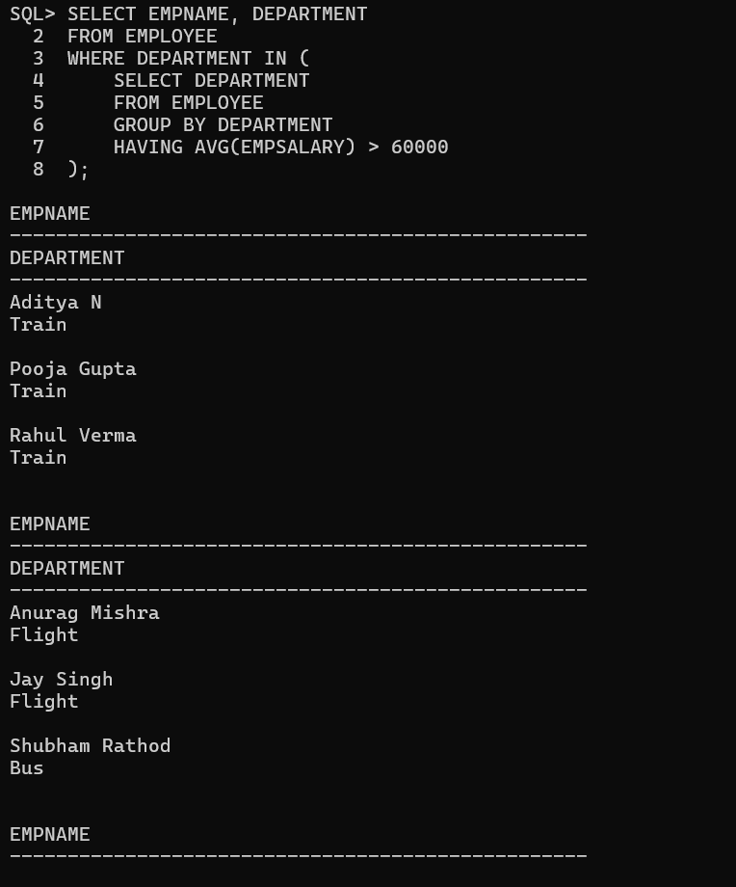

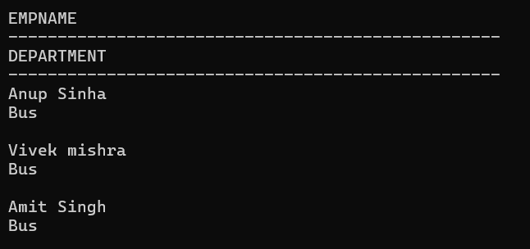

2) Flights with a destination having multiple transportation options (e.g., train, bus)

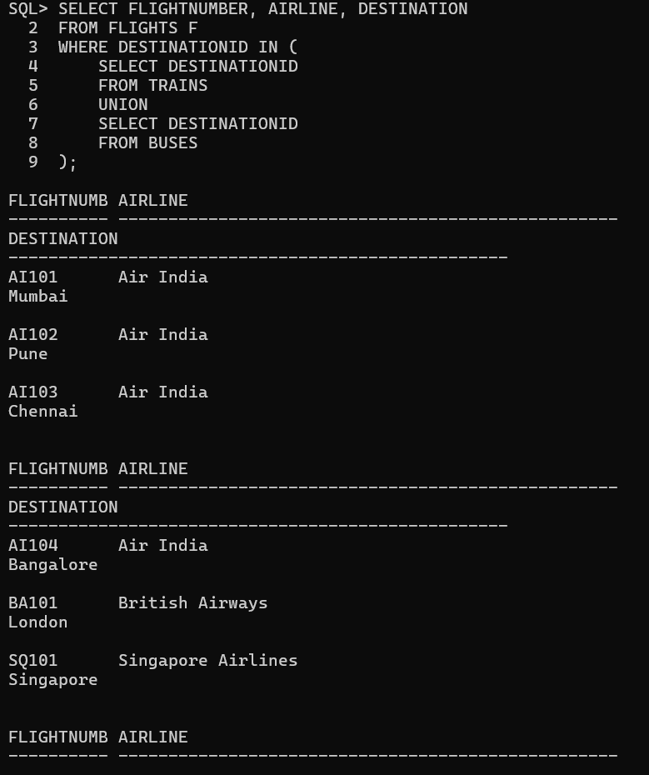

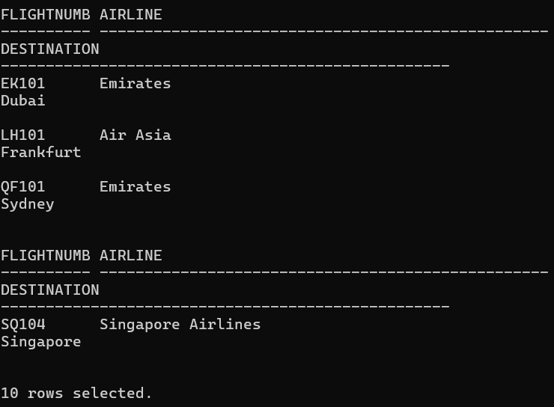

3) Trains originating from destinations with at least two flights.

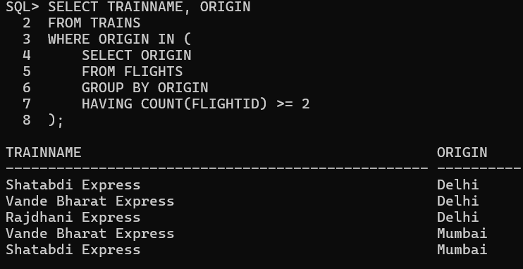

4) Find all bookings with their payment methods, including only those where the destination is in a country outside India.

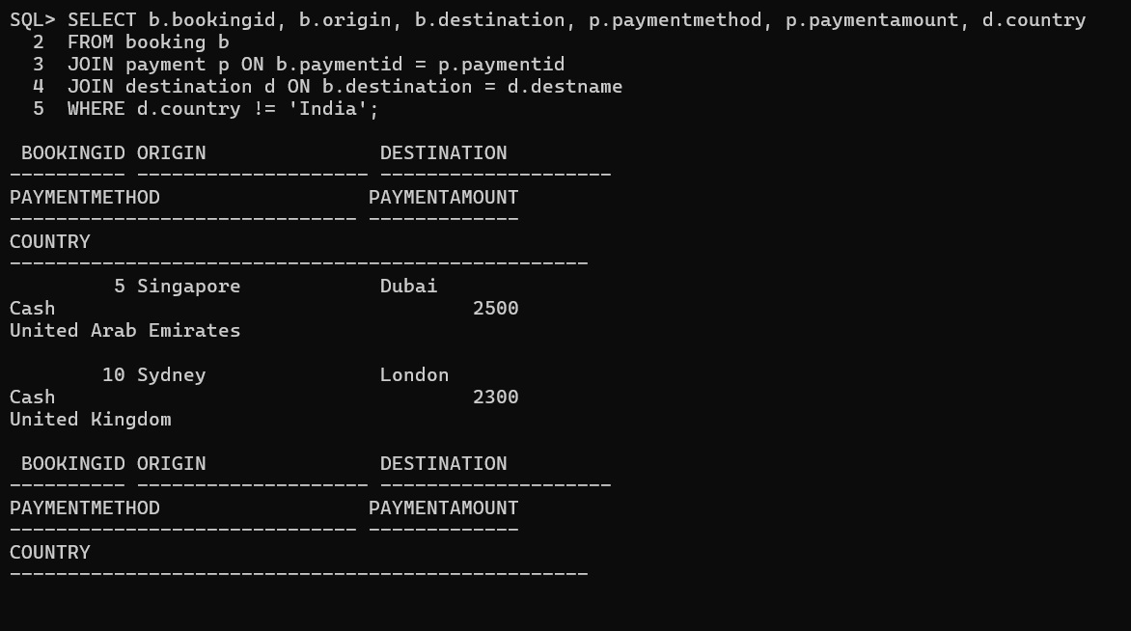

5) Find customers who have made bookings for both flights and buses to the same destination

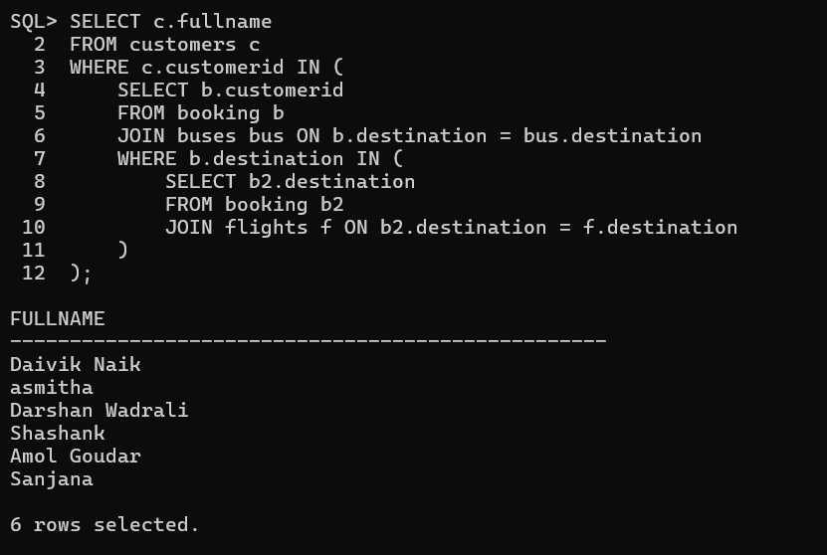

6) The most frequently booked destination.

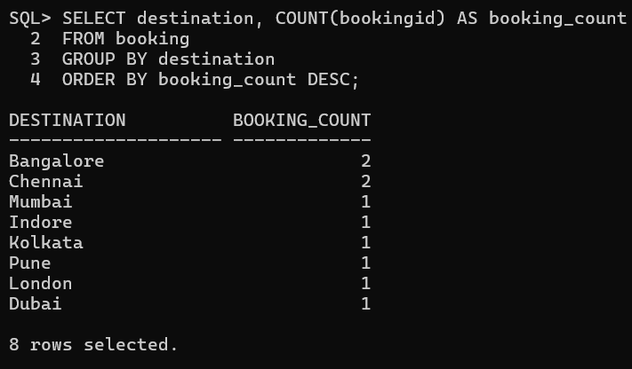

7) Flights with both departure and arrival times overlapping train schedules.

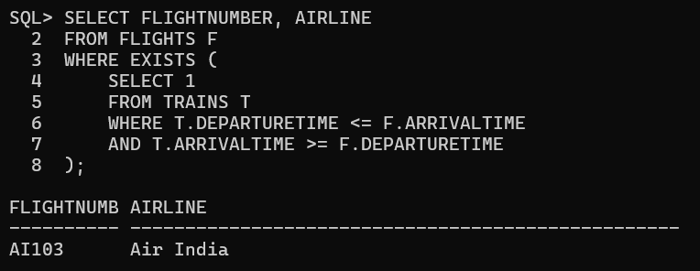

8) Bookings where the payment method is the most common across all bookings.

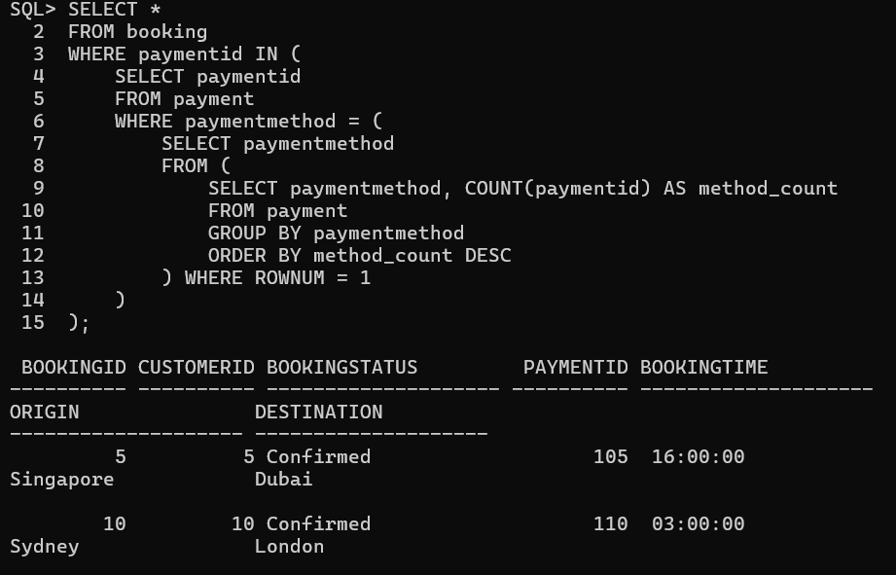

9) Customers who made bookings to destinations with distances greater than 1000 km.

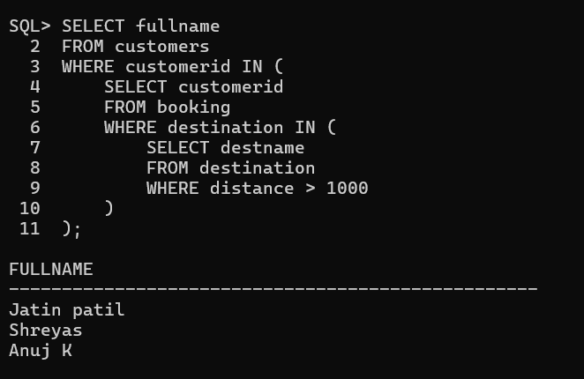

10) Customers traveling only by flights.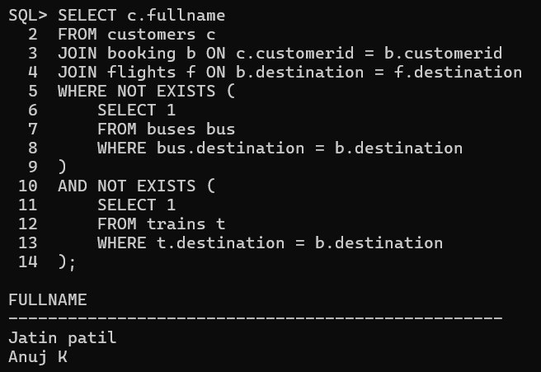

11) Find employees who work in the 'Train' department and have a salary greater than the average salary in their department, and their department has more than 3 employees.

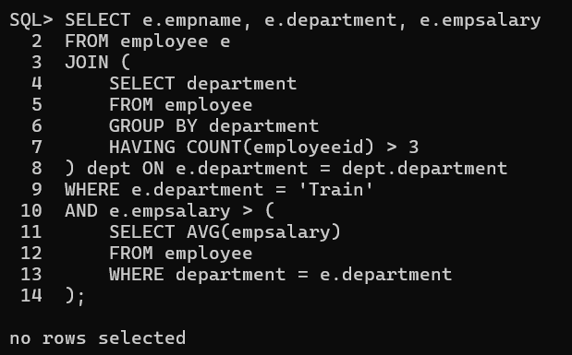

12) Find employees who have the highest salary in their respective departments and work in departments with more than 2 employees.

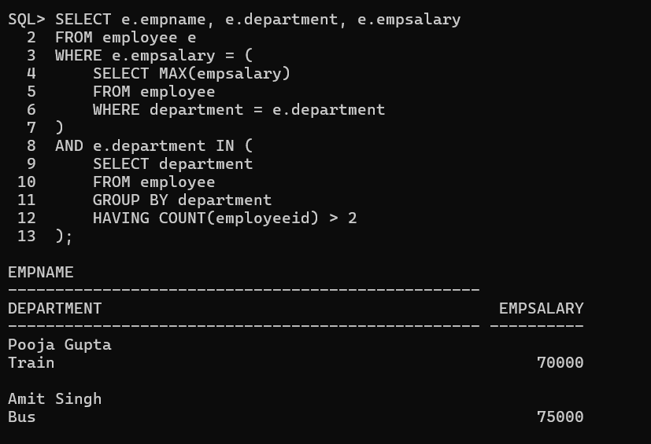

13) Find the top 3 most frequent payment methods used by customers for bookings to international destinations.

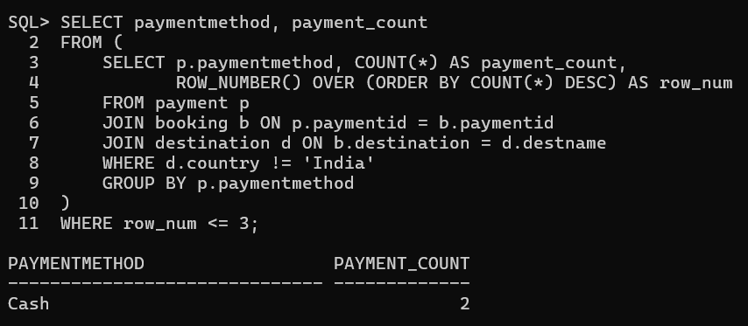

14) **Find employees who are supervisors in departments where the total salary expenditure is more than 100,000.**

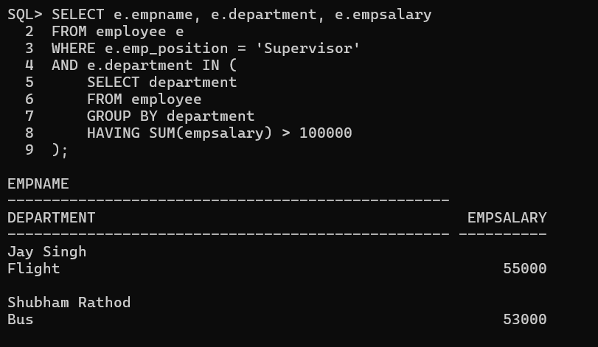

**15) Find employees who work in departments with a higher average salary than the overall average salary of all employees**

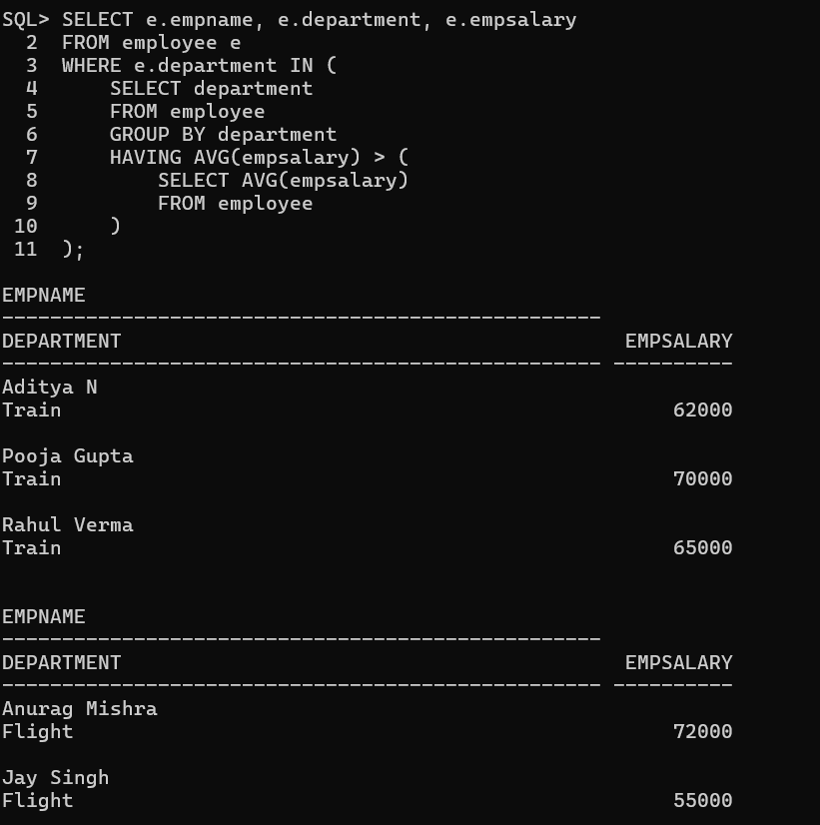

**16) Find customers who have made bookings to both domestic and international destinations.**

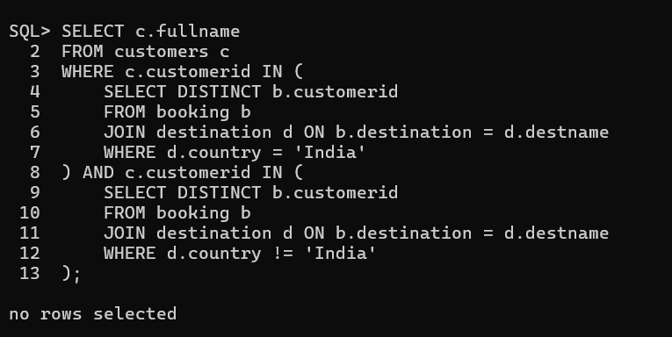

**17) Find customers who have made the highest number of bookings and traveled to international destinations**

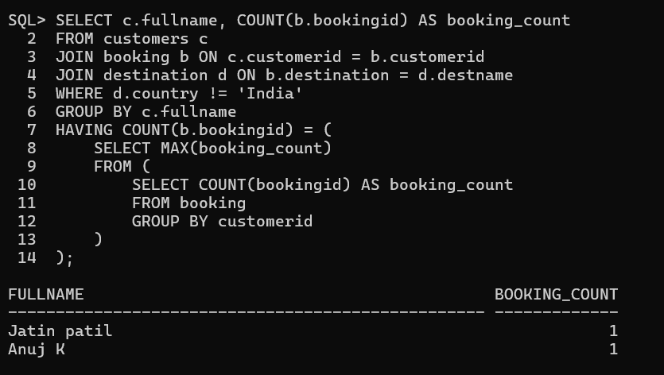

**18) Find the departments where the highest-paid employee earns more than the total salary of the department’s lowest-paid employee**

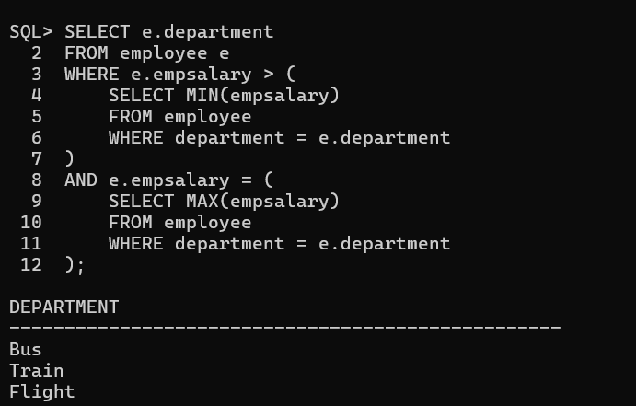

**19) Find the total number of bookings made for destinations with distances greater than 1500 km, grouped by the country**

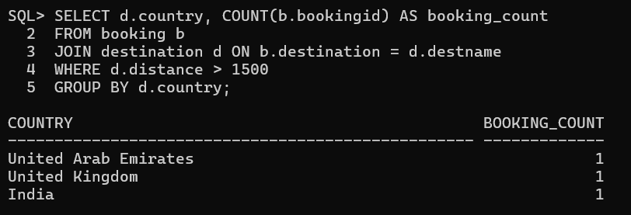

**20) Find employees who have been assigned the same position in more than one department**

