Open jupyter and upload each file one by one.

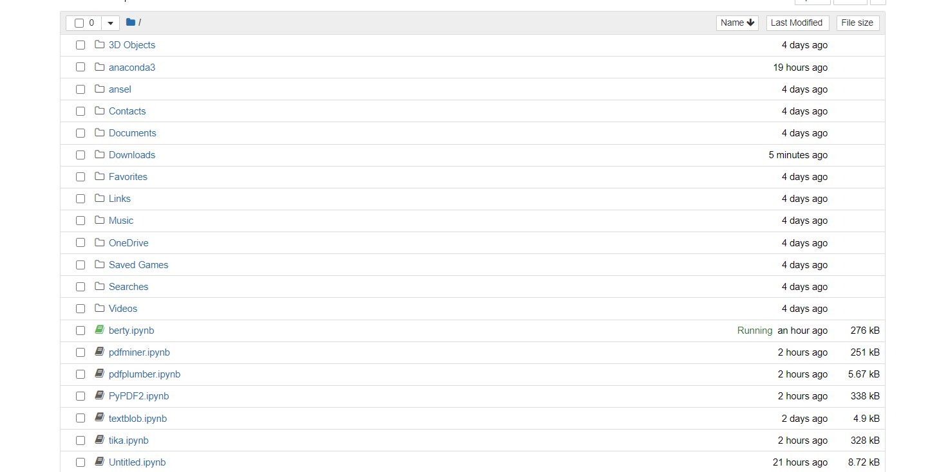

Once uploaded, just provide the location of the pdf file present in the folder followed by the name of the pdf file, in each code file and make sure to install all the libraries, if not done already.

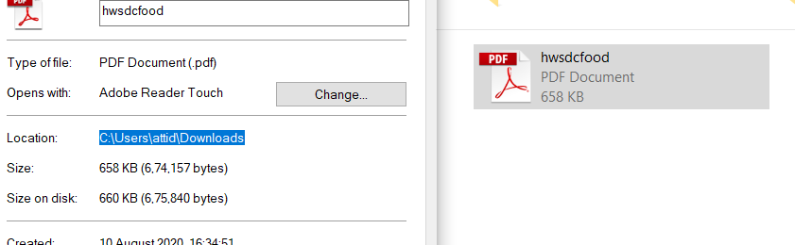



The same process needs to done for each code file in this folder.