**Pre-processing steps:**

1. Import Dependencies from requirements.txt file.
2. Provide text input from the created data frame.

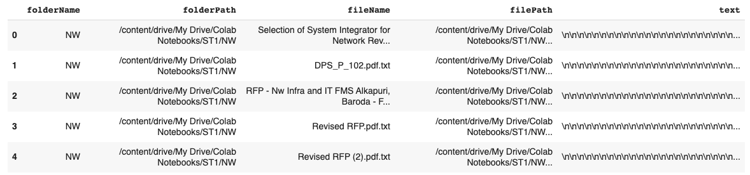

1. After running the code a new column named ‘cleanText’ should be created.

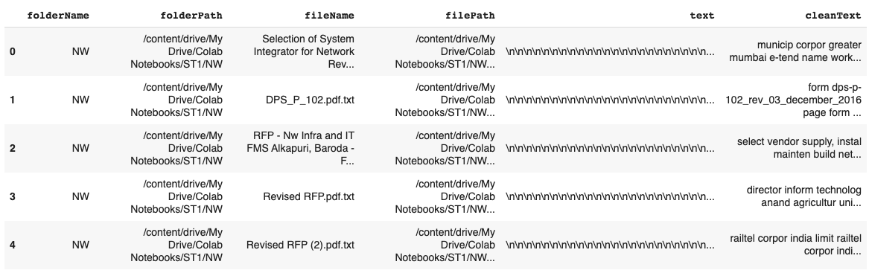

**Word Embeddings steps:**

1. Import all dependencies and required packages from sklearn.feature_extraction.text and tqdm.
2. Make sure the data frame has ‘cleanText’ column for text each file.
3. Run the code.