Name : Daivik Sheth  PRN: 1262243520  Panel: TYBTech AI-DS  Batch: F2 | UIUX Assignment 1  Domain: Gamified EduTech  Websites Evaluated: Duolingo, Babbel

Duolingo
Parameter | Justification | Rating (1-10)
Learnability | Opens straight to one path of lessons with a Start button on the next one, so you don't really need anyone to tell you what to do. | 9
Usability | Answer, press Check, press Continue. That's basically it. A lesson is done in a few minutes with barely any clicks. | 9
Consistency | Same green buttons, same rounded cards and same owl everywhere. Every language course has the same layout too. | 9
Use of Metaphors | Flame for streak, hearts for lives, gems for money, trophy for leagues. It's all game stuff and the path works like a journey map. | 9
Navigation Structure | Left sidebar covers most things (Learn, Leaderboards, Quests, Shop, Profile) but a few features are hidden under More and you have to hunt for them. | 7
Visual Hierarchy | Current lesson is the biggest, brightest circle on the page, done ones are gold and locked ones are grey. Easy to see what's next. | 9
Accessibility | Big text and buttons, and you can skip listening/speaking with "Can't listen now". But the light green and grey text is low contrast and right/wrong relies a lot on colour. | 7
Responsiveness | Layout shrinks fine when you resize it (can check using dev tools), sidebar turns into a bottom bar. Keeps nudging you to download the app though. | 8
Efficiency of Interaction | Enter to check and continue, and the answer box is already selected, so you can do a whole lesson without touching the mouse much. | 8
Feedback and System Status | Green or red banner pops up right after each answer with a sound, and shows the right answer if you were wrong. Progress bar on top and XP at the end. | 10
Error Prevention and Recovery | Wrong answers come back at the end of the lesson so you get another try. But quitting halfway loses the lesson, and hearts run out for free users. | 7
Aesthetic and Minimalist Design | One question per screen with lots of space, very clean. Super ads and shop popups break it a bit. | 8
Content Readability | Big font, short sentences, an audio button on every phrase and you can hover over words to see the meaning. | 9
Search and Discoverability | No proper search. You find things by following the path or the menus, and some stuff is only under More. | 6
Performance Perception | Next question shows up instantly and the animations are quick. Audio is sometimes a little late. | 8
Trust and Credibility | Everyone knows it and it talks about the research behind it. The pushy reminders and upsells take away a little bit. | 8
Personalization | Placement test, daily goal, streaks, leagues and practice based on your own mistakes. Feels made for you. | 10
User Satisfaction | Fun and keeps you coming back every day. People mostly complain about hearts and the Super paywall. | 9

Evidence Screenshots
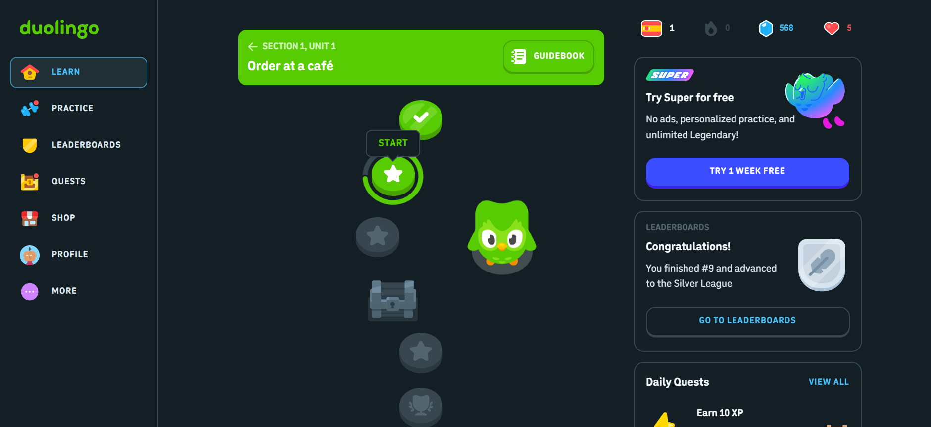
Fig. 1 — Home learning path with sidebar
- Learnability: The path with a Start bubble shows a new user where to begin.
- Navigation Structure: Left sidebar shows the main sections of the site.
- Visual Hierarchy: Active lesson is the biggest, locked units are greyed out.
- Consistency: Buttons, cards and icons all share the same rounded green style.

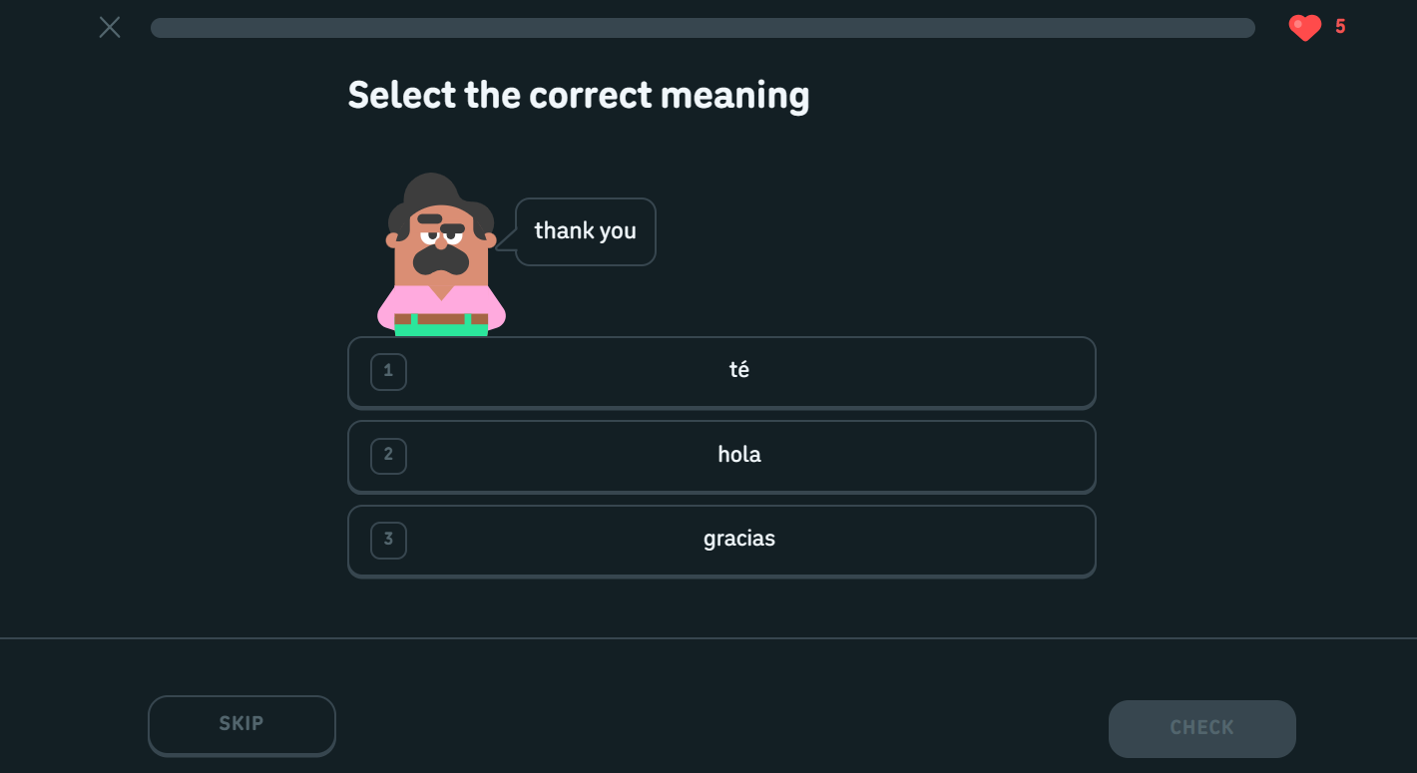
Fig. 2 — Lesson exercise screen
- Usability: One question and one main button per screen.
- Efficiency of Interaction: Word bank taps and Enter to check save clicks.
- Content Readability: Large text, audio button and word hints make it easy to read.

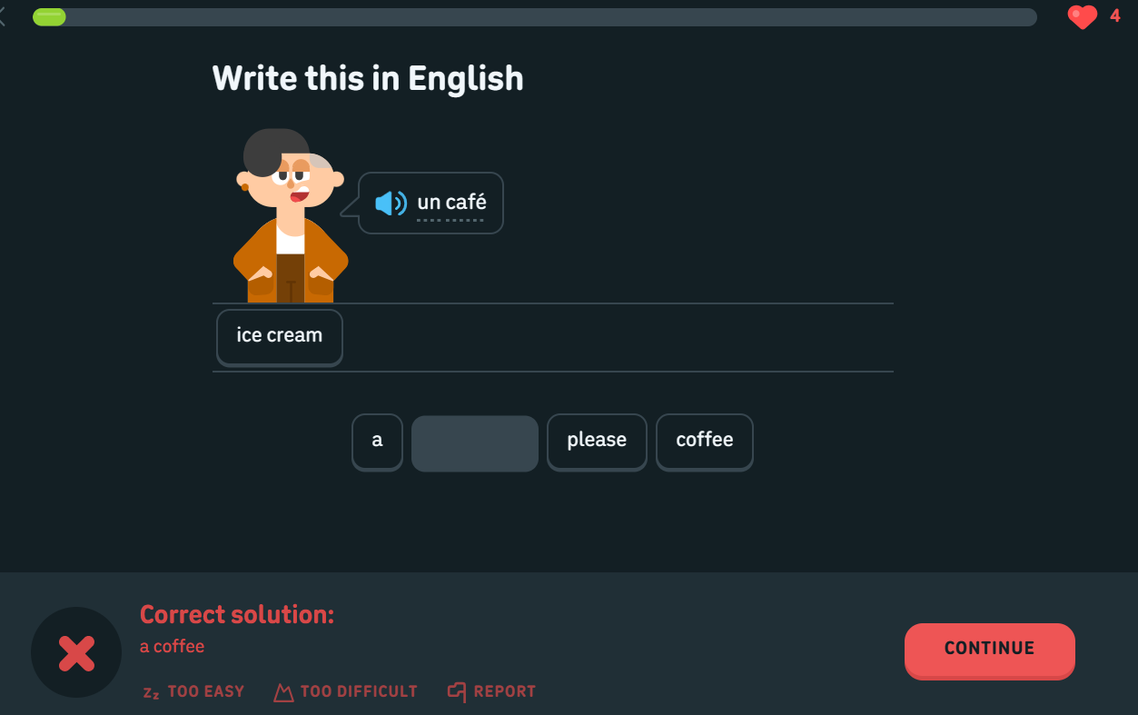
Fig. 3 — Correct / incorrect answer banner
- Feedback and System Status: Instant pass/fail banner, progress bar shows how far along you are.
- Error Prevention and Recovery: Shows the right answer and the question comes back later.

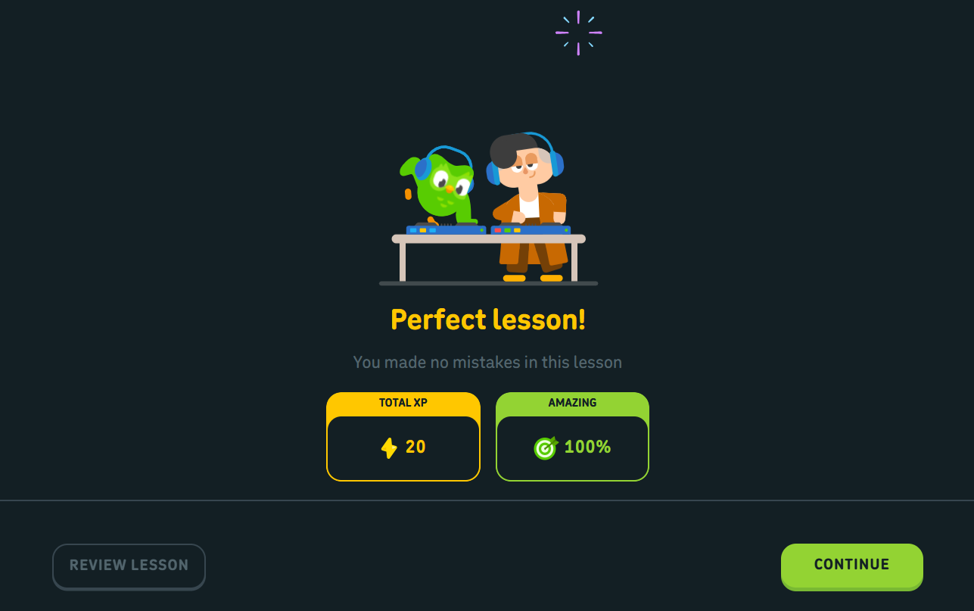
Fig. 4 — Lesson complete summary
- User Satisfaction: The celebration screen makes you want to carry on.
- Performance Perception: Stats show up right after the last question.

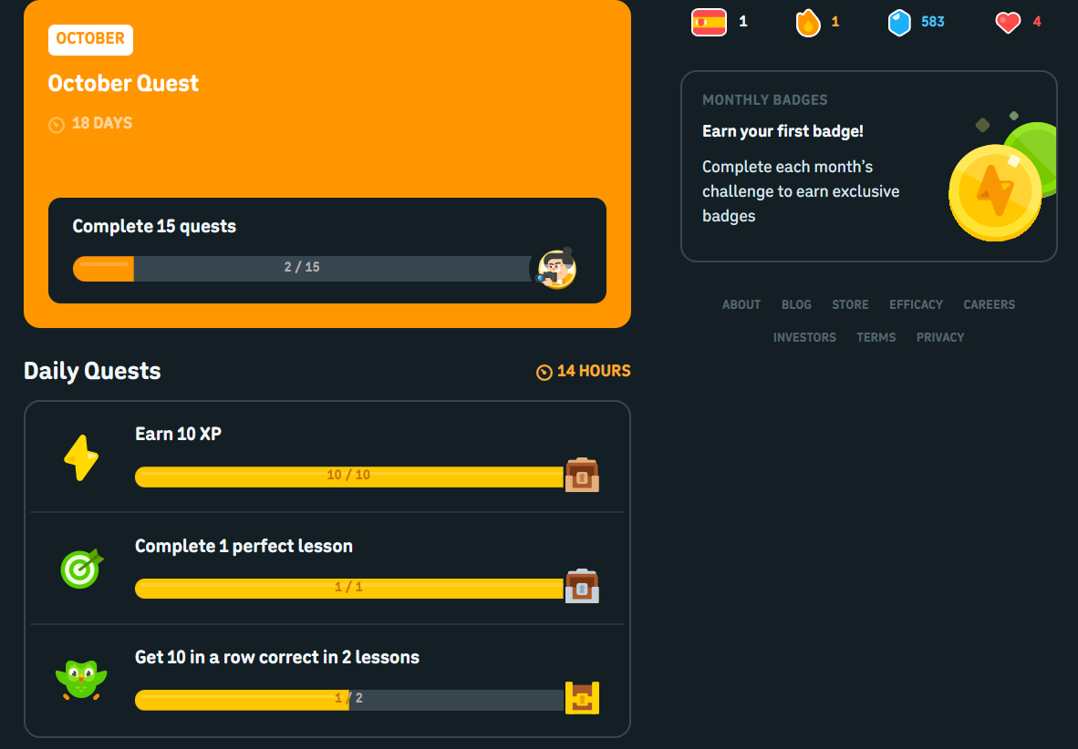
Fig. 5 — Streak, leagues and quests
- Personalization: Streak, daily goal and league rank are all based on your own account.
- Use of Metaphors: Flame, trophy and gem icons make progress feel real.

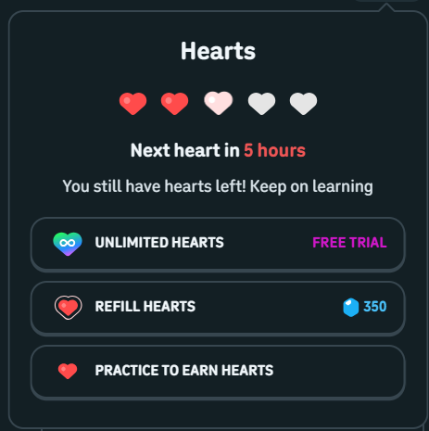
Fig. 6 — Hearts / shop popup
- Aesthetic and Minimalist Design: Lesson area is clean but upsell popups get in the way.
- Error Prevention and Recovery: No hearts means you can't continue, but Practice lets you earn them back.

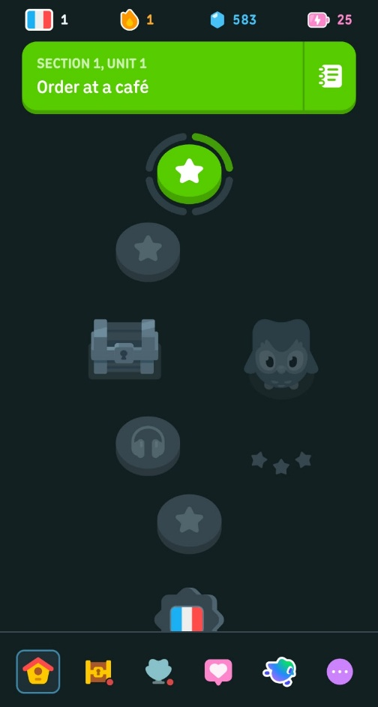
Fig. 7 — Mobile view
- Responsiveness: Sidebar becomes a bottom bar and the path fits in one column.

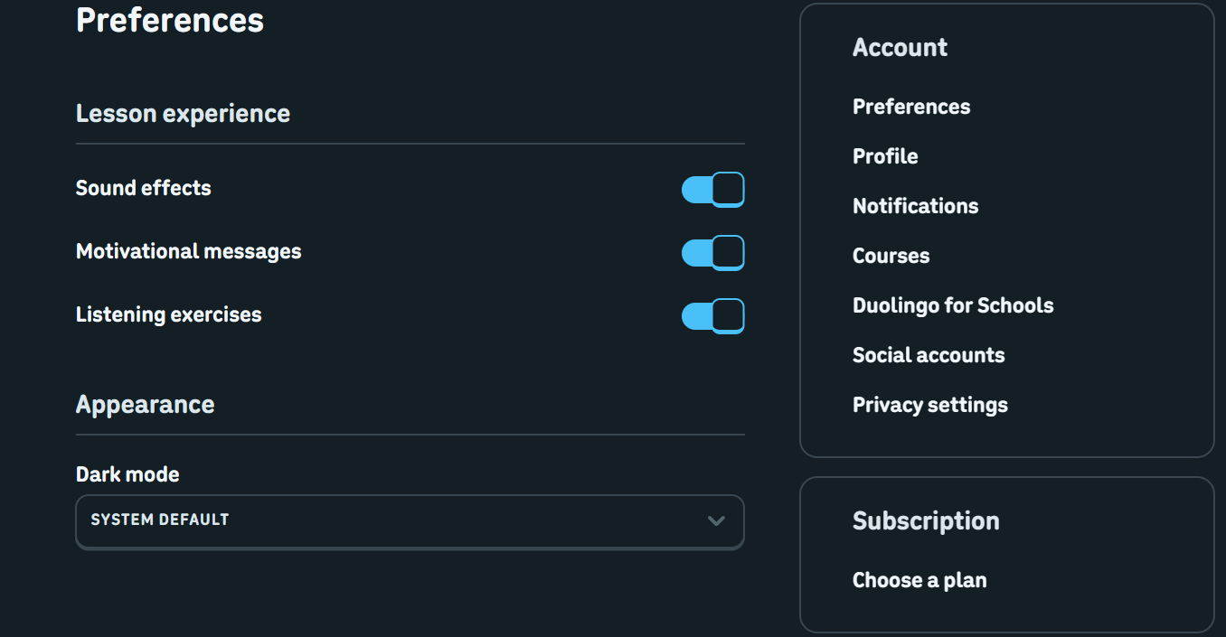
Fig. 8 — Settings page
- Accessibility: You can turn sounds and speaking exercises off, but the contrast is still low.

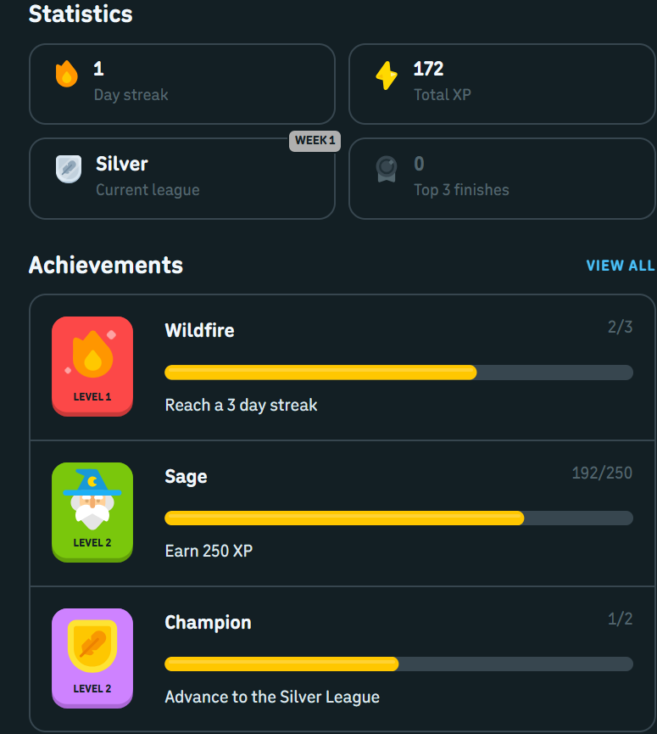
Fig. 9 — Profile / efficacy page
- Trust and Credibility: Stats, achievements and research claims make it feel legit.

Babbel
Parameter | Justification | Rating (1-10)
Learnability | Starts with a few questions (language, level, goal) and then puts you into a course. Pretty easy, but the paywall shows up quite early. | 8
Usability | Lessons mix listening, typing and speaking exercises, each with one clear button. Finishing a lesson takes just a few clicks. | 8
Consistency | Same orange and white look and same exercise layout across all lessons and courses. | 8
Use of Metaphors | Not much. Just plain icons like a flag for the language and a speaker for audio. No mascot or game stuff like Duolingo. | 5
Navigation Structure | Top menu keeps the main sections apart, but the course page has a long list of lessons so you end up scrolling a lot. | 7
Visual Hierarchy | Current lesson is highlighted on the course page but everything else looks kind of the same, so less eye catching than Duolingo. | 7
Accessibility | Text size is good and contrast is decent (mostly dark text on white). Not many accessibility settings though. | 7
Responsiveness | Works on smaller screens when resized, the layout just stacks into one column. | 8
Efficiency of Interaction | You can type answers and press Enter to continue, but there are no real shortcuts beyond that and some screens need extra clicks. | 7
Feedback and System Status | Tells you right away if it was correct and shows the right answer, plus a progress bar for the lesson. Less flashy than Duolingo. | 8
Error Prevention and Recovery | Mistakes get corrected and the Review section brings back words you got wrong. Leaving a lesson halfway might lose your progress. | 7
Aesthetic and Minimalist Design | Clean and mostly white with a lot of space, nothing distracting during a lesson. | 8
Content Readability | Dialogues and vocab are in clear type with audio, and the grammar tips are short and easy to read. | 8
Search and Discoverability | Picking a course is easy but there's no real search for specific lessons or topics. | 6
Performance Perception | Pages load okay, but audio and the speech check can take a second. | 7
Trust and Credibility | Looks professional, content is made by language experts and it's clear what is free and what is paid. | 9
Personalization | Asks your goal and level, suggests lessons, and Review picks the words you need to practise. | 8
User Satisfaction | Feels more serious and useful for real conversations, but less fun, and almost everything needs a subscription. | 8

Evidence Screenshots
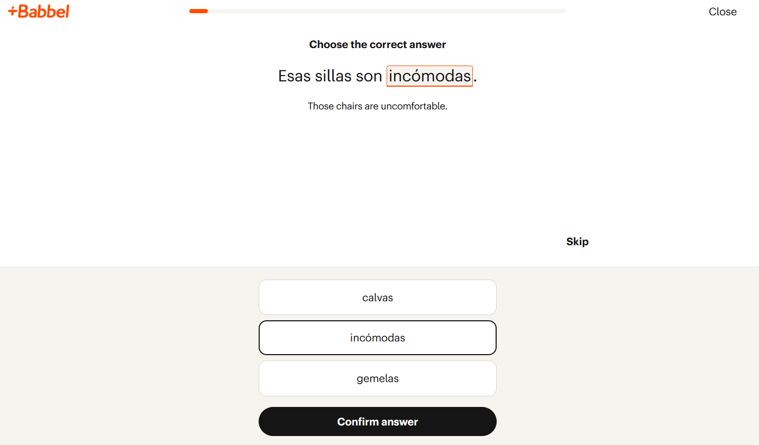
Fig. 10 — Onboarding questions (language, level, goal)
- Learnability: Short step by step questions, easy to follow for a new user.
- Personalization: Your goal and level decide which course you get.

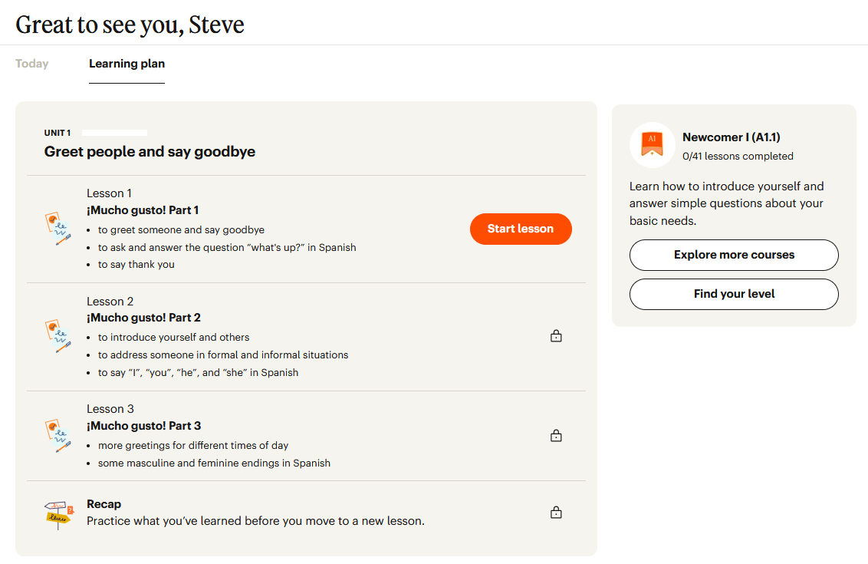
Fig. 11 — Course overview with lesson list
- Navigation Structure: Top menu plus a lesson list shows where you are in the course.
- Visual Hierarchy: Current lesson is highlighted but the rest look very similar.
- Use of Metaphors: Only simple icons (flag, speaker), nothing game-like.
- Consistency: Same colours and card style on every page.

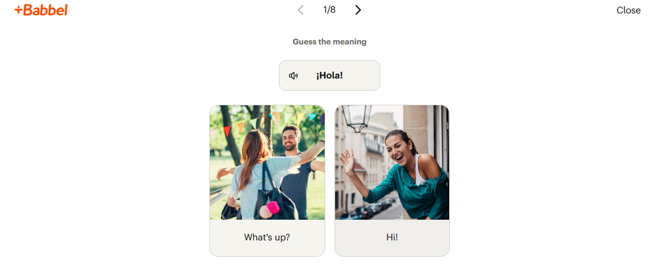
Fig. 12 — Exercise screen
- Usability: One task at a time with a clear Continue button.
- Efficiency of Interaction: Typing and Enter work well, no other shortcuts.
- Content Readability: Clear text with audio next to the phrases.
- Aesthetic and Minimalist Design: Plain white screen with no distractions.
- Accessibility: Good text size and contrast.

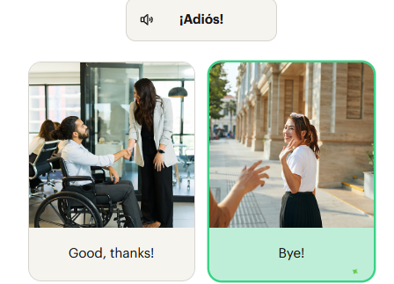
Fig. 13 — Correct / incorrect feedback
- Feedback and System Status: Shows right away if it is correct and what the answer should be.
- Performance Perception: Result is quick, speech check takes a little longer.
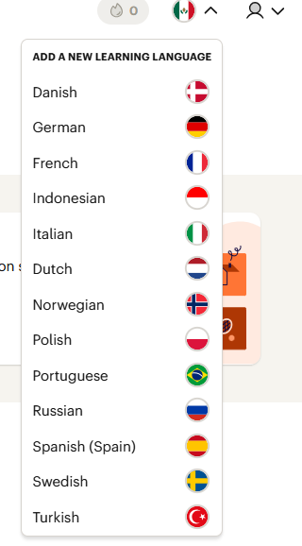
Fig. 14 — Course / language picker
- Search and Discoverability: Easy to pick a language, but no search for lessons or topics.

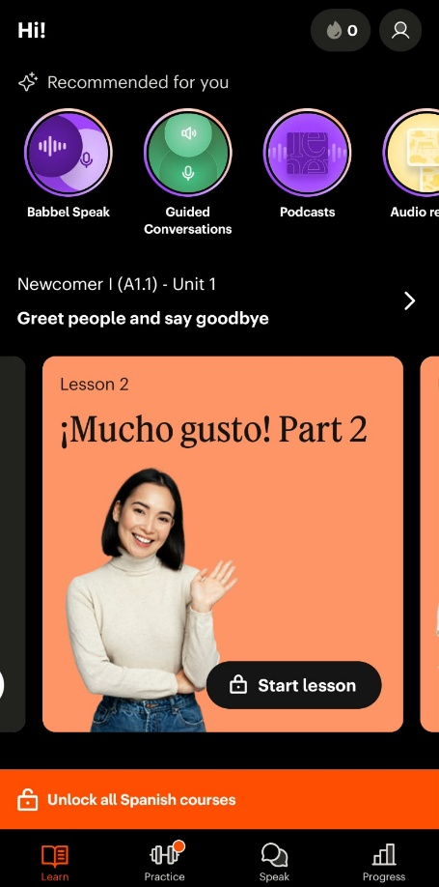
Fig. 15 — Mobile view
- Responsiveness: Layout becomes one column and still works fine.

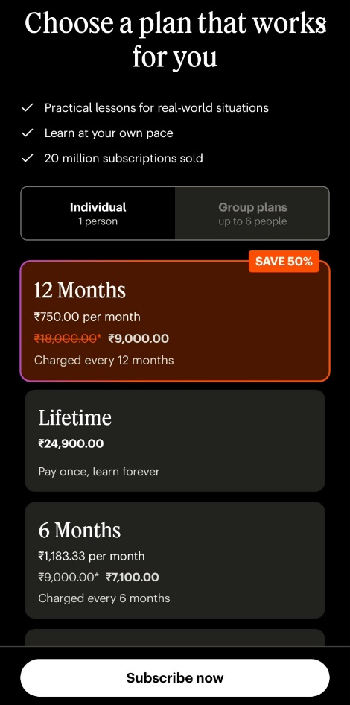
Fig. 16 — Pricing / about page
- Trust and Credibility: Clear about what is paid and mentions expert-made content.
- User Satisfaction: Useful, but most of it is locked behind the subscription.

