LAB ASSIGNMENT V : HUERISTIC EVALUATION
SYSTEM EVALUATED : __________
Groups members NAME : ………………………………………………….
**Evaluation to be done by other Group
PART I : HUERISTIC EVALUATION BASED ON NIELSEN'S 10 GENERAL PRINCIPLES FOR INTERACTION DESIGN. (0 is lowest and 5 is highest)
S.No. | Heuristic Evaluation Parameter | Mention Violation if any | Severity 0-5 (0- minimum and 5 is maximium) | Ways to improve
1 | User Control: Interface will allow the user to perceive that they are in control | Cannot skip questions or navigate non-linearly within a lesson quiz. | 3 | Add question drawer or skip button to review at the end.
2 | Human Limitations: Interface will not overload the users cognitive, auditory and motor skills | Desktop review screen presents dense explanatory text cards at once. | 4 | Use expandable cards for grammar tips to reduce cognitive load.
3 | Accommodation: The interface will fit the way each user group works and thinks (personas) | Fixed curriculum path without separate tracks for grammar vs conversational learners. | 3 | Offer elective learning tracks based on learner goals.
4 | Linguistic Clarity: Interface will communicate as efficiently as possible | Idiomatic expressions lack instant inline word-by-word translation before answering. | 4 | Add tap-to-translate tooltips on individual Spanish words.
5 | Aesthetic Integrity :The interface will have an attractive and appropriate design | Secondary metadata text has low contrast against the dark background. | 2 | Increase contrast ratio on secondary gray labels for better legibility.
6 | Simplicity: The interface will have a simple design | Question prompt details are partly repeated in the right-hand review panel. | 3 | Streamline review panel to show only new explanations.
7 | Predictability :The interface will behave in such a manner that the user can accurately predict what will happen next | Check answer button shows a lock icon without explicit enablement criteria. | 2 | Show tooltip or helper text: "Select an option to enable".
8 | Accuracy: Interface will be free from errors | Weekly study bar chart uses unlabelled dashes for inactive days. | 2 | Label inactive days clearly as "Rest day" or "0 min".
9 | Technical Clarity: Interface will have the highest possible fidelity. | Ultra-wide desktop screens result in excessive horizontal whitespace. | 2 | Constrain content within a centered max-width container.
10 | Fulfillment : The interface will provide a satisfying user experience | Lacks celebratory feedback or milestone badges upon completing a unit. | 3 | Add subtle milestone rewards or completion summary animations.
11 | Consistency: Interface will be consistent | Primary action button labels vary across minigames ("Continue", "Next post", "Next phrase"). | 3 | Standardize primary CTA button text to "Continue" across all exercises.
12 | User Support: Interface will provide additional assistance as needed or requested | No speed adjustment toggle for audio playback during quiz exercises. | 2 | Provide 0.75x slow audio playback toggle alongside normal speed.
13 | Precision: The interface will allow the users to perform a task exactly | Practice is restricted to multiple choice; lacks spelling or speech input. | 3 | Introduce optional typing and microphone pronunciation exercises.
14 | Forgiveness: Interface will make action recoverable | Once user proceeds past a question, they cannot return to reread its explanation. | 4 | Include a "Previous Question" button or bookmarking feature.
15 | Responsiveness: The interface will inform users about the results of their actions and their interface status | Audio playback lacks visual waveform or progress indicator while sound plays. | 4 | Add an animated waveform icon during active audio playback.
 | Total Score |  | 44/75

**Attach Screenshots
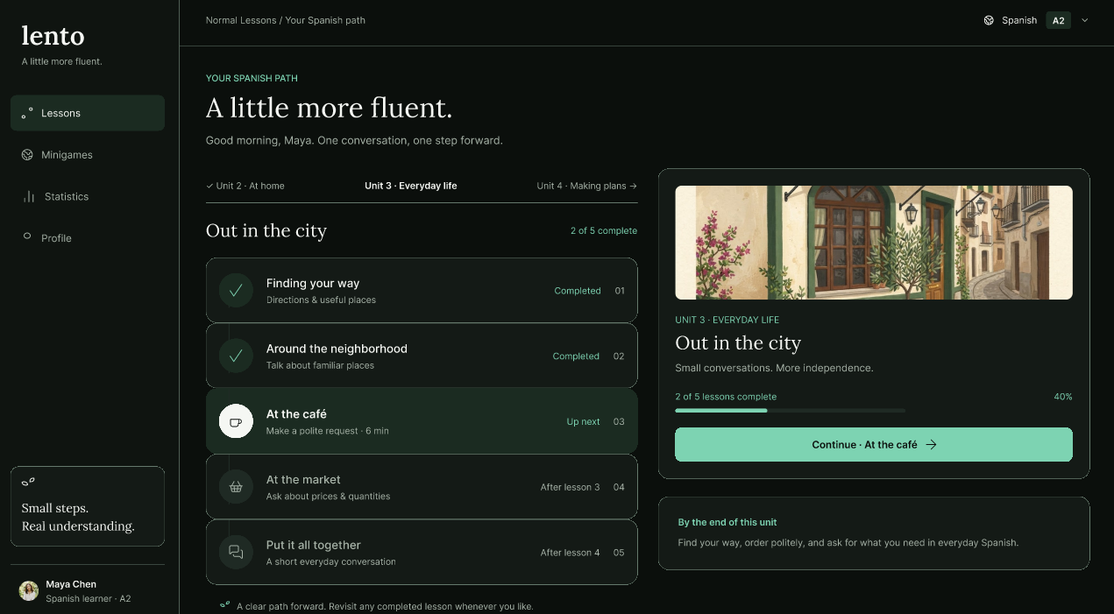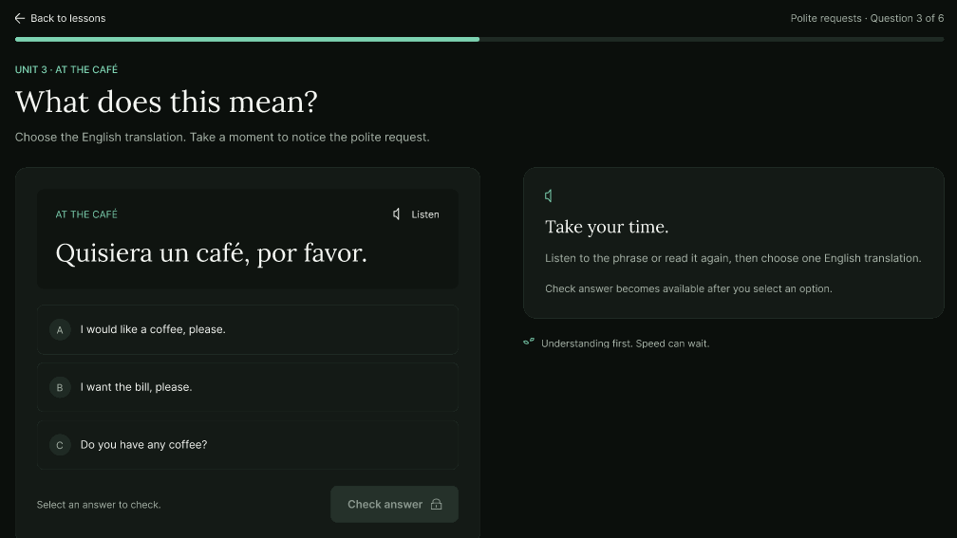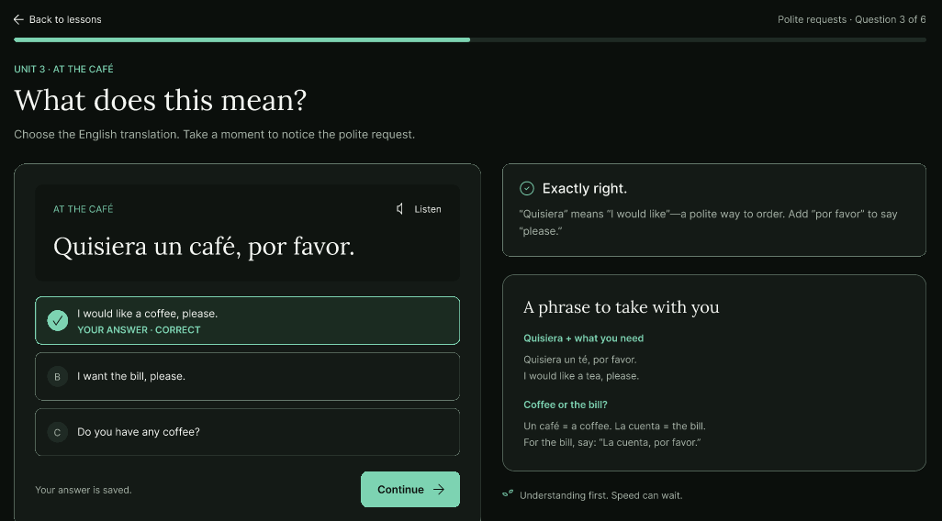
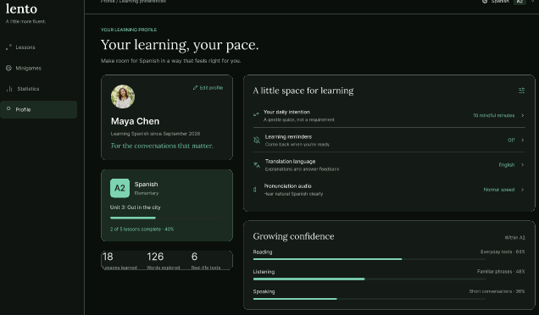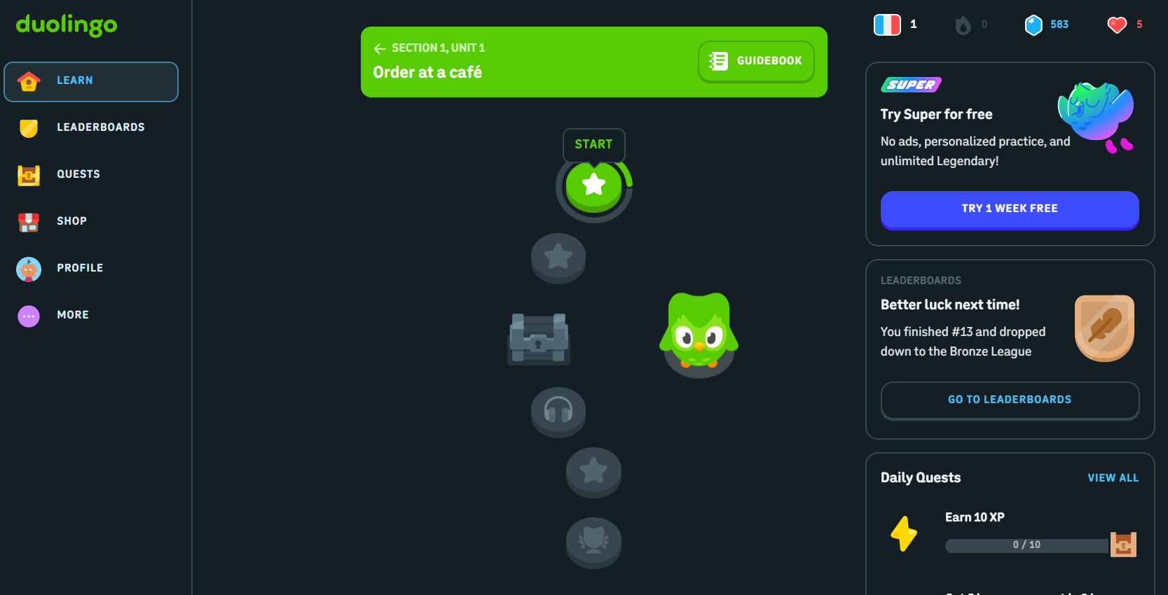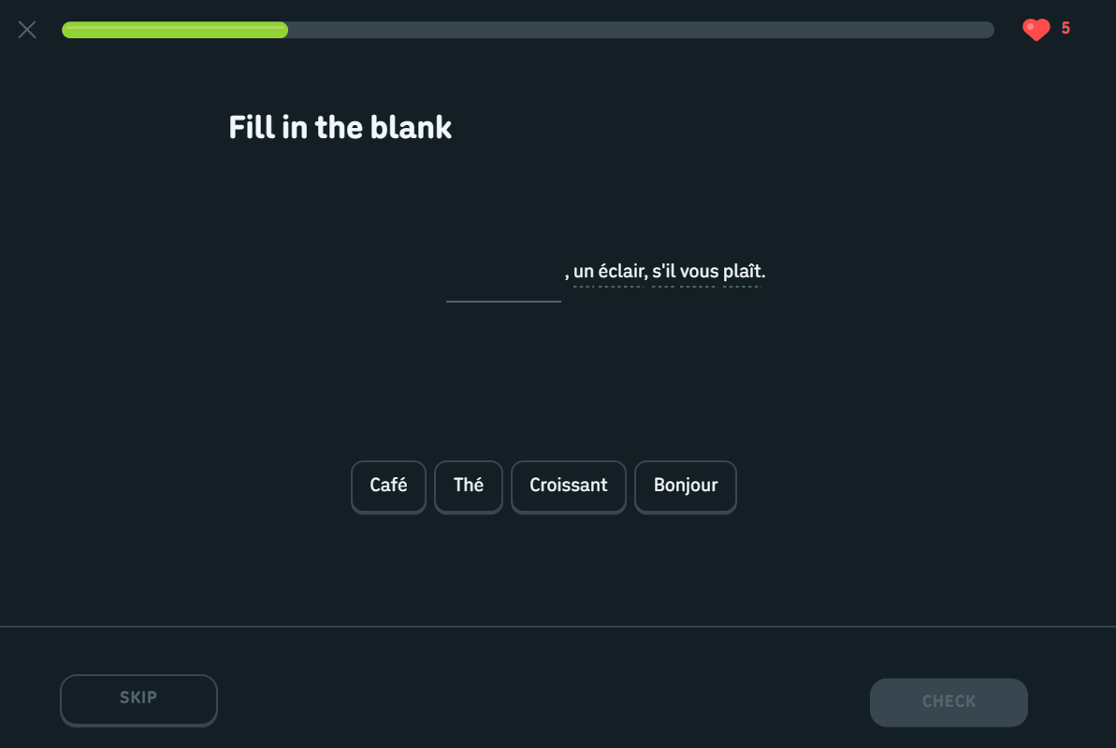
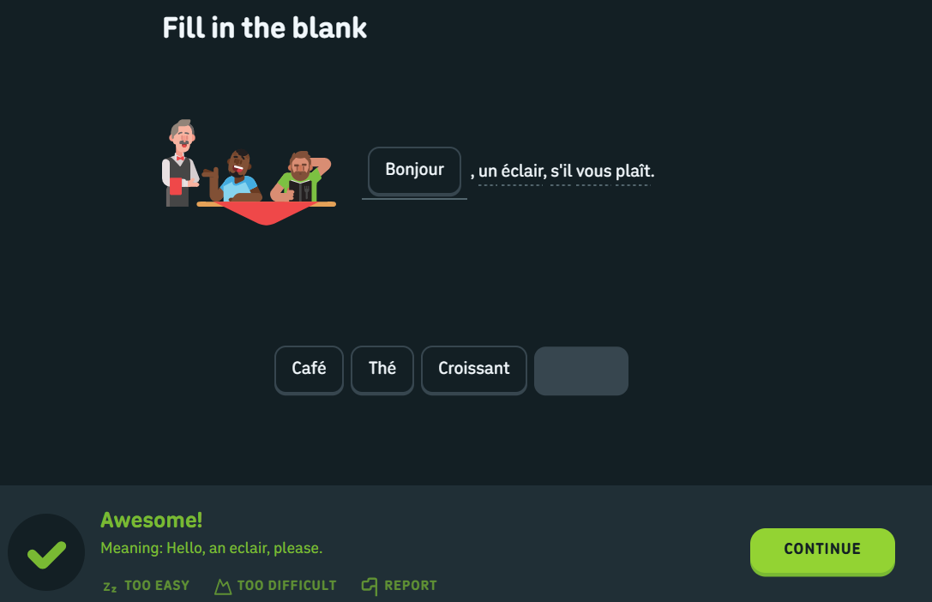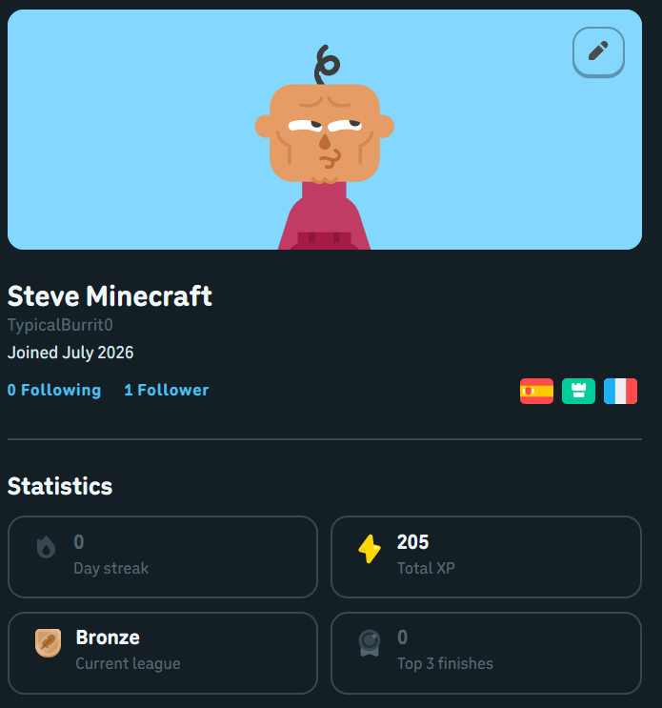

PART II : List out any other points that you may have missed out . (Other than Nielsen’s Principles)

S.NO | OBSERVATIONS | COMMENTS
1 | Low-pressure mindful learning model | Removes anxiety-inducing streaks and aggressive timers, promoting long-term retention.
2 | Comprehensive accessibility suite | Inclusion of motor, older adult, hearing, and colorblind modes is industry-leading.
3 | Authentic cultural reading materials | Using real-world news and social media posts improves contextual language immersion.
4 | Absence of community / peer interactions | Lacks peer leaderboards, study groups, or tandem conversation exchange options.

Students Evaluation Team : group that is evaluation ………………………………………………………………………………..

