How to setup and run jsonshark web application to capture packets on the remote server?
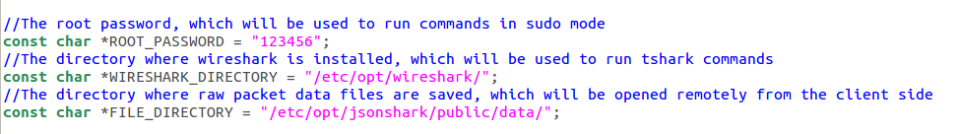
- copy or unzip the jsonshark project, say its directory is "/etc/opt/jsonshark".

- modify the "echldwrapper.cc" file, and input the right root password, wireshark directories as follows, e.g. on my machine, the root password is "123456", wireshark is installed at "/etc/opt/wireshark/".

- Recompile the wrapper under the wrapper folder in jsonshark, i.e. run "sudo node-gyp rebuild".
- Go to the jsonshark directory, and run "node app.js" to start the node.js server.
- Open browser and type "http://localhost:8080", and you will see the following web page:
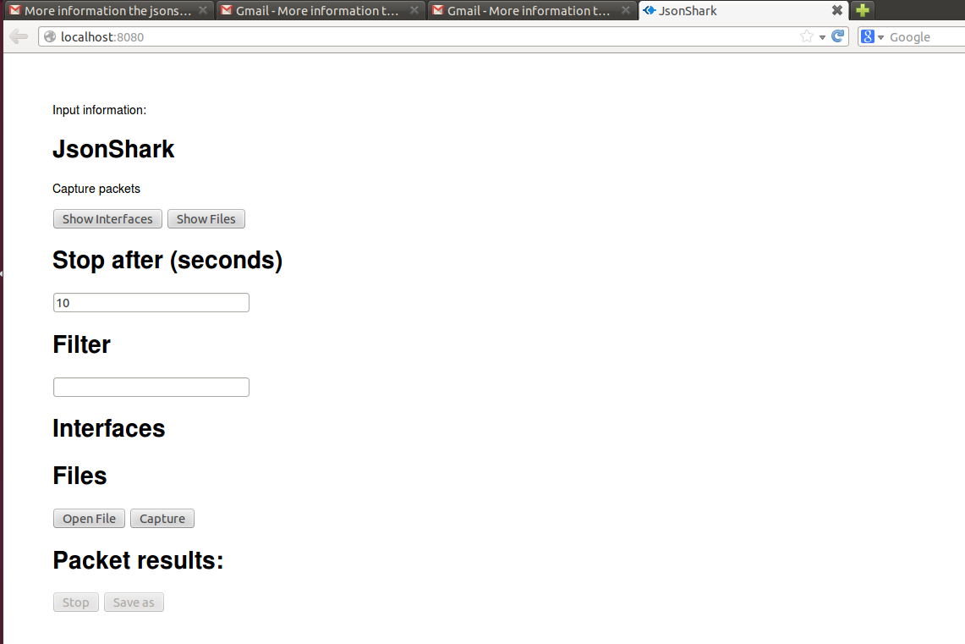

- Click "Show Interfaces" button, and you will see the according available interfaces on the server side, as follows:
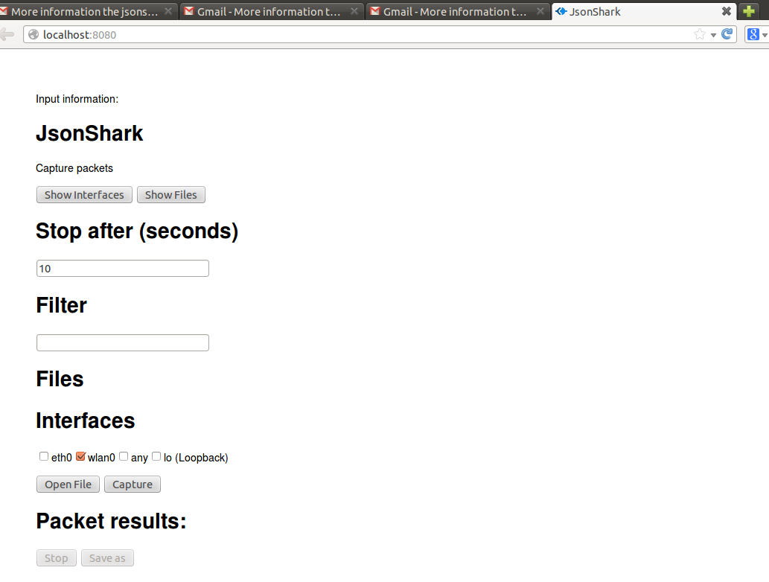

- Check the interfaces on which you want to monitor and capture packets, say "wlan0" interface here. Then, click the "Capture" button. You will thus see the captured packets listed one by one as follows. Click "Stop" button if you want to stop capturing the packets immediately.
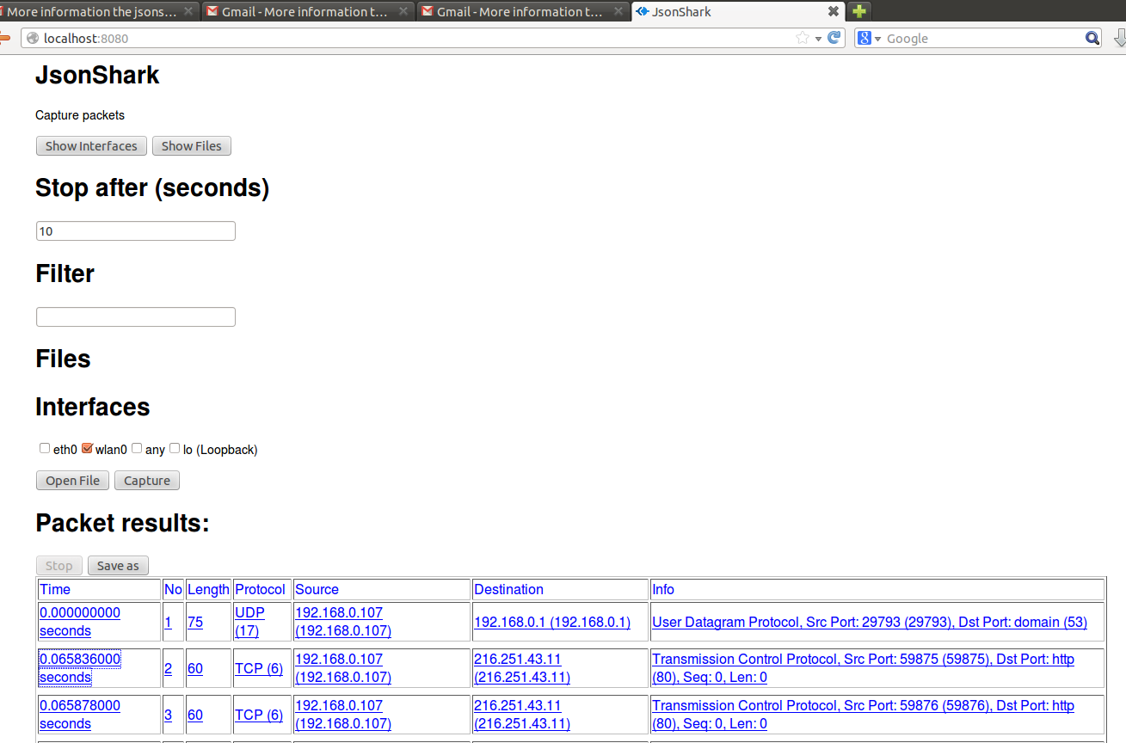

- You may see more detailed information on a packet by clicking the line of that packet. It will thus be expanded as follows. You may also click and get further information on the protocols or fields, if there is an underline with it.
