DSP Lab Report
Exercise 1
Grayscale and double image
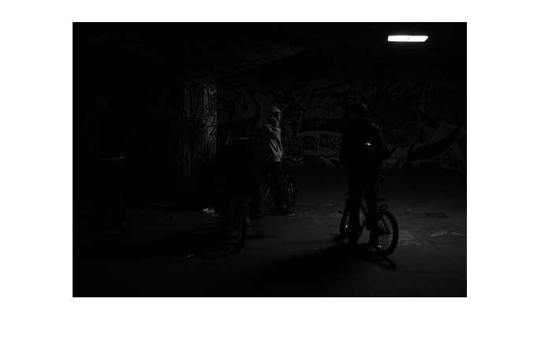
there is no color in this image only grayvalue for every pixel, dark place is close to black and bright space close to white. The light and the man with hoodie stands out.
Histogram
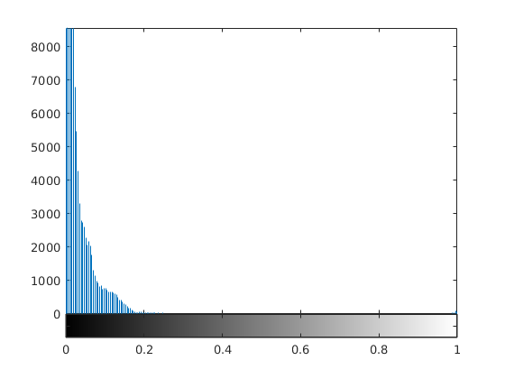
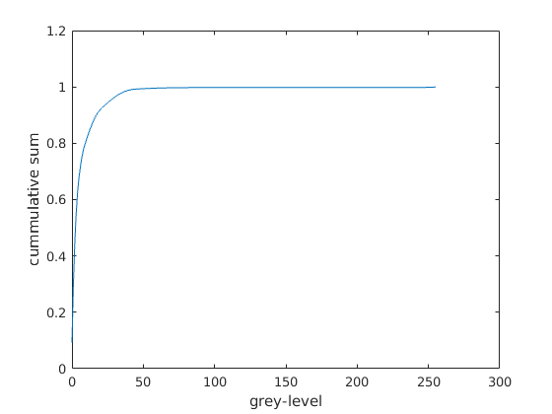
From the Cumulative distribution function above, we can see that the image’s gray level contains mainly on dark place which very close to black, this matches with what we saw from the gray image.
Both the histogram and CDF show that the image are mostly dark color.

Image after histogram adjust
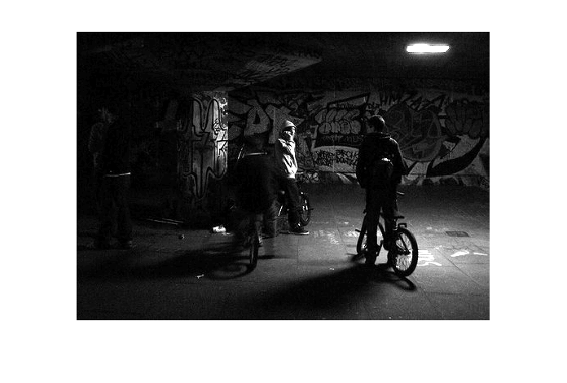
The corresponding histogram
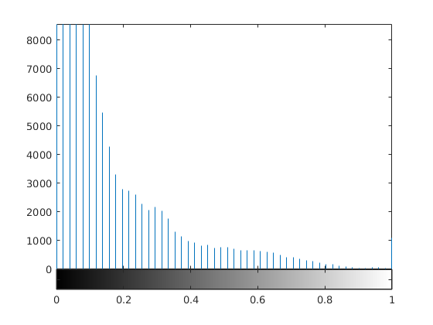
Gamma correction
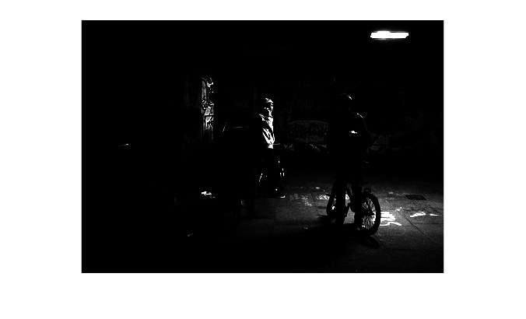
Gamma = 3

Gamma = 0.2
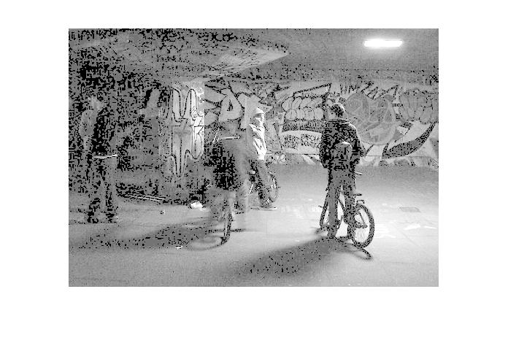
Through the different Gamma value, we can know that if gamma is less than 1, the mapping is weighted toward brighter output value, if gamma is greater that 1, the mapping is weighted toward darker output value.

contrast-stretch transformation m = 0.275, E = 2
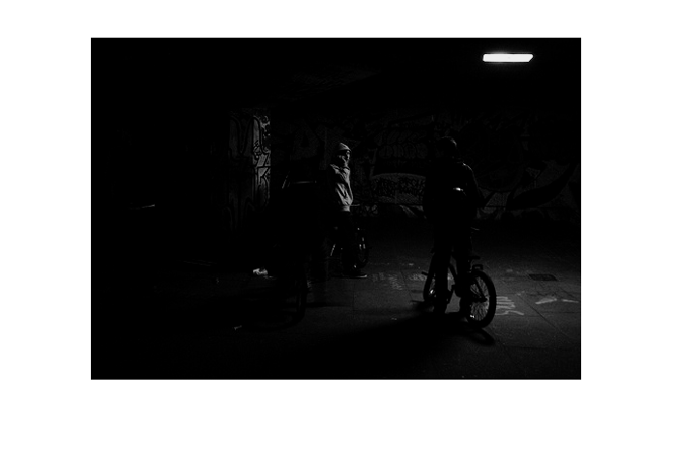
After the contrast-stretch we can see the contrast becomes larger at the man with sweater which is basically the image center.

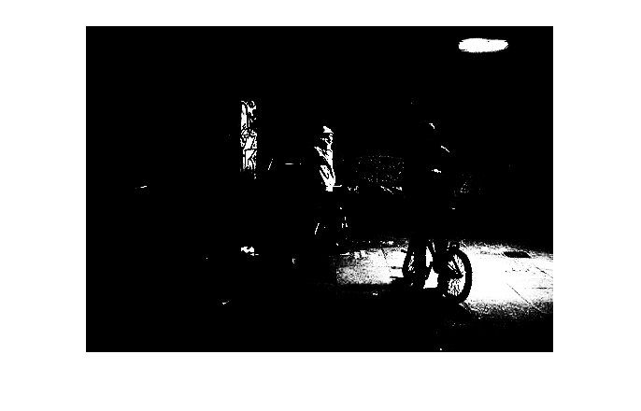
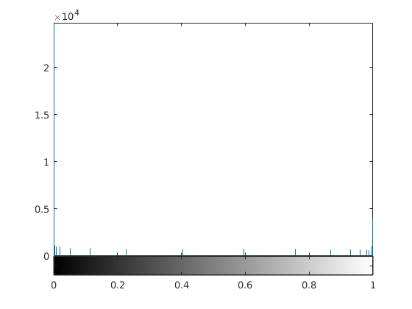
M = 0.1, E = 20
Obviously the result is an image of very high contrast, from the histogram we can know that most of the pixel goes to black or white, only the grey level close to threshold evenly spread out on the axis.

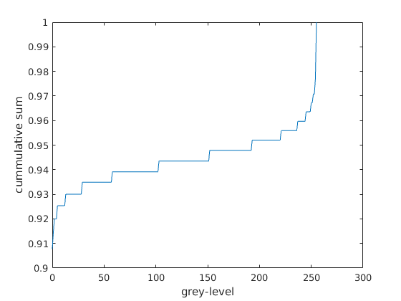
Exercise 2
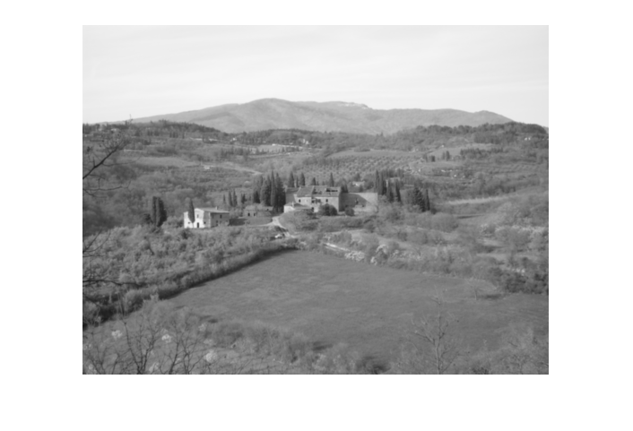
Landscape

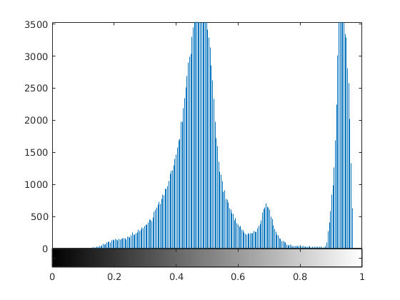
Histogram
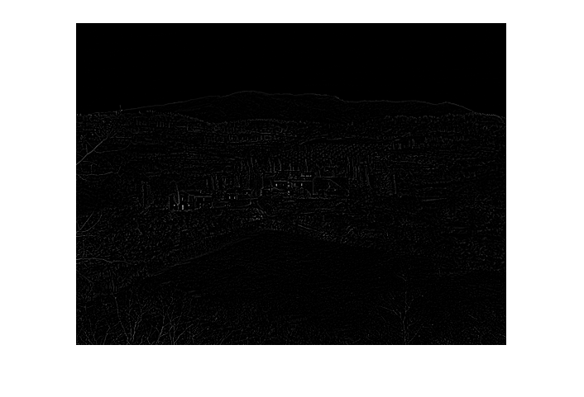

filter the image use laplacian filter

We can see from the image that constant pixel level became zero and only the edge which there is gray level change remain white.
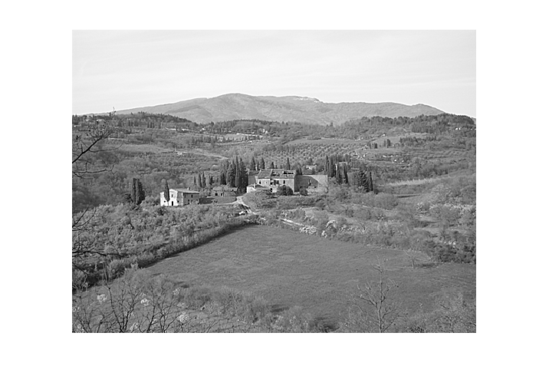
The Laplacian of an image highlights regions of rapid intensity change, After subtract the edge from the original image, it produces a very good result, the image became very clear.
It should be the way that subtract the laplacian filtered image from the original image, otherwise it will become even darker.
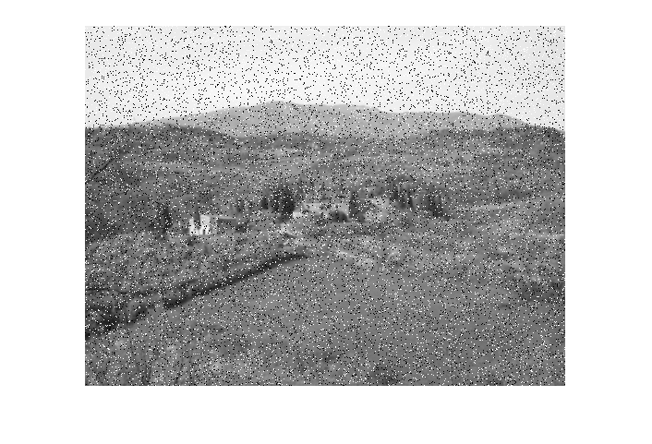
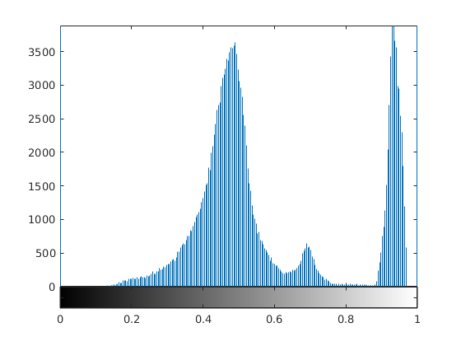
the image presents itself as sparsely occurring white and black pixels cause by the salt & pepper noise.

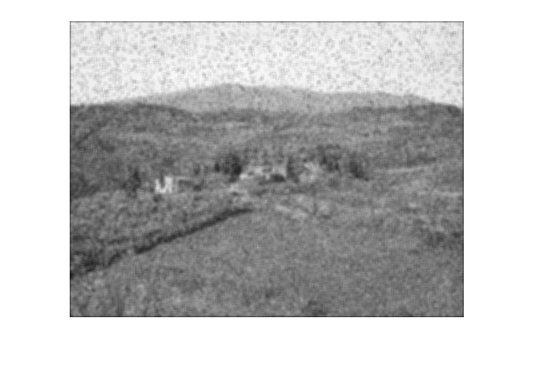

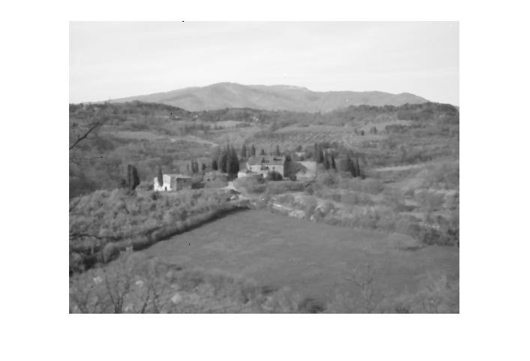
From the comparison we know that median filter works for salt & pepper noise better. Averaging filter still keep the noise only make them blur, the median filter completely remove the noise and make the image clear. Because the salt & pepper noise is just black and white pixel, it has extreme pixel level, what median filter did is simply compute the midian of the ordered sequence which will consider all the surrounding pixels and help decrease the extreme pixel level to median.

Exercise 3

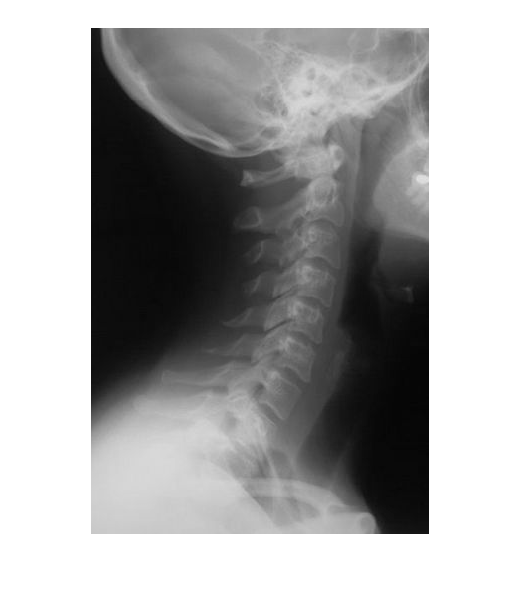
Image & histogram & Frequency domain

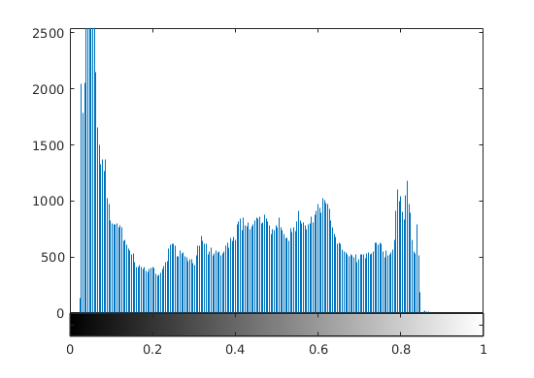
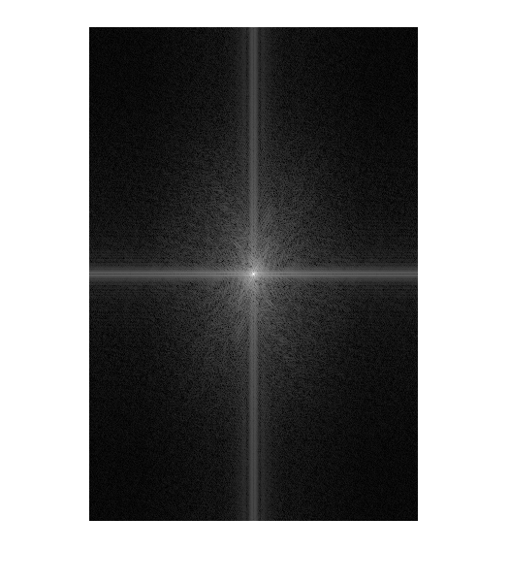
Apply a Butterworth high pass filter to the image, the result and spectrum at frequency domain
From the spectrum above we can know the center is the DC-value and it’s magnitude is biggest, after pass by high pass filter the DC-value and its nearby area which is lower frequency was filtered. The further away from the center an image point is, the higher is its corresponding frequency.

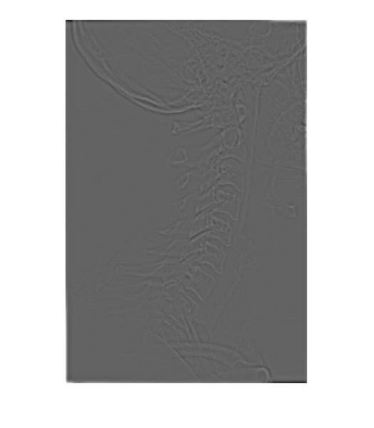

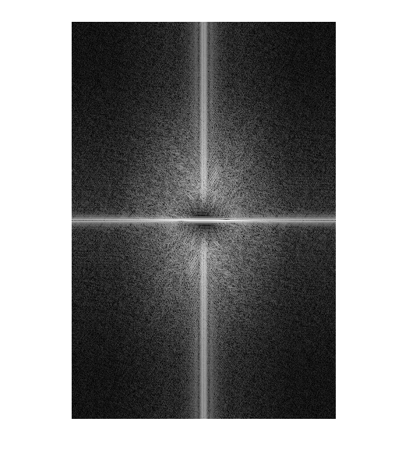

Different a & b
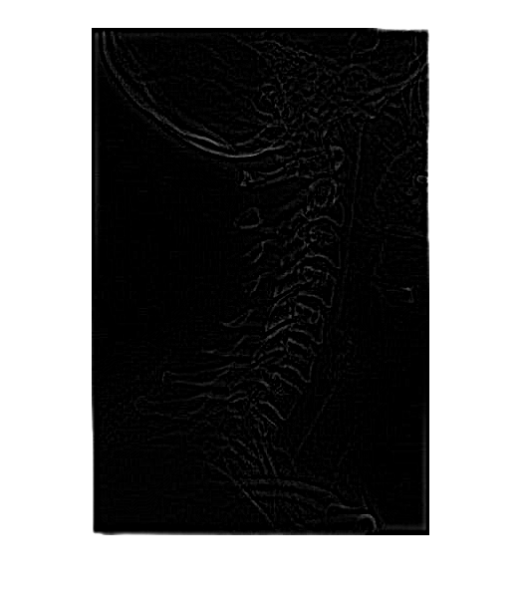
a = 0.01 b = 5

a = 0.01 b = 50
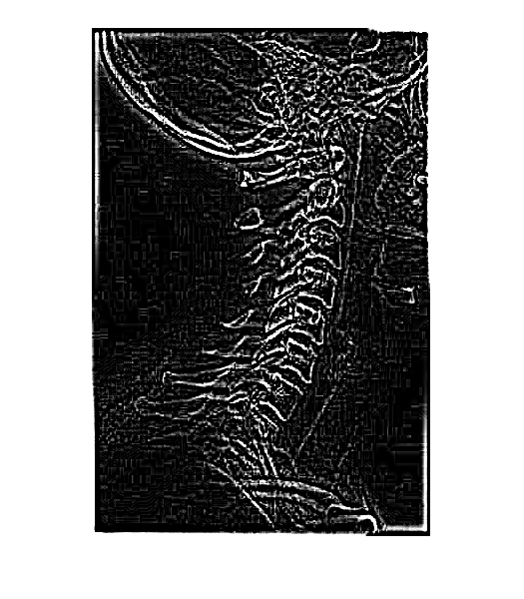

The bigger the b is, the clearer the edge of skull became, because the b which is constant multiplier highlights the high frequency.

a = 0.01 b = 5

a = 1 b = 5

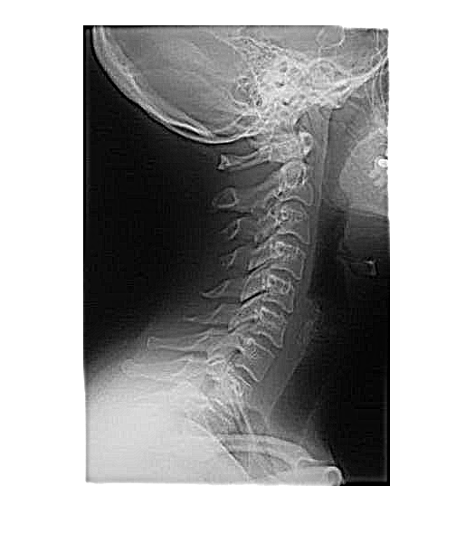

a is lower frequency offset, it increase the low frequency also, but because compare to multiplier it is very small, so the enhancement is less than multiplier.

Use a = 0.5 b = 2 and perform high frequency emphasis filtering and histogram equalization
Original image histogram equalization
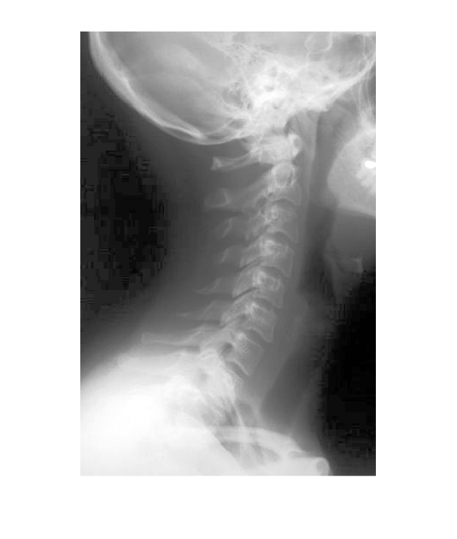

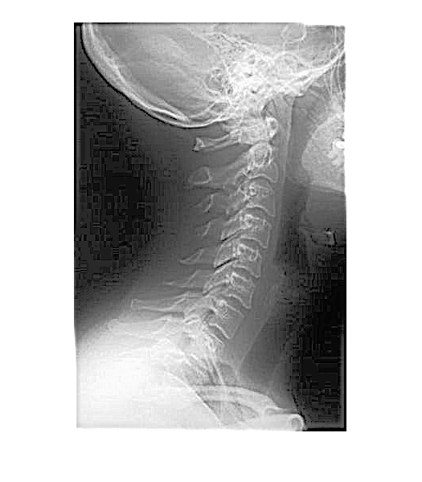
Histogram equalization on emphasized image

After the high frequency emphasis filtering and equalization the image display the high frequency component much more clear and doesn’t lose much of the lower frequency information. The clarity of the skull and some other details are not visible on original image, and the result of the combination of high frequency emphasis filter and histogram equalization is better.

Exercise 4
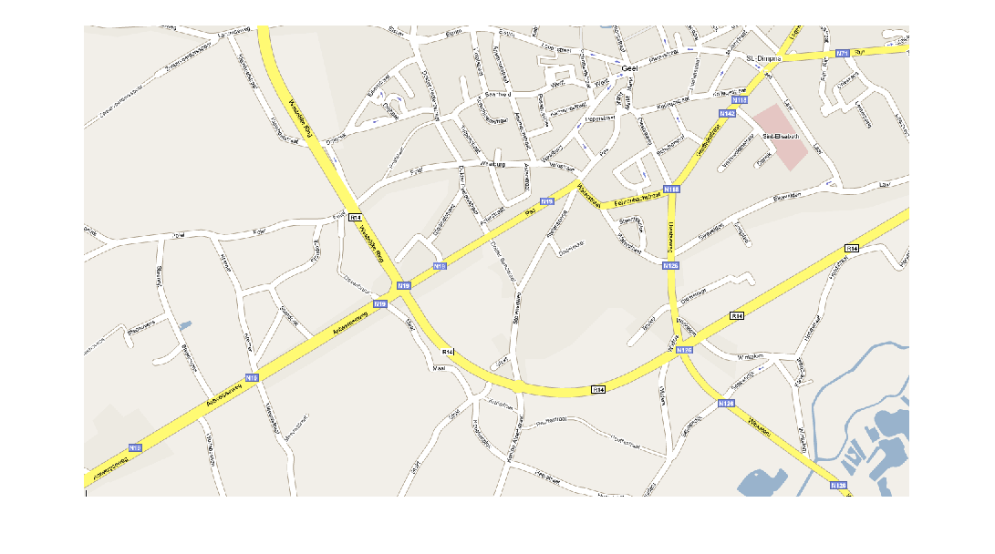
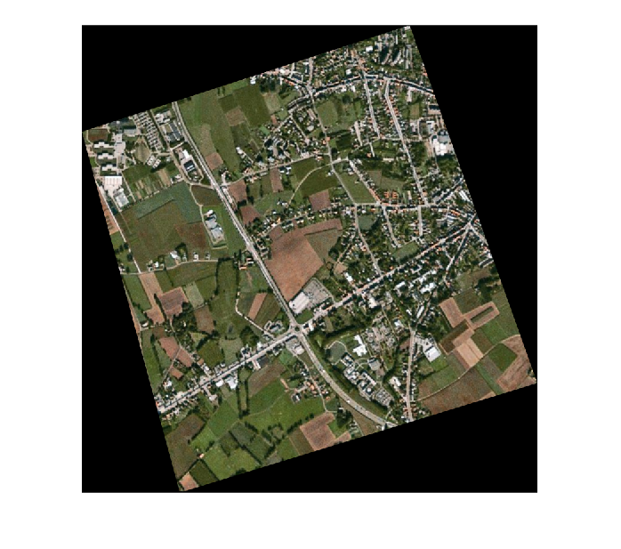

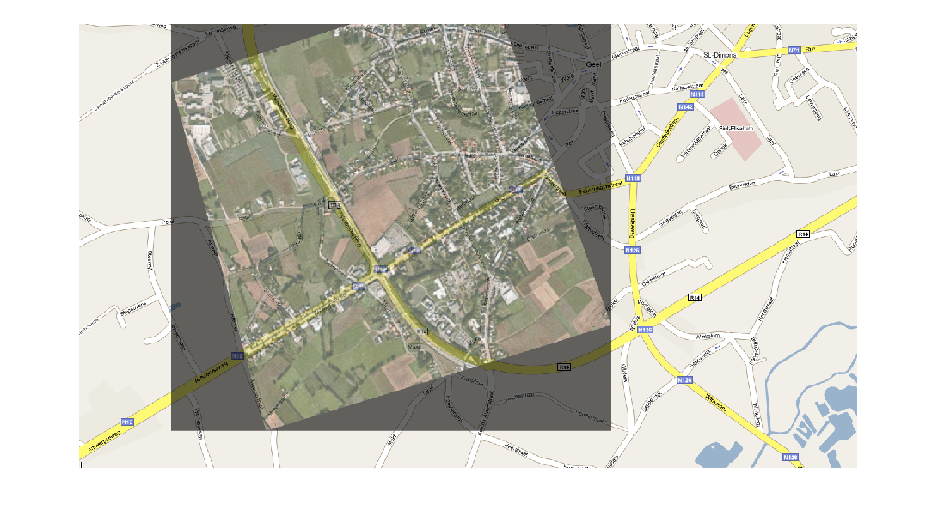
the result is correct, the main road is matched very well.
If the key points are too close together the transformation will not successes because the calculation will not correctly compute the main direction and rotation.

