420-541-VA Game Programming 2
Lab 9 and 10 : Testing a game and TRC ( 2%)
Today we will be looking into testing our game.

In order to download the project you will have to clone this git repository :
https://github.com/amcnabbbaltar/420-541-Week12_Lab2

Then :
Task 1) Open the game project, then go in to Build and run in the options and build the game. You can put the build in a Build folder.
The scene are in \Assets\Karting\Scenes
Task 2) Fill out the little TRC in the next page ( Page 2)
Task 3) Find a major bugs and fill out a bug report on it.
Hint : The expected behavior is that the pickups should speed you up.
Task 4 ) Fill a play test report.

How to submit your project.

- Fill out this form and send it back through LEA.
Task 2 :

1. Basic Functionality
- Launching & Exiting
  - Task: Launch the game and observe any initial loading screens.
  - Question: Did the game start up without errors? How long did the initial load take?
- Yes, the game starts up without any error, and the initial load took 3 seconds. _____________________________________________
  - Observation: Is there a clear way to exit or quit from the game?
  - There is no exit or quit button in main menu, but it can be quit with close window. ____________________________________________
- Main Menu Navigation
  - Task: Use the game’s main menu to start a single race or level.
  - Question: Are menu items clearly labeled and easy to understand?
  - The main menu is easy to understand as it uses properly labeled for navigation._________________________________________________
  - Observation: Is there a “Back” or “Exit” option at every menu level?
  - There is a pause option using “Tab” or “P” but no actual button to exit the game. __________________________________________________

2. Performance Check
- Frame Rate & Stability
  - Task: Play a race or level for at least 5 minutes.
  - Question: Do you notice any severe lag, frame drops, or freezing?
  - The gameplay is stable as there are no severe lag, frame drops or freezing._______________________________________________________________
  - Observation: Note any spots where performance drops noticeably (e.g., too many objects on screen).
  - There is no performance drops so far in any spots of my observations____

- Loading Times
  - Task: Return to the main menu or restart a race multiple times.
  - Question: Is loading time consistent, or does it get slower over repeated loads?
  - The loading time consistent as it does not slow on repeated loads._______
  - Observation: Record approximate load times (e.g., 2s, 5s).
  - Approximate load time is 2s.____________________________________________

4. Audio & Visual Clarity
- Audio Levels
  - Task: Listen to background music, sound effects, and any voiceovers.
  - Question: Can you hear everything clearly, or are some sounds too loud/quiet?
  - All sound effects and background music is perfect and vibrant to hear. __

  - Observation: Do volume sliders or audio options work if available?

  - There us no volume sliders or audio options.____________________________

- Graphics & HUD
  - Task: Observe the Heads-Up Display (HUD) during gameplay (lap count, speedometer, items, etc.).
  - Question: Is the information easy to read and not overlapping?
  - The HUD has information simple to understand without any overlaps.___

  - Observation: Check for any visual glitches (flickering, texture pop-in).
  - No visual glitches have appeared during the test.________________________

6. Bugs & Crashes
- Stress Test
  - Task: Try to trigger intense moments (lots of items on screen, speed boosts, collisions, etc.).
  - I tried to add a number of blenders’ stop sign from previous blender lab._

  - Question: Does the game stay stable, or does it crash or show major glitches?

  - The game stays stable without any sign of crash or glitches._____________

- Reporting Mechanism
  - Task: If there’s an in-game bug reporting or feedback system, test it.
  - Question: Does it successfully send feedback or create an error log?
  - It successfully sends feedback or create an error log console____________
  - Observation: Is there a crash log or a simple error message you can review?
  - There is one crash log, or a simple error message of unassigned reference exception is showing on the console.____________________________________

7. Overall User Experience
- First Impressions
  - Task: Ask a classmate who hasn’t played the game to try it for 5 minutes.
  - Question: How easy was it to understand and start playing?
  - They have figured the game very fast while they were playing the first time._______________________________________________________________
  - Observation: Note any confusion points or areas where the user needed extra help.
  - They were just confused as the powerups doesn’t work while colliding with the kart._______________________________________________________

- Fun Factor & Engagement
  - Task: Reflect after the test session.
  - Question: Were the controls, UI, and performance good enough to enjoy the game?
  - Controls, UI, performance and the game as whole was very enjoyable and fun to play as it is very simple game. ___________________________________

  - Observation: Note suggestions for improvement (e.g., better tutorials, more feedback, clearer instructions).

  - The game needs some improvements including quit button or exit feature in pause menu, volume slider, game objective a little bigger than its usual size, better feedback and instructions system. ___________________

Task 3 : Bug report
Now you will need to fill out this bug report.
Go through a power up block and notice the behavior then fill out the bug report that has been partially filled.

Bug report to complete :
BUG Report
Bug Description:
The power-up blocks do not speed up the player as expected while colliding with them.

Reproduction Steps:
- Open the level and press Play.
- Drive the kart toward a power-up block.
- Drive over the block and observe the kart’s speed.

Expected Behavior: When the player goes over a power up block it should speed the player up.

Actual Behavior: The player does not speed up after going over the power-up blocks.

Platform and Environment:
- Unity 6, running in the Unity Editor on Windows.

Screenshot/Video:
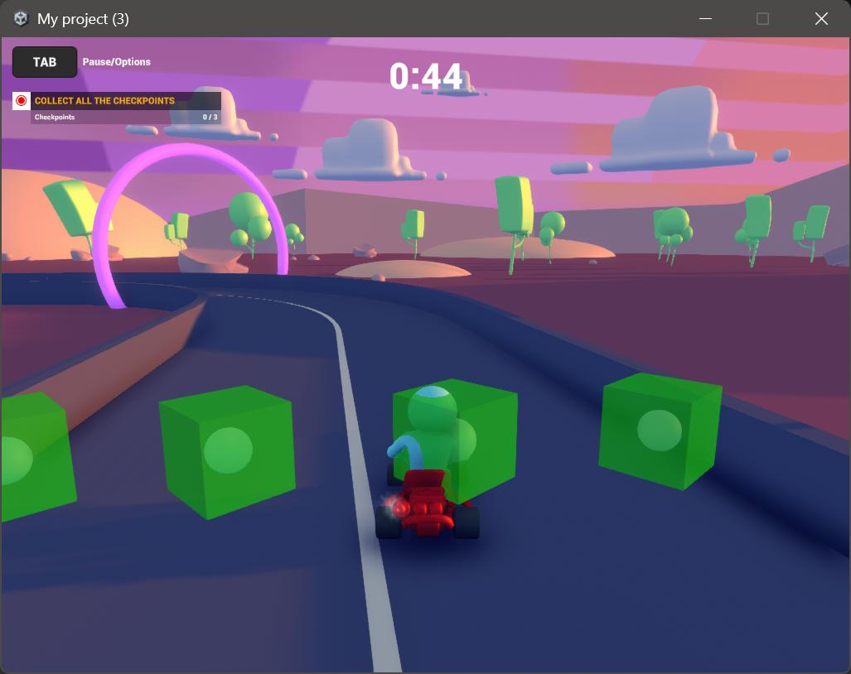
Task 4: Fill in a play test report;

In the file PickupComponent uncomment the code in Assets\Addtional Assets\Prefabs\PickupComponent:

/*gameObject.SetActive(false);
Invoke("Reset",3.0f);

ArcadeKart ak = other.transform.parent.GetComponent<ArcadeKart>();
if (ak != null)
{
ak.AddPowerup(powerup);
}*/
Then fill out
General Questions
- How would you rate your overall experience with the game?
  - Excellent
  - Good ✔
  - Fair
  - Poor

Gameplay Experience
- Did you find the game enjoyable?
Please explain your answer.
  - I find the game very enjoyable.
- Which aspects of the game did you like the most?
(e.g., racing mechanics, track design, power-ups)
  - I very much like track design, aesthetics, simple mechanics and game art as overall a solid game.
- Which aspects did you like the least or found frustrating?
  - The least favorite is pause menu as I can’t quit to main menu when I don’t want to continue and instructions system.
- Did you find the game intuitive and easy to understand?
  - Yes ✔
  - Somewhat
  - No
Please explain your answer.
  - The game mechanics is simple even without seeing the controls menu.

Controls and Mechanics
- How responsive did you find the controls?
  - Very responsive ✔
  - Somewhat responsive
  - Not responsive
- Were the controls easy to learn and use?
  - Yes ✔
  - Somewhat
  - No
- Did you encounter any issues with the steering, acceleration, or braking mechanics?
If yes, please describe.
  - No comments.
- Do you have any suggestions for improving the controls or mechanics?
  - Quit button or exit system in pause menu, volume slider and better feedback system.

Graphics and Sound
- How would you rate the overall graphics of the game?
  - Excellent ✔
  - Good
  - Fair
  - Poor
- Did the visual style appeal to you?
Please explain your answer.
  - I really like the game environment as its aesthetics are very appealing.

Bugs and Technical Issues
- Did you encounter any bugs or crashes during your playtime?
If yes, please provide details.
  - As mentioned before, a bug on environment script with unassigned reference exception as element 4 was showing none.
- Did you experience any performance issues (e.g., lag, frame rate drops)?
If yes, please describe.
  - No performance issue to be found.

