# **[tungsten-replicator安装](http://www.cnblogs.com/Smilence1024/p/7864980.html)**

# (从mysql -> mongodb)

# Pater

tungsten-replicator安装 1

Pater 1

# 安装:

## 安装之前的准备

1. yum install ruby

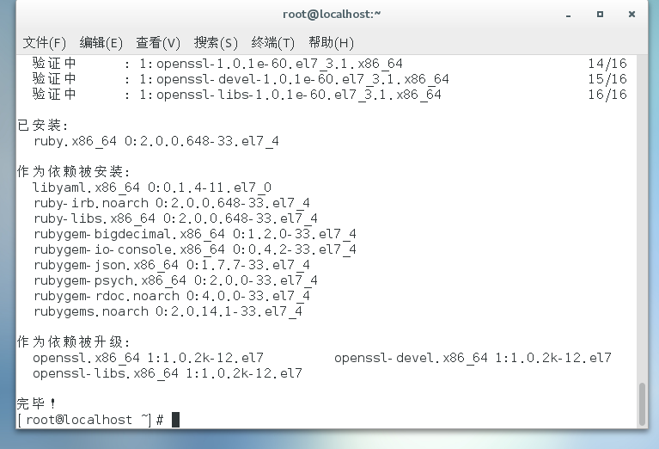

1. yun install ant

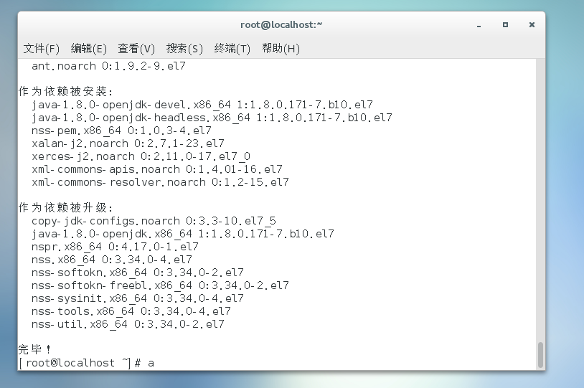

1. curl -O https://fastdl.mongodb.org/linux/mongodb-linux-x86_64-v3.4-latest.tgz