**Report:**

To begin we wanted to ensure that the general pipeline for using ESM3 works.

We installed ESM3 from the repository: <https://github.com/evolutionaryscale/esm>

Pip install esm

We used python 3.11 with cuda 12.1 and torch 2.3.1

Now to test out ESM 3 we took the following outer membrane protein A (OMPA) TRANSMEMBRANE DOMAIN from the PDB database with the id 1BXW and chain ID A

Next we want to select a motif ( a distinct sequence of amino acids ) to highlight from the structure.

The shape of the array is (n_residues, 37, 3) where n_residues is the number of residues in the protein and 37 is the number of possible distinct atoms that may be present across all amino acids (e.g. the first three atoms are the N, C-alpha, and C atoms corresponding to the protein backbone). The 3 corresponds to the x, y, and z coordinates of each atom.

We received the following view:

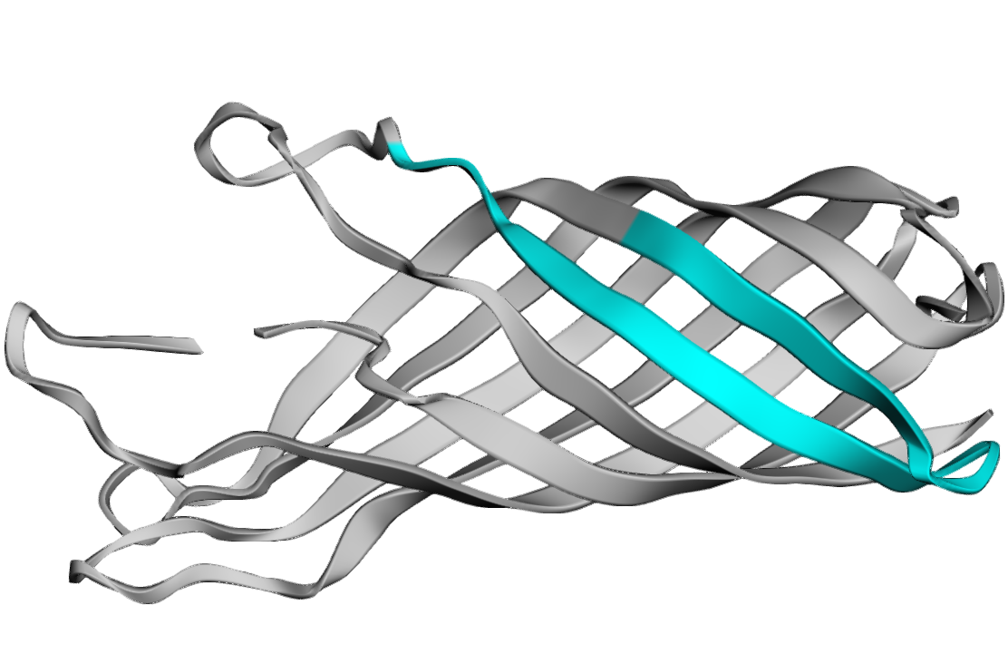

Next we will create a prompt for the model to use that’s 200 characters with the motif we chose will be the conditioning and the rest of the characters are masked.

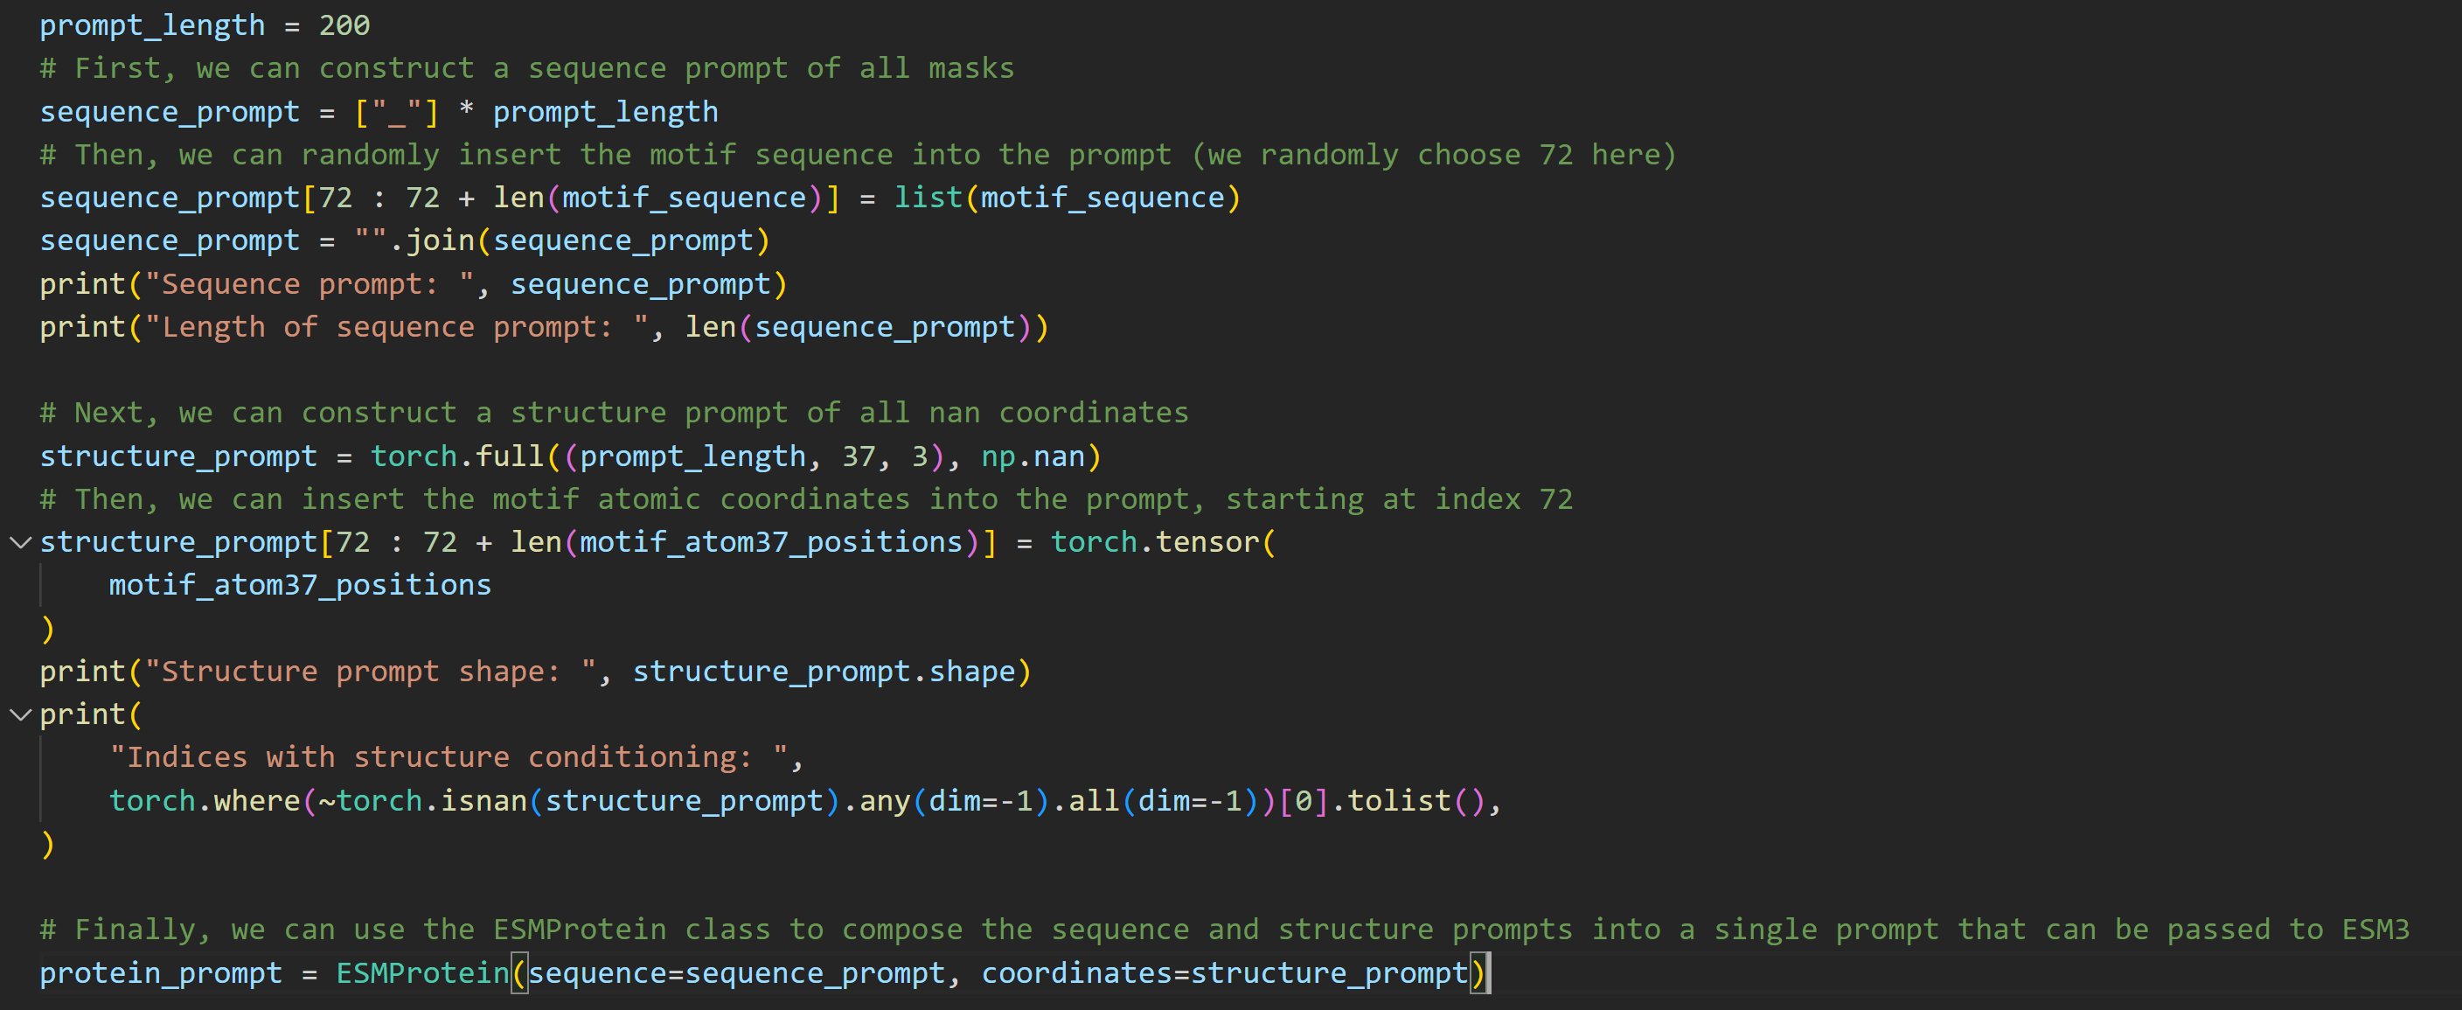



Now we can generate!

And we can also view the generated structure compared to the original structure

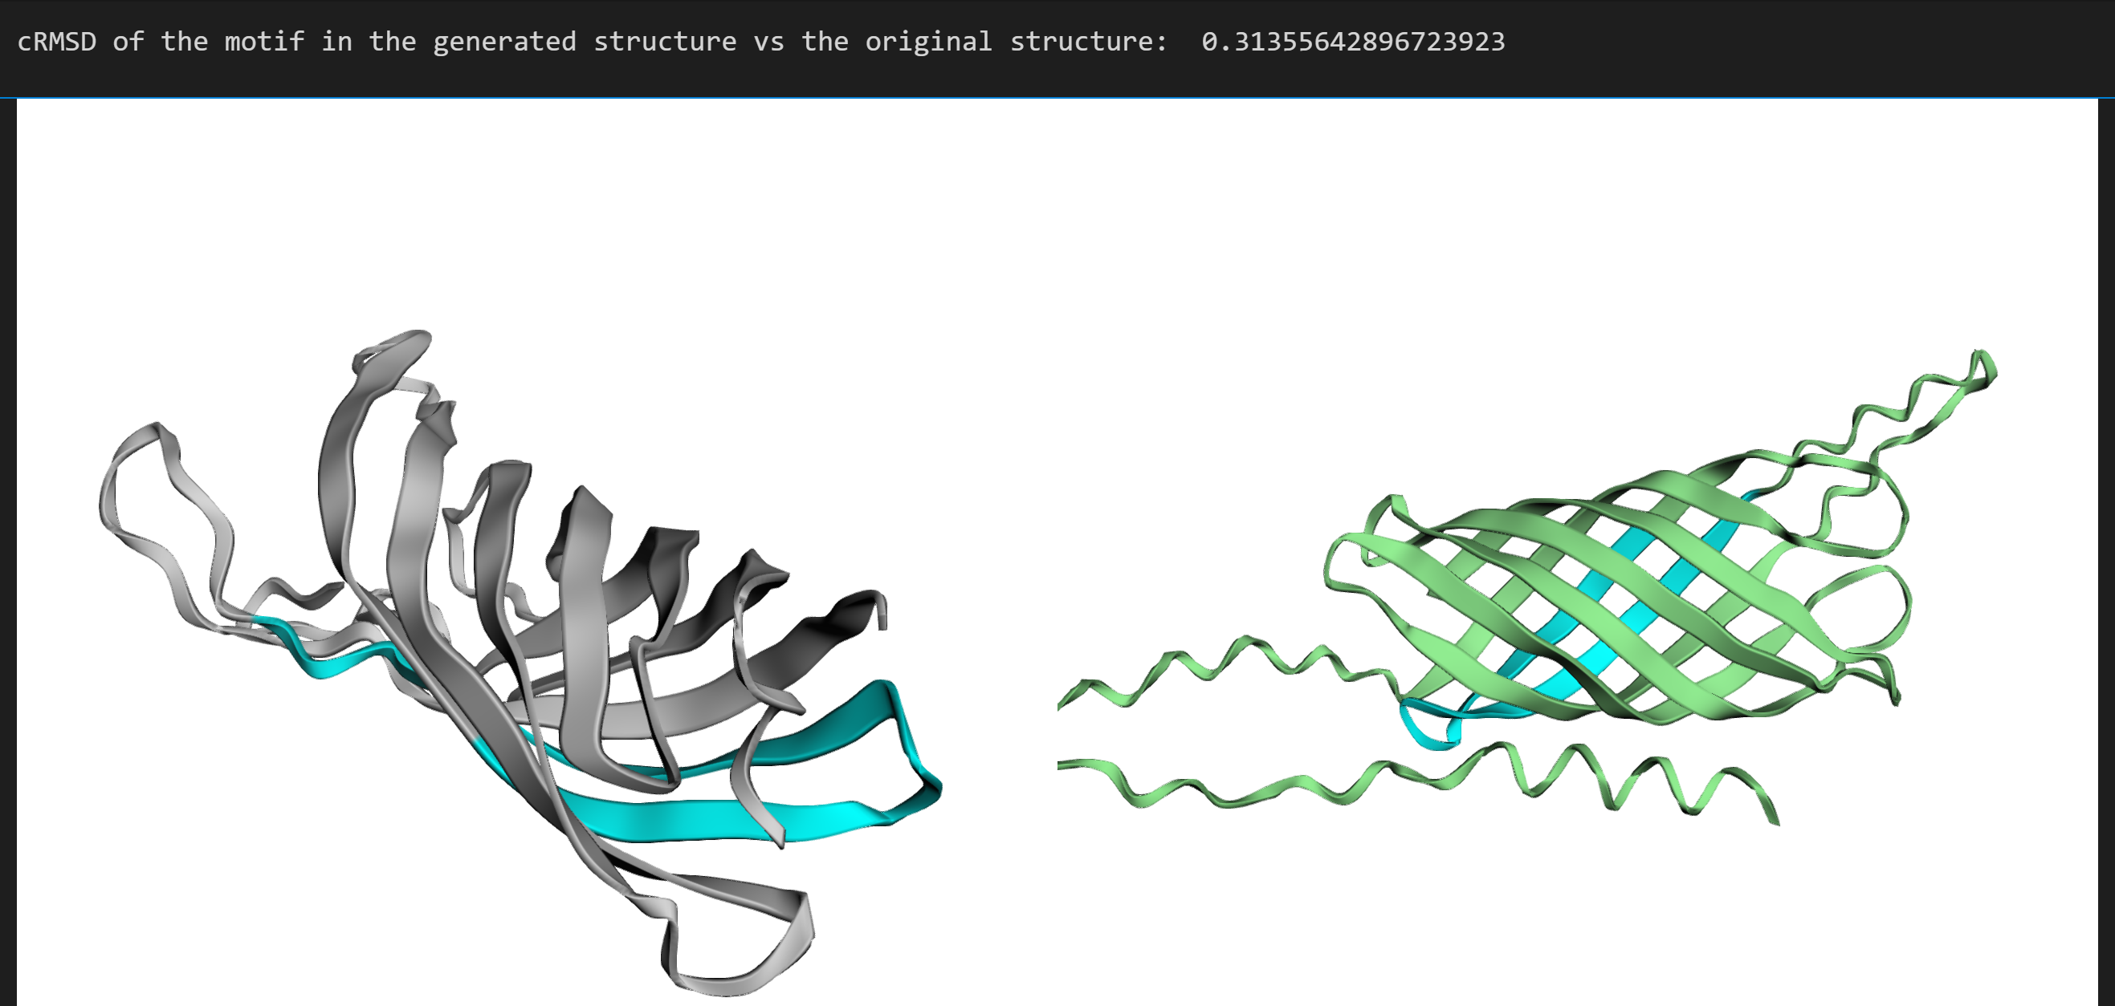

Now that we are confident in how to use ESM3 and protein structures we can begin the project.