Survey Questionnaire on the Current Status of Undergraduate-to-Graduate Transition

|  |  |  |
| --- | --- | --- |
| Type | Questions | Options |
| basic information | [Single Choice]1. What is your learning style? | 1. Professional Master 2. Academic Master |
| [Multiple Choice]2. Did you participate in any of the following research-related activities during your undergraduate studies? | 1. Academic Paper Writing 2. Participation in Research Projects (e.g., supervisor-led projects, undergraduate innovation programs) 3. Application for Patents or Software Copyrights 4. Did Not Participate |
| [Single Choice]3. Have you participated in any real engineering projects or had work experience in a company? | 1. Yes 2. No |
| research foundation | [Single Choice]4. Do you have a clear understanding of how to identify or establish a research direction? | 1. Yes 2. No |
| [Single Choice]5. How familiar are you with academic literature search techniques?(Rate from 1 to 5, with 1 being the lowest and 5 being the highest) | 1. 1 score 2. 2 score 3. 3 score 4. 4 score 5. 5 score |
| [Single Choice]6. How familiar are you with designing scientific research experiments?(Rate from 1 to 5, with 1 being the lowest and 5 being the highest) | 1. 1 score 2. 2 score 3. 3 score 4. 4 score 5. 5 score |
| [Single Choice]7. How familiar are you with data analysis and visualization?(Rate from 1 to 5, with 1 being the lowest and 5 being the highest) | 1. 1 score 2. 2 score 3. 3 score 4. 4 score 5. 5 score |
| [Single Choice]8. How familiar are you with academic paper writing and the submission process?(Rate from 1 to 5, with 1 being the lowest and 5 being the highest) | 1. 1 score 2. 2 score 3. 3 score 4. 4 score 5. 5 score |
| practical foundation | [Single Choice]9. How many programming languages are you familiar with? | 1. 1 2. 2 3. 3 4. 4 5. 5 or more |
| [Single Choice]10. Are you familiar with version control tools? | 1. Yes 2. No |
| [Single Choice]11. Do you have the ability to independently develop and deploy a complete project? | 1. Yes 2. No |
| overall evaluation | [Multiple Choice]12. In which fundamental skills areas do you hope the college will provide stronger support? | 1. Literature search and Technical document interpretation 2. Use of research and practice tools 3. Academic writing skills 4. Output of research results |

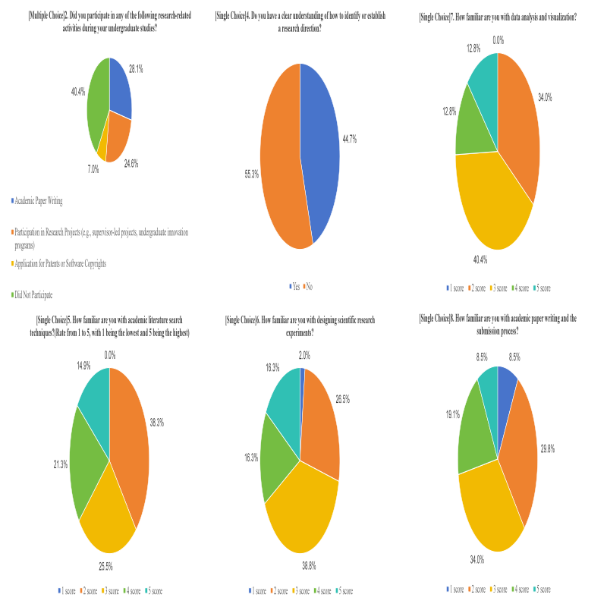

Survey Results on Research Foundation

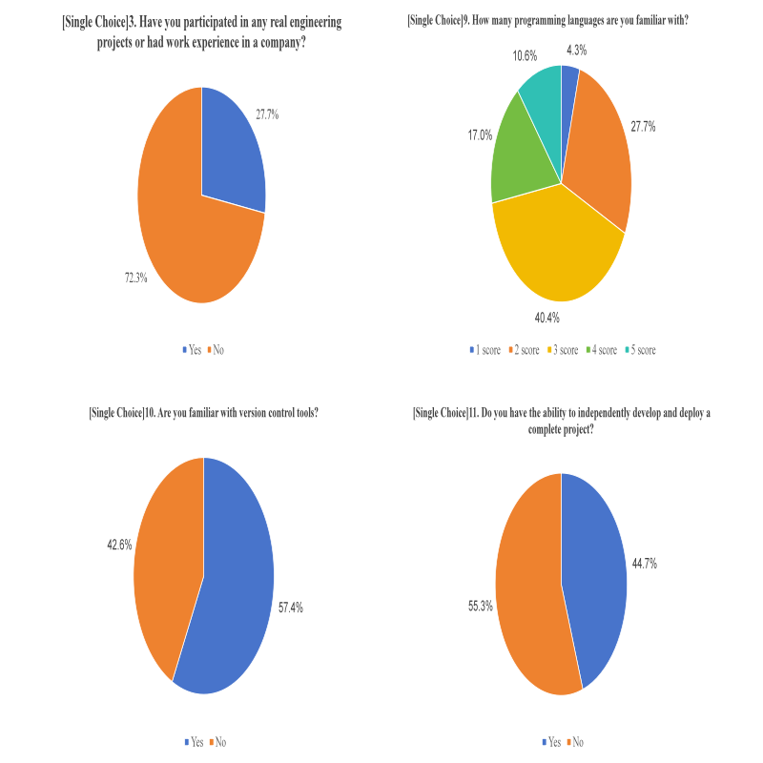

Survey Results on Practical Foundation

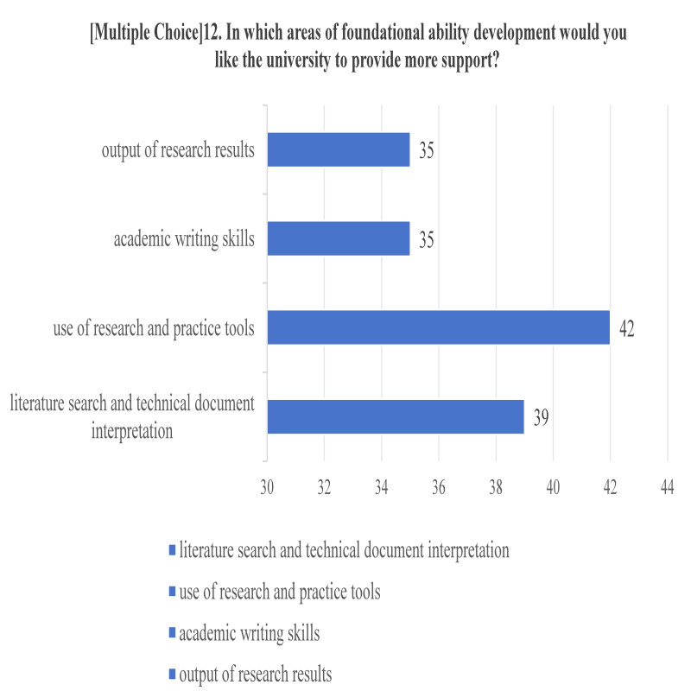

Survey Results on Student Suggestions

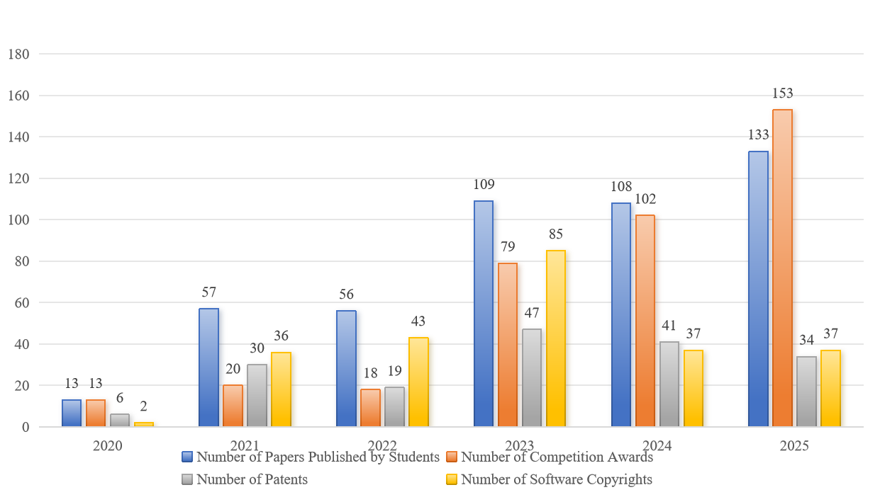

Research Output of Graduating Cohorts(2020-2025)

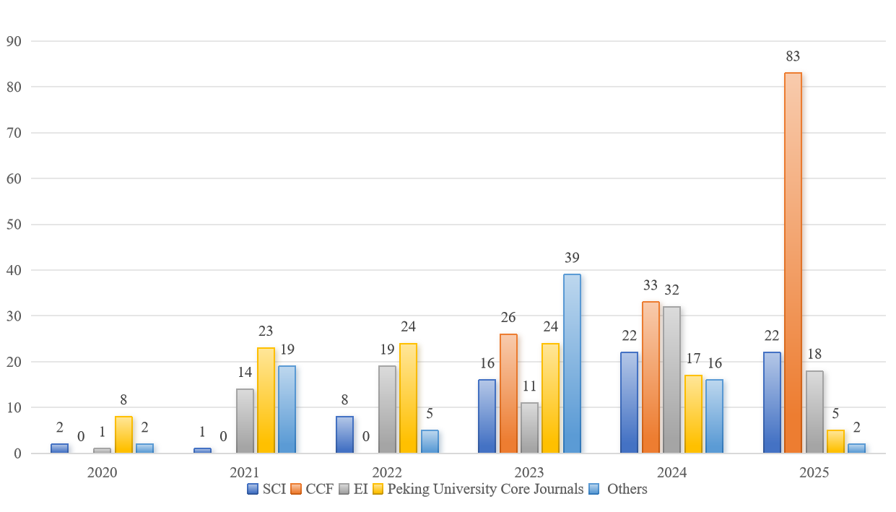

Academic Papers Published by Graduating Cohorts (2020-2025)

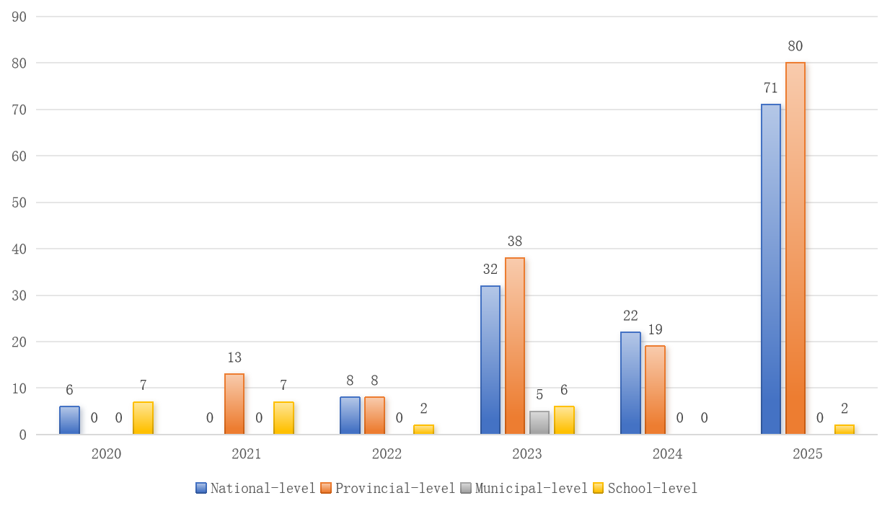

Awards-Winning Competition by Graduating Cohorts (2020-2025)