Assumption:

* The information of the employee details usually include employee first name, last name, gender, contact (can be email or phone number), address.
* From the query transaction a) we define an attribute “Position” (or “occupation”). Assume the employee can be an employee who worked at the NZCSA agency, or an applicant that fill an open which provided by this agency. The employee position/occupation shows the position/occupation in the company or agency.
* Enroll status: enrolled, pending and withdraw
* Course type: Basic topic and advanced topic
* Training session type: Practical course and theoretical course. Practical course has maximum size 10 applicants; theoretical course has maximum 20 applicants.

Business Rules:

1. Qualification & Prerequisite: Each prerequisite include many qualification; each qualification can include with only one prerequisite.
2. Qualification & Agency: Each agency certificate many qualifications; each qualification can associate with only one agency.
3. Qualification & Opening: Each opening required many qualifications; each qualification is required by only one opening.
4. Qualification & Applicant: Each applicant can hold several qualifications; each qualification can only be held by one applicant.
5. Prerequisite & Course: Each course can have many prerequisites; each prerequisite can only rule for one course.
6. Course & Training Session: Each course can have many training sessions; each training session can be included in only one course.
7. Training session & Enrolment: Each training session can be enrolled by many times; each enrolment can contain only one training session.
8. Enrolment & Applicant: Each applicant can make many enrolments; each enrolment can be made by only one applicant.
9. Applicant & Payment: Each applicant can pay for many payments; each payment can be made by only one applicant.
10. Applicant & PlacementRecord: Each applicant can maintain many PlacementRecords; each PlacementRecord can only maintained by only one applicant.
11. Applicant & JobHistory: Each applicant can have many JobHistory; each JobHistory can belongs to only one applicant.
12. PlacementRecord & Opening: Each PlacementRecord record many opening; each opening can be recorded in one PlacementRecord at once.
13. JobHistory & Employee: Each employee can have many JobHistory; each JobHistory can recorded by only one employee.
14. JobHistory & Company: Each JobHistory can involve many companies; each company can be recorded once in one JobHistory.

Normalize process:

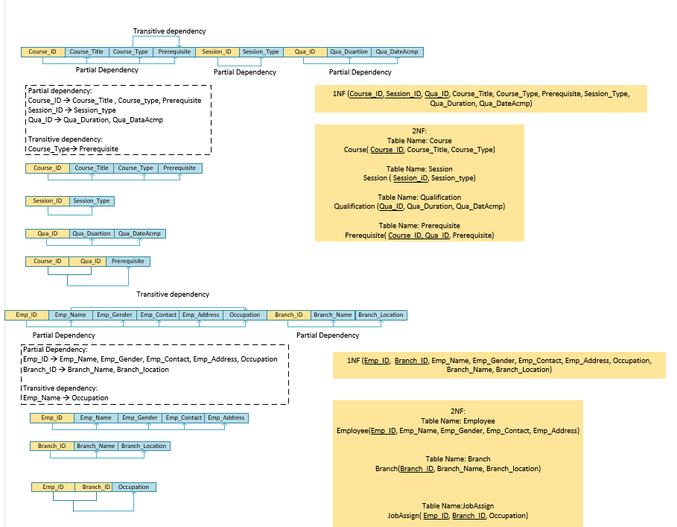

Content of tables:

