備份

1. 使用Heroku Dashboard

進入專案

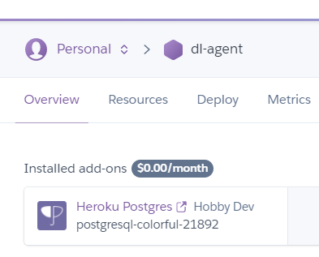

進入Postgresql Durability

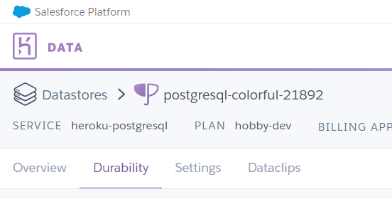

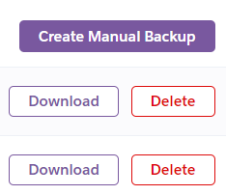

Download🡪(latest.dump)

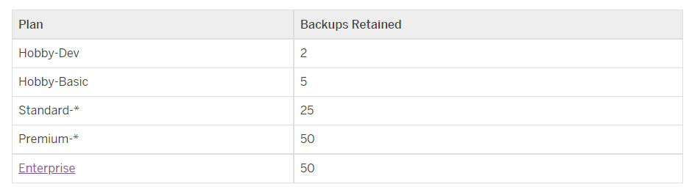

1. CMD

heroku pg:backups:download b003 -a dl-agent

復原

heroku pg:backups restore b003 DATABASE_URL --app dl-agent

heroku pg:backups restore b003 DATABASE_URL -a dl-agent

[linux]

heroku pg:backups:restore 'https://s3.amazonaws.com/me/items/mydb.dump' DATABASE_URL -a s dl-agent

### [window] (“ “ 而不是’ ‘ 被搞死了，花費4HR，簽名的URL誤以為一定要認證)

heroku pg:backups:restore “https://s3.amazonaws.com/me/items/mydb.dump” DATABASE_URL -a s dl-agent

1. hfs.exe + ngrok.exe

執行hfs.exe ，拖曳備份檔如下(latest.dump)

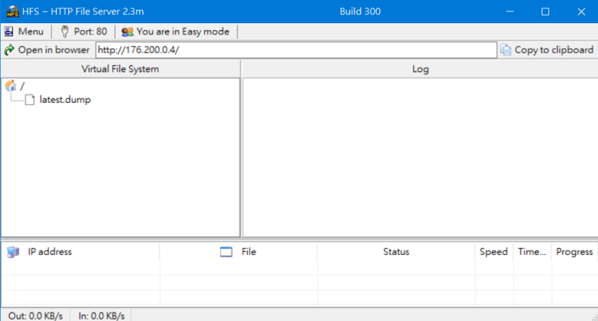

CMD

ngrok http 80

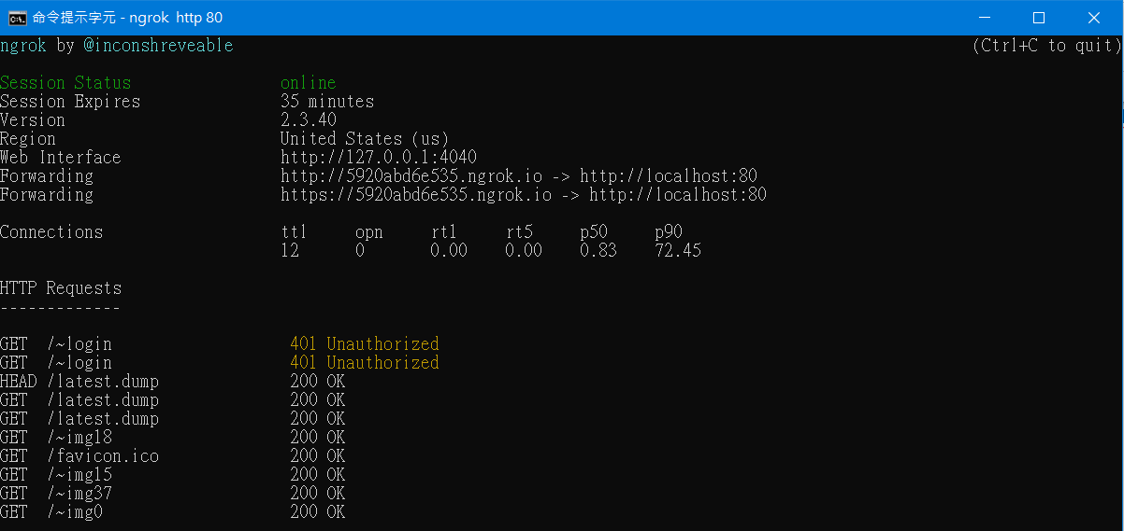

(先確認瀏覽器<https://5920abd6e535.ngrok.io/latest.dump>能自動下載)

heroku pg:backups restore "https://5920abd6e535.ngrok.io/latest.dump" DATABASE_URL --app dl-agent

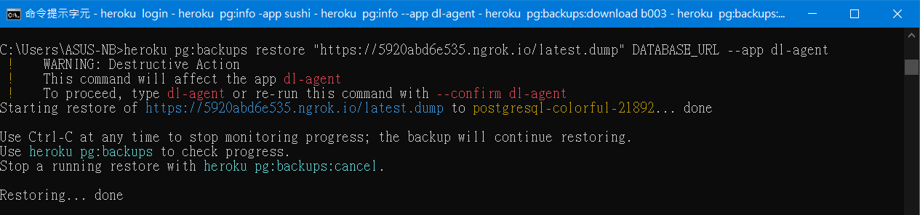

需再輸入dl-agent做確認，也可直接指令加入--confirm dl-agent

1. GCP的Cloud Stroage

建立專案

Cloud Stroage

Create Bucket

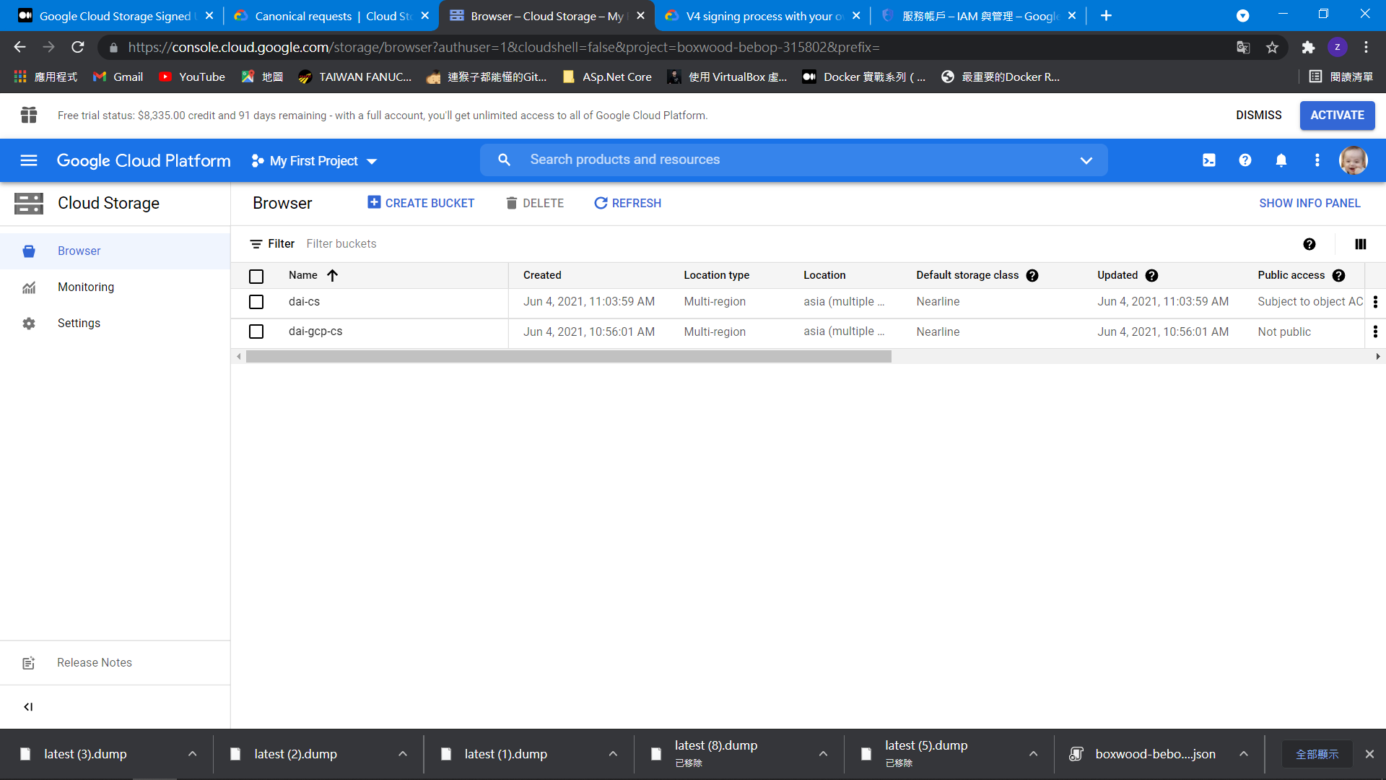

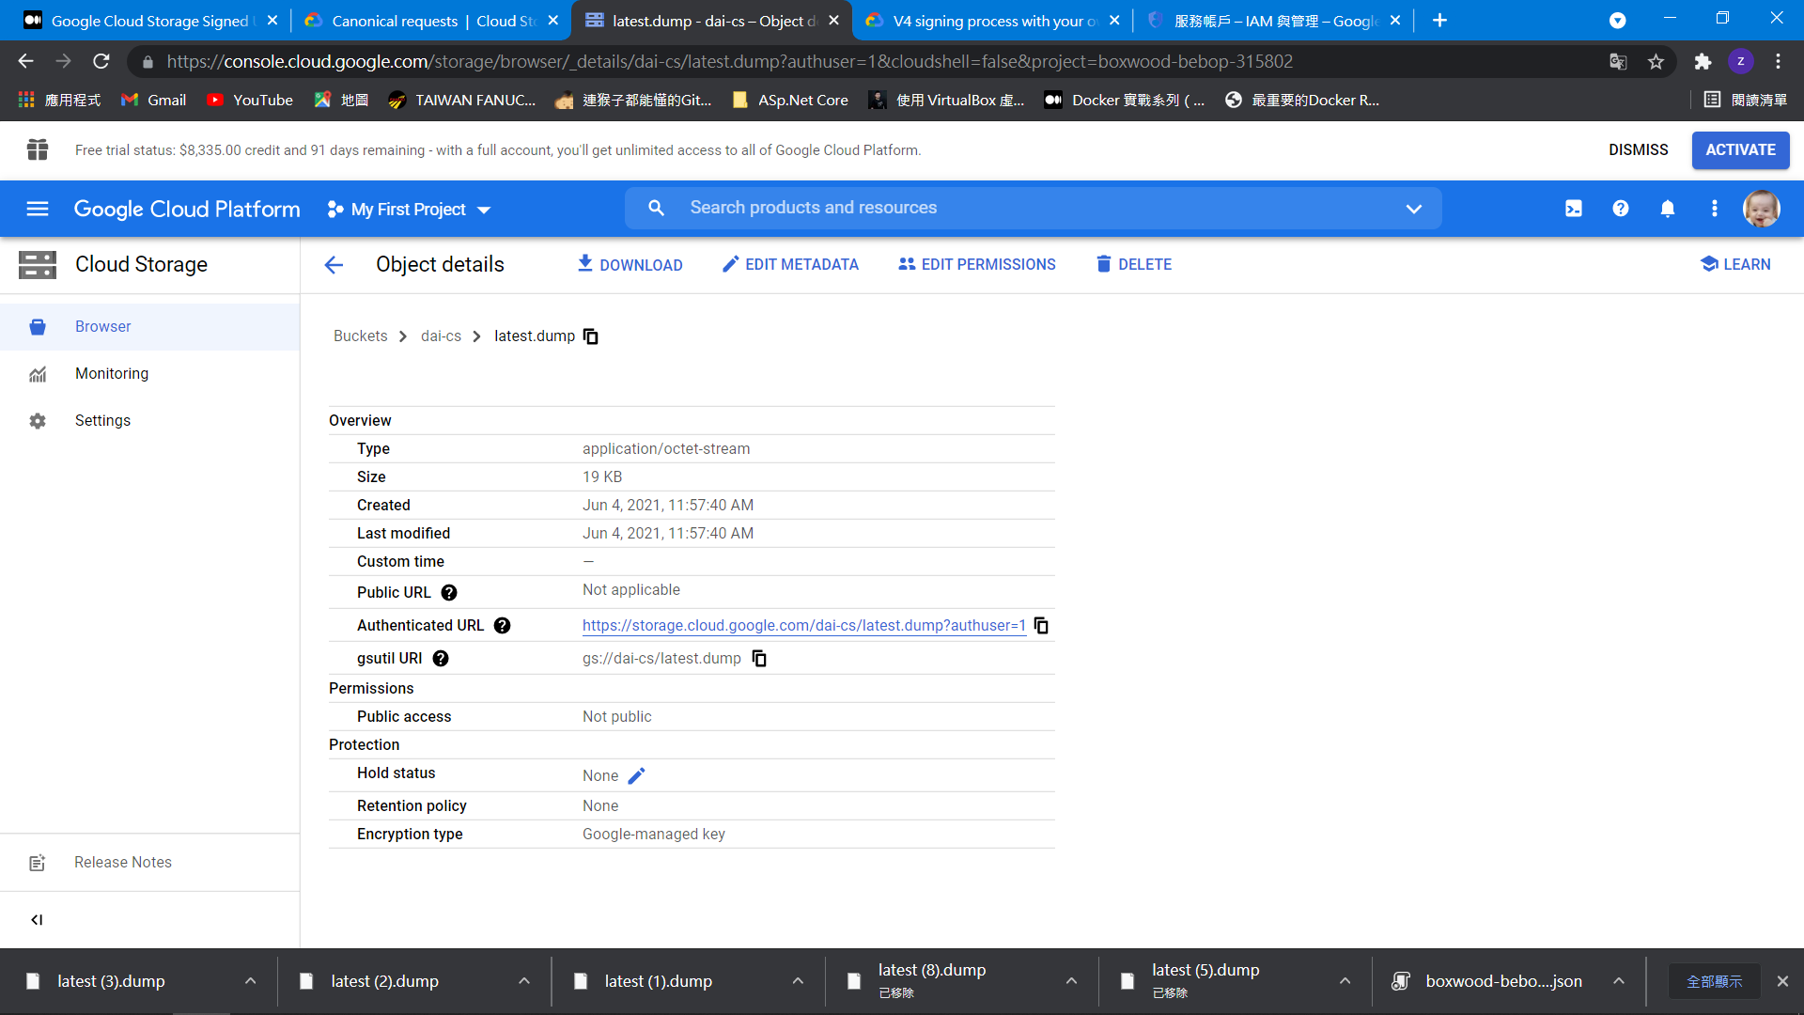

credentialFilePath

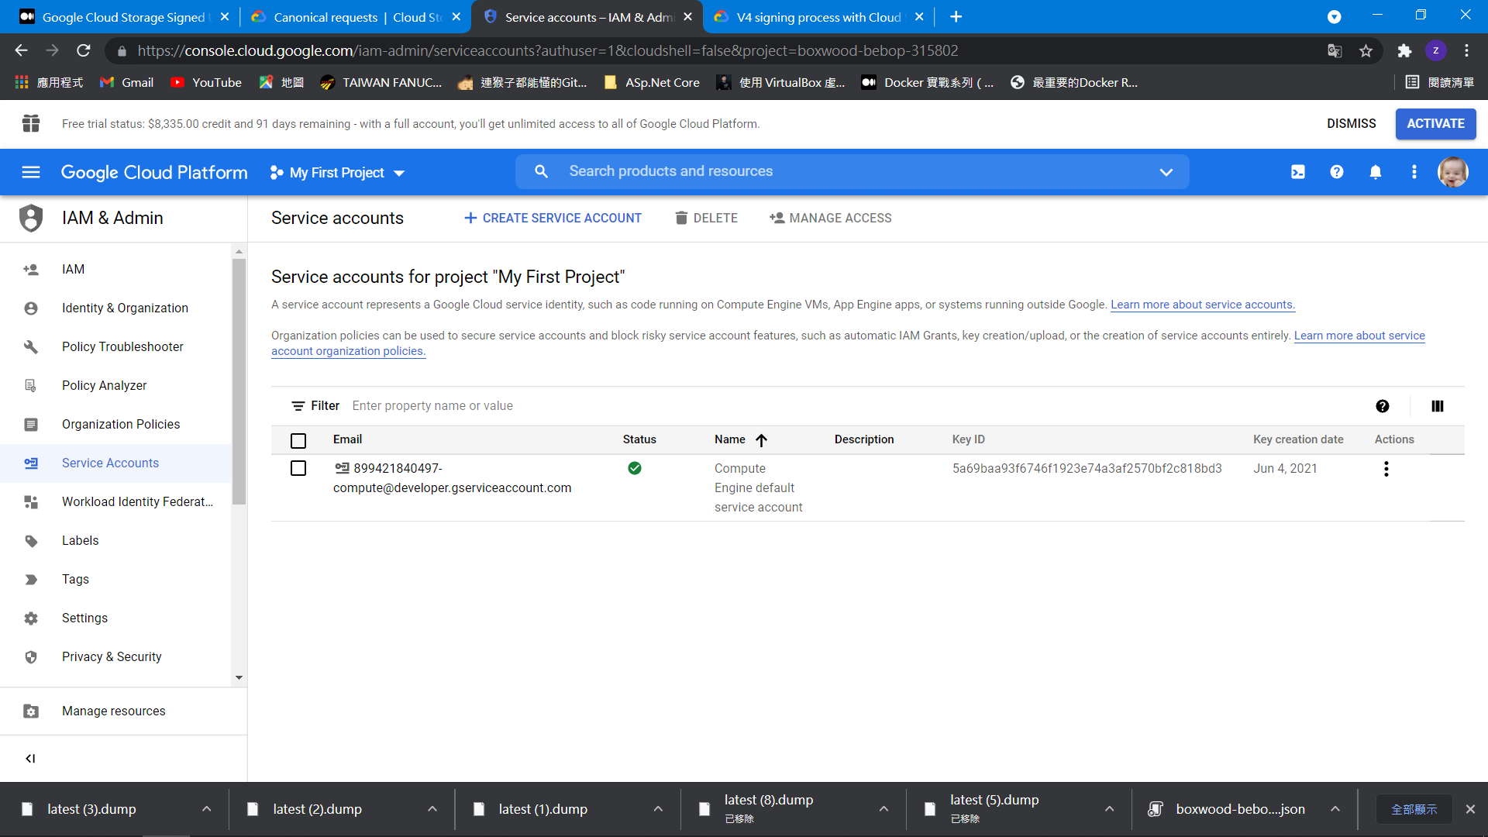

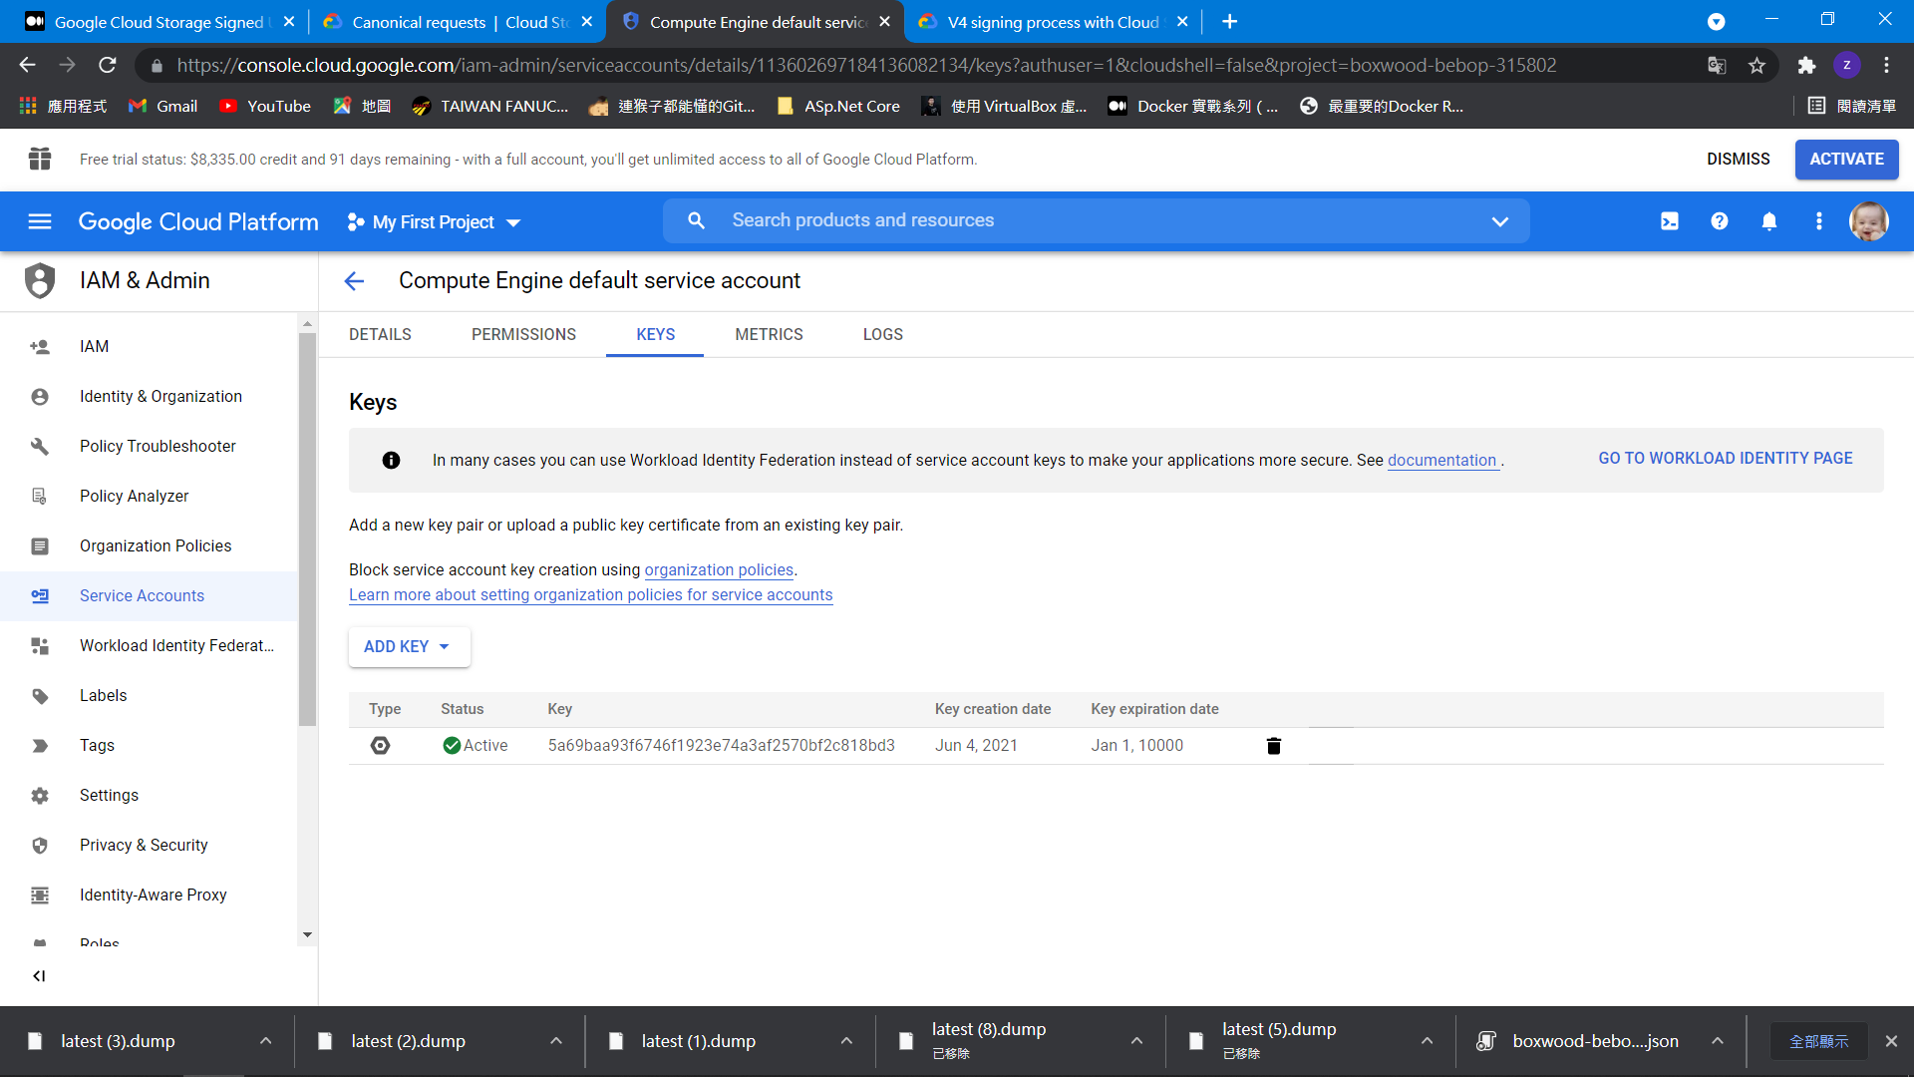

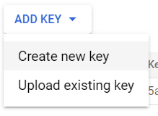

Save *.json (copy to d:\boxwood.json)

下載GoogleCloudSDKInstaller.exe

gsutil signurl -d 10m d:\boxwood.json gs://dai-cs/latest.dump

產生如下網址(測試能否直接下載)

<https://storage.googleapis.com/dai-cs/latest.dump?X-Goog-Algorithm=GOOG4-RSA-SHA256&X-Goog-Credential=899421840497-compute%40developer.gserviceaccount.com%2F20210604%2Fauto%2Fstorage%2Fgoog4_request&X-Goog-Date=20210604T061324Z&X-Goog-Expires=3599&X-Goog-SignedHeaders=host&X-Goog-Signature=>

使用C#

如C:\Users\ASUS-NB\source\repos\ConsoleApp1

一樣回產生https://storage.googleapis.com/dai-cs/latest.dump…..

最後CMD執行

heroku pg:backups restore "https://storage.googleapis.com/dai-cs/latest.dump?X-Goog-Algorithm=GOOG4-RSA-SHA256&X-Goog-Credential=899421840497-compute%40developer.gserviceaccount.com%2F20210604%2Fauto%2Fstorage%2Fgoog4_request&X-Goog-Date=20210604T061324Z&X-Goog-Expires=3599&X-Goog-SignedHeaders=host&X-Goog-Signature=" DATABASE_URL --app dl-agent

查閱備份和恢復紀錄

heroku pg:backups -a dl-agent

重新啟動App

heroku restart -a dl-agent

恢復時，不要取消，資料庫會沒有資料(Size=0)，造成App異常

