Prototypes: Lo-fi, Med-fi, and Hi-fi Mockups

Team 2: Omar Ahmadi, Taha Khan, Branden Klemens, Alex Gleizer

Directions to run the Demo (Hi-Fi) version of Mobile Arena:

<http://appinventor.mit.edu/explore/ai2/setup-emulator.html>

Download emulator first

<http://ai2.appinventor.mit.edu>

.aia file

<https://drive.google.com/?utm_source=en&utm_medium=button&utm_campaign=web&utm_content=gotodrive&usp=gtd&ltmpl=drive&pli=1#folders/0B34si536-SOgQVkyQlFCMk1salU>

In the app inventor menu hit Projects > import projects (.aia) from my computer

Open the downloaded aiStarter software then In the App Inventor menu hit Connect > Emulator

**Personas Mobile Arena is Designer for:**

*"Dennis"*

Dennis is a 42 year old accountant. He is married with two children. Sports were a passion of his while growing up, both the competition of playing sports as well as watching them. He played high school and some college football. From an early age, Dennis and his father would watch Giants games on Sundays in the fall. His father was an avid Giants’ fan and he became an avid Giants’ fan as a result. He also played fantasy football with his college buddies. Now, however, his job and family duties don’t leave him much time to indulge in his passion for sports.

*"George"*

George loves soccer. He plays just about every Sunday with his three brothers, with a lot of teasing based on who did poorly that week. Since he himself is playing Sunday mornings, he cannot be at other games and watch the tournaments his brothers participate in as they happen. Fortunately, one of his brother’s told him about Mobile Arena!

Our two personas are based on a superfan of one team and a fan of a sport without teams, two very different types of sports fans. A third possible Persona would be someone who just wants to track ALL teams within a specific sport. This kind of user seemed most likely to have already chosen other very powerful tools to gain the information they wanted.

**Low-Fidelity MockUp:**

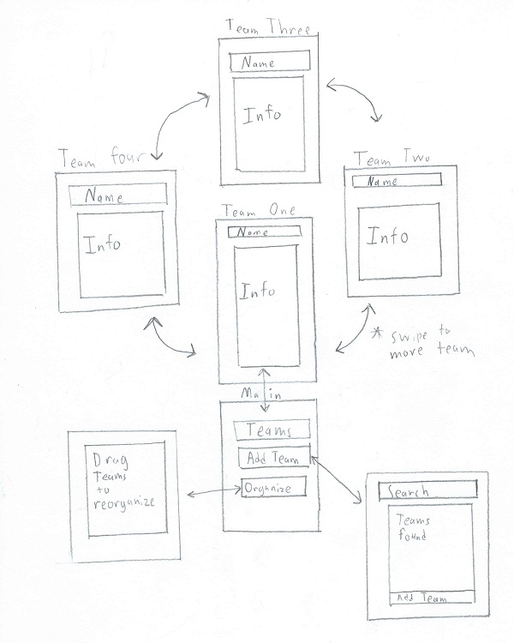

After the initial installation, the user is placed onto the "Add Teams" screen where they add all the teams they are interested in following. When loading the app with teams added, it will go to the "Main" screen. The main screen has three paths available, adding new teams, going to the teams you have followed, and reorganizing the team order. Adding a new team is done by searching for a team and then selecting the one you are interested in and clicking the "Add Team" button. By hitting the "Teams" button you immediately get information of your first team. You can get information on other teams by swiping left and right. Finally, you can hit "Organize" button which allows you to reorganize the teams because the teams that are in the middle of the list are more challenging to get to.

Targeted user requests

"The most common feature request was a desire to make easy to get more details quickly"

Pros:

1.Users would get more information right away

2.Teams can be reordered to get to favorite teams faster

Cons:

1. Longer to get to the teams in the middle of the list.

**Medium Fidelity Mockup:**

Found via the Medium-Fi PowerPoint

When the application is loaded, the user is met with the 'Main' screen; three options are available: 'Teams', 'Add Team' and 'Organize'. When the 'Teams' button is pressed, the user is brought to the screen in which information on their followed team is viewable and additional teams can be viewed by swiping the screen. This 'Teams' screen contains three options as well: 'Schedules', 'News' and 'Scores'; the buttons bring the user to their respective screens with information on schedules, news or scores. Returning to the 'Main' screen, the user has the option of adding new teams. When the 'Add Team' button is pressed, the user is brought to the 'Add Team' screen in which they can search for teams and are given results based on their query. When a result is selected, the user is brought to the 'Team Description' screen which displays the team name, description and option for adding the team. Lastly, returning to the 'Main' screen, the user may select 'Organize'; the user is then taken to the 'Organize' screen in which they can reorganize the order of the teams they are following. The changes made will be reflected in the ‘Teams’ section of the application, allowing the user to place their favorite teams earlier in the list to reduce the amount of swiping and searching.

**High Fidelity Mockup:**

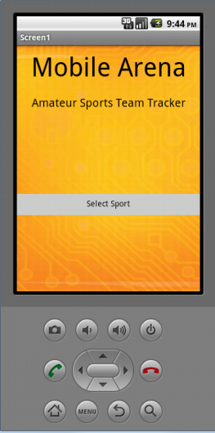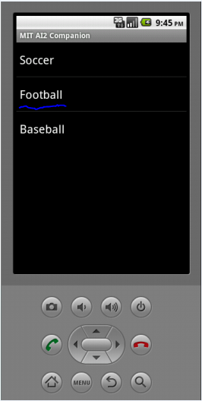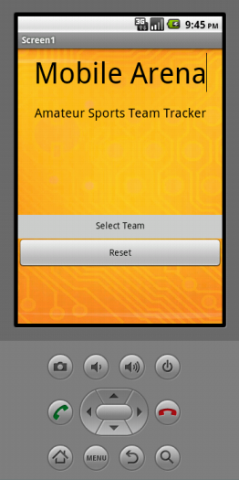

**Lo-Fi to Hi-Fi Changes:**

We built the Hi-Fi Prototype from the "Quick Look up" Lo-fi Prototype. The largest change was the removal of the initial setup page, replacing it with the sport/team selection page. We also fixed a design flaw by placing a button in the sports hub that directs users to select a different team. These added features give users more navigational tools and power to access the content they desire.

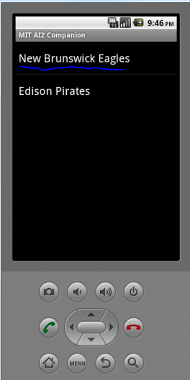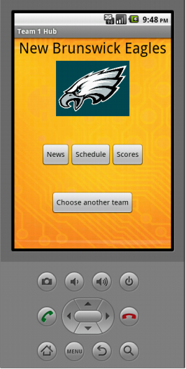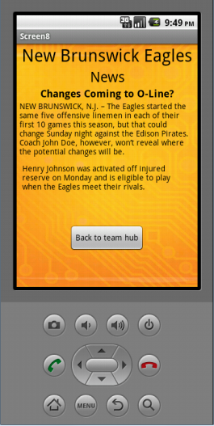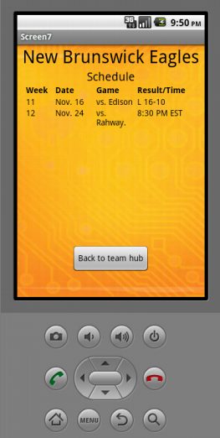

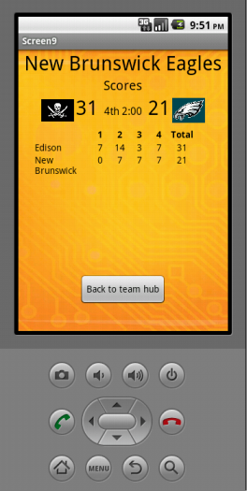

**Overview:**

This Hi-Fi prototype demonstrates our mobile interface and interactive flow of the Mobile Arena application.

In this scenario the user starts by going through the initial setup/main screen choosing a sport and team. For demonstration purposes, we have limited the selection to the New Brunswick Eagles football team in the demo.

After selecting the combination of a sport and team, the app loads up a team hub with three buttons:

* News - displays the newest article about the team
* Schedule - displays the upcoming games along with dates
* Scores - displays the latest scores

The user can also go back another team by returning to the main screen from any team hub page.

ER Diagram

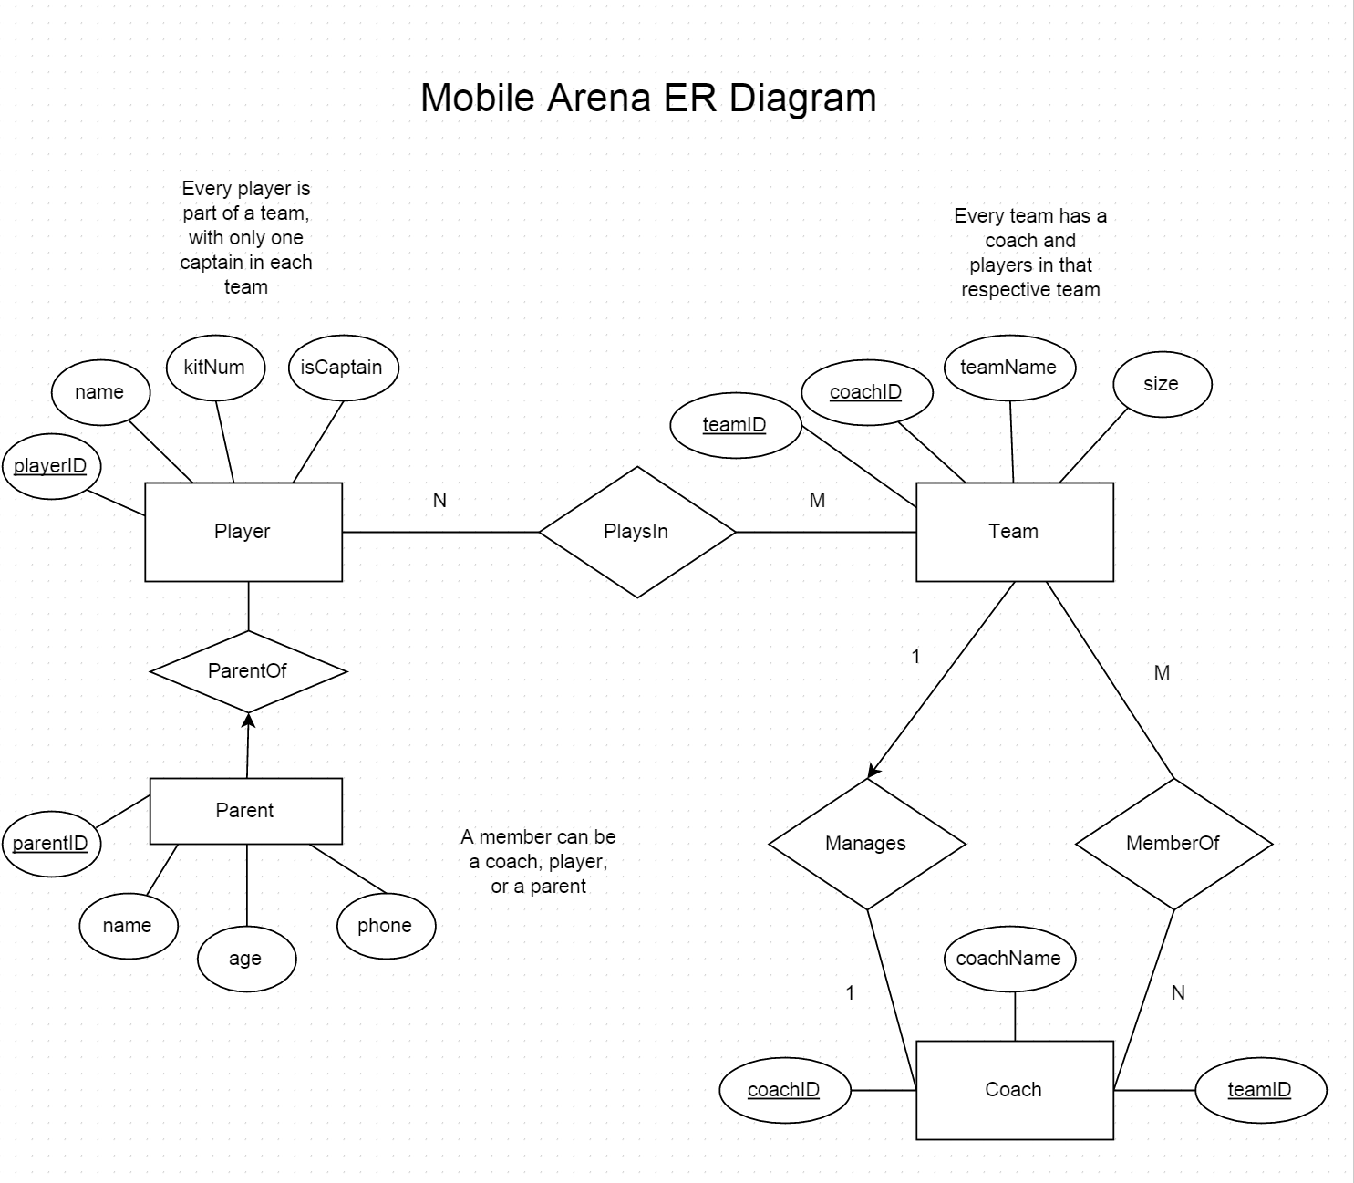

Entities:

Player: playerID (PK int), Name (string), kitnum (int), isCaptain (bool)

Parent: parentID (PK, int), Name (string), age (int), phone (int)

Team: teamID (PK, int), coachID (FK, string), teamName (string), size (int)

Coach: coachID (PK, int), teamID (FK, string), coachName (string)